MedTrace Guard: Pharmaceutical Provenance with Accepted Custody and Safety Gates
CSE 540 Engineering Blockchain Applications
Project Proposal | Fall B 2026
Ananya Mishra, Hemanth Reddy Narendrababu
Sai Harsha Yerapothu, Ridham Shah

Abstract—We plan to build MedTrace Guard to track medicine batches from the manufacturer to the pharmacy. The system will record who holds each batch and require the next participant to accept a transfer. It will block transfers and dispensing for recalled or expired batches and batches with an unresolved temperature warning. Certificates will be stored off-chain and checked against their registered hashes. We will test these controls and compare their costs with a simpler tracking contract.
- Problem Statement and Motivation
Manufacturers, distributors, and pharmacies may keep separate records, making a batch's history harder to follow. We want to provide a shared record of where a batch came from, who accepted it, and whether recorded safety issues should stop its distribution. WHO reported in 2017 that an estimated one in ten medical products in low- and middle-income countries was substandard or falsified [1]. This is a historical estimate, not a current worldwide rate.
Blockchain is useful here because several organizations can check the same signed records without one trading partner controlling the ledger. The FDA describes DSCSA tracing at the package level [2]. Our project will track batches for a classroom demonstration; it will not establish regulatory compliance or prove that a physical medicine is genuine.
- Literature Review and Project Contribution
Sylim et al. [3] proposed blockchain-based pharmaceutical tracking with smart contracts and distributed file storage. Their work supports our choice of a shared ledger with documents kept off-chain. Our project will focus on three controls that we can demonstrate and test:
• Accepted custody: custody changes only after the intended recipient accepts a transfer request before its deadline.
• Temperature holds: an out-of-range simulated reading blocks further transfers and dispensing until a regulator reviews and releases the hold.
• Clear verification results: the dashboard shows custody history, recorded safety warnings, and whether a certificate matches its registered hash.
The pharmacy will also be able to dispense part of a batch while the contract checks that the total dispensed does not exceed the registered quantity. These are additions to our basic tracking baseline, not claims of new blockchain research.
- Proposed Architecture
The manufacturer registers a batch. The distributor and pharmacy each accept custody before the batch moves to the next stage. A regulator can recall a batch or review a temperature hold. An administrator assigns the approved wallet roles. Public viewers can read the batch history without connecting a wallet.
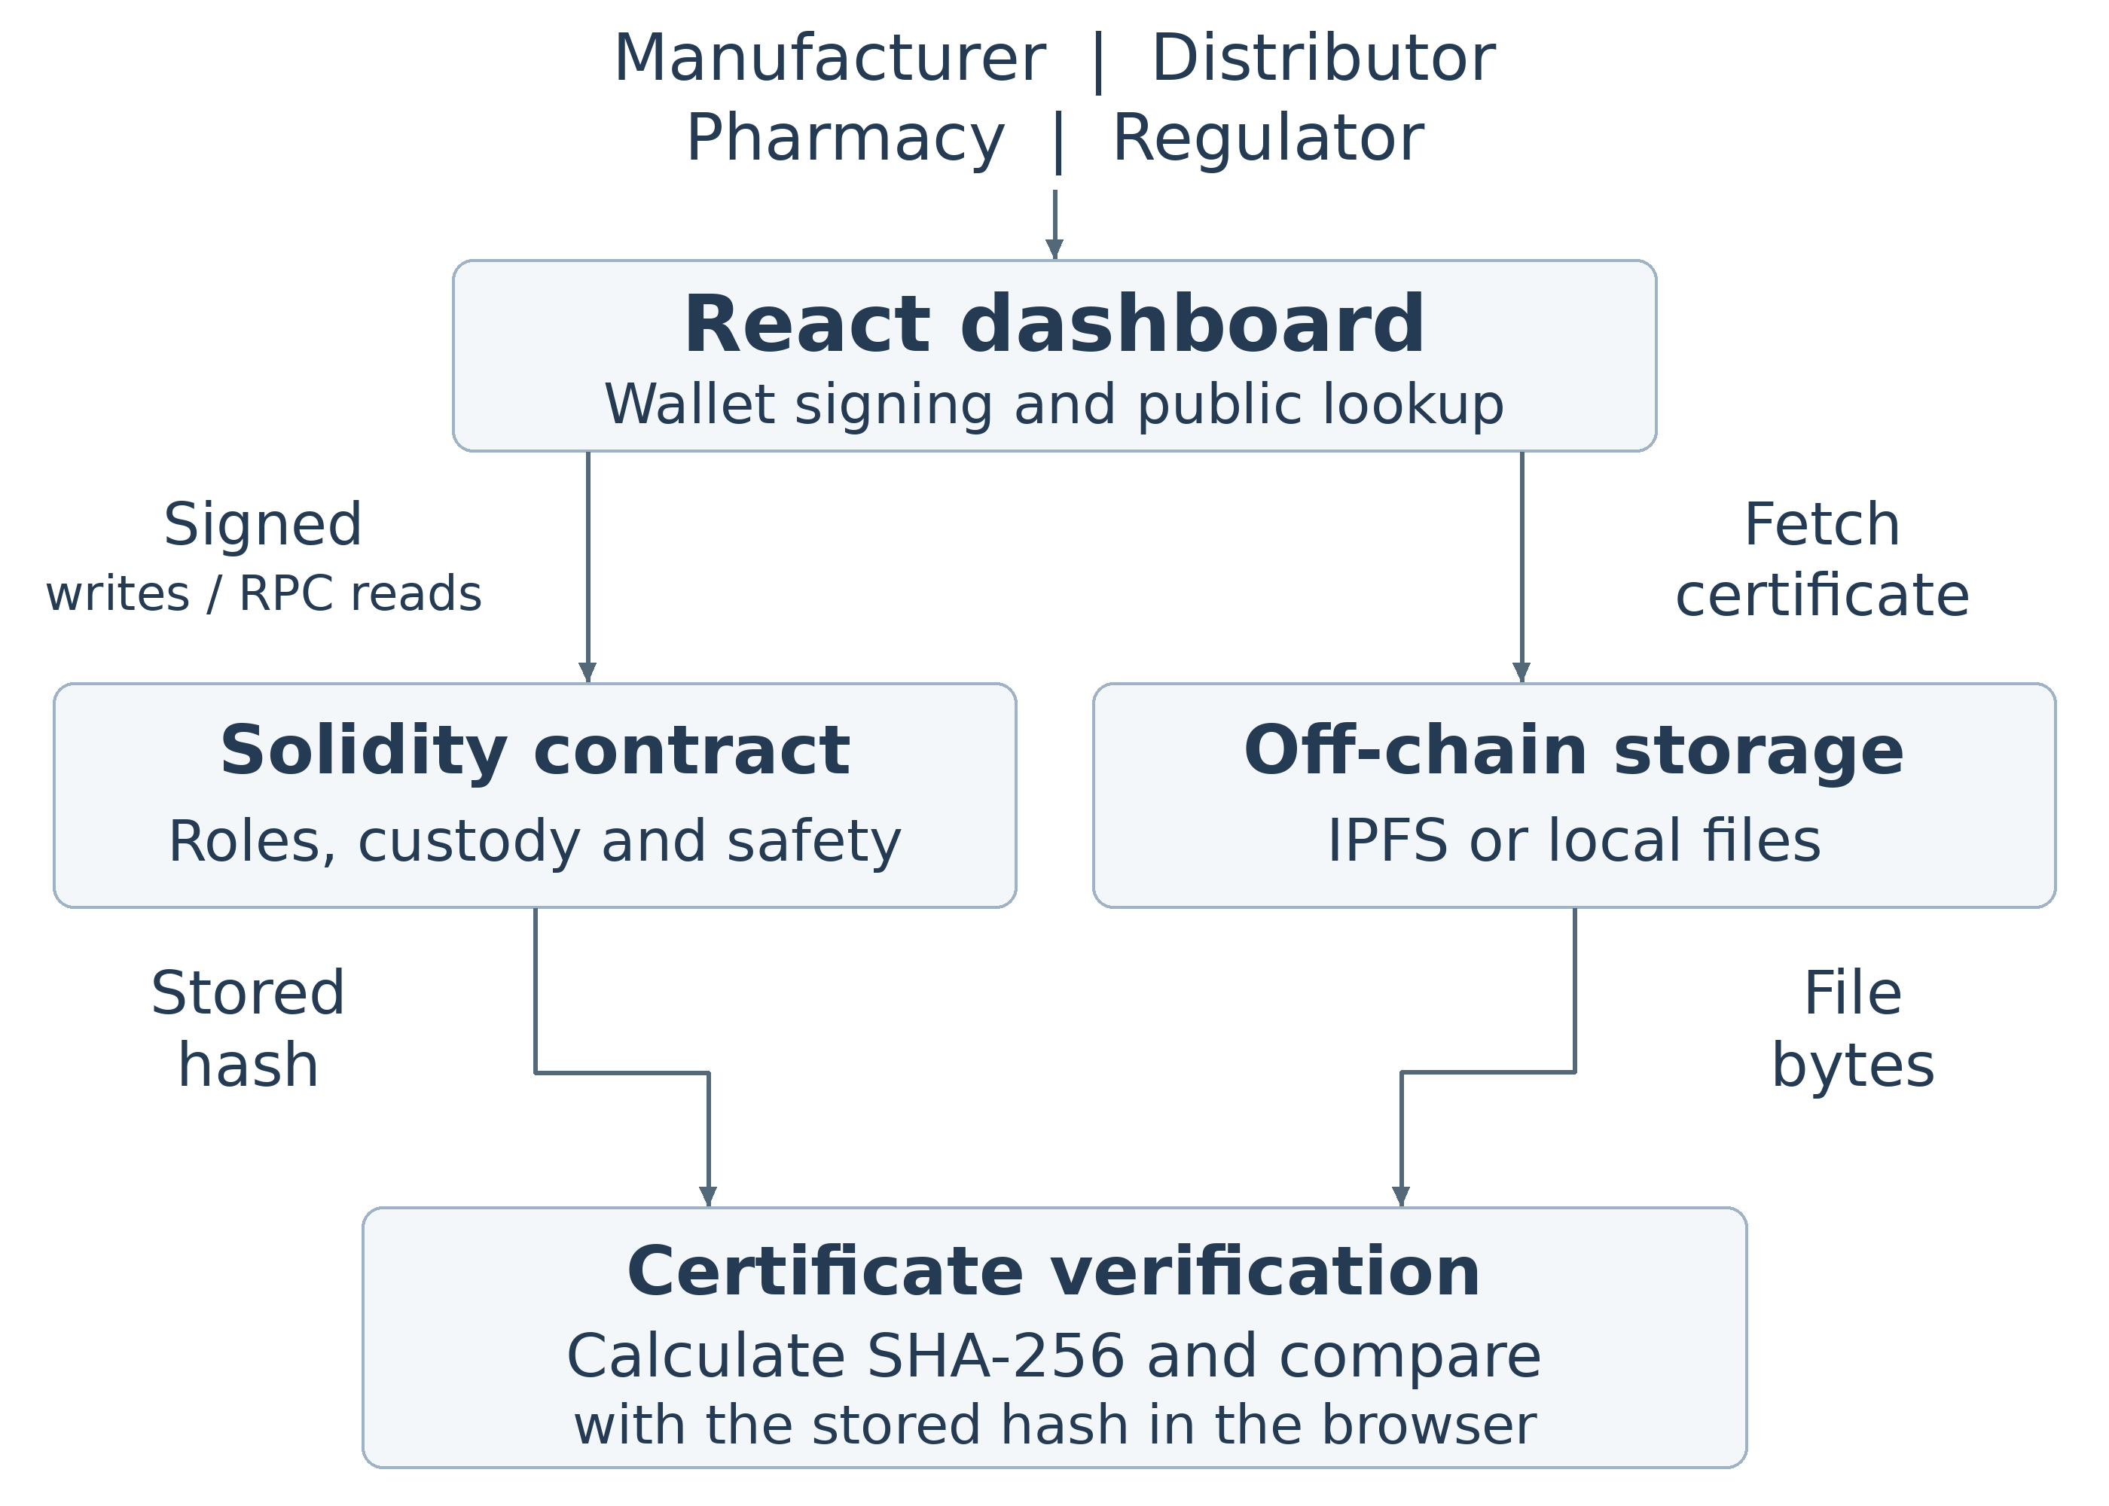
Figure 1: MedTrace Guard architecture and certificate check
- Chosen Platform
We will use Solidity contracts on Polygon Amoy, an Ethereum-compatible test network, with React, ethers.js, and MetaMask. This lets us use Solidity and familiar Ethereum wallet tools while demonstrating transactions without real funds. We will develop and test on a local chain first so that faucet or network problems do not stop progress.
- Data and Smart Contract Workflow
Each batch record will include its ID, manufacturer batch code, medicine name, current custodian, production and expiry dates, registered and remaining quantities, temperature limits, safety flags, and certificate reference. Duplicate codes from the same manufacturer will be rejected. The application will not provide functions to edit earlier history entries.
The workflow is registration, an accepted transfer to the distributor, an accepted transfer to the pharmacy, and dispensing. Each transfer request has a recipient, a unique request number, and a deadline. The contract checks the caller's role, current custody, expiry, recall status, temperature hold, and remaining quantity before allowing an action. A normal temperature reading cannot clear an earlier hold; a regulator must record a review. A recall cannot be reversed.
Certificates will be stored on IPFS, with local sample files available during development. The browser will calculate SHA-256 from the exact file bytes and compare it with the hash on-chain. A matching file does not prove the laboratory or medicine is genuine. IPFS files must be retained or pinned to stay available [4]. Temperature readings will be simulated, and their original records will be kept off-chain.
- Scope Evaluation and Feasibility
We will build one manufacturer-distributor-pharmacy route using synthetic batch records and certificates. The dashboard will support registration, accepted transfers, partial dispensing, safety warnings, certificate checks, a custody timeline, and QR links. We will not include real sensors, patient data, payments, batch splitting, or regulatory integrations.
We will write a simpler baseline contract that records batches, direct transfers, recalls, and dispensing. It is a comparison for our design, not a reproduction of another project's code. We will evaluate:
• the normal batch journey and rejected actions involving wrong roles, invalid requests, expired or recalled batches, and temperature holds.
• gas used by key operations, counting both the proposal and acceptance transactions for a complete transfer;
• local read times with 10, 50, and 100 batches.
• modified certificates and files that cannot be retrieved.
The baseline stores less data, so gas differences will reflect the whole design rather than the cost of one feature alone. Local tests will not establish public-network throughput. We will report measured results after running the experiments.
- Milestones and Limitations
2026 date | Planned deliverable
Oct 25 | Proposal and team contract
Nov 1 | Contract draft tests and GitHub README
Nov 15 | Prototype and five minute demo
Dec 4 | Code evaluation seven to ten minute demo and four to eight page IEEE report

The four members will divide the contract, interface, storage, testing, and evaluation work as listed in the team contract document. The first draft will cover registration and custody, followed by safety controls and the complete demonstration.
The ledger preserves submitted records, but it cannot detect every false input, copied QR label, or omitted temperature report. We still depend on trusted role assignment, account security, and document availability. We will compare this approach with a centralized database that uses permissions and signed audit logs.
REFERENCES
[1] World Health Organization, "1 in 10 medical products in developing countries is substandard or falsified," Nov. 28, 2017. [Online]. Available: https://www.who.int/en/news/item/28-11-2017-1-in-10-medical-products-in-developing-countries-is-substandard-or-falsified
[2] U.S. FDA, "Drug Supply Chain Security Act (DSCSA)." Accessed: Oct. 24, 2026. [Online]. Available: https://www.fda.gov/drugs/drug-supply-chain-integrity/drug-supply-chain-security-act-dscsa
[3] P. Sylim, F. Liu, A. Marcelo, and P. Fontelo, "Blockchain Technology for Detecting Falsified and Substandard Drugs in Distribution: Pharmaceutical Supply Chain Intervention," JMIR Res. Protoc., vol. 7, no. 9, e10163, 2018, doi: 10.2196/10163.
[4] IPFS Docs, "Persistence, permanence, and pinning." Accessed: Oct. 24, 2026. [Online]. Available: https://docs.ipfs.tech/concepts/persistence

