Scenario: Workforce Adjustment Time
Objective
To analyze how the speed of workforce adjustment influences system stability and service performance.

Method
Two cases were compared:
- Base Case: Workforce Adjustment Time = 5 hours
- Scenario Case: Workforce Adjustment Time = 2–3 hours
All other parameters were kept constant.

Observations
- Order Backlog:
In the base case, backlog exhibits higher fluctuations and takes longer to stabilize.
With faster workforce adjustment, backlog peaks are lower and stabilization occurs more quickly.
- Rider Workforce:
Workforce increases gradually in the base case due to delayed hiring.
In the scenario case, workforce responds more rapidly and reaches the required level earlier.
- Inventory Level:
Inventory stabilizes in both cases; however, faster workforce adjustment reduces initial fluctuations.
- System Behavior:
The base model shows oscillatory behavior due to adjustment delays.
Faster adjustment reduces oscillations and improves overall system stability.

Key Insight
Delays in workforce adjustment are a major source of instability. Reducing this delay improves system responsiveness, resulting in faster backlog clearance and improved service performance without altering system structure.

Conclusion
Managerial responsiveness, particularly in hiring decisions, plays a critical role in maintaining operational stability. Improving adjustment speed significantly enhances system performance even without increasing total resources.
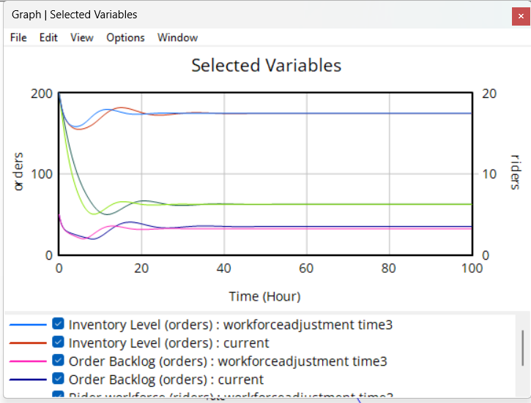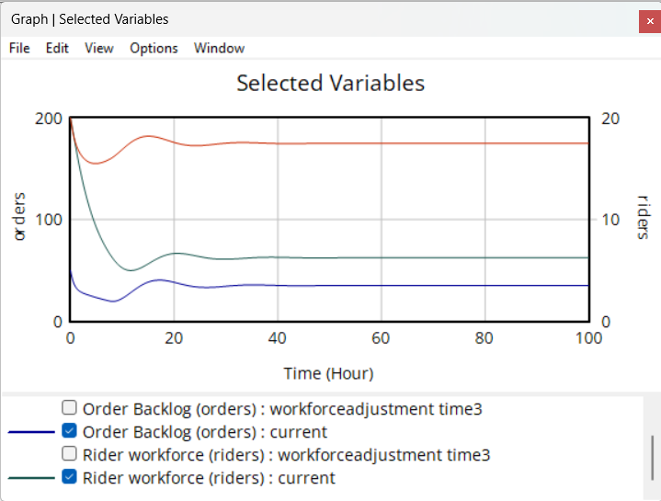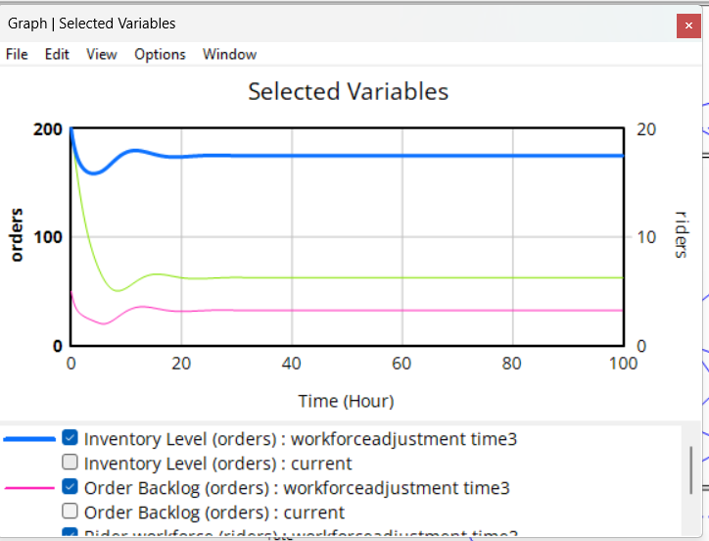

Scenario: Service-Sensitive Demand
Objective
To study how customer demand changes when it becomes more sensitive to service quality.

Method
Two cases were compared:
- Base Case: Demand is directly proportional to service level
- Scenario Case: Demand is proportional to the square of service level
All other parameters were kept the same.

Observations
- Order Backlog:
In the base case, backlog fluctuates and takes time to stabilize.
In the modified case, backlog reduces faster and stabilizes at a lower level.
- Inventory Level:
Inventory shows more variation in the base case.
With higher demand sensitivity, inventory stabilizes more smoothly.
- System Behavior:
The base model shows oscillations due to delays in adjustment.
In the modified model, the system stabilizes faster with fewer fluctuations.

Key Insight
When demand is highly sensitive to service quality, even a small drop in service leads to a sharp reduction in demand. This reduces system load and helps the system recover faster.

Conclusion
Customer behavior plays an important role in system dynamics. Making demand more responsive to service quality improves system stability and reduces backlog buildup.
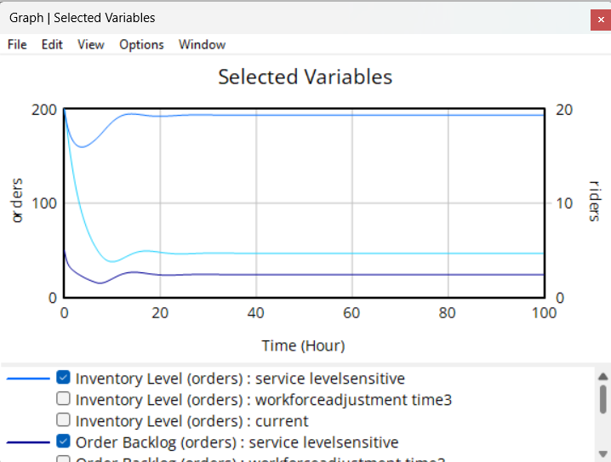

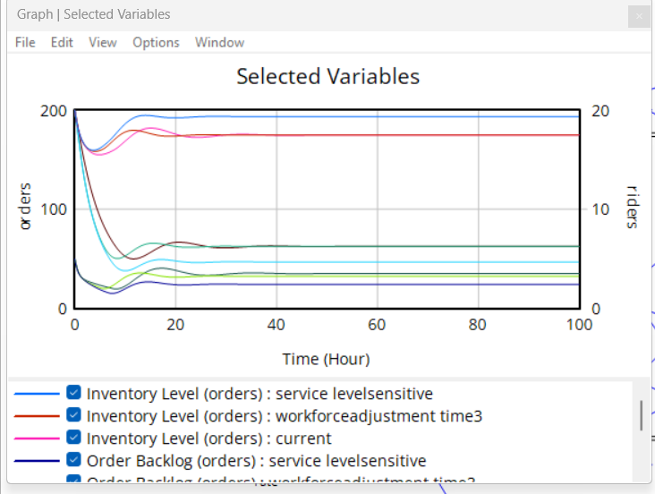

Scenario: Rider Attrition due to High Work Pressure
Real-World Context
Recent news reports highlighted protests and strikes by delivery partners of platforms like Blinkit, Zepto and Swiggy Instamart due to high work pressure and unsafe delivery expectations. Companies were also asked by the government to move away from strict 10-minute delivery commitments.

Method
To simulate this situation, the attrition fraction was increased from 0.05 to 0.15 to represent higher rider exits due to stress and dissatisfaction. All other parameters were kept constant.

Observations
- Rider Workforce:
Workforce declines significantly due to higher attrition and does not recover quickly.
- Order Backlog:
Backlog increases sharply as delivery capacity reduces.
- Delivery Delay:
Delivery delays increase due to reduced workforce availability.
- System Behavior:
The system becomes unstable as workforce reduction limits the ability to fulfill orders.

Key Insight
The system becomes workforce-constrained rather than demand-constrained. High attrition reduces capacity and leads to service deterioration even when demand remains strong.

Conclusion
This scenario shows that workforce sustainability is critical in quick commerce systems. Excessive operational pressure can lead to worker exits, which in turn destabilize the entire system.
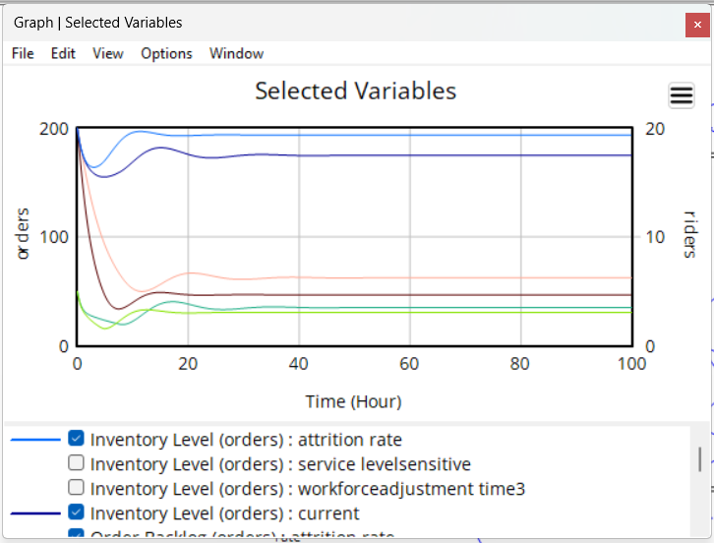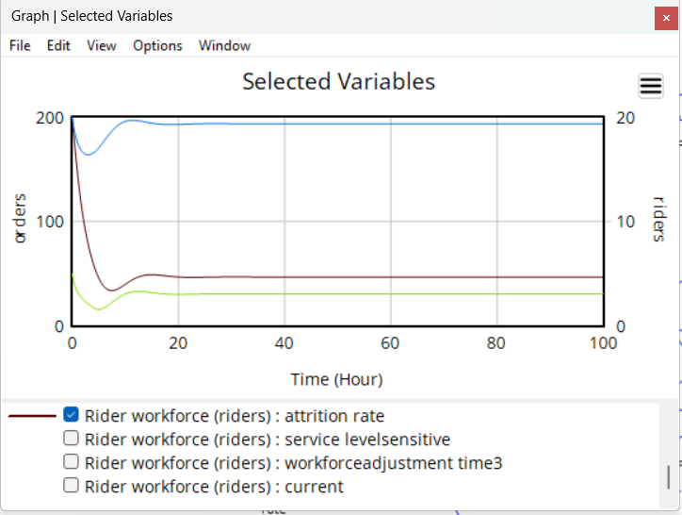
Scenario: Demand Surge due to Discounts
Real-World Context
Quick commerce platforms often offer heavy discounts and free delivery during competitive campaigns and festive periods. This leads to a sudden increase in order demand, putting pressure on delivery systems.

Method
To simulate this situation, base demand was increased from 25 to 45 orders per hour to represent a surge in customer orders. All other parameters were kept constant.

Observations
- Order Backlog:
Backlog increases sharply due to higher demand.
- Delivery Delay:
Delivery delays increase as the system becomes overloaded.
- Rider Workforce:
Workforce increases gradually but cannot immediately match the surge in demand.
- System Behavior:
The system experiences temporary instability before stabilizing.

Key Insight
Sudden demand surges can overwhelm system capacity, especially when workforce adjustment is slow.

Conclusion
While discounts help increase demand, they can negatively impact service performance if system capacity is not prepared for sudden spikes.
