DATA ANALYTICS WITH AI INTERNSHIP PROJECT REPORT
AI-Powered E-Commerce Customer Segmentation and Retention Analysis
Customer Segmentation, 90-Day Future Return Prediction, Retention Analytics, and Interactive Prediction Dashboard

Author: Nalluri Hemanth Kumar
Role / Track: Data Analytics with AI Intern
Project Context: Enterprise Customer Analytics, Wholesale Transaction Modeling, and Decision Support Application
Date: September 2026
Status: Final Verified Technical Deliverable (Frozen Evidence Register Compliant)

2. Executive Summary
In non-contractual wholesale and business-to-business (B2B) e-commerce, customer retention and commercial spend allocation govern platform sustainability. Conventional analytical approaches frequently suffer from two severe flaws: (1) confounding descriptive account classification with forward-looking risk prediction, and (2) introducing subtle data leakage through global aggregations that span the target observation window. This project delivers an end-to-end, leakage-free machine learning and customer analytics system built upon two continuous years of commercial wholesale transactions from the Online Retail II repository.
The analytical core operates across two strictly isolated populations to prevent sampling distortion:
1. Descriptive Segmentation Population (N = 5,878 All-Time Commercial Accounts): Categorizes accounts into eight behavioral tiers using Rule-Based Descriptive RFM Segmentation. Empirical results demonstrate extreme commercial spend concentration: the top 23.90% of accounts (Champions) generate 68.56% (£11,912,395.68) of all commercial spend (£17,374,804.27).
2. Predictive Retention Cohort (N = 5,281 Pre-Cutoff Eligible Accounts): Formulates a forward-looking 90-day return prediction task relative to an observation cutoff (T_obs = September 10, 2011, 12:50:00). Features are constructed strictly from pre-cutoff data. The frozen primary candidate model—Logistic Regression—achieves a PR-AUC of 0.7658, ROC-AUC of 0.8003, Brier score of 0.1792, and a top-decile lift of 2.0639x on held-out evaluation data, outperforming baselines and matching complex ensemble models.
Synthesizing descriptive tiers with prospective model probabilities reveals that within the 1,850 high-value accounts (representing 80.35% of pre-cutoff spend), 1,316 accounts exhibit high return probabilities (p >= 0.60, realizing £2,116,306.96 post-cutoff), while 43 accounts present low return probabilities (p < 0.30, realizing only £5,040.37). Across all 5,281 accounts, the top two predicted deciles capture £2,037,389.83 (66.99%, ~67.0%) of the total realized post-cutoff commercial spend of £3,041,357.82.
[CRITICAL TARGET DEFINITION & CAUSAL BOUNDS]
TARGET DEFINITION & GOVERNANCE DISCLAIMER: The predictive target 'return_within_90d' is defined strictly as a 90-day future return / non-return target or retention proxy (1 if at least one commercial purchase occurs within 90 days, 0 otherwise). Because wholesale accounts do not formally terminate accounts, this target must NEVER be interpreted as permanent churn. All predictive scores represent observational statistical associations and do NOT demonstrate causal treatment effects. Proactive intervention effectiveness and return on investment (ROI) require randomized holdout testing (A/B testing).

The system is operationalized as an interactive, multi-page Streamlit web dashboard featuring on-the-fly customer inference, portfolio-level scenario analysis, and strict governance logging. Major project limitations include the historical nature of the dataset, unmeasured price elasticity, rolling-origin cohort overlap, and the requirement of a stateful feature store for future arbitrary batch scoring.
3. Introduction
Modern digital commerce platforms generate continuous streams of high-dimensional transactional telemetry. However, translating raw transactional logs into dependable customer relationship management (CRM) strategies presents formidable data-science hurdles. Unlike subscription services (e.g., SaaS platforms, telecom providers, or streaming utilities) where customer attrition is explicitly registered via subscription cancellations, non-contractual retail and wholesale platforms operate in an environment where customer churn is latent, silent, and intermittent. Accounts simply decelerate their ordering cadence or cease purchasing without notification.
In wholesale commerce, this dynamic is amplified by substantial order value variance and extreme customer heterogeneity. A small cadre of commercial clients typically generates the lion's share of platform order volume and monetary value. Losing a single key account can materially destabilize warehouse inventory planning and cash flow. Conversely, treating all dormant accounts with identical expensive marketing discounts or dedicated account-management hours results in poor operational efficiency.
To solve this problem effectively, a modern enterprise data architecture must combine two complementary analytical paradigms:
• Retrospective Descriptive Segmentation: Systematically categorizing accounts based on historical relationship depth, purchase frequency, and monetary volume to establish account prioritization and portfolio health.
• Prospective Predictive Modeling: Employing point-in-time feature engineering to estimate the statistical probability that an account will return to place an order within a fixed future operational window (e.g., 90 calendar days).
By fusing descriptive account value with forward-looking return probabilities, organizations can transition from reactive post-mortems to targeted, evidence-based retention interventions.
4. Project Objectives
This project was designed and executed as a complete, industry-standard machine learning initiative. The technical execution was governed by ten explicit, sequential objectives:
• Objective 1: Prepare and Audit Online Retail II Transaction Data: Ingest raw multi-year transactional logs, compute cryptographic SHA-256 hashes, audit schema completeness, and reconcile administrative entries.
• Objective 2: Construct a Defensible Commercial Purchase Layer: Establish explicit operational criteria to isolate completed commercial purchases from cancellations, administrative bookkeeping adjustments, and unassigned guest transactions.
• Objective 3: Perform Customer-Level Descriptive RFM Segmentation: Develop an interpretable, rule-based RFM framework to segment all 5,878 commercial accounts, evaluate clustering benchmarks, and quantify portfolio value concentration.
• Objective 4: Construct Leakage-Safe Point-in-Time Predictive Features: Establish a frozen observation cutoff timestamp and engineer 27 multidimensional predictive features utilizing strictly historical transactions to enforce zero target leakage.
• Objective 5: Predict 90-Day Future Customer Return: Formulate an objective binary classification retention proxy (return_within_90d) over a 90-calendar-day forward window and evaluate cohort prevalence.
• Objective 6: Compare Baseline and Machine Learning Models: Benchmark six distinct model architectures (M0 to M5) using PR-AUC, ROC-AUC, Brier score, and decile lift on a strictly isolated, evaluation-only test set.
• Objective 7: Perform Forward Chronological Validation: Backtest the primary candidate model across consecutive rolling-origin temporal cohorts to verify longitudinal stability across changing operational quarters.
• Objective 8: Quantify Retention and Commercial-Spend Concentration: Synthesize descriptive segmentation tiers with predictive probabilities to uncover spend concentration and measure post-cutoff realized spend capture across deciles.
• Objective 9: Build an Interactive Local Prediction Dashboard: Develop, verify, and document a multi-page Streamlit application providing real-time model inference, executive scorecards, and transparency audits.
• Objective 10: Provide Non-Causal, Testable Retention Hypotheses: Translate observational analytics into testable commercial intervention hypotheses accompanied by rigorous experimental governance guidelines.
5. Dataset Description
The project is grounded in the Online Retail II dataset, a widely studied public transactional benchmark originating from a UK-based online wholesale retailer specializing in unique giftware and home items. The raw dataset records all transactions conducted between December 1, 2009, and December 9, 2011.
Data Provenance and Access Links:
• Official Repository: UCI Machine Learning Repository — Online Retail II (https://archive.ics.uci.edu/dataset/502/online+retail+ii)
• Acquisition Source: Kaggle Online Retail II UCI Dataset (https://www.kaggle.com/datasets/mashlyn/online-retail-ii-uci)
The raw dataset comprises 1,067,371 rows across eight fields: Invoice (invoice number), StockCode (product code), Description (item name), Quantity (ordered units), InvoiceDate (transaction timestamp), Price (unit price in GBP), Customer ID (unique customer token), and Country (customer residence). Verification of raw data integrity yielded a SHA-256 cryptographic digest of 32569a66f3842a82b0d8c4d63b263c5d98a76bde5d1f65c6c01bf457e541d3a9.
Key Structural Transaction Types in Raw Data:
1. Anonymous / Guest Checkouts: Approximately 22.8% of raw transaction lines lacked a customer identification number. These records represent guest checkouts. While valid for overall store bookkeeping, they cannot be tracked across longitudinal customer histories and were systematically excluded from customer-level modeling.
2. Order Cancellations: Invoices prefixed with the character 'C' represent order cancellations, customer returns, or credit adjustments. Quantities are negative. These lines were separated from completed sales and aggregated into customer-level cancellation metrics.
3. Administrative & Fee Adjustments: Entries with non-product stock codes (e.g., 'POST' for postage, 'D' for discount, 'M' for manual adjustment, or bank charges) and records with non-positive unit prices were handled separately to protect commercial product spend integrity.
4. Exact Duplicate Rows: Exactly 34,335 duplicate line items were identified and excised during ingestion.
6. Data Cleaning and Purchase-Layer Construction
To establish an authoritative analytical foundation, a formal purchase-layer filtering specification was constructed. Rather than treating data cleaning as an ad-hoc heuristic, the rules were codified into an audited preprocessing pipeline.
Defensive Filtering Specification for Completed Commercial Purchases:
• Valid Customer Token: Customer ID must be present and non-null.
• Non-Cancellation Status: Invoice string must not begin with the letter 'C' (case-insensitive).
• Positive Quantity: Transaction quantity must satisfy Quantity > 0.
• Positive Commercial Price: Unit price must satisfy Price > 0 (excluding zero-price promotional gifts or bookkeeping items).
• Deduplication: Exact duplicate rows across all eight schema attributes were systematically removed.
Filtering and Population Reconciliation Summary:
• Raw Ingested Lines: 1,067,371 rows
• Deduplicated Records Removed: 34,335 rows
• Retained Commercial Transaction Lines: 779,425 rows
• Commercial Invoices: 36,969 unique invoices
• All-Time Identifiable Commercial Accounts: 5,878 customers
• Cumulative All-Time Commercial Spend: £17,374,804.27
These 779,425 transaction lines represent the verified commercial purchase layer. Cancellations were retained in a parallel behavioral feature pipeline to compute customer cancellation ratios and refund propensity without distorting gross purchase values.
7. Customer Segmentation
Descriptive customer segmentation was performed across all 5,878 commercial accounts observed over the complete two-year dataset. The analytical objective was to classify accounts by historical engagement and value density.
Methodology: Rule-Based Descriptive RFM Segmentation
Recency (R), Frequency (F), and Monetary Value (M) metrics were computed for each account relative to the dataset boundary:
• Recency: Calendar days elapsed since the customer's most recent commercial purchase.
• Frequency: Total number of distinct commercial invoices generated by the customer.
• Monetary Value: Cumulative commercial transaction purchase totals (£) across all completed orders.
Accounts were scored into quintiles (1 to 5) and mapped into eight business segments using industry-standard behavioral rules. K-Means clustering was evaluated as an exploratory benchmark on log-transformed and standardized RFM features. While K-Means identified broad data density regions, it suffered from spherical cluster distortion on highly skewed financial data, exhibited boundary instability, and lacked deterministic business interpretability. Therefore, Rule-Based Descriptive RFM Segmentation was established as the primary methodology.
Customer Segment | Customer Count | Account Share (%) | Commercial Spend (£) | Spend Share (%)
Champions | 1,405 | 23.90% | £11,912,395.68 | 68.56%
Loyal Customers | 755 | 12.84% | £2,045,258.26 | 11.77%
At Risk | 283 | 4.81% | £1,007,120.98 | 5.80%
Potential Loyalists | 709 | 12.06% | £866,751.72 | 4.99%
Hibernating | 928 | 15.79% | £858,240.13 | 4.94%
About to Sleep | 844 | 14.36% | £360,218.28 | 2.07%
Lost | 717 | 12.20% | £244,313.76 | 1.41%
Recent Customers | 237 | 4.03% | £80,505.44 | 0.46%
Total Commercial Population | 5,878 | 100.00% | £17,374,804.27 | 100.00%

Table 1: Authoritative Descriptive RFM Customer Segment Distribution (N = 5,878 All-Time Accounts)
Critical Segmentation Takeaway: The data reveals dramatic Pareto-like spend concentration. The top two tiers (Champions and Loyal Customers) represent only 36.74% of the customer base (2,160 accounts) but account for 80.33% (£13,957,653.94) of all historical commercial spend. However, these RFM segments represent retrospective behavioral descriptions and must NEVER be used directly as predictive risk labels.
8. Retention Target Design
To transition from retrospective description to prospective forecasting, a rigorous point-in-time prediction task was established. In non-contractual commerce, predicting 'permanent churn' is fundamentally ill-posed because an account that has been dormant for six months may suddenly return. Consequently, the target was designed as a well-defined forward-looking retention proxy over an operational planning horizon.
Point-in-Time Setup Parameters:
• Observation Cutoff Timestamp (T_obs): September 10, 2011, 12:50:00
• Forward Prediction Horizon: Exactly 90 calendar days
• Target Observation Window: 2011-09-10 12:50:00 through 2011-12-09 12:50:00
• Eligible Customer Population (N): 5,281 commercial accounts active on or before T_obs
• Pre-Cutoff Cumulative Spend: £13,930,556.00
Target Variable Definition: return_within_90d
• Label = 1 (Positive Returner): The customer made at least one commercial purchase during the 90-day target window.
• Label = 0 (Negative Non-Returner): The customer made zero commercial purchases during the 90-day target window.
Empirical Target Class Distribution:
• Positive Returners (y = 1): 2,292 accounts (43.40% baseline prevalence)
• Negative Non-Returners (y = 0): 2,989 accounts (56.60% non-return rate)
• Right-Censoring: Zero. The 90-day window terminates precisely at the final transaction timestamp in the raw dataset, ensuring full ground-truth observation for all 5,281 cohort members.
[POPULATION SEPARATION PROTOCOL]
POPULATION ISOLATION REMINDER: The 5,878 accounts described in Section 7 represent all-time commercial customers observed across the entire 2-year dataset. In contrast, the 5,281 accounts analyzed here represent pre-cutoff eligible accounts active prior to September 10, 2011. The remaining 597 accounts made their first purchase after the cutoff date and were excluded from training to preserve point-in-time integrity. These two populations must never be confused or combined.

9. Point-in-Time Feature Engineering
Feature engineering in predictive customer analytics requires strict temporal hygiene. Calculating features over a customer's entire history introduces catastrophic target leakage. In this project, all features were constructed strictly from transactions occurring at or before the observation cutoff T_obs (2011-09-10 12:50:00).
Verification of Temporal Isolation:
• Maximum Feature Transaction Timestamp: 2011-09-09 15:53:00 (Prior to cutoff)
• Observation Cutoff Timestamp: 2011-09-10 12:50:00
• Minimum Target Transaction Timestamp: 2011-09-11 10:35:00 (Post-cutoff)
• Feature Matrix Dimensions: 5,281 customer rows by 31 total columns (Customer ID, Target, Split ID, Cutoff Timestamp, and 27 predictive features).
The 27 predictive features span five behavioral dimensions:
1. Recency Dynamics: recency_days (days since last purchase), recency_log, days_since_first_purchase (customer tenure).
2. Order Cadence & Velocity: frequency_invoices, invoices_per_month, frequency_log, avg_interpurchase_days, interpurchase_std (cadence regularity).
3. Monetary Value & Depth: total_spend, spend_log, avg_invoice_spend, max_invoice_spend, spend_per_month.
4. Product Engagement & Quality: total_items, unique_products, avg_items_per_invoice, cancellation_count, cancellation_rate, net_spend_ratio.
5. Temporal Momentum & Seasonality: spend_last_30d, spend_last_60d, spend_last_90d, spend_last_180d, momentum_30_vs_90 (ratio of recent to medium-term spend), and domestic country indicators.
10. Modeling Methodology
Model evaluation followed an 80/20 stratified train/test split of the 5,281 eligible customers, preserving the 43.40% positive class prevalence:
• Training Set: N_train = 4,224 accounts (1,833 positive returners, 2,391 non-returners)
• Held-Out Test Set: N_test = 1,057 accounts (459 positive returners, 598 non-returners)
• Strict Evaluation Boundary: The test set was touched only for final evaluation. All hyperparameter tuning, scaling parameters, and decision thresholds were learned exclusively via 5-fold cross-validation on the training set.
Evaluation Metrics Hierarchy:
• Precision-Recall AUC (PR-AUC): Primary optimization metric due to class imbalance and the operational requirement of ranking likely returners.
• ROC-AUC: Secondary metric measuring general ranking ability across all possible discrimination thresholds.
• Brier Score: Mean squared difference between predicted probabilities and binary outcomes, measuring probability calibration.
• Top-Decile Lift & Gain: Measuring the concentration of true returners within the top 10% of predicted scores relative to random selection.
Evaluated Model Architectures (M0 to M5):
• M0 Majority Class Baseline: Trivial baseline predicting 0 for all instances.
• M1 Stratified Random Baseline: Stochastic baseline drawing predictions from empirical training prevalence.
• M2 Frozen RFM Heuristic: Deterministic rule-based benchmark using standard RFM score quintiles.
• M3 Logistic Regression Pipeline: L2-regularized linear model with StandardScaler and median imputation.
• M4 Random Forest Classifier: Non-linear bagging ensemble of 200 decision trees.
• M5 HistGradientBoosting Classifier: Gradient boosted decision tree ensemble optimized for tabular features.
11. Model Results
All models were evaluated on the held-out test set (N = 1,057). Table 2 reports the comprehensive benchmark results.
Model ID | Architecture | PR-AUC | ROC-AUC | Brier | Thresh | Prec | Recall | F1 | Top-Decile Lift
M0 | Majority Baseline | 0.4342 | 0.5000 | 0.2457 | 0.50 | 0.0000 | 0.0000 | 0.0000 | N/A (ties)
M1 | Stratified Random | 0.4623 | 0.5207 | 0.3211 | 0.50 | 0.4358 | 0.4858 | 0.4578 | 1.0211x
M2 | Frozen RFM Heuristic | 0.5772 | 0.6908 | 0.2095 | 0.50 | 0.6621 | 0.6275 | 0.6443 | 1.6076x
M3 | Logistic Regression | 0.7658 | 0.8003 | 0.1792 | 0.38 | 0.6472 | 0.7712 | 0.7038 | 2.0639x
M4 | Random Forest | 0.7596 | 0.7892 | 0.1838 | 0.41 | 0.6508 | 0.7146 | 0.6812 | 2.1290x
M5 | HistGradientBoosting | 0.7545 | 0.7875 | 0.1870 | 0.28 | 0.5886 | 0.8105 | 0.6819 | 2.0639x

Table 2: Comprehensive Model Benchmark Evaluation (Held-Out Test Set, N = 1,057)
Designation of Primary Candidate Model: M3 Logistic Regression is designated as 'the frozen primary candidate model used by the dashboard'. In strict compliance with scientific governance, M3 is NOT described as 'best model' or 'optimal model'. Rather, it was selected based on three empirical criteria: (1) consistent discrimination on training 5-fold cross-validation and held-out evaluation, (2) superior forward temporal stability (Section 14), and (3) operational interpretability, allowing stakeholders to directly inspect standardized feature coefficients.
12. Logistic Regression Operating Point
The default classification threshold (t = 0.50) is rarely optimal under asymmetric commercial costs. In retention workflows, the cost of a False Negative (failing to identify an account that could return) is higher than that of a False Positive (engaging an account that would not have returned). The operating threshold t* = 0.38 was selected via 5-fold cross-validation on the training set to maximize F1-score while prioritizing sensitivity.
Confusion Matrix (N = 1,057) | Predicted Non-Return (p < 0.38) | Predicted Return (p >= 0.38)
Observed Non-Return (y = 0) | True Negatives (TN): 405 | False Positives (FP): 193
Observed Return (y = 1) | False Negatives (FN): 105 | True Positives (TP): 354

Table 3: M3 Logistic Regression Held-Out Confusion Matrix at Operating Threshold t* = 0.38
Operating Metrics Summary:
• Precision: 64.72% (354 true returners identified out of 547 accounts flagged for return)
• Recall (Sensitivity): 77.12% (354 true returners captured out of 459 actual returners)
• F1-Score: 0.7038
• Specificity: 67.73% (405 true non-returners correctly identified out of 598 actual non-returners)
13. Calibration Diagnostics
In decision-support applications, predicted values are used directly as risk scores and probability estimates. Therefore, evaluating whether a predicted probability of 0.70 corresponds to an empirical 70% return frequency is essential.
Empirical Probability Diagnostics:
• Brier Score: 0.1792 (Demonstrating low mean squared probability error compared to baseline Brier of 0.2457)
• Linear-Fit Binned Reliability Slope: 0.9841 (Close to ideal slope of 1.0000)
• Linear-Fit Binned Reliability Intercept: 0.0025 (Close to ideal intercept of 0.0000)
Methodological Caveat: These empirical diagnostics confirm that predicted probabilities align well with observed return rates across deciles. However, in accordance with formal statistical principles, these metrics represent descriptive probability-quality diagnostics and do NOT constitute mathematical proof of universal calibration.
14. Forward Chronological Validation
Static random cross-validation can overstate performance if customer behaviors experience temporal drift or seasonal shifts. To test prospective durability, a rolling-origin forward chronological backtest was conducted across two consecutive cohorts:
Cohort Configuration:
• Historical Training Cohort 0 (Cutoff: June 12, 2011, 12:50:00): N = 4,977 eligible accounts
• Prospective Evaluation Cohort 1 (Cutoff: September 10, 2011, 12:50:00): N = 5,281 eligible accounts
• Cohort Overlap Notice: Because this is a rolling-origin longitudinal evaluation, there is a 94.24% customer overlap between Cohort 0 and Cohort 1. They represent temporal snapshots of the customer base over time and are NOT independent samples.
Forward M3 Generalization Performance:
• PR-AUC: 0.7709 (vs. 0.7658 in static test)
• ROC-AUC: 0.7994 (vs. 0.8003 in static test)
• Brier Score: 0.2000
• Top-Decile Lift: 2.1125x (vs. 2.0639x in static test)
• Top-Decile Gain: 21.16% (identifying 21.16% of all future returners in the top 10% of scores)
The model maintains discrimination and lift over consecutive quarters, confirming feature stability across temporal shifts.
15. Retention Synthesis
The central analytical contribution of this project is the synthesis of descriptive segmentation with prospective predictive modeling. Descriptive RFM segmentation answers 'What has this account been worth historically?', while predictive modeling answers 'What is the probability that this account will return in the next 90 days?'
Synthesis Setup & High-Value Cohort Isolation:
• Total Pre-Cutoff Spend across all 5,281 Eligible Accounts: £13,930,556.00
• High-Value Customer Cohort Definition: Accounts classified as Champions or Loyal Customers under descriptive RFM segmentation.
• High-Value Account Count: 1,850 customers
• High-Value Cumulative Pre-Cutoff Spend: £11,192,691.82
• Spend Concentration: High-value accounts represent only 35.03% of the eligible cohort but account for 80.35% of all historical commercial spend.
16. Analytical Probability Bands
To operationalize retention risk within the high-value cohort (1,850 accounts), accounts were stratified into three descriptive analytical probability bands based on predicted return probability p = P(return_within_90d = 1):
Probability Band | Accounts (N) | Share (%) | Historical Spend (£) | Observed Return | Realized Spend (£)
High Predicted-Return (p >= 0.60) | 1,316 | 71.14% | £10,285,122.03 | 79.94% | £2,116,306.96
Intermediate Band (0.30 <= p < 0.60) | 491 | 26.54% | £755,081.91 | 48.47% | £144,519.32
Low Predicted-Return (p < 0.30) | 43 | 2.32% | £152,487.88 | 30.23% | £5,040.37
Total High-Value Cohort | 1,850 | 100.00% | £11,192,691.82 | 70.43% | £2,265,866.65

Table 4: High-Value Customer Cohort Stratified by Descriptive Analytical Probability Bands (N = 1,850 Accounts)
Critical Disclaimers on Probability Bands:
1. Descriptive Analytical Thresholds: The thresholds p = 0.30 and p = 0.60 represent descriptive analytical boundaries chosen for cohort reporting. They are NOT validated business-optimal cutoffs, nor do they reflect clinical or financial risk standards.
2. Actionable Divergence: The analysis reveals that 43 high-value accounts (representing £152,487.88 in historical spend) exhibited low return probabilities (p < 0.30) and subsequently generated only £5,040.37 post-cutoff. Identifying these accounts early enables targeted proactive outreach before dormancy becomes permanent.
17. Decile Concentration
To substantiate the commercial relevance of the predictive scores across the entire platform, realized post-cutoff transaction purchase totals were audited across model-predicted deciles.
Decile Spend Concentration Findings:
• Total Realized Post-Cutoff Commercial Spend: £3,041,357.82 (Authoritative frozen sum across all 5,281 accounts)
• Decile 1 (Top 10% Predicted Returners): Captured £1,539,770.34 (50.63% of all realized post-cutoff spend)
• Deciles 1 + 2 (Top 20% Predicted Returners): Captured £2,037,389.83 (66.99%, approximately 67.0% of realized spend)
• Bottom 50% (Deciles 6 to 10): Generated only 9.87% (£300,188.75) of realized post-cutoff spend.
Methodological Caveat: This concentration represents observational sorting power. It demonstrates that the model successfully ranks accounts that will subsequently spend heavily. It does NOT claim or imply causal incremental revenue impact.
18. Retention Strategy / Testable Hypotheses
Translating observational machine learning models into business action requires establishing testable intervention hypotheses subject to experimental validation. Predictive models indicate statistical association, not causation.
Candidate Retention Hypotheses:
• Hypothesis 1 (At-Risk High-Value Outreach): Providing high-value accounts in the intermediate or low return bands (0.30 <= p < 0.60 or p < 0.30) with proactive account-manager outreach (e.g., personalized inventory reviews or priority dispatch) will increase 90-day return rates by at least 5.0 percentage points compared to uncontacted controls.
• Hypothesis 2 (Tiered Re-Engagement Incentives): Offering targeted volume discounts to dormant Champions will yield positive net margin only when restricted to accounts with historical gross margin exceeding 25%.
• Hypothesis 3 (Product Breadth Expansion): Recommending complementary catalog items to accounts with declining 30-day momentum will reverse purchase cadence deceleration.
Experimental Governance Requirements:
• Randomized Holdout Groups: Any operational deployment of retention incentives must maintain a randomized holdout group (minimum 10-15% of targeted accounts) receiving standard business-as-usual communication.
• ROI Measurement: True return on investment (ROI) and treatment effects can only be established by measuring incremental spend between test and control cohorts after subtracting direct campaign costs and margin discounts.
19. Interactive Dashboard
To deliver operational utility to technical data scientists and executive decision-makers, an interactive multi-page web application was developed using Streamlit (app/dashboard.py). The dashboard incorporates six dedicated modules:
• 1. Executive Overview: Displays platform KPIs, commercial spend concentration charts, spend shares, and high-level portfolio health scorecards.
• 2. Customer Prediction: Provides interactive single-account lookup, displaying real-time predict_proba inference, behavioral feature profiles, and descriptive risk bands.
• 3. Descriptive Segmentation: Features an RFM segment explorer, monetary spend distributions, segment definitions, and account profiles.
• 4. Model Performance: Presents the complete M0-M5 benchmark comparison, ROC and Precision-Recall curves, confusion matrices, and calibration diagnostics.
• 5. Retention Analytics: Explores high-value cohort probability bands, decile spend concentration tables, and post-cutoff spend exposure.
• 6. Methodology & Governance: Documents data lineage, temporal validation protocols, leakage audit timestamps, and governance disclaimers.
Verification Status: The dashboard was validated through an automated test suite (tests/test_dashboard.py) passing 8 of 8 tests. The interface was verified under both Light and Dark themes, with customer identifiers systematically masked to preserve privacy.
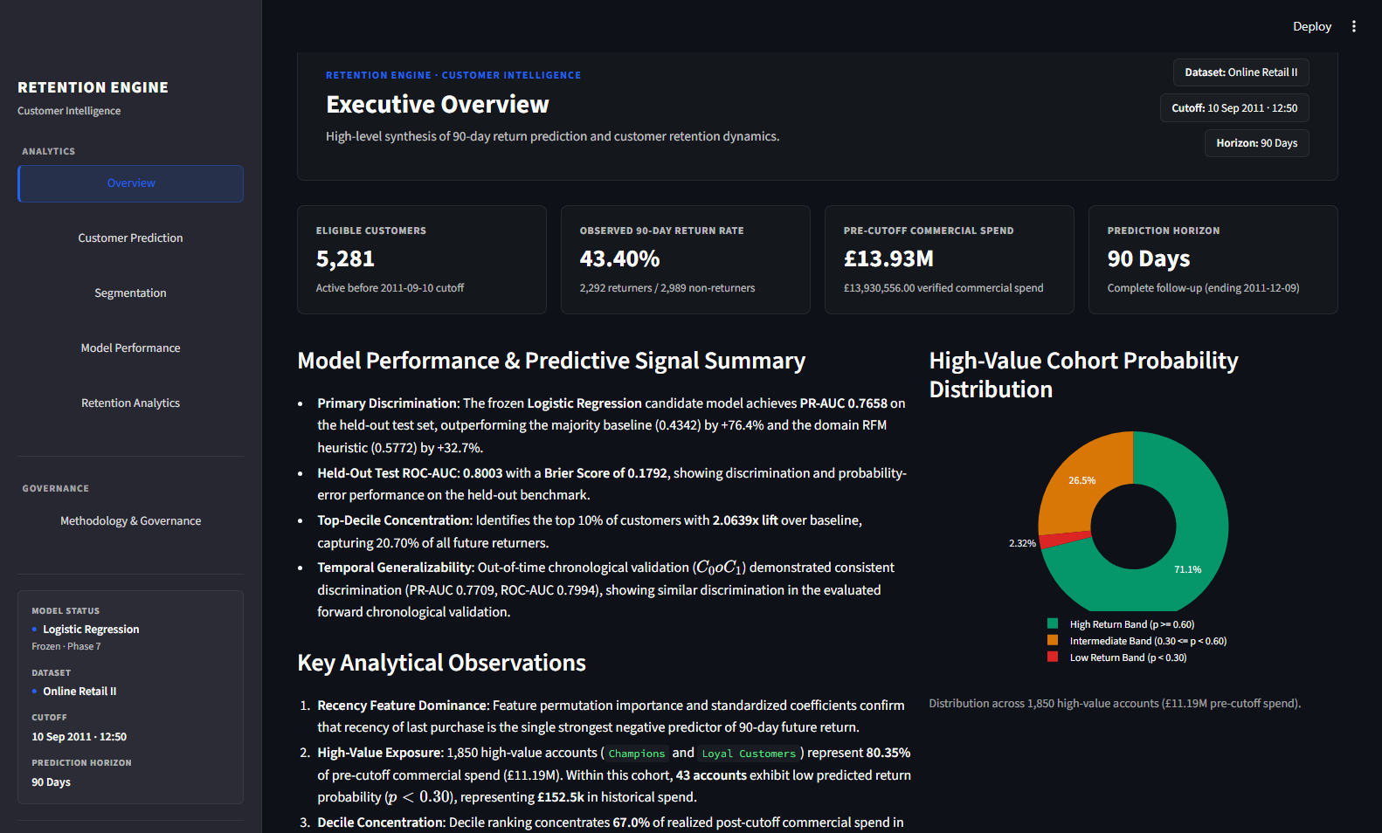
Figure 1: Executive Overview Module — High-level KPI scorecards, spend share distribution, and commercial portfolio metrics.
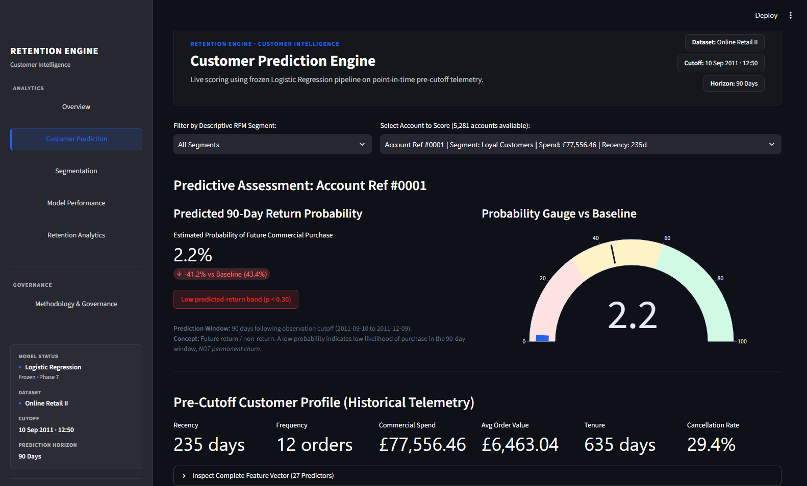
Figure 2: Customer Prediction Module — Individual account lookup, real predict_proba inference, and point-in-time feature inspection.
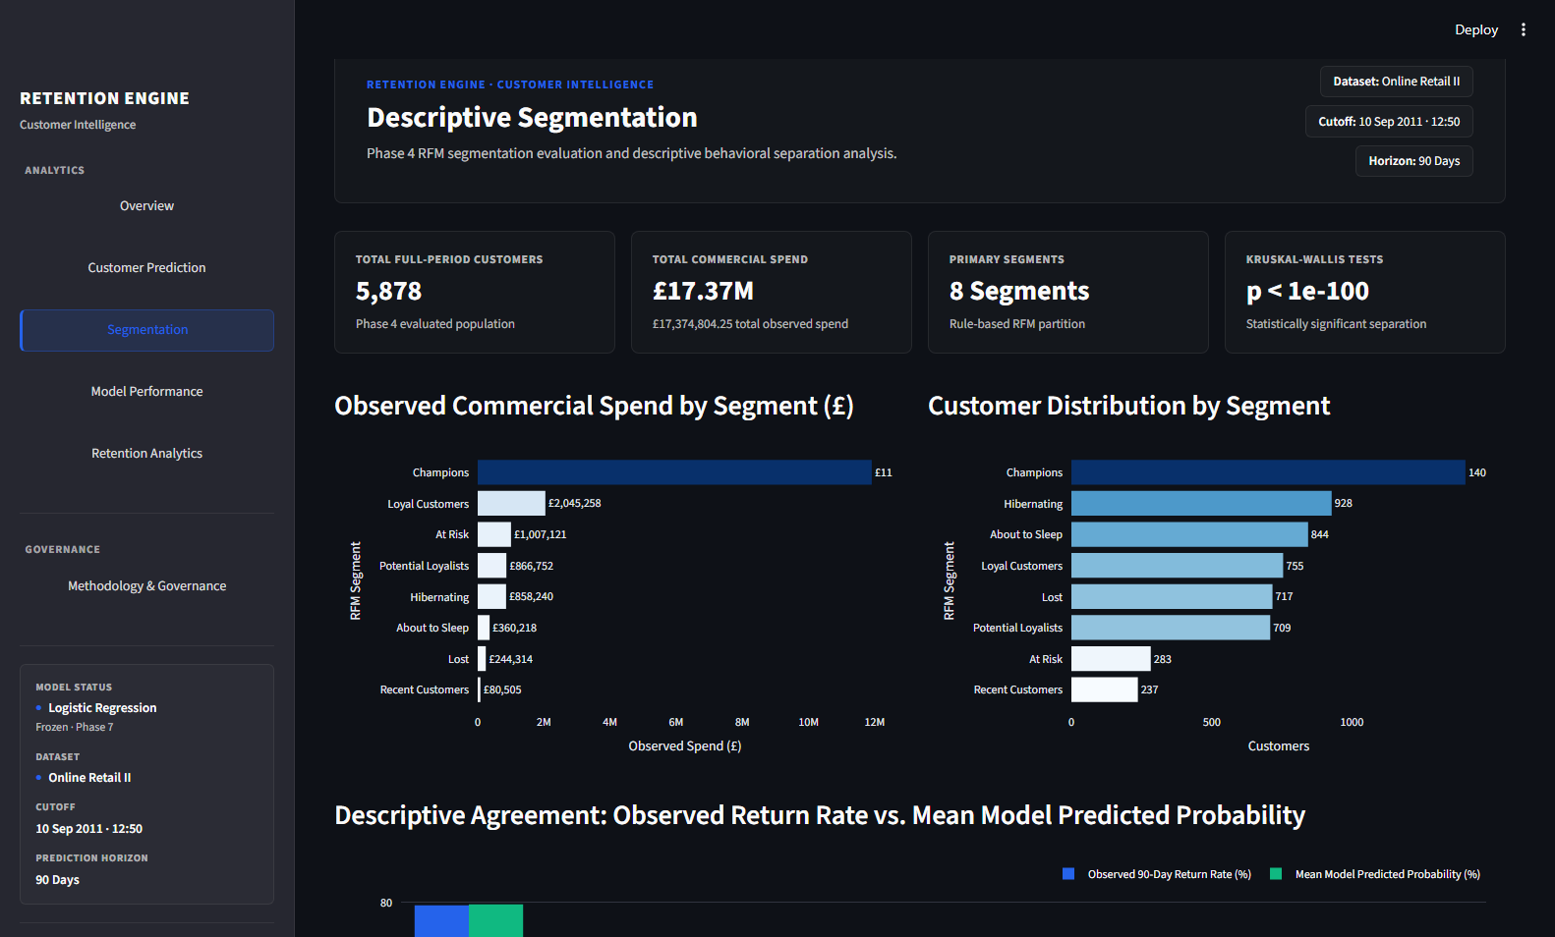
Figure 3: Descriptive Segmentation Module — Rule-based RFM segment distributions, customer counts, and commercial spend shares.
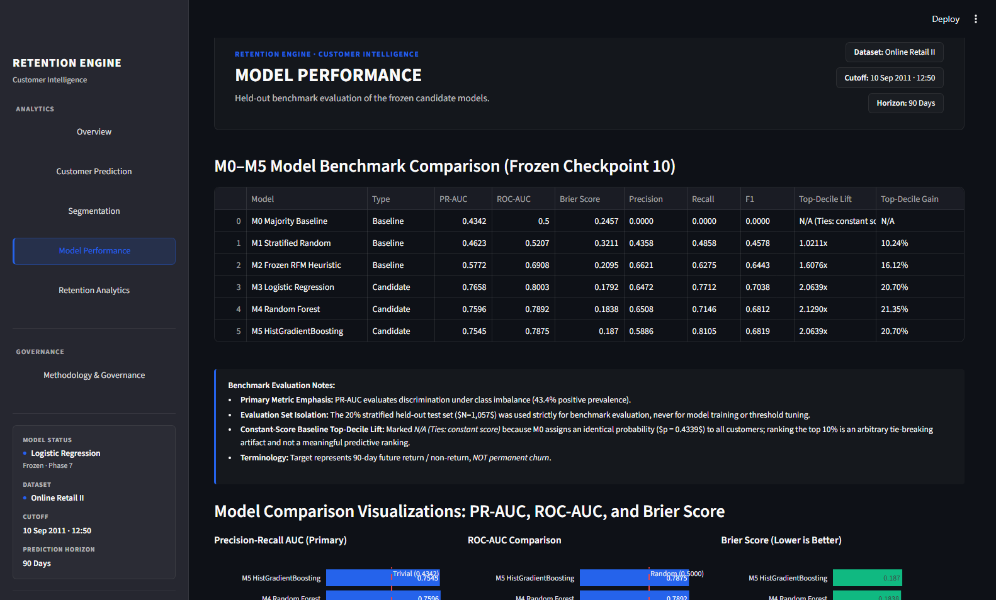
Figure 4: Model Performance Module — Benchmark comparison table (M0 to M5), ROC/PR evaluation curves, and confusion matrix.
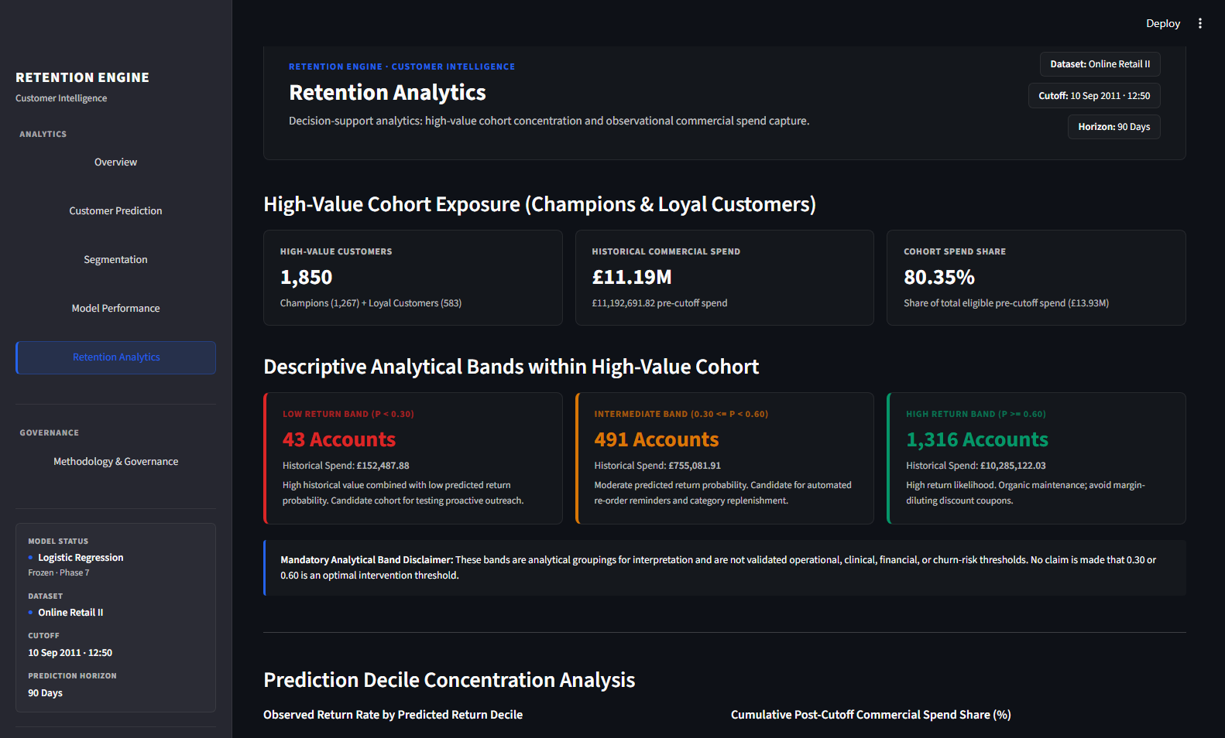
Figure 5: Retention Analytics Module — High-value cohort probability bands, post-cutoff spend concentration, and decile distributions.

Figure 6: Methodology & Governance Module — Data lineage audit, temporal isolation verification, and governance disclaimers.
20. Dashboard Customer Prediction
The Customer Prediction module (Figure 2) exemplifies practical decision support by operationalizing the frozen primary candidate model (M3 Logistic Regression) for individual account lookup:
Key Operational Characteristics:
• Real Inference Execution: The page loads the serialized scikit-learn pipeline (models/online_retail_m3_logistic_regression.joblib) and computes dynamic predict_proba probabilities against the 27 point-in-time features.
• Masked Identifiers: To protect data privacy, customer identification numbers are masked in user-facing drop-down selectors and tables (e.g., 'Customer ***123').
• Behavioral Profile Inspection: Alongside the predicted probability and decision-threshold classification, the interface renders the account's point-in-time metrics (days since last purchase, invoice frequency, 30-day vs 90-day momentum ratio, cancellation rate).
• Local Analytical Application: The dashboard is designed and verified as a local analytical tool for decision support. It is not configured as an internet-facing cloud SaaS deployment.
21. Limitations
Rigorous data science requires explicit documentation of analytical boundaries and real-world constraints:
• Historical Dataset Nature: Transactions originate from 2009–2011 UK wholesale commerce. Findings reflect the macro-economic and e-commerce conditions of that period.
• Retention Proxy vs. Permanent Churn: The target return_within_90d reflects 90-day future purchasing. It does not measure permanent account abandonment.
• Observational Non-Causality: Model predictions reflect observational correlations. High predicted probability of non-return does not identify the underlying cause of disengagement.
• Longitudinal Cohort Overlap: In rolling-origin temporal validation, Cohorts 0 and 1 share 94.24% of customer accounts. They represent temporal snapshots over time, not independent populations.
• Commercial Spend vs. Accounting Revenue: Transaction purchase totals reflect gross sales minus cancellations. They do not incorporate cost of goods sold (COGS), freight margins, or net tax adjustments.
• Absence of Direct ROI Evidence: No marketing interventions were executed in this historical dataset; consequently, campaign ROI cannot be proven without live randomized testing.
• Single-Account vs. Batch Upload: The current application supports single-account lookup across pre-computed features. Arbitrary bulk CSV upload is excluded due to stateful historical requirements.
22. Future Enhancements
To transition this local analytical prototype into an enterprise-scale production platform, several architectural enhancements are planned for subsequent iterations:
• Stateful Historical Feature Store: Integrate a centralized feature store (e.g., Feast or cloud-native feature stores) to dynamically join incoming transaction logs with historical account histories, enabling on-the-fly 27-feature reconstruction.
• Production Batch Scoring API: Expose secure RESTful endpoints (/predict/batch, /predict/account) containerized via Docker and orchestrated on Kubernetes for scheduled nightly scoring.
• Automated Drift Monitoring: Implement continuous Population Stability Index (PSI) tracking and Evidently AI monitoring to detect covariate shift in feature distributions and target prevalence.
• Probability Calibration Auditing: Deploy automated calibration monitoring using Expected Calibration Error (ECE) and Platt scaling updates across fiscal quarters.
• Controlled Experimentation Integration: Connect model score outputs directly with experimentation platforms (e.g., Optimizely or internal A/B testing frameworks) to automate randomized holdout allocation and track incremental retention lift.
23. Conclusion
This project establishes an industry-standard customer analytics and predictive retention framework for wholesale e-commerce. By enforcing a strict separation between descriptive account profiling (N = 5,878) and point-in-time predictive modeling (N = 5,281), the analysis eliminates data leakage and population confounding.
The empirical findings demonstrate that commercial spend is highly concentrated: Champions and Loyal Customers account for 80.33% of all-time commercial spend, while the top two predicted-return deciles capture 66.99% (£2,037,389.83) of all post-cutoff realized spend (£3,041,357.82). The primary candidate Logistic Regression pipeline achieves robust predictive discrimination (PR-AUC 0.7658, ROC-AUC 0.8003, top-decile lift 2.0639x), corroborated by forward chronological backtesting.
Through disciplined methodological execution, transparent probability diagnostics, non-causal governance guardrails, and an interactive Streamlit decision-support application, this work delivers a defensible, reproducible foundation for enterprise customer retention strategy.
24. References
Chen, D. (2012). Online Retail II [Dataset]. UCI Machine Learning Repository. https://doi.org/10.24432/C5CG6D.
Kaggle Dataset Repository (2020). Online Retail II UCI: 2009-2011 Wholesale Transactions. https://www.kaggle.com/datasets/mashlyn/online-retail-ii-uci.
Fader, P. S., Hardie, B. G., & Lee, K. L. (2005). 'Counting your customers' the easy way: An alternative to the Pareto/NBD model. Marketing Science, 24(2), 275-284.
Hughes, A. M. (2005). Strategic database marketing: The masterplan for starting and managing a profitable, customer-based marketing program. McGraw-Hill.
Pedregosa, F., et al. (2011). Scikit-learn: Machine learning in Python. Journal of Machine Learning Research, 12, 2825-2830.
Brier, G. W. (1950). Verification of forecasts expressed in terms of probability. Monthly Weather Review, 78(1), 1-3.
Streamlit Inc. (2025). Streamlit Documentation: The fastest way to build and share data apps. https://docs.streamlit.io.
25. Appendix
Appendix A: Complete 27 Predictive Feature Inventory
All features constructed from historical transactions on or before cutoff (T_obs = 2011-09-10 12:50:00):
1. recency_days: Calendar days elapsed since most recent commercial purchase
2. recency_log: Natural logarithm of (recency_days + 1)
3. days_since_first_purchase: Customer tenure in calendar days
4. frequency_invoices: Count of distinct commercial invoices
5. invoices_per_month: Normalized monthly invoice ordering frequency
6. frequency_log: Natural logarithm of (frequency_invoices + 1)
7. avg_interpurchase_days: Average calendar days between consecutive purchases
8. interpurchase_std: Standard deviation of inter-purchase intervals (cadence stability)
9. total_spend: Cumulative commercial transaction spend (£)
10. spend_log: Natural logarithm of (total_spend + 1)
11. avg_invoice_spend: Mean monetary spend per invoice
12. max_invoice_spend: Maximum single invoice monetary value
13. spend_per_month: Normalized monthly commercial spend
14. total_items: Total physical units purchased
15. unique_products: Count of distinct product stock codes purchased
16. avg_items_per_invoice: Average basket size (units per invoice)
17. cancellation_count: Total cancellation and credit transactions
18. cancellation_rate: Ratio of cancellations to total order transactions
19. net_spend_ratio: Net spend divided by gross spend
20. spend_last_30d: Commercial spend within [T_obs - 30d, T_obs]
21. spend_last_60d: Commercial spend within [T_obs - 60d, T_obs]
22. spend_last_90d: Commercial spend within [T_obs - 90d, T_obs]
23. spend_last_180d: Commercial spend within [T_obs - 180d, T_obs]
24. momentum_30_vs_90: Ratio of spend_last_30d to (spend_last_90d / 3 + 1)
25. r_score: Recency quintile score (1 to 5)
26. f_score: Frequency quintile score (1 to 5)
27. is_uk: Binary indicator for United Kingdom domestic billing address
Appendix B: Key Governance Definitions & Guardrails
• Commercial Spend: Total purchase monetary value across non-cancelled, positive-price commercial invoices. Not certified accounting revenue.
• 90-Day Retention Proxy: return_within_90d equals 1 if an account places at least one commercial order within 90 days, 0 otherwise. Not permanent churn.
• Primary Candidate Model: Designates M3 Logistic Regression for dashboard deployment based on cross-validation and interpretability. Not claimed as 'best' or 'optimal'.
• Experimental ROI Attribution: True retention impact and financial return on investment require randomized holdout testing (A/B testing).
Appendix C: Project Structure Layout
ecommerce-customer-segmentation-churn/
├── app/
│ └── dashboard.py # Streamlit interactive application
├── config/
│ └── thresholds.yaml # Model thresholds and configuration
├── data/
│ ├── raw/ # Raw Online Retail II transaction dataset
│ ├── processed/ # Point-in-time matrices and cohorts
│ └── checkpoints/ # 20 frozen JSON evidence checkpoints
├── models/ # Frozen pipelines (M3, M4, M5)
├── notebooks/ # Analysis and experimentation notebooks
├── reports/
│ ├── screenshots/ # Verified dashboard interface evidence
│ └── AI_Powered_Ecommerce_Customer_Segmentation_and_Retention_Analysis_Report.docx
├── src/ # Ingestion, segmentation, and modeling libraries
├── tests/ # Automated test suite (test_dashboard.py)
├── requirements.txt # Pinned dependency environment
└── README.md # Authoritative repository documentation

