Ex.No :3

**DML Commands – INSERT, SELECT**

1.Populate all the five tables with your own data.

2.Modify the date of birth for the faculty whose name is 'RAM' with a value ‘1983-05-01’.

3.Remove all faculty who are having over 65 years.

4.View all the records from the five tables.

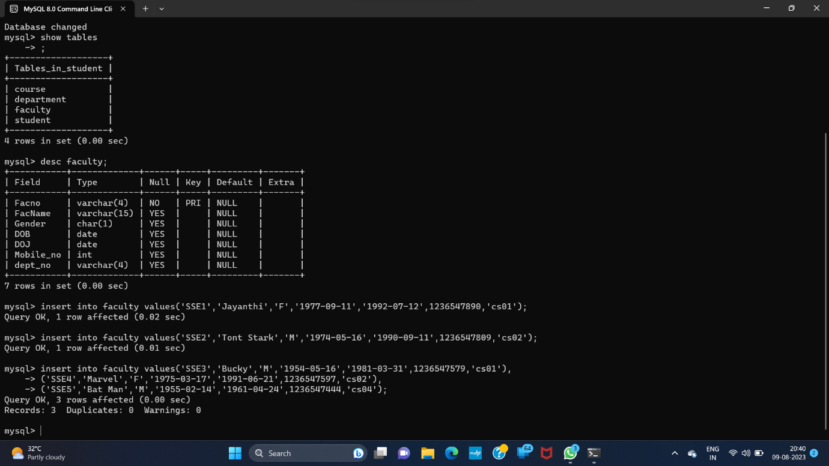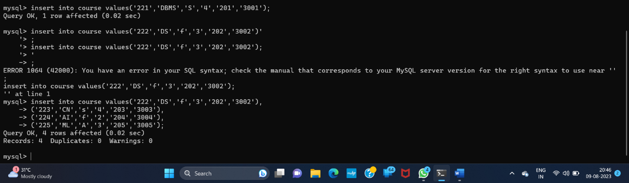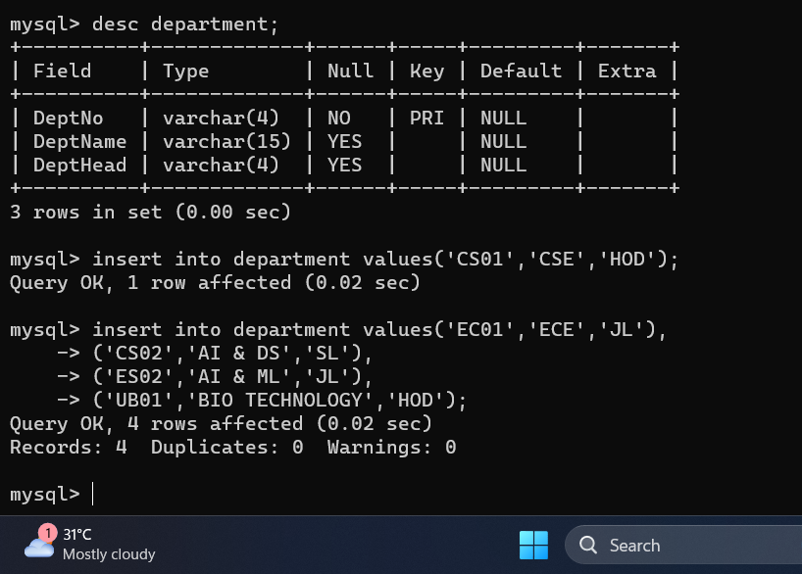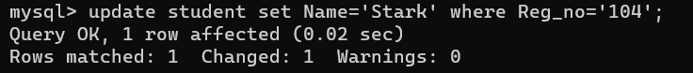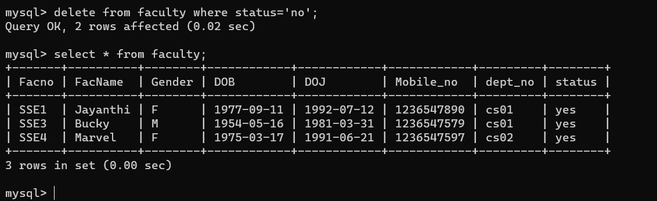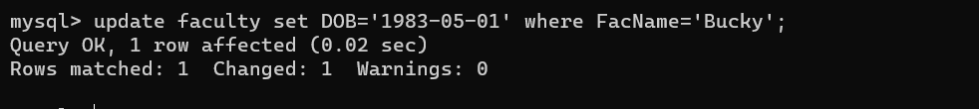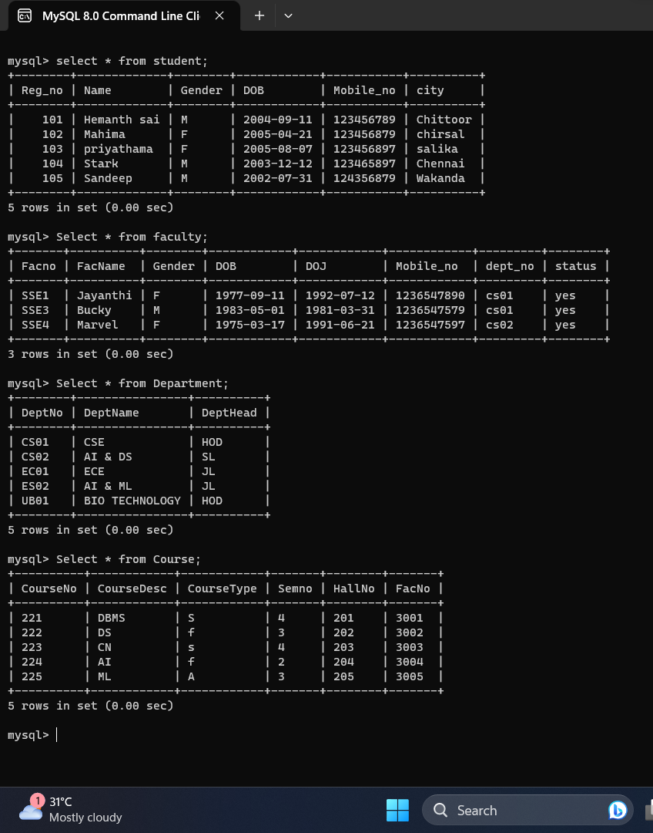

**RESULT**:

Data Manipulation Language (DML) Commands such as INSERT, SELECT are performed in the five tables.