**Ex. No.: 7**

**QUERY WITH SUBQUERY & CORRELATED QUERY**

1.Which of the student’s score is greater than the average score?

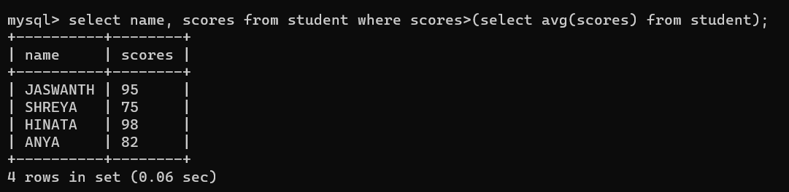

2.Which of the students’ have written more than one assessment test?

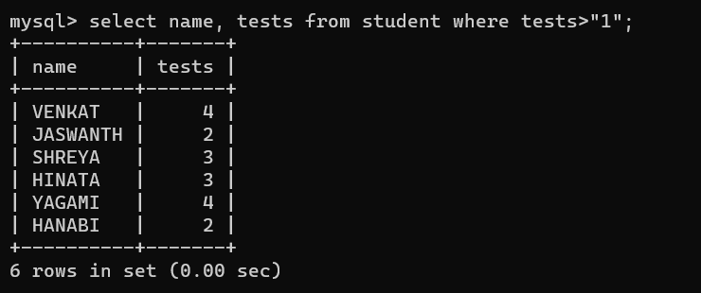

3.Which faculty has joined recently and when?

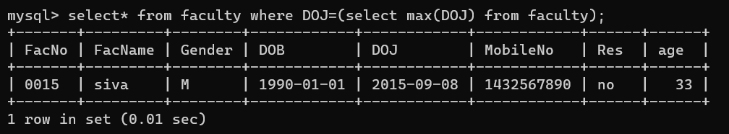

4.List the course and score of assessments that have the value more than the average score each Course

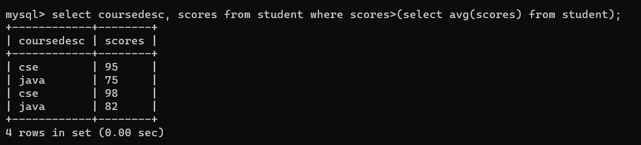

RESULT: The records from the tables are displayed using Sub-Query and Correlated Sub-Query.