**EX.NO.8**

**Joins- EQUIJOIN , INNER JOIN,OUTER JOIN**

1.list the department where the faculty members are working

2.find the student who has no score in any of the courses .list the student name and course number

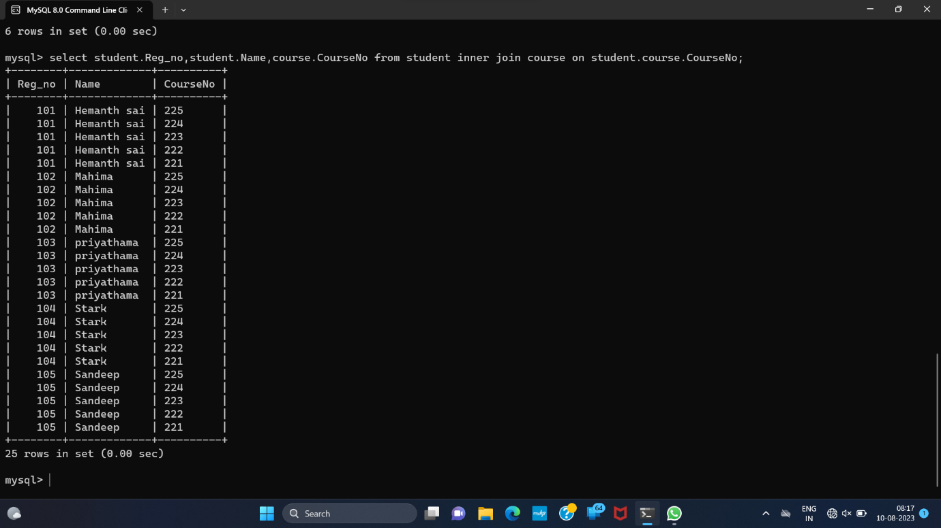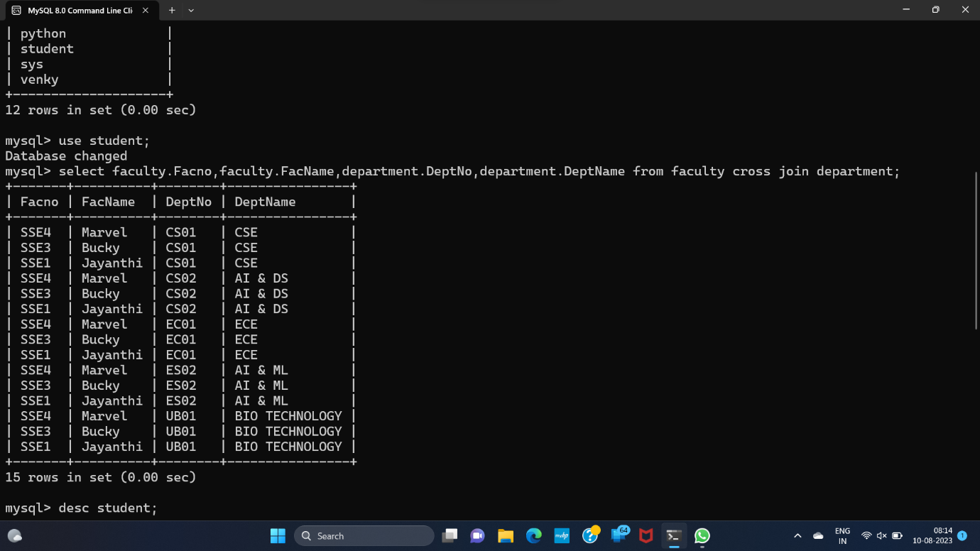

**RESULT :** The records from the tables are displayed using JOIN using EQUI JOIN , INNER JOIN , OUTER JOIN