Ex:No: 13

Date:

**DCL COMMANADS**

**Aim:**

To learn how to use various DCL commands GRANT and REVOKE SQL commands

**Procedure**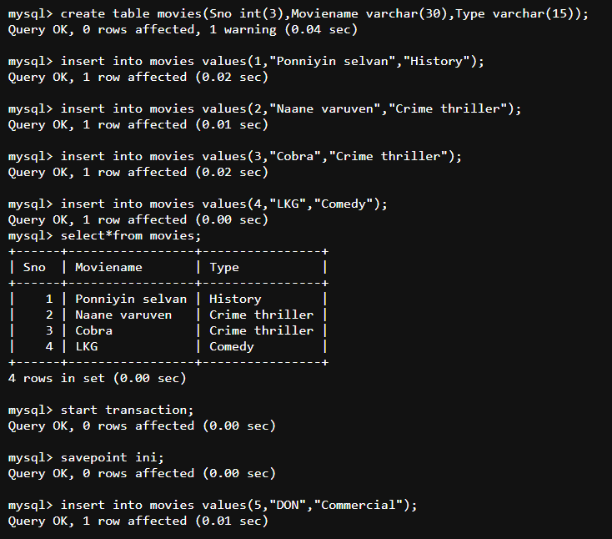

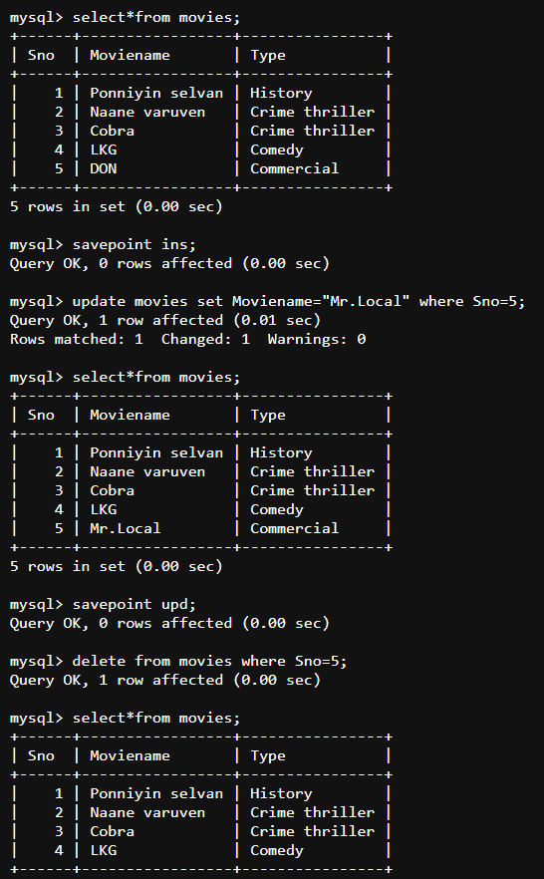

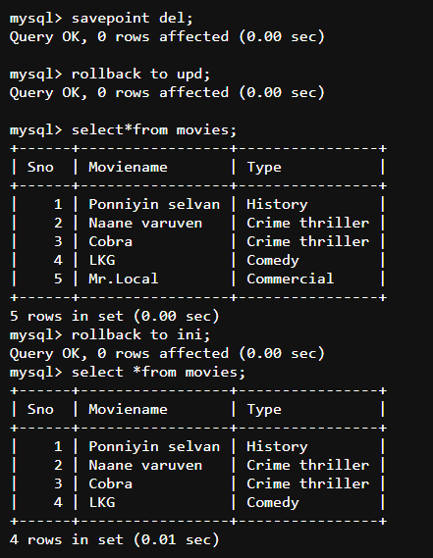

**RESULT:** Thus the DCL commands GRANT and REVOKE SQL executed successfully.