Ex. No.: 6

Date:

**SELECT with various clause – GROUP BY, HAVING, ORDER BY**

**AIM:**

To view the records from the tables using SELECT commands with Group By, Having, Order By

**GROUP BY - HAVING**

1. How many students are registered for each course? Display the course description and the number of students registered in each course.

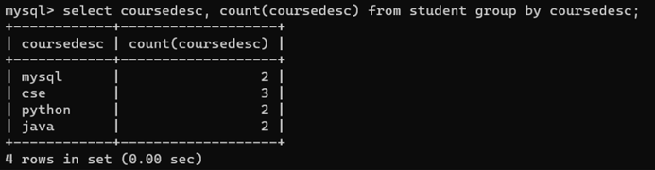

2.How many courses did each student register for? Use Assessment table.

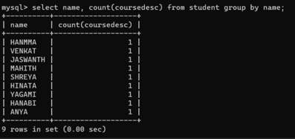

**ORDER BY**

1. Retrieve Name, Gender, MobileNo of all the students in ascending order of RegNo

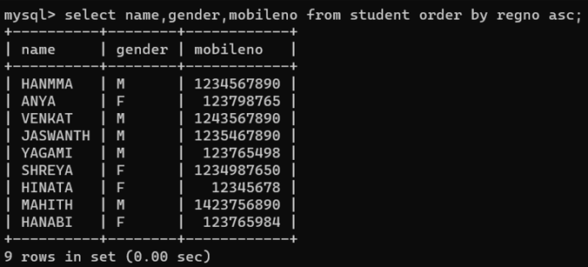

2.List the faculty members in the order of older faculty first.

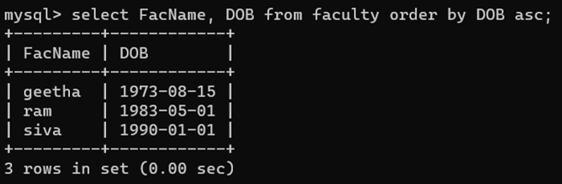

**RESULT**:

The records from the tables are displayed using SELECT commands with GROUP BY, HAVING and ORDER BY.

