**Aim:** Analysis of Discrete-Time Signals Using Z-Transform

## IDE:

Install Library pip install sympy Example 1:

import sympy as sp # Define symbols

n, z, a = sp.symbols('n z a')

# Define the signal x[n] = a^n * u[n] x_n = a**n

# Compute the Z-transform

X_z = sp.summation(x_n * z**(-n), (n, 0, sp.oo)) # Print the result

print("Z-transform of x[n] = a^n u[n]:") sp.pprint(X_z, use_unicode=True)

# OUTPUT:

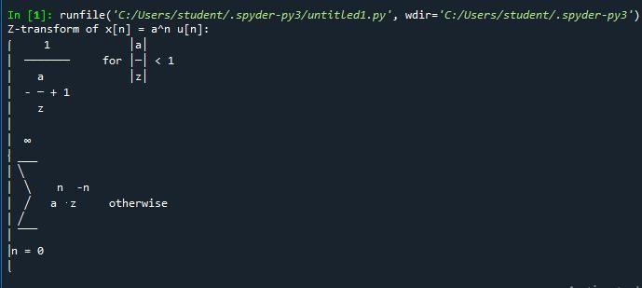

Example 2:

# Define symbols

n, z, a = sp.symbols('n z a')

# Define the signal x[n] = a^n * u[n] x_n = 2**n

# Compute the Z-transform

X_z = sp.summation(x_n * z**(-n), (n, 0, sp.oo)) # Print the result

print("Z-transform of x[n] = a^n u[n]:") sp.pprint(X_z, use_unicode=True)

# OUTPUT:

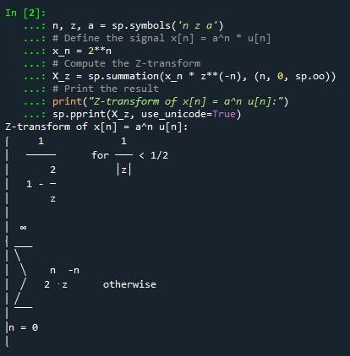

Example 3:

import sympy as sp # Define symbols

n, z = sp.symbols('n z')

# Define the unit step signal u[n] u_n = 1

# Compute the Z-transform

U_z = sp.summation(u_n * z**(-n), (n, 0, sp.oo)) # Print the result

print("Z-transform of the unit step signal u[n]:") sp.pprint(U_z, use_unicode=True)

# OUTPUT:

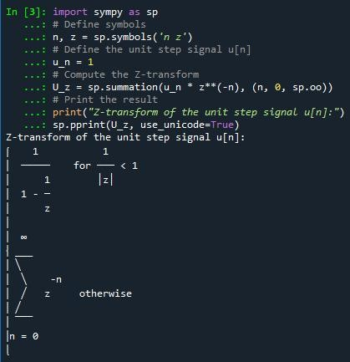

Example 4:

import sympy as sp # Define symbols

n, z, alpha = sp.symbols('n z alpha')

# Define the signal x[n] = exp(alpha * n) * u[n] x_n = sp.exp(alpha * n)

# Compute the Z-transform

X_z = sp.summation(x_n * z**(-n), (n, 0, sp.oo)) # Print the result

print("Z-transform of x[n] = exp(alpha * n) u[n]:") sp.pprint(X_z, use_unicode=True)

# OUTPUT:

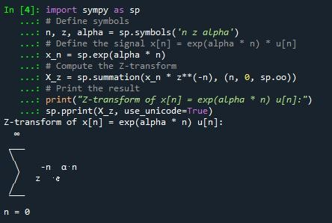

Example 5:

import sympy as sp # Define symbols

n, z = sp.symbols('n z')

# Define the finite sequence x[n] = {1, 2, 3} x_n = [1, 2, 3]

# Compute the Z-transform manually

X_z = sum(x_n[i] * z**(-i) for i in range(len(x_n))) # Print the result

print("Z-transform of the finite sequence {1, 2, 3}:") sp.pprint(X_z, use_unicode=True)

# OUTPUT:

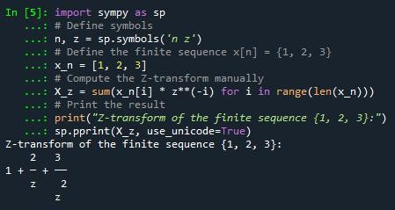

Example 6

import sympy as sp # Define symbols

n, z, omega = sp.symbols('n z omega')

# Define the sinusoidal sequence x[n] = sin(omega * n) * u[n] x_n = sp.sin(omega * n)

# Compute the Z-transform

X_z = sp.summation(x_n * z**(-n), (n, 0, sp.oo)) # Print the result

print("Z-transform of x[n] = sin(omega * n) u[n]:") sp.pprint(X_z, use_unicode=True)

# OUTPUT:

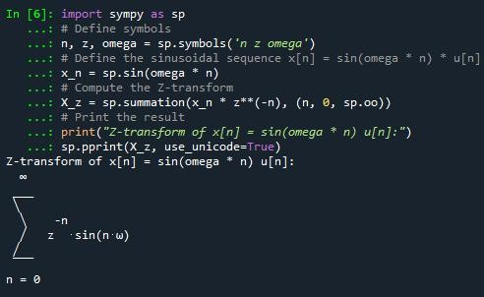

## Post Lab Exercise:

* Using Python, compute the Z-transform of the sequence  = 3[].

# INPUT:

import sympy as sp

# Define symbols

n, z = sp.symbols('n z')

# Set alpha = ln(3) alpha = sp.log(3)

# Define the signal x[n] = 3^n * u[n] = exp(alpha * n) * u[n] x_n = sp.exp(alpha * n)

# Compute the Z-transform: sum from n = 0 to ∞ of x[n] * z^(-n) X_z = sp.summation(x_n * z**(-n), (n, 0, sp.oo))

# Print the result

print("Z-transform of x[n] = 3^n * u[n]:")

sp.pprint(X_z, use_unicode=True)

# OUTPUT:

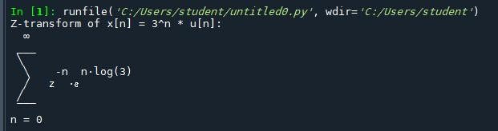

* Using Python, compute the Z-transform of the sequence  = cos ()[].

# INPUT:

import sympy as sp

# Define symbols

n, z, w = sp.symbols('n z w', real=True)

# Define the signal x[n] = cos(w * n) * u[n] x_n = sp.cos(w * n)

# Compute the Z-transform: sum from n = 0 to ∞ of x[n] * z^(-n) X_z = sp.summation(x_n * z**(-n), (n, 0, sp.oo))

# Print the result

print("Z-transform of x[n] = cos(ωn) * u[n]:") sp.pprint(X_z.simplify(), use_unicode=True)

OUTPUT:

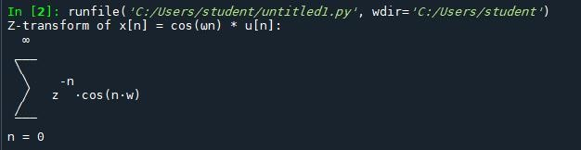

github:

<https://github.com/hemanth-singampalli/pwp.git>