CSS

**SELECTOR**

A class selector in CSS targets HTML elements with a specific class attribute.  
It starts with a dot (.), followed by the class name (e.g., .button { color: red; }).

**CODE**

<!DOCTYPE html>

<html>

  <head>

    <title>tech tamizhan</title>

    <style>

      h1 {

        color: red;

      }

      .test {

        color: yellow;

      }

      #header {

        background-color: aliceblue;

        height: 200px;

      }

    </style>

  </head>

  <body>

    <div id="header">

      <h1>tech tamizhan</h1>

      <h2 class="test">tech tamizhan</h2>

      <h3 class="test">tech tamizhan</h3>

    </div>

  </body>

</html>

**OUTPUT**

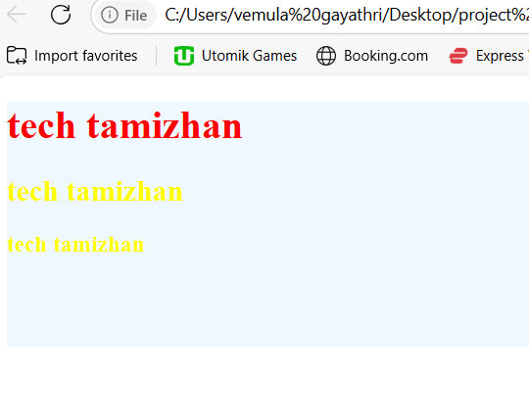

**STYLE SHEET**

A **style sheet** is a file or block of code that defines the visual presentation (like colors, fonts, and layout) of HTML elements.  
It can be external, internal, or inline, and is written using CSS (Cascading Style Sheets).

**CODE**

<!DOCTYPE html>

<html>

  <head>

    <title>tech tamizhan</title>

    <style>

      h2 {

        color: yellow;

      }

    </style>

    <link rel="stylesheet" type="text/css" href="css/style.css"

  </head>

  <body>

    <h1 style="color: red">tech tamizhan</h1>

    <h2>tech tamizhan</h2>

    <h3>tech tamizhan</h3>

  </body>

</html>

**OUTPUT**

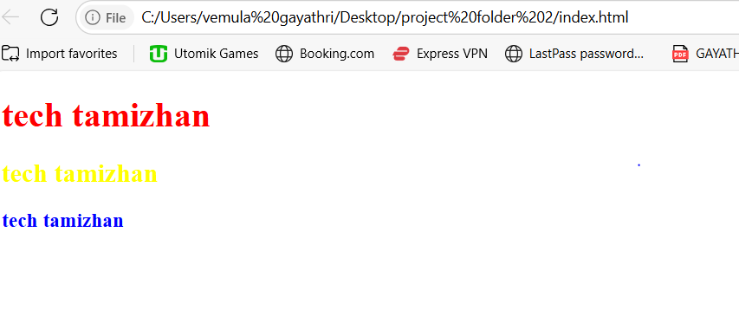

**CSS COMMENTS/COLORS/WIDTH/HEIGHT**

In CSS, comments are written like this:

/* This is a comment */

There are no specific "comment colors" defined by CSS itself — the color of comments depends on the text editor or IDE you're using, like VS Code, Sublime Text, etc.

However, most editors display comments in gray or green to distinguish them from actual CSS code.

Example in two lines:

/* This is a comment line */

/* Another comment line */

These lines are ignored by browsers and only help developers document their code.

**CODE**

<!DOCTYPE html>

<html>

  <head>

    <title>tech tamizhan</title>

    <style></style>

    <link rel="stylesheet" type="text/css" href="css/style.css" />

  </head>

  <body>

    <h1>tech tamizhan</h1>

    <img src="images.1/images.jfif" />

  </body>

</html>

**OUTPUT**



**BACKGROUND COLOR**

**Background color** refers to the color that fills the area behind text, images, or elements on a screen or page. It helps with visual contrast, readability, and design aesthetics.

**CODE**

<!DOCTYPE html>

<html>

  <head>

    <title>tech tamizhan</title>

    <style></style>

    <link rel="stylesheet" type="text/css" href="css/style.css" />

  </head>

  <body>

    <h1>tech tamizhan</h1>

  </body>

</html>

**OUTPUT**

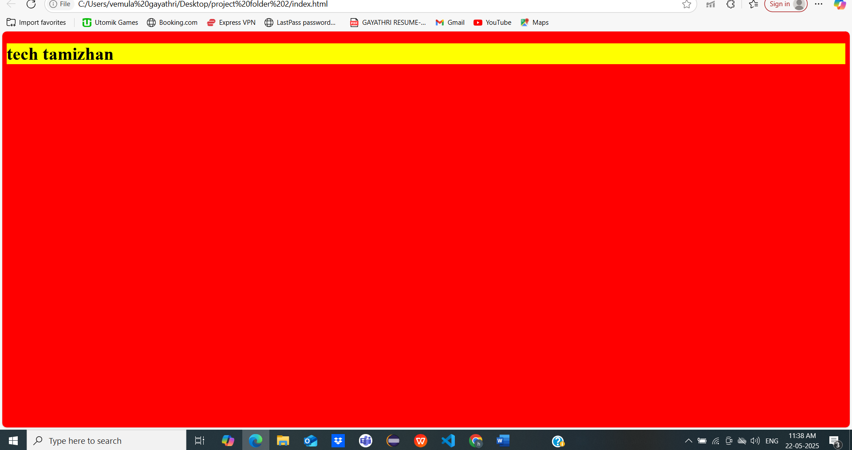

**BACKGROUND IMAGE**

**Background image** is a graphic or photo set behind content on a webpage or screen element. It enhances visual appeal and can convey branding or thematic context.

**CODE**

/* background css property */

body {

  background-image: url("../images.1/images.jfif");

  background-repeat: no-repeat;

}

h1 {

  background-color: yellow;

}

**OUTPUT**

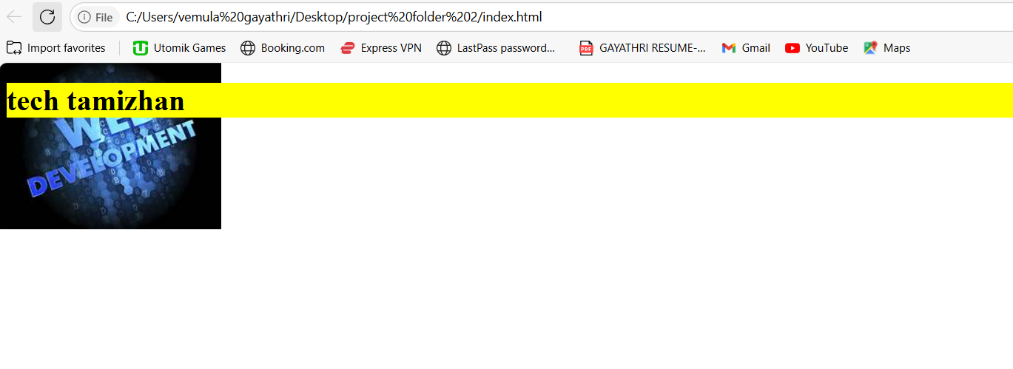

**BACKGROUND ATTACHMENT**

**Background attachment** is a CSS property that controls how a background image behaves when scrolling. It can be set to values like scroll, fixed, or local to define whether the image moves with the page or stays in place.

**CODE**

/* background css property */

body {

  background-image: url("../images.1/images.jfif");

  background-repeat: no-repeat;

  background-position: right top;

  background-attachment: fixed;

}

h1 {

  background-color: yellow;

}

**OUTPUT**

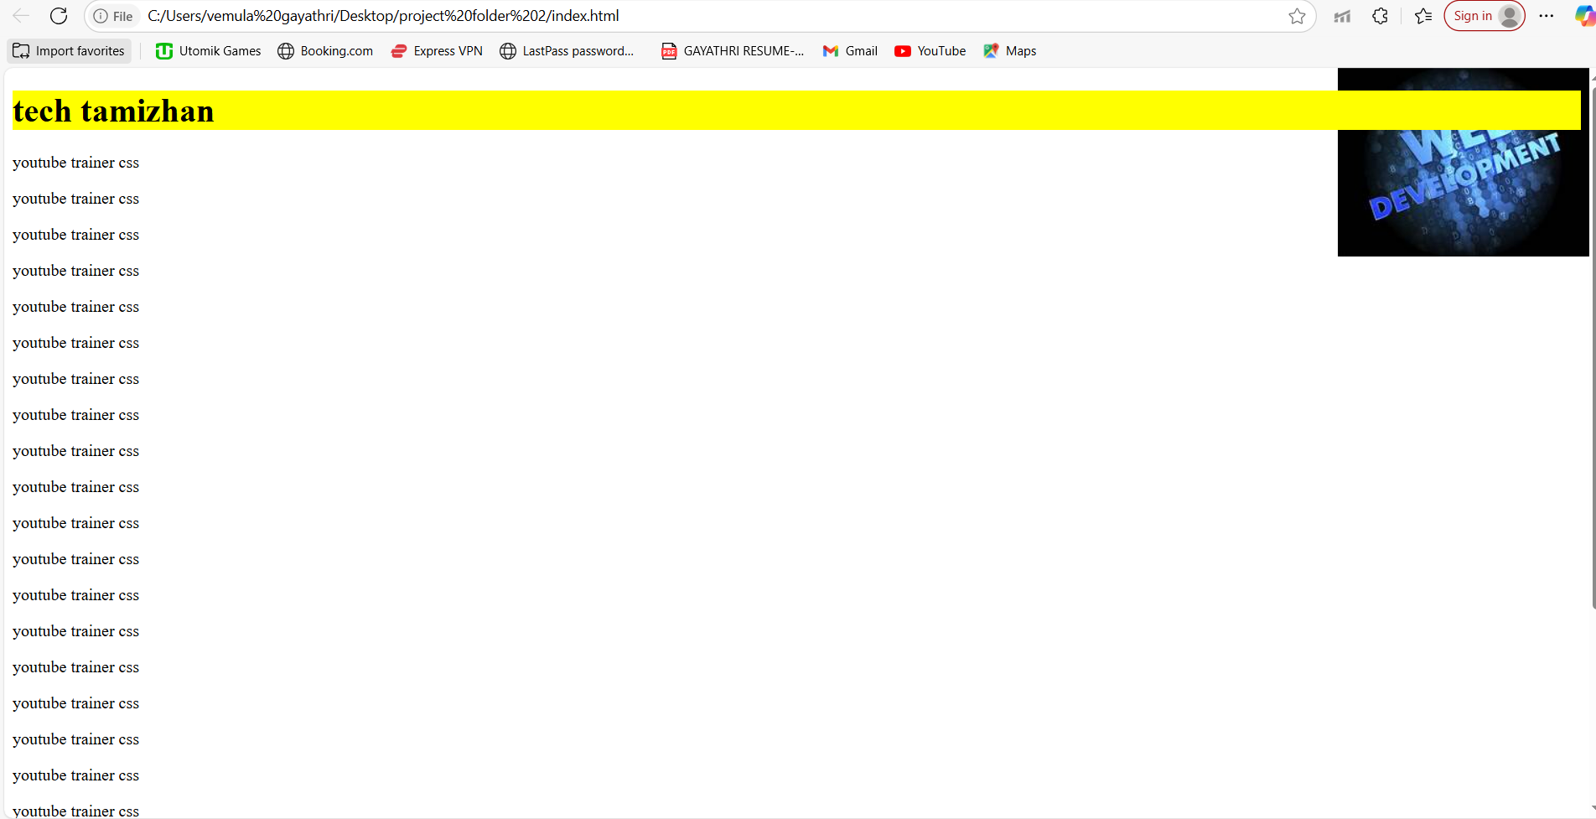

**MARGIN AND PADDING**

**Margin** is the space **outside** an element's border, creating distance between elements.  
**Padding** is the space **inside** an element's border, creating space between the content and the border.

**CODE**

/* background css property */

div {

  background-color: yellow;

  color: red;

  border: 3px solid black;

  margin-top: 50px;

  margin-left: 50px;

  padding: 50px;

}

**OUTPUT**

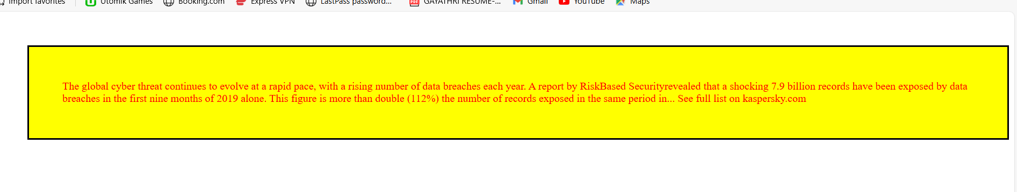

**TEXT PROPARTY**

The **text properties** in CSS control the appearance and alignment of text, such as text-align, text-transform, and text-decoration.  
They help manage how text is displayed, including spacing, capitalization, and decoration styles.

**CODE**

/* background css property */

h1 {

  color: red;

  background-color: blue;

  text-align: center;

}

h3 {

  color: green;

  text-align: left;

  text-shadow: 2px 2px;

}

span {

  text-decoration: line-through;

}

a {

  text-decoration: none;

}

p {

  color: pink;

  font-size: 20px;

  text-decoration: underline;

  text-transform: capitalize;

  text-indent: 50px;

  letter-spacing: 3px;

  line-height: 2;

  word-spacing: 10px;

}

.bro {

  color: aqua;

  background-color: brown;

  padding: 20px;

  width: 100px;

}

**OUTPUT**

