HTML

**TEXTAREA.HTML**

A <textarea> in HTML is a form element used to create a multi-line text input field. It allows users to enter more than one line of text, unlike an <input> element with type="text".

**CODE**

<html>

  <head>

    <title>basic form</title>

  </head>

  <body>

    <h1>comment form</h1>

    <form>

      <p>

        Name: <br />

        <input type="text" name="your_name" />

      </p>

      <p>

        email: <br />

        <input type="text" name="email_id" />

      </p>

      <p>

        comments: <br />

        <textarea

          name="comments"

          cols="40"

          row="10"

          placeholder="enter your comments"

        ></textarea>

      </p>

    </form>

  </body>

</html>

**output**

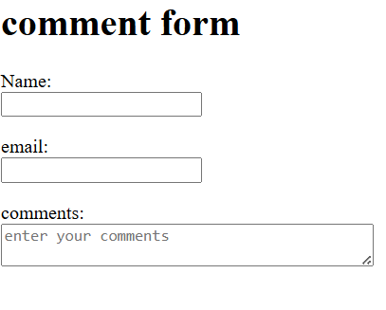

**MEDIA.HTML**

In HTML, media refers to elements like <audio> and <video> used to embed sound or video content. These elements support controls and attributes for playback, volume, and more**.**

**CODE**

<!DOCTYPE html>

<html>

  <head>

    <title>tech tamizhan</title>

  </head>

  <body>

    <!-- html media elements -->

    <!-- html video tag -->

    <video>

      <source src="medias/movie/" type="video/" />

    </video>

    <!-- html audio tag -->

    <!-- html youtube videos -->

    <iframe

      width="560"

      height="315"

      src="https://www.youtube.com/embed/H9nUgvlMXOw?si=JLRDzWtxdNyDRAT7"

      title="YouTube video player"

      frameborder="0"

      allow="accelerometer; autoplay; clipboard-write; encrypted-media; gyroscope; picture-in-picture; web-share"

      referrerpolicy="strict-origin-when-cross-origin"

      allowfullscreen

    ></iframe>

  </body>

</html>

**OUTPUT**

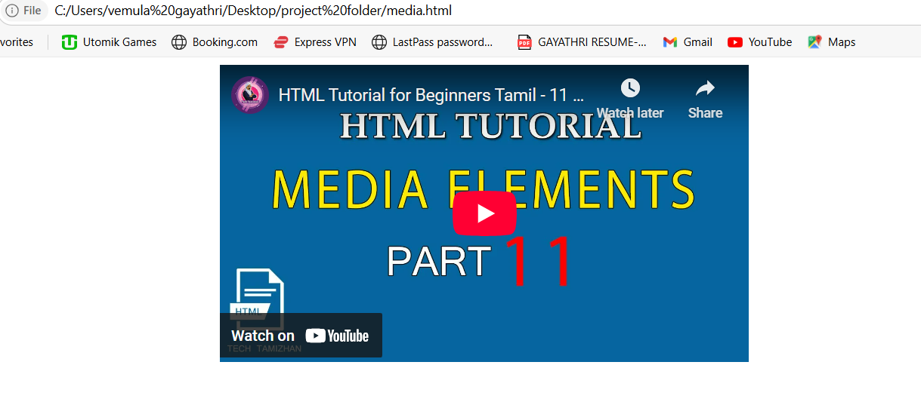

**CITATION AND DEFINIATION.HTML**

**In HTML:**

* Citation (<cite>) is used to reference the title of a creative work (e.g., book, movie, article).  
  Example: <cite>The Great Gatsby</cite>
* Definition (<dfn>) is used to indicate a term being defined.  
  Example: <dfn>HTML</dfn> stands for HyperText Markup Language.

**CODE**

<html>

  <head>

    <title>citation and definition tag</title>

  </head>

  <body>

    <h1>citation and definition tag</h1>

    <p>

      the <cite>thirukural</cite> is a classic tamil text consising of 1330

      couples dealing with the everyday virtues of an individual

    </p>

    <p>

      <dfn>aram</dfn> is a tamil word for what is known in sanskrit as dharma

    </p>

  </body>

</html>

**OUTPUT**

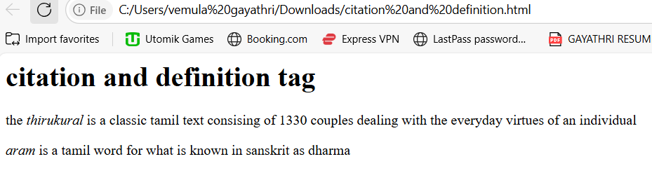

**ADDRESS.HTML**

In HTML:

* **<address>** is used to define contact information for the author or owner of a document.  
  Example: <address>Email: info@example.com</address>

**CODE**

<html>

  <head>

    <title>address tag</title>

  </head>

  <body>

    <h1>address tag</h1>

    <address>

      <p>

        <b>kamarajar arangam,</b><br />

        anna salai,<br />

        teynampet,<br />

        chennai-600 006.

      </p>

    </address>

  </body>

</html>

**OUTPUT**

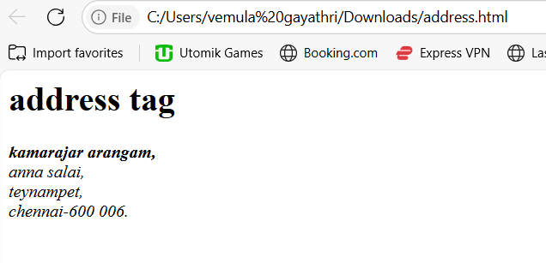

**DEL AND INS .HTML**

In HTML:

* **<del>** represents deleted text, usually shown with a strikethrough.  
  Example: <del>Old Price</del>
* **<ins>** represents inserted text, usually underlined.  
  Example: <ins>New Price</ins>

**CODE**

<html>

  <head>

    <title>delete, insert and strikout tags</title>

  </head>

  <body>

    <h1>delete, insert and strikout tags</h1>

    <p>i,plan to buy a <del>samsung</del>/ <ins>dell</ins> monitor</p>

    <p>i'm willing to pay <s>12k</s> / 15k rupees</p>

  </body>

</html>

**OUTPUT**

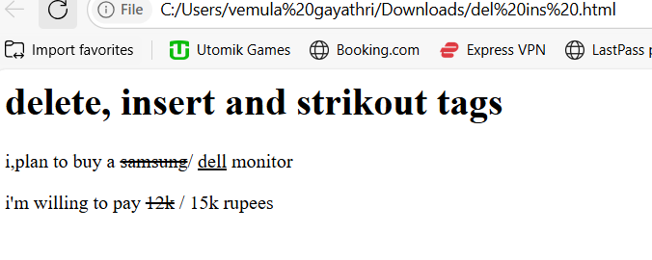

**EMAIL LINK.HTML**

In HTML:

* An email link is created using the <a> tag with the mailto: protocol.  
  Example: <a href="mailto:someone@example.com">Send Email</a>

**CODE**

<html>

    <head>

        <title>email links</title>

    </head>

    <body>

        <h1>email links</h1>

        <my>my email id is <a href="mailto:hemanthaaleswara@gmail.com">hemanthaaleswara@gmail.com</p>

        <p><a herf="mailto:youremailid@yourdomain">contact me </a>if you have any questions!</p>

    </body>

</html>

OUTPUT

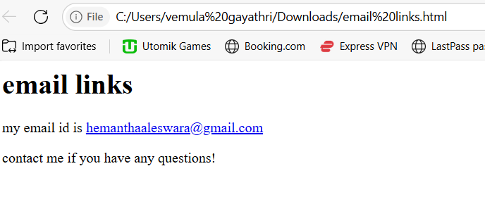

**CONTACT FORM.HTML**

In HTML:

* A **contact form** collects user information like name, email, and message for communication.
* It uses the <form> element with input types like <input>, <textarea>, and <button>.

**CODE**

<html>

  <head>

    <title>contact form</title>

  </head>

  <body>

    <h1>contact form</h1>

    <form action="">

      <p>

        name: <br />

        <input text="text" name="your_name" />

      </p>

      <p>

        email: <br />

        <input text="text" name="email_id" />

      </p>

      <p>

        subject: <br />

        <input text="text" name="subject" />

      </p>

      <p>

        is this a <br />

        <input type="radio" name="request_type" /> sales request?

        <input type="radio" name="request_type" /> support request

      </p>

      <p>

        message: <br />

        <textarea

          name="message"

          id="message"

          cols="30"

          rows="10"

          placeholder="enter your message"

        ></textarea>

      </p>

      <p>

        <input type="submit" value="send message" name="contact_form" />

      </p>

    </form>

  </body>

</html>

**OUTPUT**

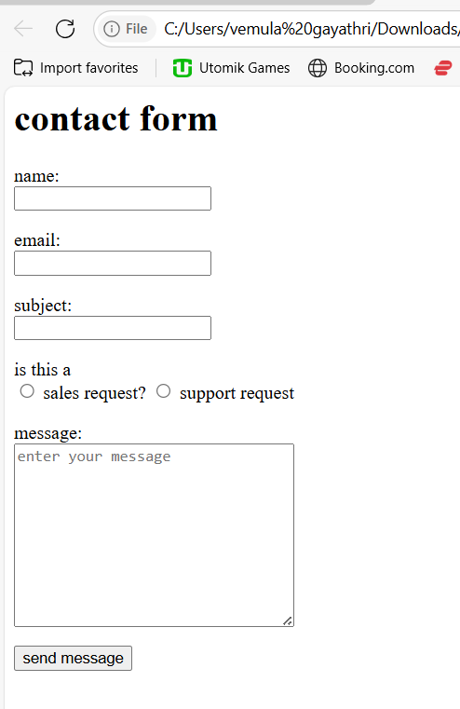

**CLASS ID .HTML**

In HTML:

* **class** is used to apply the same style or behavior to multiple elements.
* **id** is used to uniquely identify a single element on a page.

**CODE**

<!DOCTYPE html>

<html>

  <head>

    <title>tech tamizhan</title>

    <style>

      #header {

        height: 80px;

        background-color: red;

      }

      #nav {

        height: 80px;

        background-color: black;

      }

      #footer {

        height: 80px;

        background-color: green;

      }

      .para {

        color: aqua;

        font-size: 20px;

        text-align: center;

      }

    </style>

  </head>

  <body>

    <!-- html class and id -->

    <div id="header">

      <p class="para">

        Cyber security, also known as information technology security, refers to

        the practice of protecting systems, networks, and programs from digital

        attacks. These cyber-attacks are usually aimed at accessing, changing,

        or destroying sensitive information, extorting money from users, or

        interrupting normal business processes.

      </p>

    </div>

    <div id="nav">

      <p class="para">

        Cyber security, also known as information technology security, refers to

        the practice of protecting systems, networks, and programs from digital

        attacks. These cyber-attacks are usually aimed at accessing, changing,

        or destroying sensitive information, extorting money from users, or

        interrupting normal business processes.

      </p>

    </div>

    <div id="footer">

      <p class="para">

        Cyber security, also known as information technology security, refers to

        the practice of protecting systems, networks, and programs from digital

        attacks. These cyber-attacks are usually aimed at accessing, changing,

        or destroying sensitive information, extorting money from users, or

        interrupting normal business processes.

      </p>

    </div>

  </body>

</html>

**OUTPUT**

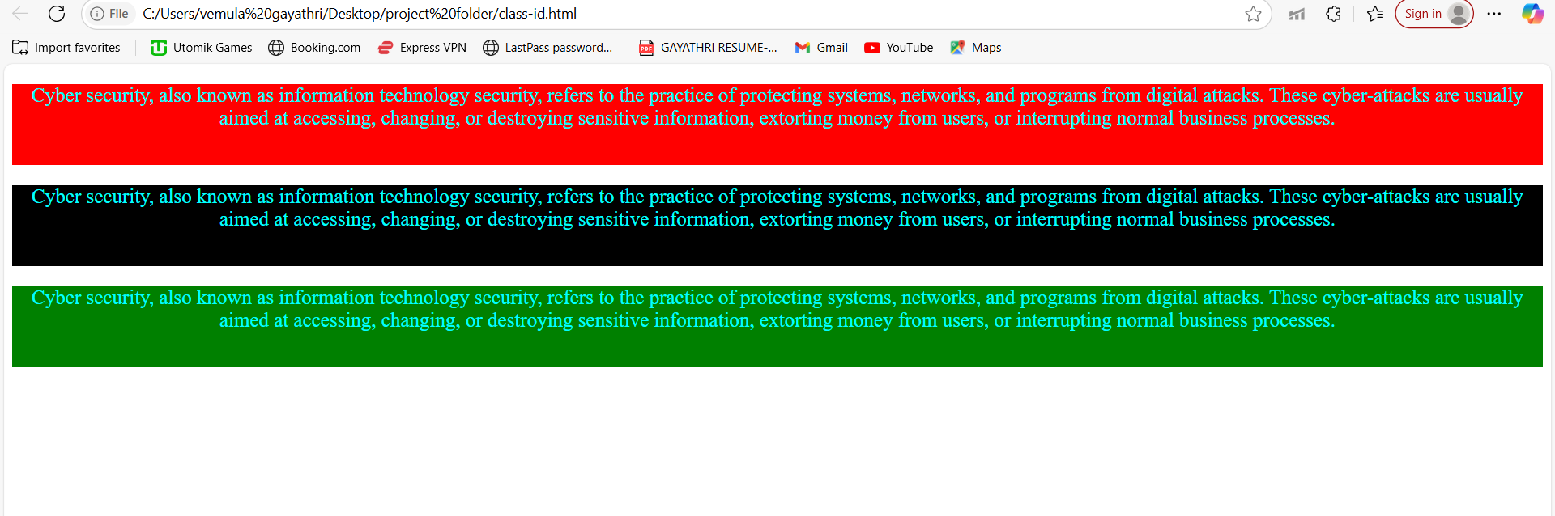

**DIVISION.HTML**

In HTML:

* The **<div>** tag is a container used to group and organize HTML elements.
* It helps with layout and styling using CSS or JavaScript.

**CODE**

<!DOCTYPE html>

<html>

  <head>

    <title>tech tamizhan</title>

  </head>

  <body>

    <!--html div and span -->

    <div style="background-color: yellow; height: 100px"></div>

    <p>

      yogi<span style="color: orange; font-size: 20px">website developer</span

      >chennai

    </p>

  </body>

</html>

**OUTPUT**

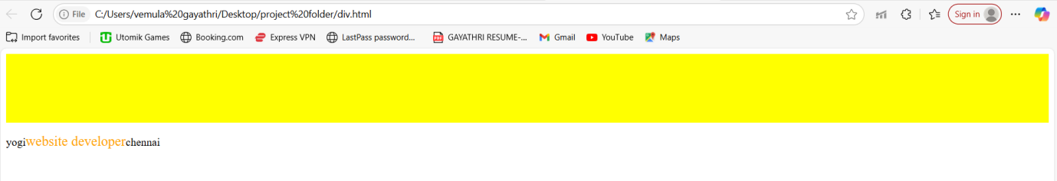

**TABLE.HTML**

In HTML:

* A **table** displays data in rows and columns using the <table> element.
* It includes tags like <tr> for rows, <th> for headers, and <td> for data cells.

**CODE**

<!DOCTYPE html>

<html>

  <head>

    <title>tech tamizhan youtuber</title>

    <style>

      table,

      tr,

      td,

      th {

        border: 1px solid black;

        border-collapse: collapse;

        padding: 10px;

        text-align: center;

      }

    </style>

  </head>

  <body>

    <!-- html tables -->

    <table>

      <tr>

        <th>company</th>

        <th>contact</th>

        <th>contry</th>

      </tr>

      <tr>

        <td>yogi</td>

        <td>12456789</td>

        <td>indian</td>

      </tr>

      <tr>

        <td>yogi</td>

        <td>12456789</td>

        <td>indian</td>

      </tr>

      <tr>

        <td>yogi</td>

        <td>12456789</td>

        <td>indian</td>

      </tr>

      <tr>

        <td>yogi</td>

        <td>12456789</td>

        <td>indian</td>

      </tr>

      <tr>

        <td>yogi</td>

        <td>12456789</td>

        <td>indian</td>

      </tr>

    </table>

    <br />

    <table>

      <tr>

        <th>Name</th>

        <td>yogi</td>

      </tr>

      <tr>

        <th rowspan="2">telephone</th>

        <td>9765432781</td>

      </tr>

      <tr>

        <td>2314567789</td>

      </tr>

    </table>

  </body>

</html>

**OUTPUT**

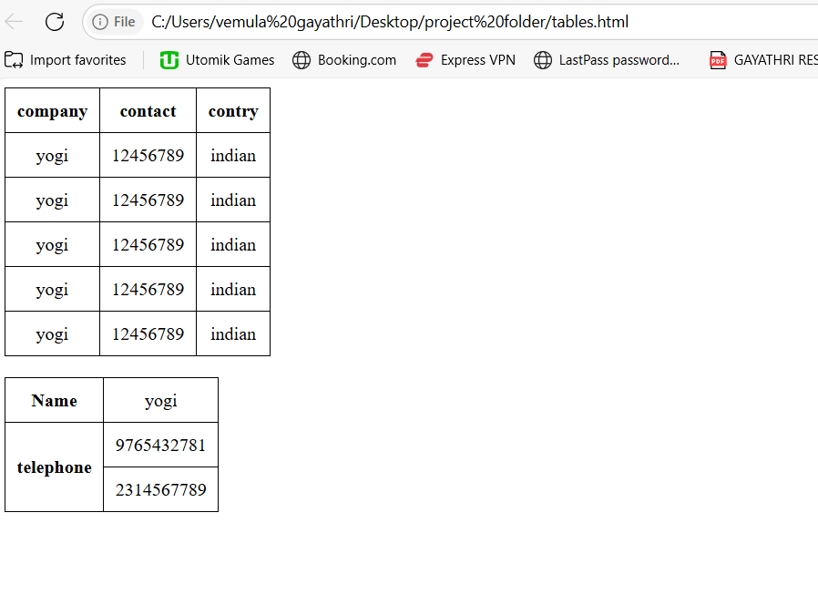

**LIST .HTML**

In HTML:

* A **list** is used to group related items using <ul> (unordered), <ol> (ordered), or <dl> (description list).
* Each item in a list is defined using the <li> tag.

**CODE**

<html>

  <head>

    <title>tech tamzhan youtuber</title>

  </head>

  <body>

    <!-- html lists -->

    <ul>

      <li>web design</li>

      <li>development</li>

      <li>SEO</li>

    </ul>

    <ol>

      <li>web design</li>

      <li>development</li>

      <li>SEO</li>

    </ol>

    <dl>

      <dt>ram</dt>

      <dd>freelance website developer</dd>

    </dl>

    <dl>

      <dt>ram</dt>

      <dd>freelance website developer</dd>

    </dl>

  </body>

</html><!DOCTYPE html>

**OUTPUT**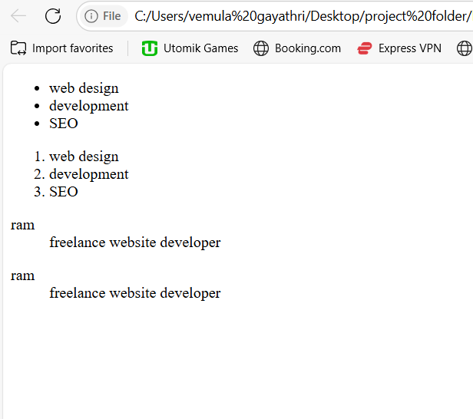

LINKS .HTML

In HTML:

* A **link** connects one page to another using the <a> (anchor) tag.
* It uses the href attribute to specify the destination URL.  
  Example: <a href="https://example.com">Visit Site</a>

**CODE**

<!DOCTYPE html>

<html>

  <head>

    <title>tech tamizhan</title>

  </head>

  <body>

    <!-- html hyperlinks -->

    <a href="index.html"> go to my home page </a>

    <br />

    <a

      href="https://in.search.yahoo.com/search?fr=mcafee&type=E210IN1357G0&p=tech+tamizhan"

    >

      tech tamizhan chennai</a

    >

    <br />

    <a

      href="https://in.search.yahoo.com/search?fr=mcafee&type=E210IN1357G0&p=tech+tamizhan"

      target="_blank"

    >

      tech tamizhan chennai new tab</a

    >

  </body>

</html>

**OUTPUT**

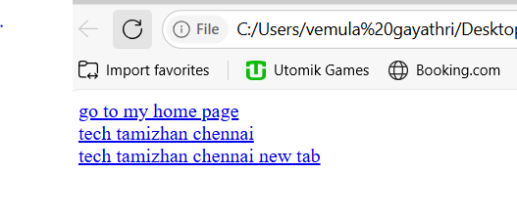

**INDEX.HTML**

In HTML:

* An **index** usually refers to the main or home page of a website, typically named index.html.
* It serves as the default page that loads when visiting a domain.

**CODE**

<!DOCTYPE html>

<html>

  <head>

    <title>tech tamizhan</title>

  </head>

  <body>

    <h1>tech tamizhan</h1>

    <h2>heading 1</h2>

    <h3>heading 2</h3>

    <h4>heading 3</h4>

    <h5>heading 4</h5>

    <h6>heading 5</h6>

    <p style="background-color: yellow; text-align: center; font-family: arial">

      System Design is the process of designing the architecture, components,

      and interfaces for a system so that it meets the end-user requirements.

      This specifically designed System Design tutorial will help you to learn

      and master System Design concepts in the most efficient way from basics to

      advanced level.

    </p>

    <hr />

    <p style="color: orange; font-size: 30px">

      Building a successful application goes beyond just having functional

      features. It is also about ensuring the system can withstand real-world

      conditions. A well-designed system is not only reliable and scalable but

      also easy to maintain and evolve as the requirements change.

      <br /><br />

      as applications grow in complexity, designing them with scalability,

      performance, and availability in mind becomes important. What to Expect

      from This System Design Tutorial? This tutorial will guide you through the

      basic ideas of system design, step by step. Whether you’re just starting

      with system design or want to improve your skills, this guide will help

      you learn how to create efficient, scalable, and reliable systems.

      <br /><br />

      cover everything from the basics of scalability to more advanced

      techniques like database sharding and caching. By following these steps

      and continually refining your approach, you can develop robust and

      efficient system designs that meet both technical requirements and user

      expectations. For those looking to delve deeper and gain a competitive

      edge, our System Design course provides a structured pathway to mastering

      these essential skills.

    </p>

  </body>

</html>

**OUTPUT**

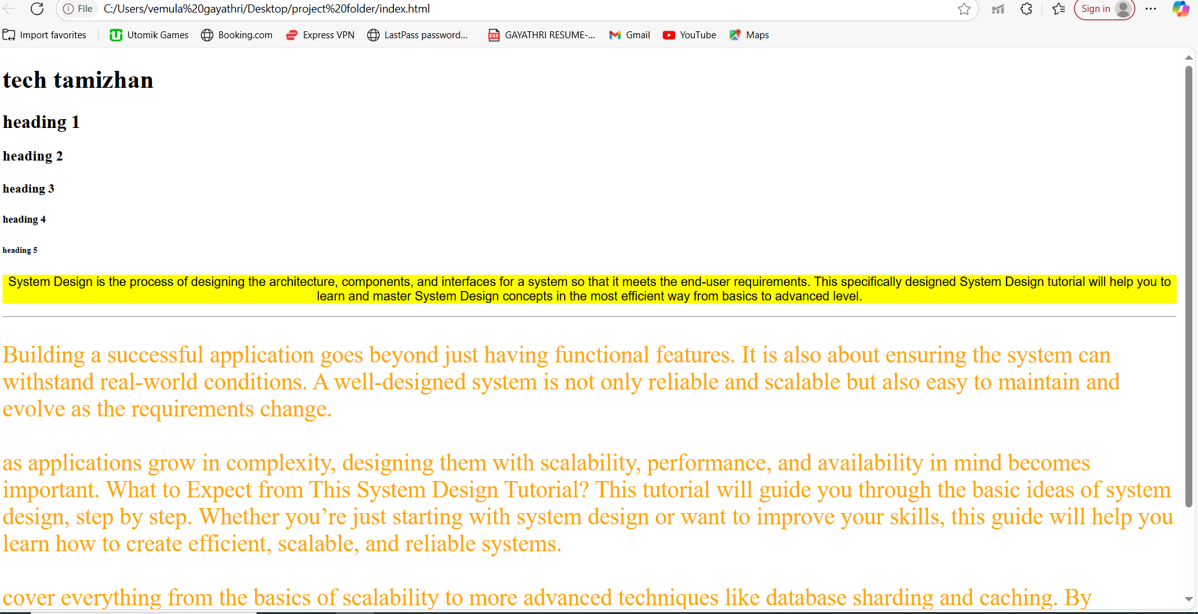

**JOB APPLICATION FORM.HTML**

A **job application form in HTML** is a web-based form that collects user input like name, email, resume, and other job-related details using HTML form elements. It typically uses tags like <form>, <input>, <textarea>, and <button> to structure the data entry interface.

**CODE**

html>

    <head>

        <title>job applicatioon form</title>

    </head>

    <body>

        <h1>job application form</h1>

        <form>

            <p>

                your name: <br>

                <input type="text" name="your_name">

            </p>

            <p>

                your education: <br>

                <select name="education">

                    <option value="be">B.E,</option>

                    <option value="btech">B.TECH,</option>

                    <option value="b.c.a">B.C.A,</option>

                    <option value="bsc">B.SC,</option>

                </select>

                <P>

                    you want to apply for the position <br>

                    <select name="position">

                        <option value="fed">front end developer</option>

                        <option value="bd"> backend developer</option>

                        <option value="fsd"> full stack developer</option>

                    </select>

                </P>

                <p>

                    your resume: <br>

                    <input type="file" name="resume">

                </p>

                <p>

                    <input type="submit" value="send details" name="sports_form">

                </p>

            </p>

        </form>

    </body>

</html>

**OUTPUT**

