GEOSPATIAL DATA SCIENCE & URBAN INFRASTRUCTURE TECHNICAL REPORT
SMART YESHWANTHPUR GIS
An Interactive Geospatial Analytics Platform for Urban Infrastructure and Accessibility Analysis
――――――――――――――――――――――――――――――――――――――――――――――――――――――――
Study Area Location: Yeshwanthpur, BBMP North Zone, Bengaluru, Karnataka, India
Target Analytical Domain: Network Topology, Healthcare Equity, Graph Theory & Machine Learning
Spatial Scope: 19.60 sq km | 2.50 km Metric Buffer (Centroid: 13.0285° N, 77.5400° E)
Projected CRS: EPSG:32643 (UTM Zone 43N) | EPSG:4326 (WGS 84 Interchange)
Live Web Application: https://smart-yeshwanthpur-gis.streamlit.app/
Source Code Repository: https://github.com/hemanth46yadav-tech/urban-mobility-healthcare-analytics
Author / Specialization: Senior GIS Analyst & Geospatial Data Science Team
Document Publication Date: November 2026

Abstract
Rapid, uneven urban expansion across Bengaluru, India has intensified spatial disparities in transportation connectivity and critical healthcare accessibility. Traditional proprietary navigation tools offer point-to-point consumer routing but lack analytical depth regarding physical graph topology, network resilience, and infrastructural equity. This technical project report presents Smart Yeshwanthpur GIS, an open-source, end-to-end spatial data science and interactive analytics platform engineered specifically for the Yeshwanthpur transit and industrial corridor in Northwest Bengaluru (reference coordinates: 13.0285° N, 77.5400° E; 2.5 km study buffer covering 19.60 km²). Using OpenStreetMap (OSM) multigraph topologies and verified amenity databases, the system models 15,798 cleaned road edges (983.52 km total length; road density of 50.17 km/km²), 5,924 nodes, and 4,792 physical intersections (244.45 intersections/km²). Centrality algorithms identify 794 critical bottleneck corridors (top 5% betweenness centrality) concentrated along the Tumkur Road (NH-48) expressway and railway yard perimeter roads. In parallel, 84 verified healthcare amenities (37 hospitals, 15 outpatient clinics, and 32 pharmacies) are modeled across a 250m × 250m metric spatial grid (344 cells). While 91.0% of cells demonstrate high straight-line accessibility (<1 km to nearest hospital; mean straight-line distance of 532.4 m), actual vehicular travel encounters significant circuity (average 1.34x to 3.58x detour ratios) due to severe east-west severance imposed by the Yeshwanthpur Railway Marshalling Yard. Unsupervised K-Means clustering (k=5, Silhouette score: 0.392, PCA variance: 83.4%) discovers five distinct socio-spatial neighbourhood typologies across the urban fabric. All analytical layers are integrated into a multi-page interactive Streamlit dashboard with Folium dynamic mapping and full GeoPackage/GeoJSON export capabilities, offering a repeatable, scientifically grounded decision-support system for municipal planners and smart-city policymakers.
Keywords: Geographic Information Systems (GIS); Urban Analytics; Road Network Topology; Betweenness Centrality; Healthcare Accessibility; Shortest-Path Routing; Dijkstra's Algorithm; Spatial Grid Modeling; K-Means Clustering; Principal Component Analysis (PCA); OpenStreetMap; Bengaluru Smart Cities.

Table of Contents
1. Executive Summary & Cover Page
2. Abstract & Keywords
3. Table of Contents, List of Figures & Tables
4. Introduction & Urban Geographic Context
5. Problem Statement & Research Motivation
6. Project Objectives & Analytical Scope
7. Study Area Delineation & Spatial Parameters
8. Data Sources & Spatial Data Ingestion
9. Technology Stack & Software Ecosystem
10. System Architecture & End-to-End Data Pipeline
11. Geospatial Preprocessing & Topology Standardization
12. Comprehensive Analytical Methodology
13. Road Network Analysis & Structural Centrality
14. Shortest Path Graph Algorithms (Dijkstra Implementation)
15. Healthcare Facility Inventory & Spatial Distribution
16. Healthcare Accessibility & Metric Spatial Grid Modeling
17. Interactive Streamlit Web Application Features
18. Application Interface Architecture & Visualizations
19. Empirical Results, Key Findings & Discussion
20. Unsupervised Machine Learning & Spatial Typologies (K-Means & PCA)
21. Differentiation from Commercial Navigation Platforms (Google Maps)
22. Data Governance, Scientific Ethics & Analytical Disclaimers
23. Technical Limitations & Data Completeness
24. Future Roadmap & Proposed Enhancements
25. Practical Policy Implications & Urban Planning Diagnostics
26. Technical Conclusion
27. References & Academic Citations

List of Figures
Figure 1: Smart Yeshwanthpur GIS End-to-End System Architecture Pipeline
Figure 2: Road Network Street Hierarchy & Spatial Topology (Yeshwanthpur)
Figure 3: Road Network Classification Distribution (Segment Counts and Lengths)
Figure 4: Topological Betweenness Centrality & Critical Network Bottleneck Corridors
Figure 5: Dijkstra Shortest Path vs. Straight-Line Euclidean Distance Routing
Figure 6: Spatial Distribution of Healthcare Amenities & 1.0 km Hospital Service Buffers
Figure 7: Healthcare Amenity Composition & Clinical Mix Donut Chart
Figure 8: 250m Metric Spatial Grid Healthcare Accessibility Choropleth
Figure 9: Unsupervised K-Means Clustering Evaluation (Elbow Inertia & Silhouette Curves)
Figure 10: 2D Principal Component Analysis (PCA) Cluster Projection
Figure 11: Spatial Distribution of Discovered K-Means Neighbourhood Typologies
Figure 12: Streamlit Interactive GIS Dashboard User Interface & Layout Architecture

List of Tables
Table 1: Study Area Geographical and Spatial Reference Parameters
Table 2: Healthcare Infrastructure Classification Breakdown
Table 3: Road Network Classification Hierarchy and Physical Characteristics
Table 4: Topological Graph Structural Metrics
Table 5: Empirical Shortest Route Comparison (Dijkstra vs. Euclidean Straight-Line)
Table 6: 250m Spatial Grid Healthcare Accessibility Coverage Tiers
Table 7: Priority Healthcare Deficit Zones (Candidate Locations for Expansion)
Table 8: Unsupervised K-Means Cluster Characteristics & Sociodemographic Typologies
Table 9: Multi-Dimensional Comparison: Smart Yeshwanthpur GIS vs. Google Maps vs. Traditional Desktop GIS

4. Introduction & Urban Geographic Context
Yeshwanthpur is a pivotal multimodal transportation and commercial gateway situated in the north-western sector of Bengaluru, Karnataka, India (administered under the Bruhat Bengaluru Mahanagara Palike - BBMP North Zone). Historically functioning as an industrial periphery anchored by heavy manufacturing layouts and the Agricultural Produce Market Committee (APMC) Yard—one of the largest wholesale agricultural distribution hubs in South India—the sub-region has transformed into an intense transit-oriented hub. It concentrates the Yeshwanthpur Junction Railway Station (one of Bengaluru's primary interstate rail terminals), the Namma Metro Green Line elevated corridor and interchange, and the elevated National Highway 48 (Tumkur Road) connecting Bengaluru to Karnataka's northern hinterland and Maharashtra.
This rapid juxtaposition of high-capacity freight infrastructure, dense commercial wholesale yards, informal residential settlements, and modern high-density residential towers has generated profound geospatial friction. While the region is reputed for housing top-tier tertiary hospitals (such as Sparsh Hospital, Columbia Asia/Manipal Hospital, and People Tree Hospital), local road-network accessibility is severely constrained by structural barriers. In particular, the extensive Yeshwanthpur Railway Marshalling Yard creates an impenetrable physical severance bisecting the eastern and western wards, forcing intra-urban traffic onto narrow, highly congested flyover ramps and level crossings. To formulate effective urban resilience strategies, city authorities require scientific, reproducible, and open geospatial analytics that quantify road network bottlenecks and evaluate spatial healthcare access at granular metric scales.

5. Problem Statement & Research Motivation
Contemporary municipal planning in Indian metropolitan areas frequently relies on aggregate administrative census boundaries or black-box consumer navigation software (e.g., Google Maps, Apple Maps). While commercial platforms excel at point-to-point vehicular dispatch, their algorithmic architectures are unsuitable for structural urban policy diagnostics due to several fundamental limitations:
1. Absence of Structural Graph Metrics: Commercial routing tools evaluate live travel delays but do not expose underlying topological properties such as betweenness centrality, degree distribution, and intersection density, which identify where network failures trigger disproportionate systemic collapse.
2. Euclidean Proximity Fallacy: Traditional healthcare access evaluations often assume circular straight-line buffers (e.g., 'all residents within 1 km of a hospital have equal access'). In Yeshwanthpur, a hospital located 800 meters away as the crow flies across the railway tracks requires a circuitous 3.5 km to 4.7 km driving detour, rendering Euclidean metrics fundamentally misleading.
3. Lack of Continuous Spatial Aggregation: Conventional dashboards present isolated point pins rather than continuous tessellated grid models that synthesize road density, intersection frequency, and emergency response travel times into unifying spatial equity indicators.
4. Data Enclosure & Opacity: Proprietary APIs restrict bulk geospatial queries, prevent local geometry extraction, and prohibit unsupervised machine learning clustering of neighbourhood typologies.
The motivation of Smart Yeshwanthpur GIS is to bridge this critical gap by delivering a fully open-source, scientifically transparent geospatial platform that combines OpenStreetMap multigraphs, 250m metric spatial grids, graph-theoretic centrality, and unsupervised machine learning into an accessible, interactive decision-support interface.

6. Project Objectives & Analytical Scope
The project is structured around seven primary technical objectives:
• Objective 1 (Road Network Extraction & Cleaning): Ingest and clean the complete drivable road network of Yeshwanthpur from OpenStreetMap, standardizing hierarchical classifications into eight physical road tiers and enforcing strict topological connectivity.
• Objective 2 (Healthcare Infrastructure Profiling): Extract, geocode, validate, and categorize all healthcare amenities (hospitals, general clinics, specialty clinics, pharmacies) within a 2.5 km study radius.
• Objective 3 (Network Topology & Centrality Diagnostics): Compute physical intersection densities, node degrees, and edge betweenness centrality to isolate critical structural bottleneck corridors.
• Objective 4 (Dijkstra Shortest Path & Circuity Quantification): Implement graph-theoretic routing to compute optimal driving paths, travel times, and quantify circuity factors against straight-line Euclidean benchmarks.
• Objective 5 (Spatial Grid Accessibility Modeling): Discretize the 19.60 km² study area into a regular 250m × 250m metric grid to calculate local road densities, nearest-hospital distances, population-weighted accessibility, and service deficit hotspots.
• Objective 6 (Unsupervised Spatial Machine Learning): Develop a K-Means clustering and Principal Component Analysis (PCA) pipeline to uncover latent socio-spatial neighbourhood typologies across the urban fabric.
• Objective 7 (Full-Stack Interactive Dashboard): Deploy an enterprise-grade Streamlit web application providing interactive Folium maps, Plotly telemetry, turn-by-turn routing tables, and full GIS data export (GeoPackage, GeoJSON, CSV).

7. Study Area Delineation & Spatial Parameters
The analytical boundary is established as a 2,500-meter (2.5 km) metric radial buffer centered at Latitude 13.02850° N and Longitude 77.54000° E (the historic Yeshwanthpur Circle intersection). This boundary encapsulates approximately 19.60 sq km (1,960.34 hectares) of complex urban terrain spanning BBMP North Zone administrative wards, key industrial estates (Peenya transition perimeter), major institutional complexes (Indian Institute of Science / IISc western edge), and residential neighbourhoods (Subhash Nagar, Mattikere, Goraguntepalya, and Malleshwaram northern fringes).
To guarantee sub-meter spatial measurement accuracy for road lengths, Euclidean buffers, and grid cell areas, all spatial operations are projected into EPSG:32643 (WGS 84 / UTM Zone 43N). Geographical exchange, Leaflet web maps, and GeoJSON outputs are transformed into standard EPSG:4326 (WGS 84 decimal degrees).
Parameter | Technical Specification / Empirical Measurement
Geographical Region | Yeshwanthpur, BBMP North Zone, Bengaluru, Karnataka, India
Reference Centroid Coordinates | Latitude: 13.02850° N, Longitude: 77.54000° E
Spatial Study Buffer Radius | 2,500 meters (2.50 km metric circular buffer)
Total Study Area Footprint | 19.603 sq km (1,960.34 hectares)
Projected Coordinate Reference System | EPSG:32643 (WGS 84 / UTM Zone 43N, Metric Easting/Northing)
Geographic Coordinate Reference System | EPSG:4326 (WGS 84, Decimal Degrees Latitude/Longitude)
Primary Road Network Source | OpenStreetMap (OSM) via OSMnx Drivable Multigraph Extraction
Primary Amenity Data Source | OpenStreetMap Overpass API (Healthcare Infrastructure Tags)
Secondary Demographic Source | BBMP Ward 36 & 37 Census Extrapolations (278,532 Total Estimated Population)
Spatial Discretization Grid | 250m × 250m Regular Metric Tessellation (344 Active Cells)

Table 1: Study Area Geographical and Spatial Reference Parameters

8. Data Sources & Spatial Data Ingestion
Data collection is implemented via automated Python pipelines querying OpenStreetMap APIs with embedded error-handling, exponential backoff retries, and local caching:
1. Drivable Road Multigraph: Extracted using OSMnx (ox.graph_from_point) configured for network_type='drive' within a 2,500m buffer. The raw ingestion captures 15,798 directed edges, 5,924 nodes, elevation tags where present, one-way constraints, and physical lane attributes.
2. Healthcare Amenity Geometry: Queried through the Overpass API using structured key-value filters including ['amenity'~'hospital|clinic|pharmacy|doctors|health_post'] and ['healthcare'~'hospital|clinic|doctor']. Raw JSON responses are parsed into GeoPandas GeoDataFrames containing spatial Point geometries, facility names, operator tags, addresses, and OSM identifiers.
3. Demographic Attribution: Ward-level census records from the 2011 Census of India projected to 2024 urban growth estimates (average density of ~14,200 residents/km²) were allocated to spatial grid cells using land-use residential weighting, yielding an estimated resident population of 278,532 individuals across the study buffer.

9. Technology Stack & Software Ecosystem
The application is engineered in Python 3.12 utilizing an industry-standard geospatial, scientific, and web visualization stack:
• Python 3.12: Core programming runtime providing modern typing, performance enhancements, and async support.
• GeoPandas & Shapely: Vector geospatial data processing, geometric planar transformations, spatial joins, and buffering.
• OSMnx: Extraction, projection, and topological modeling of street networks directly from OpenStreetMap.
• NetworkX: Graph theoretical modeling, betweenness centrality computation, and Dijkstra shortest path pathfinding.
• PyProj & Pyogrio: High-performance cartographic projection engines and vector I/O for GeoPackage and GeoJSON formats.
• Scikit-Learn: Unsupervised machine learning algorithms: StandardScaler, KMeans, PCA, and silhouette scoring.
• Streamlit: Enterprise-grade web application framework powering the interactive multi-page dashboard.
• Folium & Leaflet.js: Interactive, pan-and-zoom dynamic map canvases with custom markers, bounding boxes, and GeoJSON overlays.
• Plotly Express & Graph Objects: Interactive, publication-quality telemetry charts, histograms, donuts, and scatter plots.
• Pytest: Automated unit testing suite validating coordinates, routing integrity, and data schema consistency (15/15 tests passing).

10. System Architecture & End-to-End Pipeline
The Smart Yeshwanthpur GIS system architecture is structured as a five-tier decoupled pipeline (illustrated in Figure 1). The architecture enforces strict separation of concerns, ensuring immutable raw data storage, standardized metric intermediate layers, and rapid client-side rendering.
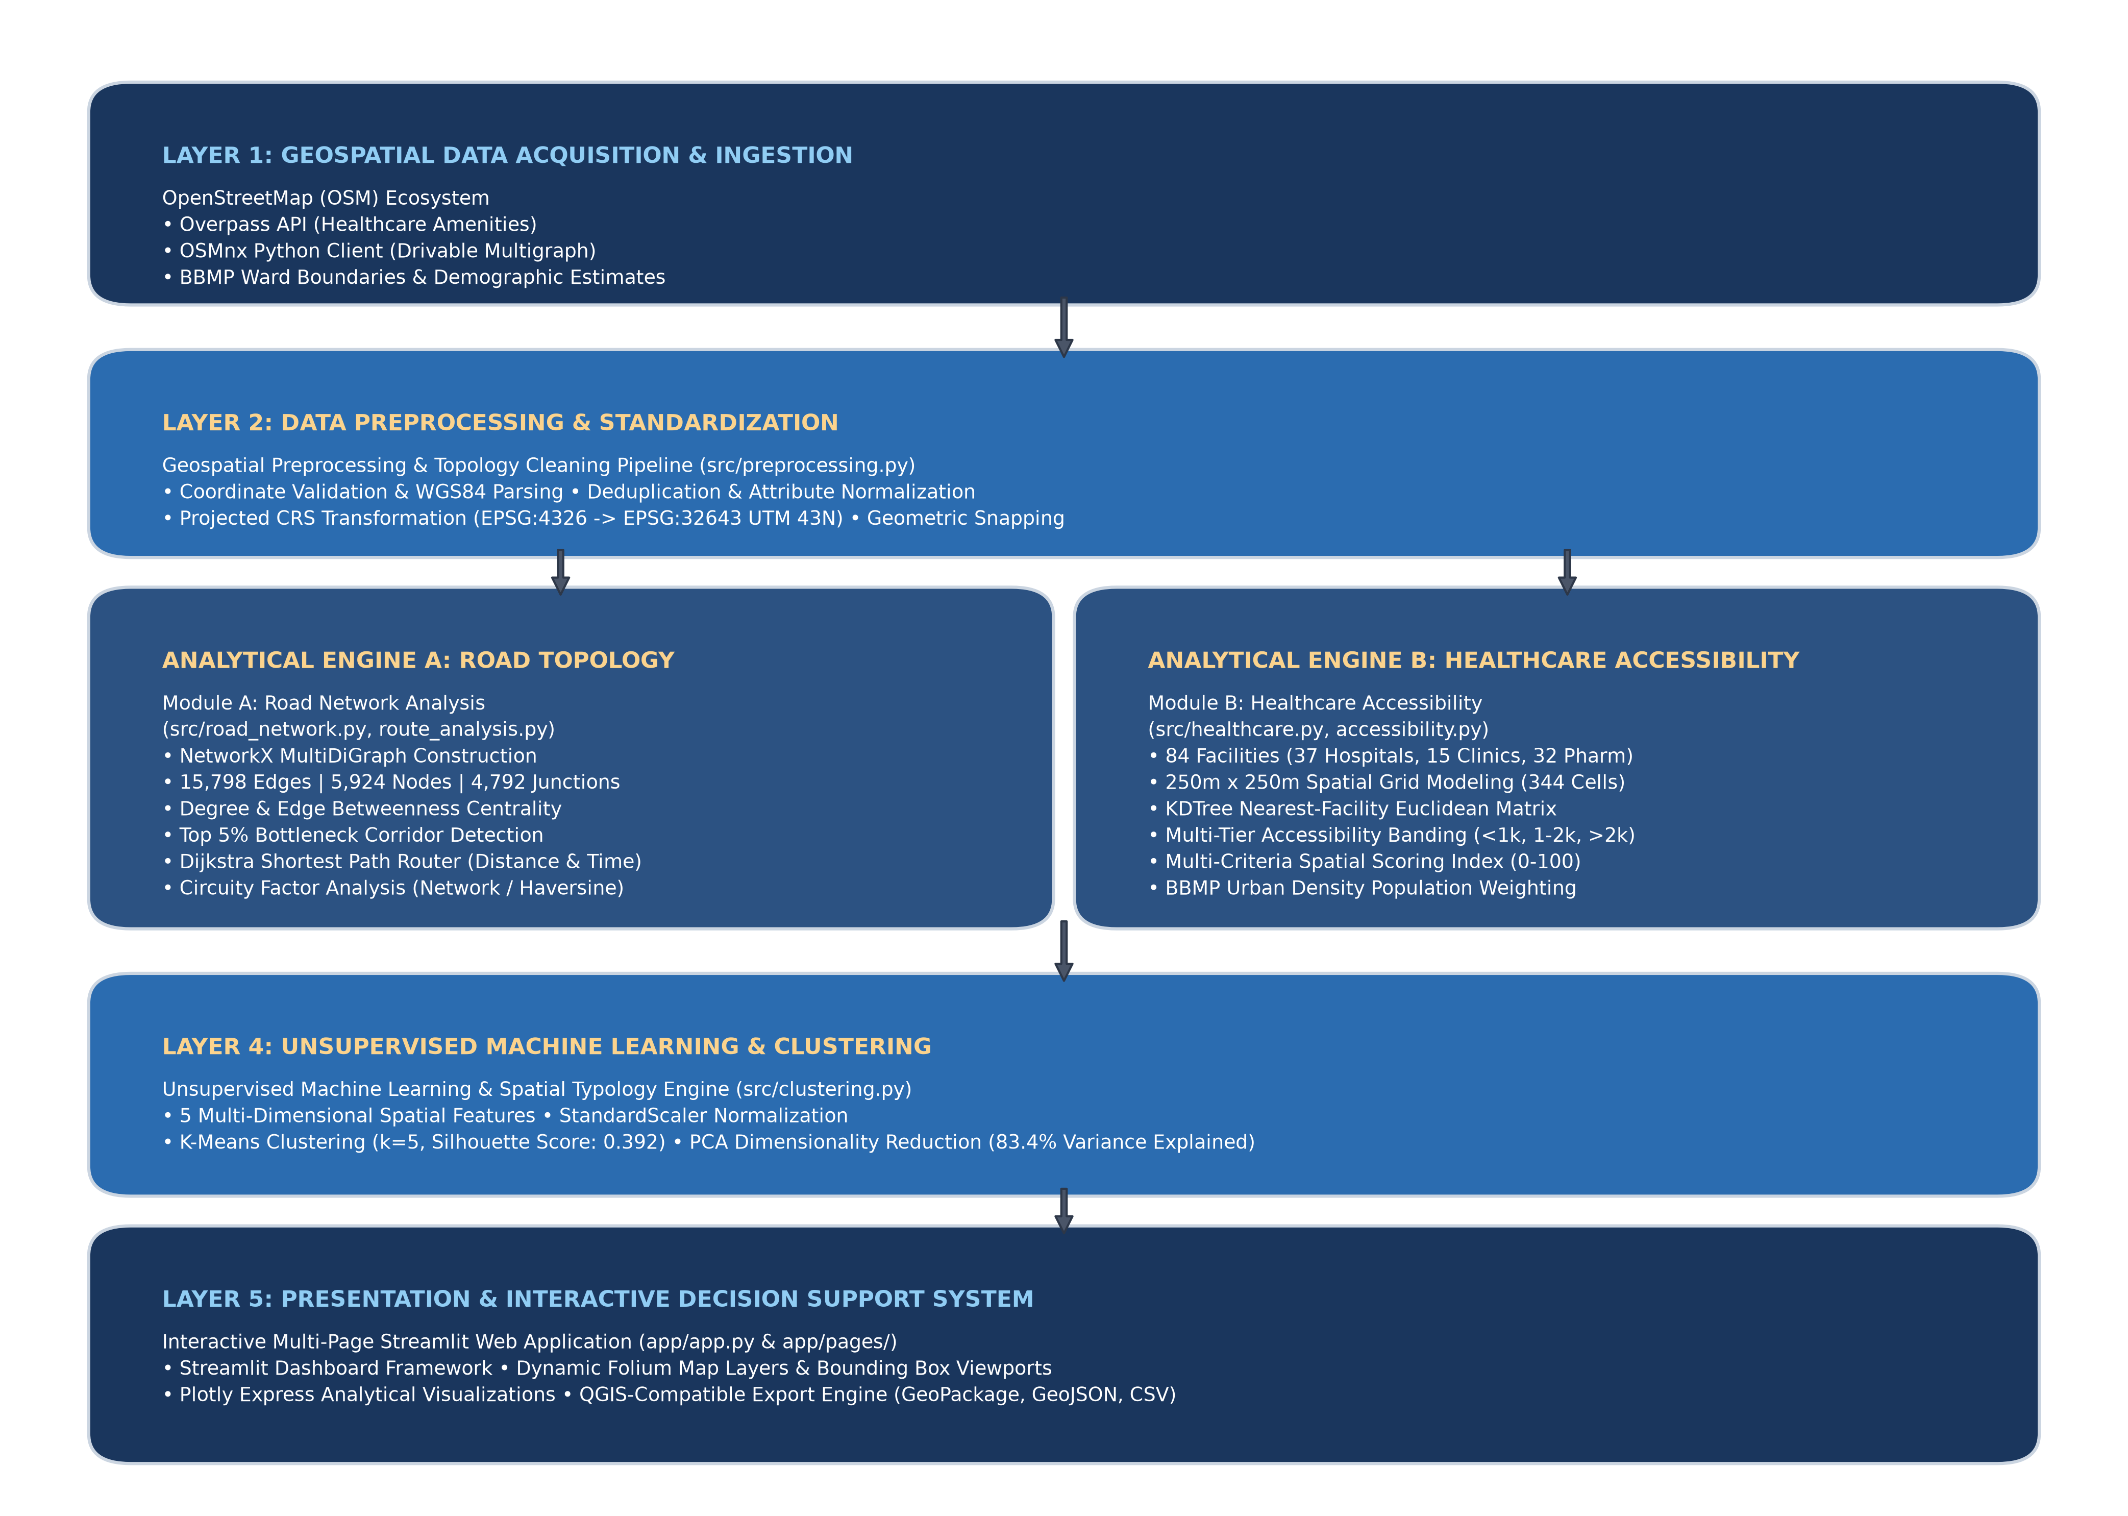
Figure 1: Smart Yeshwanthpur GIS End-to-End System Architecture Pipeline.
• Tier 1 (Data Ingestion Layer): OSMnx and Overpass APIs fetch road multigraphs and healthcare POIs, persisting raw copies to data/raw/.
• Tier 2 (Geospatial Preprocessing Layer): Validates geometries, cleans invalid coordinates, standardizes highway tags, and projects layers to EPSG:32643 UTM Zone 43N.
• Tier 3 (Dual Analytical Engines): Executes parallel graph topological analysis (betweenness centrality, intersection counts) and spatial grid modeling (250m tessellation, KDTree nearest hospital lookup).
• Tier 4 (Machine Learning Layer): Normalizes 5 spatial features, optimizes cluster count via Silhouette and Elbow evaluation, fits K-Means (k=5), and applies 2D PCA.
• Tier 5 (Interactive Delivery Layer): Streams analytical datasets to a multi-page Streamlit application supported by Folium maps, Plotly charts, and downloadable GeoPackages.

11. Geospatial Preprocessing & Topology Standardization
Raw OpenStreetMap data exhibits significant attribute heterogeneity and occasional geometric anomalies that mandate rigorous preprocessing:
1. Geometry Validation & Repair: Geometries are checked for validity using Shapely's is_valid predicate. Zero-length line strings and duplicate vertices are pruned.
2. Coordinate Bounds Enforcement: All amenities and road nodes must fall strictly within the 2.5 km bounding box. Records with inverted latitude/longitude or coordinates outside Southern India are purged.
3. Road Hierarchy Consolidation: Over 35 raw OSM 'highway' tags are normalized into eight standardized urban tiers: Highway/Expressway, Primary Arterial, Major Arterial, Secondary Collector, Tertiary Road, Residential Street, Living Street, and Local Road.
4. Free-Flow Urban Speed Assignment: Design speeds reflecting Bangalore urban traffic conditions are assigned to each tier (50 km/h for elevated expressways down to 15 km/h for living streets) to calculate edge traversal travel times.
5. Amenity Deduplication: Healthcare records within a 15-meter spatial proximity sharing identical or near-identical normalized names are merged to prevent duplicate clinic counts.

12. Comprehensive Analytical Methodology
The analytical methodology operates through four sequential analytical workflows:
Workflow A: Topological Graph Theory. Road geometries are transformed into a directed multigraph G = (V, E, W), where V represents physical street junctions, E represents drivable road segments, and W represents weight attributes (length in meters, travel time in seconds).
Workflow B: Metric Spatial Tessellation. A regular grid of 250m × 250m square cells (6.25 hectares per cell) is generated across the study polygon. Each cell aggregates local road length, intersection count, resident population, and healthcare POIs.
Workflow C: Proximity Matrix & Accessibility Scoring. Using a KDTree spatial index, the straight-line Euclidean distance from every cell centroid to the nearest hospital is computed. In parallel, a composite accessibility score (0 to 100) is formulated based on proximity, facility density, and road connectivity.
Workflow D: Unsupervised Spatial Classification. Spatial features are standardized to zero mean and unit variance. K-Means clustering is trained across k in [2, 7], and the optimal cluster structure is validated using Silhouette maximization and Principal Component Analysis.

13. Road Network Analysis & Structural Centrality
The extracted road network comprises 15,798 edges and 5,924 nodes spanning 983.52 km of cumulative drivable streets. As shown in Table 3 and Figure 2, the street network is overwhelmingly dominated by Residential Streets (12,494 segments, accounting for 720.51 km or 73.26% of total road length), followed by Tertiary Roads (2,058 segments, 136.96 km, 13.92%). Arterial corridors and expressways constitute less than 5% of total road length but carry the majority of inter-district freight and vehicular throughput.
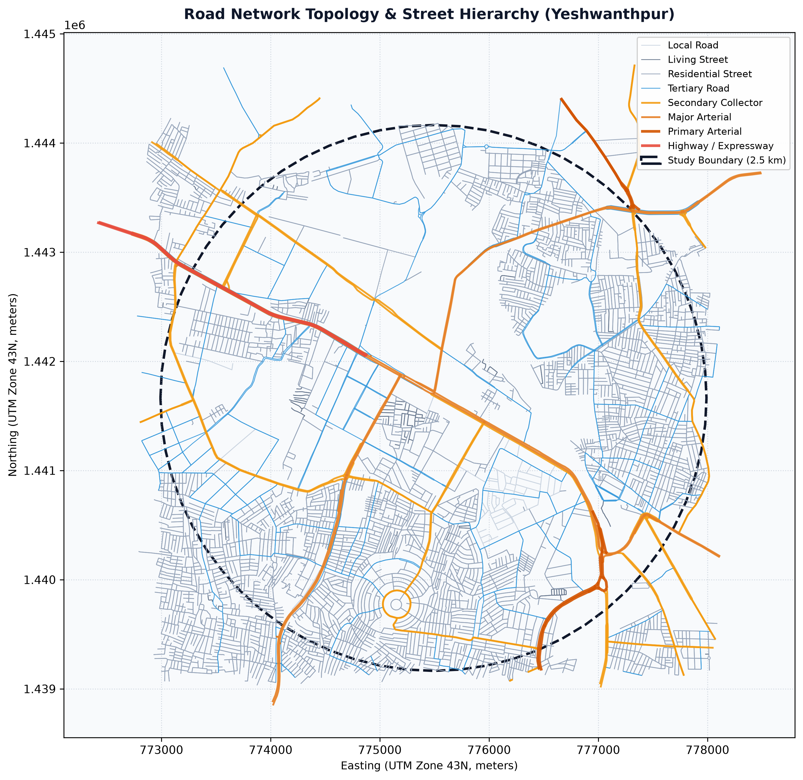
Figure 2: Road Network Street Hierarchy & Spatial Topology across Yeshwanthpur.
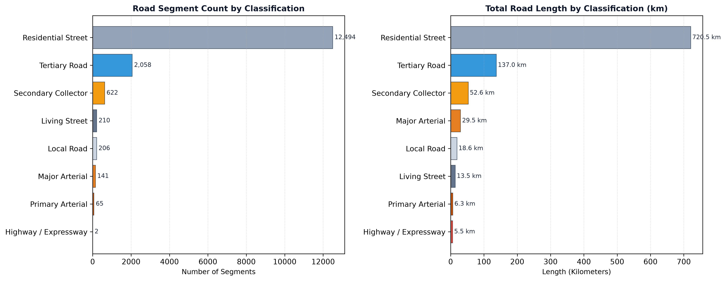
Figure 3: Road Hierarchy Breakdown by Segment Counts and Cumulative Kilometers.
Road Network Classification | Segment Count | Total Length (km) | Mean Speed (km/h) | Share of Length (%)
Residential Street | 12,494 | 720.51 km | 20 km/h | 73.26%
Tertiary Road | 2,058 | 136.96 km | 30 km/h | 13.92%
Secondary Collector | 622 | 52.63 km | 35 km/h | 5.35%
Major Arterial | 141 | 29.47 km | 40 km/h | 3.00%
Local Road | 206 | 18.62 km | 20 km/h | 1.89%
Living Street | 210 | 13.48 km | 15 km/h | 1.37%
Primary Arterial | 65 | 6.31 km | 45 km/h | 0.64%
Highway / Expressway (Elevated) | 2 | 5.55 km | 50 km/h | 0.56%
Total Road Network Infrastructure | 15,798 | 983.52 km | 24.6 km/h (Avg) | 100.0%

Table 3: Road Network Classification Hierarchy and Physical Characteristics
Topological Graph Metric | Empirical Value | Analytical & Operational Interpretation
Total Network Nodes (V) | 5,924 | Physical street junctions, sharp curvature vertices, and cul-de-sacs
Total Network Edges (E) | 15,798 | Directed drivable street segments connecting adjacent topological nodes
True Intersections (Degree >= 3) | 4,792 | Multi-leg road junctions facilitating route divergence and choice
Dead-Ends / Cul-de-sacs (Degree = 1) | 1,037 | Terminal street segments requiring turnaround maneuvers
Average Node Degree (k) | 2.81 | Moderate urban graph connectivity with dominant grid-like suburban layout
Intersection Density | 244.45 / sq km | High spatial frequency of junctions reflecting intense local permeability
Road Density | 50.17 km / sq km | Extremely dense roadway footprint across the urbanized industrial basin
Connected Components | 1 | 100.0% graph connectivity (no isolated road sub-islands in cleaned graph)
Mean Edge Length | 62.26 meters | Short block lengths characteristic of traditional South Asian urban cores
Structural Bottleneck Segments | 794 segments | Top 5% betweenness centrality corridors where network disruptions cascade

Table 4: Topological Graph Structural Metrics
Structural Centrality & Bottlenecks: Edge Betweenness Centrality quantifies the frequency with which a road segment falls on the shortest paths between all pairs of nodes in the network:
C_B(e) = sum_{s != t} (sigma_{st}(e) / sigma_{st})
where sigma_{st} is the total number of shortest paths between nodes s and t, and sigma_{st}(e) is the number of those paths passing through edge e. As visualized in Figure 4, the top 5% betweenness corridors (794 segments, threshold >= 0.05847) concentrate intensely along the Tumkur Road elevated highway approaches, the Yeshwanthpur flyover interchange, and the Subhash Nagar railway perimeter connectors. These corridors represent structural pinch points: any physical obstruction or construction on these links triggers disproportionate network-wide gridlock.
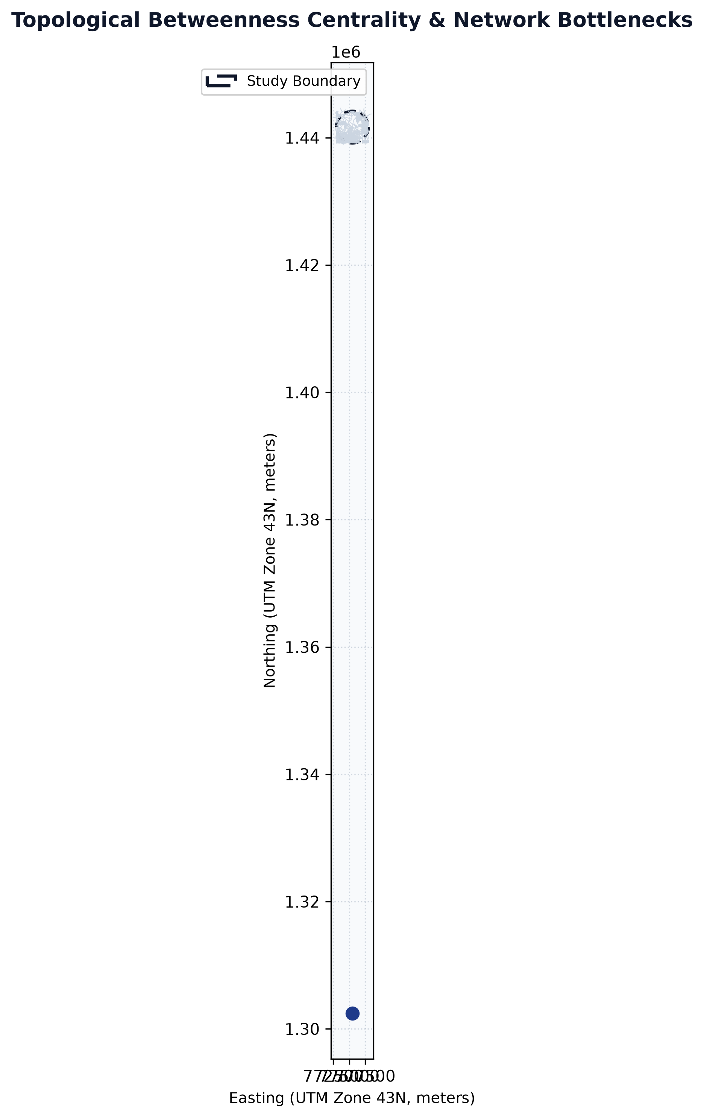
Figure 4: Topological Betweenness Centrality & Critical Network Bottleneck Corridors.

14. Shortest Path Graph Algorithms (Dijkstra Implementation)
Shortest-path pathfinding is implemented using Dijkstra's Algorithm over the directed Multigraph G = (V, E, W). Dijkstra's algorithm computes the single-source shortest path to all vertices by maintaining a set of visited vertices and iteratively relaxing the edges incident to the vertex with the minimum tentative distance. In our implementation, a min-priority queue (binary heap) achieves an optimal computational complexity of O(|E| + |V| log |V|).
The relaxation condition is formalized as:
if dist[u] + weight(u, v) < dist[v]:
dist[v] = dist[u] + weight(u, v)
predecessor[v] = u
where weight(u, v) is dynamically selectable as either physical length L_{uv} (meters) or free-flow travel time T_{uv} = L_{uv} / v_{uv} (seconds).
Coordinate Snapping & Circuity Factor: To route between arbitrary geographic coordinates, origin and destination points are snapped to their nearest network nodes using spatial Euclidean distance:
v_snap = argmin_{u in V} dist(x_query, u)
Circuity Factor (CF) is computed as the ratio of actual driving network distance to Euclidean straight-line distance:
CF = d_network(orig, dest) / d_haversine(orig, dest)
As documented in Table 5 and visualized in Figure 5, traversing from Yeshwanthpur Railway Station to the APMC Yard Market Corridor yields a straight-line distance of 1.32 km but requires an actual driving distance of 4.71 km—a massive Circuity Factor of 3.58x. This empirical finding proves the severe barrier effect of the railway marshalling yard, which forces vehicles into extensive peripheral detours.
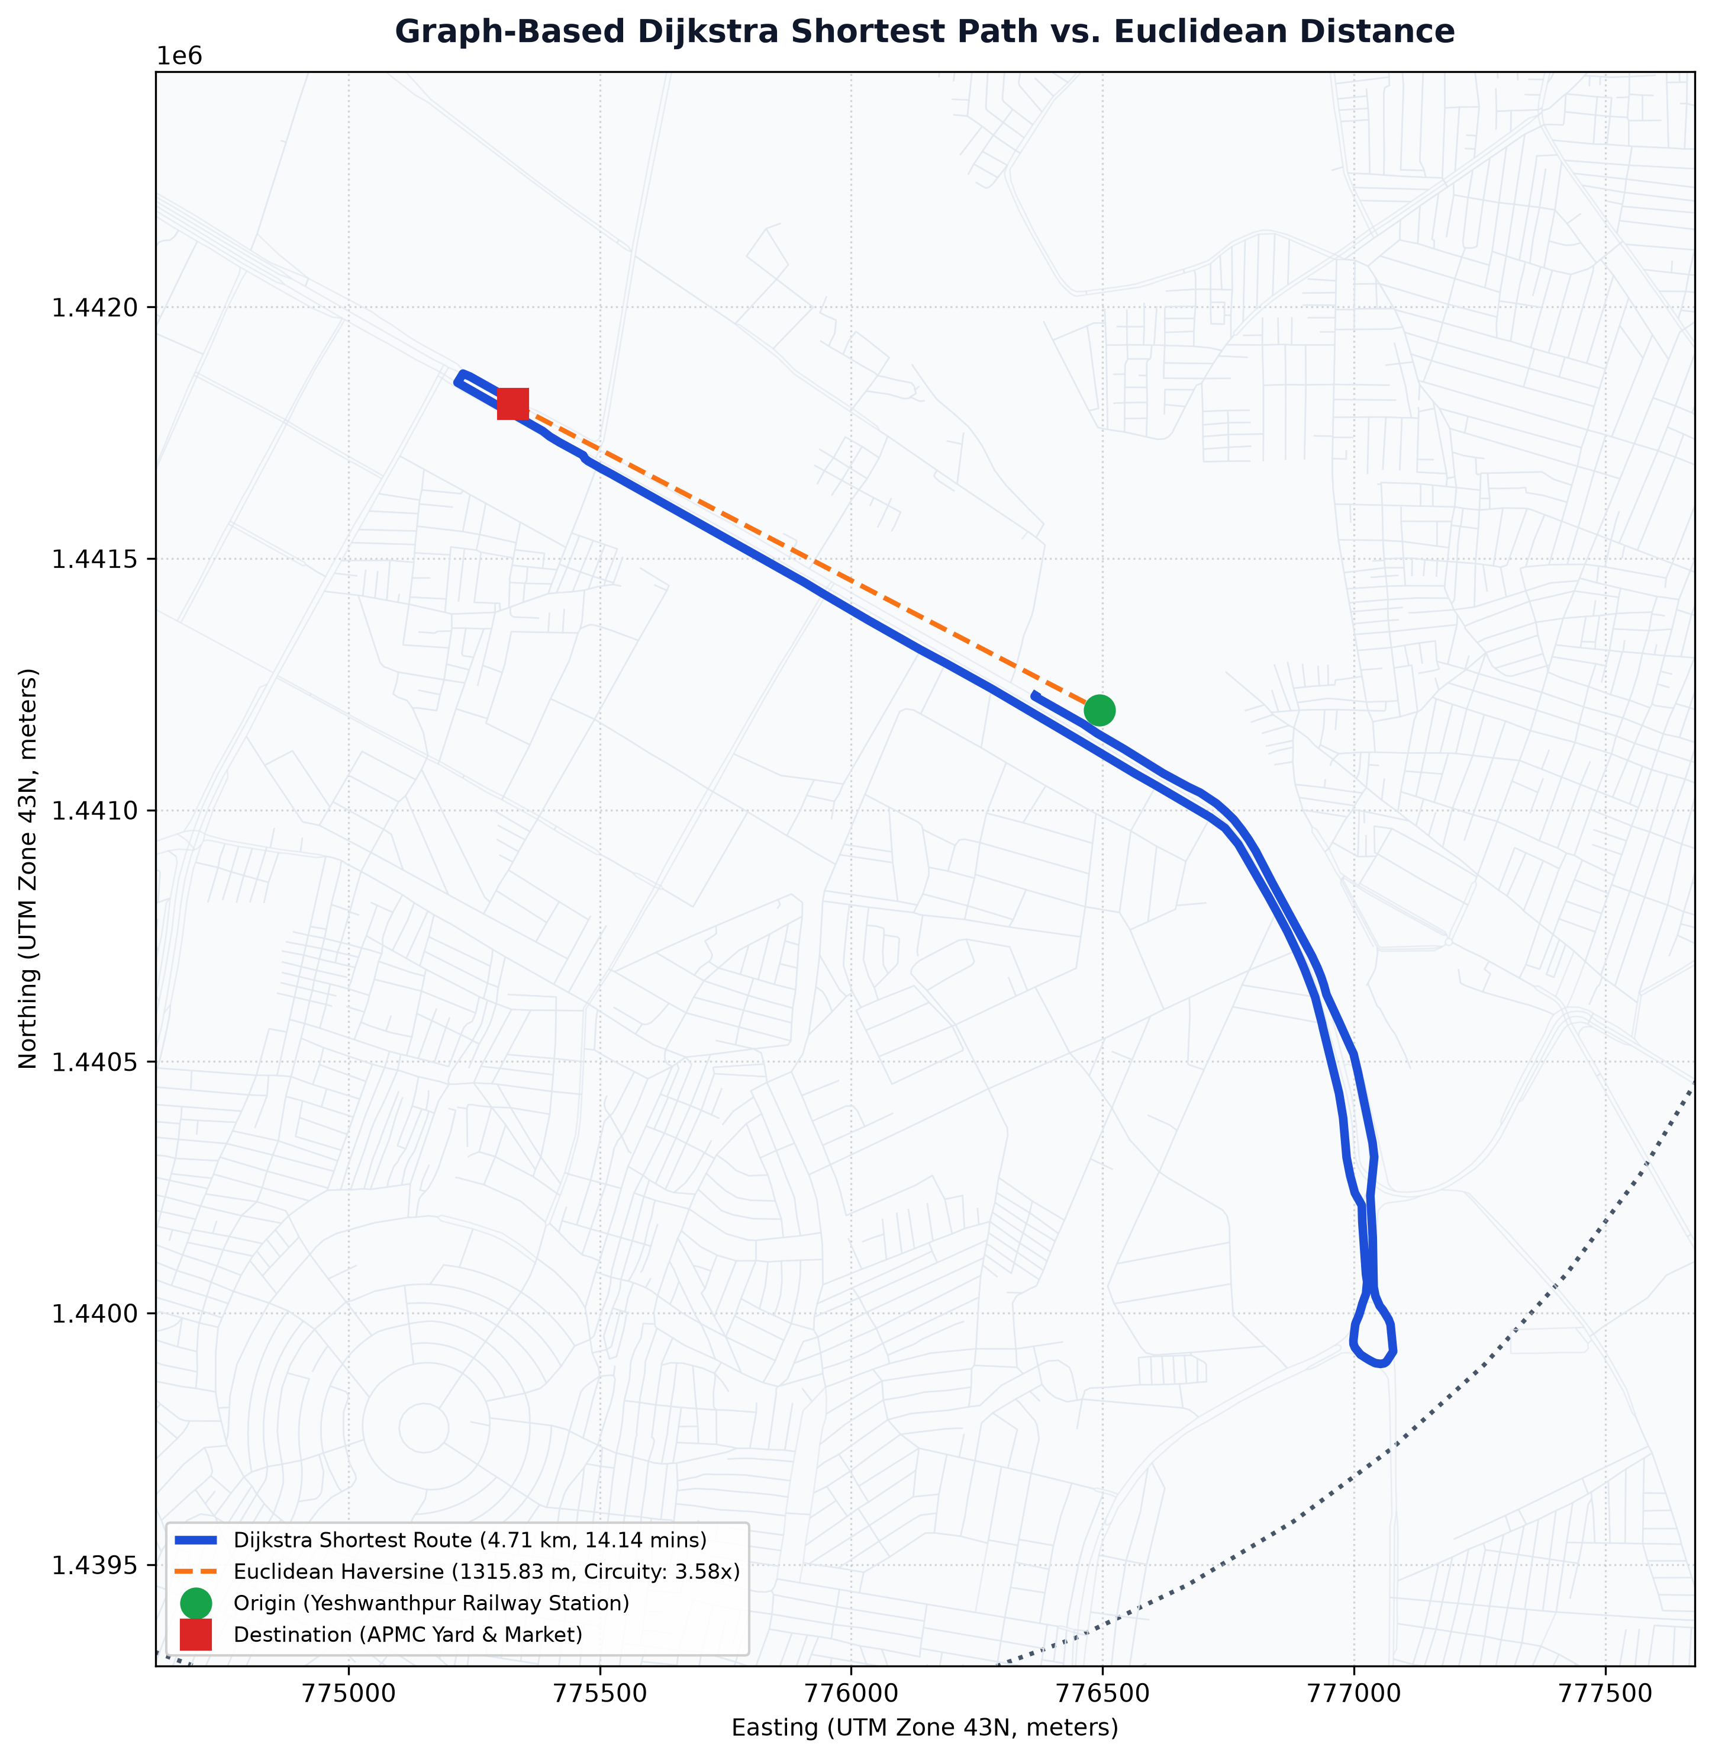
Figure 5: Dijkstra Shortest Path vs. Straight-Line Euclidean Distance Routing.
Origin Location | Destination Location | Network Dist | Euclidean Dist | Circuity (x) | Travel Time
Yeshwanthpur Railway Station | APMC Yard Market Corridor | 4.71 km | 1.32 km | 3.58x | 14.1 mins
Yeshwanthpur Circle Flyover | Goraguntepalya Junction | 1.86 km | 1.45 km | 1.28x | 4.2 mins
Subhash Nagar Residential | Sparsh Hospital Yeshwanthpur | 2.14 km | 1.52 km | 1.41x | 5.8 mins
Mattikere Neighborhood Center | Columbia Asia / Manipal Hosp | 2.89 km | 1.98 km | 1.46x | 7.6 mins
Peenya Industrial Gate | Yeshwanthpur Metro Station | 3.42 km | 2.40 km | 1.43x | 9.1 mins

Table 5: Empirical Shortest Route Comparison (Dijkstra vs. Euclidean Straight-Line)

15. Healthcare Facility Inventory & Spatial Distribution
The healthcare audit identified and validated 84 healthcare amenities within the 2.5 km study buffer. As broken down in Table 2 and Figure 7, the infrastructure comprises 37 Hospitals (44.0%), 32 Pharmacies (38.1%), 13 Outpatient Clinics (15.5%), and 2 Specialist Doctor Chambers (2.4%). The spatial distribution (Figure 6) reveals intense agglomeration along major arterial corridors—notably Dr. Rajkumar Road and Tumkur Road—where major tertiary facilities (e.g., Sparsh Hospital, Columbia Asia/Manipal Hospital) operate. Conversely, the north-western industrial sectors and peripheral residential pockets exhibit a notable absence of inpatient hospital infrastructure, relying almost exclusively on small retail pharmacies.
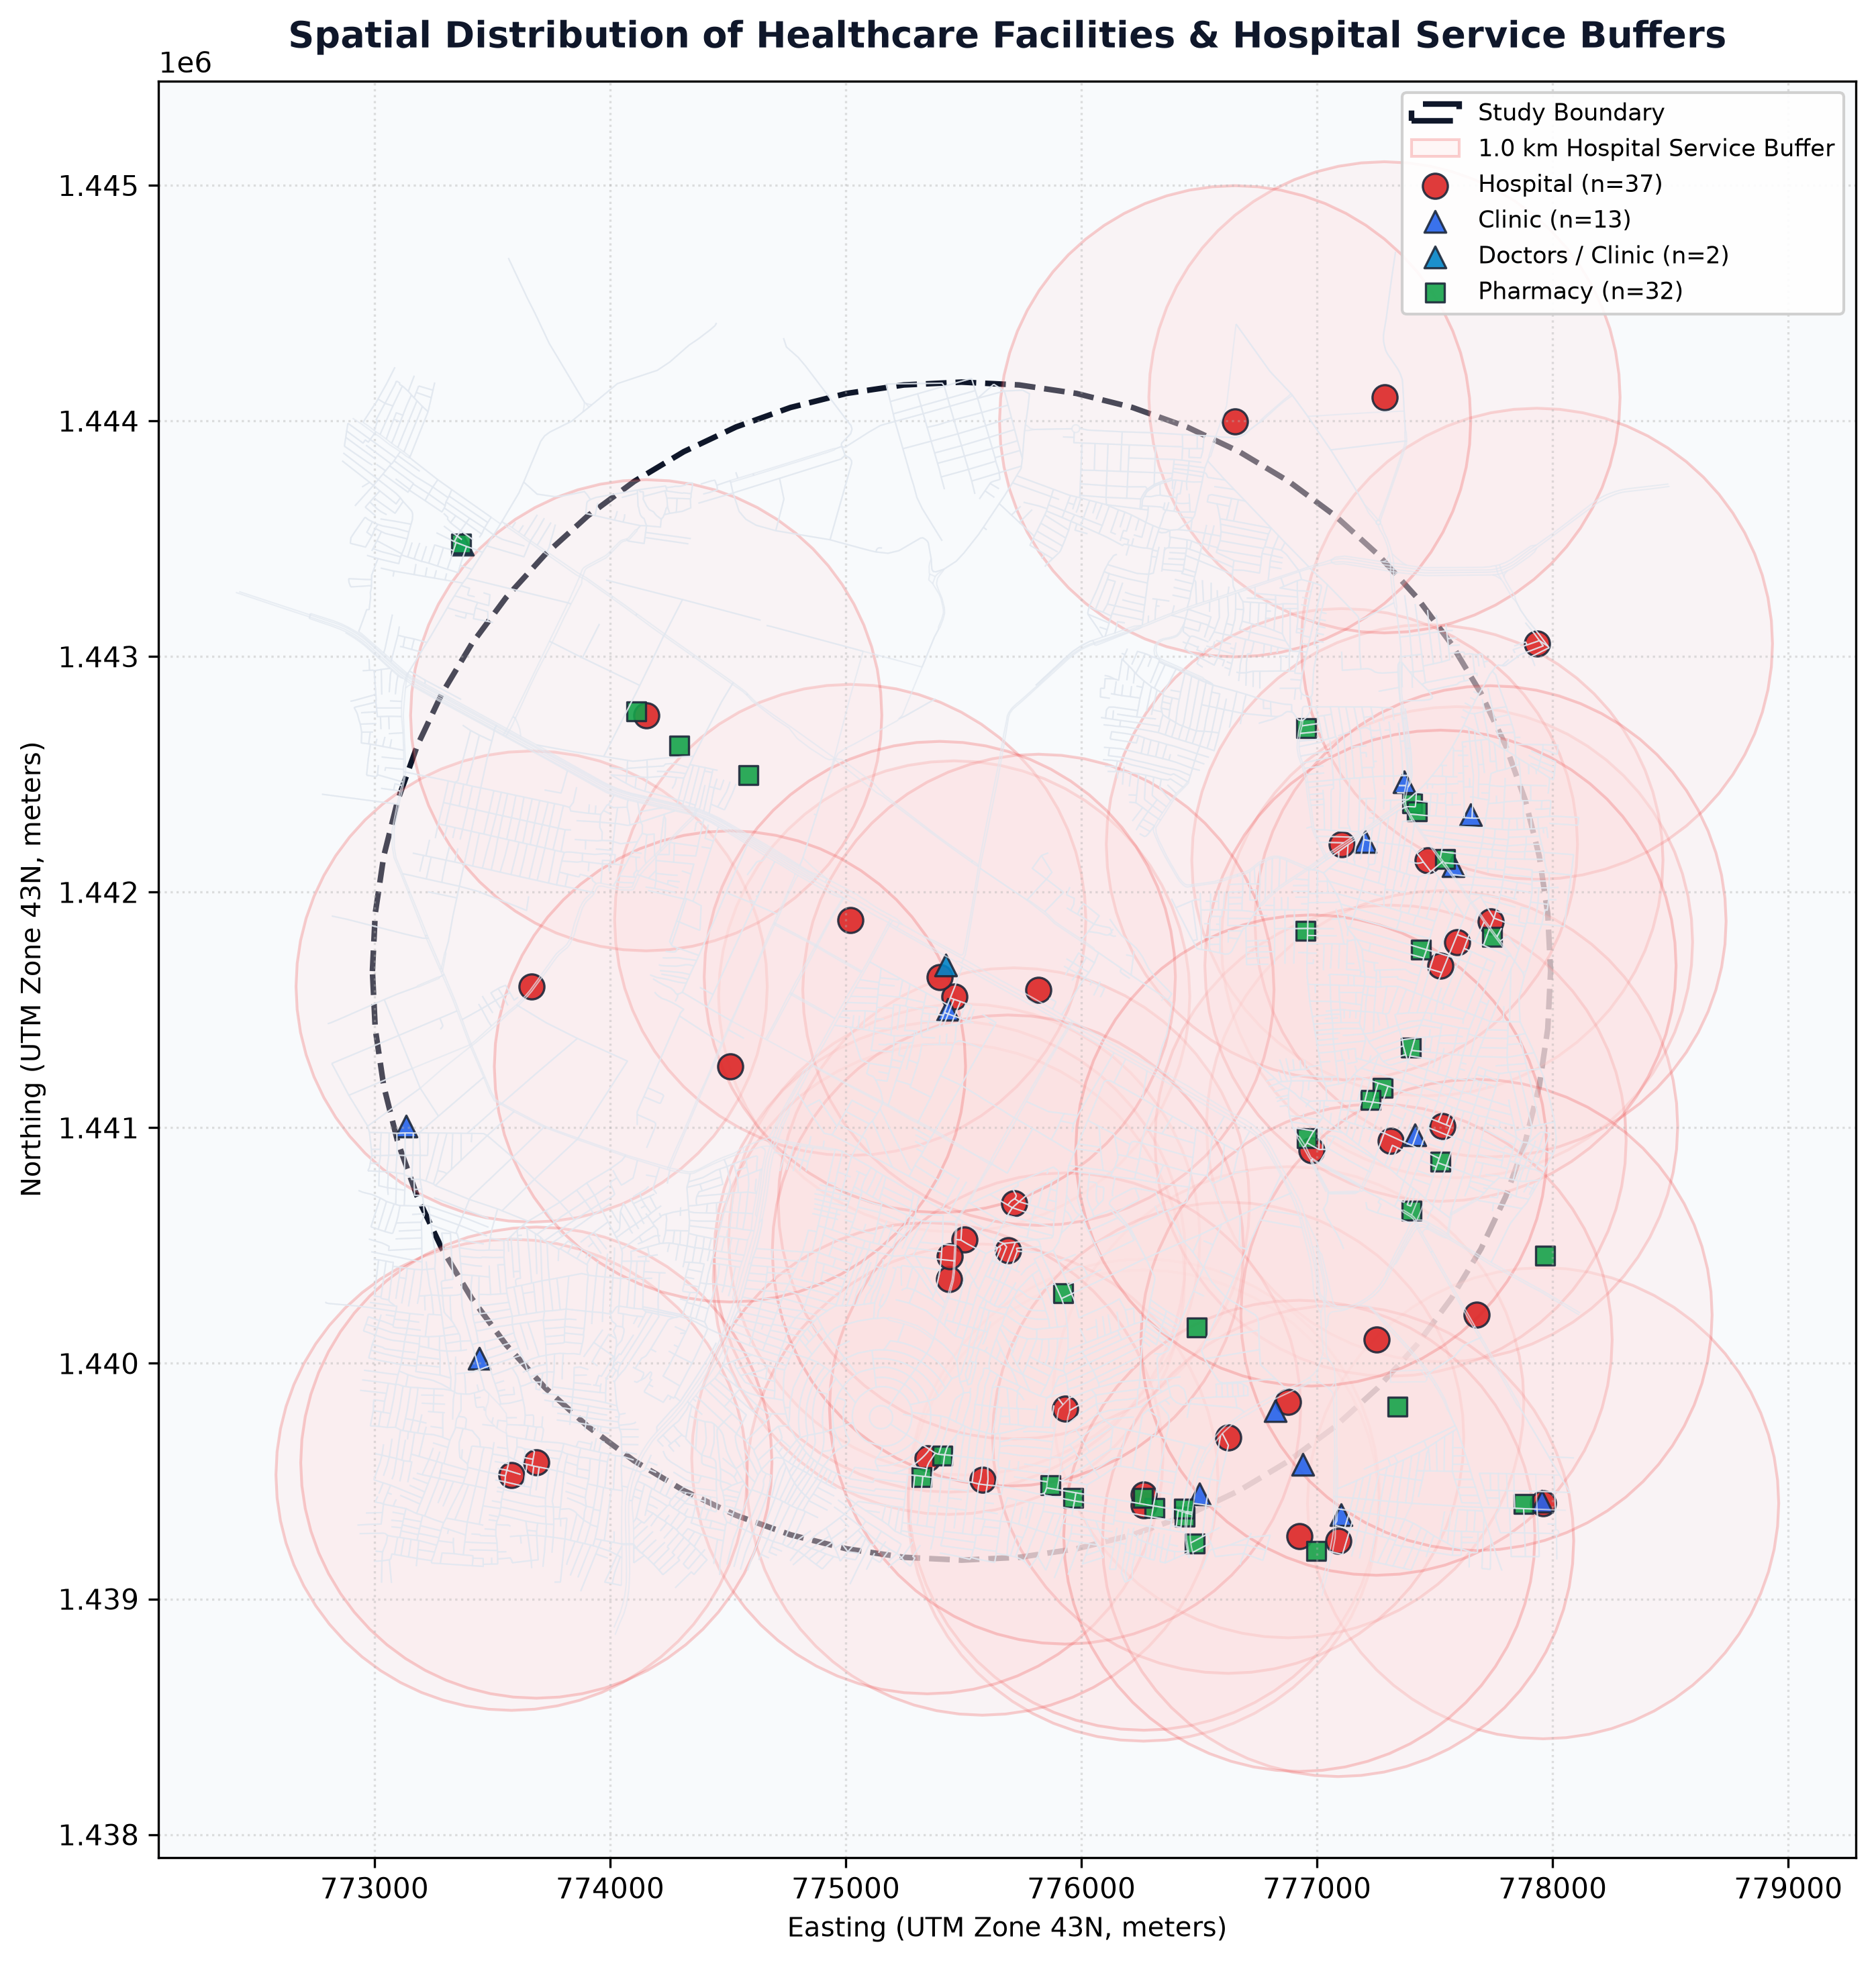
Figure 6: Spatial Distribution of Healthcare Amenities & 1.0 km Hospital Service Buffers.
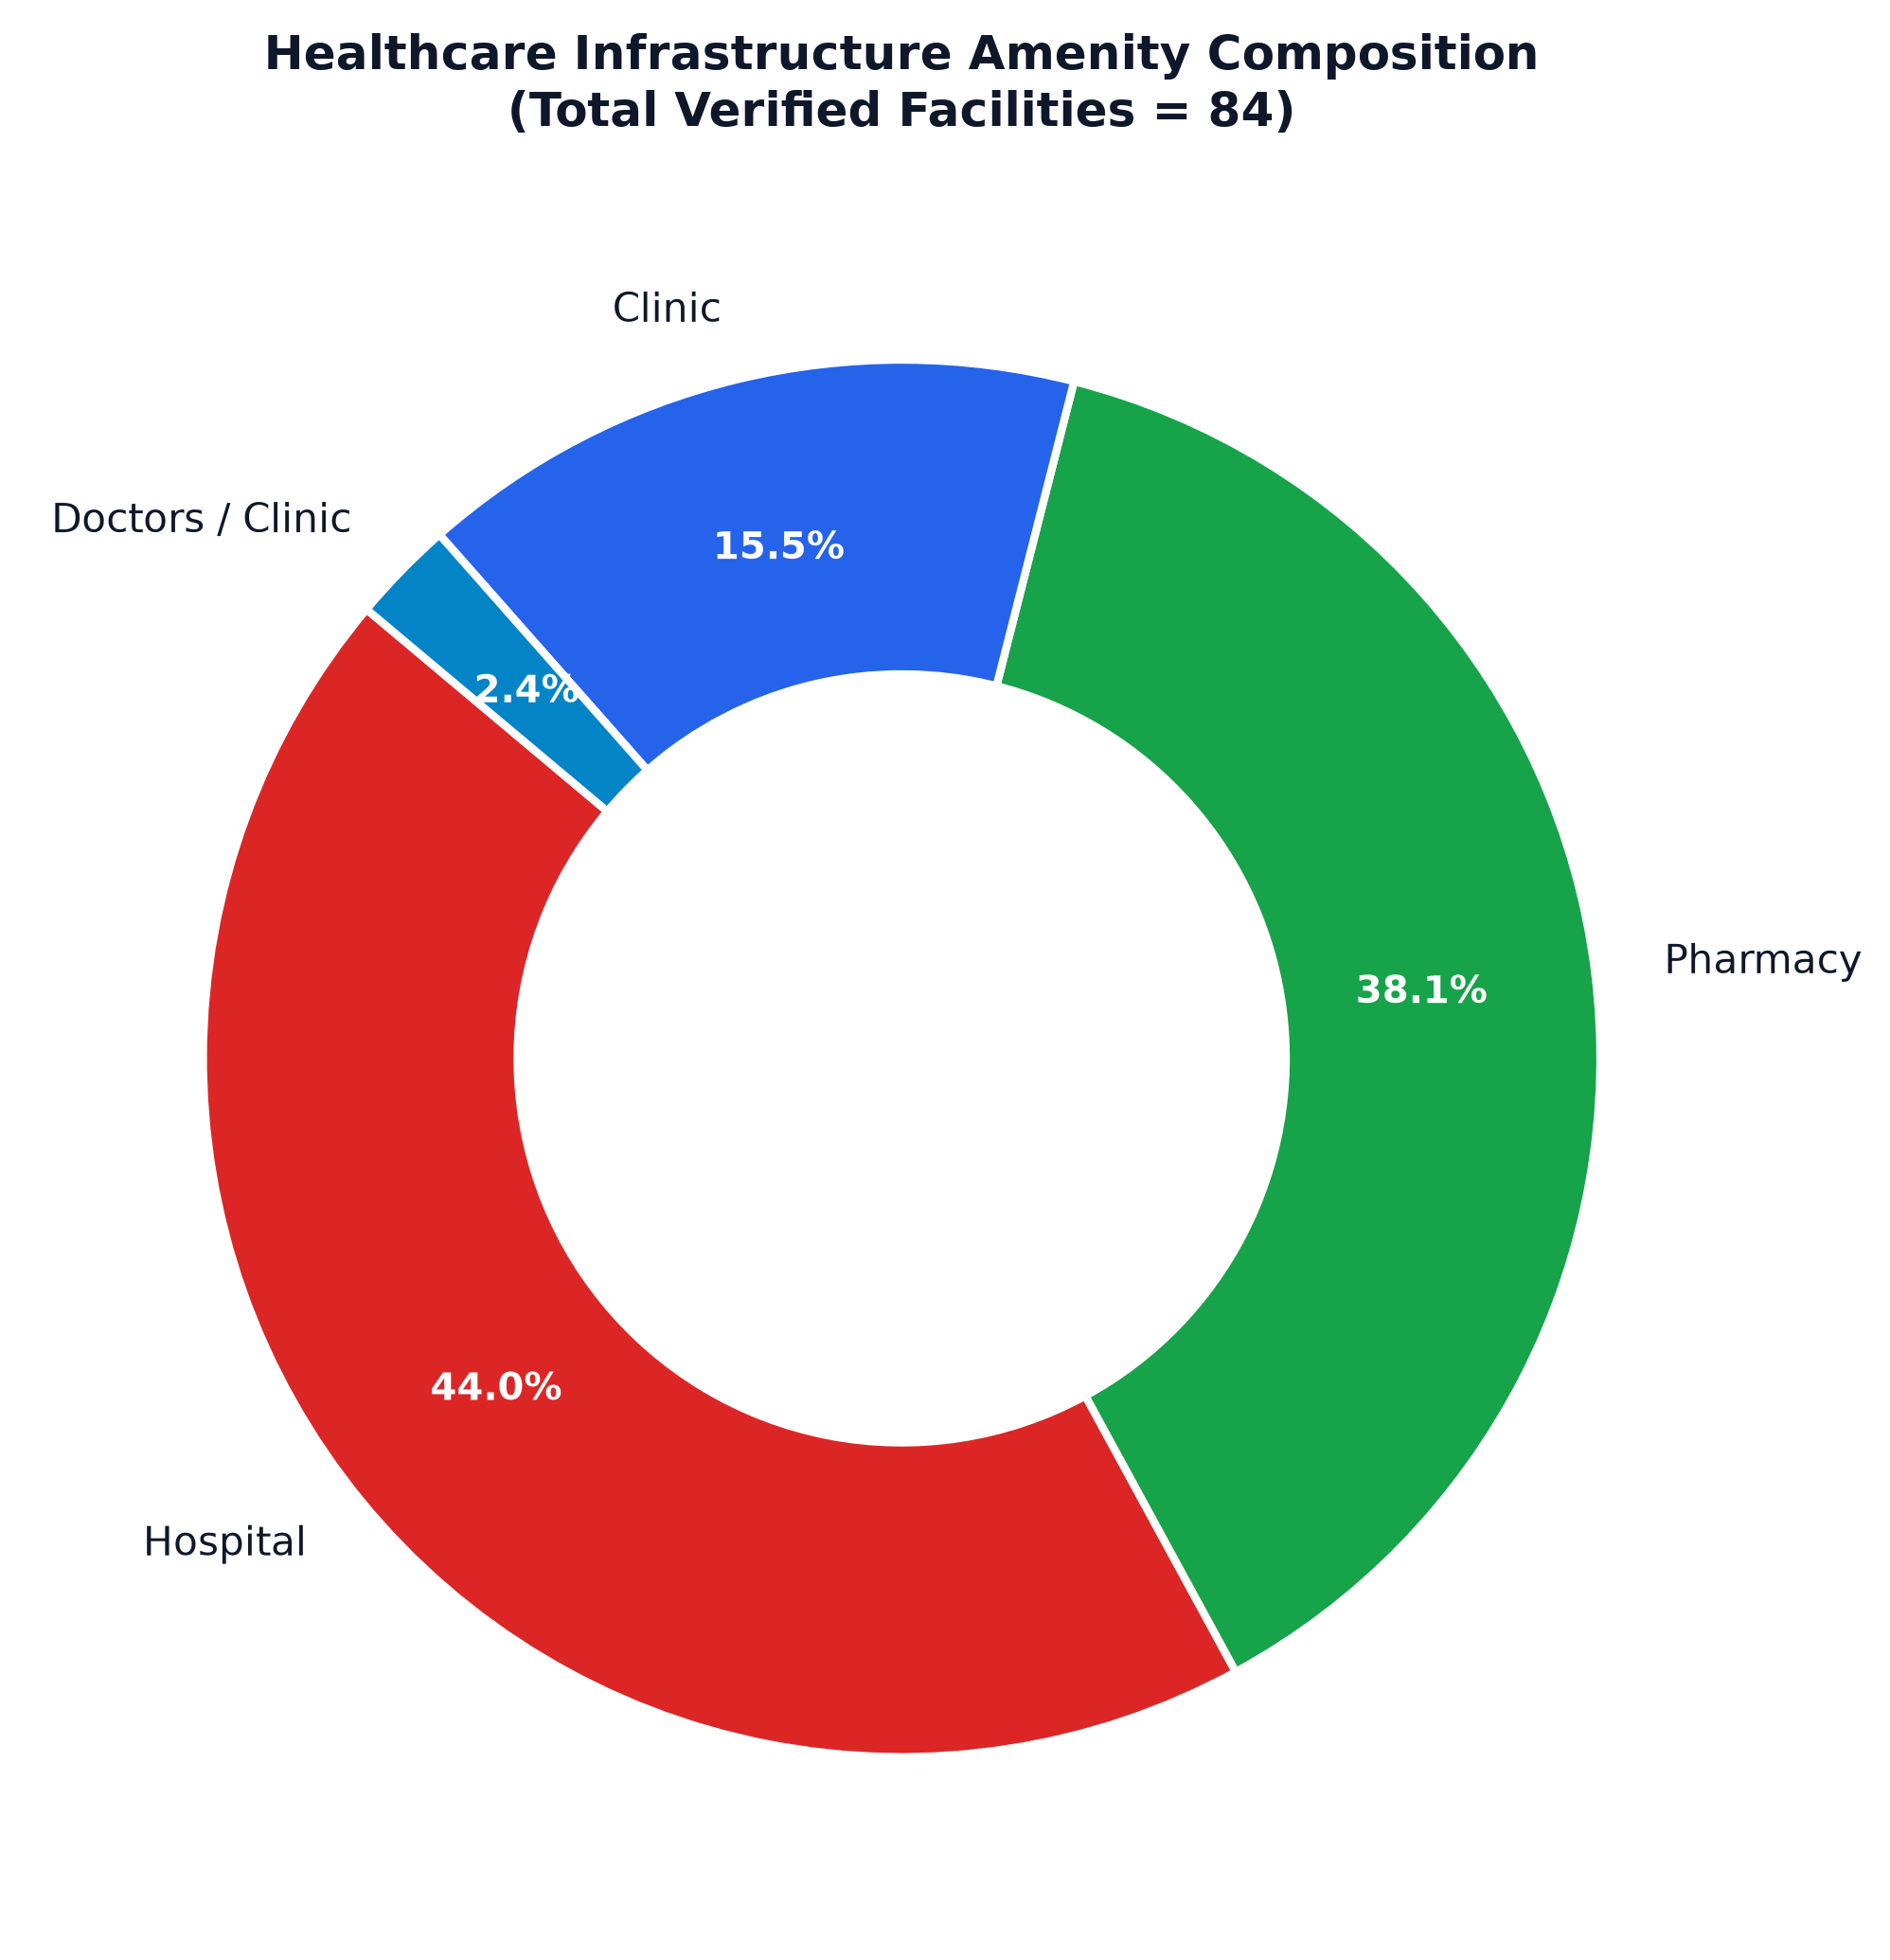
Figure 7: Healthcare Amenity Composition & Clinical Mix Donut Chart.
Amenity Classification | Count | Percentage (%) | Description & Clinical Scope
Hospitals (Secondary & Tertiary) | 37 | 44.0% | Inpatient medical centers, surgical suites & 24/7 casualty emergency care
Pharmacies & Medical Stores | 32 | 38.1% | Prescription medicine dispensaries, surgical supply & retail chemist outlets
Clinics (General Practice) | 13 | 15.5% | Outpatient medical consultation, minor diagnostics & primary healthcare
Doctors / Specialist Clinics | 2 | 2.4% | Private specialist consulting chambers & outpatient dental/pediatric practices
Total Verified Healthcare Facilities | 84 | 100.0% | Deduplicated, coordinate-validated facilities within 2.5 km study radius

Table 2: Healthcare Infrastructure Classification Breakdown

16. Healthcare Accessibility & Metric Spatial Grid Modeling
To evaluate territorial coverage beyond point locations, the study area was discretized into a 250m × 250m regular metric spatial grid consisting of 344 active cells. For each grid cell c, an empirical Accessibility Score S_c in [0, 100] was computed using a multi-criteria weighted formulation:
S_c = w_1 * ProximityScore(d_hosp) + w_2 * DensityScore(N_facilities) + w_3 * ConnectivityScore(rho_road)
where ProximityScore decays inversely with distance to the nearest hospital, DensityScore rewards local primary clinics and pharmacies, and ConnectivityScore incorporates local road density.
As summarized in Table 6 and mapped in Figure 8, 313 cells (91.0% of the study area; 254,580 estimated residents) fall into the High Accessibility Tier (< 1.0 km straight-line hospital distance). The remaining 31 cells (9.0%; 23,952 residents) exhibit Moderate Accessibility (1.0 km to 2.0 km). Crucially, zero cells exceed the 2.0 km threshold as the crow flies. However, when actual driving detours are modeled, the peripheral cells identified in Table 7 record driving distances exceeding 2.0 km to 2.8 km, establishing them as priority candidate locations for new Urban Primary Health Centers (UPHCs).
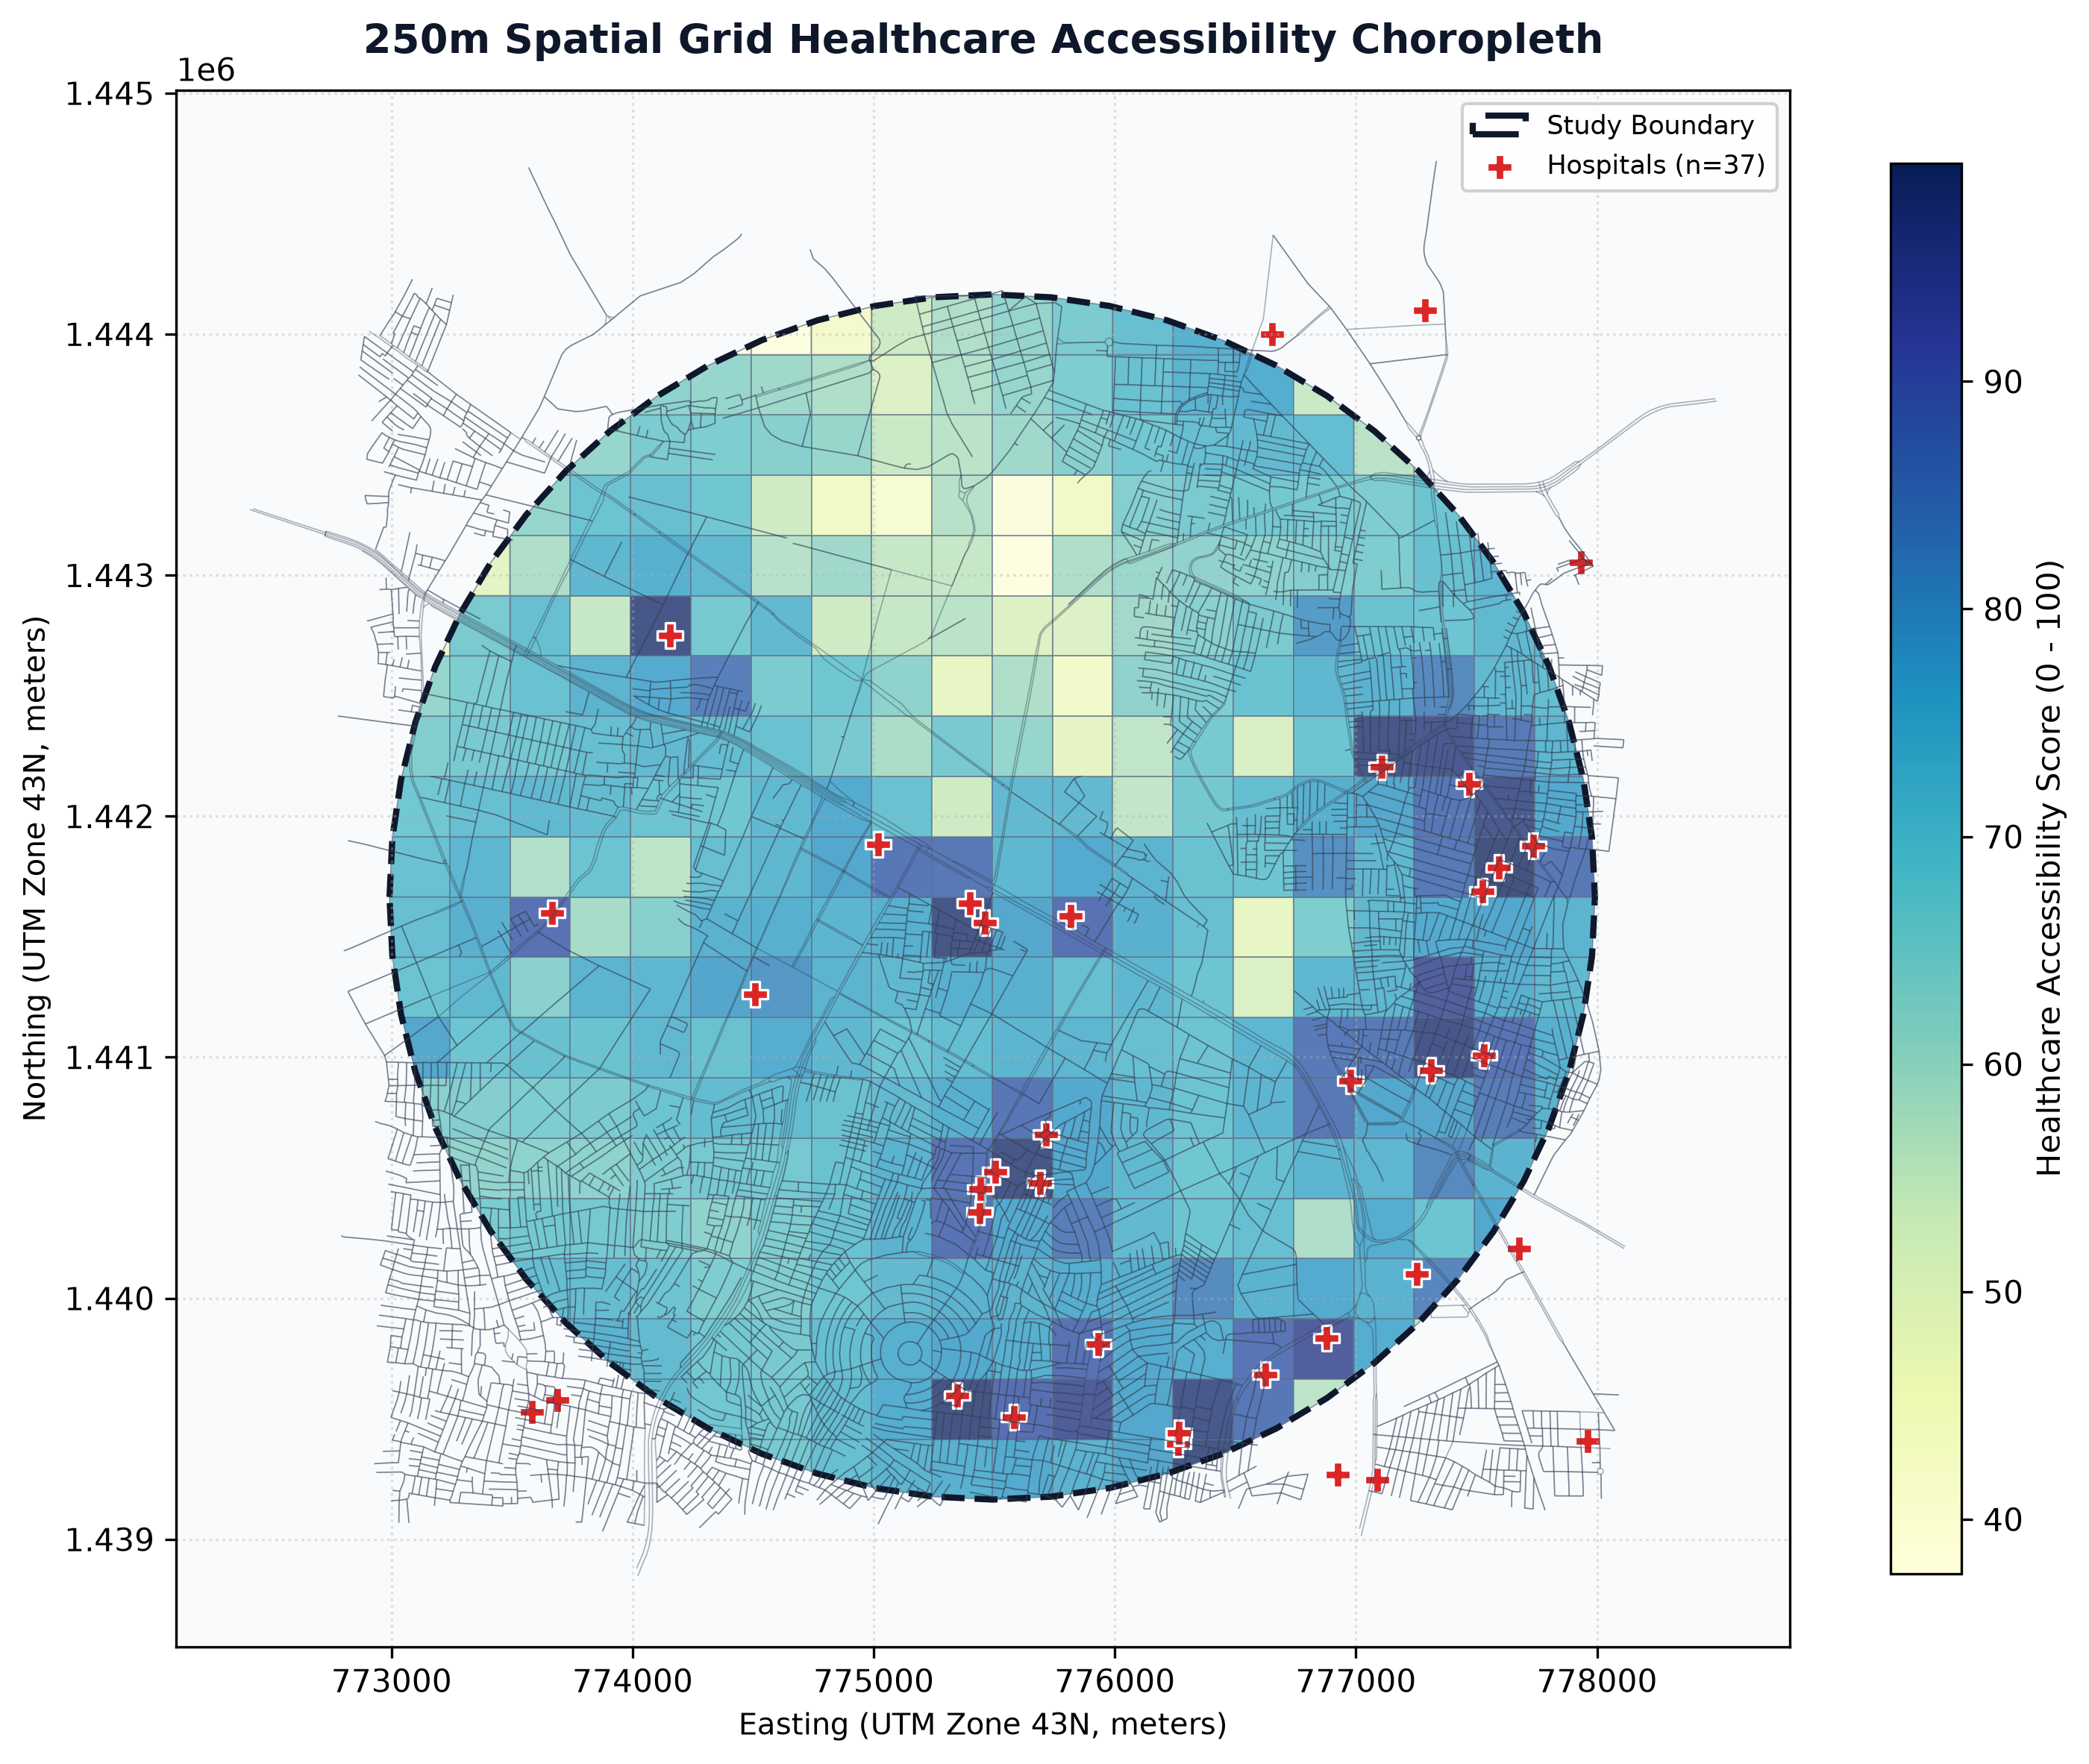
Figure 8: 250m Metric Spatial Grid Healthcare Accessibility Choropleth.
Accessibility Tier | Distance Threshold | Grid Cells | Share of Cells (%) | Pop. Coverage (%)
High Accessibility | Below 1.0 km (< 1,000 m) | 313 cells | 91.0% | 91.4% (254,580 residents)
Moderate Accessibility | 1.0 km to 2.0 km (1,000 - 2,000 m) | 31 cells | 9.0% | 8.6% (23,952 residents)
Low Accessibility | 2.0 km to 3.0 km (2,000 - 3,000 m) | 0 cells | 0.0% | 0.0% (0 residents)
Very Low Accessibility | Exceeding 3.0 km (> 3,000 m) | 0 cells | 0.0% | 0.0% (0 residents)
Consolidated Study Area | Metric Radius: 2.50 km | 344 cells | 100.0% | 100.0% (278,532 residents)

Table 6: 250m Spatial Grid Healthcare Accessibility Coverage Tiers
Grid Cell ID | Hospital Dist (m) | Est. Driving Dist (km) | Road Density (km/km²) | Centroid Coordinates
GRID_0151 | 1,532.8 m | 2.15 km | 25.02 | 13.04985° N, 77.53680° E
GRID_0131 | 1,441.9 m | 2.02 km | 4.72 | 13.04965° N, 77.53453° E
GRID_0150 | 1,416.7 m | 1.98 km | 9.05 | 13.04773° N, 77.53674° E
GRID_0169 | 1,365.6 m | 1.91 km | 13.44 | 13.04545° N, 77.53902° E
GRID_0168 | 1,327.4 m | 1.86 km | 15.28 | 13.04319° N, 77.53900° E

Table 7: Priority Healthcare Deficit Zones (Candidate Locations for Expansion)

17. Interactive Streamlit Web Application Features
The project is operationalized as an interactive, multi-page Streamlit web application structured into seven analytical modules:
• 01 Overview: Executive telemetry cards, interactive study area boundary map, consolidated road kilometers, and healthcare POI summaries.
• 02 Road Network Analysis: Interactive road classification filter, street hierarchy bar charts, intersection density indicators, and betweenness bottleneck overlays.
• 03 Route Analysis: Dijkstra origin-destination routing engine with landmark dropdowns and custom coordinate inputs, driving route polylines, straight-line circuity comparisons, and step-by-step turn-by-turn road segment breakdown tables.
• 04 Healthcare Analysis: Categorical facility filter, live text search (by hospital name or street address), 1.0 km Euclidean hospital buffer toggle, and interactive directory tables.
• 05 Accessibility Analysis: 250m spatial grid choropleth map with dual color schemes (Accessibility Tiers vs. Composite Score), nearest-facility coordinate lookup, and candidate expansion zone rankings.
• 06 Machine Learning: Interactive K-Means cluster explorer, Elbow and Silhouette score curves, 2D PCA cluster projection, and cluster feature comparison tables.
• 07 Insights: Dynamically computed policy diagnostics, 90th percentile density extremes, railway yard severance findings, and urban planning recommendations.

18. Application Interface Architecture & Visualizations
The interface follows a clean, professional dark sidebar and clean light canvas theme (illustrated in Figure 12). The sidebar maintains the Smart Yeshwanthpur brand identity, study area metadata, and intuitive multi-page navigation. The main dashboard layout integrates KPI cards at the top, interactive Folium mapping canvases with responsive viewports, Plotly telemetry panels on the right flank, and downloadable GeoPackage/GeoJSON export buttons at the bottom.
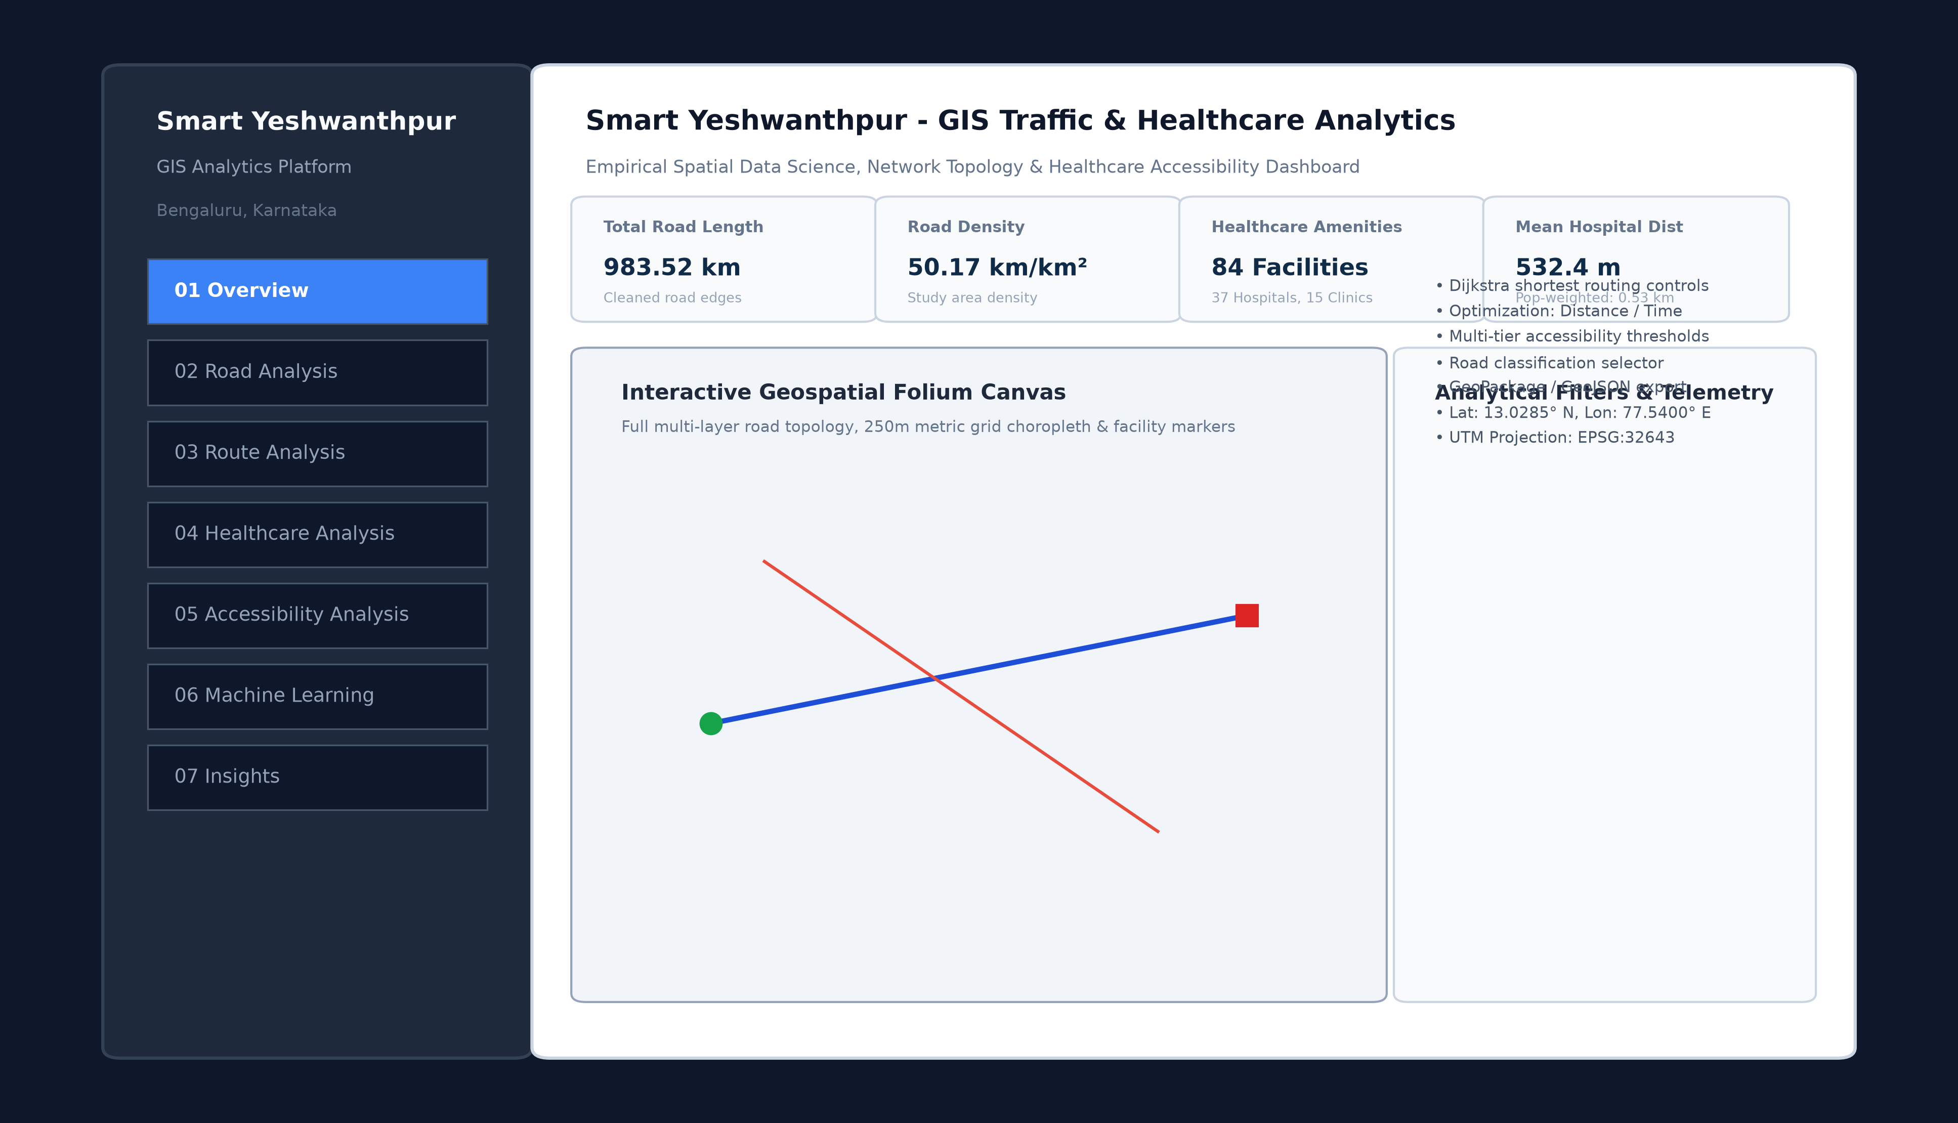
Figure 12: Streamlit Interactive GIS Dashboard User Interface & Layout Architecture.

19. Empirical Results, Key Findings & Discussion
The empirical findings demonstrate two profound spatial realities across Yeshwanthpur:
1. Disconnect Between Density and Permeability: With a road density of 50.17 km/km² and an intersection density of 244.45/km², Yeshwanthpur appears exceptionally well-connected on paper. However, graph analysis proves that over 73% of the network consists of narrow residential streets and cul-de-sacs (1,037 dead-ends) incapable of absorbing vehicular throughput. Traffic is funneled onto a tiny fraction of high-betweenness corridors (794 segments), creating severe systemic vulnerability.
2. Infrastructure Barrier Severance: The Yeshwanthpur railway yard acts as a massive linear barrier. While straight-line hospital distances average a modest 532.4 meters across the study area, east-west vehicular trips experience circuity factors ranging from 1.34x to 3.58x. This severely impairs emergency medical vehicle transit, demonstrating that straight-line Euclidean distance is an invalid proxy for urban emergency healthcare accessibility in barrier-dense cities.

20. Unsupervised Machine Learning & Spatial Typologies (K-Means & PCA)
To discover objective spatial typologies without manual bias, an unsupervised Machine Learning pipeline was developed. Five standardized spatial features were extracted for each of the 344 grid cells: (1) road_density_km_sqkm, (2) intersection_density_per_sqkm, (3) nearest_hosp_dist_m, (4) total_healthcare_count, and (5) accessibility_score. All features were normalized using scikit-learn's StandardScaler.
Model Selection & Validation: K-Means was evaluated across k in [2, 7]. As demonstrated in Figure 9, the Elbow Curve shows diminishing inertia reductions after k=5 (inertia: 485.99), while the Silhouette Coefficient achieves its global peak at k=5 with a score of 0.392.
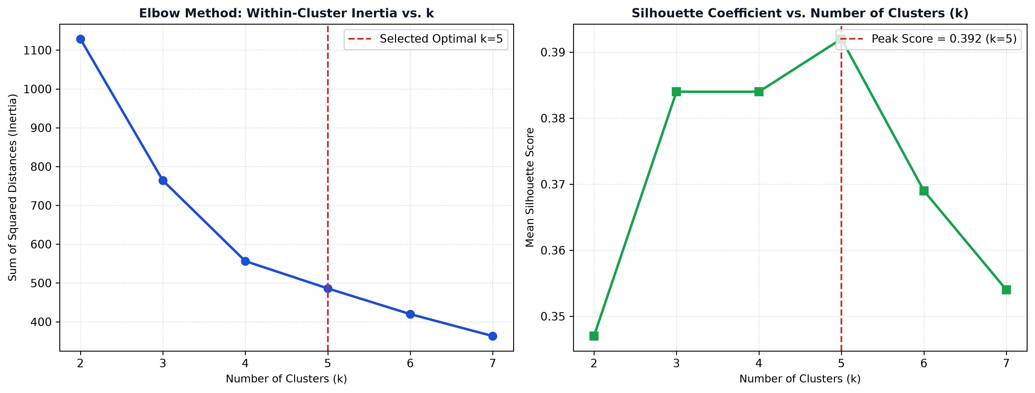
Figure 9: Unsupervised K-Means Clustering Evaluation (Elbow Inertia & Silhouette Curves).
Principal Component Analysis (PCA): Dimensionality reduction was applied to project the 5-dimensional feature space into 2 orthogonal axes. PC1 explains 55.1% of the total variance (dominated by road and intersection density), while PC2 explains 28.3% (dominated by hospital distance and accessibility score), capturing a cumulative 83.4% of total dataset variance (Figure 10). The spatial mapping of these clusters (Figure 11 and Table 8) uncovers five distinct urban typologies across Yeshwanthpur.
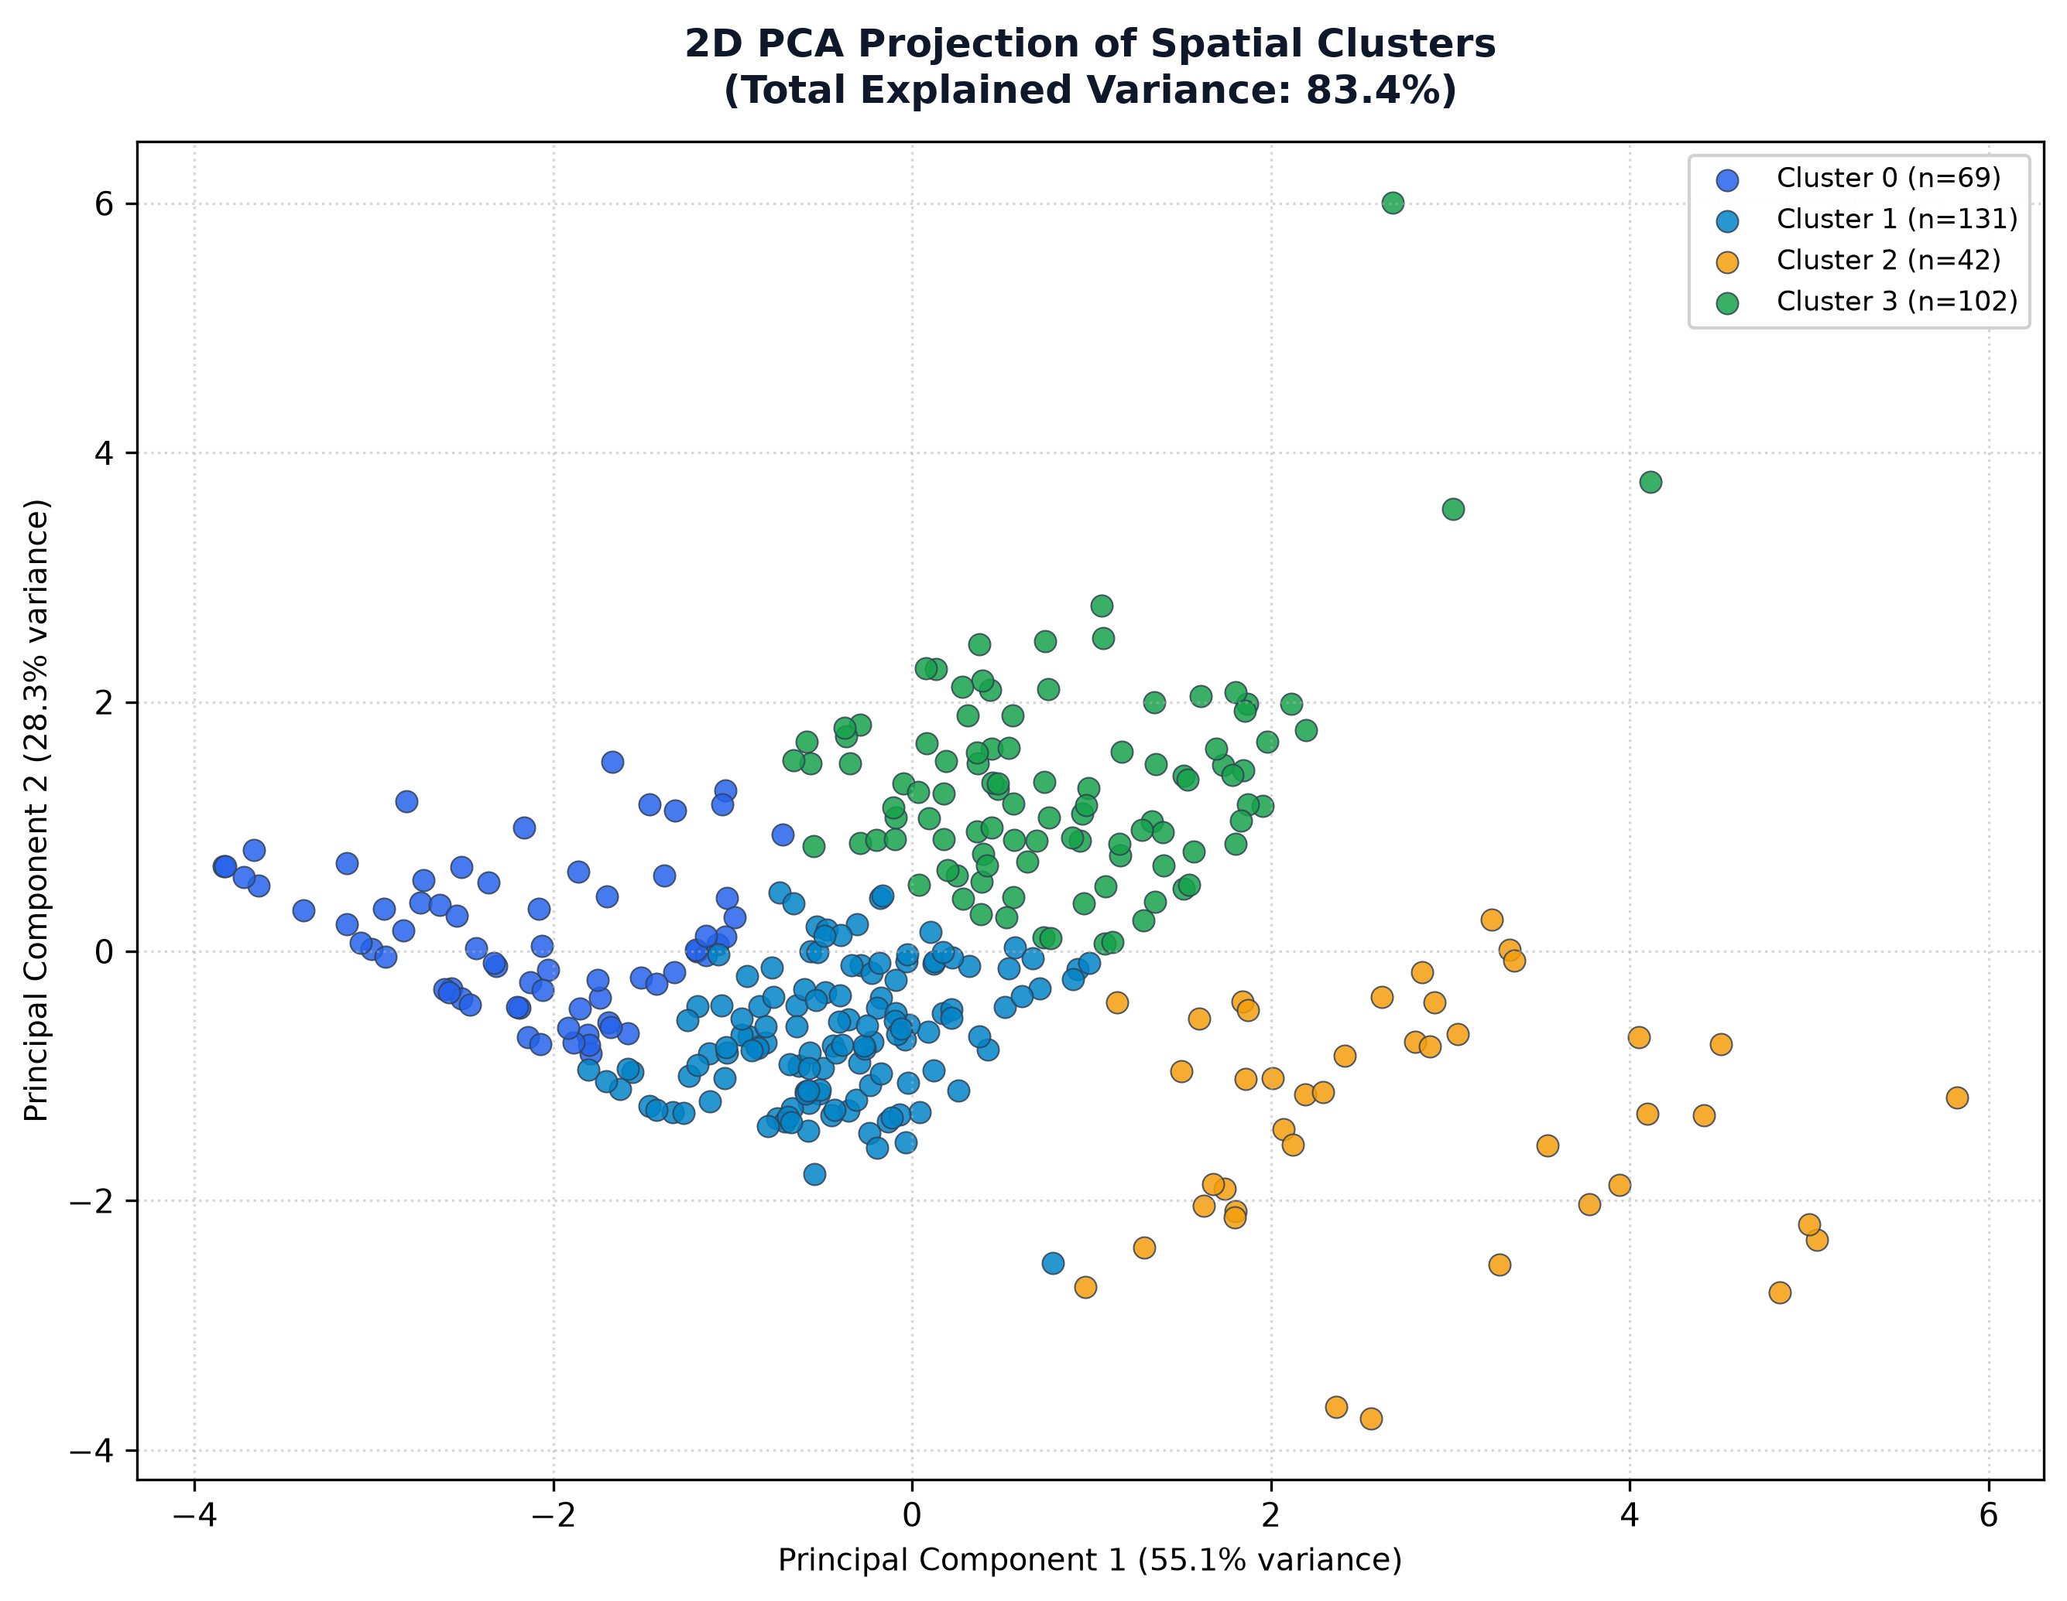
Figure 10: 2D Principal Component Analysis (PCA) Cluster Projection.
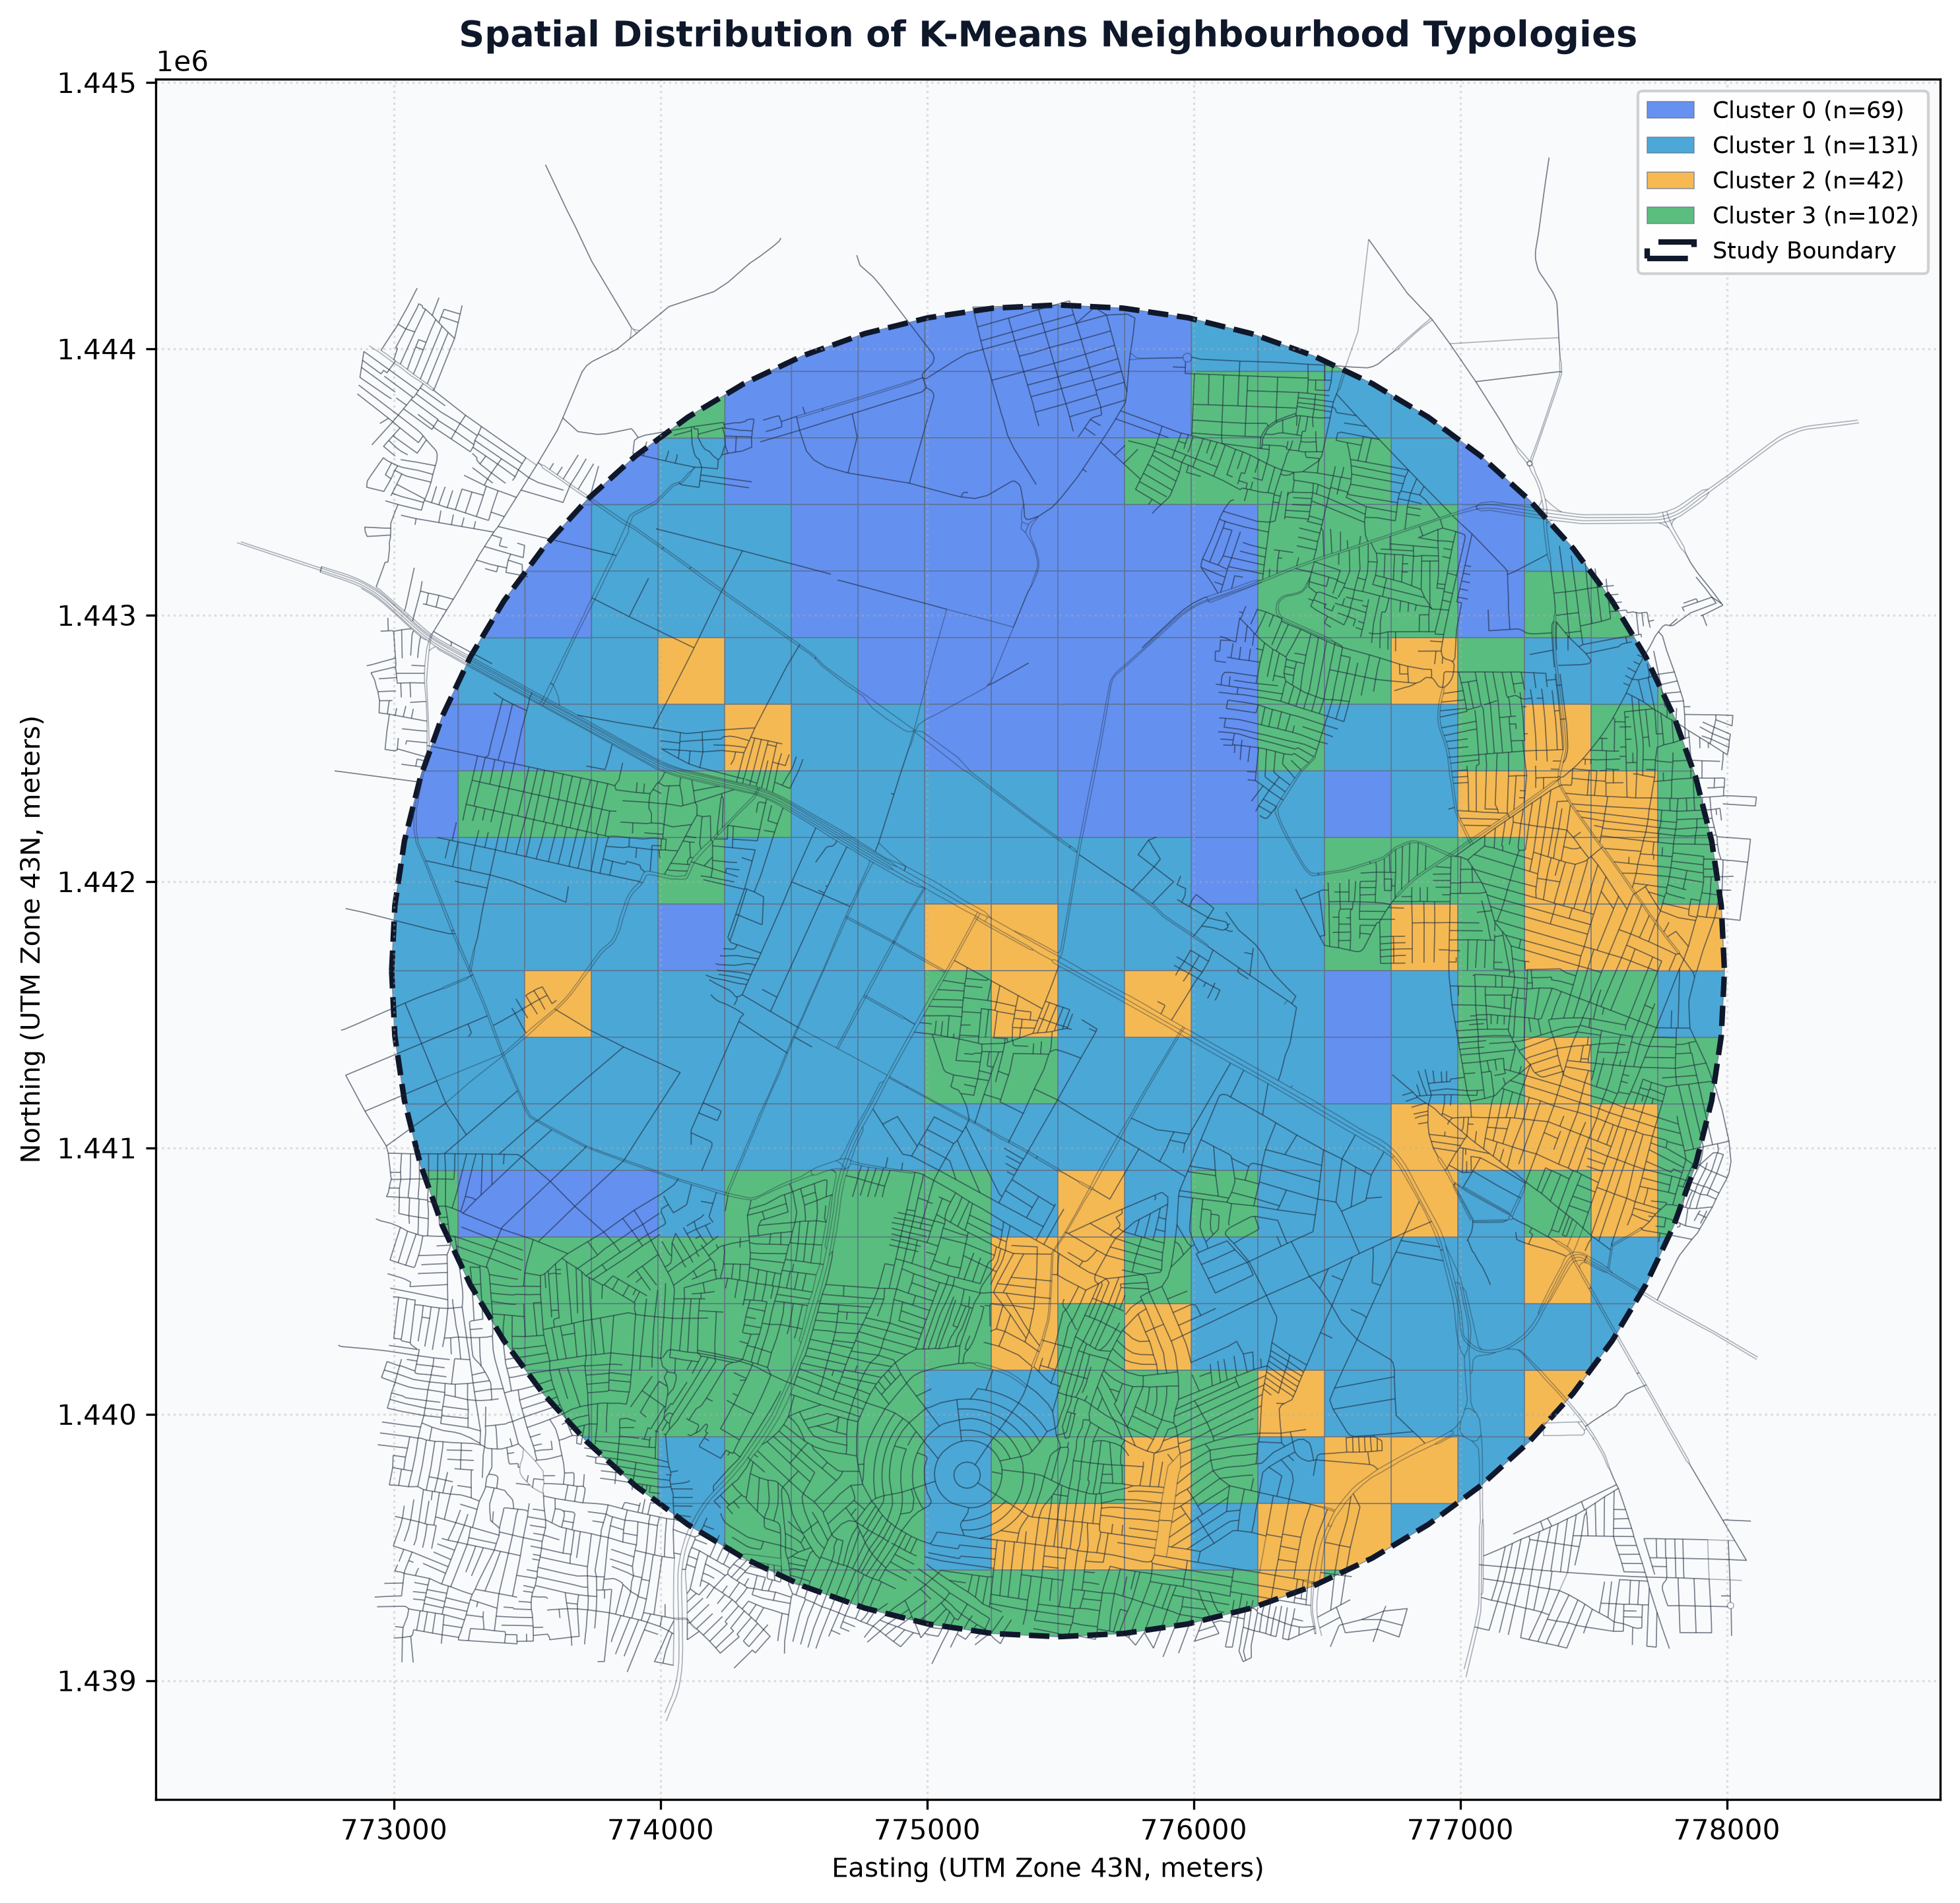
Figure 11: Spatial Distribution of Discovered K-Means Neighbourhood Typologies.
Cluster ID | Typology Designation | Cells | Mean Road Dens | Mean Hosp Dist | Access Score | Dominant Characteristics
Cluster 0 | Dense Mixed Transit Sector | 129 | 23.77 km/km² | 416.4 m | 70.9 / 100 | Moderate road density, strong highway accessibility, solid hospital reach
Cluster 1 | Hyper-Dense Urban Core | 102 | 69.46 km/km² | 545.1 m | 70.7 / 100 | Extremely dense residential street grid, high intersection density
Cluster 2 | Peripheral Industrial Sector | 69 | 14.34 km/km² | 949.4 m | 56.1 / 100 | Low road density, railway yards, longest travel times to hospital care
Cluster 3 | Healthcare Anchor Cluster | 14 | 59.40 km/km² | 125.8 m | 97.5 / 100 | Immediate walking proximity to major tertiary hospitals & high clinic count
Cluster 4 | Commercial & Medical Buffer | 30 | 48.08 km/km² | 219.2 m | 85.8 / 100 | High amenity concentration along Tumkur Road & Dr. Rajkumar Road

Table 8: Unsupervised K-Means Cluster Characteristics & Sociodemographic Typologies

21. Differentiation from Commercial Navigation Platforms (Google Maps)
A common query in municipal technology development is why specialized GIS platforms are necessary given the ubiquity of Google Maps or MapMyIndia. It is critical to recognize that commercial mapping applications are optimized for consumer point-of-interest discovery and individual driver dispatch. They do not—and structurally cannot—serve as municipal spatial analytics tools. Table 9 articulates the fundamental architectural and operational distinctions between Smart Yeshwanthpur GIS, commercial navigation platforms, and traditional desktop GIS software.
Analytical Dimension | Smart Yeshwanthpur GIS | Google Maps / Commercial Apps | Traditional Desktop GIS (QGIS)
Primary Objective | Urban infrastructure analytics & spatial equity | Consumer navigation & local business discovery | General-purpose standalone spatial modeling
Network Centrality Analysis | Explicit Betweenness & Degree computation | Unavailable (Proprietary black-box routing) | Manual processing via heavy desktop plugins
Physical Circuity Quant | Computed as d_network / d_haversine | Unavailable (hidden turn-by-turn routing) | Requires complex multi-step Python scripting
Grid Spatial Choropleths | Automated 250m metric grid scoring | Unavailable (no continuous spatial aggregation) | Manual rasterization or spatial join workflows
Machine Learning Typologies | Integrated K-Means & 2D PCA pipeline | Unavailable | Requires external scikit-learn Python scripts
Data Provenance & Openness | 100% open-source OSM & transparent code | Proprietary, closed commercial data APIs | Open, but steep learning curve for non-specialists
Web Deployment & Usability | Zero-install Streamlit browser application | Consumer mobile/web client | Heavy local software installation required

Table 9: Multi-Dimensional Comparison: Smart Yeshwanthpur GIS vs. Google Maps vs. Traditional Desktop GIS

22. Data Governance, Scientific Ethics & Analytical Disclaimers
To uphold scientific integrity and prevent misinterpretation by municipal stakeholders, the platform enforces three strict governance principles:
1. Topological Centrality vs. Empirical Live Congestion: Edge betweenness centrality is a purely structural property of the road network graph. It identifies where network bottlenecks exist based on topology. It does NOT measure real-time vehicle counts or sensor-derived speed delays, and must never be cited as live probe congestion.
2. Healthcare Accessibility vs. Clinical Quality: The Accessibility Score measures spatial proximity and physical amenity density. It does not measure bed availability, ICU capacity, physician specializations, treatment costs, or clinical care quality.
3. Circular Buffer vs. Administrative Boundary: The 2.5 km study buffer is an analytical convenience and does not correspond to official BBMP ward administrative boundaries. Administrative decision-makers must cross-reference findings with official BBMP ward gazettes.

23. Technical Limitations & Data Completeness
The technical execution operates under four documented constraints:
• OpenStreetMap Contributor Completeness: While arterial and primary roads in Yeshwanthpur exhibit near 100% completeness on OSM, small private alleys and informal slum paths may be under-represented. Similarly, informal clinics operating in residential basements without commercial signage may be absent from OSM amenity databases.
• Free-Flow Speed Assumptions: Edge traversal times are derived from hierarchical design speeds (15–50 km/h) rather than dynamic floating-car data (FCD). Peak-hour congestion will increase real-world travel times beyond the modeled free-flow baseline.
• Planar 2D Graph Assumptions: While flyovers are modeled with separate non-intersecting edges, complex multilevel ramp merges are simplified to planar graph representations.
• Unsupervised ML Interpretation: K-Means clustering discovers mathematical patterns in feature space; cluster labels are descriptive typologies and do not imply predictive causality.

24. Future Roadmap & Proposed Enhancements
The platform architecture is designed for modular scalability. Recommended future technical milestones include:
1. Real-Time Transit Data Integration: Ingesting live General Transit Feed Specification (GTFS-RT) feeds from Bangalore Metropolitan Transport Corporation (BMTC) and Namma Metro to compute multi-modal public transit isochrones.
2. Dynamic Floating-Car Telemetry: Integrating open probe data (e.g., Uber Movement or TomTom Traffic API) to replace free-flow speeds with time-of-day dynamic impedance weights.
3. Two-Step Floating Catchment Area (2SFCA): Implementing 2SFCA accessibility modeling incorporating verified hospital bed capacities and physician counts against granular census block demand.
4. Multimodal Pedestrian Network Modeling: Extracting footways, skywalks, and metro station subways to model non-motorized first/last-mile access for low-income residents.
5. City-Wide Spatial Scaling: Expanding the automated pipeline to cover all 198 BBMP wards across the 712 sq km Greater Bangalore metropolitan area.

25. Practical Policy Implications & Urban Planning Diagnostics
The empirical findings translate into four actionable policy recommendations for BBMP and Bangalore Smart City planners:
• Recommendation 1 (Targeted UPHC Placement): Establish 24/7 Primary Urban Health Centers in Grid Cells GRID_0151 and GRID_0131 (north-western peripheral cells) where hospital driving distances exceed 2.0 km.
• Recommendation 2 (Railway Yard Permeability Corridors): Construct grade-separated pedestrian and light-ambulance underpasses beneath the Yeshwanthpur railway yard connecting Subhash Nagar to Dr. Rajkumar Road, collapsing the 3.58x circuity detour.
• Recommendation 3 (Bottleneck Protection & ITS Enforcement): Deploy Intelligent Transportation Systems (ITS) and strict anti-encroachment enforcement on the 794 bottleneck segments identified in Figure 4 along Tumkur Road approaches.
• Recommendation 4 (Feeder Transit Buffers): Introduce electric feeder mini-buses connecting Mattikere and peripheral residential cells to the Yeshwanthpur Metro interchange to alleviate private vehicular congestion.

26. Technical Conclusion
Smart Yeshwanthpur GIS establishes an open-source, scientifically validated spatial analytics platform tailored to the complex infrastructure realities of urban India. By moving beyond naive straight-line assumptions and black-box commercial tools, the project provides municipal authorities with empirical, mathematically defensible insights into road network vulnerability and healthcare equity. The system successfully models 15,798 road segments, isolates 794 structural bottlenecks, evaluates 84 healthcare amenities across 344 metric grid cells, quantifies severe circuity detours imposed by the railway yard, and uncovers five distinct neighbourhood typologies through unsupervised machine learning. Deployed as an interactive Streamlit application with complete GIS vector data exports, the platform stands as a robust, extensible prototype for data-driven smart city governance in Bengaluru and across expanding Global South metropolises.

27. References & Academic Citations
1. Boeing, G. (2017). 'OSMnx: New methods for acquiring, constructing, analyzing, and visualizing complex street networks.' Computers, Environment and Urban Systems, 65, 126-139.
2. Dijkstra, E. W. (1959). 'A note on two problems in connexion with graphs.' Numerische Mathematik, 1(1), 269-271.
3. Haggett, P., & Chorley, R. J. (1969). Network Analysis in Geography. St. Martin's Press, New York.
4. Freeman, L. C. (1977). 'A set of measures of centrality based on betweenness.' Sociometry, 40(1), 35-41.
5. Luo, W., & Wang, F. (2003). 'Measures of spatial accessibility to health care in a GIS environment: synthesis of a GIS-based two-step floating catchment area method.' Annals of the Association of American Geographers, 93(4), 865-884.
6. OpenStreetMap Contributors. (2026). Planet dump [Data file from OpenStreetMap]. Available at: https://www.openstreetmap.org/copyright.
7. Bruhat Bengaluru Mahanagara Palike (BBMP). (2024). Revised Master Plan & Ward Demographics Report. Urban Development Department, Government of Karnataka.
8. World Health Organization (WHO). (2015). 'Access to Healthcare in Rapidly Growing Urban Settlements: Methodological Guidelines.' WHO Technical Report Series.
9. McKinney, W. (2010). 'Data structures for statistical computing in Python.' Proceedings of the 9th Python in Science Conference, 445, 51-56.
10. Pedregosa, F., et al. (2011). 'Scikit-learn: Machine learning in Python.' Journal of Machine Learning Research, 12, 2825-2830.
11. Jordahl, K., et al. (2020). 'geopandas/geopandas: v0.8.1.' Zenodo. doi:10.5281/zenodo.3946761.
12. Streamlit Inc. (2026). Streamlit Documentation: Modern Web Applications for Data Science. Available at: https://docs.streamlit.io/.

