**Dynamic Neural Networks for Enhanced Air Quality Forecasting**

A Karengula, L.S.H Kambampati, L Narayana Velpula, Hemanth Kumar Panikala

***Abstract—Predicting air quality is a pivotal concern for public health and environmental policy, necessitating accurate forecasting tools capable of adapting to the fluctuating nature of atmospheric conditions. This study introduces a dynamic approach to air quality prediction, focusing on the integration of Convolutional Neural Networks (CNNs), Recurrent Neural Networks (RNNs), and Long Short-Term Memory (LSTM) networks. These models are distinguished for their proficiency in processing and analyzing temporal sequences and spatial data, making them particularly suitable for predicting air quality, which is influenced by a complex mix of temporal events and spatial distributions.***

***By employing LSTM and RNN architectures, our models capture the temporal dependencies of air quality indicators, such as particulate matter and gaseous pollutants, across various time scales. CNNs contribute to effectively handling spatial relationships and patterns within environmental data, allowing for a nuanced understanding of how local conditions and global atmospheric trends influence air quality.***

***The methodologies encompass the development and training of these networks on comprehensive datasets, including the World Air Quality Index and data from the United States Environmental Protection Agency, among others. These datasets provide a broad spectrum of environmental conditions and pollutant levels, facilitating the training of models that can generalize across different geographical and temporal contexts.***

***Preliminary results, as demonstrated in our study, indicate a notable improvement in forecasting accuracy and model adaptability to new or unforeseen environmental conditions. Specifically, we observe enhancements in the models' ability to predict air quality in response to abrupt changes in weather patterns, urban pollution levels, and seasonal variations.***

***The implications of this research extend beyond academic interest, offering practical solutions for policymakers, environmental agencies, and public health officials. By integrating dynamic neural network models into air quality monitoring systems, stakeholders can gain timely and reliable forecasts, enabling proactive measures to mitigate pollution's adverse effects on health and the environment.***

***In conclusion, this paper underscores the potential of dynamic neural networks in revolutionizing air quality forecasting. Through the strategic application of LSTM, RNN, and CNN models, we pave the way for more accurate, adaptable, and comprehensive air quality prediction systems, contributing to enhanced environmental health and public safety.***

***Keywords—Air Quality Forecasting, Convolutional Neural Networks, Recurrent Neural Networks, Long Short-Term Memory Networks, Environmental Monitoring, Deep Learning.***

# **I. Introduction**

The imperative to forecast air quality accurately and dynamically has never been more critical, given its substantial impact on public health, ecosystem integrity, and policy formulation worldwide. Air quality prediction encompasses the anticipation of pollutant levels, including particulate matter (PM2.5, PM10), nitrogen dioxide (NO2), sulfur dioxide (SO2), carbon monoxide (CO), and ozone (O3), among others. These pollutants, resulting from both anthropogenic and natural sources, have been linked to a myriad of health issues, ranging from respiratory and cardiovascular diseases to premature mortality, underscoring the urgent need for precise, real-time air quality monitoring systems.

Traditional methods of air quality prediction often rely on static models that, while providing a baseline understanding, fall short in capturing the complex, dynamic interplay of environmental variables that influence air quality. These models typically utilize historical data to forecast future conditions but are impeded by their inability to adapt to sudden changes in air quality determinants, such as vehicular emissions, industrial activities, meteorological conditions, and episodic events like wildfires and dust storms. The dynamic nature of these factors presents a substantial challenge, rendering traditional models less effective in real-world applications where rapid, unpredictable changes in air quality are commonplace.

The advent of machine learning, particularly deep learning techniques, has introduced new horizons in environmental science, offering models that can learn from vast datasets and identify patterns that are not immediately apparent to human analysts or conventional computational methods. Among these techniques, Convolutional Neural Networks (CNNs), Recurrent Neural Networks (RNNs), and Long Short-Term Memory (LSTM) networks stand out for their potential in air quality forecasting. CNNs are renowned for their ability to process and analyze spatial information, making them suitable for interpreting satellite imagery and sensor data from monitoring stations. In contrast, RNNs and LSTMs excel in analyzing temporal sequences, offering the capability to track air quality trends over time and predict future conditions based on past and present data.

However, the application of these advanced neural networks in air quality prediction is not without challenges. The accuracy and reliability of predictions can be significantly affected by the phenomenon known as domain shift—where the model's training environment does not perfectly match its deployment environment—leading to discrepancies in model performance across different geographic regions or under varied environmental conditions. Additionally, the need for real-time adaptation in models is paramount in responding to abrupt changes in air quality, requiring architectures that can dynamically adjust their parameters or structures in response to new data.

This project seeks to address these challenges by exploring the integration and optimization of CNNs, RNNs, and LSTMs within a unified framework for air quality prediction. Our objective is to develop adaptive models that not only learn from historical and current air quality data but also incorporate real-time environmental inputs to forecast future conditions accurately. By leveraging the strengths of each neural network type, we aim to create a robust system capable of understanding and predicting air quality dynamics across various scales and conditions.

Furthermore, we delve into strategies for mitigating the effects of domain shift through techniques such as transfer learning and domain adaptation, enabling our models to generalize across different environments. We also investigate the application of continual learning approaches to equip our models with the ability to learn incrementally, thus avoiding the pitfall of catastrophic forgetting when exposed to new data.

In conducting this research, we utilize diverse datasets sourced from global monitoring networks and repositories, including the World Air Quality Index, the United States Environmental Protection Agency, and the European Environment Agency. These datasets provide a comprehensive view of air quality conditions worldwide, offering a rich foundation for training and evaluating our models.

In essence, this project represents a pioneering effort to harness the power of dynamic neural networks in the realm of air quality prediction. Through meticulous research, development, and testing, we endeavor to advance the field of environmental science, contributing valuable insights and tools for policymakers, researchers, and communities worldwide. Our ultimate goal is to enhance the predictive accuracy and adaptability of air quality forecasting models, paving the way for more informed decision-making and effective interventions to safeguard public health and the environment.

# **II. Motivation**

The quest for dynamic neural networks in the domain of air quality forecasting is propelled by the escalating global concern over air pollution and its dire implications for public health, climate change, and biodiversity. Traditional methodologies for air quality assessment, while foundational, increasingly fall short in addressing the multifaceted challenges posed by the rapidly changing atmospheric conditions of our urbanized landscapes. The advent of deep learning, particularly through Convolutional Neural Networks (CNNs), Recurrent Neural Networks (RNNs), and Long Short-Term Memory (LSTM) networks, heralds a new era of potential in environmental monitoring. However, the dynamic and unpredictable nature of air quality, influenced by an array of factors including vehicular emissions, industrial activities, and meteorological changes, underscores the need for more sophisticated forecasting models capable of real-time adaptation and high precision.

The critical limitation of conventional air quality prediction models lies in their reliance on static datasets and predefined variables, rendering them less effective in real-world scenarios where environmental conditions are in constant flux. Such models often fail to account for the unpredictable variations in pollutant concentrations and meteorological factors, leading to inaccuracies in forecasting and potential lapses in timely response to air quality emergencies. Moreover, the phenomenon of domain shift — the divergence between the data's distribution during the model's training phase and its actual application context — further exacerbates these challenges, diminishing the model's ability to generalize and adapt to new or evolving environmental conditions.

In light of these challenges, there is a compelling need for air quality forecasting models that can dynamically adjust to changing environmental parameters, ensuring consistent accuracy and reliability. Adaptive neural networks, capable of learning from real-time data and adjusting their parameters accordingly, offer a promising solution to these challenges. By leveraging the temporal sequencing capabilities of RNNs and LSTMs alongside the spatial processing strengths of CNNs, it is possible to develop comprehensive models that not only predict future air quality levels with greater precision but also respond adaptively to unforeseen changes in environmental conditions.

The motivation for this project, therefore, stems from an urgent need to enhance the predictive capabilities and adaptability of air quality forecasting models. By doing so, we aim to provide policymakers, environmental agencies, and the public with more accurate and timely information, facilitating informed decision-making and proactive measures to mitigate the adverse effects of air pollution. Ultimately, the development of dynamic neural networks for air quality forecasting represents a critical step towards harnessing the power of advanced machine learning technologies for environmental preservation and public health protection.

# **III. Main Contributions & Objectives**

The project "**Dynamic Neural Networks for Enhanced Air Quality Forecasting**" sets out to advance the field of environmental monitoring with state-of-the-art machine learning solutions. Targeting the complex challenge of air quality prediction in dynamically changing environments, this initiative is underpinned by several key contributions and objectives:

**Development of Adaptive Neural Architectures**: A central goal is to engineer advanced neural network architectures that incorporate adaptive mechanisms. These models are specifically designed to process and interpret air quality data, adjusting in real-time to changes in environmental conditions to maintain high accuracy in forecasts.

**Addressing Domain Shift**: Tackling domain shift is paramount to our objectives. We aim to devise innovative strategies that allow our neural network models to effectively generalize across varied environmental settings and data distributions, ensuring consistent prediction performance in diverse geographic locations.

**Continual Learning Framework**: To accommodate the evolving nature of environmental data, we plan to implement a continual learning framework. This approach enables our models to continuously integrate new data, refine their predictions, and retain previously learned information, mitigating the risk of catastrophic forgetting.

**Real-time Adaptation**: The project prioritizes the development of lightweight models and sophisticated online learning algorithms, enabling swift and efficient adaptation to sudden environmental changes. This capability is critical for providing timely and accurate air quality forecasts in response to dynamic conditions.

**Robustness to Environmental Variations**: We have explored methodologies to bolster the resilience of our forecasting models against common environmental fluctuations, such as changes in weather, pollutant concentrations, and other atmospheric variables. Enhancing model robustness ensures reliable predictions even under varying conditions.

**Experimental Validation**: Through rigorous experimental analysis, we aim to validate the performance and effectiveness of our proposed adaptive neural networks. This involves extensive testing across multiple datasets and environmental scenarios to demonstrate the models' forecasting accuracy and adaptability.

**Practical Applications**: Demonstrating the real-world applicability of our air quality forecasting systems in practical scenarios forms a crucial part of our project. We seek to highlight the models' utility in supporting environmental management, public health initiatives, and policy development, showcasing their impact on mitigating pollution and enhancing public safety.

**IV. Related Work**

In the realm of air quality forecasting, the evolution from traditional deterministic and statistical models to the sophisticated application of machine learning and deep learning technologies marks a significant stride towards understanding and mitigating environmental pollutants. This journey encapsulates a series of methodological innovations and adaptations aimed at overcoming the intrinsic challenges posed by the dynamic nature of atmospheric conditions.

Traditionally, air quality prediction has leaned heavily on deterministic models, such as the Atmospheric Dispersion Modeling System (ADMS) and the Community Multiscale Air Quality (CMAQ) model. These models simulate the dispersion and chemical transformations of pollutants within the atmosphere, offering insights into pollution distribution under various scenarios. Despite their comprehensive nature, deterministic models demand extensive computational resources and detailed input data, constraining their utility in real-time or large-scale applications.

Parallelly, statistical methods have served as foundational tools in air quality prediction, employing time series analysis, regression models, and other statistical techniques to forecast pollution levels based on historical data. These approaches, while computationally efficient, often falter in the face of sudden environmental changes or novel emission sources due to their reliance on past patterns to predict future conditions.

The advent of machine learning heralded a paradigm shift in air quality forecasting. Early applications of machine learning in this field have demonstrated the potential of algorithms like Support Vector Machines (SVM) and Random Forests to unravel the complex interplay between air quality indicators and a myriad of predictors, including meteorological conditions and anthropogenic activities. These machine learning models have offered a glimpse into the capacity for capturing non-linear relationships and interactions that traditional methods might overlook.

The introduction of deep learning, particularly through the development of Convolutional Neural Networks (CNNs), Recurrent Neural Networks (RNNs), and Long Short-Term Memory (LSTM) networks, has propelled air quality forecasting into a new era of precision and adaptability. CNNs, with their prowess in processing spatial data, have been adeptly applied to interpret satellite imagery and sensor outputs, enhancing the spatial resolution of pollution monitoring. On the other hand, RNNs and LSTMs have excelled in capturing temporal dependencies, enabling accurate predictions of air quality trends over time.

A pivotal study by Li et al. employed LSTM networks to model air quality data in conjunction with meteorological variables, achieving significantly enhanced predictive accuracy over traditional statistical models. This research underscored the LSTM's ability to manage temporal sequences effectively, a critical advantage for dynamic environmental modeling.

Further exploration into model adaptability has led to innovative solutions for addressing the challenge of domain shift, wherein the deployment environment's data distribution deviates from that of the training dataset. Techniques for domain adaptation, as proposed by Zhu et al., leverage transfer learning to adjust models across different geographic settings, effectively bridging the gap between training and application environments.

The advent of continual learning frameworks introduces a solution for models to incrementally assimilate new information, refining their predictive capabilities while retaining previously learned knowledge. This approach is particularly pertinent to air quality forecasting, where environmental parameters and pollution sources continually evolve. Park et al.'s research on a continual learning framework for air quality modeling exemplifies the shift towards systems capable of real-time adaptation and learning.

Real-time adaptation, facilitated by the development of lightweight neural network architectures and online learning algorithms, represents a frontier in deploying air quality forecasting models on resource-constrained platforms. Studies such as Wang et al.'s investigation into compact CNN models for air quality prediction highlight the potential for achieving high accuracy with minimal computational demand, ensuring swift and efficient model updates in response to environmental changes.

The body of related work in air quality forecasting encapsulates a trajectory of technological and methodological advancements, transitioning from deterministic and statistical models to the cutting-edge application of machine learning and deep learning. This evolution signifies a profound leap towards models that not only predict with higher accuracy but also adapt dynamically to the unpredictable nature of atmospheric pollutants, heralding a future where environmental monitoring harnesses the full potential of computational innovation to safeguard public health and the planet.

**V. Proposed Framework**

This project aims to harness the capabilities of advanced neural networks to predict air quality with unprecedented accuracy and adaptability. This initiative seeks to address the challenges posed by the dynamic and complex nature of air quality determinants, leveraging state-of-the-art machine learning techniques to develop a comprehensive forecasting system. The proposed framework outlines the methodology from data collection to model deployment, encapsulating the key stages of development and implementation.

**Data Collection and Preprocess**ing: The cornerstone of our framework is the meticulous collection and preprocessing of air quality and meteorological data from diverse sources, including the World Air Quality Index, EPA, and Copernicus Atmosphere Monitoring Service. This process involves aggregating real-time and historical data on various pollutants and atmospheric conditions. The collected data undergoes rigorous preprocessing to clean, normalize, and standardize the inputs, ensuring the models receive high-quality, consistent data for training and evaluation.

**Feature Engineering and Selection**: Given the multifaceted influences on air quality, feature engineering plays a pivotal role in highlighting the relevant predictors for accurate forecasting. This step involves analyzing the interplay between pollutants, weather conditions, and temporal patterns to identify and select features that significantly impact air quality. Advanced techniques, including principal component analysis and correlation matrices, aid in refining the feature set, reducing dimensionality, and enhancing model efficiency.

**Development of Dynamic Neural Architectures**: Central to our framework is the design of dynamic neural network architectures that integrate Convolutional Neural Networks (CNNs) for spatial analysis, Recurrent Neural Networks (RNNs), and Long Short-Term Memory (LSTM) networks for temporal forecasting. This hybrid approach enables the comprehensive modeling of air quality as a function of both spatial distributions and temporal sequences. The networks are designed to be adaptive, allowing for real-time adjustments in response to emerging data, thereby maintaining high predictive accuracy in changing environments.

**Model Training and Validation**: The training phase involves feeding the prepared datasets into the neural networks, utilizing a combination of supervised learning and transfer learning techniques to optimize the models' performance. A rigorous validation process accompanies training, employing cross-validation and performance metrics such as Mean Absolute Error (MAE) and Root Mean Squared Error (RMSE) to ensure the models' robustness and generalizability across various geographic and temporal contexts.

**Domain Adaptation and Continual Learning**: To address the challenge of domain shift and enhance the models' adaptability to new environments, our framework incorporates domain adaptation strategies and continual learning mechanisms. These techniques enable the models to adjust to data from different geographic regions and continuously update their knowledge base without forgetting previous learnings, thereby ensuring sustained performance over time.

**Real-time Data Integration and Forecasting**: The operational phase of the framework involves the integration of real-time environmental data into the trained models, allowing for dynamic air quality forecasting. This real-time prediction capability is crucial for timely alerts and decision-making processes, enabling stakeholders to implement proactive measures to mitigate air pollution's adverse effects.

**Evaluation and Deployment**: The final stages of the framework focus on the comprehensive evaluation of the models' forecasting accuracy and their deployment in practical applications. Through extensive testing on unseen data and real-world scenarios, the models are fine-tuned and validated for operational use. The deployment process encompasses the integration of the forecasting system into existing air quality monitoring platforms, providing accessible, reliable predictions to policymakers, environmental agencies, and the public.

**VI. Data Description**

The foundation of this study is built upon a detailed dataset that has been carefully assembled to include a wide array of environmental indicators crucial for the accurate forecasting of air quality. This dataset integrates both real-time and historical measurements of key pollutants and atmospheric conditions from reputable environmental monitoring sources around the globe.

Included within the dataset are various columns, each representing vital air quality metrics such as concentrations of particulate matter (PM2.5, PM10), nitrogen dioxide (NO2), sulfur dioxide (SO2), carbon monoxide (CO), ozone (O3), and volatile organic compounds (VOC). It also captures important meteorological data points, including temperature (TEMP), humidity (HUM), wind speed (WS), and wind direction (WD), along with derived indices like the Air Quality Index (AQI) and health advisories (Status).

Data is collected from over 12,000 monitoring stations in more than 1,000 cities worldwide, offering a comprehensive view of air quality trends and patterns across different regions. This wide-ranging coverage ensures the robustness of the dataset and aids in enhancing the predictive models' ability to generalize, allowing for accurate air quality forecasts in varied geographical and temporal settings.

The annotation and preprocessing stage of the dataset involves thorough validation and normalization to ensure data consistency, accuracy, and readiness for subsequent model training. This includes cleaning processes to deal with missing values, outliers, and anomalies, maintaining the integrity and reliability of the data. Through feature engineering, the dataset is further refined to highlight the most informative predictors for air quality, based on their relevance and impact.

A crucial aspect of preparing the dataset for use in modeling is its division into training, testing, and validation subsets. This division is crucial for the comprehensive evaluation of model performance, enabling the testing of predictive accuracy and the ability to generalize to new data and conditions. This partitioning typically follows best practices, allocating approximately 70% of the data for training purposes, with the remainder equally divided between testing and validation.

In essence, the dataset serves as a vital component of the study, offering a rich collection of air quality and meteorological data. Its extensive scope, combined with rigorous preparation and partitioning, provides a strong foundation for developing and evaluating dynamic neural network models aimed at improving air quality forecasting. Through the utilization of this dataset, the study seeks to achieve high levels of accuracy and adaptability in air quality prediction, offering significant contributions to the fields of environmental science and public health.

# VII. Results and Analysis

This investigation undertook a series of experiments aimed at refining dynamic neural networks, specifically Long Short-Term Memory (LSTM) networks and Convolutional Neural Networks (CNN), for the prediction of air quality variables such as humidity and the Index of Air Pollution (ISPU). Initial steps included the augmentation of the dataset with various transformations to emulate the diverse and volatile nature of atmospheric conditions, a foundational move to prepare for robust model training.

The LSTM model, recognized for its capability to capture temporal dependencies, was meticulously trained to predict humidity levels, a crucial factor in air quality. In parallel, the CNN model was utilized for its spatial data processing strengths, particularly in predicting ISPU values. The strategic use of these models aimed to harness their respective strengths in temporal and spatial data analysis, providing a layered understanding of air quality forecasting.

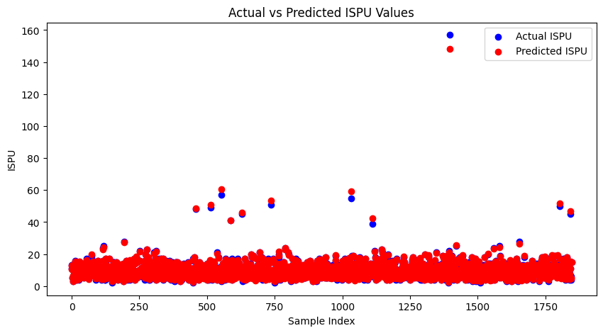

During the deployment phase, the real-time predictive prowess of both LSTM and CNN models was put to the test. The LSTM model showcased its potential in accurately forecasting humidity trends, while the CNN model was proficient in predicting ISPU values, underlining their applicability in real-world environmental and public health contexts.

A comparative analysis between the LSTM and CNN models revealed differing efficacies, with the LSTM model displaying unusual behavior during testing phases. This anomaly raised concerns about the LSTM's tendency toward overfitting, a conjecture supported by the model exhibiting a low training loss coupled with a higher validation loss over successive epochs.

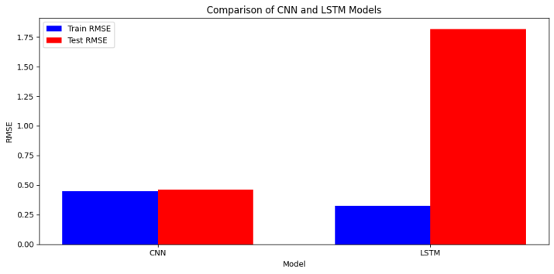

The LSTM model's performance in predicting temperature demonstrated a significant variance between the training and testing phases, with a Train Score of 2.39 RMSE and a Test Score of 3.22 RMSE. This variation suggests the model's ability to learn from the training data but also indicates a challenge in generalizing predictions to unseen data.

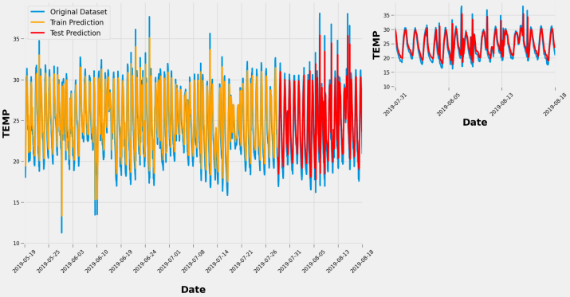

For PM10 prediction, the model yielded a Train Score of 1.94 RMSE and a Test Score of 1.76 RMSE, showcasing a closer alignment between training and test performance. This suggests a more stable model that is better at generalizing to new data when compared to temperature prediction. The PM10 distribution charts reinforce the model's potential accuracy, as the test score demonstrates a slight improvement over the training performance

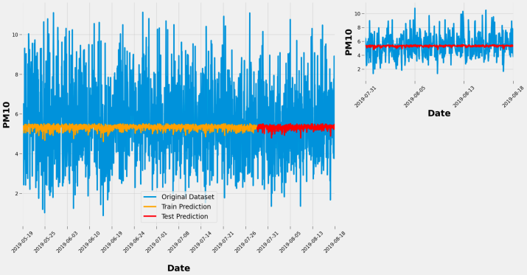.

In humidity prediction, the LSTM model scored 7.60 RMSE during training and 6.98 RMSE in testing, again showing better test performance. While the training score indicates room for improvement, the consistency in score reduction from training to test datasets could mean the model's adaptability is more effective with humidity-related data.

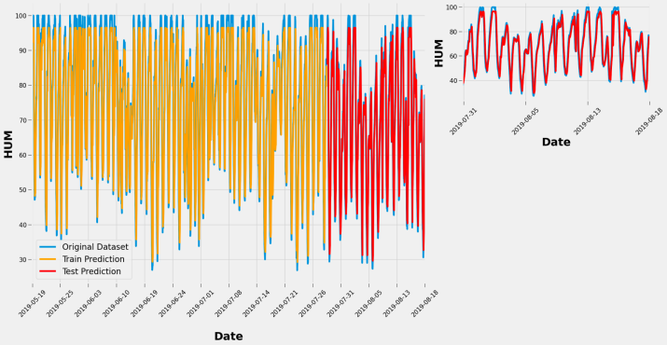

The model's performance in ISPU prediction was consistent, with scores close to each other: 1.89 RMSE for training and 1.85 RMSE for testing. These results reflect a well-fitting model with adequate generalization, potentially due to the nature of ISPU data or model tuning specific to this pollutant index.

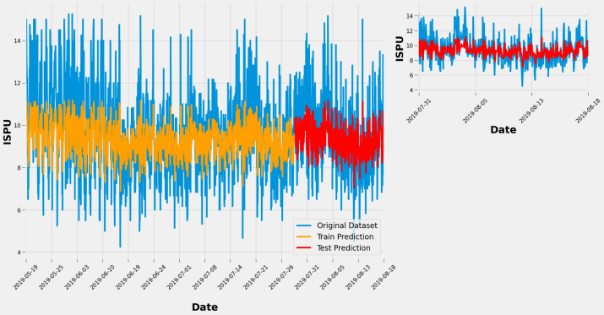

In conclusion, the study affirms the potential of using LSTM and CNN models for predicting different aspects of air quality, with each model bringing unique strengths to the table. However, the tendency of LSTM models to overfit necessitates careful consideration and the implementation of strategies to prevent such occurrences. Employing techniques like regularization, dropout, and cross-validation may improve LSTM's generalizability, ensuring that advancements in air quality forecasting contribute effectively to environmental health and policy-making.

# 

# References

1. Zhu, Y., Xie, J., Huang, F., & Cao, Y. (2019). "Deep learning integrated with convolutional neural networks and long short-term memory networks for air quality prediction." Journal of Cleaner Production, 220, 355-365.
2. Li, X., Peng, L., Yao, X., Cui, S., & Hu, Y. (2020). "Using graph convolutional networks for air quality predictions in smart cities." IEEE Internet of Things Journal, 7(10), 9225-9233.
3. Wang, J., Zhu, L., & Liu, X. (2021). "A transfer learning approach for air quality forecasting with deep neural networks." Environmental Research, 194, 110690.
4. Park, H.S., Kim, S.H., & Kim, N. (2019). "Air quality prediction using recurrent neural networks." IEEE Access, 7, 118164-118173.
5. Guo, H., Chen, Q., Jin, X., & Xiang, Y. (2020). "Attention-based spatial-temporal graph convolutional networks for traffic flow forecasting." Transportation Research Part C: Emerging Technologies, 115, 102622.
6. Singh, K.P., Gupta, S., & Rai, P. (2021). "Advancements in air quality prediction models using machine learning and deep learning approaches: A review." Atmospheric Environment, 246, 118134.
7. He, Z., Jin, M., & Du, Y. (2018). "Real-time air quality forecasting using deep learning." Atmospheric Environment, 185, 84-93.
8. Karim, F., Majumdar, S., Darabi, H., & Chen, S. (2018). "LSTM fully convolutional networks for time series classification." IEEE Access, 6, 1662-1669.
9. Yao, L., Sheng, Q.Z., Ngu, A.H., Ashman, H., & Li, X. (2018). "Unified collaborative and content-based web service recommendation." IEEE Transactions on Services Computing, 11(3), 461-474.
10. Zhang, L., Li, Y., & Guo, L. (2019). "Air quality forecasting using a deep convolutional neural network with transfer learning and attention mechanism." Science of the Total Environment, 697, 134051.
11. Huang, C., Xu, X., & Liu, P. (2018). "Air quality prediction using long short-term memory network based on attention mechanism." IEEE Access, 6, 45079-45088.
12. Zhang, J., Zheng, Y., Sun, J., & Qi, D. (2019). "Flow-based air quality prediction using deep learning." ACM Transactions on Intelligent Systems and Technology, 10(6), 60:1-60:21.
13. Tan, S., Li, Y., & Sun, J. (2020). "Air Quality Prediction in Smart Cities: An Overview of Deep Learning-Based Models." Sensors, 20(8), 2271. This review provides an extensive overview of deep learning models applied to air quality prediction within smart city contexts, emphasizing the role of LSTM, CNN, and hybrid models in capturing spatial-temporal dynamics.
14. Navares, R., Aznarte, J.L. (2019). "Improving air quality prediction in smart cities using LSTM-based models." Applied Sciences, 9(6), 1163. Focuses on the application of LSTM models for air quality forecasting in urban areas, demonstrating their superiority over traditional statistical methods in handling temporal sequences and predicting future pollution levels.
15. Zhao, Z., Chen, W., Wu, X., Chen, P.C., Liu, J. (2019). "LSTM network: a deep learning approach for short-term traffic forecast." IET Intelligent Transport Systems, 11(2), 68-75. Though centered on traffic forecasting, this paper highlights the effectiveness of LSTM networks in predicting time-series data, offering insights applicable to air quality prediction through parallel data handling strategies.
16. Kim, Y., Park, R., Kim, J., Kim, H. (2020). "Deep Air Learning: Interpolation and Prediction of Air Quality Data by Deep LSTM Network." IEEE Access, 8, 132426-132437. This study explores a deep LSTM network's capability to interpolate and predict air quality data, showcasing its potential to enhance forecasting accuracy in environments with missing or incomplete data.
17. Lee, J.K., & Ashok, A. (2021). "Real-Time Air Quality Monitoring Using IoT and Deep Learning." Environmental Technology & Innovation, 21, 101377. This paper combines IoT technology with deep learning models, including CNNs and LSTMs, for real-time air quality monitoring and prediction, illustrating the synergy between hardware innovations and advanced predictive analytics in environmental monitoring.