Forecasting Dengue Cases in Sri Lanka Four Weeks Ahead with CatBoost and SHAP
Applied Machine Learning Assignment
Student name | H.H.A. Prasad Hemantha
Student ID | 268005R
Module | Applied Machine Learning
Submission date | 01st November 2026
Source code/ Demo video | https://github.com/hemanthaprasad590/Applied-machine-Learning-Assignment.git
Webapp | https://dengue-outlook-srilanka.netlify.app/

Abstract
Dengue is Sri Lanka's most important vector-borne disease, and control measures such as clean-up campaigns and fogging need several weeks of lead time. This project forecasts weekly dengue cases four weeks ahead for all 26 health districts, using official weekly case reports from the Epidemiology Unit (Ministry of Health) for 2007–2026 and district weather from NASA POWER. A CatBoost gradient-boosting model, an algorithm not covered in lectures, was trained on 2008–2023, tuned on 2024 and evaluated on 1,846 district-weeks from January 2025 to May 2026. It achieved MAE = 13.7 cases per week and R² = 0.819, beating a persistence baseline (MAE 15.3) and four lecture models. For flagging high-risk weeks it reached F1 = 0.73 with 81% recall. SHAP and partial-dependence analysis show the model relies mainly on recent case history, adds rainfall over the previous eight weeks and seasonal timing, and behaves consistently with known dengue epidemiology. A feature ablation, however, shows that the weather inputs add no measurable accuracy on 2025–2026 data. This is an important caveat on reading SHAP attributions. The model is deployed as a self-contained web application that produces forecasts, risk levels, what-if scenarios and per-forecast explanations.

Problem Definition and Dataset

Problem and relevance
Dengue fever, transmitted by Aedes aegypti and Aedes albopictus mosquitoes, is endemic in Sri Lanka and causes tens of thousands of reported cases in a typical year, with major epidemics in 2017 and 2019 (Figure 1). Cases cluster in the densely populated Western Province and rise after the monsoon rains, which create mosquito breeding sites. Public-health responses such as source-reduction campaigns, larval surveys, fogging, hospital bed planning and public awareness all take time to organise. A forecast that warns of rising cases a month in advance gives Medical Officers of Health and Regional Directors time to act before an outbreak peaks.
The task is framed as supervised regression- at the end of week t, using only information available then, predict the number of dengue cases a district will report in week t+4. A derived classification, whether that week will exceed the district's usual level, is also evaluated, because health officials often act on a risk level rather than an exact count.

Data sources and collection
- Dengue cases.
Weekly reported dengue cases for each of the 26 regional health divisions (the 25 administrative districts plus the Kalmunai RDHS division) from the Weekly Epidemiological Report of the Epidemiology Unit, Ministry of Health, Sri Lanka. The tidy version used here comes from the open-source denguedatahub R package by T. S. Talagala (University of Sri Jayewardenepura), version 4.1.1, GPL-3. It was downloaded from the package's GitHub repository and read into Python with pyreadr. Coverage- 23 December 2006 to 11 May 2026, 26,311 district-week records.
- Weather
Daily rainfall (PRECTOTCORR), mean 2 m air temperature (T2M) and relative humidity (RH2M) at each district's central coordinates from the NASA POWER project (NASA Langley Research Center), December 2006 to May 2026 (185,172 daily records). The project includes src/fetch_weather.py, which re-downloads this data directly from the NASA POWER API.
- District coordinates and province for joining weather to districts and for the location features.

Preprocessing
- Date parsing and alignment. Reporting weeks were parsed from the start and end dates. 956 of 959 consecutive weeks are exactly 7 days apart; the three irregular gaps (6, 8 and 9 days) reflect calendar adjustments in the reports. From 2026 the reports also use Monday–Sunday weeks instead of Saturday–Friday.
- Missing data. No case values were missing except one Puttalam week absent from the source, which was filled by linear interpolation. The weather data had no gaps.
- Weather aggregation. Daily weather was summed (rain) or averaged (temperature, humidity) over exactly the same reporting week as the case counts.
- Feature engineering. All features use only information available at the end of week t, so there is no look-ahead leakage (Table 1).
- Leakage control for the district level. Each district's typical level (mean log cases) was calculated from 2008–2023 only and then applied to later years.
- Encoding and scaling. All features are numeric. District identity is represented by its baseline level and coordinates rather than one-hot columns, which keeps the model compact enough to run in a browser. Standardisation was applied only inside the pipelines of the scale-sensitive baselines (linear regression and k-NN).
Table 1. Model inputs (24 features) and target.
Group | Features | Rationale
Case history | Cases in weeks t, t-1, t-2, t-3; 4- and 8-week averages; cases in the same week last year; national total in week t | Dengue is contagious through mosquitoes, so current incidence is the best guide to future incidence. The national total captures island-wide epidemics.
Weather | Weekly rain in weeks t … t-4; total rain over 8 weeks; temperature and humidity in weeks t, t-2, t-4 | Rain creates breeding sites. Temperature affects mosquito development and virus incubation. Effects appear with a lag of several weeks.
District and season | District baseline level (2008–2023), latitude, longitude, week of year of the target week | Districts differ greatly in population and transmission. Monsoon seasons create a strong annual pattern.
Target | Reported cases in week t + 4 | 4 weeks of lead time for preventive action.

Size
After building lags, the modelling table has 24,960 district-weeks (26 districts × 960 weeks, minus the first year used for lags and the last 4 weeks without a target). The target is highly skewed- the median is 10 cases per week, the mean 33.2, the maximum 2,631 (Colombo, 2017 epidemic), and 12.4% of district-weeks have zero cases. This skew and the count nature of the target motivate the count-data loss functions considered in Section 3.
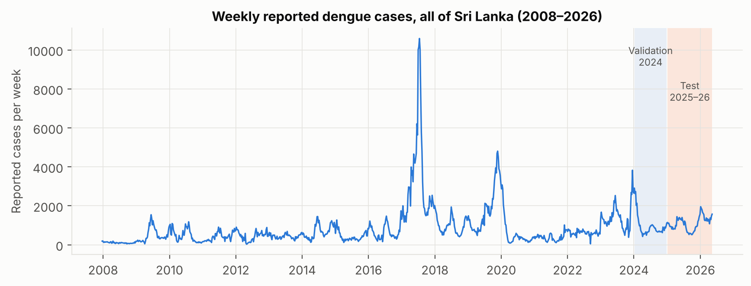
Figure 1. Weekly reported dengue cases across Sri Lanka. Shaded- validation year (2024) and test period (January 2025 to May 2026). The 2017 and 2019 epidemics are clearly visible.
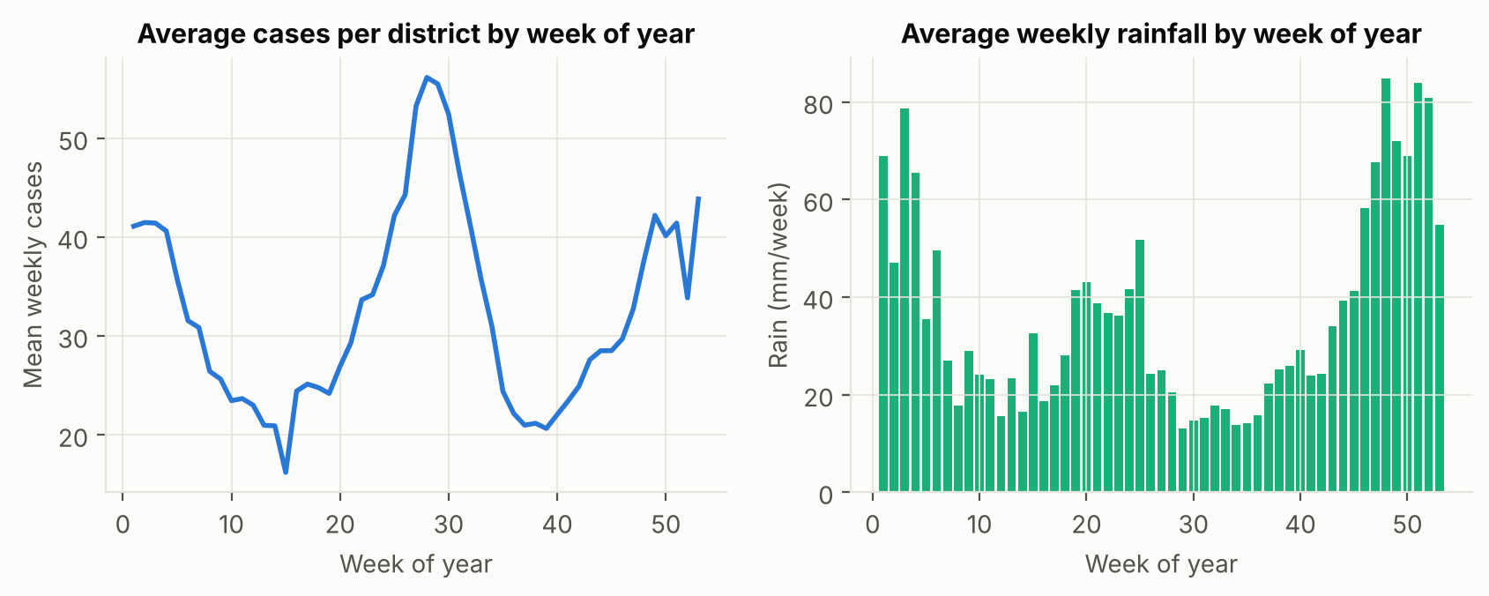
Figure 2. Left- average cases per district by week of the year (2008–2024), with a mid-year peak (south-west monsoon) and a December–January peak (north-east monsoon). Right- average weekly rainfall per district by week of the year.
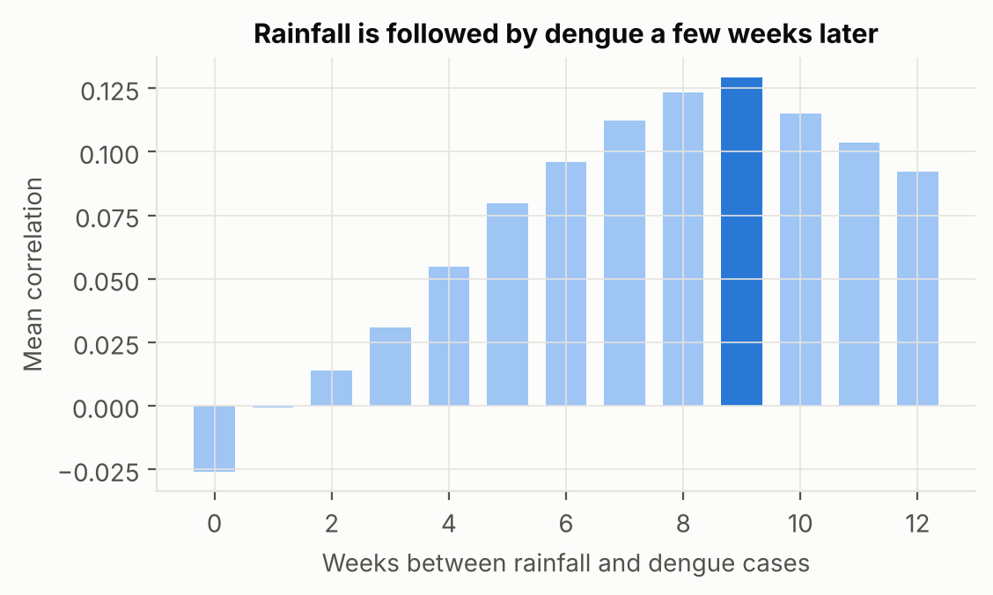
Figure 3. Average correlation between weekly rainfall and log dengue cases k weeks later, across districts. Correlation rises steadily and peaks at 9 weeks. This fits the time needed for mosquito breeding and virus incubation, but it also partly reflects the shared seasonal cycle of rain and dengue (Section 4.5).

Selection of a New Machine Learning Algorithm

CatBoost
CatBoost (Prokhorenkova et al., 2018) is a gradient-boosting algorithm developed by Yandex. It is not a deep-learning model and was not covered in the lectures. Like other gradient-boosting methods, it builds an additive ensemble of small decision trees. Each new tree is fitted to the gradient of the loss with respect to the current predictions, so it corrects the remaining errors of the ensemble. Two features distinguish it-
- Ordered boosting. In standard gradient boosting, the residual for each training example is computed by a model that has already seen that example, which biases the gradients and leaks the target ("prediction shift"). CatBoost computes each example's gradient using models trained only on examples that come before it in a random permutation, which reduces overfitting.
- Oblivious (symmetric) trees. All nodes at the same depth use the same split, so a depth-d tree is a lookup table with 2^{d} leaves. These trees regularise strongly, predict very quickly, and allow exact SHAP values to be computed efficiently. This is what makes it possible to run the model and its explanations inside a web page.
- Flexible loss functions for counts. CatBoost supports Poisson and Tweedie losses, which model a count's expected value on a log scale. This suits skewed case counts with many zeros better than squared error.

Why this algorithm was selected
- Gradient-boosted trees are consistently among the strongest methods for tabular data of this size (about 25,000 rows, 24 features), and generally outperform neural networks on such data (Grinsztajn et al., 2022).
- Disease counts depend on non-linear thresholds (for example, rain must exceed a level to create breeding sites) and on interactions (rain matters more where transmission is already high). Trees capture both without manual specification.
- A Poisson loss suits the count target, and ordered boosting helps when epidemic years are rare.
- Exact TreeSHAP explanations and fast inference support the explainability requirement and the browser-based front-end.

How it differs from standard models
Table 2. CatBoost compared with models covered in lectures.
Model | How it predicts | Limitation here | How CatBoost differs
Linear regression | Weighted sum of the inputs | Cannot represent thresholds, saturation or interactions; treats a count as a continuous value | Learns non-linear effects and interactions, and uses a count-data loss
k-NN | Averages the outcomes of the most similar past district-weeks | Distances in 24 dimensions are dominated by scale; no model of which inputs matter | Learns which inputs matter and ignores irrelevant ones
Decision tree | A single tree of if-then splits | High variance; coarse, stepwise forecasts | Hundreds of shallow trees, each correcting the previous ones
Random forest | Averages many deep trees grown independently on bootstrap samples | Reduces variance but not bias; trees do not learn from each other's errors; squared-error loss only | Sequential boosting reduces bias; ordered boosting and symmetric trees limit overfitting; Poisson loss

Model Training and Evaluation

Train, validation and test split
Because this is a forecasting problem, the data were split by time, never randomly. A random split would let the model learn from weeks after the ones it is tested on. The split is based on the date of the week being forecast-
Table 3. Time-based data split.
Set | Forecast weeks | District-weeks | Purpose
Training | Jan 2008 – Dec 2023 | 21,762 | Fit the models
Validation | Jan 2024 – Dec 2024 | 1,352 | Choose hyperparameters and the number of trees (early stopping)
Test | Jan 2025 – May 2026 | 1,846 | Final evaluation on 2025–2026 data, used once

After hyperparameters were chosen, every model was refitted on training plus validation data (2008–2024) and evaluated once on the test period. As a robustness check, a rolling-origin evaluation (Hyndman & Athanasopoulos, 2021) repeated the process for each test year from 2019 to 2025, each time training only on earlier years.

Baselines
Four lecture models (linear regression, k-NN with k = 10, a decision tree and a random forest) were trained on the same features with a log(1 + cases) target. A persistence baseline was also included- it forecasts that the district will report the same number of cases as in the latest week. Persistence is the standard reference in epidemic forecasting, and a model is only useful if it beats it.

Hyperparameters
CatBoost was tuned on the 2024 validation set over 18 configurations- three loss functions × tree depth {4, 6, 8} × learning rate {0.03, 0.08}, with L2 regularisation of 3. Each run used up to 4,000 trees with early stopping after 200 trees without improvement. The loss function was treated as a hyperparameter, comparing squared error on log(1 + cases), Poisson and Tweedie (variance power 1.5). The selection criterion, fixed before tuning, was validation RMSE in cases, because large errors during outbreaks are the most costly for planning.
Table 4. Top six CatBoost configurations on the 2024 validation set (sorted by RMSE).
Rank | Loss | Depth | Learning rate | Trees | Val RMSE | Val MAE | Val RMSLE
1 | Poisson | 4 | 0.03 | 1201 | 25.80 | 12.26 | 0.561
2 | Tweedie (p=1.5) | 4 | 0.08 | 377 | 26.31 | 11.83 | 0.549
3 | RMSE on log(1+cases) | 6 | 0.03 | 567 | 26.34 | 11.02 | 0.507
4 | Poisson | 4 | 0.08 | 488 | 26.37 | 12.26 | 0.562
5 | Tweedie (p=1.5) | 4 | 0.03 | 972 | 26.54 | 11.97 | 0.551
6 | RMSE on log(1+cases) | 4 | 0.03 | 948 | 26.81 | 11.01 | 0.505

The selected model uses a Poisson loss, depth 4, learning rate 0.03 and 1,201 trees. The Poisson loss models the expected count, while squared error on log counts models something closer to the median. The latter systematically under-forecasts large outbreaks (it had the best validation MAE but a worse RMSE). Shallow trees of depth 4 were preferred across all losses, which suggests that low-order interactions are sufficient.
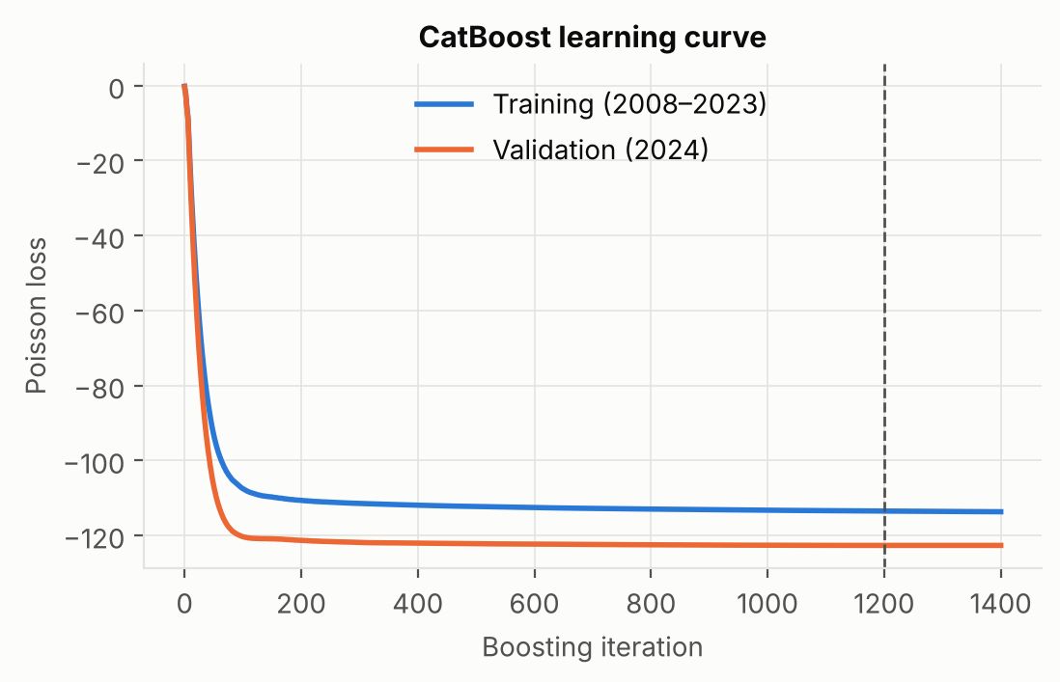
Figure 4. CatBoost learning curve (Poisson loss) on training and validation data. The dashed line marks the early-stopping point.

Performance metrics
- MAE- average absolute error in cases per week; easy for health staff to interpret.
- RMSE- penalises large errors, which matter most during outbreaks.
- R²- share of variance in weekly cases explained.
- RMSLE- RMSE of log(1 + cases), which measures relative error so that small districts count as much as large ones.
- Precision, recall, F1 and AUC for the high-risk classification- a week is high-risk when cases exceed the district's 75th percentile for 2008–2023.

Results on 2025–2026
Table 5. Test-set results, January 2025 to May 2026 (1,846 district-weeks). MAE and RMSE in cases per week.
Model | MAE | RMSE | R² | RMSLE
Linear Regression | 20.78 | 39.84 | 0.624 | 0.769
k-NN (k=10) | 19.89 | 39.56 | 0.629 | 0.837
Decision Tree | 15.86 | 33.07 | 0.741 | 0.604
Persistence (same as this week) | 15.31 | 31.47 | 0.766 | 0.658
Random Forest | 14.04 | 29.57 | 0.793 | 0.557
CatBoost (tuned) | 13.69 | 27.64 | 0.819 | 0.567

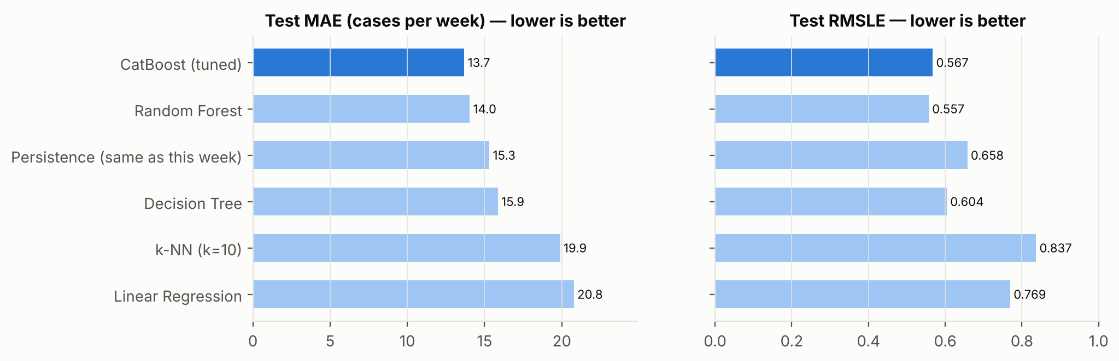
Figure 5. Test MAE and RMSLE for all models. CatBoost is shown in dark blue.
CatBoost achieved the lowest MAE (13.69) and RMSE (27.64) and the highest R² (0.819). Compared with persistence it reduced MAE by 11% and RMSE by 12%. Compared with the random forest, the strongest lecture model, it reduced RMSE by 7%, although the random forest had a slightly lower RMSLE (0.557 vs 0.567). This is consistent with the loss each model was trained on- the random forest minimised error on the log scale, which favours small districts, while CatBoost's Poisson loss targets the expected count, which favours accuracy in the large districts where most cases occur. Linear regression and k-NN perform worse than persistence, confirming that the problem is non-linear.
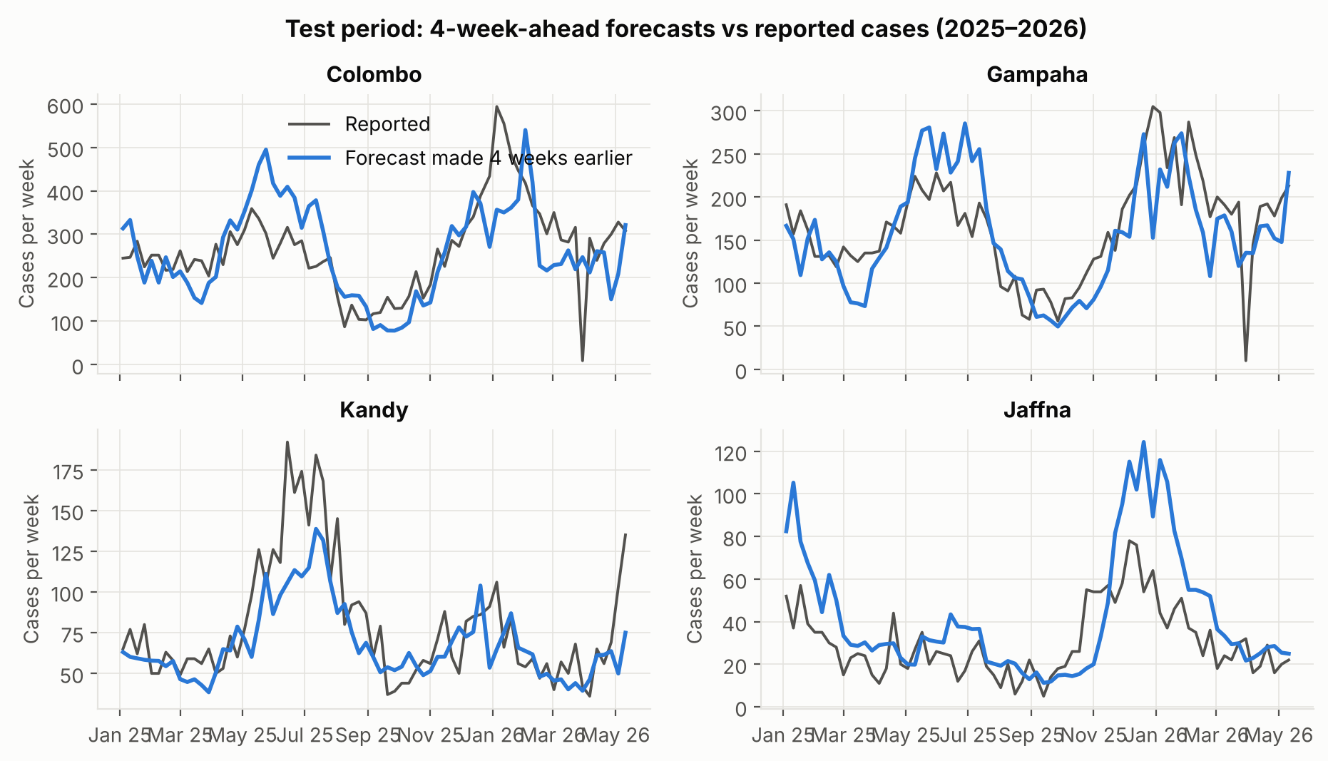
Figure 6. Forecasts made 4 weeks in advance (blue) against reported cases (grey) for four districts during the test period.
The forecasts follow both the mid-2025 and the December 2025 – January 2026 waves in all four districts. As expected of any forecast made 4 weeks in advance, turning points are detected with a short delay, and sharp single-week spikes and dips are not reproduced.
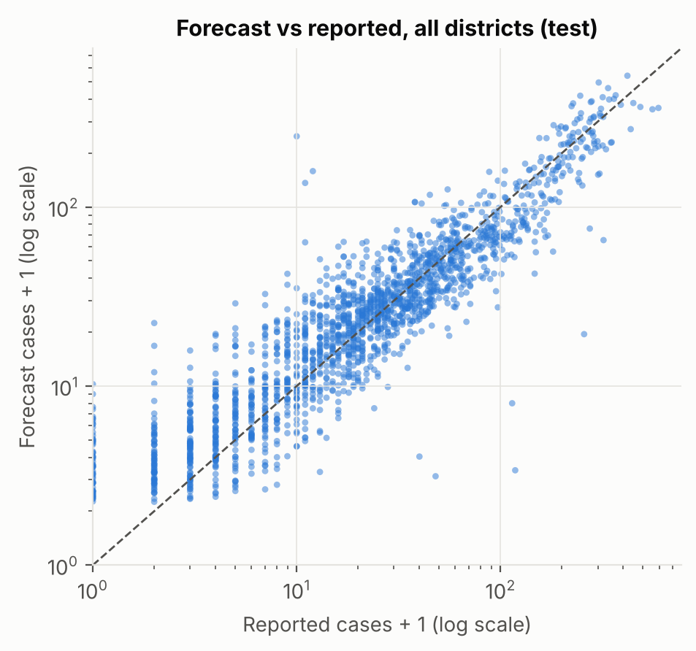
Figure 7. Forecast against reported cases for all test district-weeks (log scales).
Table 6. Rolling-origin evaluation- each year is forecast by a model trained only on earlier years.
Test year | CatBoost MAE | Persistence MAE | CatBoost RMSE | Persistence RMSE
2019 | 29.8 | 27.3 | 73.2 | 59.8
2020 | 14.3 | 16.9 | 30.1 | 40.5
2021 | 10.1 | 10.4 | 24.2 | 26.4
2022 | 14.1 | 14.9 | 24.3 | 24.8
2023 | 26.7 | 28.7 | 57.5 | 62.1
2024 | 12.3 | 16.9 | 25.8 | 41.3
2025 | 11.7 | 13.0 | 23.5 | 24.7

CatBoost had a lower MAE than persistence in 6 of 7 years and a lower RMSE in 6 of 7. The exception is 2019, the year of a large unexpected epidemic, when the model, trained mostly on calmer years, under-forecast the surge. This is a known weakness of forecasting models in epidemic years and is discussed in Section 5.
Table 7. High-risk week detection on the test set (a week is high-risk when cases exceed the district's 75th percentile; 45% of test weeks).
Method | Precision | Recall | F1 | AUC
CatBoost | 0.66 | 0.81 | 0.73 | 0.795
Persistence | 0.69 | 0.68 | 0.68 | 0.770

As an early-warning tool CatBoost identified 81% of high-risk weeks four weeks ahead, compared with 68% for persistence, at a modest cost in precision. For public-health warnings, a higher recall is usually preferred, because a missed outbreak costs more than an unnecessary inspection.
By district, CatBoost beat persistence in 20 of 26 districts. Relative error (MAE ÷ mean cases) was lowest in high-incidence districts such as Gampaha, Kandy and Colombo (about 0.22–0.27) and highest in the low-incidence northern districts (Mannar, Vavuniya, Kilinochchi, Mullaitivu), where weekly counts are often 0–5 cases and are dominated by random variation.

Explainability and Interpretation
Three methods were used. SHAP (Lundberg & Lee, 2017) decomposes each forecast into an additive contribution from every input. With TreeSHAP (Lundberg et al., 2020) these values are exact for tree ensembles. Because the model uses a Poisson log link, SHAP values are on the log scale- a contribution of +0.1 multiplies the forecast by e^{0.1} ≈ 1.105, or +10.5%. Partial dependence plots with centred ICE curves (Friedman, 2001; Goldstein et al., 2015) show how the forecast changes as one input varies. Feature-group ablation retrains the model without a group of inputs to measure how much accuracy that group adds.

Which features are most influential?
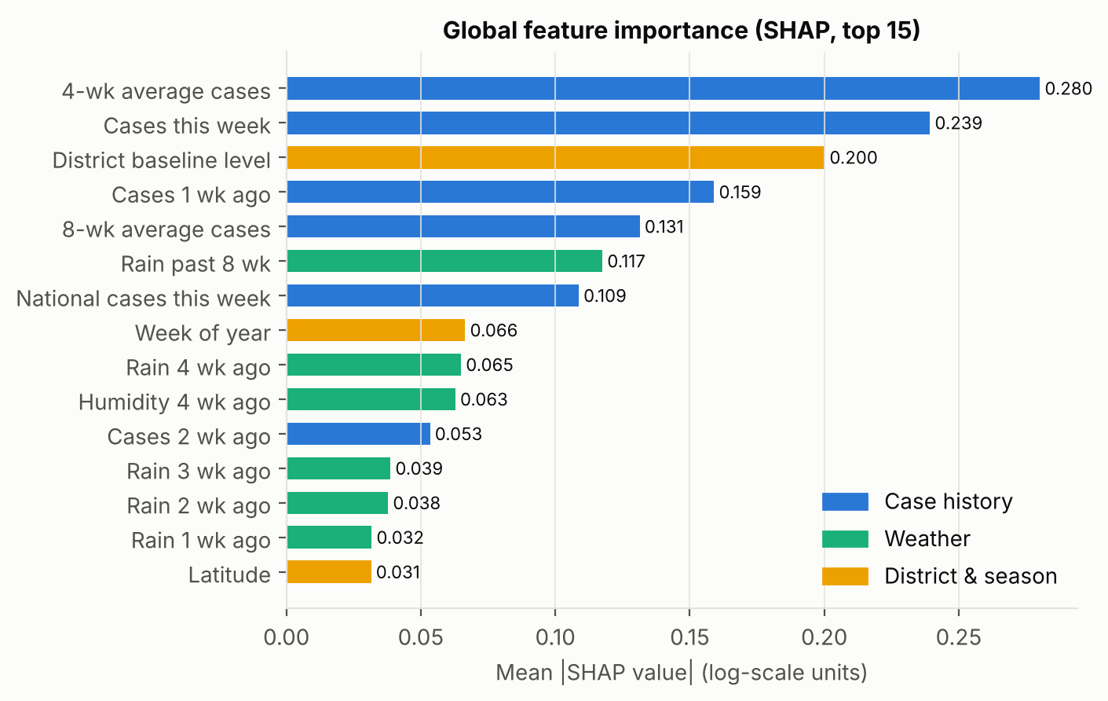
Figure 8. Mean absolute SHAP value per feature on the test set (top 15). Colours show the feature group.
Case history dominates, accounting for 57% of total SHAP attribution. The leading inputs are the 4-week average and the latest week's count. District and season account for 18%, led by the district's baseline level and the week of the year. Weather accounts for 26%, led by total rainfall over the previous 8 weeks, followed by rainfall and humidity four weeks earlier. CatBoost's own importance measure gives the same top two features, which supports the SHAP ranking.
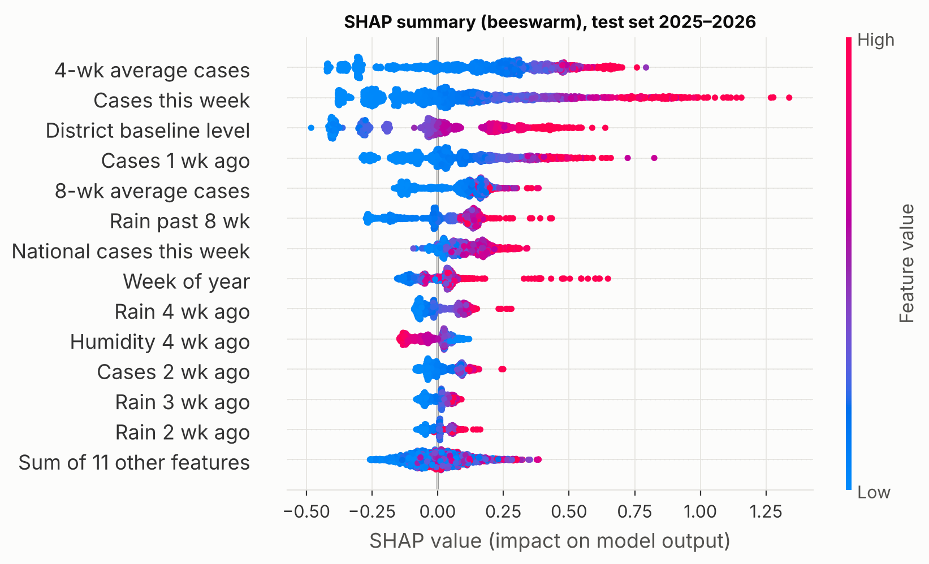
Figure 9. SHAP beeswarm for the 2025–2026 test set. Each dot is one district-week; red means a high feature value and blue a low one.

What has the model learned?
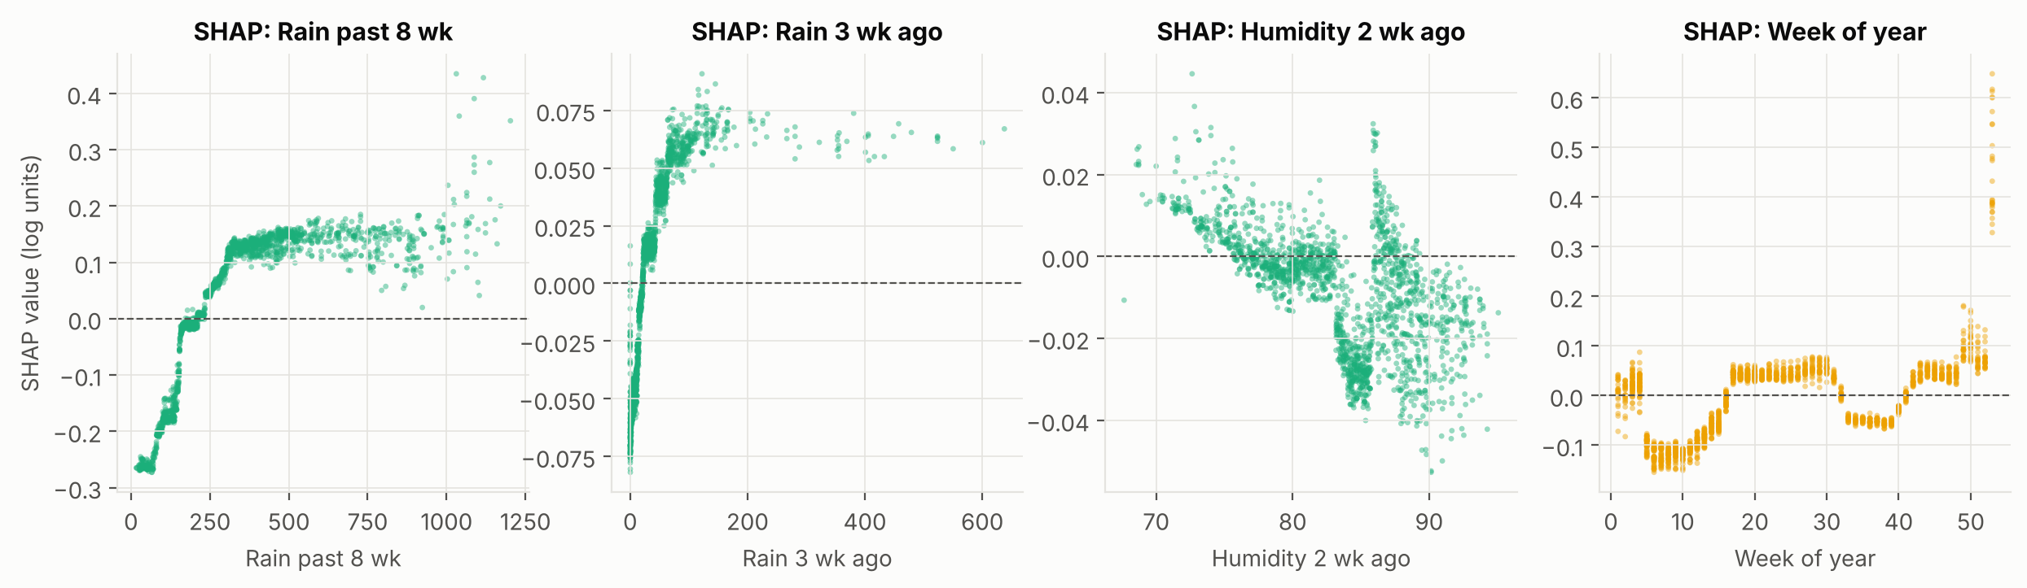
Figure 10. SHAP dependence for selected weather and season features (log-scale contributions).
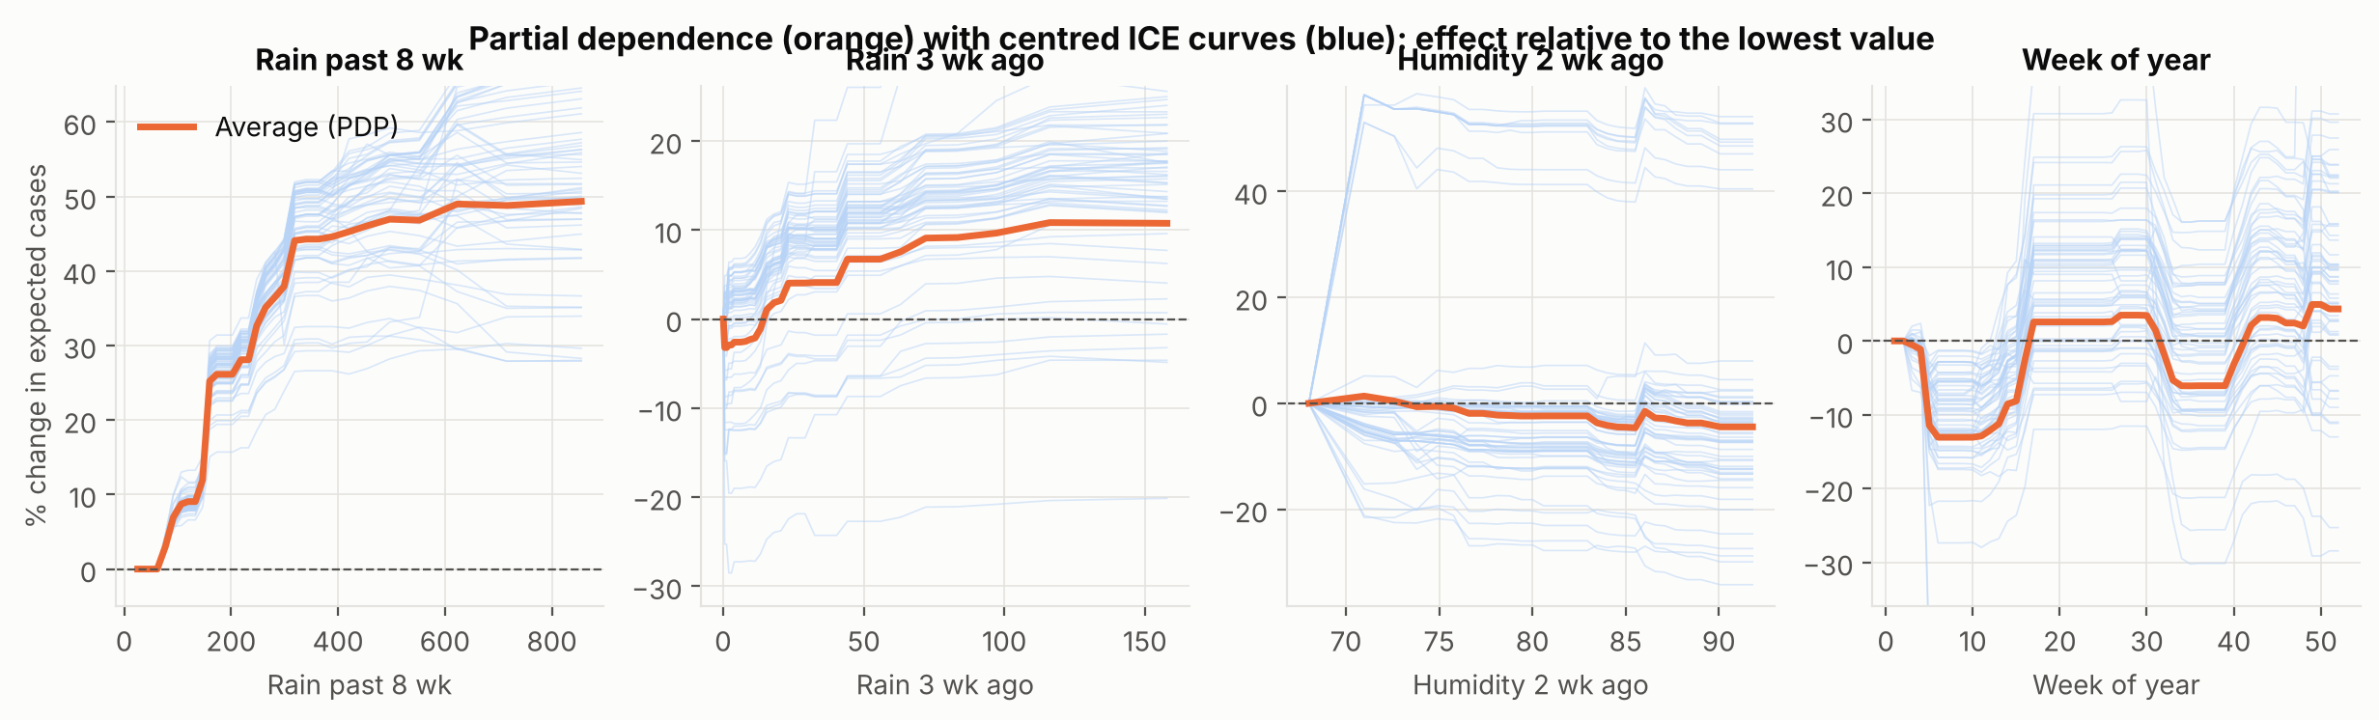
Figure 11. Partial dependence (orange) and centred ICE curves (blue), expressed as the % change in expected cases relative to the lowest value of each feature.
- Recent cases. More cases now means more cases in four weeks, with diminishing returns at very high counts, so the model expects epidemics to level off rather than grow without limit.
- Rainfall over 8 weeks. Expected cases rise steadily with cumulative rainfall and level off at about +49% once total rain over 8 weeks exceeds roughly 350–500 mm. This matches the biology- rain creates breeding sites with a lag of several weeks, but very heavy rain can flush larvae away, so the effect saturates.
- Rain 3–4 weeks earlier has a smaller positive effect beyond very dry weeks, consistent with the mosquito egg-to-adult cycle of 1–2 weeks plus the virus's incubation period.
- Seasonality. Forecasts are lowest in February–March (about -13% relative to week 1) and highest in June–July and December. These are the two monsoon-driven peaks of Sri Lanka's dengue calendar shown in Figure 2.
- Humidity. Effects are small (within about ±5%), and slightly negative at the highest humidity, which is discussed below.

Local explanation of one forecast
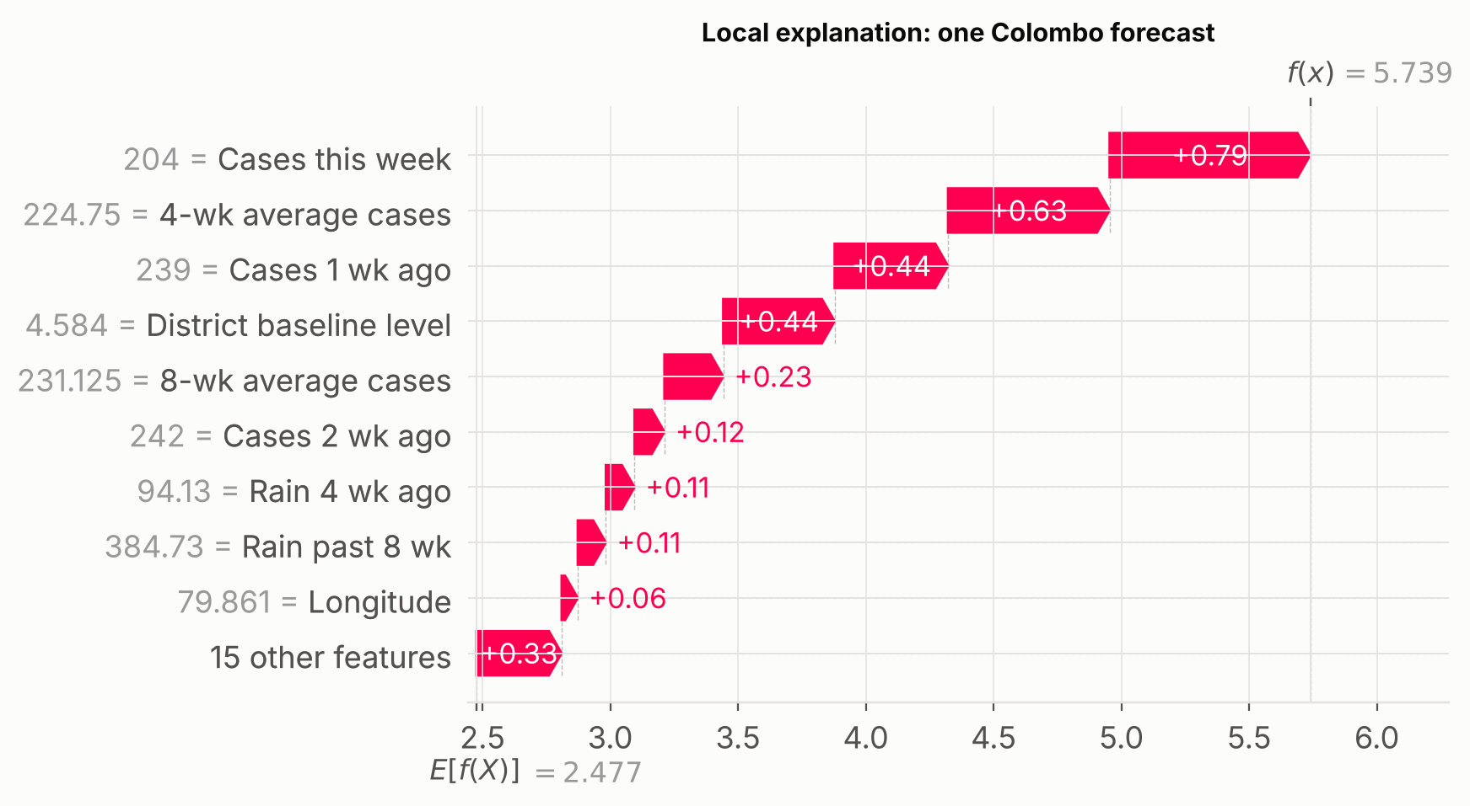
Figure 12. SHAP waterfall for one Colombo forecast. The x-axis is the model's log-scale output; e raised to the final value gives the forecast count.
In the week of 29 March 2025, Colombo reported 204 cases. Starting from the average log-forecast (2.48, about 12 cases), the high current count, the high 4-week average and Colombo's high baseline level each raised the forecast. The model forecast 311 cases for the week of 2025-04-26; 276 were reported. A health officer can read the explanation directly- the rise is driven by the current upward trend in a high-burden district rather than by an unusual weather signal.

Does the model's behaviour align with domain knowledge?
Mostly yes. The importance of recent cases reflects dengue's transmission chain. The lagged, saturating rainfall effect, peaking about two months after rain (Figure 3), agrees with the entomological literature on breeding-site creation and virus incubation (Morin et al., 2013). The two seasonal peaks match Sri Lanka's two monsoons, and Colombo, Gampaha and Kalutara having the highest baseline levels reflects population density and urbanisation in the Western Province.
Two findings need careful interpretation. First, humidity shows a small negative effect at the highest values, whereas laboratory studies show that humidity improves mosquito survival. The likely explanation is confounding- the most humid weeks coincide with heavy-rain periods that the model already credits to rainfall, and the coarse NASA grid cannot capture micro-climate. The effect is too small to interpret causally.

Ablation- does the model need weather?
Table 8. Test-set accuracy when CatBoost is retrained with different groups of inputs.
Input set | MAE | RMSE | R² | RMSLE
District & season only | 20.33 | 41.85 | 0.585 | 0.695
All features | 13.69 | 27.64 | 0.819 | 0.567
Without weather | 12.91 | 26.69 | 0.831 | 0.555
Without case history (weather + season + district) | 21.86 | 45.85 | 0.502 | 0.736

Second, the ablation in Table 8 qualifies the weather findings. Weather inputs did not improve accuracy on the 2025–2026 test period in either setting. Adding weather to a district-and-season model lowered R² from 0.585 to 0.502, and removing weather from the full model raised R² slightly, from 0.819 to 0.831 (MAE 13.7 → 12.9). So although SHAP attributes 26% of the model's reasoning to weather, and the learned shapes are epidemiologically plausible, the weather signal learned from 2008–2024 did not generalise to the test period. Likely reasons-
- Shared seasonality. Much of the rain–dengue correlation in Figure 3 comes from both following the monsoon calendar, which the week-of-year feature already captures.
- Redundancy. Rain affects dengue with a lag, so its effect is already visible in recent case counts by the time a forecast is made.
- Coarse data. One gridded point per district is a noisy measure of the rainfall that matters, which falls in local containers, drains and construction sites.
- Other drivers. Year-to-year changes such as serotype shifts, population immunity and control activities can outweigh weather.
This is a useful lesson in reading XAI outputs- SHAP explains how a particular model distributes its reasoning between correlated inputs, not how much each input adds to accuracy. Only the ablation answers the second question. Weather was kept in the deployed model so that the what-if tool can explore rainfall scenarios. For operational forecasting, the leaner model without weather would be recommended, unless better local rainfall data become available.

Critical Discussion

Limitations of the model
- Inherent forecast lag. Because recent cases dominate, the model detects turning points late and under-forecasts the start of unusually large epidemics, as the 2019 rolling-origin result showed. It extrapolates from history and cannot anticipate new events such as a new circulating serotype.
- No uncertainty intervals. The model gives a single number. Health officers would benefit from prediction intervals, for example from quantile regression or from the Poisson distribution around the forecast mean.
- Missing drivers. Population, urbanisation, serotype, vector surveys, school terms and control activities are not included. Control activities create feedback- a successful campaign makes the forecast look wrong.
- Single horizon. Only 4-week-ahead forecasts were developed. Shorter horizons are more accurate (in preliminary work, 1-week-ahead MAE was about 10 cases) but give less time to act.

Data quality issues
- Reporting artefacts. Reported cases depend on health-seeking behaviour, testing and reporting, not only on infection. Holiday weeks show clear dips- national reported cases fell by more than half in the Sinhala and Tamil New Year weeks of 2009, 2011, 2012 and 2022. In April 2026, Colombo reported only 9 cases in one week between weeks of about 300. These dips are reporting gaps, not real changes in transmission, and they distort lag features.
- Structural changes. COVID-19 disrupted health-care use and surveillance in 2020–2021, and the reporting calendar changed in 2026.
- Reporting delay. Weekly reports are published after a delay and may be revised later. The model assumes the latest week's count is final, so in real-time use the effective lead time is shorter than 4 weeks.
- Coarse weather. NASA POWER values are gridded estimates (cells of roughly 50 km) at one point per district. They cannot represent rainfall across large or mountainous districts, and they are not station measurements.
- Administrative units. Kalmunai is a regional health division rather than an administrative district, and its weather is taken at one coordinate.

Risks of bias or unfairness
No individuals are involved, but the model can still be unequal between districts. Errors are relatively much larger in the low-incidence northern districts (Mannar, Vavuniya, Kilinochchi, Mullaitivu), where counts are small and data are sparser. If forecasts were used to allocate resources by absolute numbers, populous Western Province districts would always come first and outbreaks in smaller or rural districts could be overlooked. To reduce this risk, the application expresses risk relative to each district's own history (percentile-based levels), so a small district can still be flagged as very high risk. Under-reporting may also be uneven- areas with less access to health care, or more patients treated privately, report a smaller share of true infections, and any model trained on reported cases inherits this bias.

Real-world impact and ethical considerations
Used well, a 4-week warning could help schedule clean-up campaigns before peaks, plan hospital capacity and target public awareness messages. There are also risks. A false alarm could lead to unnecessary insecticide fogging, with environmental and resistance costs; a missed warning could create false reassurance. Forecasts should therefore support, not replace, the judgement of epidemiologists and Medical Officers of Health, and be read alongside entomological surveillance. The application shows its own track record and states its limitations. Any operational use would require validation with the Epidemiology Unit, monitoring of forecast accuracy, and regular retraining. Public communication of district risk levels should be handled carefully to avoid stigmatising particular areas.

Front-End Integration
The trained model is deployed as a self-contained web application (webapp/index.html). The CatBoost model is exported to JSON and evaluated by a small JavaScript engine, which also computes exact TreeSHAP values in the browser. Its output was checked against the Python CatBoost and SHAP libraries on random test rows- the maximum differences were below 0.001 cases for forecasts and below 10⁻⁶ for SHAP values. The app needs no server or installation; it opens in any modern browser and also works on phones. Users can-
- choose a district and the latest reported week, and see the 4-week forecast, its risk level (Low, Moderate, High, Very high, relative to the district's history) and the number actually reported;
- edit recent case counts, weekly rainfall, temperature and humidity in a what-if panel; derived features such as 4- and 8-week totals are recalculated, and the forecast and explanation update immediately;
- see a "Why this forecast?" SHAP chart that shows each input's effect as a percentage change, with a plain-language summary of the three biggest influences;
- view the district's track record for 2025–2026 (forecast against reported cases, with the 90th-percentile band) and click any week to open its forecast;
- compare all 26 districts in an island-wide ranking for the selected week.
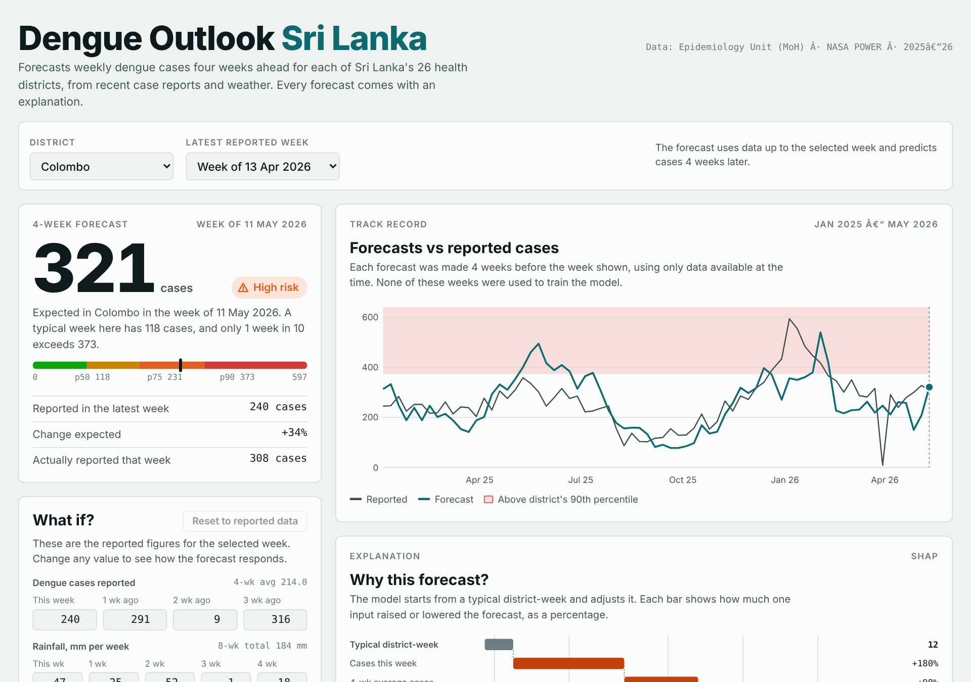
Figure 13. The Dengue Outlook Sri Lanka web application (desktop view).

Conclusion
Using official Sri Lankan dengue surveillance data and NASA POWER weather up to May 2026, a CatBoost model with a Poisson loss forecasts district dengue cases four weeks ahead with MAE = 13.7 cases per week and R² = 0.82 on 2025–2026 data. It outperforms persistence and four lecture models and detects 81% of high-risk weeks. Explainability analysis shows that it combines recent case trends, district baselines, seasonal timing and lagged rainfall in ways consistent with dengue epidemiology. However, the ablation shows that the gridded weather inputs add no measurable accuracy on 2025–2026 data, so SHAP attributions should not be read as evidence of an input's predictive value. Future work should add prediction intervals, adjust for holiday reporting dips, test longer horizons where weather should matter more, and incorporate local rain-gauge and entomological data.

References
Epidemiology Unit, Ministry of Health, Sri Lanka. Weekly Epidemiological Report, 2006–2026. https-//www.epid.gov.lk
Friedman, J. H. (2001). Greedy function approximation- a gradient boosting machine. Annals of Statistics, 29(5), 1189–1232.
Goldstein, A., Kapelner, A., Bleich, J., & Pitkin, E. (2015). Peeking inside the black box- visualizing statistical learning with plots of individual conditional expectation. Journal of Computational and Graphical Statistics, 24(1), 44–65.
Grinsztajn, L., Oyallon, E., & Varoquaux, G. (2022). Why do tree-based models still outperform deep learning on typical tabular data? NeurIPS 2022 Datasets and Benchmarks Track.
Hyndman, R. J., & Athanasopoulos, G. (2021). Forecasting- Principles and Practice (3rd ed.). OTexts. https-//otexts.com/fpp3/
Lundberg, S. M., & Lee, S.-I. (2017). A unified approach to interpreting model predictions. Advances in Neural Information Processing Systems, 30.
Lundberg, S. M., Erion, G., Chen, H., et al. (2020). From local explanations to global understanding with explainable AI for trees. Nature Machine Intelligence, 2, 56–67.
Morin, C. W., Comrie, A. C., & Ernst, K. (2013). Climate and dengue transmission- evidence and implications. Environmental Health Perspectives, 121(11–12), 1264–1272.
NASA Langley Research Center. POWER Project (Prediction Of Worldwide Energy Resources), daily data API. https-//power.larc.nasa.gov/
Prokhorenkova, L., Gusev, G., Vorobev, A., Dorogush, A. V., & Gulin, A. (2018). CatBoost- unbiased boosting with categorical features. Advances in Neural Information Processing Systems, 31.
Talagala, T. S. denguedatahub- A Tidy Format Datasets of Dengue by Country. R package version 4.1.1. https-//github.com/thiyangt/denguedatahub

