** Uniswap**

**Centralized vs Decentralized:**

The centralized exchange where a central authority holds pools of currencies then the exchange will state their exchange rate and if both parties agree to trade then the trade will be conducted, however this means that the control of the currencies lie in the central exchange which isn't so great for a currency that aims to be decentralized. Since the centralized exchange can manipulate prices to siphon profits from consumers the solution to this is a technology called smart contracts. Using math and code smart contracts can incentivize people to become market makers by staking their tokens in liquidity pools and receiving a small award for doing so. Decentralized exchanges like Uniswap also offers less fee when compared to centralized exchanges. When liquidity providers want their assets back they can burn the pool tokens and receive back their tokens, including their share of their rewards.

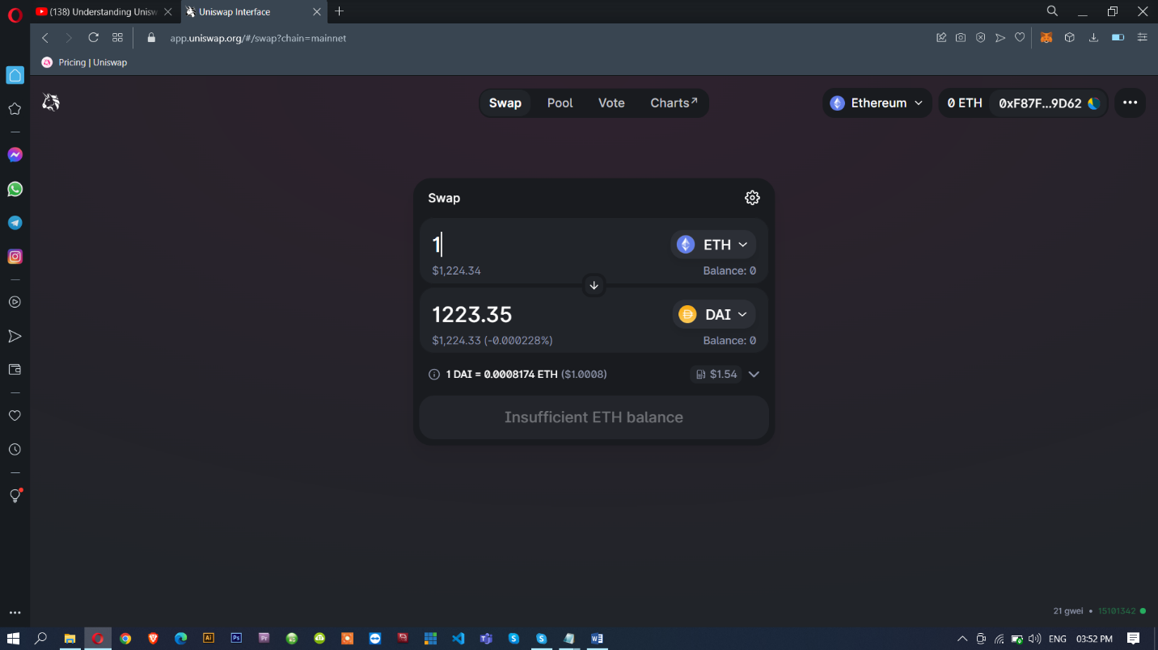

**Uniswap V1 vs V2 vs V3:**

**Uniswap V1 protocol:**

Uniswap V1 was launched on the Ethereum Main net on Nov 2, 2018. Uniswap V1 only supports the swapping of ETH-ERC 20 pairs. If the user wishes to swap USDC for DAI, the first step would be swapping USDC for ETH, succeeded by the swapping of ETH-DAI to get DAI. Uniswap V1 also facilitates the concept of LP tokens. When the Liquidity Providers (LPs) add liquidity to any pool, they receive LP tokens representing the added liquidity. These LP tokens can then be staked or burned to redeem rewards. A 0.3% trading fee is incurred to reward the liquidity providers.

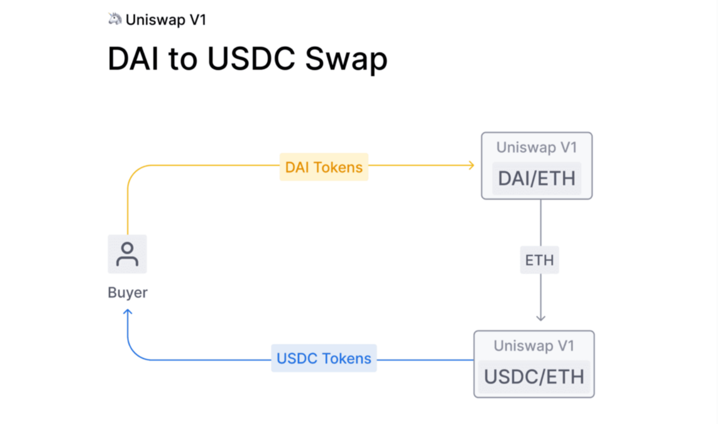

**Uniswap V2 protocol:**

The Uniswap V1’s Proof-of-Concept was a great hit, and this boosted the network to launch an updated version of Uniswap V2 in May 2020. The major drawback with the Uniswap V1 was the “ETH bridging” problem, i.e., the absence of ERC20-ERC20 token pools. This resulted in an escalated costs and high slippage when a user wants to swap one ERC20 token.

Uniswap V2 is way better than V1 in user interface and experience. Also, it eliminated the ETH bridging problem by letting in the concept of ERC20-ERC20 pools. Another significant difference is the usage of wrapped ETH in the core contracts instead of native ETH. However, the traders can use ETH through helper contracts.

Uniswap V2 also introduced a protocol fee. Community governance plays a vital role in turning on/off of this fee. A protocol fee of 0.05% of the total 0.3% trading fee will be reserved for the development of the Uniswap platform that shapes the roadmap of the network.

**Flash Swaps:**

Flash swaps are an integral feature of Uniswap V2. In fact, under the hood, all swaps are actually flash swaps! This simply means that pair contracts send output tokens to the recipient before enforcing that enough input tokens have been received.

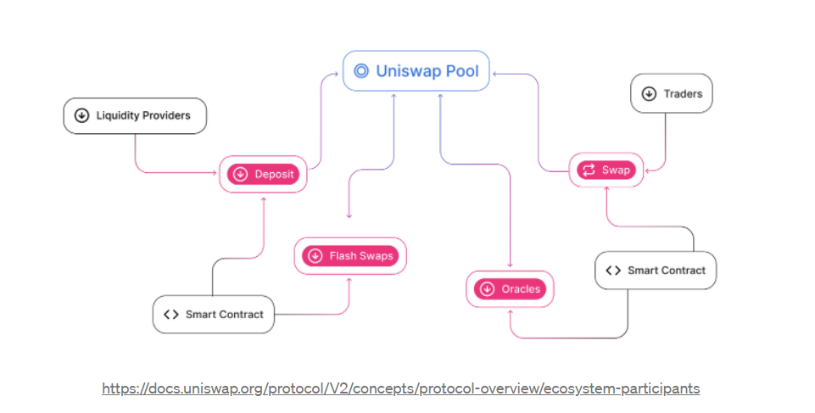

**Uniswap V3 protocol:**

The latest version, Uniswap V3, is aired on May 5, 2021. Uniswap V3, when compared to V1 and V2, provides better capital efficiency and accuracy. The fee structure is very flexible. The Liquidity providers can get high returns on their capital to provide liquidity with 4000x capital efficiency compared to V2. The main aim of Uniswap V3 is to surpass stable coin-based AMMs and centralized exchanges by facilitating low-slippage trade execution.

The main feature of the V3 is the concentrated liquidity, whereas in the V2 the amount is distributed evenly. The liquidity providers can estimate the shape of the AMM as they can build unique price curves based on their preferences. LPs’ capital can be centralized within custom price ranges, enhancing liquidity at desired prices.

When the market experiences price change and goes beyond the LP’s specified price range, the liquidity is automatically removed from the pool and will no longer earn rewards. The liquidity will be shifted to the less valuable asset while waiting for the market to arrive at the specified price range. It ensures the well-being of the liquidity providers in the Uniswap trading ecosystem. At the same time, LPs can update their price range to meet the current market price range to start getting rewards again.

Unlike the LP tokens in the V2 which are fungible, LP tokens in the V3 are in the form of NFT as the tokens need to fit in the price range. A unique NFT representing your position in the specific pool will be generated based on the pool and the parameters you select on the liquidity-providing interface. As the owner of the NFT, you can modify or redeem the position at any

time. Uniswap V3’s NFTs are supported by XML-based vector images based on two-dimensional graphics with animation and interaction functions.

**Features of Uniswap V3:**

1. *Concentrated Liquidity*
2. *Liquidity is active*
3. *Flexible fee*

On top of all the Uniswap V3 is licensed for 2 years where no one can use or fork the code.

**Liquidity pool:**

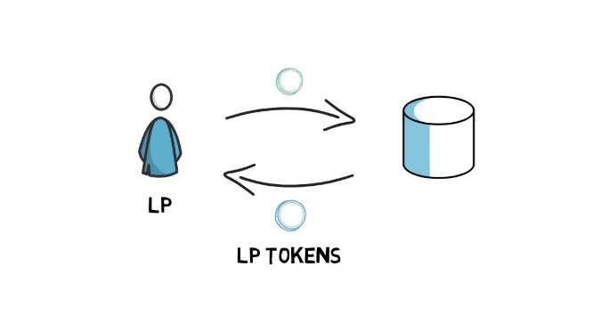A liquidity Pool is a collection of tokens or digital assets locked in a smart contract that provides essential liquidity to decentralized exchanges.

In Uniswap liquidity pool is a trading venue for a pair of ERC20 tokens. When a pool contract is created, the balances of each token are 0. In order for the pool to begin facilitating trades, someone must seed it with an initial deposit of each token. This first liquidity provider is the one who sets the initial price of the pool. They are incentivized to deposit an equal value of both tokens into the pool.

**Liquidity provider:**

Liquidity provider provides the ERC20 pair tokens to the liquidity pool which helps the DEX to exchange the cryptocurrencies. In return they earn rewards.

**Arbitrage Trading:**

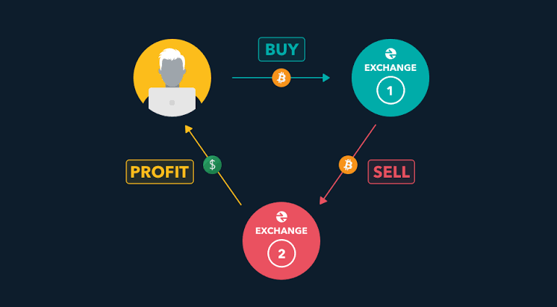Arbitrage is the simultaneous purchase and sale of the same asset in different markets in order to profit from tiny differences in the asset's listed price. It exploits short-lived variations in the price of identical or similar financial instruments in different markets or in different forms.

In simple words Arbitrage trader is the one who comes into action when there is a price difference in the stocks cryptocurrencies in the different centralized or decentralized exchanges and takes advantage of the price gap to gain profits.

For example, let’s say the price of ETH in the Binance Exchange is 100$ whereas the price in the Uniswap exchange is 98$, so here the arbitrage trader buys the ETH in the Uniswap and sells it in the Binance Exchange until the price in the Uniswap gets 100$. By doing this simple transaction traders earn profit.

**Impermanent loss:**

From a practical perspective, an impermanent loss is a net difference between the value of two cryptocurrency assets in a [liquidity pool](https://www.blockchain-council.org/defi/crypto-liquidity-pools/)-based automated market maker. It can happen by simply holding the assets in a [cryptocurrency wallet](https://www.blockchain-council.org/blockchain/types-of-crypto-wallets-explained/).

Impermanent loss is the unrealized loss that occurs when your share of a liquidity provider position becomes uneven compared to its original position

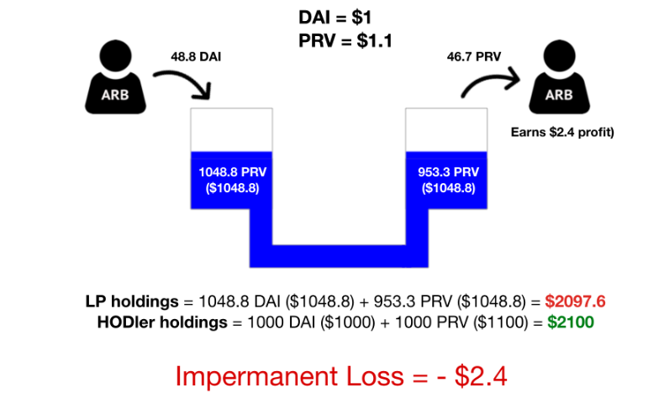In simple words impermanent loss is the loss that you get when you have less money by investing in a liquidity pool compared to the value of the assets that you would have had if you just held them in your wallet. Impermanent loss becomes permanent whenever you cash out your liquidity until you do that there is still an opportunity for the loss to normal itself out.

**Let’s understand with a simple example:**

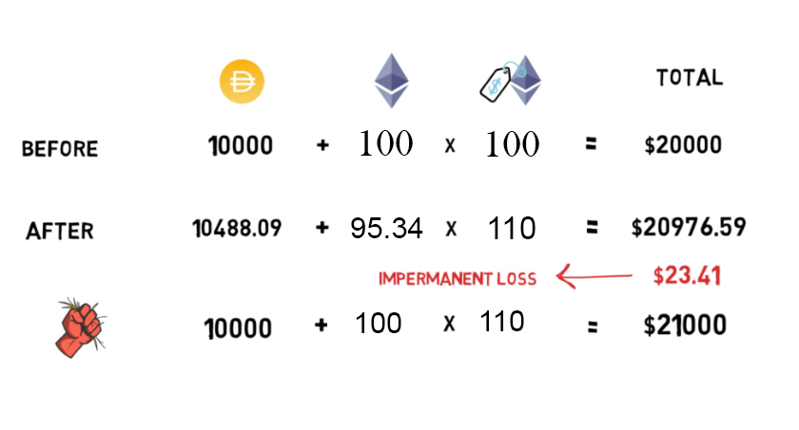LP1 provided a ETH – DAI pair with a 100ETH – 10000 DAI ratio which makes the value of ETH $100 in value, so the total value add up to $20000. Let’s say, the price of the ETH in the other exchange raised to $110, so here the arbitrage trader comes into action .The trader exchanges the ETH until the price inside the Uniswap equals with the external exchange value, so that he can earn by doing the arbitrage trading, he puts 488DAI in exchange where he gets 4.6 ETH back. Now the total amount of ETH inside the liquidity pool is 95.34 ETH which multiplied by 110$ gives $10,488, now by adding the both ETH ($10,488) and DAI ($10,488) in dollars which equals to $20976. Initially the LP1 provided total 20000$ in the liquidity pool, after increase in demand for the ETH the total value rose to $20976. He gained total of $976.

To calculate the impermanent loss we have to calculate the value of the assets that he would have had if he just held them in his personal wallet minus his tokens value in the liquidity pool ($20,976).

Initially he has 100ETH and 10000DAI worth 20000$, as the price of the ETH increased to $110, now the total value will be $21000 in his wallet. So to get the impermanent loss calculate net difference between the value of two cryptocurrency assets in a [liquidity pool](https://www.blockchain-council.org/defi/crypto-liquidity-pools/)-based automated market maker minus holdings of the assets in a [cryptocurrency wallet](https://www.blockchain-council.org/blockchain/types-of-crypto-wallets-explained/). Which will be equal to $24.

Here the LP1 would have made more money just by holding in his wallet, this is called impermanent loss. Impermanent loss only becomes permanent whenever the LP1 cash out liquidity until that there is still an opportunity for the loss to normal itself out.

**PRICING:**

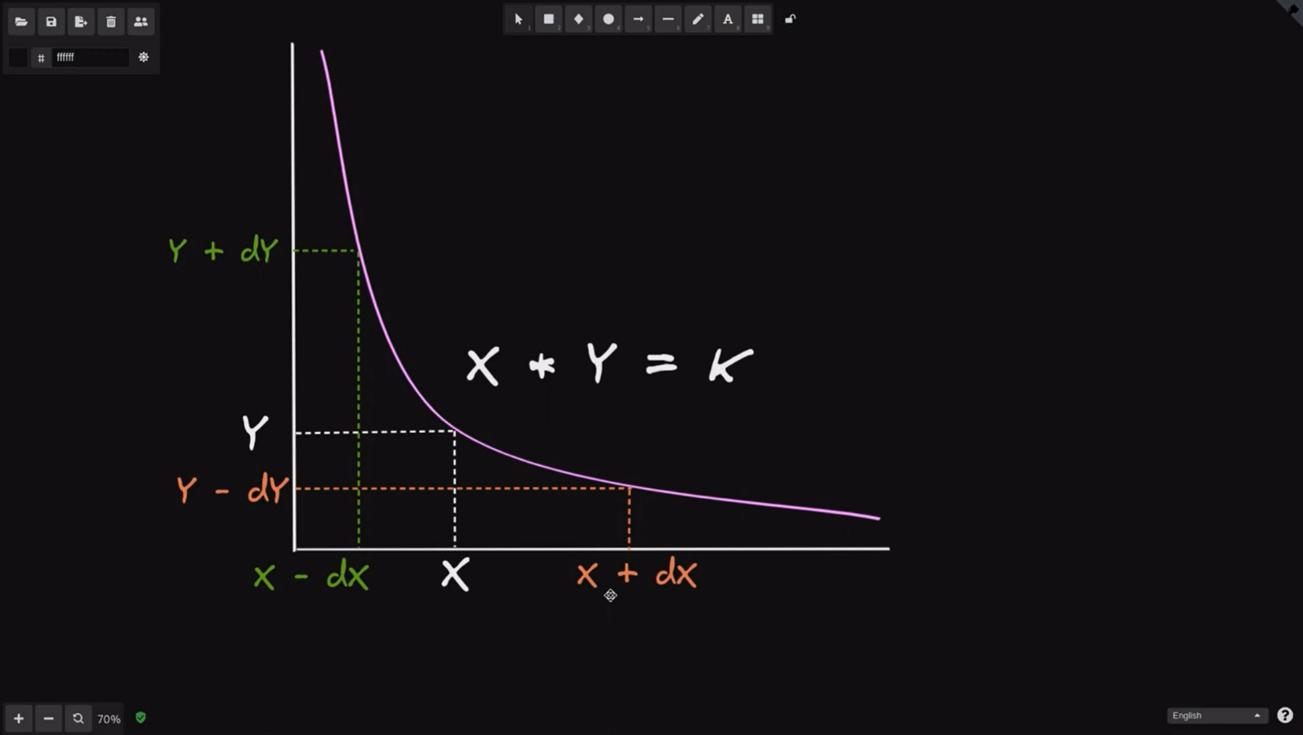The price of a token on Uniswap is calculated using a very simple formula x multiplied by y equals a constant k (x * y=k). If Trader swaps x tokens for y tokens, the amount of x tokens is inside the **Uniswap** smart contract will increase i.e., dx is the amount of tokens that trader is selling and dy is the amount of y tokens that he'll be getting from this trade. So in summary you put in dx coins and you get out dy tokens and that is how Uniswap determines how much y tokens you will get for selling x tokens . We can also do the opposite trade, where we're selling some y tokens and getting some x token. We are selling y tokens so we're increasing the amount of y tokens inside the Uniswap smart contract, so for x we'll have to subtract dx from the original x and the difference between these two positions which is equal to dx is the amount of x tokens that we'll get for putting in dy tokens.

**Example for pricing:**

For example, say the first liquidity provider LP1 believes that the conversion rate of DAI and ETH should be stabilized at 1000 to 1. He will then deposit both DAI and ETH ratios to the liquidity pool, he could be wrong about the exchange rate where he will suffer something called impermanent loss.

LP1 puts in 5000 DAI and 5 ETH into the liquidity pool and in return the, liquidity pool will give him 5 liquidity tokens, these tokens are a way of keeping track of who has contributed the most in to the liquidity pool making him the LP (liquidity provider), the more share they have in liquidity pool the more liquidity tokens they get and the more ownership they have. The tokens can help them at the time of voting and earning.

Let's keep LP1 as the only liquidity provider for now and see what happens when somebody comes to make a trade. If trader1 comes along and wants to trade 5000 DAI for ETH, he will swap with 5000 DAI and the liquidity pool will calculate how much he gets by using the constant product market maker formula, this formula indicates that the product of ETH and DAI will always remain constant (X ETH * Y DAI = constant). Since the product is currently at 5000 DAI times 5 equals to 25k and we know that the future amount of DAI is going to be the original 5000 DAI plus the 5000 DAI Trader1 has deposited which equates to 10000 DAI then we divide 25k by 10k to get that the final amount that should be inside the pool, by calculating we get 2.5 and hence Trader1 should receive 5 minus 2.5. So the trader gets 2.5 ETH for giving 5000 DAI.

Now any other trader that comes along wanting to trade ETH for DAI will be subject to the same rule. So Trader2 want to swap one ETH with DAI, so after deposit of 1ETH the amount of ETH inside the pool will be 3.5 and the amount of DAI should be 7142, hence Trader2 should receive 10K minus 7142 DAI which equals to 2858 DAI tokens. Now the first thing we noticed is that trader1 had an exchange rate of 2 000 die per ETH, whereas Trader2 had an exchange rate of 2858 DAI per ETH this may seem unfair but it's actually due to the fact that Trader2 traded at a time where ETH was more scarce. So it works on Supply and demand.

Now as the Liquidity providers should get some rewards or incentives for providing the liquidity. The rewarding amount will be from fee that are paid by the users while swapping for the tokens i.e., 0.3% of user’s deposit amount. The liquidity providers will be rewarded according to the share of the liquidity tokens they are holding, here in this example LP1 is the only liquidity provider so he gets the 100% of the rewards, now the second person came let’s say his name is LP2 he wants to become an LP so he provides 10000 DAI tokens in return he get 10 liquidity pool tokens, now the rewards are distributed as follows

LP1 owns 5 LP tokens so he gets 33.3% of the rewards.

LP2 owns 5 LP tokens so he gets 66.6% of the rewards.

The more people enter Liquidity Pool the fewer rewards they get and the more stable the token price will be.

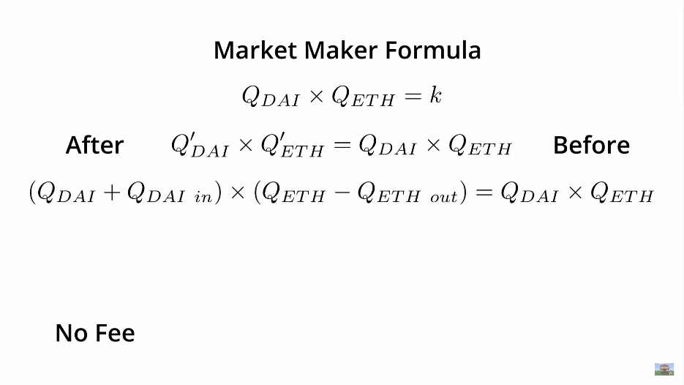

**The Market maker formula with 0.3% fee:**

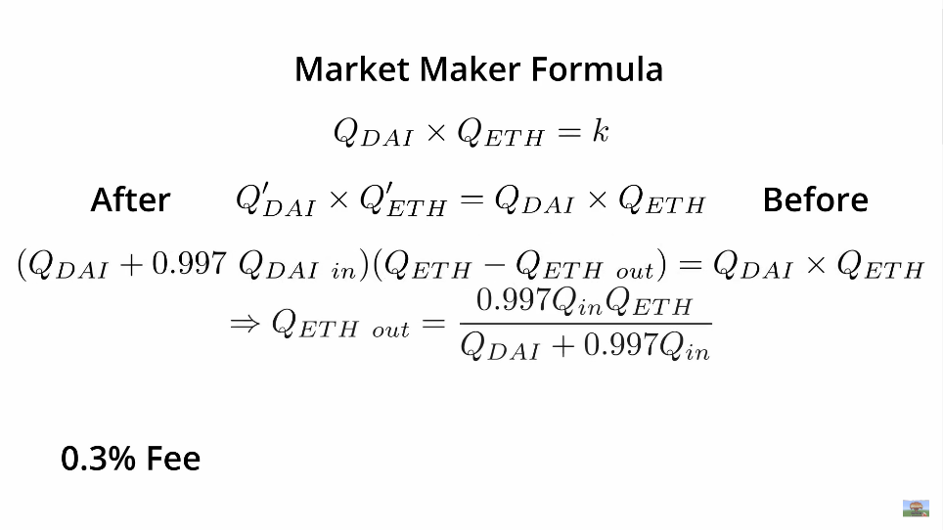

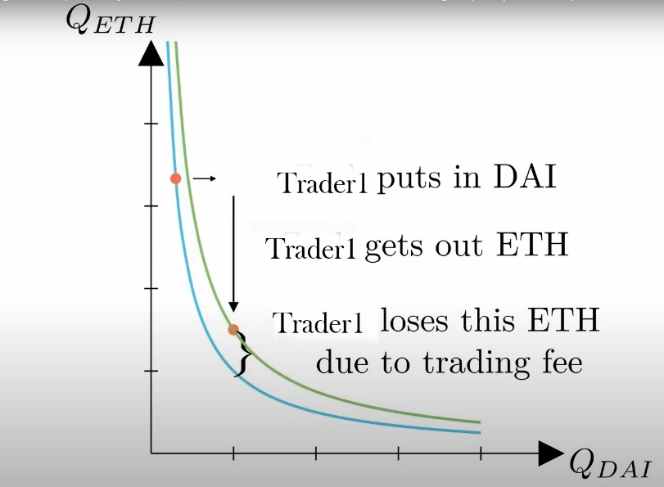

While swapping the DAI for the ETH there will be 0.3% of the 5000DAI as fee which will change the initial graph.