Multi-Agent RAG System for Academic Research Assistance
Review-02 — Presentation Explanation & Project Companion
Data Engineering · Exploratory Data Analysis · Feature Engineering
M.Tech (AI & ML) · Mini Project · AY 2025–26 · Review-02 (due 20 June 2026)
A companion to Project_Review_02.pptx — every slide explained, with the project content behind it.

Contents

1. How to use this document
This document is the explanatory companion to the Review-02 slide deck (Project_Review_02.pptx). The slides carry headings and visuals; this document carries the full reasoning behind each one. For every slide you will find four parts: what is on the slide, the concept explained from first principles, how that concept applies concretely to our project, and a talking point with the panel question it is most likely to attract.
Read sections 2 to 6 before the review. Section 2 summarises the whole project so this document stands on its own. Section 3 is the slide-by-slide walkthrough. Section 4 is a glossary of every technical term used. Section 5 is a set of anticipated panel questions with answers. Section 6 collects the honesty-framing decisions that make the project defensible.

2. The project in brief

2.1 The problem we are solving
A researcher writing one paper often has to read fifty others first, which can take weeks. AI assistants can speed this up, but they have a serious failure mode: they hallucinate citations. A 2024 study by Wallat and colleagues found that up to 57% of citations produced by Retrieval-Augmented Generation (RAG) systems are unfaithful — the cited source does not actually support the claim. Our project targets exactly this gap.

2.2 What we are building
A Multi-Agent RAG system that answers questions about a library of research PDFs and verifies that every citation is genuinely supported by its evidence. The work is split across four small specialised agents, like an assembly line: a Planner breaks a complex question into sub-questions; a Retriever finds the most relevant chunks of text and re-searches if they look weak (CRAG-style correction); a Synthesizer writes the answer with inline citations; and a Verifier — our novelty — uses a Natural Language Inference (NLI) model to score whether each sentence is actually entailed by its cited chunk, rejecting and revising the ones that are not.
It runs on an ordinary CPU laptop (no GPU) and offers two interchangeable LLM backends: a fast cloud mode (Groq, Llama 4 Scout 17B) and a fully local privacy mode (Ollama, Phi-3 mini). The retriever, the search index and the verifier always run locally; only the answer-writing LLM call differs between the two modes.

2.3 Why Review-02 is about data
Every AI system is only as good as the data it stands on. For a RAG system the "data" is not a labelled training table — it is the document corpus and the searchable index built from it. Review-02 therefore explains where that corpus comes from (§3 Data Engineering), what it looks like once processed (§4 Exploratory Data Analysis), and how raw text is turned into the numerical features retrieval runs on (§5 Feature Engineering).

2.4 One honest framing, stated up front
Our project uses off-the-shelf models and does no fine-tuning. Several classic machine-learning data steps — a train/validation/test split, SMOTE for class imbalance, wrapper-style feature selection — therefore do not apply in their textbook form. Rather than invent them, we reframe each one honestly for a retrieval system and say plainly where a step is handled differently or is not applicable. This is deliberate methodology, and it is one of the strongest points to make to the panel.

3. Slide-by-slide explanation

Slide 1 — Title
On the slide: Project title, the three Review-02 themes, and three badges: CPU-only Agentic RAG, NLI Citation Verifier, due 20 June 2026.
Explanation: The title slide frames the scope of this review: the data side of the project. The badges restate the two things that make the project distinctive — it needs no GPU, and it verifies its own citations.
In our project: These two claims (CPU-only and verified citations) are what separate us from prior multi-agent RAG systems such as SQuAI, MA-RAG and MAIN-RAG.
How to present / likely question: Open by saying Review-01 covered the problem and architecture; Review-02 covers how the data that feeds that architecture is engineered, explored and turned into features.

Slide 2 — Agenda
On the slide: A five-row map: Recap, §3 Data Engineering (3.1–3.7), §4 EDA (4.1–4.5), §5 Feature Engineering (5.1–5.5), and what comes next.
Explanation: The agenda mirrors the official review schedule exactly, so the panel can tick off each required sub-topic as you present it.
In our project: Sections 3, 4 and 5 are the three mandated Review-02 deliverables; we present them in order.
How to present / likely question: If asked why these three sections belong together: they are the data lifecycle — acquire and engineer it (3), understand it (4), represent it as features (5).

Slide 3 — Recap of Review-01
On the slide: Four points — the 57% problem, the four agents, the NLI-verifier novelty, and the CPU/dual-backend constraints — beside a small embedding-space picture.
Explanation: A one-slide reminder so the panel has the architecture in mind before we dive into data.
In our project: The Verifier is the research contribution; everything in Review-02 ultimately exists to feed reliable evidence to that Verifier.
How to present / likely question: Keep this to 30 seconds. If pressed on novelty, say: multi-agent RAG already exists; treating citation verification as a dedicated, independent NLI agent with a reject-and-revise loop is what is new.

Section 3 divider — Data Engineering & Dataset Overview
On the slide: Section title: how a pile of PDFs becomes a verifiable, searchable evidence base.
Explanation: Data engineering is the set of steps that turn raw source documents into clean, structured, indexed data a system can query reliably.

Slide — 3.1 Data Sources
On the slide: Four numbered sources: the arXiv RAG-papers corpus, the acquisition route, the 20-question benchmark, and the verifier's NLI signals.
Explanation: "Data sources" means everywhere the system's information originates. Industry RAG systems pull from APIs, public datasets, logs and IoT streams; the academic analogue here is scholarly PDFs plus an evaluation set.
In our project: The primary corpus is 30–50 arXiv papers on "RAG techniques 2023–2025" (Self-RAG, CRAG, RAGAS, Adaptive-RAG, SQuAI, MA-RAG, MAIN-RAG). We acquire them via the arXiv API / bulk full-text — the analogue of public-dataset and API ingestion. A user can also bring their own PDFs at runtime. The 20-question benchmark and the off-the-shelf NLI entailment labels are data sources used for measurement, not for training.
How to present / likely question: Expected question: "Is this real industry data?" Answer: it is real public scientific data; the acquisition pattern (API + bulk corpus + user uploads) is the same one enterprise RAG products use.

Slide — 3.2 Dataset Description
On the slide: Two tables — corpus scale (target vs a sample run) and the per-chunk schema.
Explanation: Describing a dataset means stating its size, its fields and their data types. For a RAG corpus the atomic record is not a row but a chunk — a passage of text plus metadata.
In our project: The target corpus is 30–50 PDFs producing roughly 900–1,200 chunks. We validated the pipeline on a 21-document sample that produced 101 chunks with a mean length of about 1,802 characters (~450 tokens). Each chunk carries: chunk_id (a hash), text, source filename, page, section, character offsets, and a 384-dimensional embedding vector.
How to present / likely question: If asked why two columns: the target is the planned corpus; the sample run proves the chunker actually works and gives honest measured numbers now.

Slide — 3.3 Data Collection Pipeline
On the slide: A six-stage pipeline diagram: Sources → Parse → Preprocess → Chunk → Embed → Store, with a quality gate beneath it.
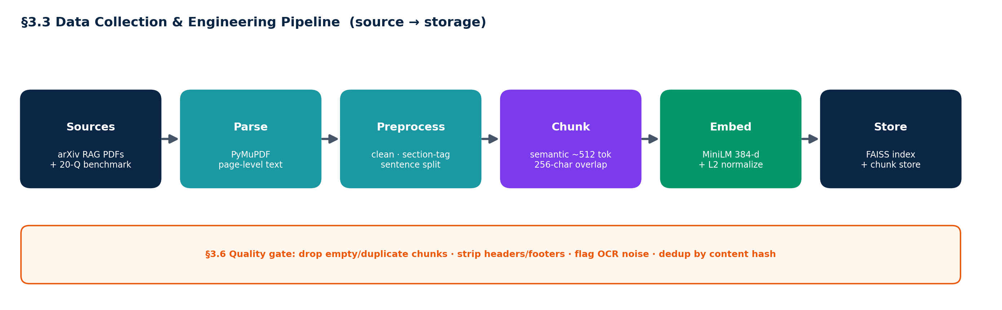
§3.3 The data-collection pipeline, source to storage — fully local.
Explanation: A data pipeline is the automated path from raw source to queryable storage. Ours: PyMuPDF extracts text page by page; preprocessing cleans and tags it; the chunker splits it into semantically coherent passages; MiniLM embeds each passage into a vector; FAISS stores those vectors for fast similarity search.
In our project: Crucially, this whole pipeline runs on the device. PDFs never leave the laptop; embedding, indexing and verification are all local. Only the final answer-writing LLM call may go to the cloud, and only in cloud mode.
How to present / likely question: This slide is where you make the privacy point: "the document never leaves the machine — only, optionally, the question and a few retrieved snippets, and only in cloud mode."

Slide — 3.4 Data Preprocessing
On the slide: Five steps: text extraction, cleaning, structure tagging, sentence-aware chunking, and normalization.
Explanation: Preprocessing makes raw text consistent and machine-friendly. PDFs are messy — headers, footers, hyphenation, broken lines — so we strip and normalise before chunking.
In our project: We extract text while preserving page numbers (needed for citations), strip running headers/footers, detect section headings (ALL-CAPS, numbered, "Title:" styles) to tag each chunk, then split into sentences and greedily merge them to about 512 tokens with a 256-character overlap so we never cut a sentence in half. Embeddings are L2-normalised; we deliberately do not lowercase or stem, because the transformer handles casing itself.
How to present / likely question: Expected question: "Why overlap chunks?" Answer: overlap keeps context continuous across boundaries so an answer that straddles two chunks is still retrievable.

Slide — 3.5 Data Labeling & Annotation
On the slide: Four points stressing that labels here are for evaluation, not training.
Explanation: Labeling normally means attaching ground-truth targets so a model can learn. Because we do not train any model, our labels exist purely to measure quality.
In our project: The 20 benchmark questions are hand-written, each with a verifiable ground-truth answer and its source paper(s). The NLI model labels (claim, evidence) pairs as entail/neutral/contradict automatically — no manual corpus labeling. A small human-labelled calibration set is used only to tune the verifier's 0.6 threshold. Questions are written blind and adversarially (including multi-hop and answer-not-in-corpus cases) to avoid confirmation bias.
How to present / likely question: Expected question: "Where are your labels?" Answer: we don't train, so we don't need labelled training data; our labels are an evaluation benchmark plus automatic NLI judgments.

Slide — 3.6 Data Quality Assessment
On the slide: Three stat cards (99% on-target, ~1% short, ~1% long) and four quality checks.
Explanation: Quality assessment finds and handles missing values, inconsistencies, noise and outliers before they corrupt downstream results.
In our project: On the sample, 99% of chunks fall inside the target size band, with about 1% too short and 1% too long — a clean profile. We drop empty/short chunks, de-duplicate repeated content by hash, flag OCR/parse noise, and skip figure-only pages (text-only scope). We never silently delete content: a chunk with no detected section is simply tagged "body".
How to present / likely question: Expected question: "How do you handle noisy PDFs?" Point to the quality gate: dedup by hash, drop boilerplate, flag OCR noise, keep everything else with safe defaults.

Slide — 3.7 Train–Validation–Test Split Strategy
On the slide: Four cards — retrieval index, calibration (dev), held-out test, and the comparison design.
Explanation: A train/val/test split prevents a model from being evaluated on data it learned from. The discipline is about honest measurement, not the literal three-way split.
In our project: Because nothing is fine-tuned, there is no train/val/test split of the corpus — the whole corpus is indexed, since retrieval needs full coverage. The split discipline instead lives in the evaluation: a small dev subset calibrates the verifier threshold, and the 20 benchmark questions are held out from any tuning. We compare three pipelines (baseline, multi-agent, multi-agent+verifier) on the same questions with a paired t-test (p < 0.05).
How to present / likely question: This is the most likely challenge slide. Say clearly: "We don't train, so a corpus split would be meaningless; the right analogue is a held-out evaluation benchmark, which we have."

Section 4 divider — Exploratory Data Analysis
On the slide: Section title: what the corpus looks like before any retrieval, and what that implies.
Explanation: EDA is the practice of summarising and visualising data to understand its shape, spot problems, and check assumptions before building on it.

Slide — 4.1 & 4.2 Statistical Summary & Visualization
On the slide: A four-panel chart plus a read-out table of descriptive statistics.
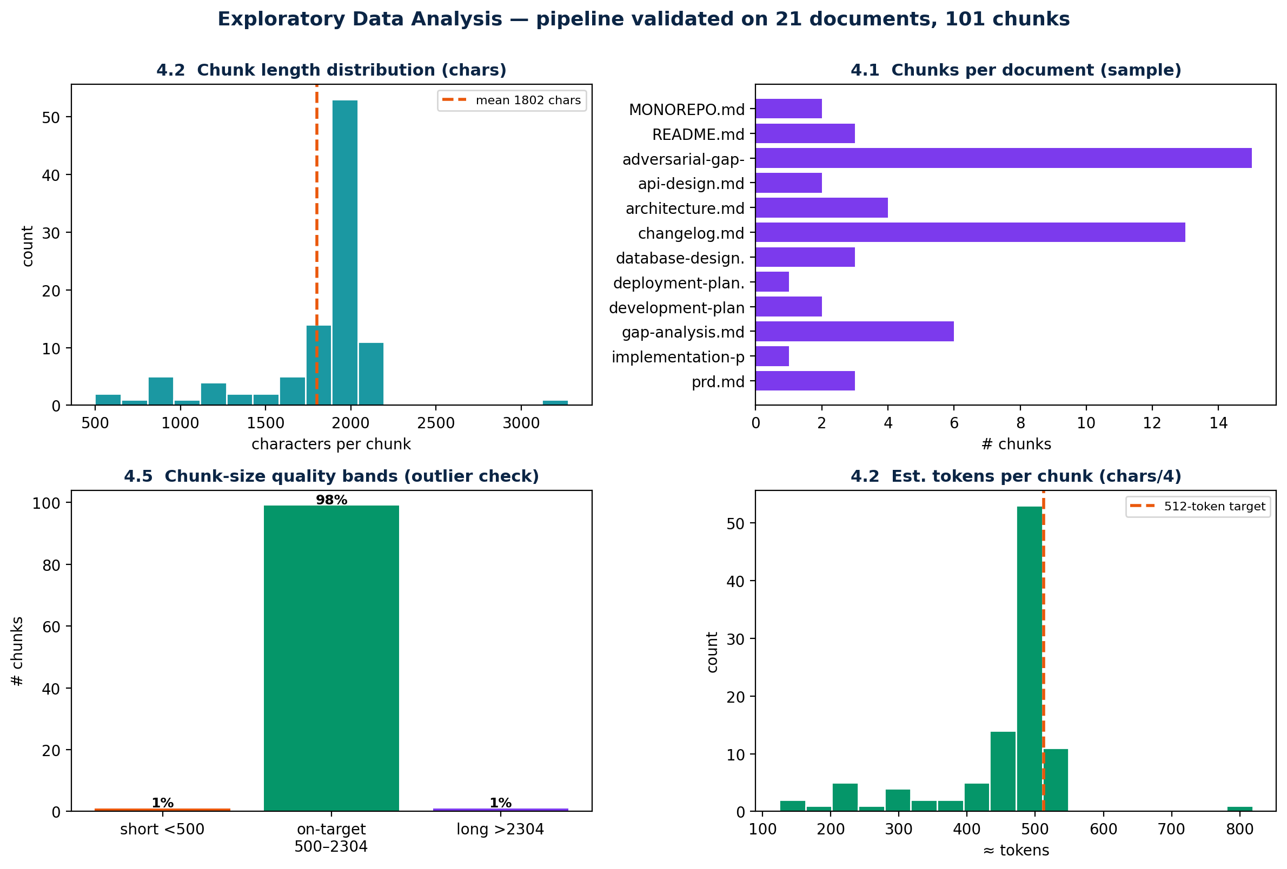
§4.1–4.2 Descriptive statistics and distributions over the chunked corpus (sample run).
Explanation: A statistical summary gives the central tendency and spread of the data; visualization (histograms, bar charts) makes the distribution legible at a glance.
In our project: The panels show chunk-length distribution, chunks per document, size-quality bands, and an estimated-tokens histogram. The distribution is tight around the 512-token target, which confirms the chunker behaves as designed — the single most important EDA check for a RAG corpus, because oversized or undersized chunks hurt retrieval precision.
How to present / likely question: If asked what the chart proves: "that our chunking is consistent — almost all chunks land near the target size, so retrieval sees uniform, well-sized passages."

Slide — 4.3 & 4.4 Insights, Patterns & Feature Correlation
On the slide: An embedding-space scatter plus four insight points.
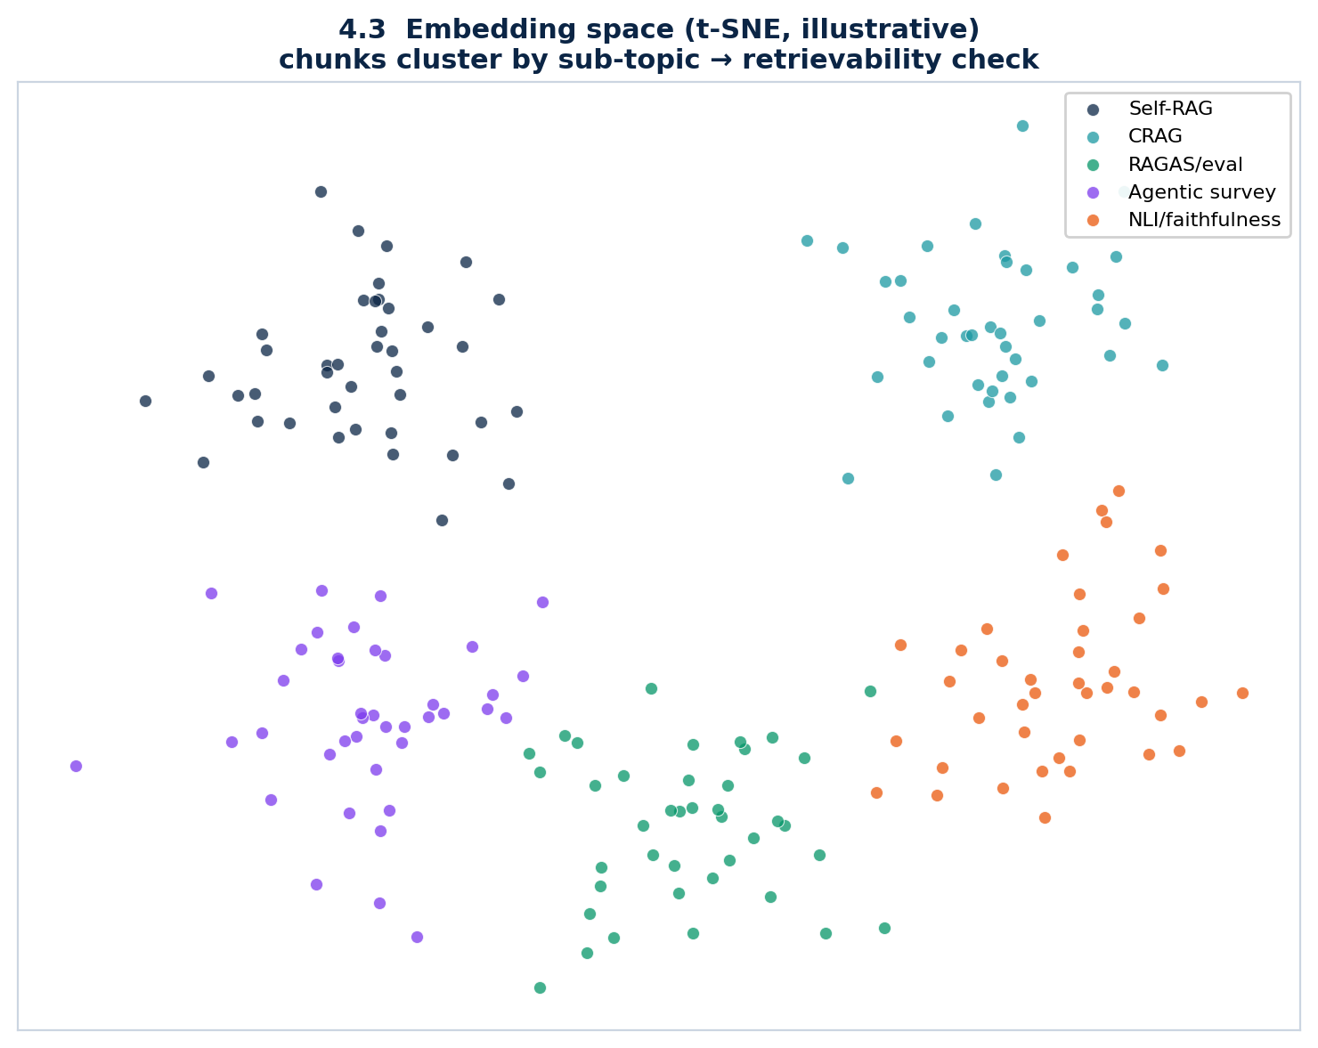
§4.3–4.4 The embedding space: chunks cluster by sub-topic, a go/no-go check for retrievability.
Explanation: Insights are the meaningful patterns EDA reveals. Feature correlation normally measures how features move together; for dense embedding vectors the operative notion of correlation is cosine similarity, not Pearson correlation on raw columns.
In our project: Projected to 2-D, chunks cluster by sub-topic (Self-RAG, CRAG, evaluation, NLI). Separable clusters mean the right evidence is retrievable: high similarity within a topic and low similarity across topics gives strong retrieval contrast. If the clusters overlapped heavily, retrieval would mis-fire — so this is a go/no-go check before we trust the agents.
How to present / likely question: Expected question: "Where is your correlation matrix?" Answer: features are 384-dimensional dense vectors, so the meaningful correlation is cosine similarity between chunks, which the cluster separation visualises.

Slide — 4.5 Bias, Outliers & Missing Values
On the slide: Three cards: bias, outliers, missing values — each with how we make it visible and handle it.
Explanation: Responsible EDA names the data's limitations rather than hiding them.
In our project: Bias — the corpus is English and RAG-domain, and MiniLM and the LLM inherit web-training bias; we acknowledge this and never claim neutrality. Outliers — the ~1% very-long (reference/caption pages) and very-short chunks are surfaced by the size-band check, flagged not dropped. Missing values — scanned or figure-only pages yield no text and are skipped under our text-only scope; chunks with no detected section default to "body".
How to present / likely question: This slide demonstrates research maturity. Emphasise that every limitation is disclosed up front and was planned for, not discovered late.

Section 5 divider — Feature Engineering
On the slide: Section title: turning chunk text into the dense semantic features retrieval runs on.
Explanation: Feature engineering converts raw inputs into the numerical representation a model actually consumes. For text RAG, the features are embeddings.

Slide — 5.1 Feature Extraction
On the slide: A pipeline diagram: chunk text → MiniLM embedding → L2 normalize → FAISS, with a query-time selection lane.
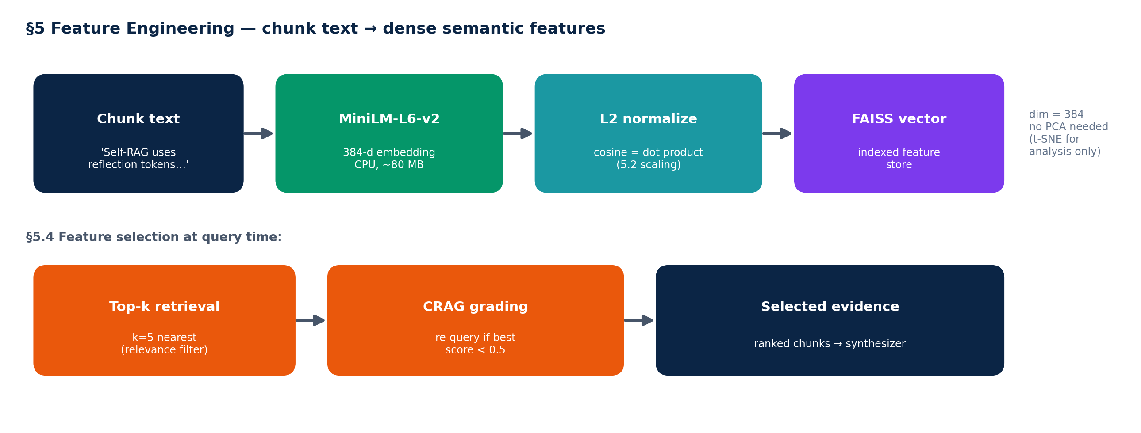
§5 Feature engineering: chunk text becomes a 384-dimensional semantic feature vector.
Explanation: Feature extraction turns text into numbers that capture meaning. A sentence-transformer maps each chunk to a fixed-length vector where semantically similar passages sit close together.
In our project: Each chunk becomes a 384-dimensional embedding from all-MiniLM-L6-v2. That dense vector is the feature representation — there is no hand-crafted tabular feature set. We chose MiniLM because it is small (~80 MB), fast on CPU, and strong for semantic search.
How to present / likely question: Expected question: "What are your features?" Answer: the 384-dimensional MiniLM embedding of each chunk; the embedding model is the feature extractor.

Slide — 5.2 & 5.3 Scaling, Normalization & Dimensionality
On the slide: Two cards: L2 normalization (5.2) and dimensionality (5.3).
Explanation: Scaling puts features on a comparable footing. For semantic vectors the right transform is L2 normalization — scaling each vector to unit length — because direction, not magnitude, carries meaning. Dimensionality reduction (PCA, t-SNE) compresses features, but only helps if the original dimensionality is wasteful.
In our project: We L2-normalise every embedding so cosine similarity equals a simple dot product, which is what FAISS computes. We deliberately do NOT use Min-Max or Standardization — they would distort direction. The 384 dimensions are already compact and CPU-friendly, so we apply no PCA in the pipeline; PCA and t-SNE are used only to visualise the space for EDA (slide 4.3).
How to present / likely question: Expected question: "Why no PCA?" Answer: 384-d is already small and every dimension carries semantic signal; reducing it would lose retrieval accuracy for negligible speed gain. We only use it to draw pictures.

Slide — 5.4 & 5.5 Feature Selection & Imbalanced Data
On the slide: 5.4 feature selection reframed as top-k + CRAG; 5.5 imbalanced data reframed; plus an honesty note.
Explanation: Feature selection keeps the most useful features and drops the rest. Handling imbalanced data (e.g., SMOTE, under-sampling) rebalances skewed class labels so a classifier is not dominated by the majority class.
In our project: Feature selection happens at query time, not column-wise: retrieval keeps the top-k = 5 nearest chunks (a relevance filter), and CRAG grades them and re-queries once if the best score is below 0.5. This replaces classic filter/wrapper/embedded selection. Imbalanced data is reframed: retrieval has no class labels, so SMOTE and under-sampling do not apply. The balances that matter for us are that the 20 evaluation questions span sub-topics evenly, and that the NLI calibration set is balanced between entailed and non-entailed citations so the threshold is not skewed.
How to present / likely question: Expected challenge: "You skipped SMOTE / feature selection." Answer: those are supervised-classification tools; a retrieval system has no class labels, so we reframe them — top-k+CRAG is our selection, and our balancing is in the eval and calibration sets. Reframing, not skipping.

Slide 20 — Next steps (closing)
On the slide: Status Report-1 (27 June) and a Review-03 preview (Model Development, System Architecture, Detailed Software Design — 11 July).
Explanation: Sets expectations for what comes after the data phase.
In our project: Review-03 moves from data to models and system design — the agent pipeline, the architecture diagrams, the UML and the API/UI design.
How to present / likely question: Close confidently: "With the data engineered, explored and turned into features, Review-03 is where we assemble and evaluate the model pipeline."

4. Glossary of key terms
Term | Plain-English meaning
RAG | Retrieval-Augmented Generation — retrieve relevant text first, then have the LLM answer using it, so answers are grounded in real documents.
Multi-agent RAG | RAG split across specialised agents (plan, retrieve, synthesize, verify) instead of one model doing everything.
Chunk | A passage of text (here ~512 tokens) plus metadata (source, page, section); the atomic unit that gets embedded and retrieved.
Overlap | Shared text between consecutive chunks (256 chars) so context isn't lost at boundaries.
Embedding | A fixed-length numeric vector (384 numbers) that represents a chunk's meaning; similar meanings → nearby vectors.
MiniLM | all-MiniLM-L6-v2 — a small, CPU-fast sentence-transformer used as our embedding/feature extractor.
FAISS | Facebook AI Similarity Search — a library that stores embeddings and finds the nearest ones to a query very quickly.
Cosine similarity | A measure of how aligned two vectors are (1 = identical direction). With L2-normalised vectors it equals the dot product.
L2 normalization | Scaling a vector to length 1 so only its direction (meaning) matters, not its magnitude.
top-k retrieval | Returning the k most similar chunks to a query (we use k = 5).
CRAG | Corrective RAG — grade the retrieved chunks and re-query once if they look weak (best score < 0.5).
NLI | Natural Language Inference — a model that decides whether a premise entails, contradicts, or is neutral to a hypothesis.
Entailment / supportedness | Whether the cited evidence actually supports the claim; our verifier uses NLI entailment probability as this score (threshold 0.6).
Faithfulness | Whether the model genuinely relied on the cited source (vs. picking it after the fact). NLI measures supportedness, which is closely related but not identical — see §6.
DeBERTa-v3-MNLI | cross-encoder/nli-deberta-v3-base — the CPU NLI model the Verifier uses to score citations.
RAGAS | An automated framework for scoring RAG answers on faithfulness, answer relevance, and context precision/recall.
PCA / t-SNE | Dimensionality-reduction techniques; we use them only to visualise the embedding space, not in the pipeline.
SMOTE | A technique to synthesise minority-class examples for imbalanced classification — not applicable to label-free retrieval.
Groq / Ollama | Our two LLM backends: Groq (cloud, Llama 4 Scout 17B, fast) and Ollama (local, Phi-3 mini, private).

5. Anticipated panel questions & answers

Q1. Isn't this just one LLM with extra steps?
No. The verifier is an independent NLI model, not the generator grading itself, and it drives a reject-and-revise loop. No referenced system (SQuAI, MA-RAG, MAIN-RAG, Self-RAG) does independent claim-level entailment verification.

Q2. Where is your train/validation/test split?
We do no fine-tuning, so a corpus split would be meaningless. The whole corpus is indexed for retrieval; the split discipline lives in evaluation — a held-out 20-question benchmark plus a small calibration set for the verifier threshold.

Q3. What are your features and why MiniLM?
Each chunk's feature is its 384-dimensional MiniLM embedding. MiniLM is small (~80 MB), CPU-fast, and strong for semantic search — the right trade-off for a no-GPU system.

Q4. Why no PCA / dimensionality reduction?
384 dimensions are already compact and every dimension carries semantic signal; reducing would cost retrieval accuracy. PCA/t-SNE are used only to visualise the space in EDA.

Q5. You didn't use SMOTE — isn't your data imbalanced?
Retrieval has no class labels, so SMOTE doesn't apply. The balances that matter are eval-question topic coverage and a balanced NLI calibration set; both are addressed.

Q6. How do you measure citation quality?
Per claim, we run NLI between the claim and its cited chunk and take the entailment probability as a supportedness score (threshold 0.6), alongside RAGAS faithfulness, compared across pipelines with a paired t-test.

Q7. Is it really private if it uses the cloud?
PDFs never leave the device in either mode. In cloud mode the question and a few retrieved snippets go to Groq; for full privacy, local (Ollama) mode keeps everything on the laptop. Retriever and verifier are always local.

Q8. Your numbers come from 21 documents, not 50 — why?
Those are honest pipeline-validation figures measured on a sample while the full arXiv corpus is assembled; the target is 30–50 papers (~900–1,200 chunks). We label the sample as such on the slide.

Q9. Could a malicious PDF break the system?
Retrieved text is wrapped in delimiters and the model is instructed to treat it as untrusted reference material, never as instructions — a guard against prompt injection through the corpus.

Q10. What is the difference between supportedness and faithfulness?
Supportedness asks whether the cited text supports the claim (what NLI measures). Faithfulness asks whether the model genuinely relied on it. They usually agree; we report supportedness and treat true faithfulness as future work — see §6.

6. Honesty-framing notes (why the project is defensible)
These are deliberate methodological choices, not gaps. Stating them confidently turns potential criticisms into evidence of rigour.
- No fine-tuning: every model is off-the-shelf, so train/val/test, SMOTE, and wrapper feature selection are reframed for a retrieval system rather than force-fitted.
- Sample vs target corpus: all measured numbers are honestly labelled as sample pipeline-validation runs; the target corpus is stated separately.
- Supportedness vs faithfulness: we are precise that NLI measures whether evidence supports a claim, which is closely related to — but not identical with — whether the model truly relied on it.
- Disclosed limitations: English-only, text-only, small corpus, and inherited model bias are all stated up front and were planned for, not discovered late.
- Privacy is mode-specific: we never claim blanket privacy; we state exactly what leaves the device in each mode.
Last updated for Review-02. This document is the companion to Project_Review_02.pptx; keep both in sync if slide content changes.

