AWS CLOUD COMPUTING • PROJECT DOCUMENTATION
STUDENT TASK MANAGER
Highly Available and Auto-Scalable
Three-Tier Web Application on AWS
PRODUCTION-INSPIRED AWS ARCHITECTURE
INTERNET | ALB | EC2 × 2 | FLASK / NGINX | RDS MYSQL
Internet → Application Load Balancer → Auto Scaling EC2 → Flask/Gunicorn + Nginx → Private RDS
DOCUMENT | Complete Project Documentation
AWS REGION | Asia Pacific (Mumbai) — ap-south-1
TECHNOLOGY | HTML/CSS/JavaScript/Bootstrap • Python/Flask • Gunicorn/Nginx • MySQL/RDS
ARCHITECTURE | Public ALB • Auto Scaling application tier • Private database tier
✓ IMPLEMENTATION EVIDENCE • ✓ HIGH AVAILABILITY TESTED • ✓ SECURITY HARDENED
Academic project • AWS cloud-computing portfolio • Implementation and evidence record

Table of Contents
1. Abstract
2. Problem Statement
3. Objectives
4. Requirements
5. System Architecture
6. AWS Services
7. Technology Stack
8. VPC and Network Architecture
9. Security Group Architecture
10. EC2 and Linux Application Server
11. Backend Architecture and Flask REST API
12. Database Design and Amazon RDS MySQL
13. Application Load Balancer
14. Auto Scaling and High Availability
15. CloudWatch Monitoring
16. S3 and VPC Endpoint
17. Frontend
18. Frontend-to-API Integration
19. Security Hardening
20. System Workflow
21. Testing and Results
22. Evidence / Screenshot Checklist
23. Limitations and Known Issues
24. Future Enhancements
25. GitHub Portfolio Documentation
26. Cost and Operational Considerations
27. AWS Cleanup Procedure
28. Conclusion

1. Abstract
The Student Task Manager is a cloud-hosted web application designed to help students organize academic tasks, priorities, due dates, completion status, and dashboard statistics. The application is implemented as a production-inspired three-tier system on Amazon Web Services (AWS), with a public Application Load Balancer (ALB), Linux-based application servers running Flask, and a private Amazon RDS MySQL database.
The main objective is not only to provide task-management functionality but also to demonstrate practical cloud engineering concepts including Amazon VPC networking, subnets, route tables, Security Groups, EC2, IAM, Nginx, Gunicorn, REST APIs, Application Load Balancing, Auto Scaling, Amazon RDS, CloudWatch monitoring, and cost-conscious AWS deployment.
The application tier is designed for high availability by maintaining multiple application targets behind the ALB and using an Auto Scaling Group (ASG) to replace unhealthy or terminated instances. The database is intentionally kept private and the Security Group relationships enforce Internet-to-ALB, ALB-to-EC2, and EC2-to-RDS communication.

2. Problem Statement
Students commonly manage assignments, academic deadlines, priorities, and completion status using scattered notes, spreadsheets, or multiple applications. This can make it difficult to maintain a consistent view of pending work and urgent deadlines.
The Student Task Manager addresses this problem by providing a centralized web application for registration, login, task creation, task viewing, editing, deletion, completion tracking, priority management, due dates, filtering, and dashboard statistics.
A second problem addressed by the project is the deployment of a student application on infrastructure that is scalable, monitored, and protected rather than relying on a single directly exposed server.

3. Objectives
- Develop a simple web-based Student Task Manager.
- Provide registration and login functionality.
- Support task creation, viewing, editing, deletion, completion, priorities, due dates, and filtering.
- Display dashboard statistics such as total, completed, pending, and high-priority tasks.
- Deploy the application using a three-tier AWS architecture.
- Build a VPC with public and private networking components.
- Deploy the Flask application on Linux EC2.
- Use Nginx as the web server/reverse proxy and Gunicorn as the Flask application server.
- Store application data in private Amazon RDS MySQL.
- Use an Application Load Balancer as the public application entry point.
- Use Auto Scaling to demonstrate application-tier high availability and instance replacement.
- Use IAM and Security Groups to restrict access.
- Use CloudWatch metrics to monitor infrastructure and load-balancer behavior.
- Maintain a cost-conscious AWS deployment and avoid NAT Gateway creation.

4. Requirements

4.1 Functional Requirements
- User registration.
- User login.
- Create tasks.
- View tasks.
- Edit tasks.
- Delete tasks.
- Mark tasks as completed.
- Assign task priority.
- Assign due dates.
- Filter tasks by status.
- View dashboard statistics and recent tasks.

4.2 Non-Functional Requirements
- Availability at the application tier through multiple targets.
- Scalability using Auto Scaling.
- Private database access.
- Network isolation using VPC subnets and Security Groups.
- Password hashing and secure configuration.
- Monitoring through CloudWatch.
- Cost-conscious deployment suitable for a beginner AWS account.
- Maintainable frontend/backend separation.

5. System Architecture
Target production-inspired architecture:
Users
|
v
Internet
|
v
Application Load Balancer (public)
|
+-----------------------------+
| |
v v
EC2 / Flask #1 EC2 / Flask #2
Nginx + Gunicorn Nginx + Gunicorn
| |
+-------------+---------------+
|
v
Amazon RDS MySQL
(private)
Supporting:
VPC • Subnets • Route Tables • IGW • Security Groups
IAM • CloudWatch • S3 Gateway VPC Endpoint
The final architecture is based on the project requirement that EC2 application servers should not be directly accessible from the Internet, the ALB should be the public entry point, and RDS should remain private.
Tier | Primary Components | Purpose
Presentation | HTML, CSS, JavaScript, Bootstrap, Nginx | User interface and HTTP entry handling.
Application | EC2, Flask, REST API, Gunicorn, Auto Scaling, ALB | Business logic, APIs, health checks, load distribution, availability.
Database | Amazon RDS MySQL | Persistent users and task data.

6. AWS Services
AWS Service | Role in Project | Implementation Status
Amazon VPC | Isolated network for the application. | Implemented
Internet Gateway | Internet connectivity for public components. | Implemented
Amazon EC2 | Linux application servers. | Implemented
Application Load Balancer | Public entry point and request distribution. | Implemented
Target Group | Registers and health-checks EC2 targets. | Implemented
Auto Scaling Group | Maintains application capacity and replaces terminated instances. | Implemented
Amazon RDS MySQL | Private relational database. | Implemented
IAM | EC2 role and controlled AWS permissions. | Implemented
Security Groups | Tier-to-tier network access control. | Implemented
CloudWatch | EC2, ALB, target-group and ASG metrics. | Implemented
Amazon S3 | Optional object storage extension. | Not used by core application
S3 Gateway VPC Endpoint | Private VPC path to S3. | Implemented as infrastructure
SNS | Optional alerting extension. | Not configured

7. Technology Stack
Layer | Technology
Frontend | HTML5, CSS3, JavaScript, Bootstrap 5, Bootstrap Icons
Backend | Python 3, Flask, Flask-CORS, PyMySQL
Application Server | Gunicorn
Web Server / Reverse Proxy | Nginx
Database | MySQL 8.4 on Amazon RDS
Operating System | Amazon Linux 2023
Cloud | AWS, region ap-south-1
Development / API Tools | VS Code, Git, GitHub, Postman, SSH

8. VPC and Network Architecture
Implemented VPC:
Component | Value
VPC name | student-task-vpc
VPC CIDR | 10.0.0.0/16
Public subnet A | 10.0.0.0/20
Public subnet B | 10.0.16.0/20
Private application subnet A | 10.0.128.0/20
Private application subnet B | 10.0.144.0/20
Region | ap-south-1 (Mumbai)
NAT Gateway | Not created, by design
S3 Gateway VPC Endpoint | Created
The network separates public-facing load-balancing resources from private application/database resources. The project deliberately avoids a NAT Gateway to control cost.

8.1 Traffic Flow
- A user sends an HTTP request from the Internet.
- The request reaches the public Application Load Balancer.
- The ALB listener forwards the request to the target group.
- The target group selects a healthy EC2 application server.
- Nginx receives the HTTP request on the application server.
- Nginx serves frontend files and proxies /api/ requests to Gunicorn.
- Flask processes the API request.
- Flask connects to the private RDS MySQL database.
- The response travels back through Flask/Nginx and the ALB to the user.

9. Security Group Architecture
Security Group | Inbound Rule | Purpose
student-alb-sg | HTTP 80 from 0.0.0.0/0 | Public web entry point.
student-alb-sg | HTTPS 443 from 0.0.0.0/0 | Reserved HTTPS entry rule.
student-app-sg | HTTP 80 from student-alb-sg | Only ALB can reach application HTTP.
student-app-sg | SSH 22 from controlled administrator source | Administration during development.
student-db-sg | MySQL/Aurora 3306 from student-app-sg | Only application tier reaches RDS.
The application Security Group was hardened by removing the public HTTP rule and the TCP 5000 rule. The application tier therefore uses the ALB as its normal HTTP entry point. The database Security Group allows MySQL only from the application Security Group.

10. EC2 and Linux Application Server
Item | Implemented Value
Primary instance | student-task-app-1
Instance type | t3.micro
OS | Amazon Linux 2023
Private IP | 10.0.10.208
IAM role | student-task-ec2-role
IAM managed policy | AmazonSSMManagedInstanceCore
Application directory | /home/ec2-user/student-task-manager
Frontend directory | /var/www/student-task-manager/frontend
Gunicorn service | student-task.service
Nginx | Enabled and configured

10.1 Gunicorn Service
[Service]
User=ec2-user
Group=ec2-user
WorkingDirectory=/home/ec2-user/student-task-manager/backend
Environment="PATH=/home/ec2-user/student-task-manager/backend/venv/bin"
ExecStart=/home/ec2-user/student-task-manager/backend/venv/bin/gunicorn --bind 0.0.0.0:5000 app:app
Restart=always
RestartSec=5

10.2 Nginx Role
Nginx serves the frontend from /var/www/student-task-manager/frontend. Requests beginning with /api/ are reverse-proxied to Gunicorn on localhost:5000. This keeps the browser-facing application on HTTP port 80 while the Flask process remains behind Nginx.
location /api/ {
proxy_pass http://127.0.0.1:5000;
proxy_set_header Host $host;
proxy_set_header X-Real-IP $remote_addr;
proxy_set_header X-Forwarded-For $proxy_add_x_forwarded_for;
proxy_set_header X-Forwarded-Proto $scheme;
}
location / {
try_files $uri $uri/ /index.html;
}
Verification: After reboot, both Gunicorn and Nginx were confirmed active and the /api/health endpoint returned a healthy response.

11. Backend Architecture and Flask REST API
The backend is implemented in Flask and exposes REST-style endpoints for authentication, task management, dashboard statistics, and health checking.
Method | Endpoint | Purpose | Status in Project
POST | /api/register | Register a user. | Implemented/tested
POST | /api/login | Authenticate a user. | Implemented/tested
POST | /api/tasks | Create a task. | Implemented/tested
GET | /api/tasks?user_id=<id> | List tasks for a user. | Implemented/tested
GET | /api/tasks/<id> | Get one task. | Specified by original plan; implementation not independently verified
PUT | /api/tasks/<id> | Update a task. | Implemented/tested
DELETE | /api/tasks/<id>?user_id=<id> | Delete a task. | Implemented/tested
PATCH | /api/tasks/<id>/complete | Mark task complete. | Implemented/tested
GET | /api/dashboard?user_id=<id> | Dashboard statistics. | Implemented/tested
GET | /api/health | Health check. | Implemented/tested

11.1 Health Endpoint
{"message":"Student Task Manager API is running","status":"healthy"}

11.2 Configuration Security
Database connection parameters were moved from hard-coded values into environment variables loaded from a .env file. The .env file was protected with 600 permissions and excluded from source control through .gitignore.
DB_HOST=<RDS endpoint>
DB_USER=<database user>
DB_PASSWORD=<database password>
DB_NAME=student_tasks
DB_PORT=3306
No secret values are reproduced in this report.

12. Database Design and Amazon RDS MySQL
Property | Implemented Value
DB identifier | student-task-db
Engine | MySQL Community 8.4.9
Instance class | db.t3.micro
Database | student_tasks
Username | admin
Availability | Single-AZ
AZ | ap-south-1a
Public access | No
Storage | 20 GiB gp3
Encryption | Enabled
Backup retention | 1 day
Auto storage scaling | Disabled
DB subnet group | student-db-subnet-group
Security Group | student-db-sg

12.1 Database Tables
Table | Purpose
users | Stores registered user records and password hashes.
tasks | Stores task title/details, priority, due date, completion status, and user relationship.
The RDS instance is not publicly accessible. Port 3306 is allowed only from the application Security Group, enforcing the intended application-to-database trust boundary.

13. Application Load Balancer
Property | Implemented Value
ALB | student-task-alb
Type | Application Load Balancer
Scheme | Internet-facing
IP type | IPv4
Region | ap-south-1
Availability Zones | ap-south-1a and ap-south-1b
Listener | HTTP :80
Target Group | student-task-targets
Target protocol | HTTP :80
Health path | /api/health
Health status | 2 healthy targets at documented checkpoint
The ALB is the public entry point. The target group routes traffic only to registered healthy application instances. The health check uses /api/health so the load balancer can determine whether the Flask application path is operational.

14. Auto Scaling and High Availability
Property | Implemented Value
Auto Scaling Group | student-task-asg
Minimum capacity | 1
Desired capacity | 1
Maximum capacity | 2
Launch Template | student-task-launch-template
Instance type | t3.micro
The project demonstrated failure recovery by intentionally terminating an Auto Scaling-managed instance. The ASG automatically launched a replacement and the target group returned to two healthy targets.
A secure AMI named student-task-manager-secure-v3 was subsequently created from the corrected original instance. The Launch Template was updated to use that AMI and an Instance Refresh completed successfully. This was used to bring the ASG instance configuration into alignment with the hardened application server.
Known limitation: A stale frontend copy was observed on one ASG instance during a later check. The original EC2 was verified to contain the corrected dashboard file, but the stale private instance was not directly modified because no approved access path was available at that point. The issue was treated as a minor deployment-consistency/UI issue rather than an AWS architecture failure.

15. CloudWatch Monitoring
Metric / Area | Purpose | Evidence
EC2 CPUUtilization | Shows application-server CPU usage. | Verified during monitoring.
EC2 status | Shows instance/system health state. | Verified.
ALB RequestCount | Shows number of requests handled by ALB. | Verified with non-zero graph.
ALB TargetResponseTime | Shows time taken by targets to respond. | Metric available/verified.
TargetGroup HealthyHostCount | Shows number of healthy application targets. | Verified; 2 healthy at checkpoint.
ASG CPUUtilization | Monitors ASG instance CPU. | Verified.
ASG group metrics | Tracks desired/in-service/total instances. | Enabled through Auto Scaling metrics collection.
No CloudWatch Agent or SNS alarm configuration was required for the core demonstration. Basic AWS service metrics were sufficient for the documented monitoring objective.

16. S3 and VPC Endpoint
The original specification defines S3 as an optional extension for task attachments or exported reports. The implemented infrastructure includes an S3 Gateway VPC Endpoint, but S3 is not part of the core application data path documented in this report.
Private EC2 -> S3 Gateway VPC Endpoint -> Amazon S3
Status: S3 application attachment/report functionality was not implemented as a core feature and should not be claimed as completed.

17. Frontend
The frontend was developed as a modern responsive Student Task Manager interface using HTML, CSS, vanilla JavaScript, Bootstrap 5, and Bootstrap Icons.
Page | Functionality
Landing | Project introduction and navigation.
Register | New user registration.
Login | User authentication.
Dashboard | Task statistics and recent tasks.
My Tasks | Search, filter, sort, complete, edit, and delete tasks.
Profile | Student profile and settings presentation.
The UI includes light/dark themes, responsive layouts, loading/empty states, modal dialogs, toast notifications, task status indicators, and dashboard statistics.

18. Frontend-to-API Integration
The intended and deployed traffic path is:
Browser -> Application Load Balancer -> Nginx -> Gunicorn -> Flask -> RDS MySQL
- JavaScript uses fetch() to call the REST API.
- API requests and responses use JSON.
- The ALB provides the browser-facing application endpoint.
- Nginx routes /api/ requests to Gunicorn.
- Flask performs validation, authentication processing, task operations, and database access.
- The UI provides loading, success, error, and empty states.

19. Security Hardening
Control | Implementation / Purpose
IAM | EC2 uses student-task-ec2-role with AmazonSSMManagedInstanceCore.
Network isolation | Application and database resources are separated into VPC subnets.
ALB SG | Public HTTP/HTTPS entry rules.
Application SG | HTTP 80 allowed from ALB SG; unnecessary TCP 5000/public HTTP rule removed.
Database SG | 3306 allowed only from application SG.
RDS privacy | Public access disabled.
Password hashing | Werkzeug password hashing used by Flask application.
Secrets | Database configuration moved to environment variables; .env protected with 600 permissions.
Nginx | Acts as reverse proxy in front of Gunicorn.
SSH | Controlled administrator access rather than public unrestricted SSH.
IMDSv2 | Required on the primary EC2.
Source control | .env and virtual environment excluded through .gitignore.
The database password was intentionally excluded from this documentation. A previously exposed database credential should be rotated before treating the deployment as production-ready.

20. System Workflow

20.1 Registration and Login
- User opens the Student Task Manager through the ALB.
- User submits registration or login credentials.
- Frontend sends the request to /api/register or /api/login.
- ALB forwards the request to a healthy EC2 target.
- Nginx forwards /api/ requests to Gunicorn.
- Flask validates the request and accesses RDS.
- The API returns a JSON response to the frontend.

20.2 Task Creation
- User opens the Create Task dialog.
- User enters title, optional description, priority, and due date.
- Frontend sends POST /api/tasks.
- Flask validates and stores the task in RDS.
- Dashboard/task list refreshes from the API.

20.3 High Availability
- The ALB continuously health-checks registered targets.
- Traffic is sent to healthy targets.
- If an ASG-managed instance is terminated or becomes unhealthy, Auto Scaling attempts to restore desired capacity.
- The replacement instance joins the target group after passing health checks.
- The application can continue to serve traffic through available healthy targets.

21. Testing and Results
Test | Expected Result | Observed / Status
Login | Valid credentials authenticate. | Successful.
Create task | Task appears in dashboard/task list. | Successful.
Read tasks | Tasks are returned from API/database. | Successful.
Update task | Edited task persists. | Successful.
Delete task | Task is removed. | Successful.
Complete task | Task changes to completed. | Successful.
Dashboard | Counts reflect stored tasks. | Successful.
ALB health | Target passes /api/health. | Successful; healthy targets observed.
Load balancing | ALB forwards requests to registered targets. | Implemented and observed.
Terminate ASG instance | Replacement instance launches. | Successful.
Application availability | Application remains available with healthy target(s). | Successful during HA test.
CloudWatch metrics | Infrastructure/load-balancer metrics visible. | Successful.
Unauthorized access | Unauthorized operation rejected. | Not independently evidenced in available record.
Invalid input | Invalid input handled safely. | Not independently evidenced in available record.
The testing results above distinguish between tests that were explicitly demonstrated during the project and tests that were required by the original specification but do not have sufficient recorded evidence to claim completion.

22. Evidence / Screenshot Checklist
- Project landing page.
- Login page.
- Registration page.
- Dashboard with task statistics.
- Create Task modal.
- Task list showing pending task.
- Task marked as completed.
- Delete confirmation dialog.
- Profile/settings page.
- VPC overview and subnet layout.
- Security Group: student-alb-sg.
- Security Group: student-app-sg.
- Security Group: student-db-sg.
- RDS student-task-db showing Available and private configuration.
- EC2 student-task-app-1 summary.
- ALB student-task-alb showing Active and two Availability Zones.
- Target Group student-task-targets showing 2 healthy targets.
- Auto Scaling Group student-task-asg showing desired/min/max configuration.
- CloudWatch ALB RequestCount graph.
- CloudWatch target response-time / healthy-host metric.
- ASG replacement event showing old instance termination and replacement launch.
- Instance Refresh completion.
- Final end-to-end application test through ALB.
Documentation tip: Add screenshots with figure numbers and captions such as 'Figure 12 — Target Group with two healthy application instances'. Avoid screenshots that expose passwords, access keys, private credentials, or other secrets.

23. Limitations and Known Issues
- The current authentication design is a prototype and relies on client-provided user identity rather than a production-grade session/JWT authorization model.
- The core database is Single-AZ, so the database tier is not fully highly available.
- No NAT Gateway was created to preserve cost control; therefore private instances do not have general outbound Internet access through NAT.
- SSM connectivity to a private ASG instance was unavailable during one troubleshooting point because an appropriate SSM network path was not configured.
- One ASG instance was observed with an older frontend copy containing the label 'Mock Mode Active (AWS ALB Ready)'. The original EC2 was verified to contain the corrected dashboard. This is a frontend deployment-consistency issue, not an AWS service feature.
- The optional S3 application attachment/export functionality was not implemented.
- CloudWatch alarms/SNS notifications were not configured for the core project.
- Unauthorized-access and invalid-input tests require additional recorded evidence before being claimed as completed.
- The ALB currently uses HTTP; HTTPS with ACM and a custom domain was considered but postponed.

24. Future Enhancements
- Use Amazon Cognito or secure session/JWT authentication with proper authorization.
- Move database secrets to AWS Secrets Manager.
- Use HTTPS through AWS Certificate Manager and a Route 53 custom domain.
- Use Multi-AZ RDS for database high availability.
- Add automated CloudWatch alarms and SNS notifications.
- Add CloudWatch application logs.
- Implement S3 task attachments or report exports through the existing VPC endpoint.
- Use a CI/CD pipeline for consistent deployment to all ASG instances.
- Use immutable AMI or container-based deployment to prevent frontend drift between instances.
- Add automated testing for all REST endpoints.
- Add stronger input validation, rate limiting, and audit logging.
- Add backup/restore validation and disaster-recovery procedures.

25. GitHub Portfolio Documentation
The project specification requires a professional GitHub repository containing documentation and deployment evidence.
Repository Item | Required Content
README.md | Project overview, architecture, setup, deployment, screenshots, API summary.
Architecture diagram | Internet -> ALB -> EC2/ASG -> RDS with VPC/security boundaries.
Screenshots | AWS infrastructure and application evidence.
API documentation | Methods, endpoints, request/response examples, common errors.
Setup instructions | Local and AWS deployment procedure.
AWS deployment documentation | VPC, EC2, RDS, ALB, ASG, CloudWatch configuration.
.gitignore | Exclude .env, venv, credentials and generated files.
.env.example | Variable names only; never real secrets.

25.1 Example Commit Messages
- feat: add Flask REST API for task management
- feat: integrate RDS MySQL database
- feat: add responsive student task manager frontend
- feat: deploy application behind AWS ALB
- feat: configure Auto Scaling for application tier
- security: restrict EC2 and RDS security group access
- ops: add CloudWatch monitoring evidence
- docs: add AWS architecture and deployment documentation

26. Cost and Operational Considerations
The project was deliberately designed for a Free Tier/Free Plan beginner account. The original specification requires warnings before potentially billable resources and explicitly prohibits creating NAT Gateways in the initial implementation.
Resource | Cost Consideration
ALB | May incur charges depending on current AWS pricing and usage.
Public IPv4 | May incur charges under current AWS pricing.
EC2 | Eligibility depends on current Free Tier terms and account status.
RDS | Instance hours, storage, backup and other usage can incur charges.
EBS | Storage usage may incur charges.
CloudWatch | Metrics/logs beyond applicable free allowances can incur charges.
NAT Gateway | Intentionally not created because it is a billable resource.
The deployment used a budget and Free Tier monitoring at the account level. For overnight pauses, the intended cost-conscious procedure is to reduce the ASG desired/minimum capacity as appropriate, stop the primary EC2, and stop RDS when it is not needed. The ALB does not provide a simple stop operation and therefore should be considered a continuing cost item until deleted.

27. AWS Cleanup Procedure
When the project is permanently finished, clean up in dependency-safe order.
- Reduce or delete the Auto Scaling Group; confirm ASG-managed instances are terminated.
- Delete the Application Load Balancer.
- Delete the target group after it is no longer associated with the ALB.
- Terminate remaining EC2 instances.
- Delete or retain the RDS database according to whether the data must be preserved. Create a final snapshot only if required.
- Delete the S3 bucket and objects if the optional extension was used.
- Delete the S3 VPC endpoint.
- Delete unused Security Groups after dependent resources are removed.
- Delete route tables that are no longer required.
- Delete subnets.
- Detach and delete the Internet Gateway.
- Delete the VPC.
- Review EC2 AMIs and snapshots created during the project and delete unused ones if no longer needed.
- Review the AWS Billing console and Cost Explorer for remaining billable resources.
Important: Do not delete the VPC or dependent networking components while resources still reference them. AWS will block deletion when dependencies remain.

28. Conclusion
The Student Task Manager demonstrates how a simple academic web application can be transformed into a cloud-deployed, production-inspired three-tier system using AWS. The project combines frontend development, Flask REST APIs, Linux administration, network design, private database deployment, load balancing, Auto Scaling, monitoring, and security controls.
The implemented environment successfully demonstrated the central cloud architecture: Internet traffic reaches an Application Load Balancer, the ALB routes requests to healthy Linux application servers, Flask provides the REST API, and application data is stored in a private RDS MySQL database.
The Auto Scaling failure test demonstrated automatic instance replacement, while CloudWatch provided infrastructure and load-balancer metrics. Security hardening removed unnecessary public application access, restricted database access to the application tier, and moved database configuration into protected environment variables.
The project is therefore suitable as a strong AWS/cloud-computing portfolio project, while the documented limitations identify the remaining steps required for a more production-grade implementation.

Appendix A — Project Resource Inventory
Resource | Name / Identifier | Purpose
VPC | student-task-vpc | Application network.
ALB SG | student-alb-sg | Public load-balancer access.
App SG | student-app-sg | Application server access control.
DB SG | student-db-sg | RDS access control.
RDS | student-task-db | MySQL database.
DB subnet group | student-db-subnet-group | Private RDS subnets.
Primary EC2 | student-task-app-1 | Application server.
IAM role | student-task-ec2-role | EC2 AWS permissions.
ALB | student-task-alb | Public application entry point.
Target group | student-task-targets | Healthy application targets.
ASG | student-task-asg | Application-tier availability/scaling.
Launch Template | student-task-launch-template | ASG instance configuration.
Secure AMI | student-task-manager-secure-v3 | Hardened application image.

Appendix B — Final Architecture Summary
Internet
|
v
Public Application Load Balancer
|
v
Target Group (/api/health)
|
+--------------------+
| |
v v
EC2 / Nginx / EC2 / Nginx /
Gunicorn / Flask Gunicorn / Flask
| |
+---------+----------+
|
v
Private RDS MySQL
Security:
Internet -> ALB SG
ALB SG -> App SG
App SG -> DB SG
Monitoring:
EC2 + ALB + Target Group + ASG -> CloudWatch

Appendix C — Documentation Source and Evidence Note
Primary specification source: supplied project specification 'Student Task Manager – Highly Available and Auto-Scalable Three-Tier Web Application on AWS'. The specification defines the project phases from planning and cost safety through VPC, EC2, RDS, Flask, ALB, Auto Scaling, CloudWatch, S3, frontend, security, testing, documentation, GitHub, and cleanup.
Implementation-specific details in this report are based on the recorded AWS configuration, application testing, and screenshots from the project work. Where the available record did not establish a requirement as completed, the report deliberately labels it as not verified or pending.

Screenshots and Project Evidence
This section records the AWS console and application-interface evidence captured during implementation and testing. The figures are ordered from AWS infrastructure and security configuration through load balancing, monitoring, and end-user functionality.
Figure | Evidence area | Purpose
1 | VPC | Network topology and subnet/route-table relationships
2–4 | Security Groups | ALB, application, and database traffic controls
5 | RDS | Database availability and connectivity configuration
6 | EC2 | Application instance configuration
7–9 | ALB / Target Group / ASG | Load balancing, health, and scaling evidence
10 | CloudWatch | Operational monitoring evidence
11–20 | Application UI | Functional and interface testing evidence

Figure 1. VPC resource map
The AWS VPC resource map shows the student-task-vpc VPC with four subnets distributed across ap-south-1a and ap-south-1b. It also shows the associated public/private route tables and the Internet Gateway and S3 VPC endpoint network connections.
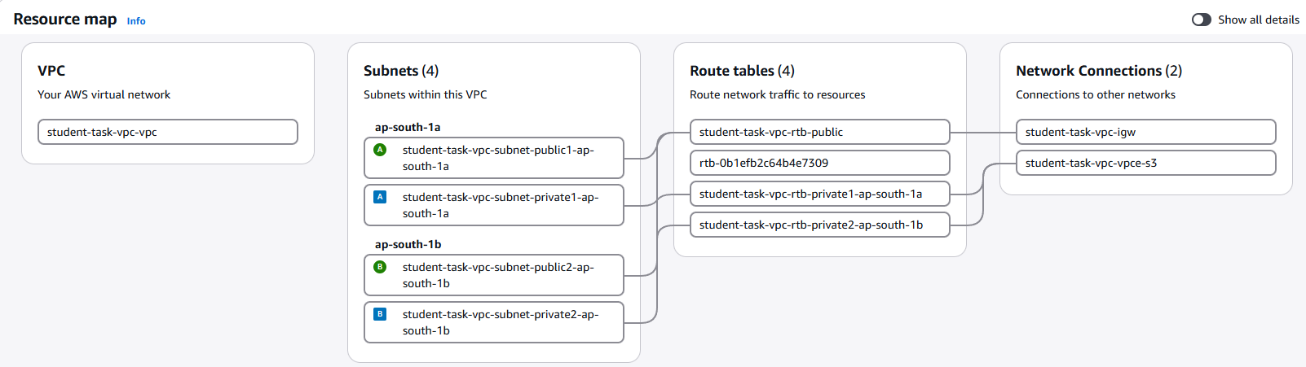
Figure 1. VPC resource map

Figure 2. Application Load Balancer security group
The student-alb-sg security group permits HTTP on port 80 and HTTPS on port 443 from 0.0.0.0/0, allowing internet clients to reach the internet-facing Application Load Balancer.
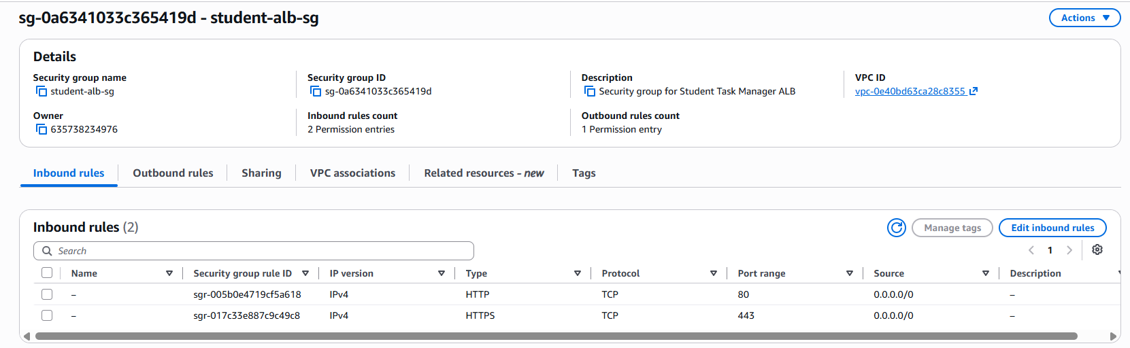
Figure 2. Application Load Balancer security group

Figure 3. Application server security group
The student-app-sg security group allows HTTP port 80 from the ALB security group. SSH port 22 is restricted to the configured administrator IP and the EC2 Instance Connect prefix list.
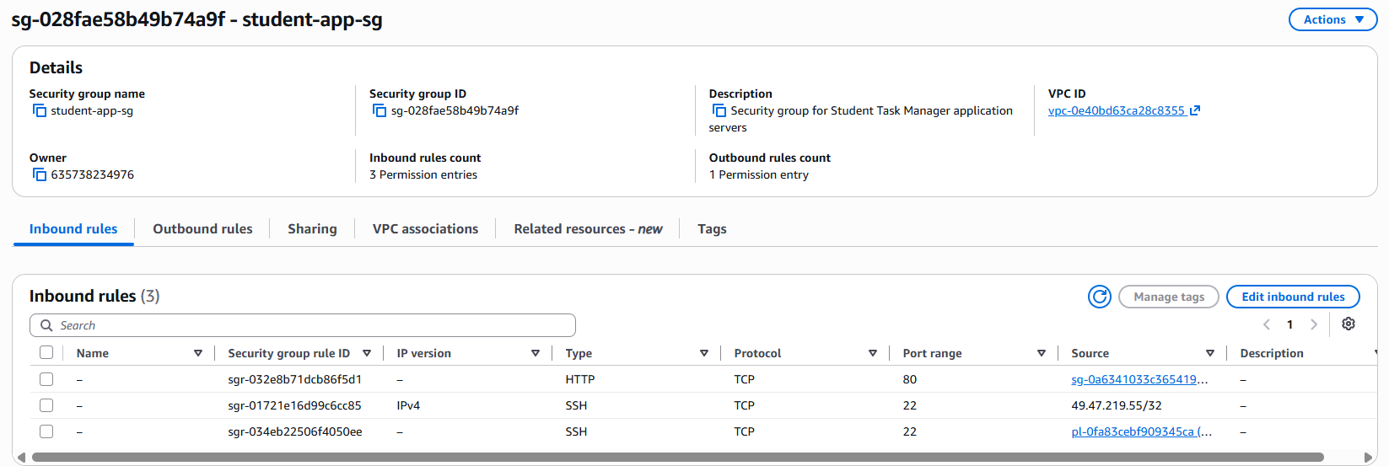
Figure 3. Application server security group

Figure 4. Database security group
The student-db-sg security group allows MySQL/Aurora traffic on port 3306 only from the application server security group, keeping the database tier isolated from direct internet access.
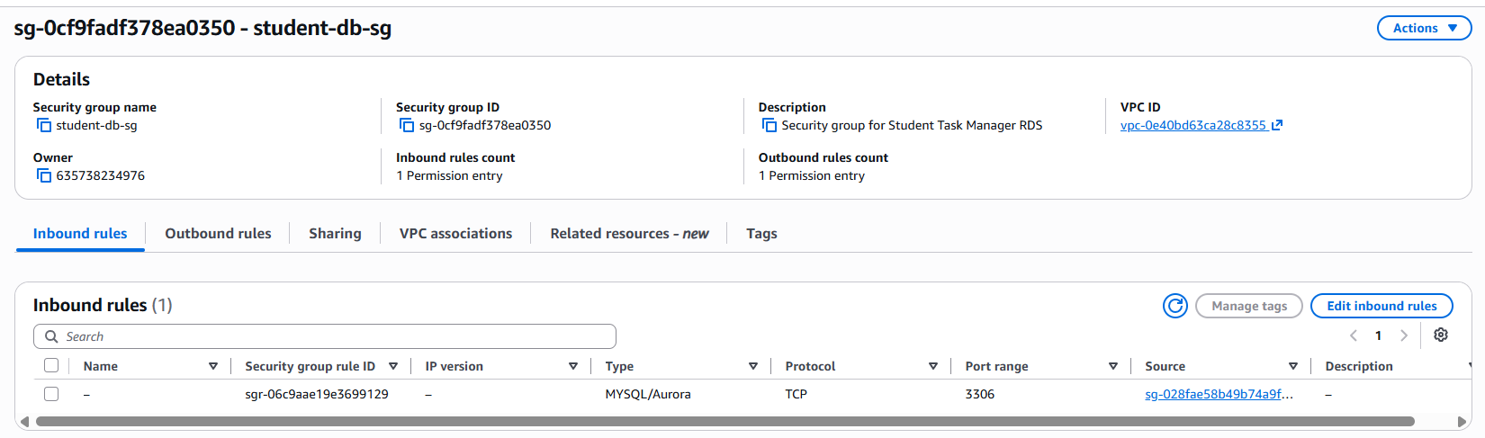
Figure 4. Database security group

Figure 5. Amazon RDS database overview
The student-task-db RDS instance is shown as Available, using MySQL Community on db.t3.micro in ap-south-1a. The connectivity view also indicates that internet access is disabled.
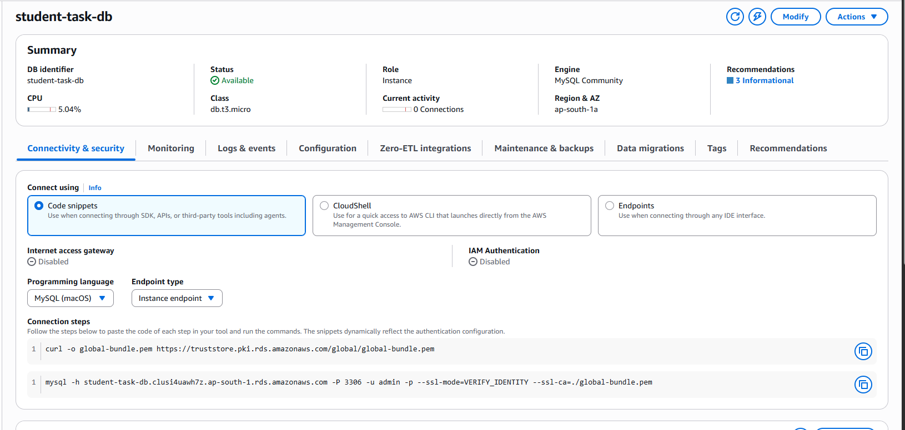
Figure 5. Amazon RDS database overview

Figure 6. EC2 application instance details
The EC2 instance summary identifies student-task-app-1 as a running t3.micro instance in the project VPC, with its IAM role, public IPv4 address, private IPv4 address, and subnet details visible.
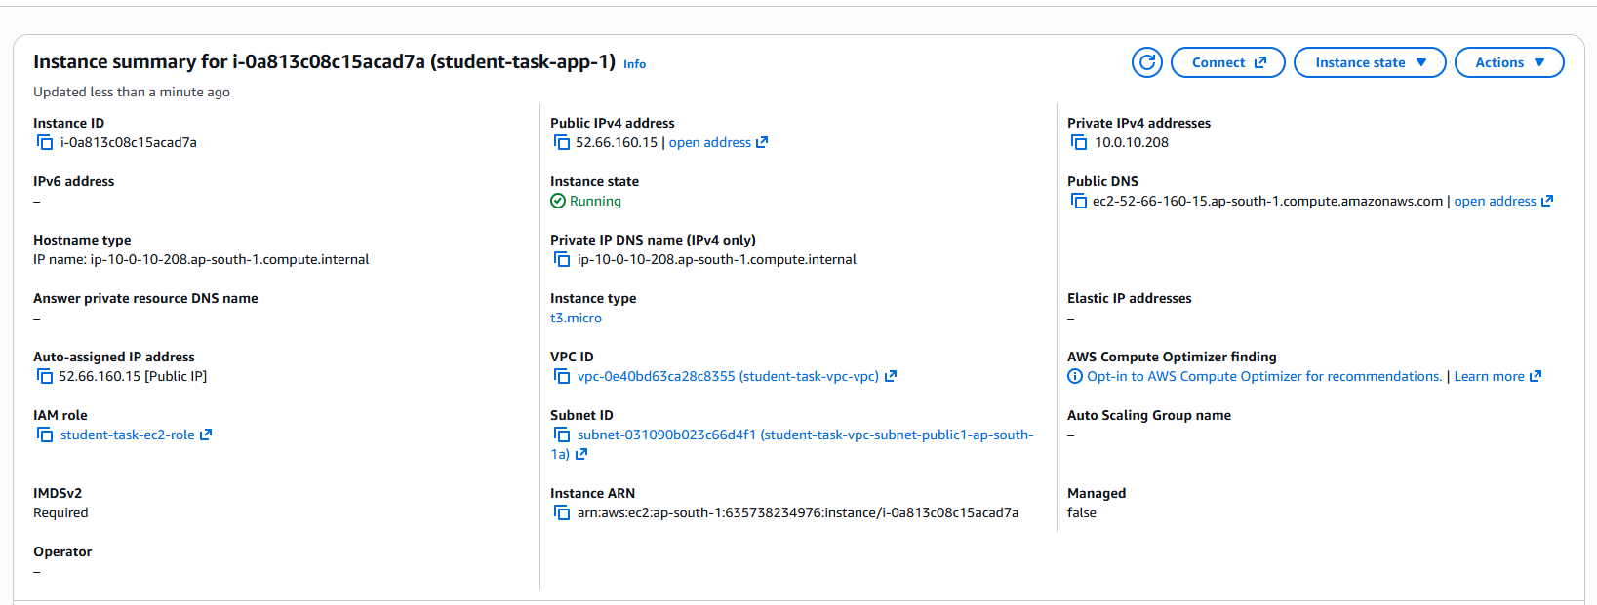
Figure 6. EC2 application instance details

Figure 7. Application Load Balancer details
The student-task-alb is an active, internet-facing Application Load Balancer in the project VPC, spanning ap-south-1a and ap-south-1b. Its AWS-provided DNS name is shown in the details panel.
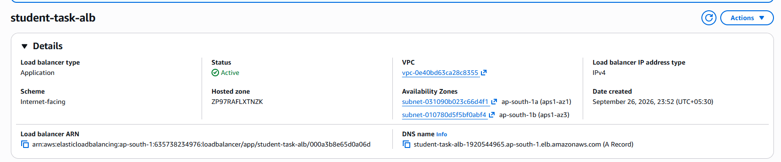
Figure 7. Application Load Balancer details

Figure 8. Target group with two healthy targets
The student-task-targets target group uses HTTP port 80 and currently reports two total targets, both healthy and with zero unhealthy targets. This provides direct evidence of the application's multi-instance target configuration.
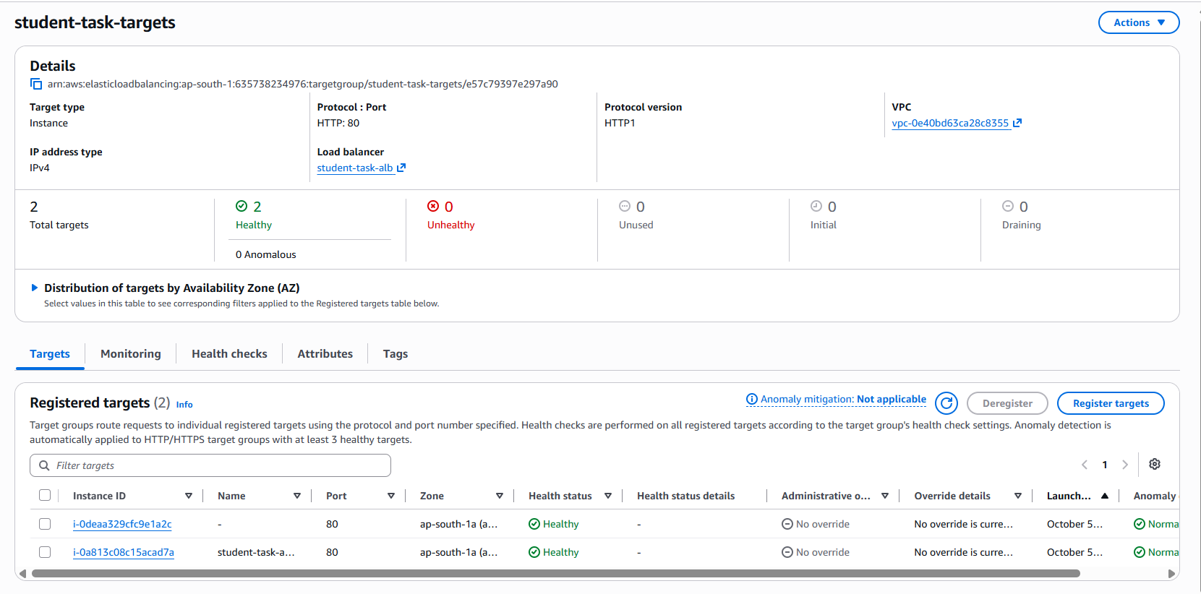
Figure 8. Target group with two healthy targets

Figure 9. Auto Scaling group capacity
The student-task-asg Auto Scaling group is at its desired capacity of 1 instance, with scaling limits of 1 to 2 instances.
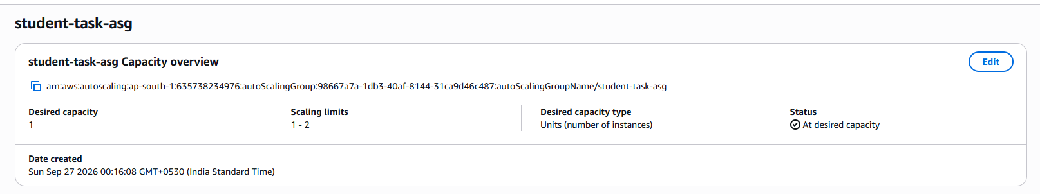
Figure 9. Auto Scaling group capacity

Figure 10. CloudWatch Application Load Balancer metrics
The CloudWatch ApplicationELB namespace is shown with metric groupings for per-ALB, per-AZ, target-group, and request-related measurements, providing monitoring visibility for the load balancer.
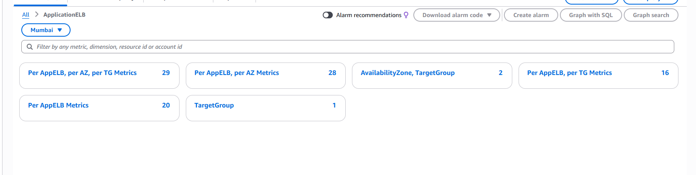
Figure 10. CloudWatch Application Load Balancer metrics

Figure 11. Student Task Manager landing page
The landing page presents the StudentTaskManager branding, primary navigation, feature messaging, call-to-action controls, and a dashboard preview illustrating the intended academic task-management experience.
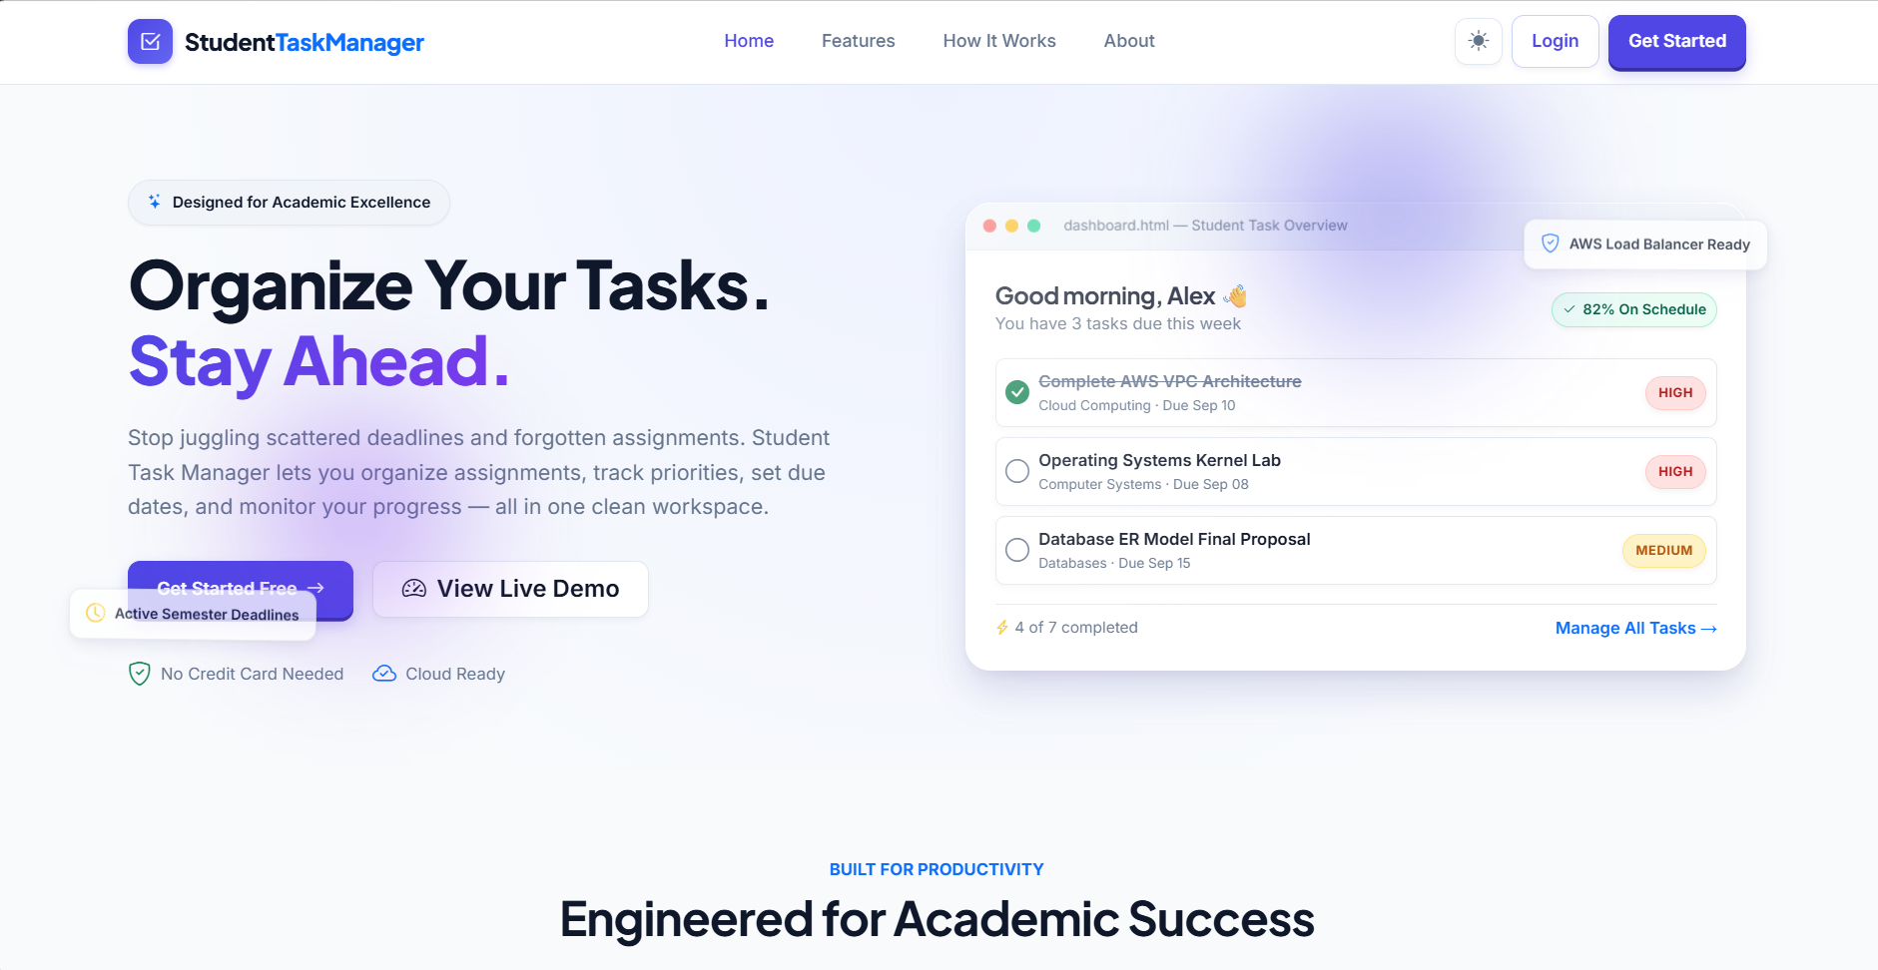
Figure 11. Student Task Manager landing page

Figure 12. User login page
The login page provides email and password fields, a remember-me option, sign-in control, and navigation to account registration.
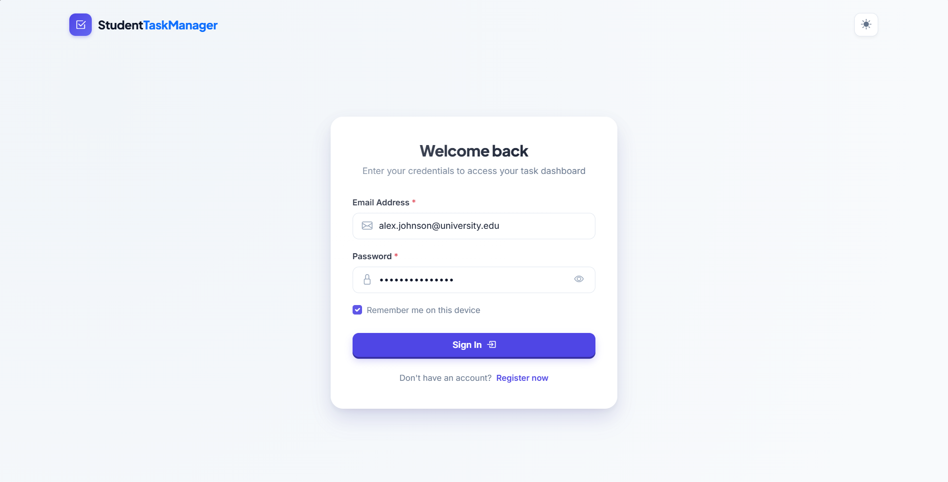
Figure 12. User login page

Figure 13. User registration page
The registration page collects full name, email address, password, and password confirmation, with visible password-strength requirements and validation guidance.
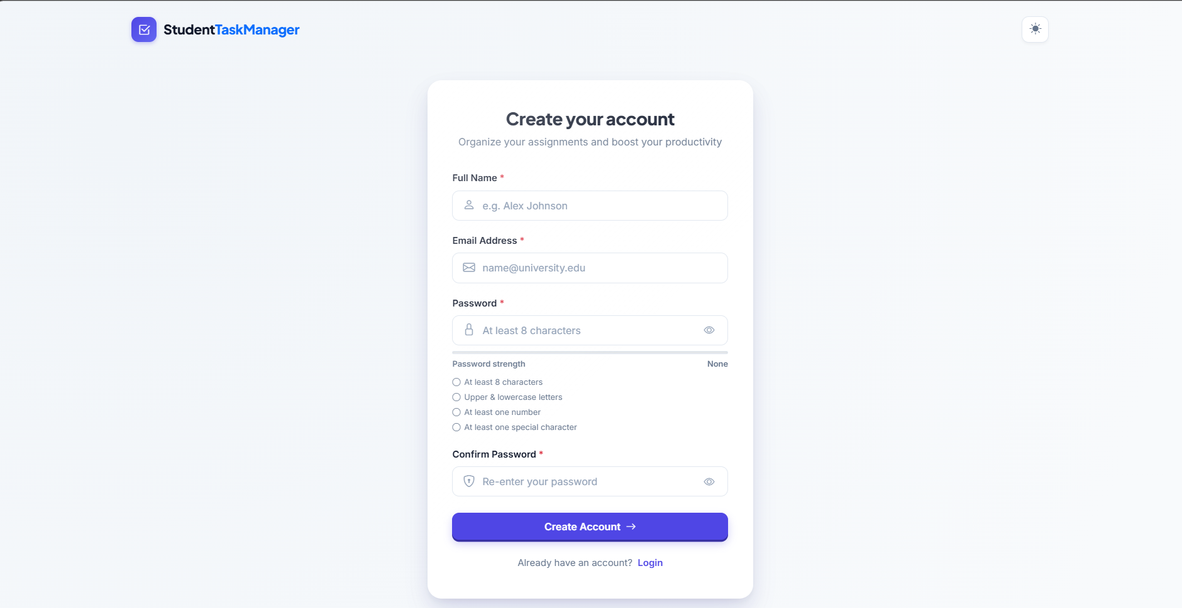
Figure 13. User registration page

Figure 14. Dashboard empty state
The dashboard shows task summary cards for total, completed, pending, and high-priority tasks, together with an empty-state prompt encouraging the user to create the first task.
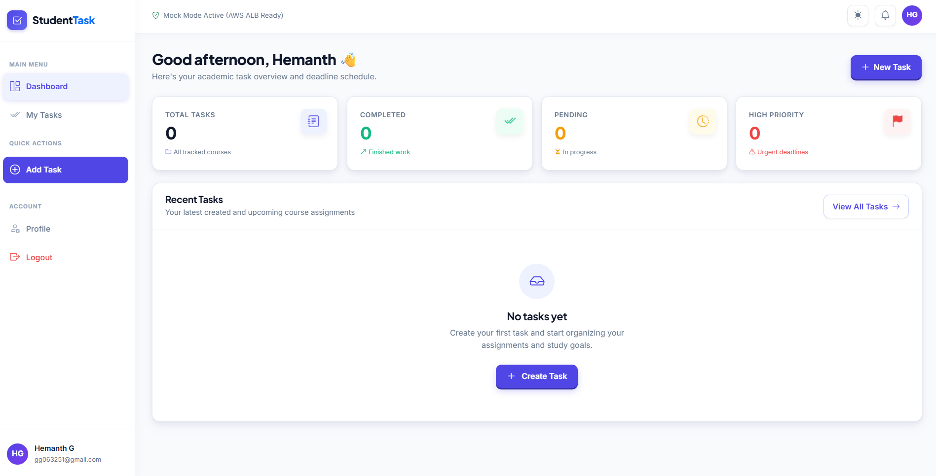
Figure 14. Dashboard empty state

Figure 15. Create new task dialog
The Create New Task dialog provides fields for task title, optional description, priority, and due date, with Cancel and Save Task actions.
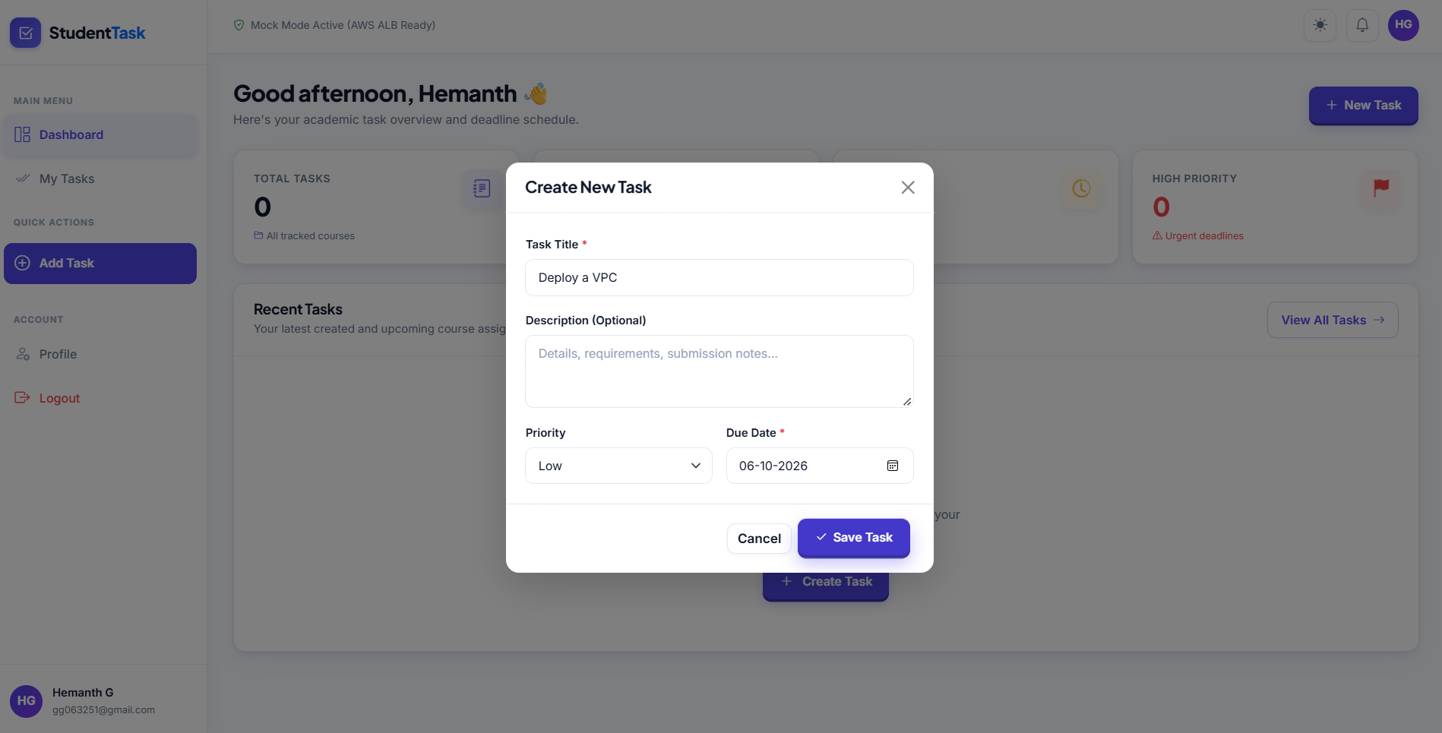
Figure 15. Create new task dialog

Figure 16. Dashboard after task creation
The dashboard reflects a newly created pending task and updates the total and pending task counts while displaying the task's priority, due date, status, and actions.
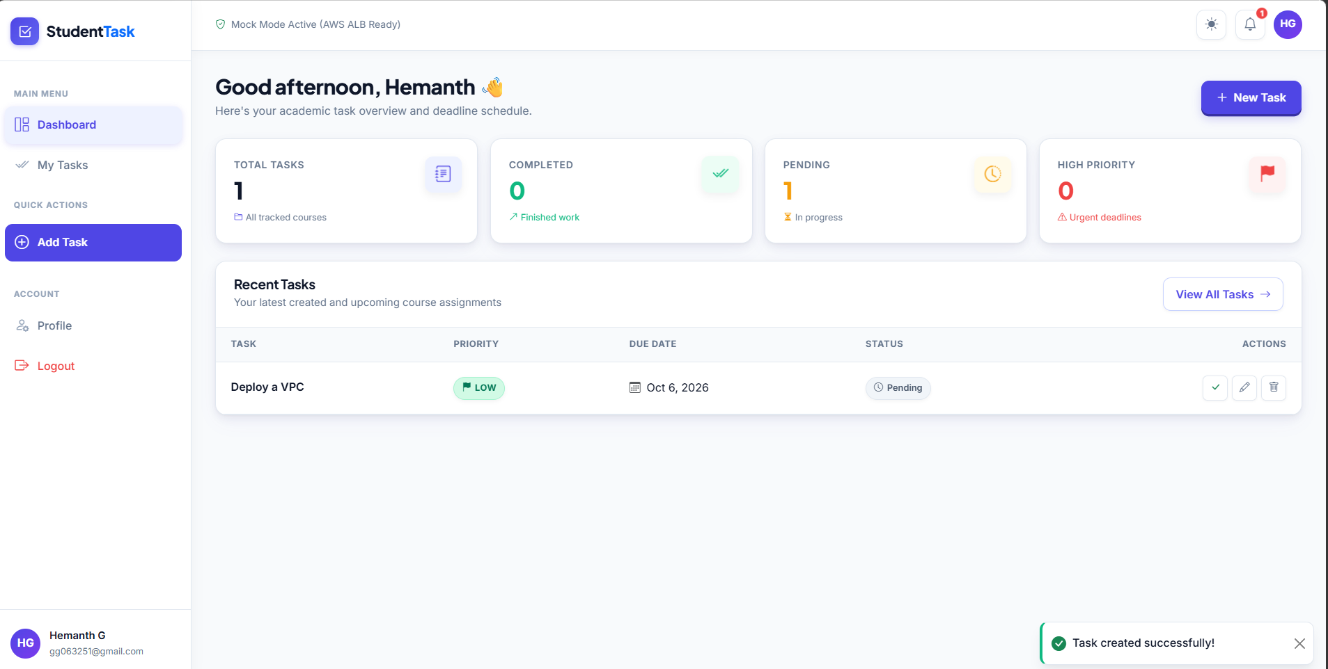
Figure 16. Dashboard after task creation

Figure 17. My Tasks list and task actions
The My Tasks page displays the created task in a structured table with search, status and priority filters, sorting, due date, status, creation time, and Complete/Edit/Delete controls.
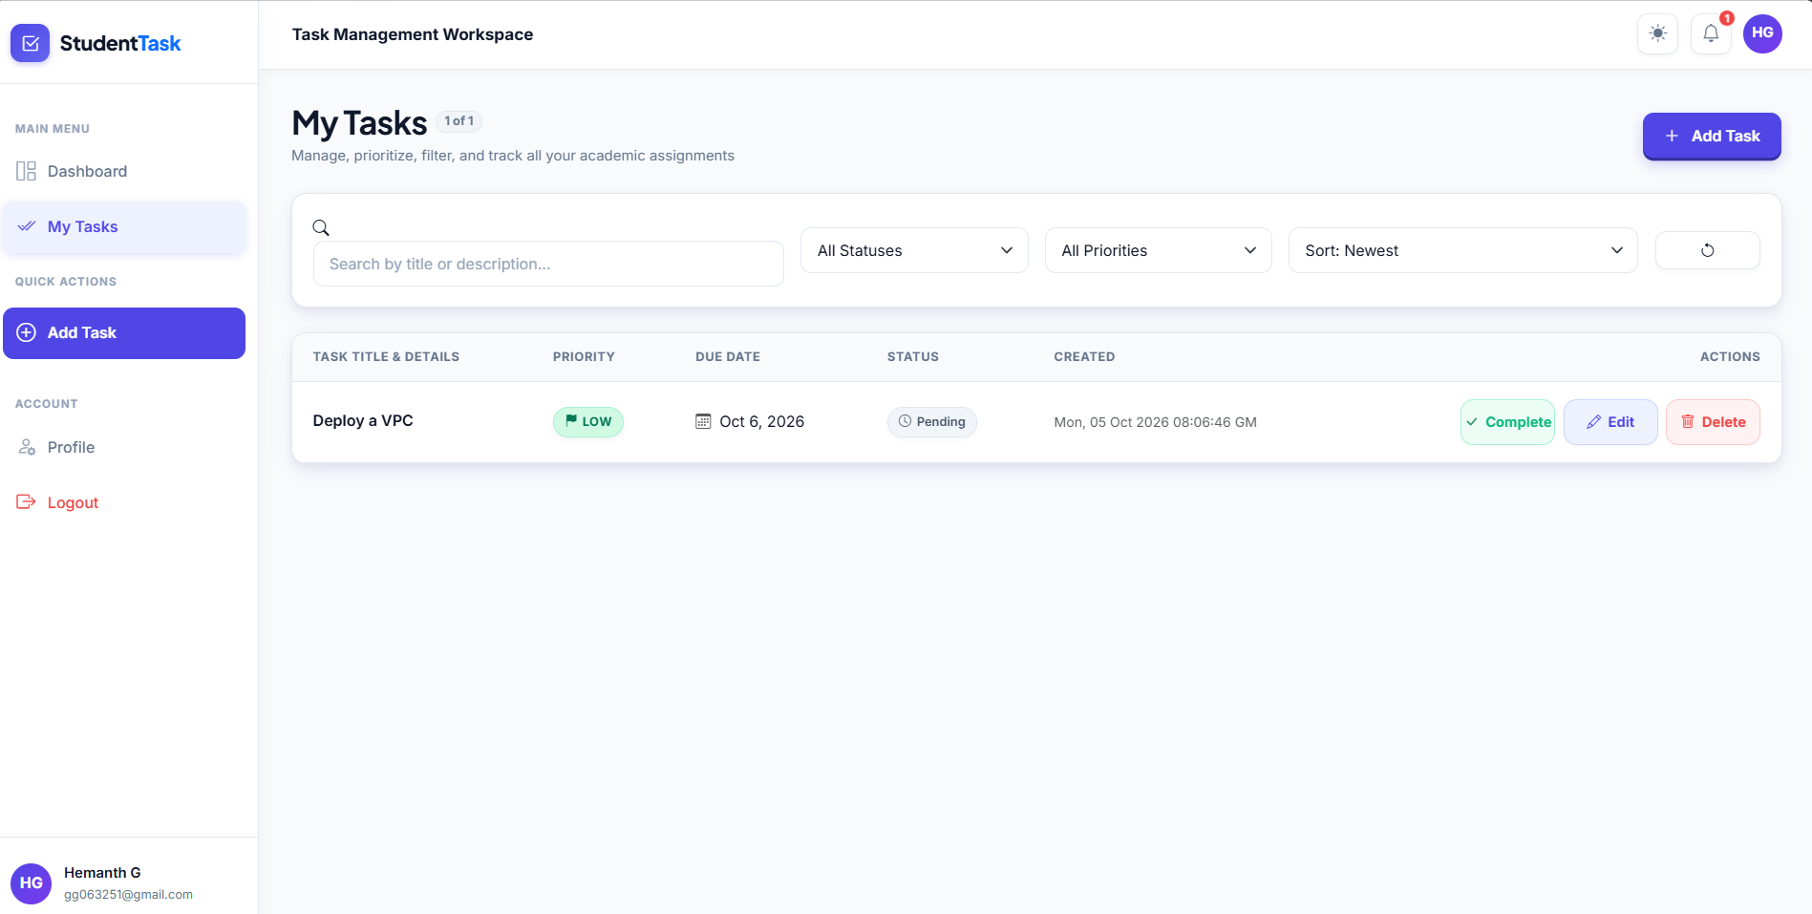
Figure 17. My Tasks list and task actions

Figure 18. Tasks workspace — completed task
The My Tasks workspace shows a completed task with its priority, due date, status, creation timestamp, and available Reopen, Edit, and Delete actions.
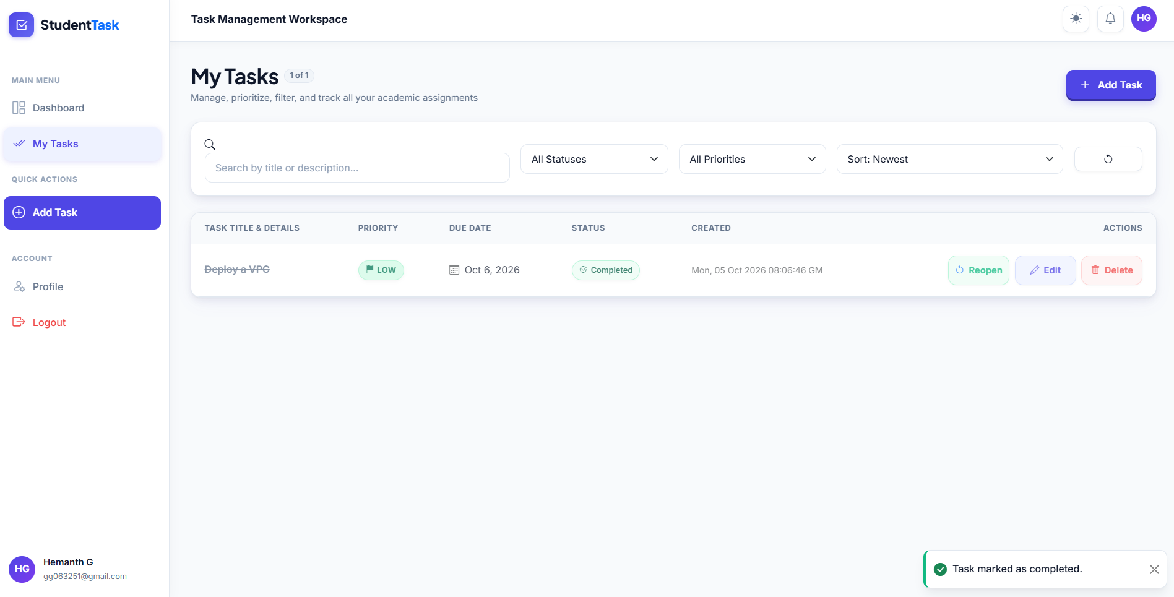
Figure 18. Tasks workspace — completed task

Figure 19. Task deletion confirmation
The application displays a confirmation modal before deleting a task, explicitly warning that the action cannot be undone.
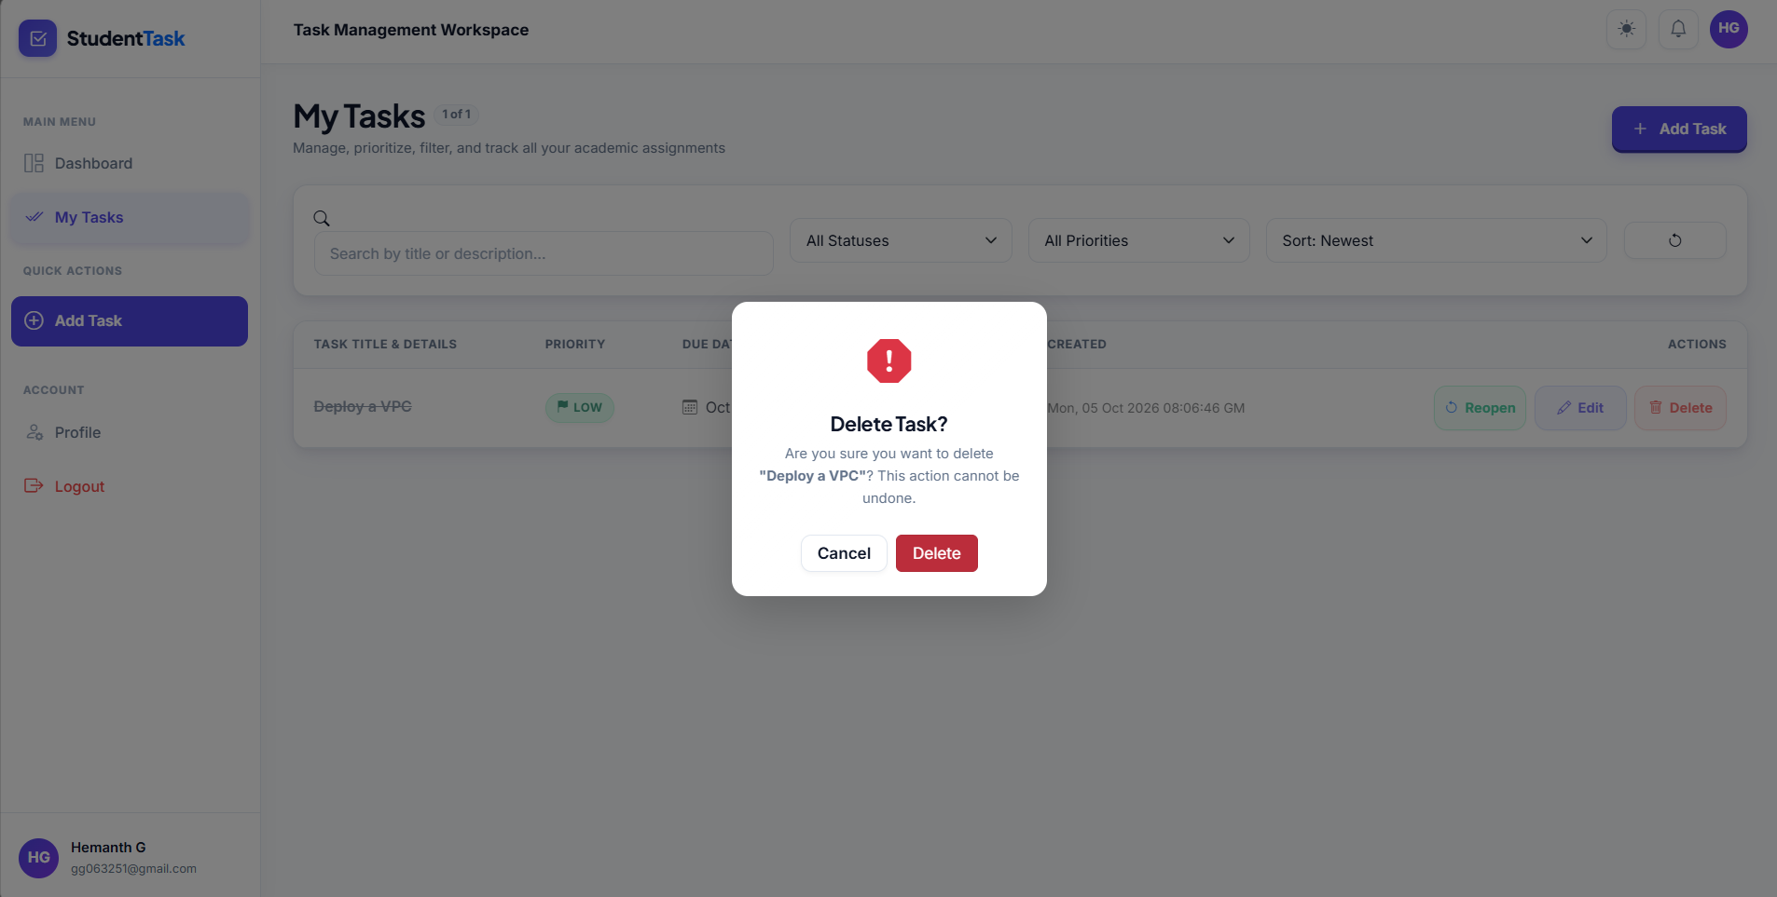
Figure 19. Task deletion confirmation

Figure 20. Student profile and settings
The profile page presents personal information, academic details, account status, password controls, and preference toggles. The page also displays the application's cloud synchronization/ALB-ready status.
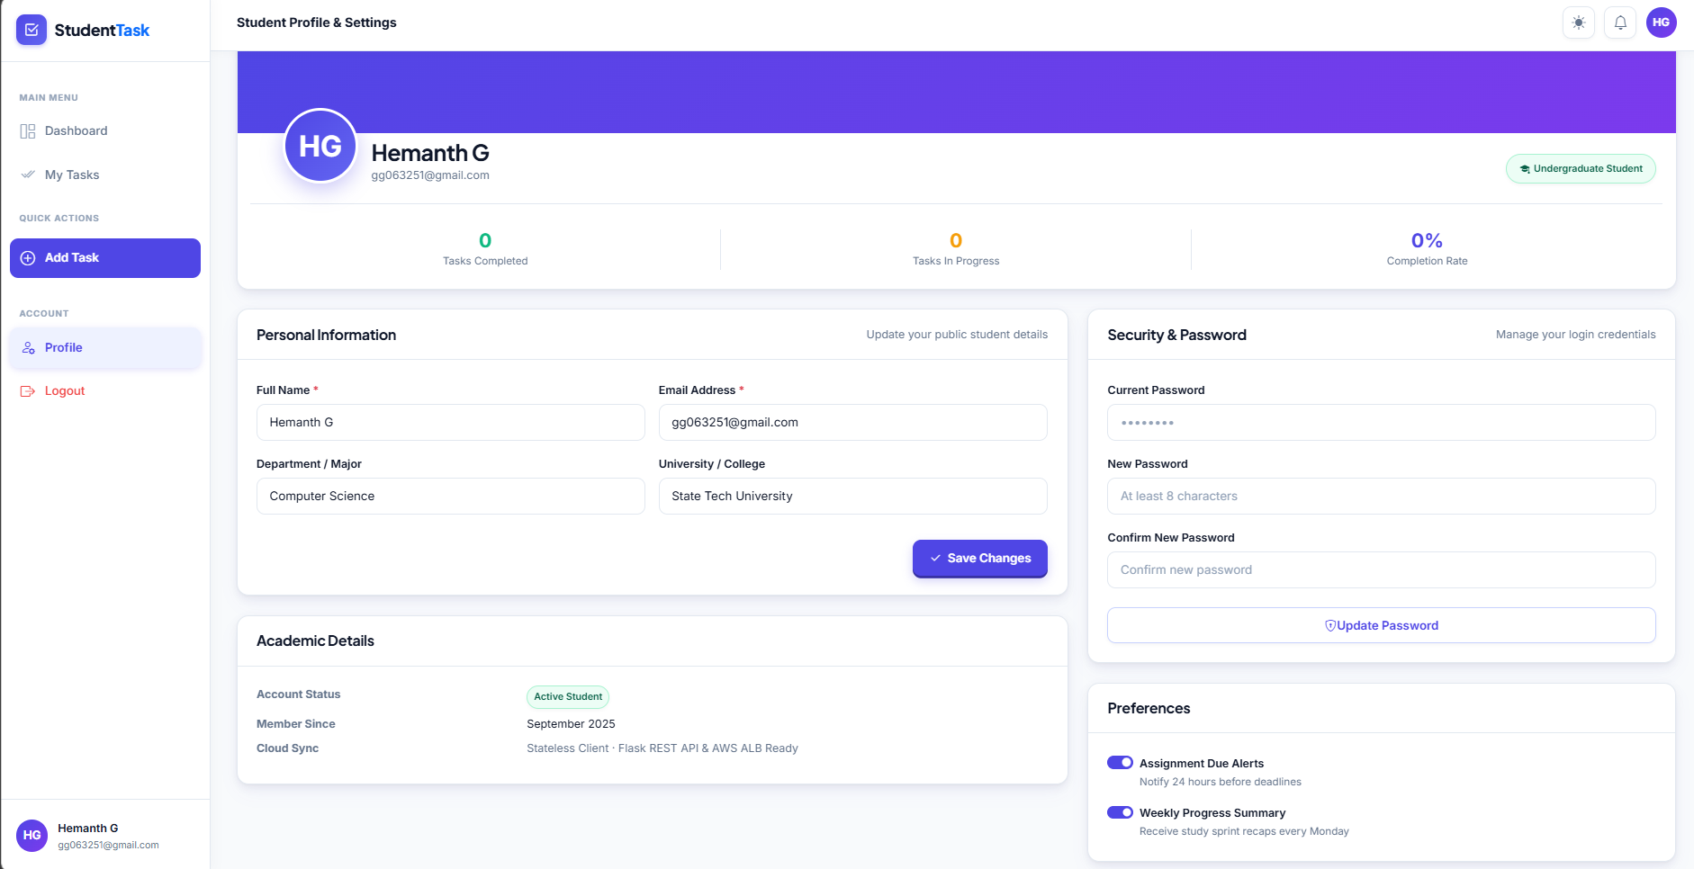
Figure 20. Student profile and settings

Evidence interpretation
Together, these screenshots demonstrate the implemented AWS network foundation, security-group isolation, private RDS configuration, EC2 application hosting, internet-facing ALB, healthy target registration, Auto Scaling configuration, CloudWatch visibility, and the major Student Task Manager user workflows.

