Sender

File selection

MAC key generation

Appling MAC

Append

AES key

Encryption

File transfer

CA

File Transfer

Receiver 2

Receiver 1

AES key

AES key

Decryption

Decryption

Getting MAC key

Getting MAC key

Applying MAC

Applying MAC

Integrity Checking

Integrity Checking

Modules:

1.MAC yielding

2.File ciphering using AES and transfer

3.CA deployment and data distribution

4.File retrieve using AES

5.Data integrity checking

Use Case Diagrams:

Sender

Central Authority

Receiver

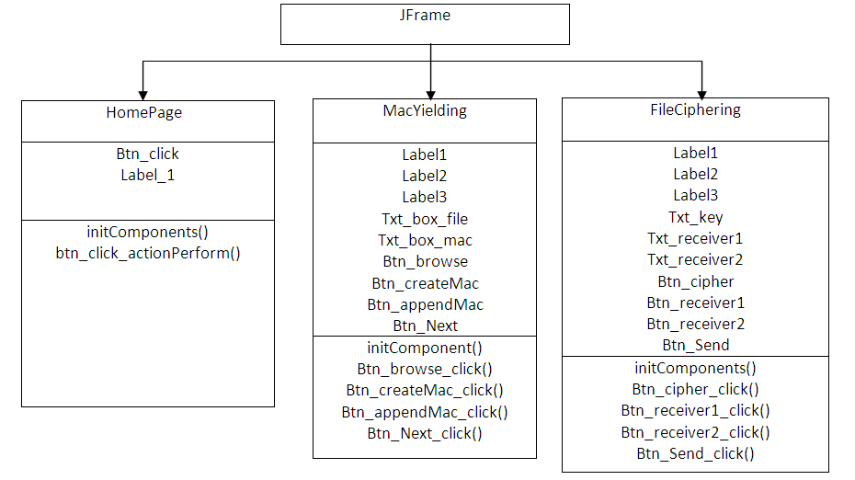Class Diagrams:

**Sender:**

**Central Authority:**

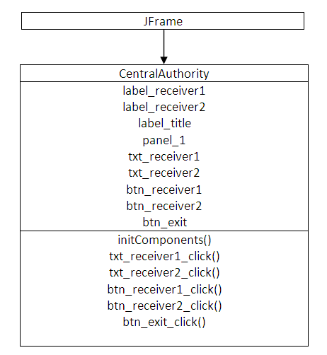

**Reciever:**

