Activity | Data Type
Number of beatings from Wife | Discrete/Nominal
Results of rolling a dice | Discrete/Nominal
Weight of a person | Continuous
Weight of Gold | Continuous
Distance between two places | Continuous
Length of a leaf | Continuous
Dog's weight | Continuous
Blue Color | Discrete/Nominal
Number of kids | Discrete/Nominal
Number of tickets in Indian railways | Continuous
Number of times married | Discrete/Nominal
Gender (Male or Female) | Discrete/Nominal
Q1) Identify the Data type for the Following:

Q2) Identify the Data types, which were among the following
Nominal, Ordinal, Interval, Ratio.
Data | Data Type
Gender | Nominal
High School Class Ranking | Ordinal
Celsius Temperature | Interval
Weight | Ratio
Hair Color | Ordinal
Socioeconomic Status | Ordinal
Fahrenheit Temperature | Ratio
Height | Ratio
Type of living accommodation | Ordinal
Level of Agreement | Interval
IQ(Intelligence Scale) | Ordinal
Sales Figures | Interval
Blood Group | Nominal
Time Of Day | Interval
Time on a Clock with Hands | Interval
Number of Children | Ratio
Religious Preference | Nominal
Barometer Pressure | Ratio
SAT Scores | Ratio
Years of Education | Nominal

Q3) Three Coins are tossed, find the probability that two heads and one tail are obtained?
A: The total possible outcomes 2^3=8
[HHH,HHT,HTT,THT,TTH,HTH,THH,TTT]
Number of favorable outcomes = 3
3/8 = 0.375
Q4) Two Dice are rolled, find the probability that sum is
- Equal to 1
- Less than or equal to 4
- Sum is divisible by 2 and 3
A: :- a) Sum is equal to 1 is not possible i.e. Probability is Zero(0)
b) <=4: can be possible only by (1,1) (1,2) (1,3) (2,1) (2,2) (3,1)
Favorable outcomes is 6
Number of possible outcomes are 36
Probability is 6/36 = 1/6
- Sum is divisible by 2 and 3
Divisible by both 2 and 3 are 6 and 12
Favorable outcomes is (1,5) (2,4) (3,3) (4,2) (5,1) (6,6)
Favorable outcomes is 6
Number of possible outcomes are 36
Probability 6/36 = 1/6
Q5) A bag contains 2 red, 3 green and 2 blue balls. Two balls are drawn at random. What is the probability that none of the balls drawn is blue?

A: 5c2/7c2 = (5*4/1*2)/(7*6/1*2) = 10/21
Q6) Calculate the Expected number of candies for a randomly selected child
Below are the probabilities of count of candies for children (ignoring the nature of the child-Generalized view)
CHILD | Candies count | Probability
A | 1 | 0.015
B | 4 | 0.20
C | 3 | 0.65
D | 5 | 0.005
E | 6 | 0.01
F | 2 | 0.120
Child A – probability of having 1 candy = 0.015.
Child B – probability of having 4 candies = 0.20
A: Expected number of candies for a randomly selected child will be
E(x)= (1*0.015+4*0.20+3*0.65+5*0.005+6*0.01+2*0.0120)
E(x)= 1.015+0.80+1.95+0.025+0.06+0.24
E(x)= 3.13
Q7) Calculate Mean, Median, Mode, Variance, Standard Deviation, Range & comment about the values / draw inferences, for the given dataset
- For Points, Score, Weigh>
Find Mean, Median, Mode, Variance, Standard Deviation, and Range and also Comment about the values/ Draw some inferences.
Use Q7.csv file
A: Mean – points 3.596563, score 3.217250, Weigh 17.848750
Median – points 3.695, Score 3.325, Weigh 17.710
Mode – points Score Weigh
0 3.07 3.44 17.02
1 3.92 NaN 18.90
VARIANCE – Points 0.285881, Score 0,95379, Weigh 3.193166
STANDARD DEVIATION - Points 0.534679, Score 0.978457, Weigh
1.786943
RANGE – Points 2.17, Score 3.911, Weigh 8.399
Histogram of points-
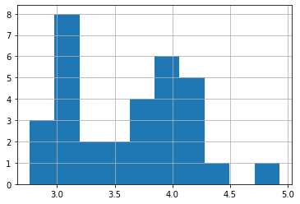
Skewness factor of points - 0.29278021324083486
Histogram of score-
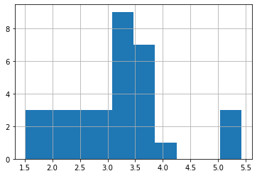
Skewness factor of score - 0.4659161067929858

Histogram of weigh –
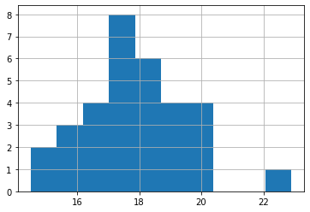
Skewness factor of weigh - 0.4063466292404903
Q8) Calculate Expected Value for the problem below
- The weights (X) of patients at a clinic (in pounds), are
108, 110, 123, 134, 135, 145, 167, 187, 199
Assume one of the patients is chosen at random. What is the Expected Value of the Weight of that patient?
A: Expected value for the random patient would be
E(X)=1/9*(108+110+123+134+135+145+167+187+199)
E(X)=1/9*(1298)
E(X)=144.22 pounds

Q9) Calculate Skewness, Kurtosis & draw inferences on the following data
Cars speed and distance
Use Q9_a.csv
A: Skewness value: 0.18161654815794095
Kurtosis value: 0.09476390781488098
Inferences:
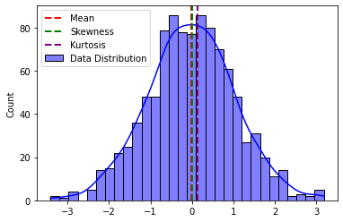

SP and Weight(WT)
Use Q9_b.csv
Kurtosis_value: 0.027597238324240436
Inferences
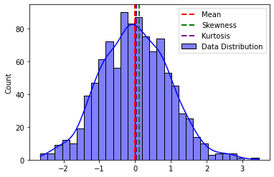

Q10) Draw inferences about the following boxplot & histogram
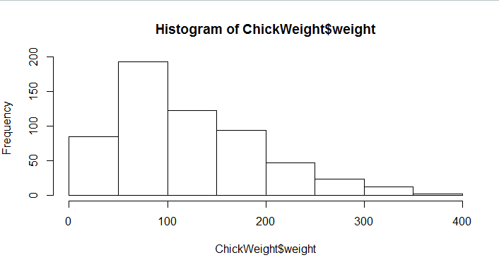

A: INFERENCES:-
Mean and median are far away from each other
It has widely distributed data
It is a multimodal histogram i.e it has no. of heads
It is a positively skewed histogram
And the data has outliers
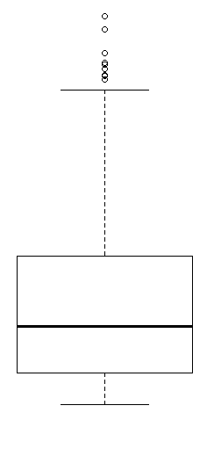
Inferences :-
Line inside the box is closer to the bottom so it is called as the lower
quartile, the data is distributed negatively skewed
And the boxplot has outliers

Q11) Suppose we want to estimate the average weight of an adult male in Mexico. We draw a random sample of 2,000 men from a population of 3,000,000 men and weigh them. We find that the average person in our sample weighs 200 pounds, and the standard deviation of the sample is 30 pounds. Calculate 94%,98%,96% confidence interval?
A: 94.0% Confidence Interval: (198.738325292158, 201.261674707842)
98.0% Confidence Interval: (198.43943840429978, 201.56056159570022)
96.0% Confidence Interval: (198.62230334813333, 201.37769665186667)

Q12) Below are the scores obtained by a student in tests
34,36,36,38,38,39,39,40,40,41,41,41,41,42,42,45,49,56
- Find mean, median, variance, standard deviation.
- What can we say about the student marks?
A: 1) Mean: 41.0
Median: 40.5
Variance: 24.11111111111111
Standard Deviation: 4.910306620885412
2) Considering maximum marks as 60, the over all pass percentage of
classroom is 68.33
Q13) What is the nature of skewness when mean, median of data are equal?
A:
- Mean = Median: The distribution is symmetric
- Skewness = 0: The data points are symmetrically distributed around the mean. There is no skewness is the distribution
So, if you observe that the mean and median are equal in a dataset, you can infer that the distribution is symmetric, and the skewness is zero.

Q14) What is the nature of skewness when mean > median ?
A: When the mean>median than the graph is positively skewed (right side).

Q15) What is the nature of skewness when median > mean?
A: When the median>mean than the graph is negatively skewed (left side).

Q16) What does positive kurtosis value indicates for a data ?
A: Positive kurtosis value indicates the heavier tail and sharper peak than the
normal distribution.

Q17) What does negative kurtosis value indicates for a data?
A: Positive kurtosis value indicates the lighter tail and flatter peak than the
normal distribution.

Q18) Answer the below questions using the below boxplot visualization.
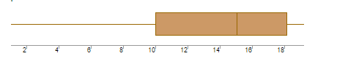
What can we say about the distribution of the data?
A: Data is not symmetrically distributed.
What is nature of skewness of the data?
A: Left whisker is longer than the right side, so NEGATIVELY SKEWED.
What will be the IQR of the data (approximately)?
A: Variability is long

Q19) Comment on the below Boxplot visualizations?
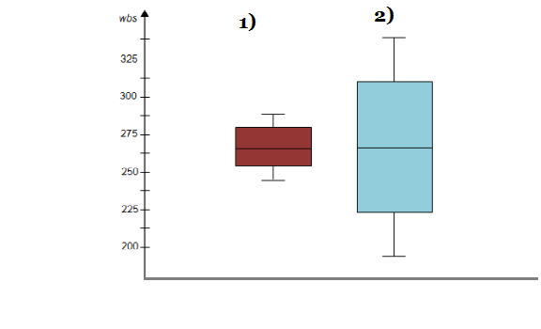
Draw an Inference from the distribution of data for Boxplot 1 with respect Boxplot 2.
A: In both the boxplots the data is distributed symmetrically but in the first case
data is shortly distributed where as in second case data is widely distributed.
There is no outliers in both the boxplots.
Q 20) Calculate probability from the given dataset for the below cases

Data _set: Cars.csv
Calculate the probability of MPG of Cars for the below cases.
MPG <- Cars$MPG
  - P(MPG>38)
A)P(MPG > 38): 0.4074074074074074

  - P(MPG<40)
A) P(MPG < 40): 0.7530864197530864

c. P (20<MPG<50)
A) P(20 < MPG < 50): 0.8518518518518519

Q 21) Check whether the data follows normal distribution
- Check whether the MPG of Cars follows Normal Distribution
Dataset: Cars.csv
A) The data follows a normal distribution.
- Check Whether the Adipose Tissue (AT) and Waist Circumference(Waist) from wc-at data set follows Normal Distribution
Dataset: wc-at.csv
A) Z calculated value: 1.772
P-value : 0.078
H1 is rejected and Ho is accepted.
The data follows a normal distribution

Q 22) Calculate the Z scores of 90% confidence interval,94% confidence interval, 60% confidence interval
A: 90.0% Confidence Interval: Z-score: 1.6449
94.0% Confidence Interval: Z-score: 1.8808
60.0% Confidence Interval: Z-score: 0.8416
Q 23) Calculate the t scores of 95% confidence interval, 96% confidence interval, 99% confidence interval for sample size of 25
A: 95.0% Confidence Interval: t-score: 2.0639
96.0% Confidence Interval: t-score: 2.1715
99.0% Confidence Interval: t-score: 2.7969

Q 24) A Government company claims that an average light bulb lasts 270 days. A researcher randomly selects 18 bulbs for testing. The sampled bulbs last an average of 260 days, with a standard deviation of 90 days. If the CEO's claim were true, what is the probability that 18 randomly selected bulbs would have an average life of no more than 260 days
Hint:
rcode pt(tscore,df)
df degrees of freedom
A: Probability that 18 randomly selected bulbs would have an average life of
no more than 260 days: 0.32167253567098364

