CTS Deep Skilling - HOL 1 Progress Screenshots
Screenshots captured during completion of HOL 1.

1. Git version and global configuration
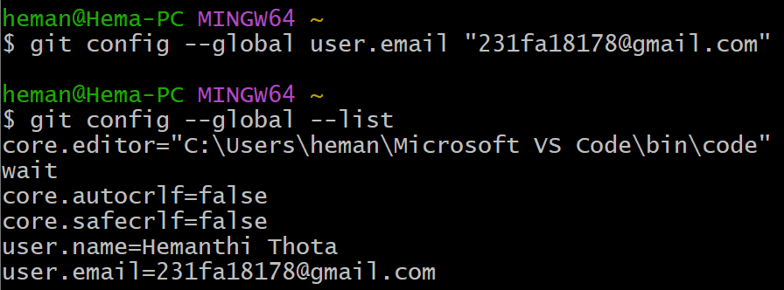

2. Repository initialization and file creation
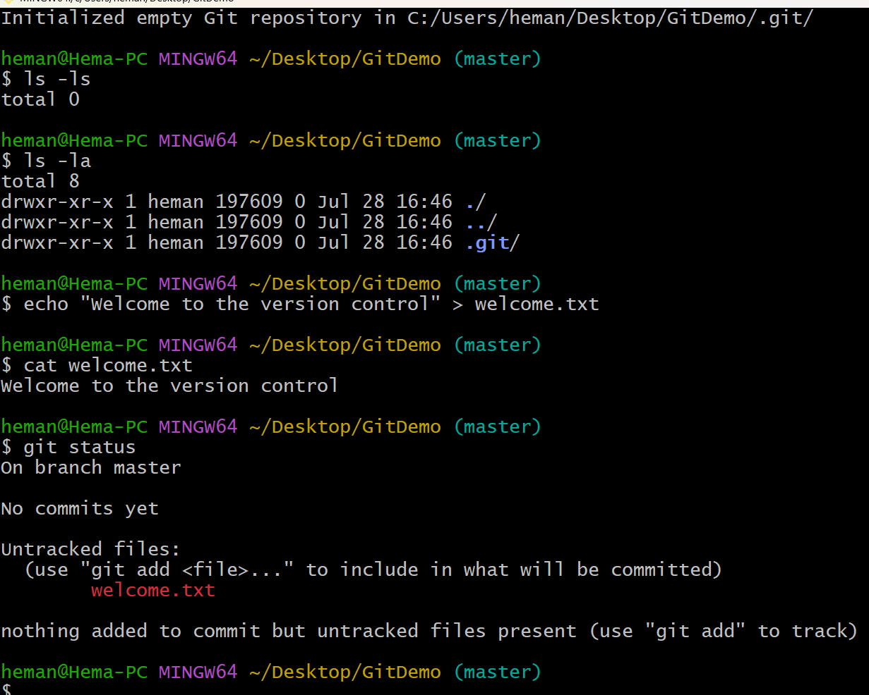

3. Add, commit, and clean working tree
