CTS Deep Skilling - HOL 2 (.gitignore) Screenshots
Evidence collected for HOL-2.

1. Create .gitignore from Git Bash
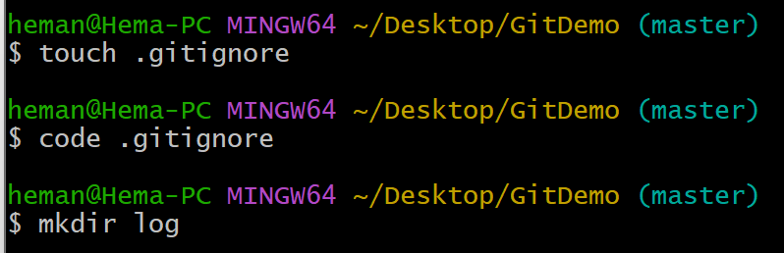

2. .gitignore content in VS Code
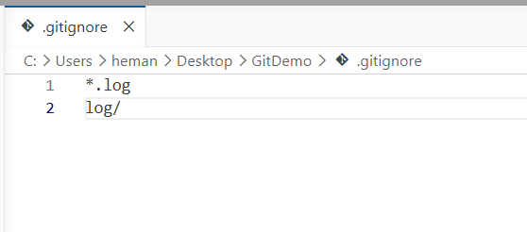

3. Create log folder and test files
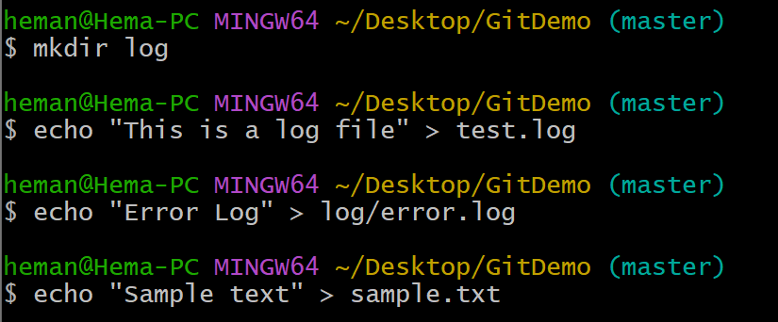

4. git status, add, and commit
