CTS Deep Skilling - HOL 3 (Branching & Merging) Screenshots
Evidence collected for HOL-3.

1. Verify clean repository
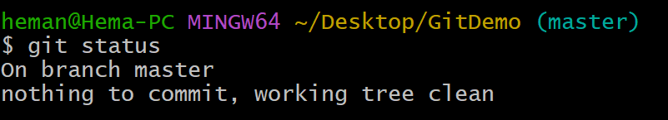

2. Create and list branch
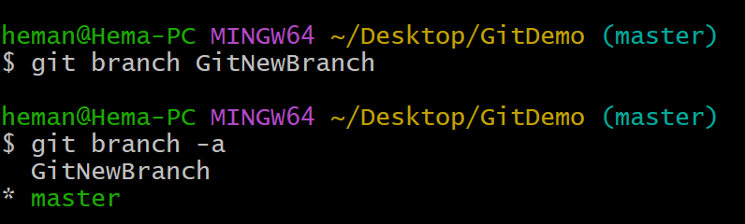

3. Switch to branch
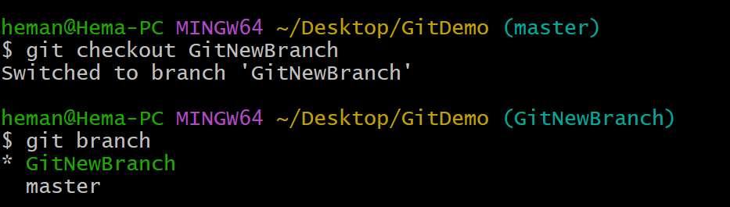

4. Create, add and commit branch file
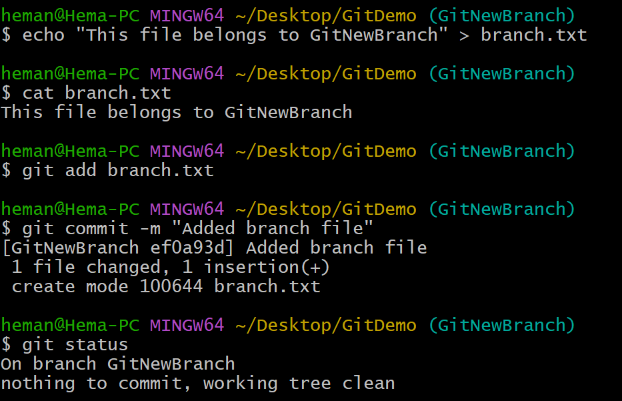

5. Compare master and branch
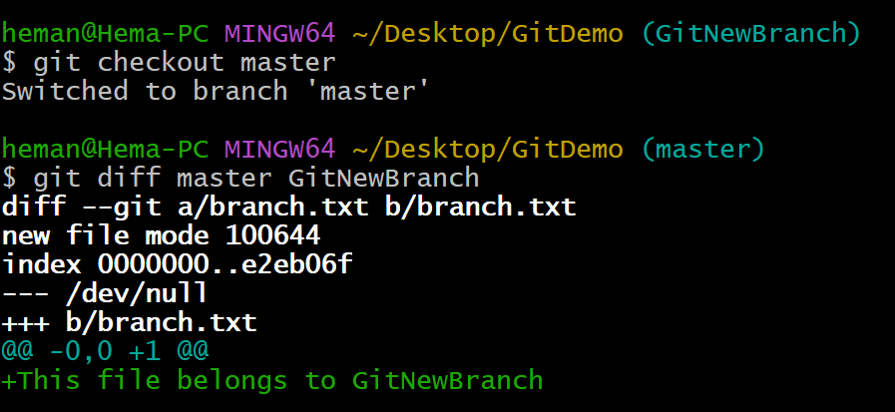

6. Merge branch
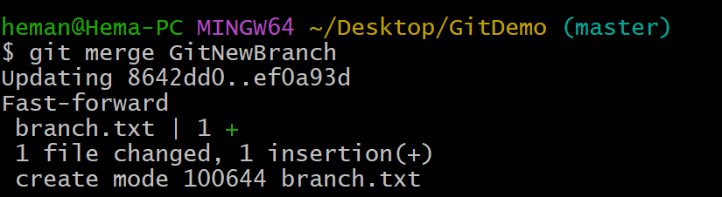

7. View commit log
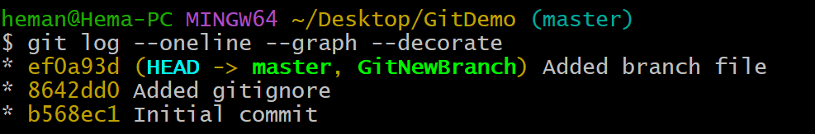

8. Delete branch
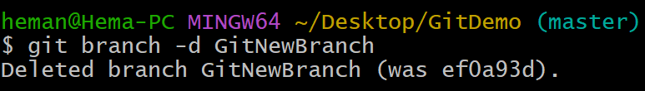

9. Final verification
