CTS Deep Skilling - HOL 4 (Merge Conflict Resolution) Screenshots
Evidence collected for HOL-4.

1. Clean repository
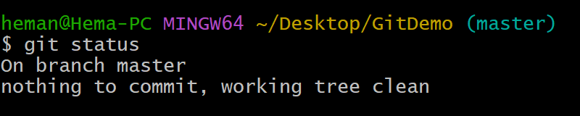

2. Create GitWork branch
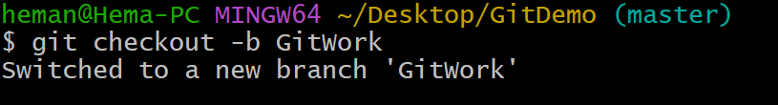

3. Add hello.xml in GitWork
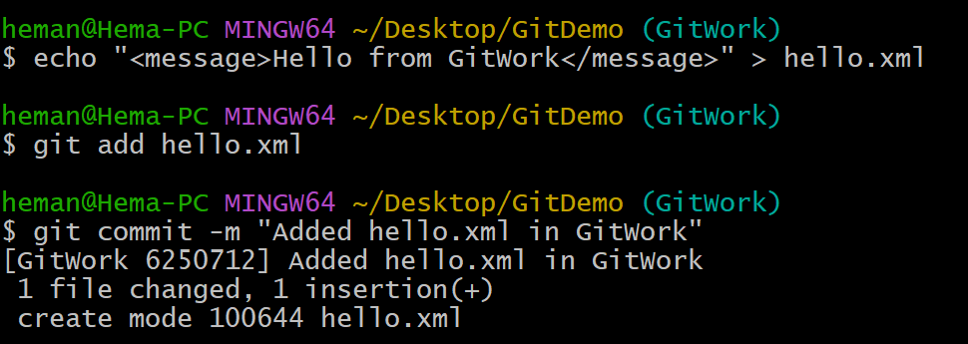

4. Add hello.xml in master
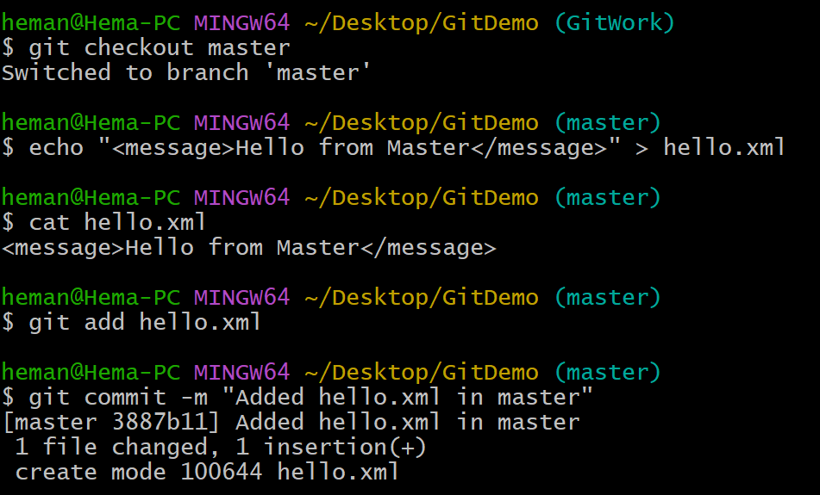

5. Commit graph
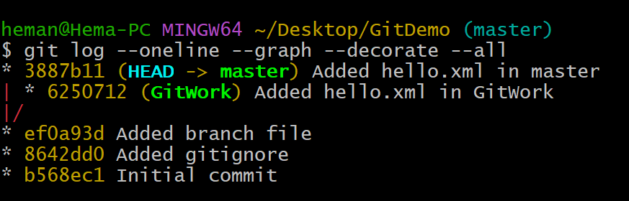

6. Compare branches
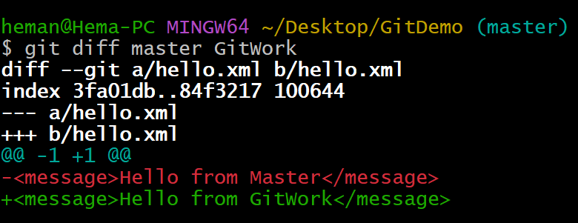

7. Merge conflict
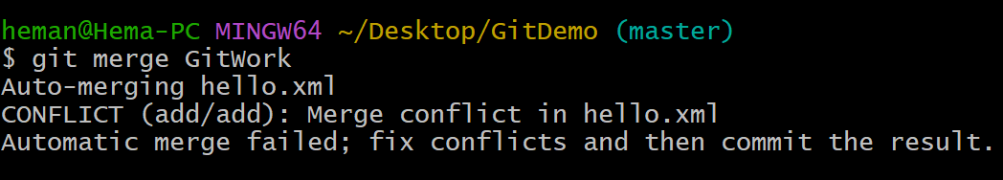

8. Resolved file in VS Code
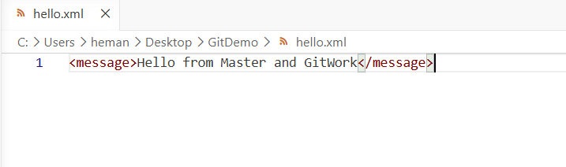

9. Commit resolved conflict
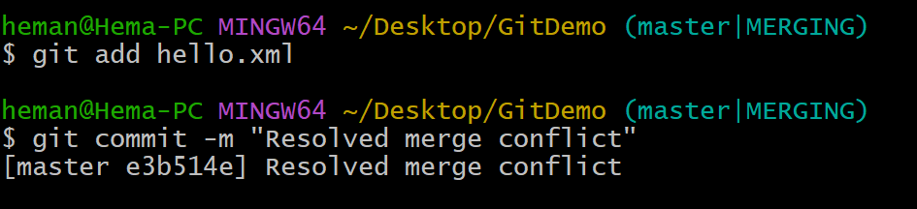

10. Update .gitignore
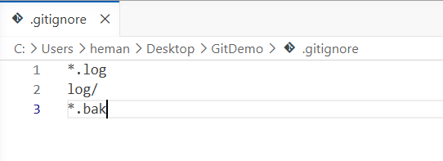

11. Commit gitignore
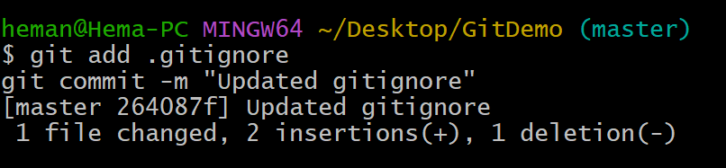

12. Delete GitWork branch
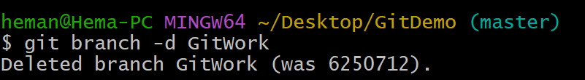

13. Final verification
