CTS Deep Skilling - HOL 5 (Remote Repository) Screenshots
Summary of the final Git remote repository exercise.

1. Push initially rejected (fetch first)
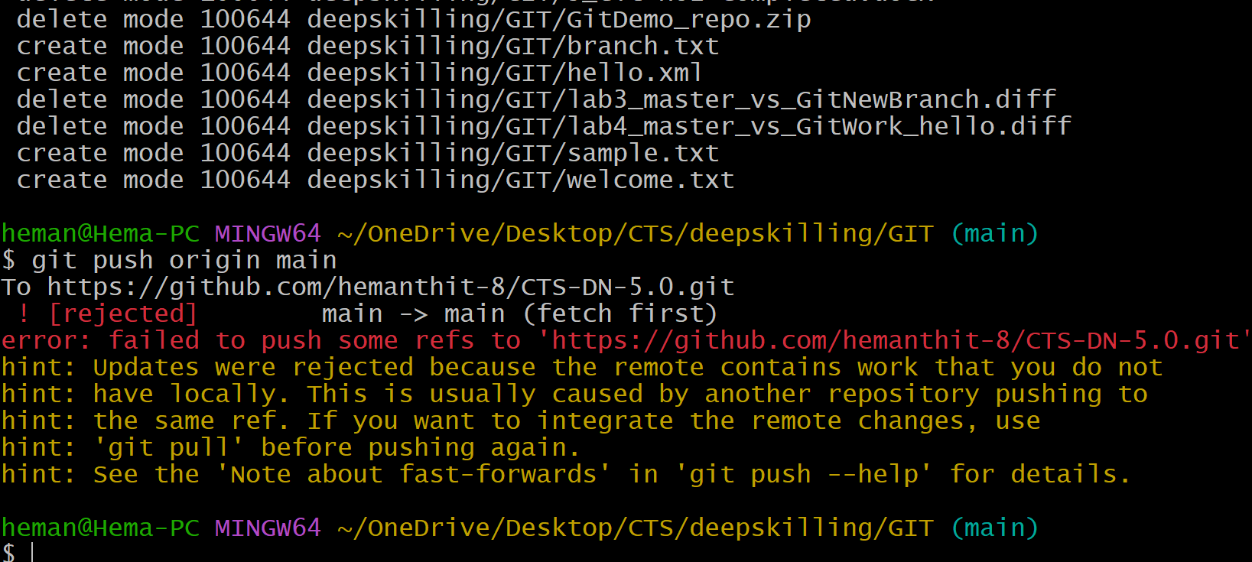

2. Pull from remote repository
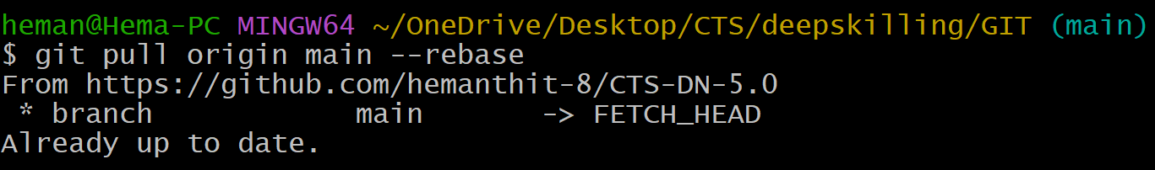

3. Git status
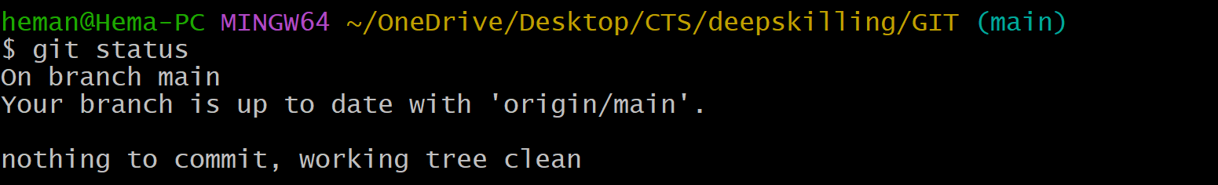

4. Branch tracking
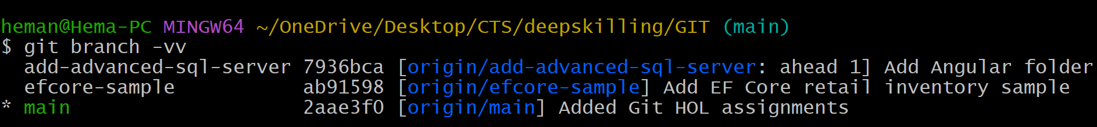

5. Commit history verification

