In this example, I will create a CollegeStaff table in Amazon DynamoDB. I will also know to perform insert,update,delete operations on DynamoDB and export the data to S3 in JSON format. This table, has the following details.

• Partition key – Professor

• Sort key – subjectTitle

Create a DynamoDB database

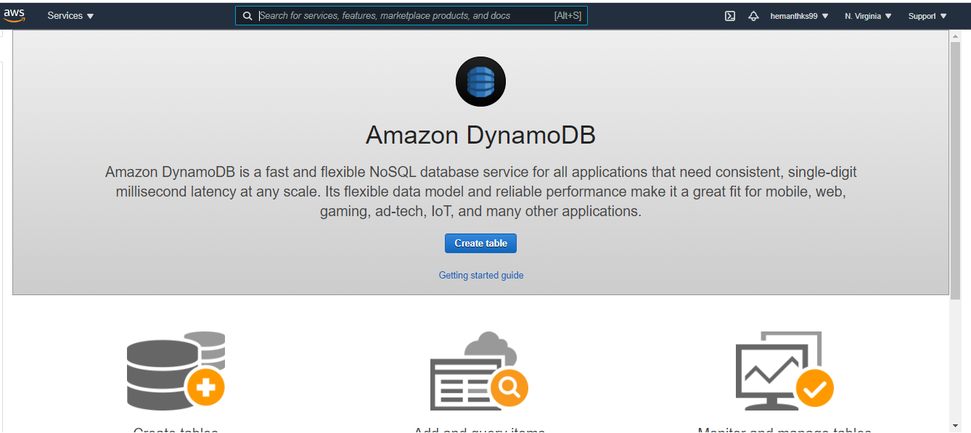

Enter the table details as follows:

a. For the table name, enter CollegeStaff

b. For the partition key, enter Professors.

c. Choose Add sort key. d. Enter SubjectTitle as the sort key.

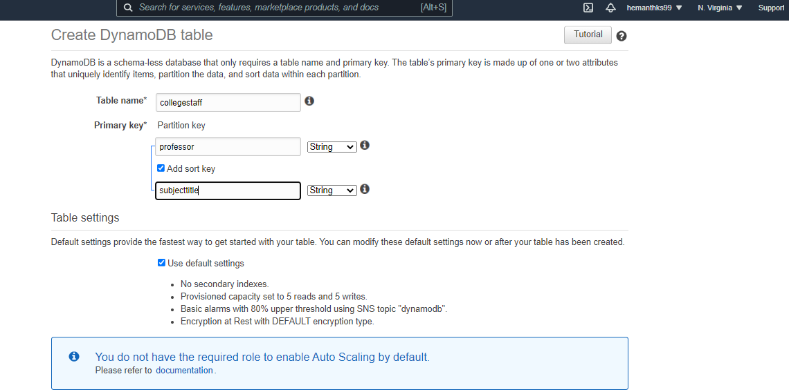

Write Data to the Table CollegeStaff

1. Open the DynamoDB console at <https://console.aws.amazon.com/dynamodb/>.

2. In the navigation pane on the left side of the console, choose Tables.

3. In the table list, choose the CollegeStaff table.

4. Choose the Items tab for the CollegeStaff table.

5. On the Items tab, choose Create item.

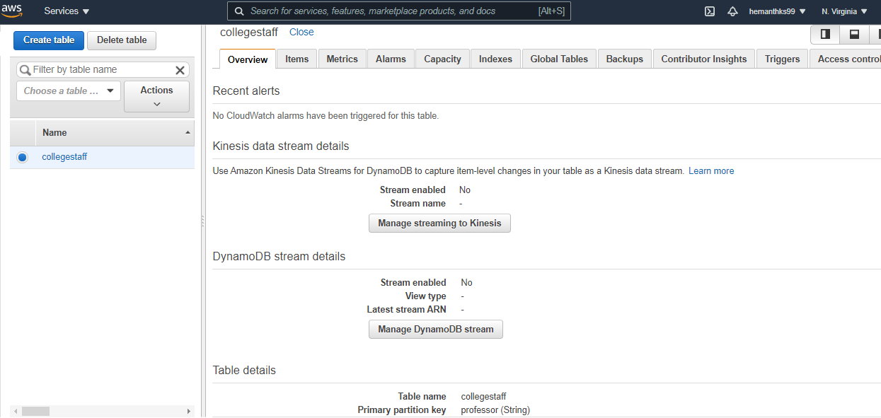

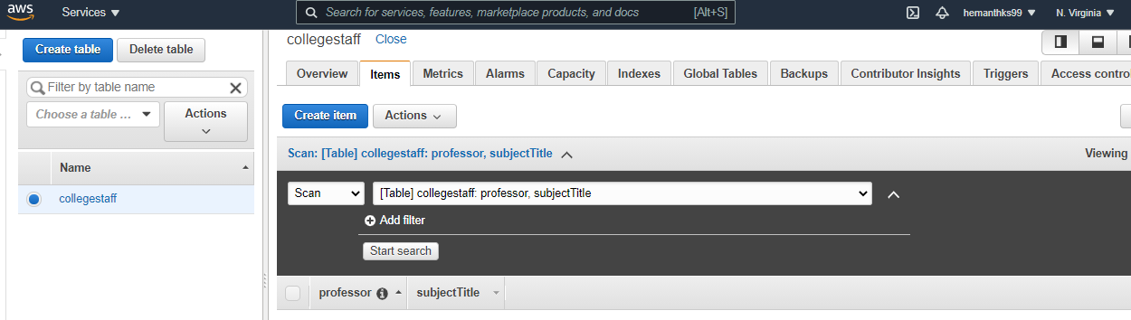

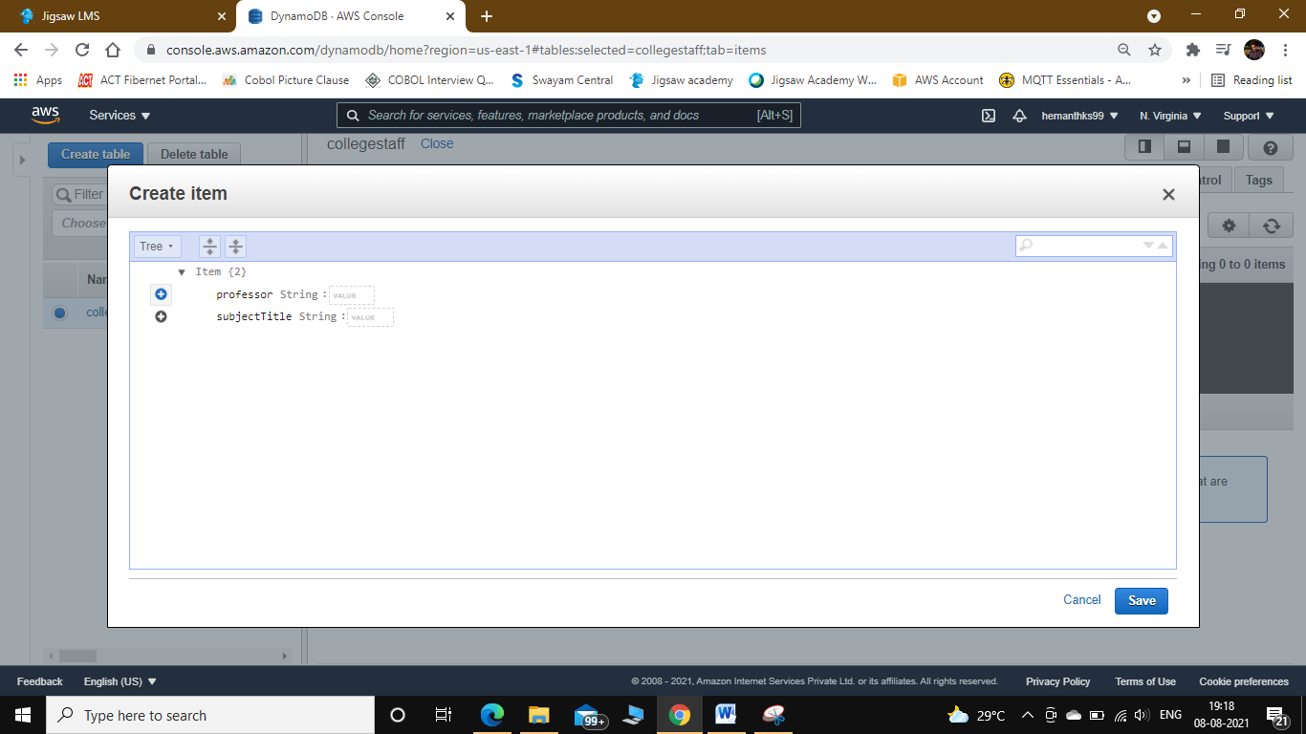

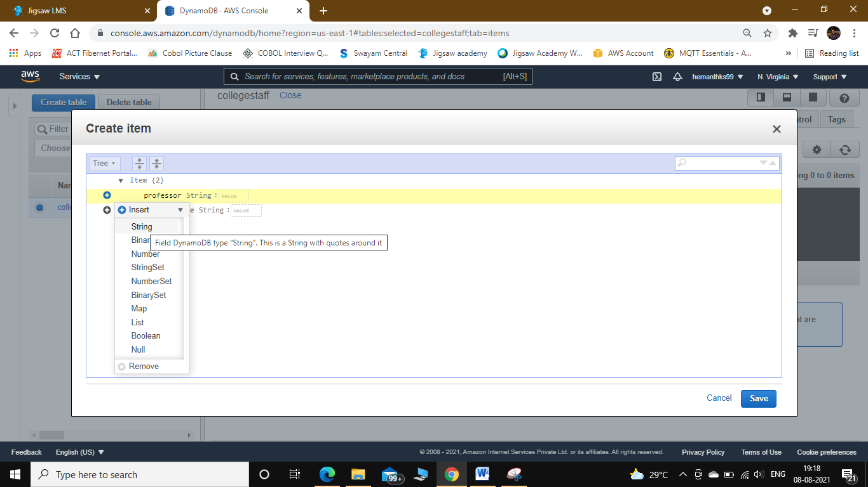

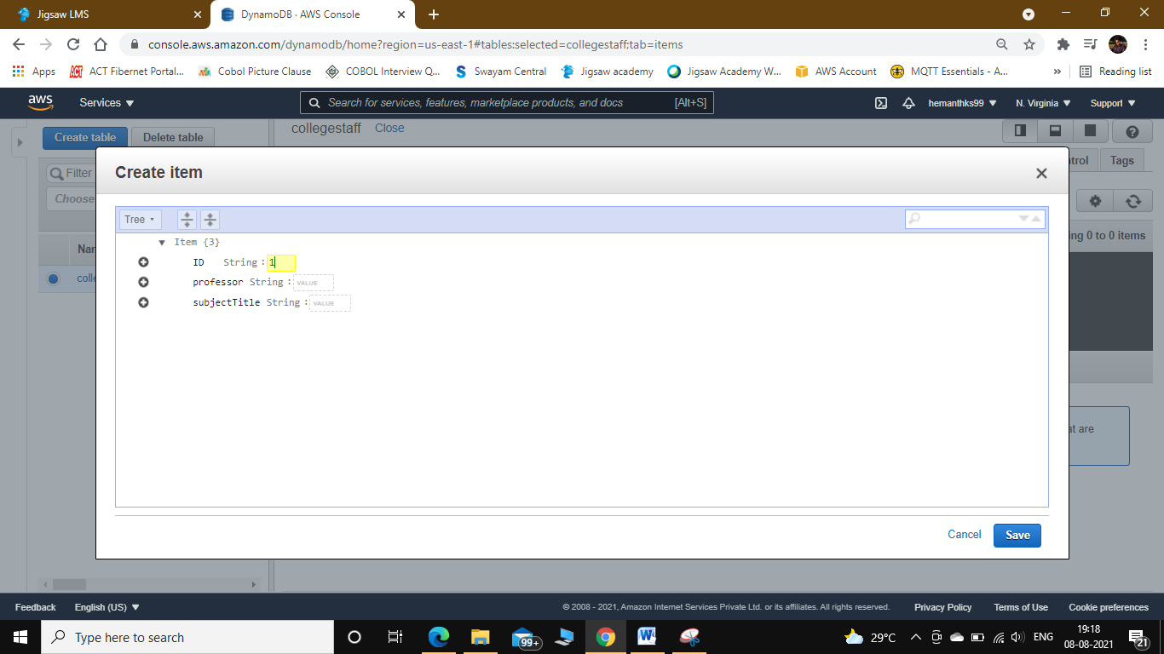

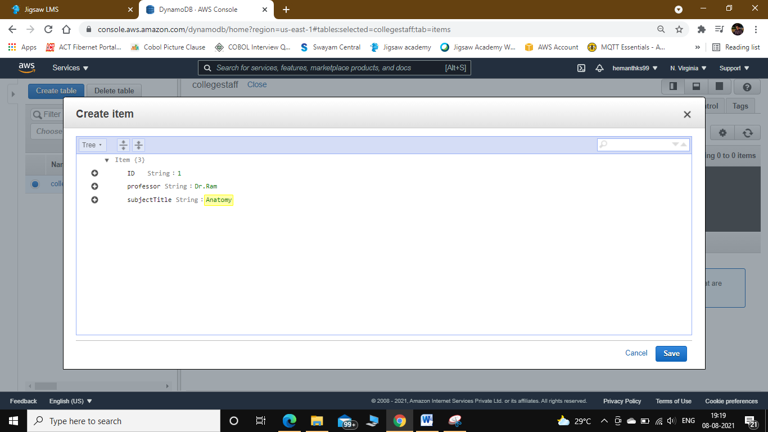

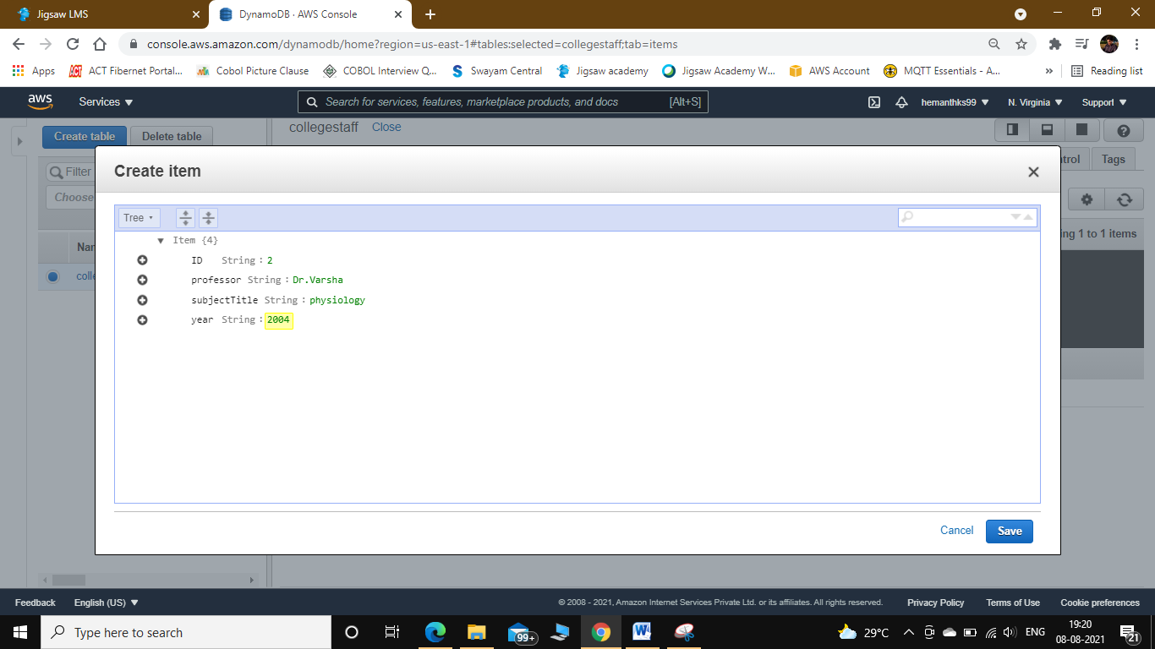

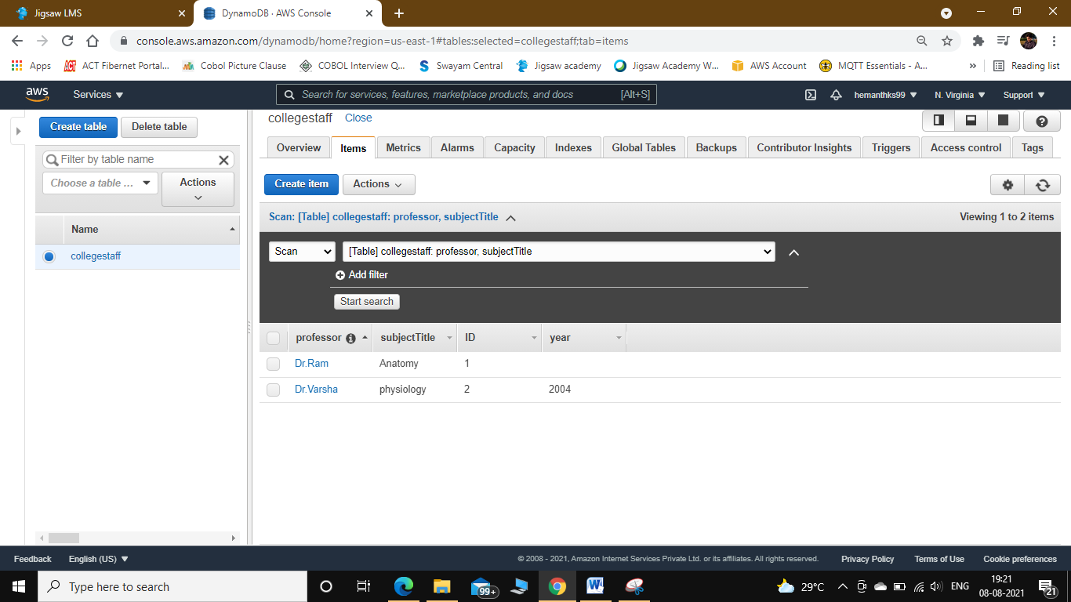

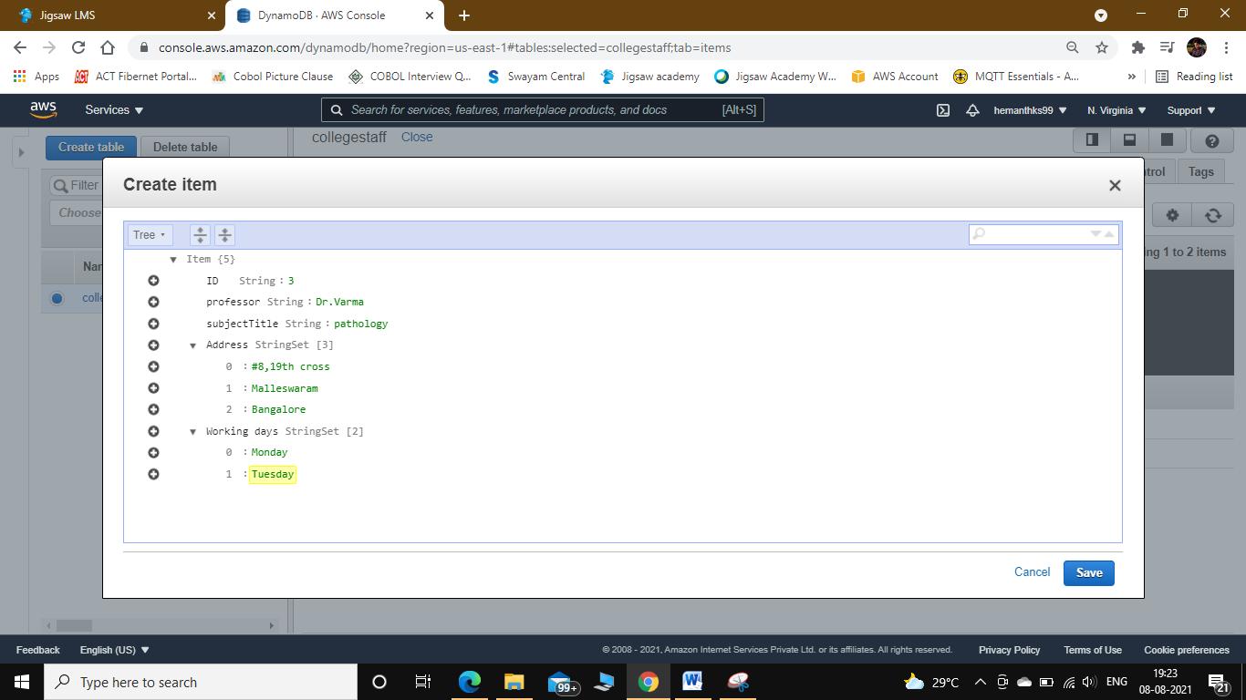

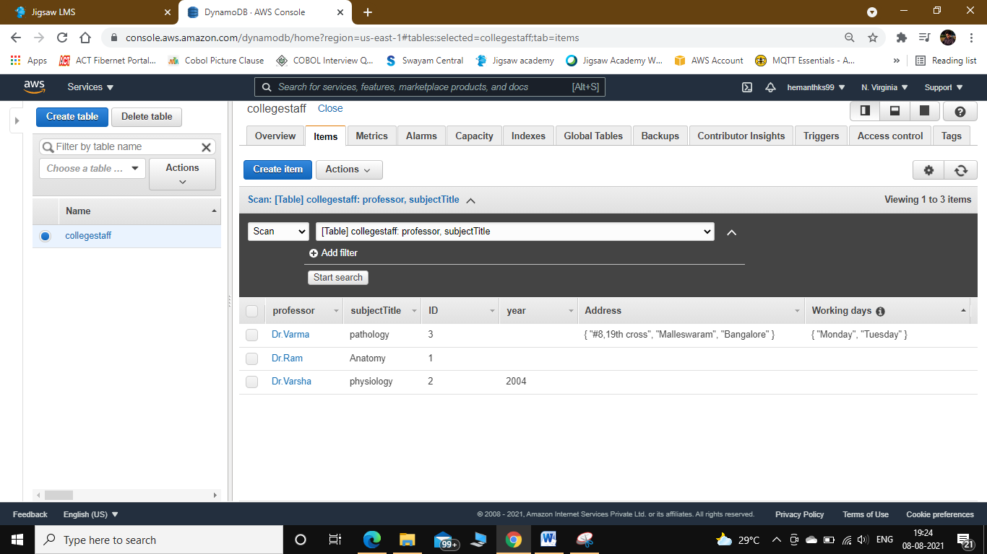

Read Data from DynamoDB

1. In the navigation pane on the left side of the console, choose Tables.

2. Choose the CollegeStaff table from the table list.

3. Choose the Items tab for the CollegeStaff table.

4. On the Items tab, view the list of items stored in the table, sorted by “Professor” and “SubjectTitle”

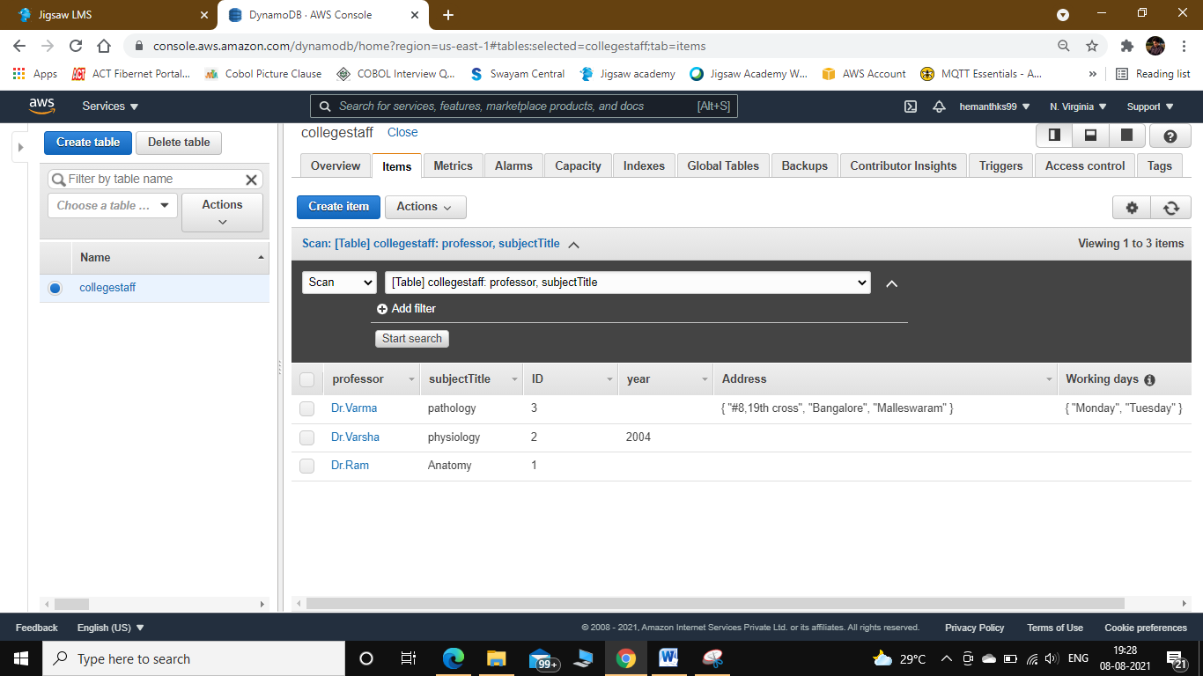

Step 4: Update Data

1. In the navigation pane on the left side of the console, choose Tables.

2. Choose the CollegeStaff table from the table list.

3. Choose the Items tab for the CollegeStaff table.

4. Choose the item whose Professor value is Dr.Ram and SubjectTitle value is “Anatomy”

5. Update the InterestedSubject value to Modern Anatomy, and then choose Save.

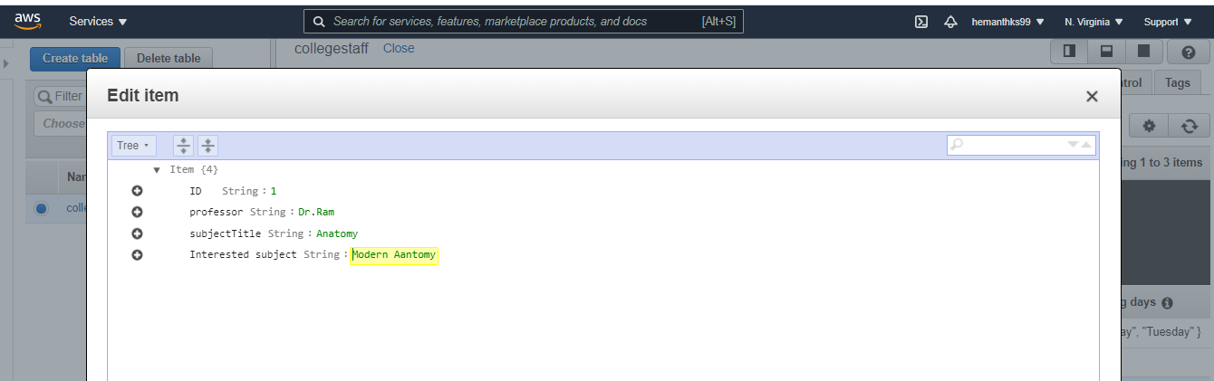

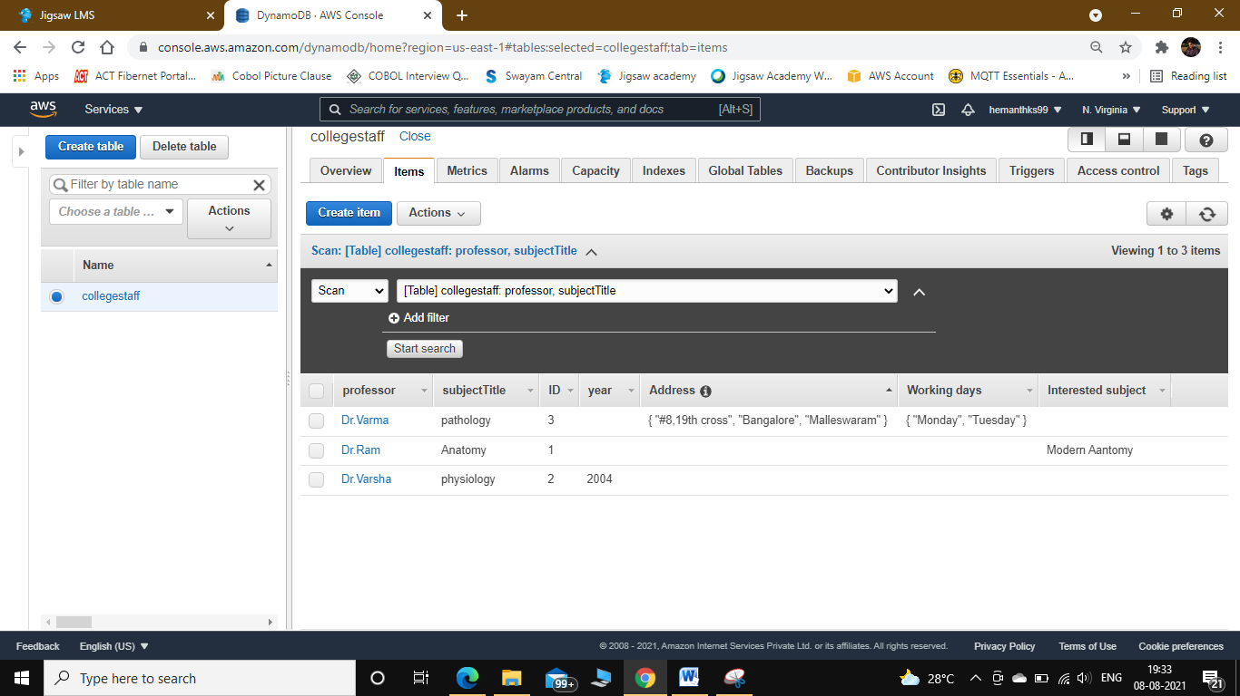

Step 5: Query Data

1. In the navigation pane on the left side of the console, choose Tables.

2. Choose the CollegeStaff table from the table list.

3. Choose the Items tab for the CollegeStaff table.

4. In the drop-down list, choose Query.

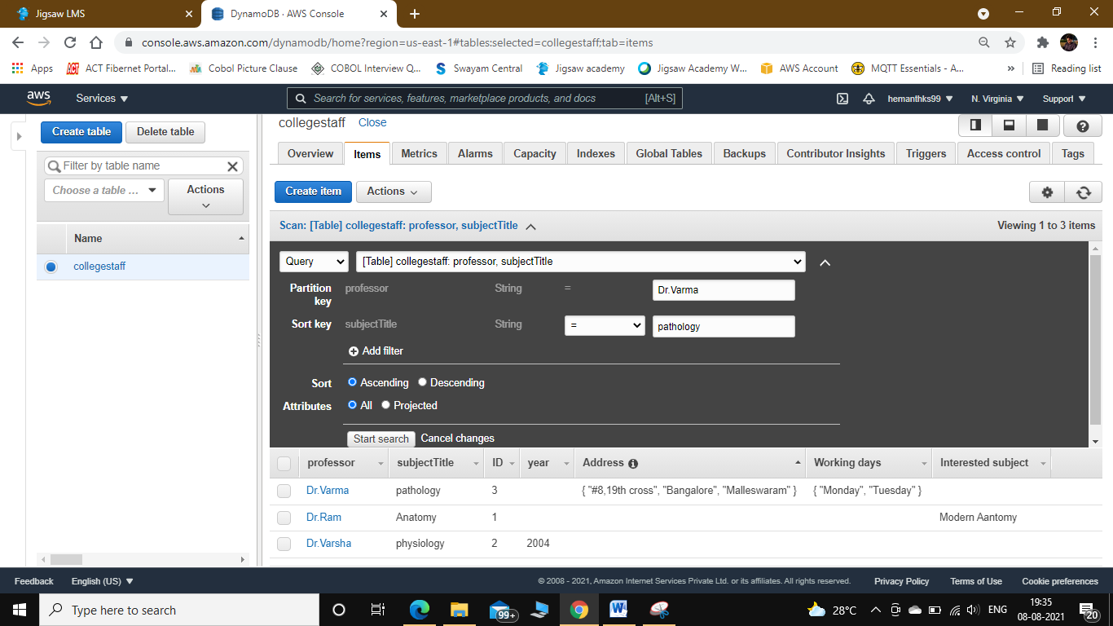

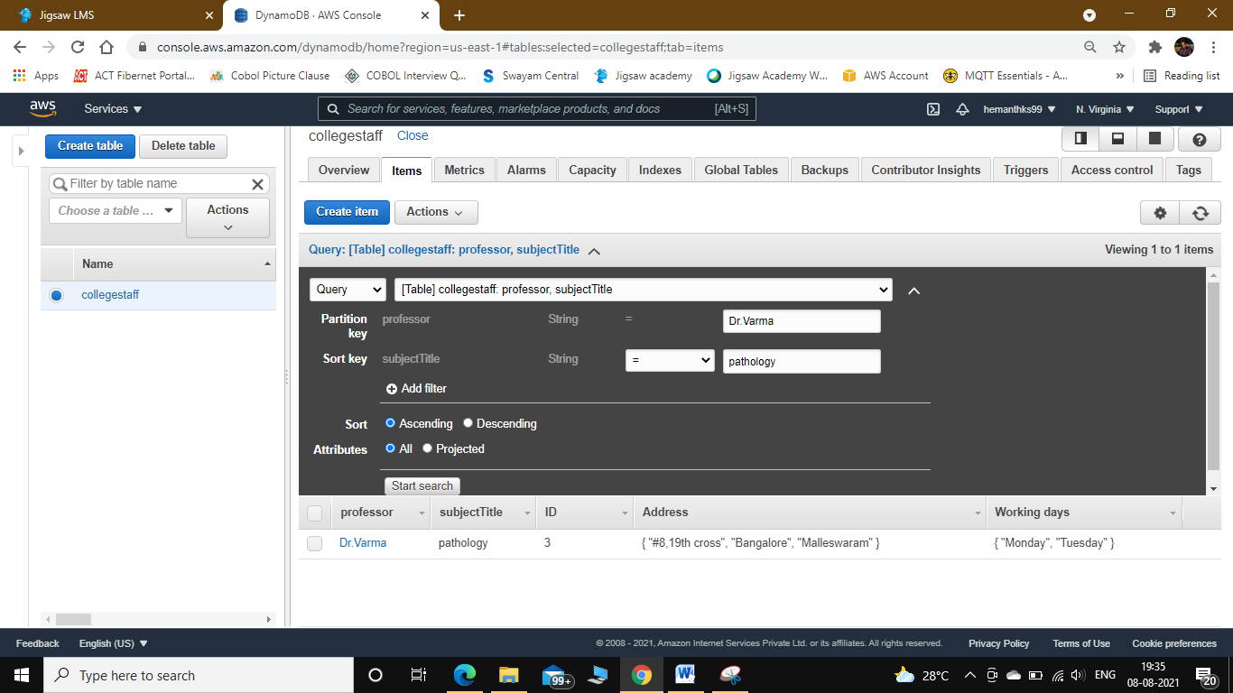

partiQ editor for DynamoDB:

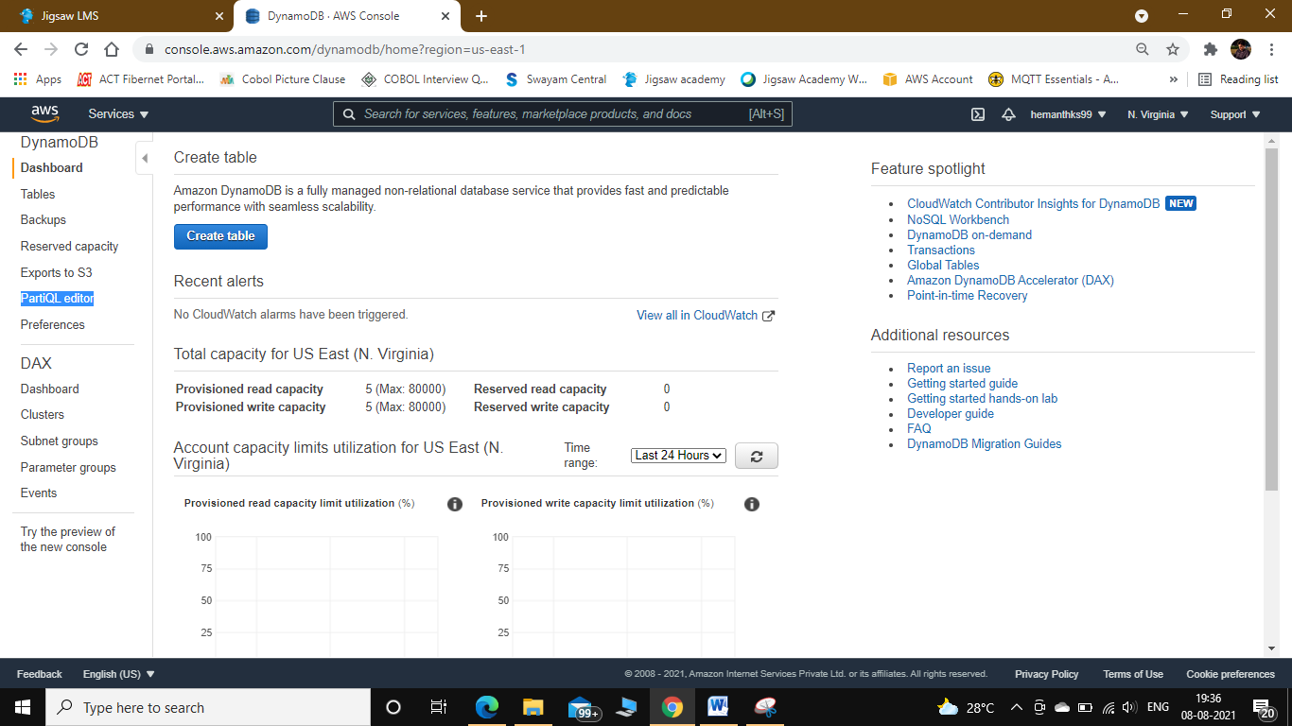

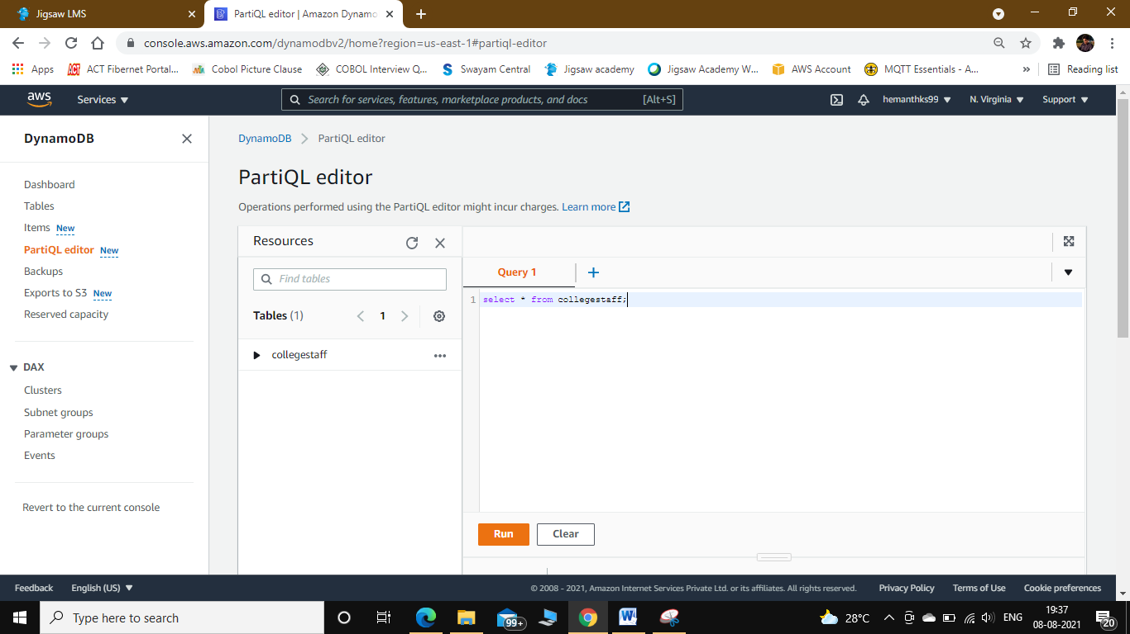

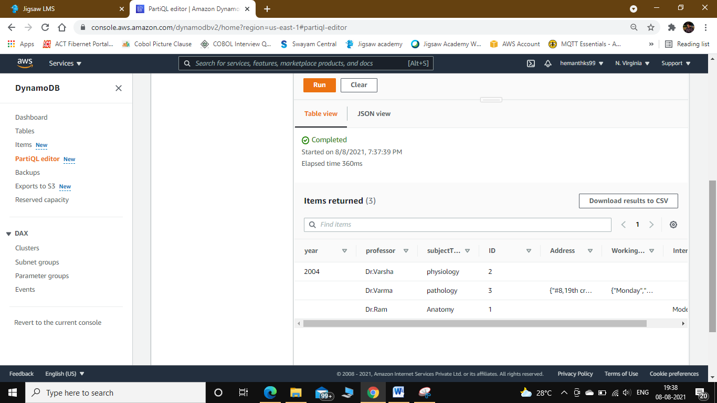

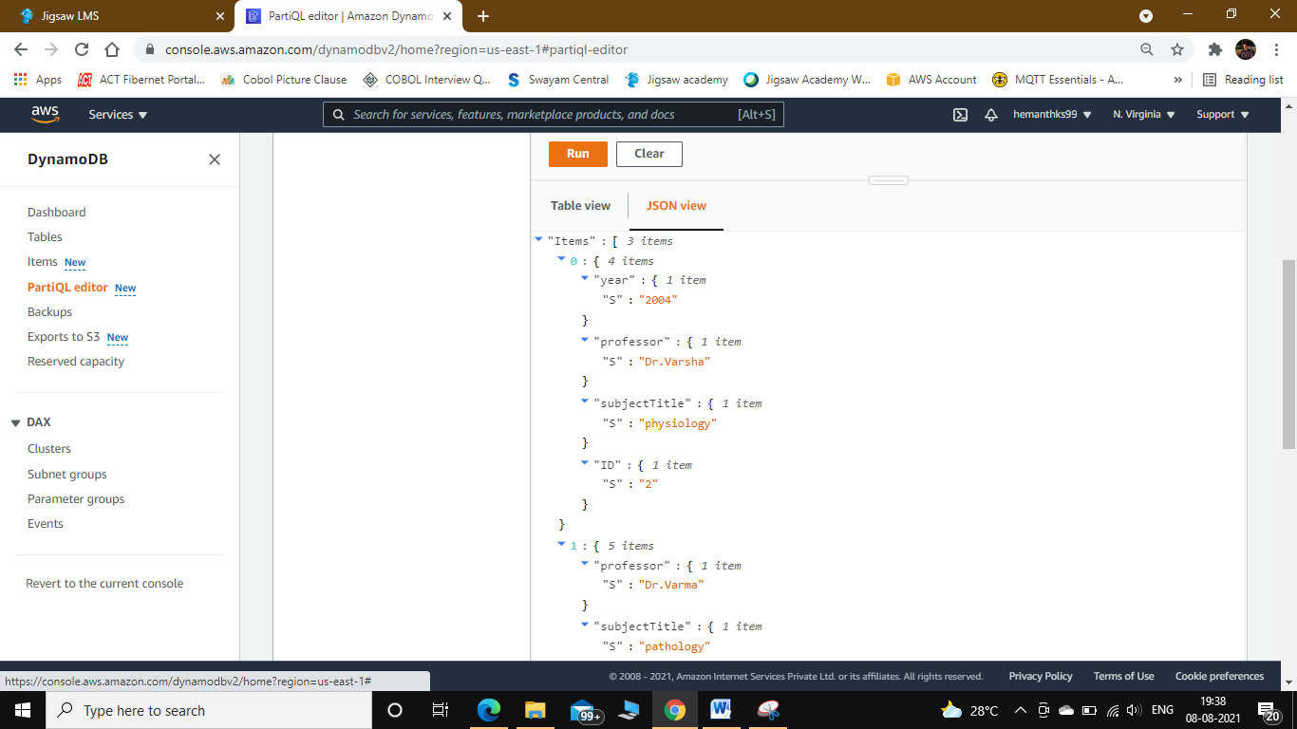

Export to S3:

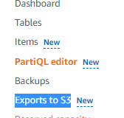

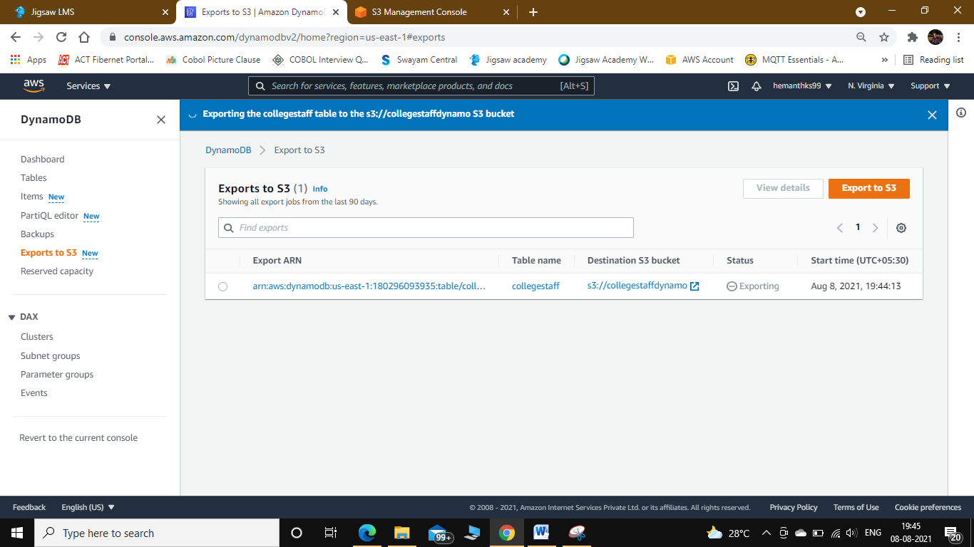

Wait till the status changes to completed.

Select uploaded bucket from S3

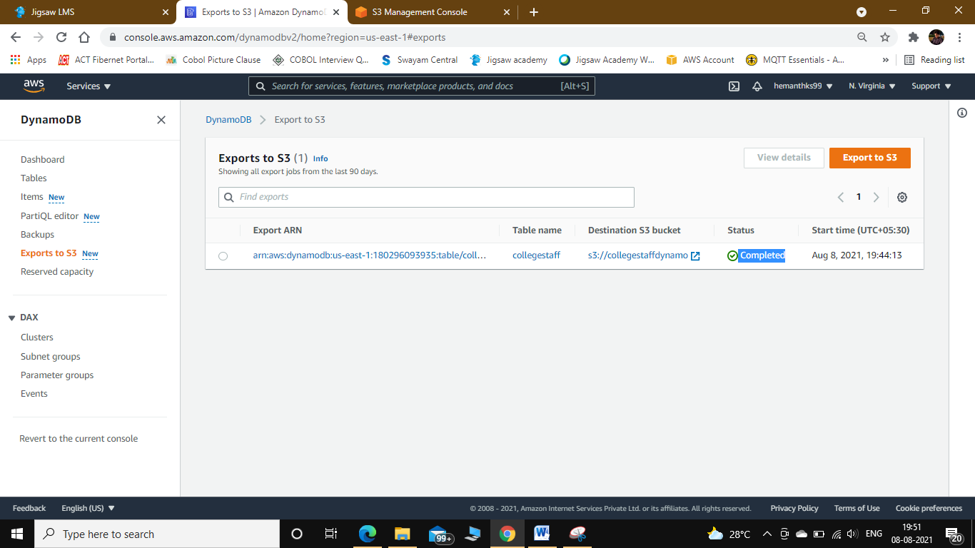

Go Inside all the sub folders and See the file is uploaded in JSON format in S3.

