A MINOR PROJECT REPORT ON
Spotify Songs' Genre Segmentation and Music Recommendation System
Submitted in partial fulfilment of the requirements for the degree of
Bachelor of Technology in Computer Science and Engineering
Submitted by
[Student Name(s)]
[Roll Number(s)]
Under the guidance of
[Guide Name and Designation]
[Department of Computer Science and Engineering]
[College Name]
[University Name]
[Month, Year]

Table of Contents
1. Abstract 2
2. Introduction 3
3. Problem Statement 4
4. Objectives 5
5. Dataset 6
6. Methodology 8
7. Data Preprocessing 9
8. Data Analysis 10
9. Correlation Analysis 16
10. K-Means Clustering 17
10.1 Why scaling is required 17
10.2 How K-Means works 17
10.3 Choosing the number of clusters 17
10.4 Cluster visualization 18
10.5 Cluster characteristics 19
10.6 Clusters compared with playlist genre 20
10.7 Clusters compared with playlist name 21
11. Recommendation System 22
11.1 Cosine similarity 22
11.2 Working of the recommender 22
11.3 Example 22
11.4 Evaluation 22
12. System Architecture 24
13. Results 25
14. Screenshots 26
15. Conclusion 27
16. Future Scope 28
17. References 29

1. Abstract
Music streaming platforms hold millions of songs, and listeners need help finding songs they will enjoy. This project studies a Spotify dataset of 32,833 song records with 23 columns, including nine audio features such as danceability, energy, loudness and valence. After cleaning, 26,229 unique songs remained. The data was explored with visualizations, and the relationships between audio features were studied with a correlation matrix.
The audio features were standardized and grouped using the K-Means algorithm. The number of clusters, K = 6, was chosen using the Elbow method and the Silhouette score. Each cluster was described by its average audio features and compared with playlist genres and playlist names. Some clusters matched a genre strongly (a speech-heavy cluster was 57.5% rap and a mostly instrumental cluster was 56.3% EDM), while other clusters mixed several genres.
Finally, a content-based recommendation system using cosine similarity was built and connected to a simple web interface created with Flask, HTML, CSS and JavaScript. In a test on 300 random songs, 36.7% of the recommended songs had the same genre as the selected song, compared with 16.9% expected by chance.
Keywords: Spotify, audio features, K-Means clustering, cosine similarity, recommendation system, Flask.

2. Introduction
Online music services let users listen to a very large number of songs. With so many choices, a listener often does not know which song to play next. Recommendation systems help by suggesting songs that match the listener's taste.
Spotify describes each track with numerical audio features, for example danceability, energy, loudness, speechiness, acousticness, instrumentalness, liveness, valence and tempo. These numbers describe how a song sounds, so songs with similar values usually sound similar. Playlists on the platform also carry a genre and a name, but these labels are chosen by the playlist creator and do not always describe the actual sound of a song.
This project uses machine learning in two ways. First, clustering (K-Means) groups songs by their audio features without using any genre label, and the groups are then compared with playlist genres and names. Second, a content-based recommender uses cosine similarity between audio features to suggest songs similar to a song chosen by the user. The project is kept simple: it uses Python with Pandas, NumPy, Matplotlib, Seaborn and Scikit-learn for the analysis, and Flask with HTML, CSS and JavaScript for the web interface.

3. Problem Statement
Playlist genre labels are assigned by people and may not describe how a song actually sounds. Listeners also cannot easily find songs that sound like a song they already like among thousands of tracks.
The problem addressed in this project is to (i) group Spotify songs according to their audio characteristics, (ii) study how these groups relate to playlist genres and playlist names, and (iii) build a simple system that recommends songs with a similar sound to a song selected by the user.

4. Objectives
- To inspect and preprocess the Spotify dataset by handling missing values and duplicate songs.
- To perform data analysis and create meaningful visualizations of genres, popularity and audio features.
- To find the correlation between the important numerical audio features and show it as a correlation matrix.
- To standardize the audio features and group songs using K-Means clustering, choosing the number of clusters with the Elbow method and Silhouette score.
- To analyse the clusters and compare them with playlist genres and playlist names.
- To build a content-based recommendation system using cosine similarity and connect it to a simple Flask web application.

5. Dataset
The project uses a Spotify songs dataset provided as a CSV file. Each row is one song in one playlist, and the file contains song details, playlist details and Spotify audio features. The dataset source used is: [add the source/link of the dataset]. Table 1 summarises the dataset before cleaning.
Table 1: Summary of the original dataset
Item | Value
Number of rows | 32,833
Number of columns | 23
Missing values | track_name, track_artist and track_album_name: 5 each
Fully duplicate rows | 0
Repeated track_id values | 4,477 (28,356 unique track_ids)
Numerical columns (13) | track_popularity, danceability, energy, key, loudness, mode, speechiness, acousticness, instrumentalness, liveness, valence, tempo, duration_ms
Categorical columns (10) | track_id, track_name, track_artist, track_album_id, track_album_name, track_album_release_date, playlist_name, playlist_id, playlist_genre, playlist_subgenre
Playlist genres (6) | edm 6,043; rap 5,746; pop 5,507; r&b 5,431; latin 5,155; rock 4,951
Playlist subgenres | 24 different values
Playlist names | 449 different names

Although no row was fully identical, the same song appears in several playlists, which is why track_id repeats. Table 2 explains the important columns in simple language.
Table 2: Important columns and their meaning
Column | Meaning
track_name, track_artist | Name of the song and the artist. Shown in the recommendations.
track_popularity | Popularity score of the song from 0 to 100.
playlist_name | Name of the playlist in which the song was found.
playlist_genre, playlist_subgenre | Genre and subgenre of the playlist (6 genres, 24 subgenres).
danceability | How suitable the song is for dancing (0 to 1).
energy | How intense and active the song feels (0 to 1).
loudness | Overall volume in decibels. Values are negative; closer to 0 means louder.
speechiness | Amount of spoken words in the song (0 to 1).
acousticness | Confidence that the song is acoustic and not electronic (0 to 1).
instrumentalness | Likelihood that the song has no vocals (0 to 1).
liveness | Likelihood that the song was recorded with a live audience (0 to 1).
valence | How happy or positive the song sounds (0 to 1).
tempo | Speed of the song in beats per minute.

The nine audio features used for clustering and recommendation are danceability, energy, loudness, speechiness, acousticness, instrumentalness, liveness, valence and tempo.

6. Methodology
The project follows the steps shown in Figure 1. Each step uses the output of the previous step.
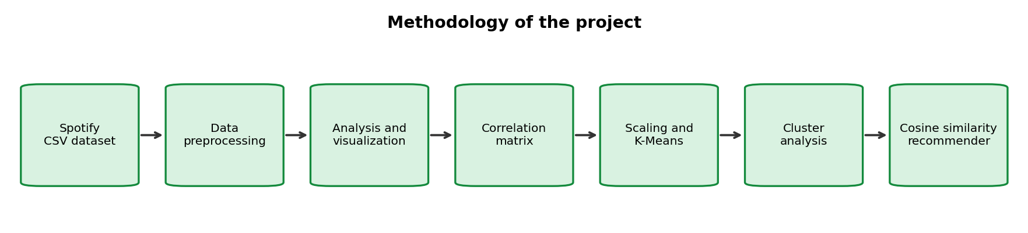
Figure 1: Methodology of the project
- Dataset inspection: check size, columns, data types, missing values and duplicates.
- Preprocessing: remove rows with missing song names, remove duplicate songs, keep the relevant columns and save the cleaned dataset.
- Analysis and visualization: plot genres, subgenres and the distributions of key features.
- Correlation analysis: compute and plot the correlation matrix of the nine audio features.
- Clustering: standardize the features, choose K with the Elbow method and Silhouette score, and run K-Means.
- Cluster analysis: describe each cluster and compare it with playlist genres and names.
- Recommendation: compute cosine similarity between songs and return the most similar songs.
- Web application: connect the recommender to a Flask backend and an HTML, CSS and JavaScript frontend.
Table 3: Tools and technologies used
Tool | Purpose
Python 3.11 | Programming language
Pandas, NumPy | Loading, cleaning and processing data
Matplotlib, Seaborn | Graphs and heatmaps
Scikit-learn | StandardScaler, K-Means, PCA, silhouette score, cosine similarity
Joblib | Saving and loading the trained model and scaler
Flask | Backend web server
HTML, CSS, JavaScript | Frontend web page

7. Data Preprocessing
Preprocessing prepares the raw data so that the analysis and models are not affected by missing or repeated rows. The steps and their effect on the number of rows are shown in Table 4.
Table 4: Preprocessing steps and results
Step | Action | Rows after step
1 | Load the CSV file | 32,833
2 | Drop the 5 rows with missing track_name and track_artist (a song with no name cannot be recommended) | 32,828
3 | Remove 4,476 repeated track_id values, keeping the first occurrence | 28,352
4 | Remove 2,123 more rows with the same track_name and track_artist but a different track_id (for example album and single versions) | 26,229
5 | Check audio features: all are numeric and have no missing values | 26,229
6 | Keep 16 relevant columns and save spotify_cleaned.csv | 26,229

The 16 columns kept are track_id, track_name, track_artist, track_popularity, playlist_name, playlist_genre, playlist_subgenre and the nine audio features. After cleaning, the genre counts are rap 5,165, pop 4,836, edm 4,603, r&b 4,067, latin 3,819 and rock 3,739, so all six genres are still well represented.
Note: because duplicate songs were removed, each song keeps only the first playlist in which it appeared. This is a limitation when comparing clusters with playlist names and genres.

8. Data Analysis
This section presents the visualizations created from the cleaned dataset of 26,229 songs. Each graph is followed by one observation based on the actual result.
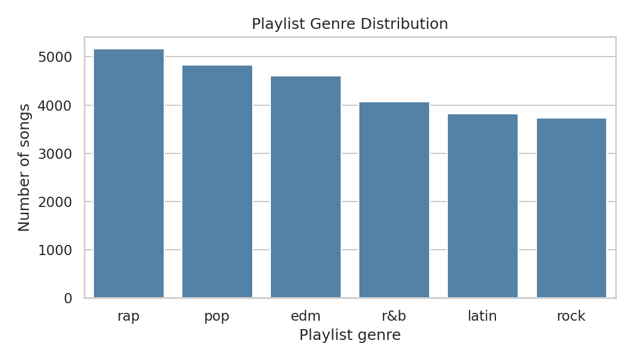
Figure 2: Playlist genre distribution
Observation: Shows the number of songs in each playlist genre. The genres are fairly balanced: rap is the largest (5,165 songs) and rock the smallest (3,739).
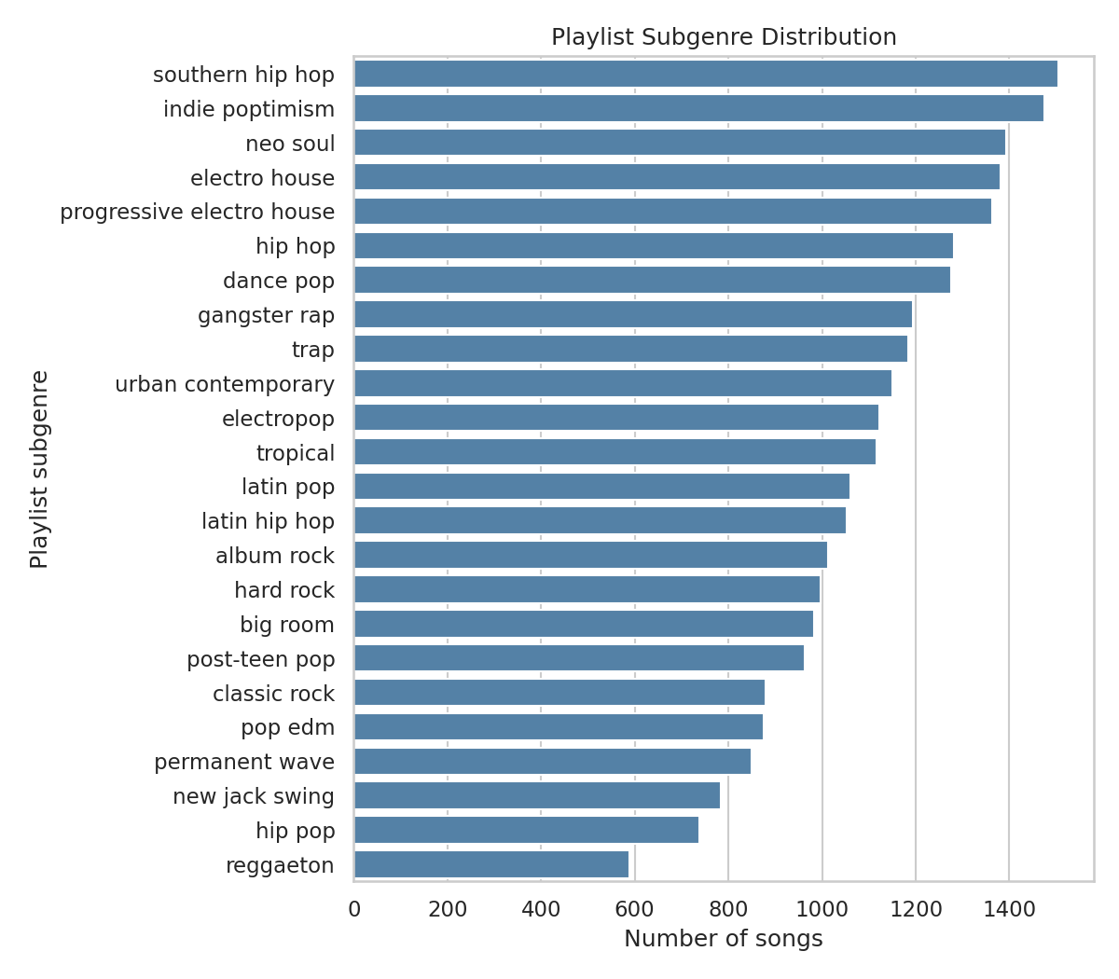
Figure 3: Playlist subgenre distribution
Observation: Shows the number of songs in each of the 24 subgenres. The largest are southern hip hop (1,505), indie poptimism (1,474) and neo soul (1,393); the smallest is reggaeton (588).
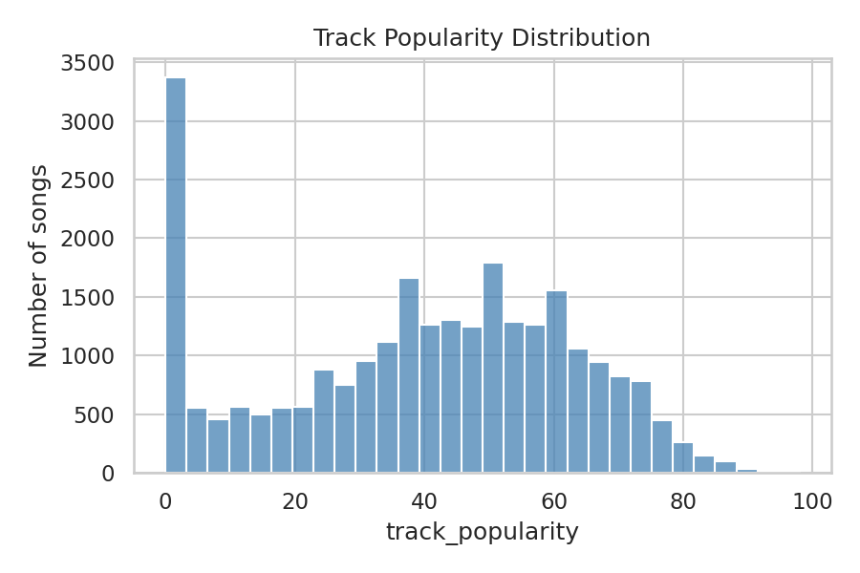
Figure 4: Track popularity distribution
Observation: Most songs lie between about 40 and 60 (median 42, mean 39.5), but 2,368 songs have a popularity of exactly 0.
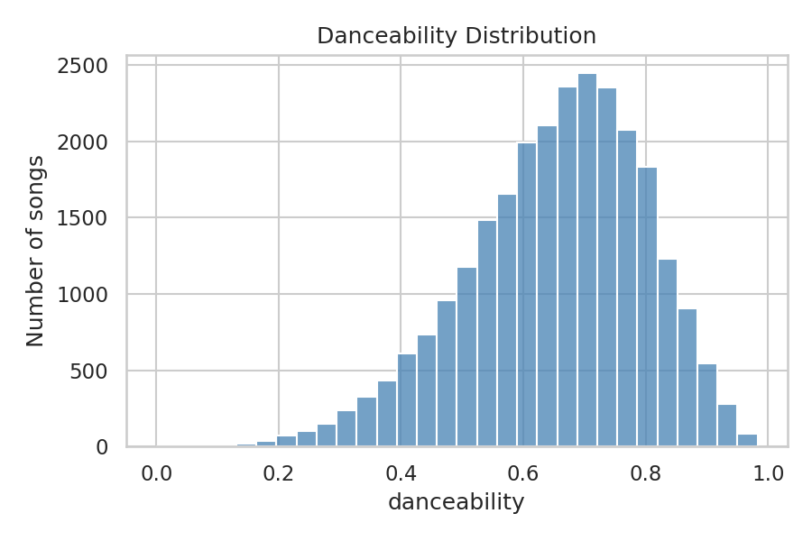
Figure 5: Danceability distribution
Observation: The mean danceability is 0.654 and the median is 0.670, so most songs are fairly danceable.
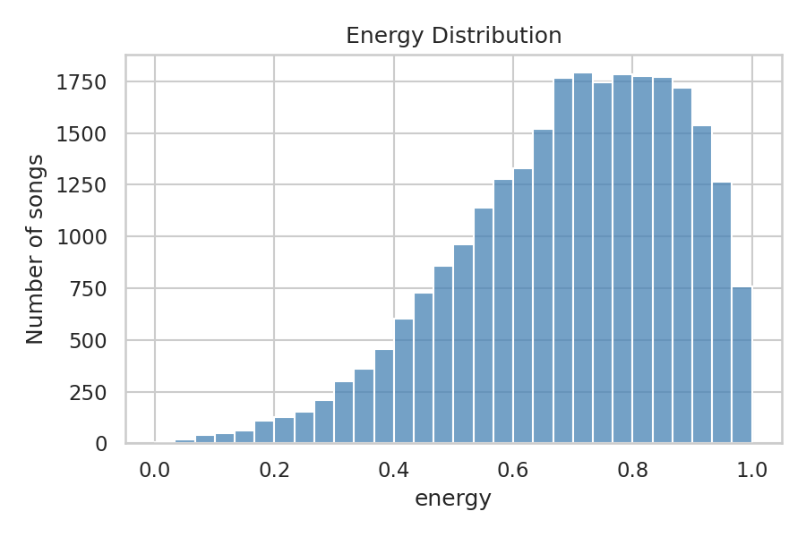
Figure 6: Energy distribution
Observation: The mean energy is 0.697 and the median is 0.720, so the dataset leans towards high-energy songs.
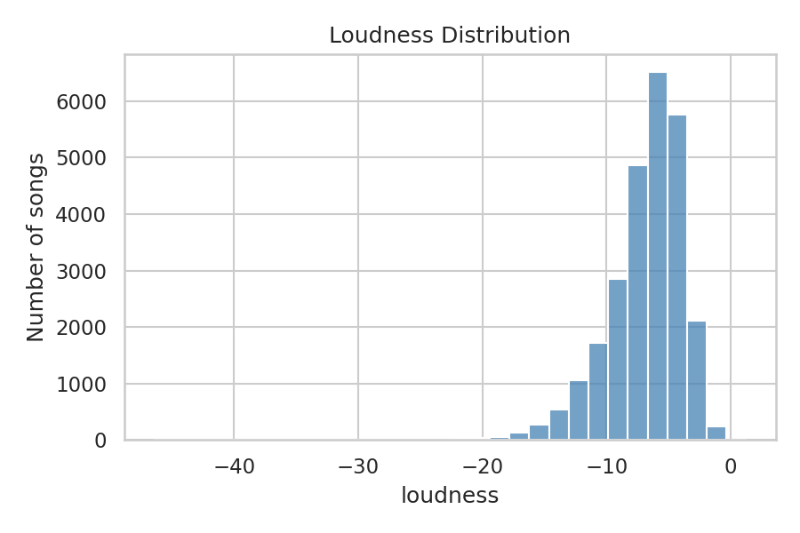
Figure 7: Loudness distribution
Observation: The median loudness is -6.27 dB, and 86.1% of songs are louder than -10 dB.
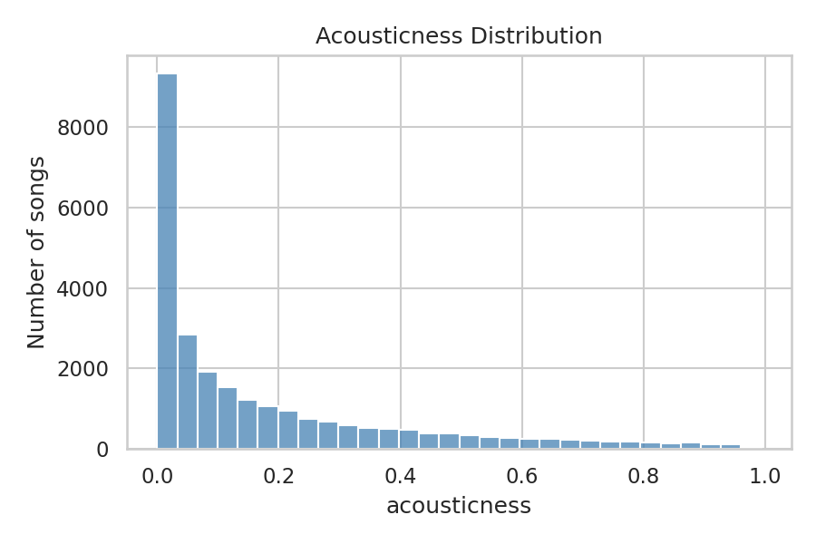
Figure 8: Acousticness distribution
Observation: The distribution is strongly skewed: the median is only 0.082 and 68.5% of songs have acousticness below 0.2, so most songs are not acoustic.
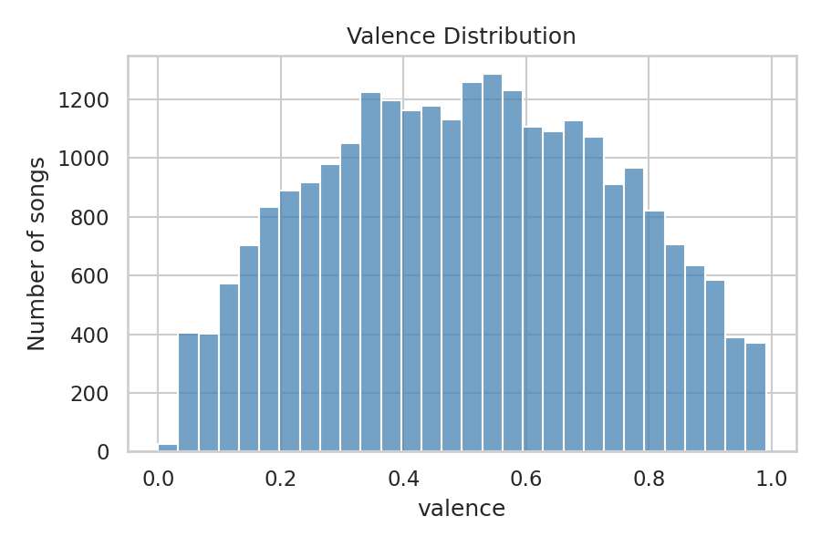
Figure 9: Valence distribution
Observation: Valence is centred in the middle (mean 0.506), so happy and sad songs are evenly mixed.
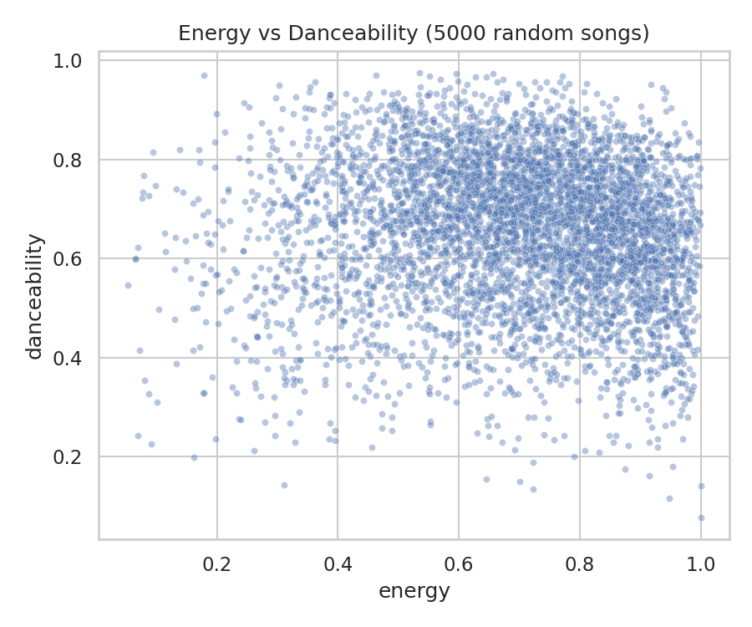
Figure 10: Energy vs danceability (5,000 random songs)
Observation: The correlation between energy and danceability is -0.073, so a high-energy song is not necessarily more danceable.
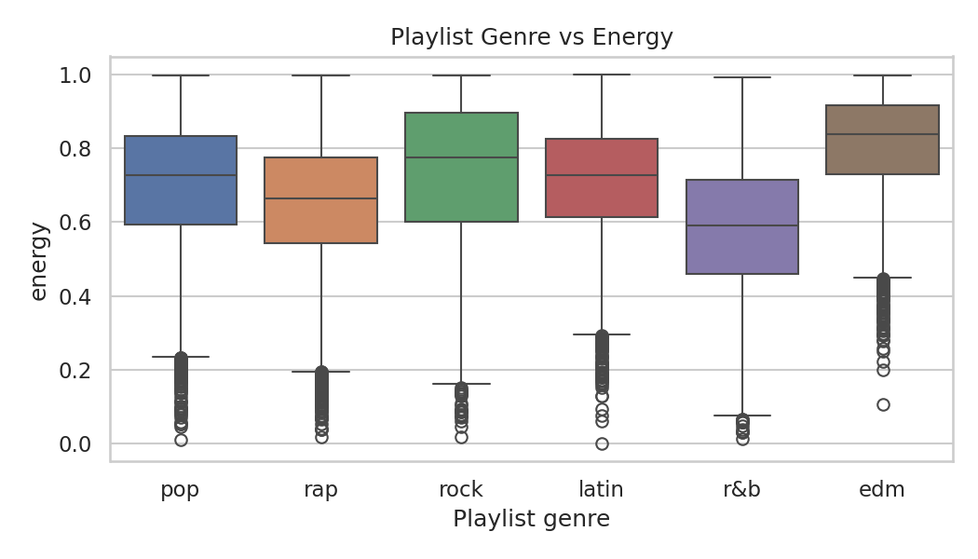
Figure 11: Playlist genre vs energy
Observation: EDM has the highest median energy (0.838) and R&B the lowest (0.590). Rock has 0.775, latin 0.728, pop 0.727 and rap 0.665.
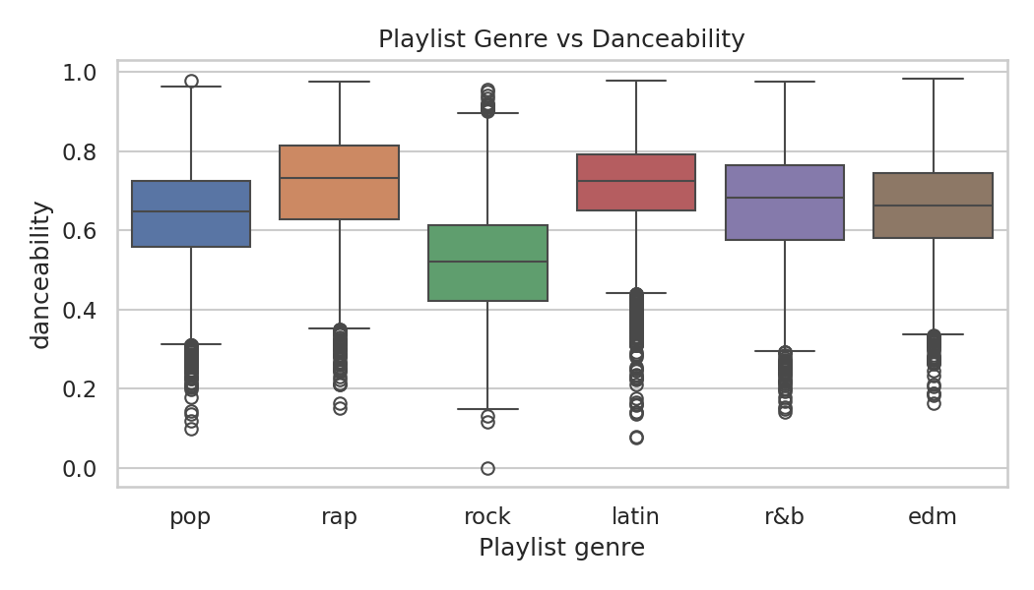
Figure 12: Playlist genre vs danceability
Observation: Rap (0.733) and latin (0.726) have the highest median danceability and rock the lowest (0.521).

9. Correlation Analysis
The correlation matrix shows how strongly each pair of audio features moves together. A correlation value lies between -1 and +1. A positive correlation means that when one feature increases the other tends to increase. A negative correlation means that when one feature increases the other tends to decrease. A weak correlation (close to 0) means that the two features are almost unrelated.
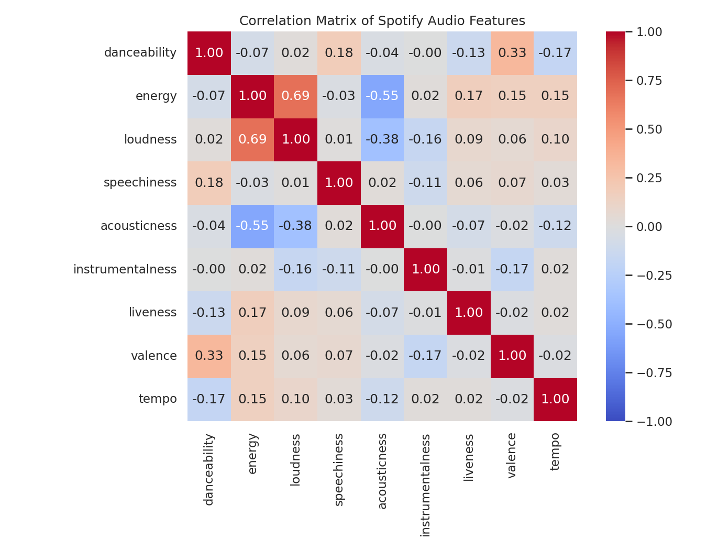
Figure 13: Correlation matrix of the nine audio features
Table 5: Selected correlation values from the matrix
Feature pair | Correlation | Type
energy and loudness | 0.686 | Strong positive
danceability and valence | 0.335 | Moderate positive
energy and acousticness | -0.551 | Strong negative
loudness and acousticness | -0.377 | Moderate negative
danceability and instrumentalness | 0.001 | Weak (almost none)
acousticness and instrumentalness | 0.004 | Weak (almost none)
loudness and speechiness | 0.013 | Weak (almost none)

Energetic songs tend to be louder and less acoustic. Only 2 of the 36 feature pairs have a correlation above 0.5 in either direction, so most features carry different information. For this reason all nine features were kept for clustering and recommendation.

10. K-Means Clustering

10.1 Why scaling is required
K-Means works with distances between songs. Tempo (up to about 240) and loudness (down to about -46) have much larger numbers than features such as danceability that lie between 0 and 1. Without scaling, tempo and loudness would dominate the distance. StandardScaler converts every feature to mean 0 and standard deviation 1 so that every feature has an equal influence.

10.2 How K-Means works
- Choose K starting centre points.
- Assign every song to its nearest centre.
- Move each centre to the average of the songs assigned to it.
- Repeat steps 2 and 3 until the centres stop moving.

10.3 Choosing the number of clusters
The number of clusters was not chosen randomly. K-Means was run for K = 2 to 10 on the scaled features, and two measures were recorded. Inertia (Elbow method) is the total distance of songs from their cluster centre; it always decreases as K increases, and a good K is where the decrease becomes slow. The Silhouette score measures how well songs fit their own cluster compared with other clusters; higher is better (the maximum is 1).
Table 6: Inertia and silhouette score for different K
K | Inertia | Silhouette score
2 | 199,550.7 | 0.1939
3 | 177,570.3 | 0.1391
4 | 161,042.8 | 0.1519
5 | 146,773.8 | 0.1538
6 | 136,480.1 | 0.1575
7 | 128,946.8 | 0.1441
8 | 122,863.6 | 0.1388
9 | 117,887.2 | 0.1453
10 | 113,889 | 0.1445

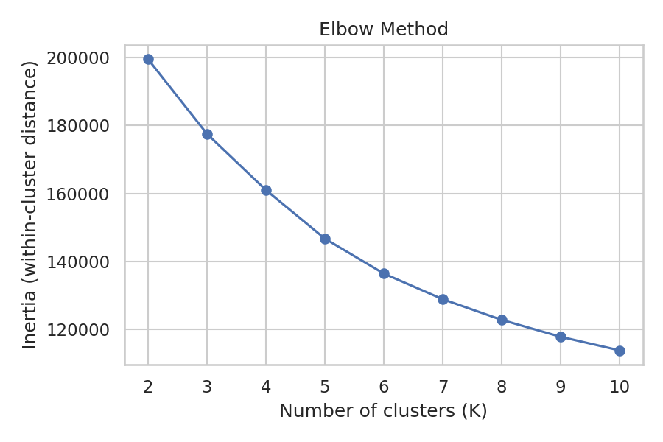
Figure 14: Elbow method graph
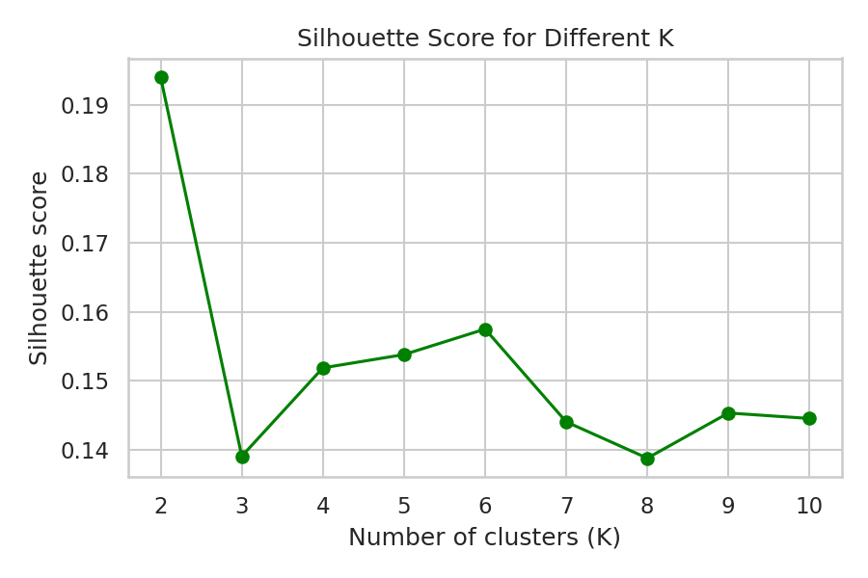
Figure 15: Silhouette score for different values of K
The elbow curve decreases smoothly without a sharp corner, but the decrease becomes smaller from K = 6 onwards. K = 2 has the highest silhouette score (0.1939), but two clusters are too broad to compare with six genres and 24 subgenres. Among K = 4 to 10, K = 6 has the highest silhouette score (0.1575). Therefore K = 6 was selected.
All silhouette scores are low (between 0.14 and 0.19). This means that the clusters overlap and are not sharply separated, which is common for music data because songs change gradually from one style to another.

10.4 Cluster visualization
The nine features cannot be drawn directly, so Principal Component Analysis (PCA) was used only for plotting, to squeeze the data into two dimensions. These two dimensions keep 41.0% of the information, so the picture can only give a rough idea of the clusters. The overlapping of colours in Figure 16 agrees with the low silhouette scores.
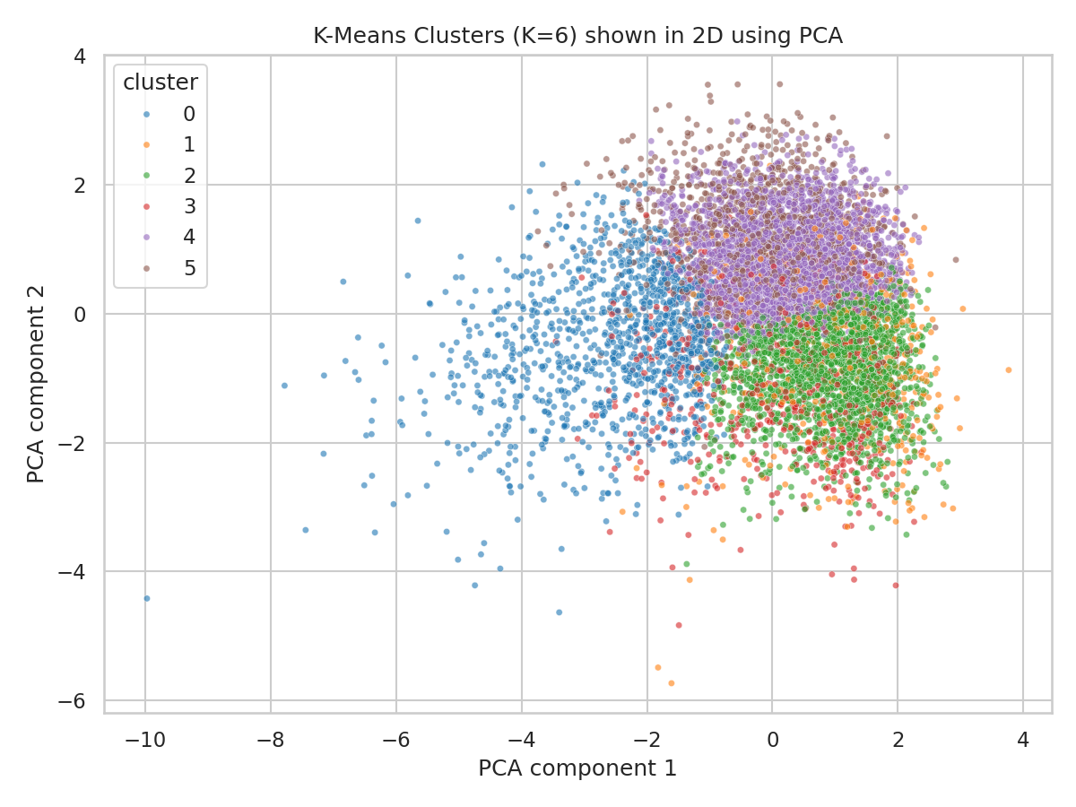
Figure 16: K-Means clusters (K = 6) shown in two dimensions using PCA

10.5 Cluster characteristics
After clustering, each song was given its cluster number and the average audio features of each cluster were calculated (Table 7). The overall averages of the dataset are danceability 0.654, energy 0.697, loudness -6.84, speechiness 0.109, acousticness 0.181, instrumentalness 0.095, liveness 0.191, valence 0.506 and tempo 121.0.
Table 7: Number of songs and average audio features of each cluster
Cluster | Songs | Dance. | Energy | Loud. | Speech. | Acoust. | Instr. | Live. | Valence | Tempo
0 | 3,743 | 0.600 | 0.416 | -10.69 | 0.072 | 0.541 | 0.108 | 0.146 | 0.386 | 112.5
1 | 1,679 | 0.606 | 0.785 | -6.01 | 0.113 | 0.122 | 0.066 | 0.628 | 0.502 | 122.6
2 | 6,736 | 0.548 | 0.790 | -5.34 | 0.073 | 0.069 | 0.024 | 0.175 | 0.373 | 132.7
3 | 2,169 | 0.667 | 0.775 | -7.12 | 0.071 | 0.075 | 0.755 | 0.166 | 0.392 | 124.8
4 | 8,366 | 0.739 | 0.723 | -6.38 | 0.076 | 0.146 | 0.017 | 0.149 | 0.682 | 113.9
5 | 3,536 | 0.725 | 0.663 | -6.93 | 0.316 | 0.190 | 0.011 | 0.177 | 0.543 | 121.3

The clusters are described below using only their actual feature values, without assuming any genre name.
Table 8: Description of each cluster
Cluster | Main characteristics
0 | Most acoustic cluster (acousticness 0.541 against 0.181 overall), lowest energy (0.416) and quietest (-10.69 dB): calm and acoustic songs.
1 | Very high liveness (0.628 against 0.191 overall), so these songs sound like live recordings; energy is high (0.785).
2 | Highest energy (0.790), loudest (-5.34 dB), fastest tempo (132.7 BPM) and lowest danceability (0.548): loud and intense songs.
3 | Very high instrumentalness (0.755 against 0.095 overall), so these songs have little or no singing; energy is high (0.775).
4 | Highest danceability (0.739) and highest valence (0.682): happy and danceable songs. It is the largest cluster (8,366 songs).
5 | Very high speechiness (0.316 against 0.109 overall), so these songs contain a lot of spoken or rapped words; danceability is high (0.725).

10.6 Clusters compared with playlist genre
Table 9 shows what percentage of the songs of each cluster belong to each playlist genre. The overall genre shares are rap 19.7%, pop 18.4%, edm 17.5%, r&b 15.5%, latin 14.6% and rock 14.3%.
Table 9: Cluster vs playlist genre (% of the songs in each cluster)
Cluster | edm | latin | pop | r&b | rap | rock
0 | 3.7 | 11.3 | 19.2 | 31.8 | 16.3 | 17.8
1 | 26.3 | 13.2 | 15.0 | 11.3 | 16.5 | 17.7
2 | 25.8 | 7.9 | 23.6 | 7.3 | 10.7 | 24.7
3 | 56.3 | 8.4 | 12.4 | 3.4 | 10.9 | 8.6
4 | 10.2 | 24.5 | 21.4 | 17.8 | 15.4 | 10.7
5 | 5.9 | 11.5 | 6.2 | 18.0 | 57.5 | 0.9

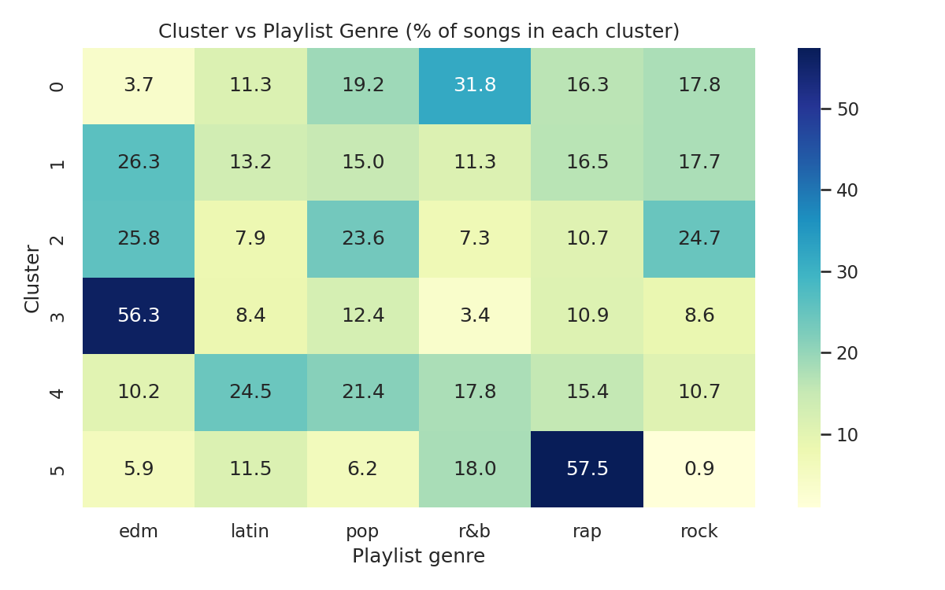
Figure 17: Cluster vs playlist genre
Two clusters match a genre clearly: cluster 3 (instrumental) is 56.3% EDM against 17.5% overall, and cluster 5 (speech-heavy) is 57.5% rap against 19.7% overall. Cluster 0 leans towards R&B (31.8% against 15.5%). Clusters 1, 2 and 4 contain several genres; for example, cluster 2 is divided almost equally between EDM (25.8%), rock (24.7%) and pop (23.6%). Therefore audio features separate some genres well but not all of them.

10.7 Clusters compared with playlist name
The dataset has 449 playlist names, so the 10 playlists with the most songs were used. Table 10 shows what percentage of each playlist's songs fall in each cluster.
Table 10: Top 10 playlists vs cluster (% of the playlist's songs)
Playlist name | 0 | 1 | 2 | 3 | 4 | 5
Indie Poptimism | 5.7 | 5.3 | 42.4 | 2.8 | 41.3 | 2.5
Permanent Wave | 17.3 | 6.2 | 48.6 | 11.1 | 16.3 | 0.5
Hard Rock Workout | 0.0 | 7.5 | 83.6 | 3.0 | 4.5 | 1.5
Southern Hip Hop | 1.2 | 10.4 | 9.1 | 0.0 | 26.2 | 53.0
Urban Contemporary | 32.9 | 11.0 | 15.5 | 3.9 | 18.7 | 18.1
post teen pop | 4.3 | 6.5 | 33.1 | 0.0 | 50.4 | 5.8
Dance Pop | 2.2 | 5.2 | 48.1 | 2.2 | 38.5 | 3.7
Urban contemporary | 72.8 | 0.0 | 9.6 | 3.5 | 7.0 | 7.0
Tropical Vibes | 3.6 | 2.7 | 18.0 | 49.5 | 24.3 | 1.8
New Jack Swing | 13.1 | 5.6 | 5.6 | 0.9 | 71.0 | 3.7

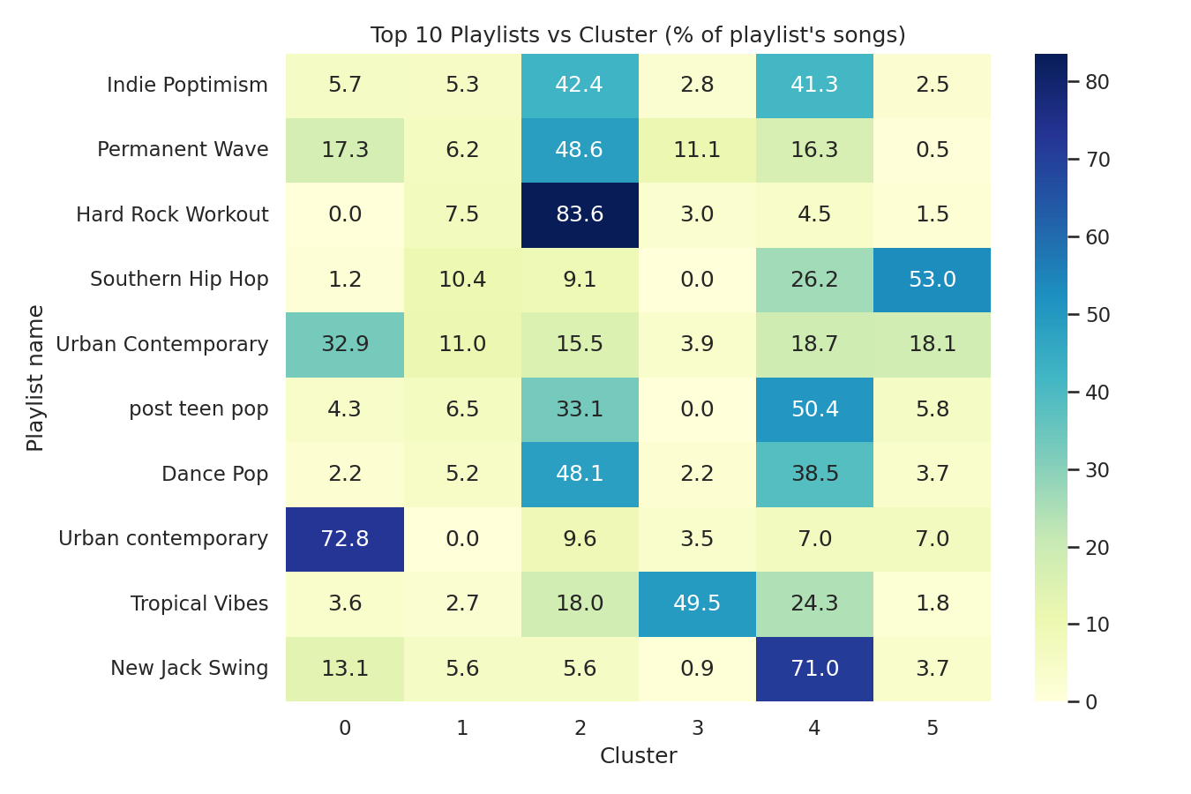
Figure 18: Top 10 playlists vs cluster
Playlists with a specific style fall mostly into one cluster. For example, 83.6% of the songs of Hard Rock Workout are in cluster 2 (loud and intense), 71.0% of New Jack Swing are in cluster 4 (happy and danceable) and 53.0% of Southern Hip Hop are in cluster 5 (speech-heavy). Broad playlists such as Indie Poptimism and Dance Pop are divided mainly between clusters 2 and 4. The dataset contains both "Urban contemporary" and "Urban Contemporary" as separate playlist names with different results (72.8% and 32.9% in cluster 0), because playlist names are free text.

11. Recommendation System
A simple content-based recommendation system was built. It recommends songs that sound similar to the song selected by the user, using only the audio features.

11.1 Cosine similarity
Each song is represented by its nine scaled audio features. Cosine similarity measures the angle between the feature vectors of two songs: similarity = (A · B) / (|A| × |B|). A value close to 1 means that the two songs have almost the same feature pattern.

11.2 Working of the recommender
- The user enters or selects a song name. The search is not case-sensitive, and if several songs share the name, the most popular one is used.
- The audio features of the song are taken and scaled with the same scaler that was used for clustering.
- Cosine similarity is calculated between the selected song and all other songs.
- The selected song itself is removed, the songs are sorted by similarity, and the top 5 are returned with song name, artist, genre and similarity score.
This is implemented in the function recommend_song(song_name, n=5) in recommender.py. If the song is not found, the function raises an error with a clear message ("Song ... was not found in the dataset. Please try another name."), which the web application shows to the user. No song names are hardcoded.

11.3 Example
For the song The Box by Roddy Ricch (rap), the system returned the songs in Table 11.
Table 11: Top 5 recommendations for "The Box"
Song Name | Artist | Genre | Similarity Score
Tengo Tantas Ganas de Ti | Arcangel | latin | 0.9838
Rather Be | Clean Bandit | pop | 0.9807
Grow Up | Bolier | latin | 0.9793
Buoy | RICCI | edm | 0.9654
Get Your Way | Brasstracks | r&b | 0.9607

11.4 Evaluation
To check the system, 300 random songs were selected and the genres of their 5 recommended songs were compared with the genre of the selected song. 36.7% of the recommended songs had the same genre as the selected song. If songs were picked completely at random, only about 16.9% would match. The recommender is therefore better than random, at about twice the chance level.
The recommendations are not perfect because the system only uses nine audio numbers and does not know the lyrics, language or artist style. Recommended songs can therefore sound similar but belong to different genres, as the example above shows. Different versions of the same song (for example a remastered version) can also appear as recommendations, because they have different track IDs and names.

12. System Architecture
The system has three parts: the frontend in the browser, the Flask backend, and the recommendation model with its data. Figure 19 shows how they are connected.
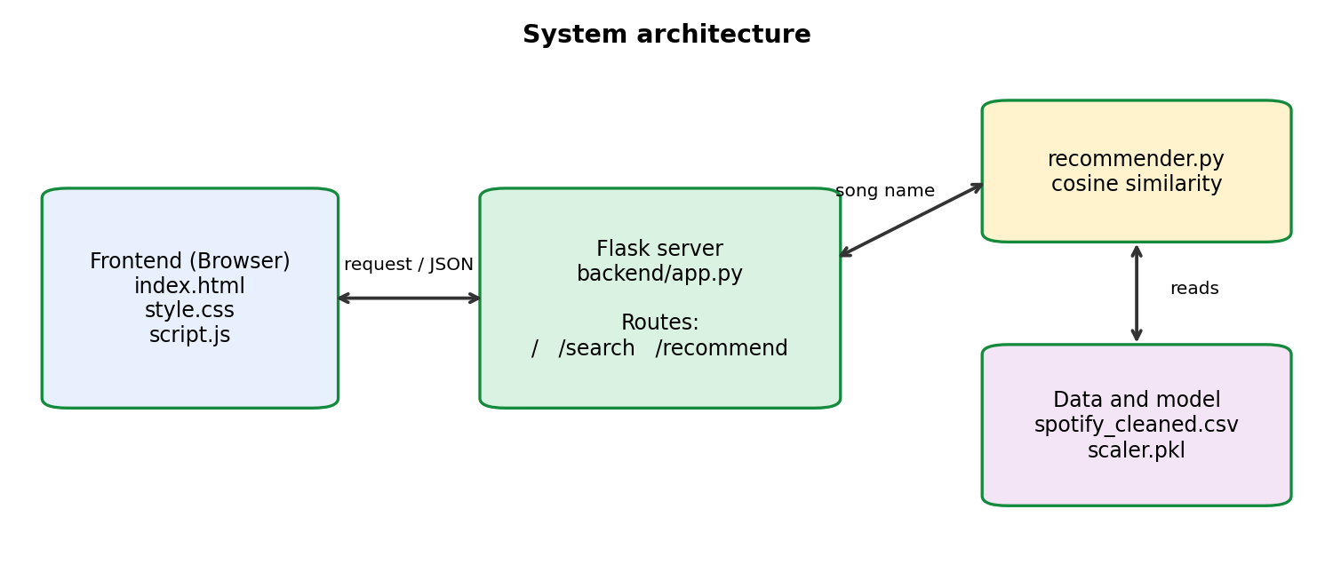
Figure 19: System architecture
Table 12: Routes of the Flask application
Route | Purpose
/ | Sends the home page (index.html)
/search?q=text | Returns songs whose name contains the typed text, for the search suggestions
/recommend?song=name | Returns the top 5 similar songs as JSON, or an error message if the song is not found

Working: (1) the user types a song name in the web page; (2) JavaScript sends the name to the /recommend route; (3) Flask calls recommend_song(); (4) the recommender uses the cleaned dataset and the saved scaler to calculate the similar songs; (5) Flask returns the result as JSON; (6) JavaScript shows the recommended songs on the page.
Files: the backend consists of backend/app.py and backend/recommender.py; the frontend consists of frontend/index.html, frontend/style.css and frontend/script.js; the trained model and scaler are saved with Joblib in the model folder.

13. Results
Table 13: Summary of results
Stage | Result
Dataset | 32,833 rows and 23 columns; 5 rows with missing song names; 4,477 repeated track_id values
After preprocessing | 26,229 unique songs and 16 columns
Correlation | Strongest positive: energy and loudness (0.686); strongest negative: energy and acousticness (-0.551); only 2 of 36 pairs above 0.5 in magnitude
Clustering | K = 6 chosen using the Elbow method and Silhouette score (0.1575 at K = 6); clusters overlap
Cluster vs genre | Instrumental cluster 56.3% EDM; speech-heavy cluster 57.5% rap; other clusters mix several genres
Cluster vs playlist name | Specific playlists mostly fall in one cluster (for example Hard Rock Workout 83.6% in cluster 2)
Recommender | 36.7% of recommended songs share the genre of the selected song, against 16.9% by chance (300 random songs)
Web application | Search box, Recommend button and a list of 5 songs with artist, genre and similarity score; shows an error message for an unknown song

The results show that audio features carry useful information about how songs sound, and that this information matches playlist genres only partly. The recommender uses this information to suggest similar songs through a simple web interface.

14. Screenshots
Figure 20 shows the web interface after a song was searched and the Recommend button was clicked. Figure 21 shows the message shown when a song name is not found.
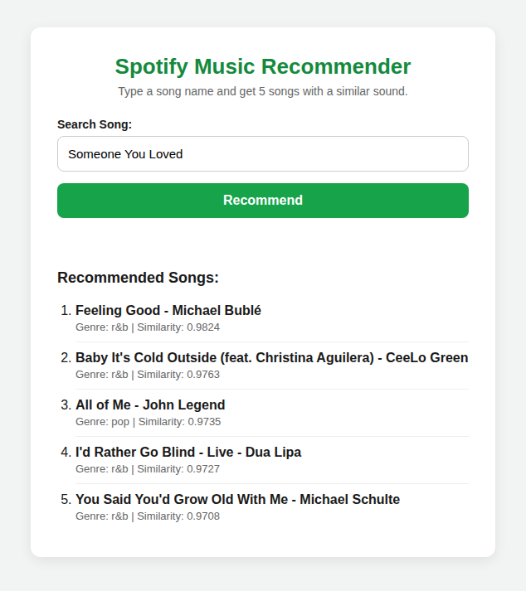
Figure 20: Web interface showing the recommended songs
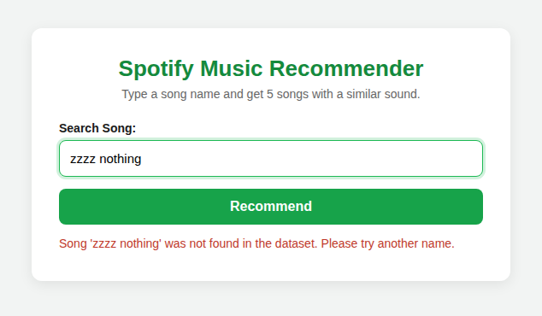
Figure 21: Web interface showing the message for a song that is not found

15. Conclusion
In this project, a Spotify dataset of 32,833 records was cleaned to 26,229 unique songs, analysed with visualizations, and studied with a correlation matrix. The audio features were standardized and grouped into six clusters with K-Means, using the Elbow method and Silhouette score to choose the number of clusters.
The cluster analysis showed that audio features separate some genres well, for example a speech-heavy cluster that is mostly rap and an instrumental cluster that is mostly EDM, while other clusters contain several genres. The low silhouette scores show that songs overlap and that genre labels on playlists do not always match how songs sound.
A content-based recommender using cosine similarity was built and connected to a simple Flask web application. In the test, its recommendations matched the genre of the selected song about twice as often as random selection. The project therefore meets its objectives using simple and easily explained methods.

16. Future Scope
- Add more information to the recommender, such as lyrics, artist, language or release year, so that recommendations are less limited to the sound alone.
- Detect and merge different versions of the same song (remastered, remix, live) so that they are not recommended for each other.
- Combine the content-based approach with user listening history to build a hybrid recommender.
- Try other clustering methods such as hierarchical clustering or Gaussian mixture models and compare them with K-Means.
- Use the cluster and playlist information to predict the genre of a new song with a classification model.
- Improve the web interface, for example with song previews, and deploy the application online.

17. References
[1] Spotify for Developers, "Web API Reference: Audio Features," Spotify AB. (Description of danceability, energy, valence and the other audio features.)
[2] J. MacQueen, "Some methods for classification and analysis of multivariate observations," Proceedings of the 5th Berkeley Symposium on Mathematical Statistics and Probability, vol. 1, 1967, pp. 281-297.
[3] P. J. Rousseeuw, "Silhouettes: a graphical aid to the interpretation and validation of cluster analysis," Journal of Computational and Applied Mathematics, vol. 20, 1987, pp. 53-65.
[4] F. Pedregosa et al., "Scikit-learn: Machine Learning in Python," Journal of Machine Learning Research, vol. 12, 2011, pp. 2825-2830.
[5] W. McKinney, "Data Structures for Statistical Computing in Python," Proceedings of the 9th Python in Science Conference, 2010, pp. 56-61.
[6] J. D. Hunter, "Matplotlib: A 2D Graphics Environment," Computing in Science & Engineering, vol. 9, no. 3, 2007, pp. 90-95.
[7] Pallets Projects, "Flask Documentation," https://flask.palletsprojects.com
[8] Scikit-learn Documentation, "Clustering" and "sklearn.metrics.pairwise.cosine_similarity," https://scikit-learn.org
[9] Dataset: [add the source/link of the Spotify dataset used in this project].

