
Name: Hemanth Kumar B(192421263)

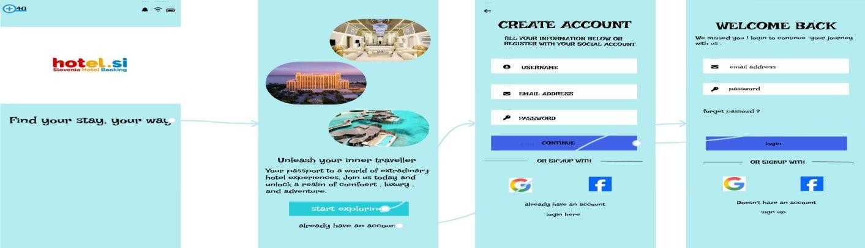
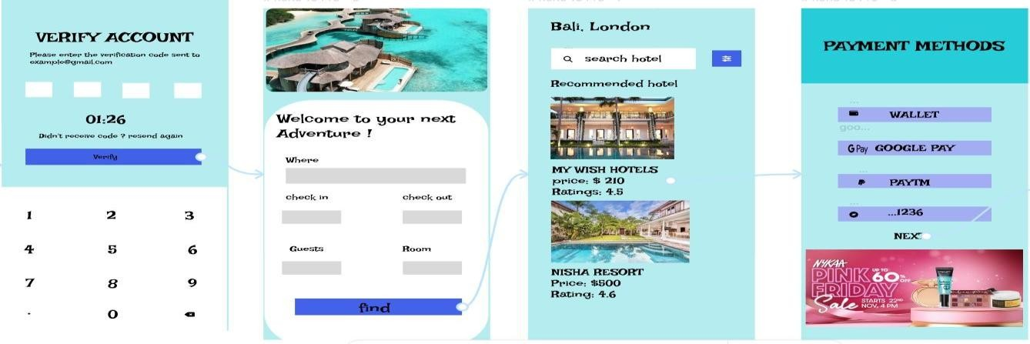



HOTEL BOOKING
S
YSTEM

