

Name: Mobile Computing for Modern App Development Name: Hemanth Kumar B (192421263)

Course Code: ITA0306

19) Develop a user interface prototype for an Android application using Figma.

Aim:
To Develop a user interface prototype for an Android application using Figma.

Procedure:

- Create a file
- Add The First Frame
- Add Shapes
- Add Text
- Create The Second Frame
- Add Prototyping Design:

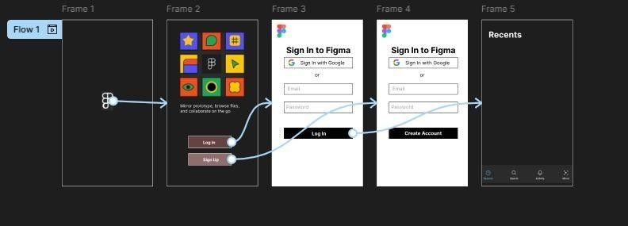

Result:
Hence the Develop a user interface prototype for an Android application created and executed successfully

