**SBA-2**

Program 1:

Write a program to reverse the String (use char[] or String built in method)

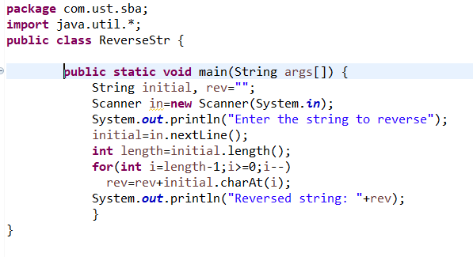

Output:

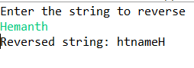

Program 2:

Write programs to depict the usage of contains(), length(), replace(), concat(), equals()

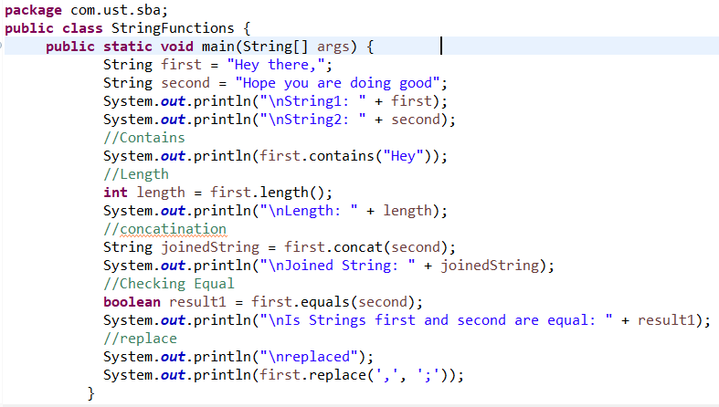

Output:

