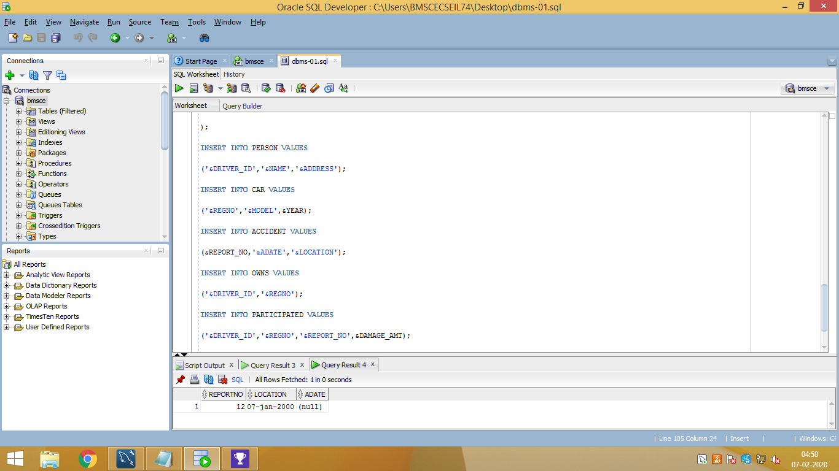

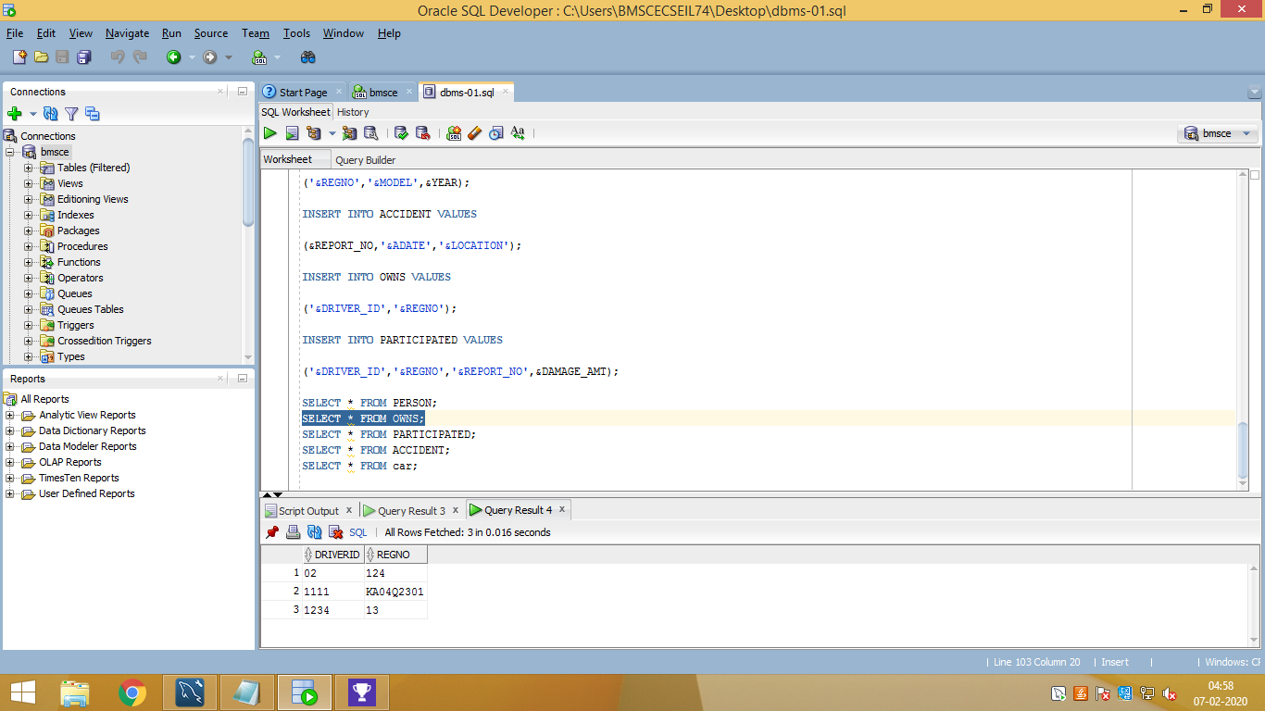

r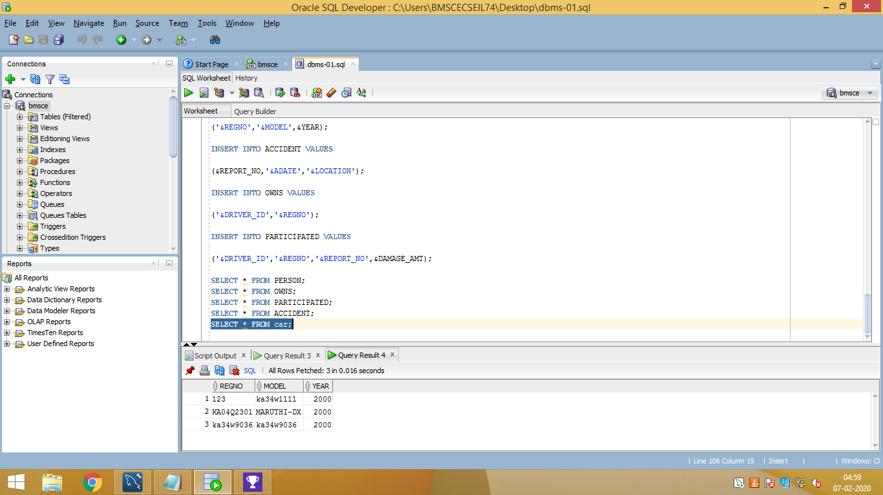

CREATE TABLE PERSON

(

DRIVER_ID VARCHAR2(10),

NAME VARCHAR2(20),

ADDRESS VARCHAR2(15),

PRIMARY KEY(DRIVER_ID)

);

CREATE TABLE CAR

(

REGNO VARCHAR2(10),

MODEL VARCHAR2(10),

YEAR NUMBER(4),

PRIMARY KEY(REGNO)

);

CREATE TABLE ACCIDENT

(

REPORT_NO NUMBER(5),

ADATE DATE,

LOCATION VARCHAR2(15),

PRIMARY KEY(REPORT_NO)

);

CREATE TABLE OWNS

(

DRIVER_ID VARCHAR2(10),

REGNO VARCHAR2(10),

PRIMARY KEY(DRIVER_ID,REGNO),

FOREIGN KEY(DRIVER_ID) REFERENCES PERSON(DRIVER_ID),

FOREIGN KEY(REGNO) REFERENCES CAR(REGNO)

);

CREATE TABLE PARTICIPATED

(

DRIVER_ID VARCHAR2(10),

REGNO VARCHAR2(10),

REPORT_NO NUMBER(5),

DAMAGE_AMT NUMBER(7,2),

PRIMARY KEY(DRIVER_ID,REGNO,REPORT_NO),

FOREIGN KEY(DRIVER_ID,REGNO) REFERENCES OWNS(DRIVER_ID,REGNO) ON DELETE CASCADE,

FOREIGN KEY(REPORT_NO) REFERENCES ACCIDENT(REPORT_NO) ON

DELETE CASCADE

);

INSERT INTO PERSON VALUES

('&DRIVER_ID','&NAME','&ADDRESS');

INSERT INTO CAR VALUES

('&REGNO','&MODEL',&YEAR);

INSERT INTO ACCIDENT VALUES

(&REPORT_NO,'&ADATE','&LOCATION');

INSERT INTO OWNS VALUES

('&DRIVER_ID','&REGNO');

INSERT INTO PARTICIPATED VALUES

('&DRIVER_ID','&REGNO','&REPORT_NO',&DAMAGE_AMT);

SELECT * FROM PERSON;

SELECT * FROM OWNS;

SELECT * FROM PARTICIPATED;

SELECT * FROM ACCIDENT;

SELECT * FROM car;