Core Python

***How to add comments in python code?***

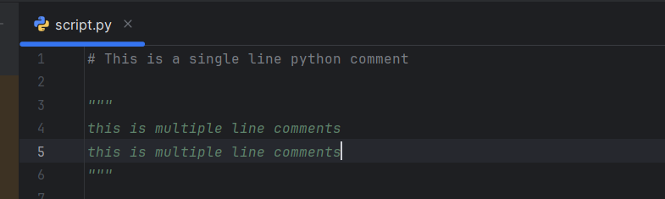

***Rules Of naming conventions and DataType:***

*) Python ***supports snake case*** which is used for the ***naming conventions*** to ***cleanly separate the words in the variable***

Example:

***product_name*** = “gameBoy”

*) In Python remember the ***constants*** are always declared as ***captial letters variable***

Example:

***PI*** = 3.14

Python supports following dataType ***int, string, float , complex, boolean, list, tuple, set, dictionaries.***

***How type ints works in python?***

Binding variable along with the dataType.

Synatax:

***Varaible:dataType = value***

Example:

***name: str =*** “Jhon Wick”

***isAdult: bool =*** True

***salary: float*** = 9000.23

***emp_id:int*** = 136

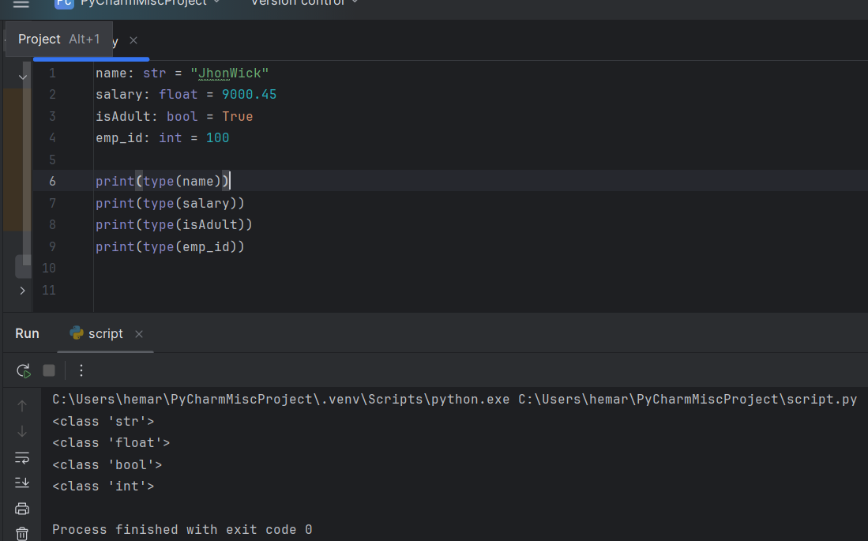

***How Type conversion works in python?***

This mainly to convert from ***one datatype to another datatype*** by mentioning the ***dataType before the variable***.

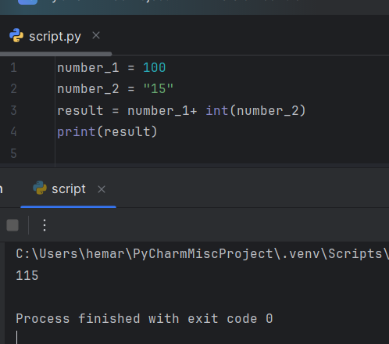

***What operators Python supports?***

***+***  --> addition operator

***-***  --> subtractor operator

***/***  --> division operator

***%*** --> modulo division operator

**\***  --> multiply operator

**\*\*** --> power (example 10 ** = 3 that means 10 power 3 (10^3 = 1000))

***and , or , not*** operator also used in python

***==*** equal to operator checks only value if the variables

***is*** operator is used to check the memory of the variables.

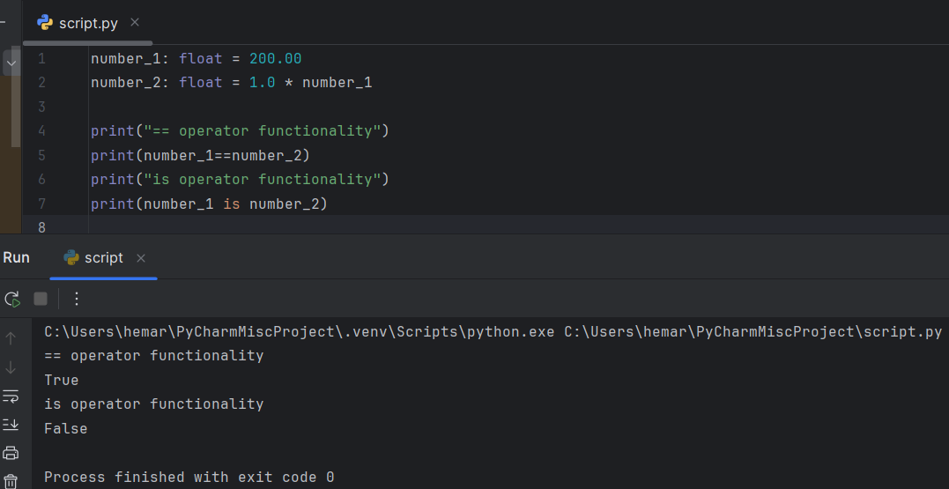

Power operator:

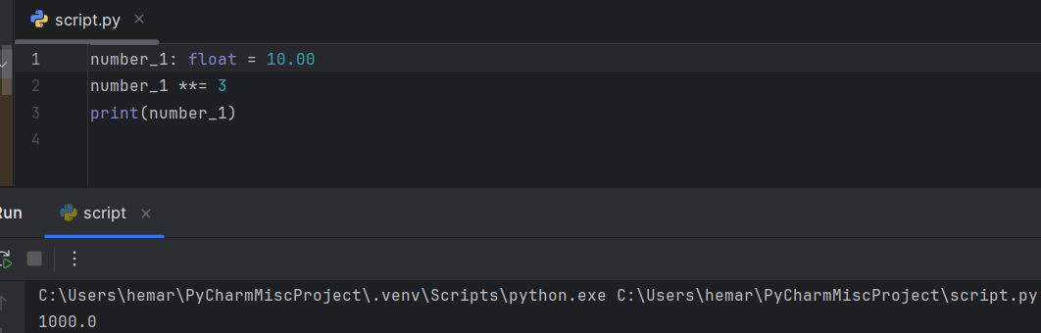

***Collection Types DATATYPE Python:***

List:

--> In this we can multiple dataTypes without any issue

--> Even we can restrict the list to store only one DataType

--> It always follow insertion order

***Syntaxes:***

***Variable:list[dataType] = [mention objects]***

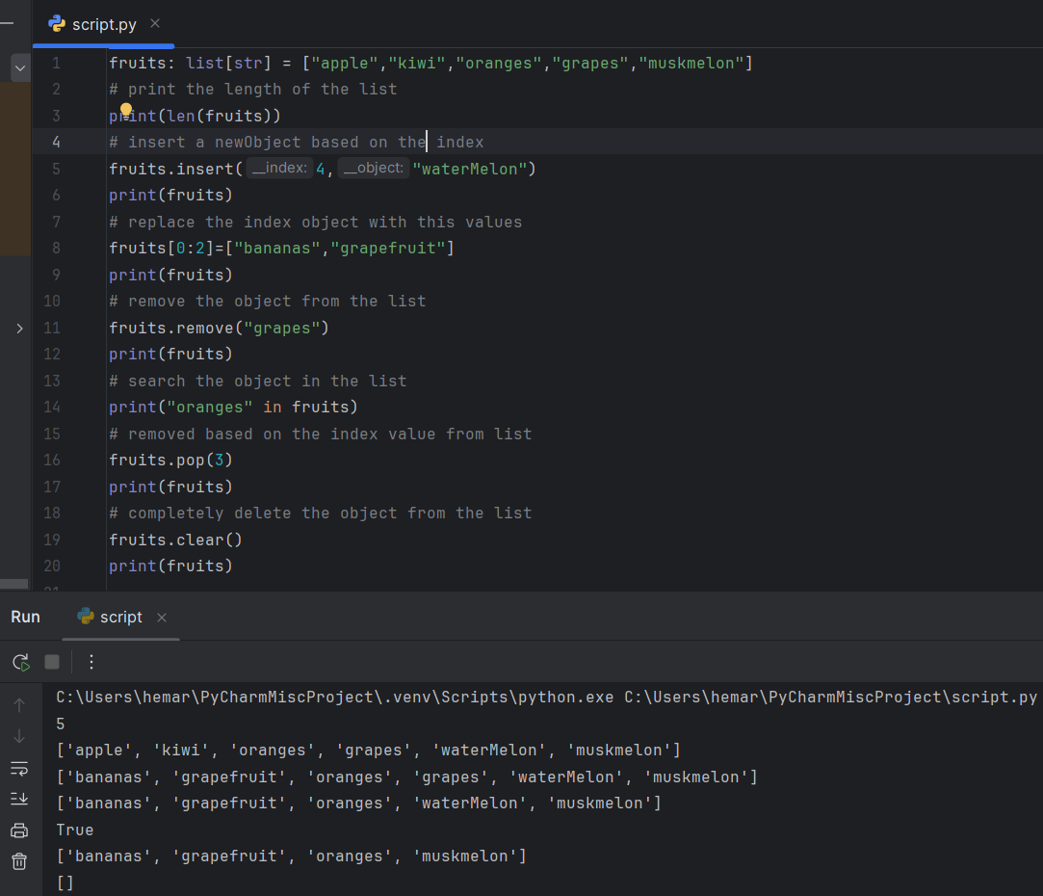

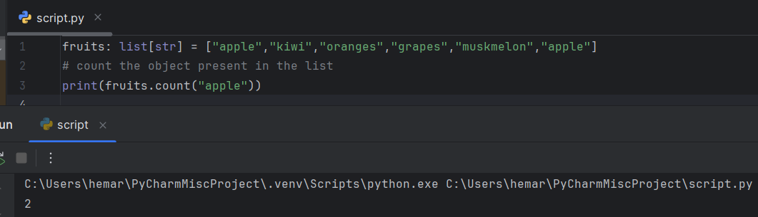

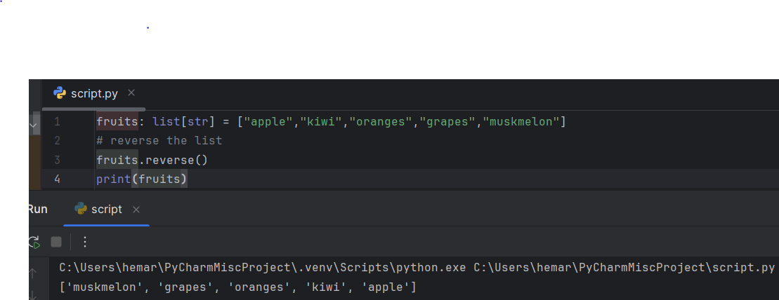

***Tuple:***

--> You cannot add , update or delete the objects that is present in the tuple.

--> it follows the insertion order

--> This is mainly used for the memory optimization and exceutes the python code faster

***Synatax:***

**Variable: tuple[dataType] = (mention the object values)**

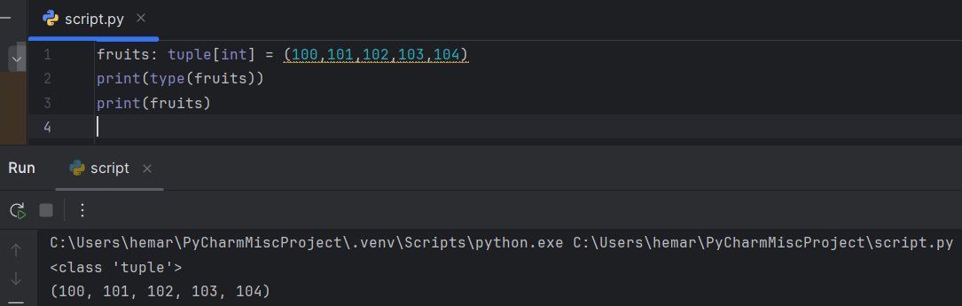

***SET:***

--> It does not follow any insertion order

--> it won’t allow the duplicates get stored in the sets.

--> used for the memory optimization and exceutes the python code faster

***Syntax:***

***Varaible: set[dataType] = {mention the object values}***

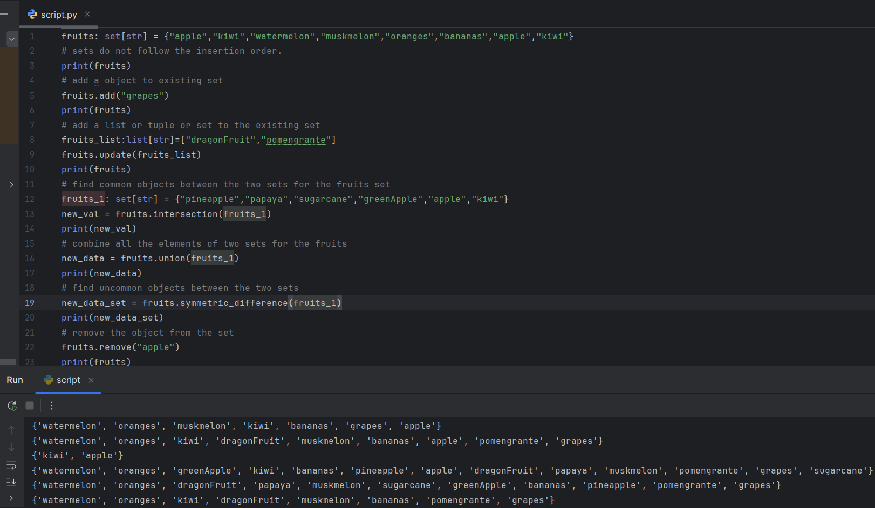

***Dictionary:***

--> it stores the value in the form of key and value.

Syntax:

***Variable:dict = {key1:value1,key2:value2,…….}***

***Variable = {}***

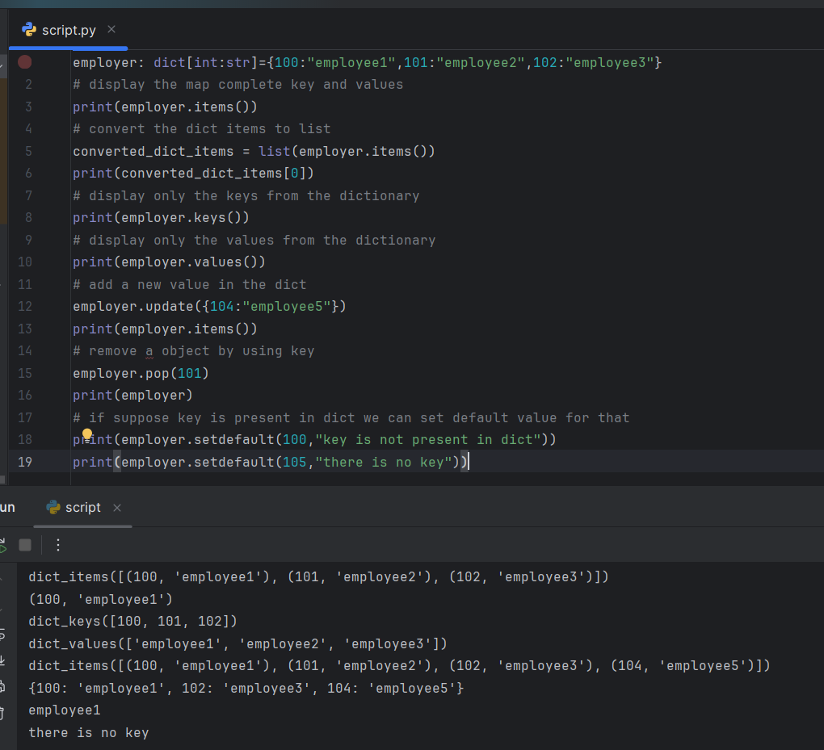

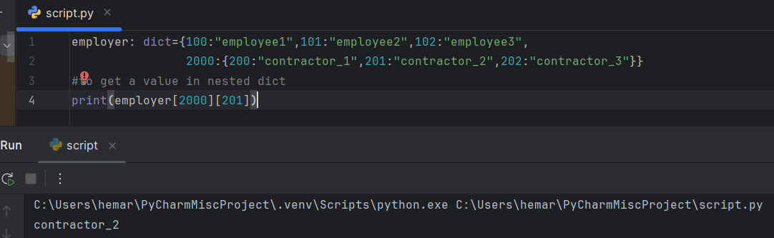

***Control Flows Python:***

***For loop list iterate example:***

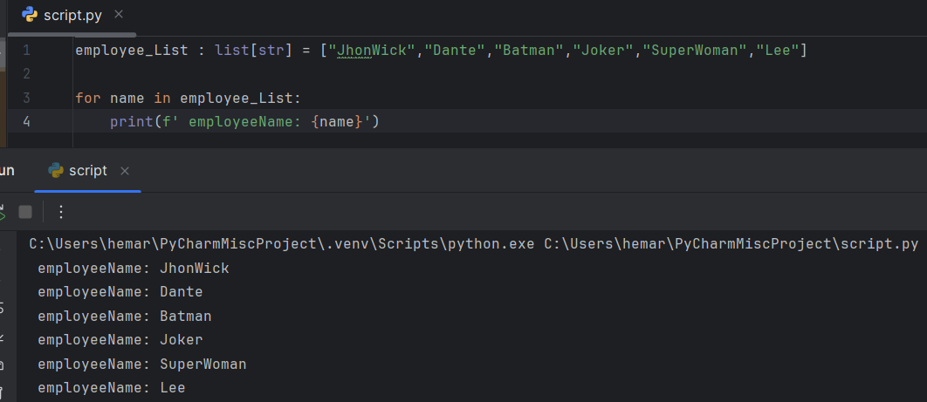

***For nested loop example:***

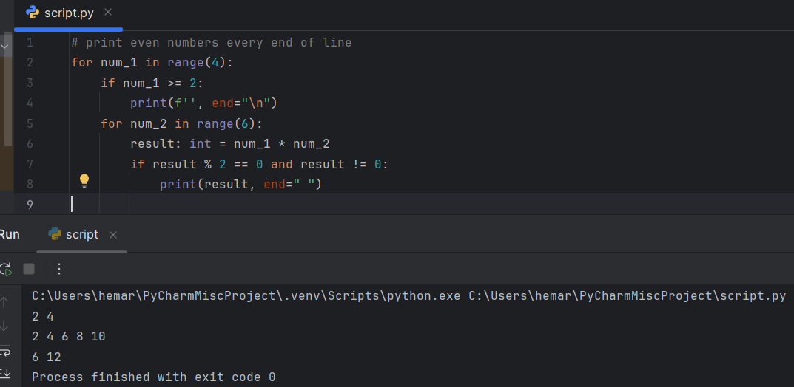

***While loop example:***

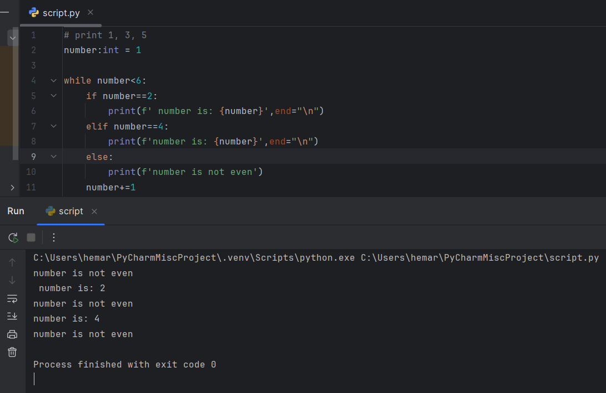

***Break and Continue:***

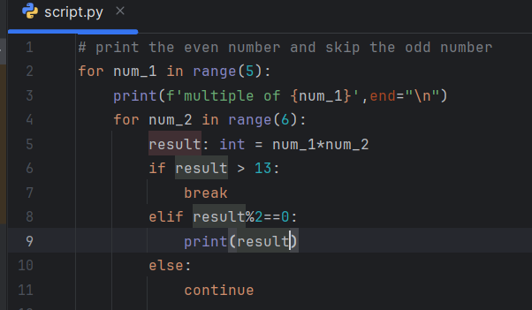

***Python Method Signature:***

*Method signature with the return type:*

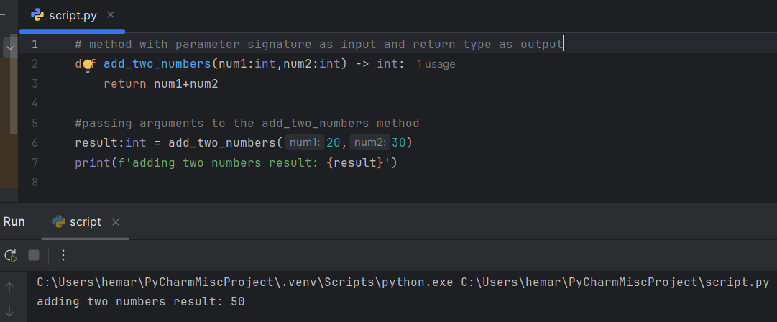

method signature which as ***\* in front of the*** ***method*** which means when you invoke the method you need to ***pass the parameter name along with arguments(values)*** if you don’t pass the parameter name method will throw error with yellow line

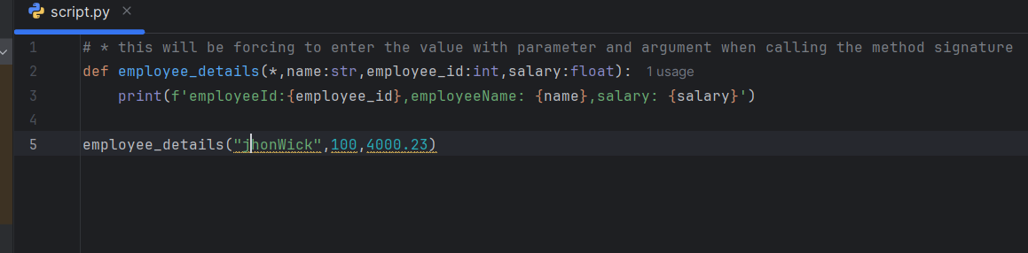

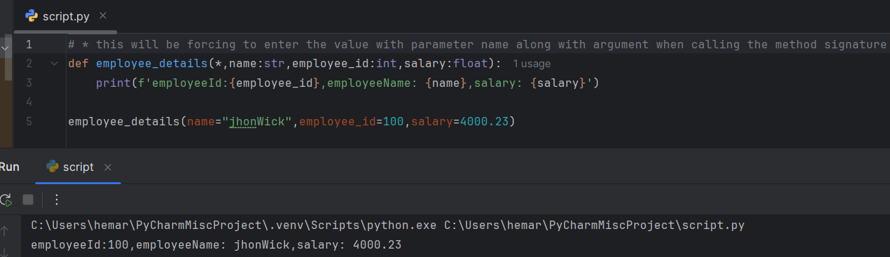

Method signature with ***/ at the end of the method which*** means you invoke the method arguments ***needs to pass in the positional value.***

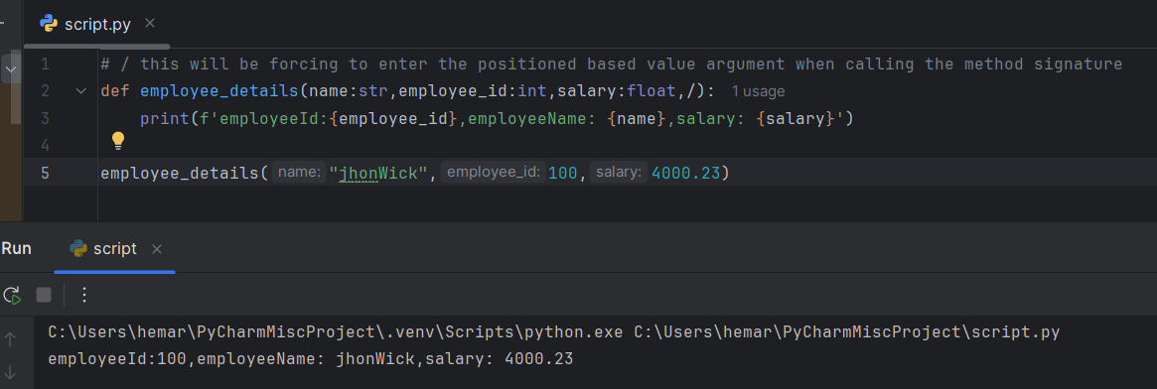

Method signature with ***\*variable in the method*** which means that value will be taken ***as the tuple***. While invoking the method you can enter as many values.

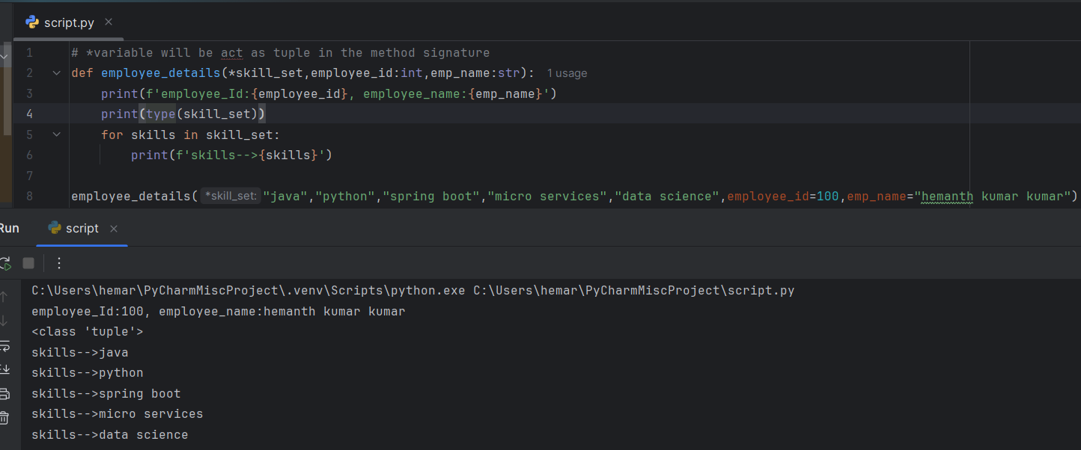

Method signature with ***\*\*variable in the method*** which means that ***value be takes as the dict***. While invoking the method you need to ***pass the value*** In the form of ***key and value pair*** like parameter with argument in to it.

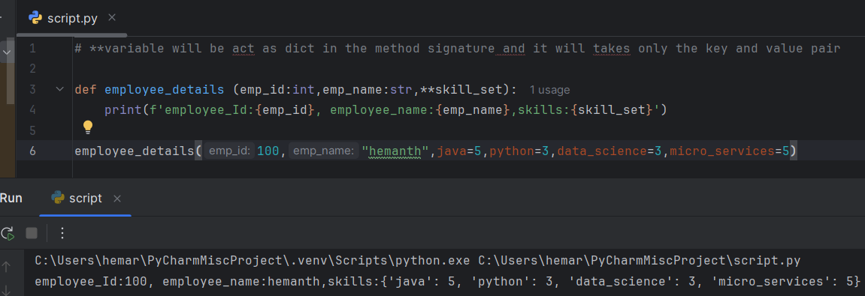

***Try , except, Finally and raise***

In the ***try block*** execute ***your program logic*** and if any ***exception occurs*** it will be ***capture in the except block*** and ***finally*** will be execute ***no matter exception occurred or logic worked*** .

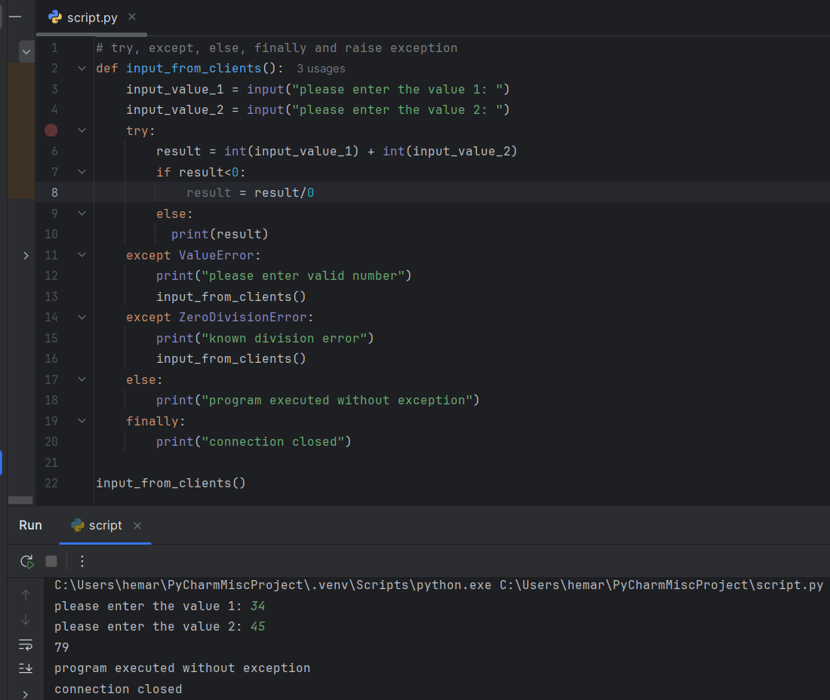

***Raise means throwing a custom exception :***

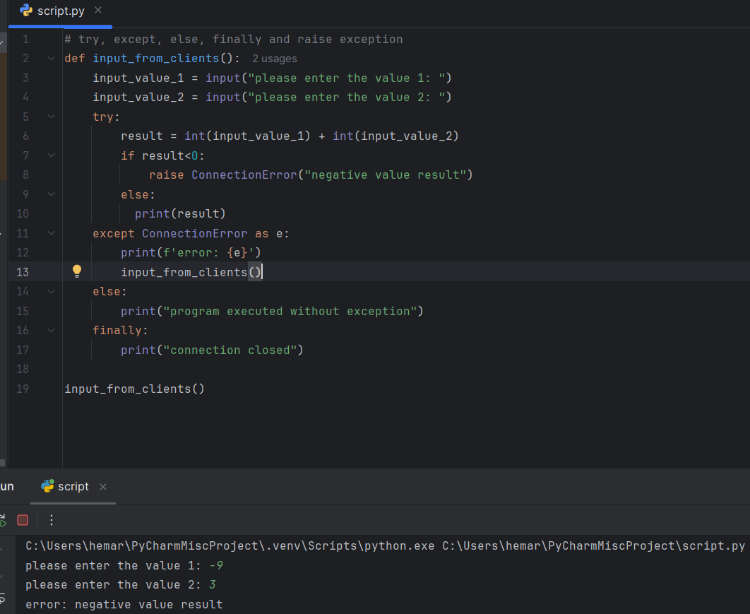

***How to Import module and packages in python:***

***Import a module (file)***

*) *import module_name as alias_name*

***module_name*** is said to be the ***file name*** once you declared it you can able to access the methods or functions that is available in the module (file)

***Import a package from that import module:***

*) *from package_name import module_name_1 as alias_name, module_name_2 as alias_name*

*) *import package_name.module_name_1 as alias_name, package_name.module_name_2 as alias_name*

Package as multiple modules (files)

***Import as module example:***

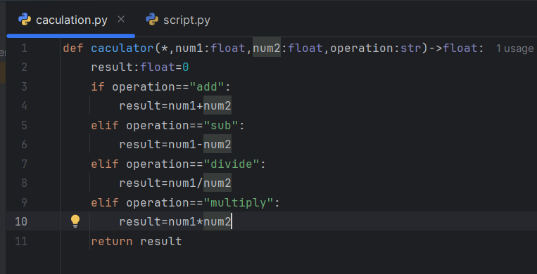

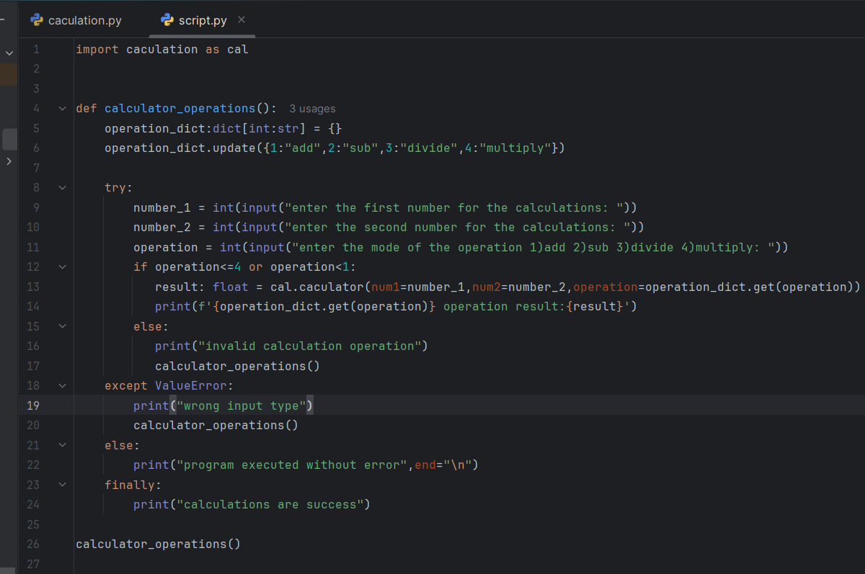

***Import package example in python:***

*from calculator_package import caculation as cal,sample_module_2 as sam2*

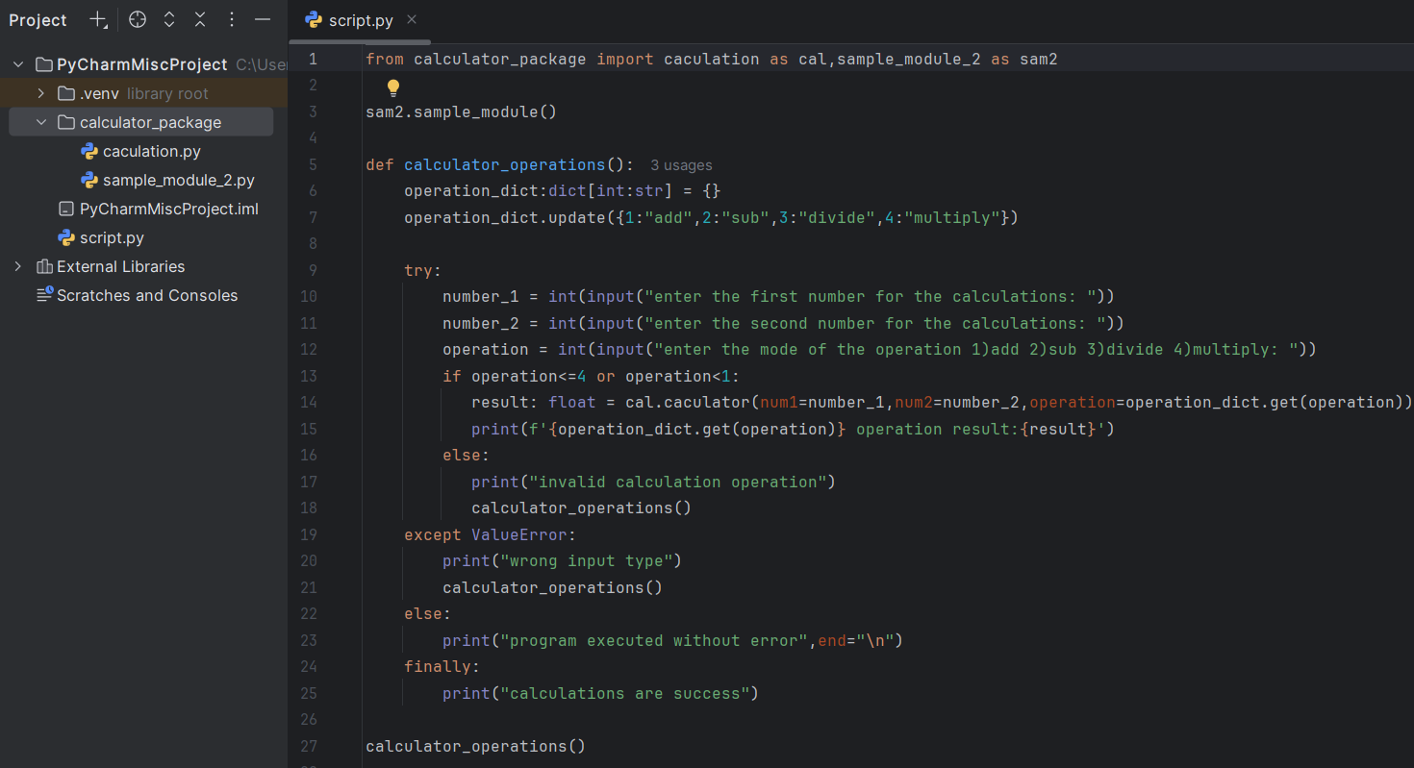

***Import package example-2 in python:***

*import calculator_package.caculation as cal,calculator_package.sample_module_2 as sam2*

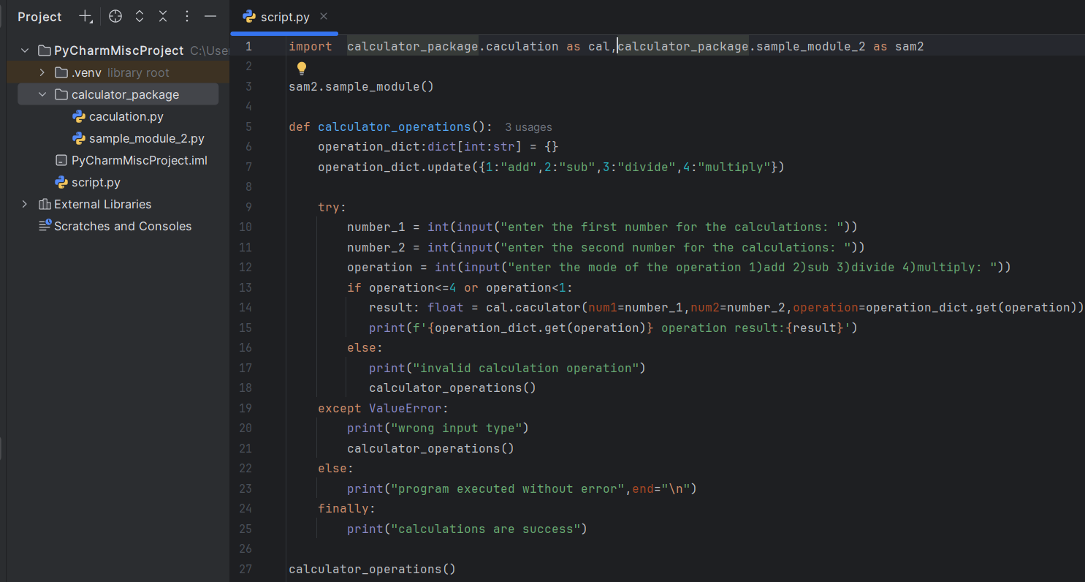

***Usage Of With KeyWord in python programming language:***

***With*** keyword mainly used in the file system where it can automatically close the file we do not need to manually call the ***file.close()*** method

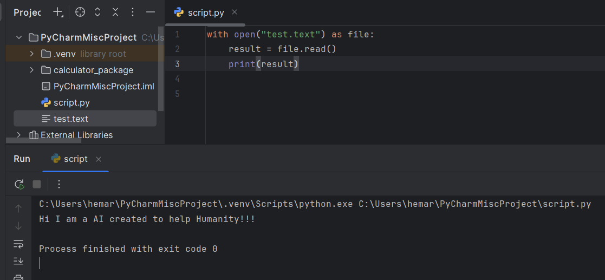

***How to decalre a enum and use the enum in python?***

***Enum*** is ***kind of constant*** through out the ***program*** . Enum as two methods one is name() and other is value(). Name() provides the exact of the Enum in string value and Value() provides the enum value what we declared in the progam.

Step 1 --> from enum import Enum ***(from enum pacakage import Enum module which means file)***

Step 2 --> Declare a class and pass the Enum in the method signature

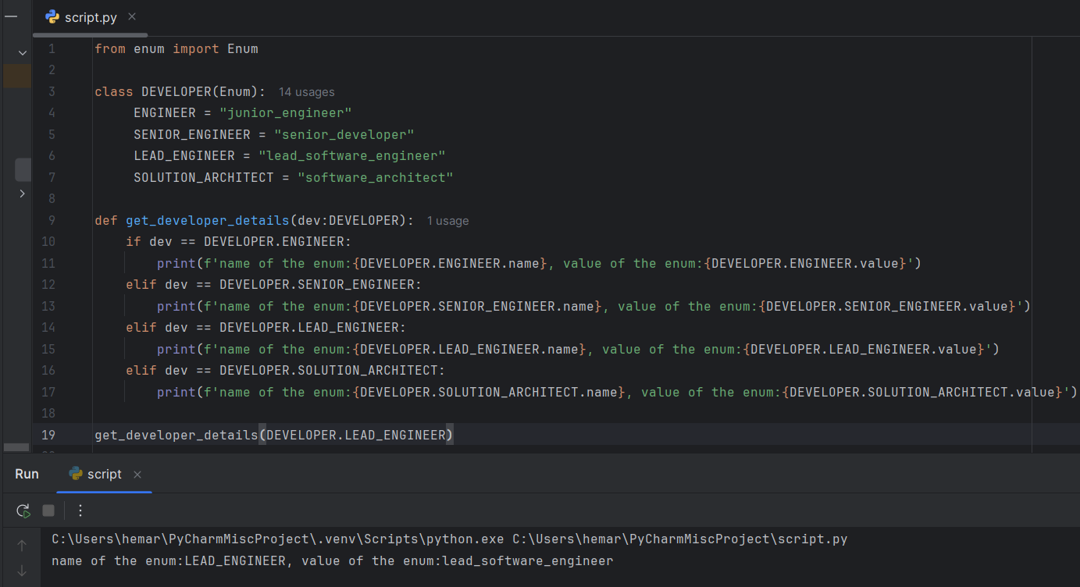

***What is the purpose of using the main name check in the python?***

Once you implemented a main check in the python whatever method is invoked inside the main method that method only be called not all the methods or imports(from other modules or packages) used inside the module (file)

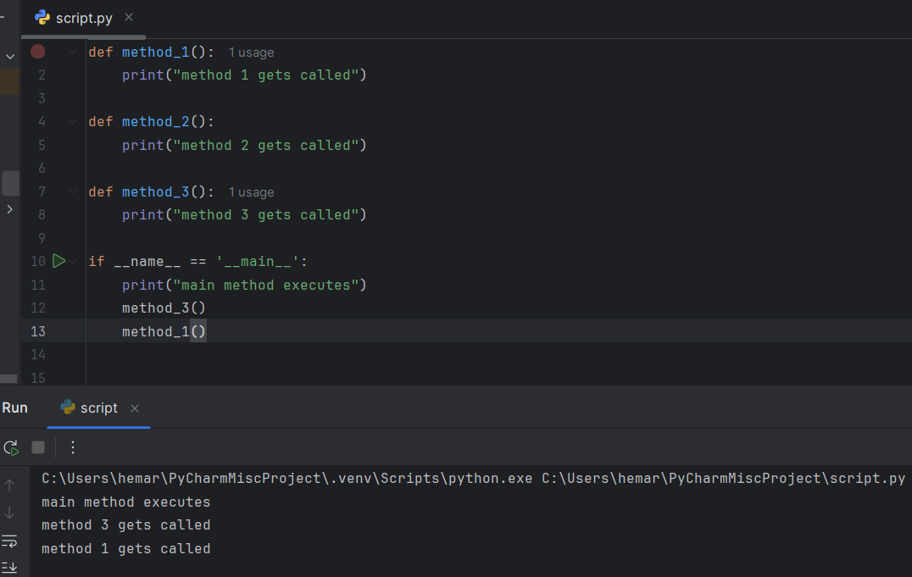

***What are the scopes in the Python?***

***#***Remember there are two scopes in python ***global scopes*** and ***nonlocal scopes:***

inside the ***functions the scope is always considered to be local*** but we can override the ***global variables values inside the functions*** by providing ***global before the variable***.

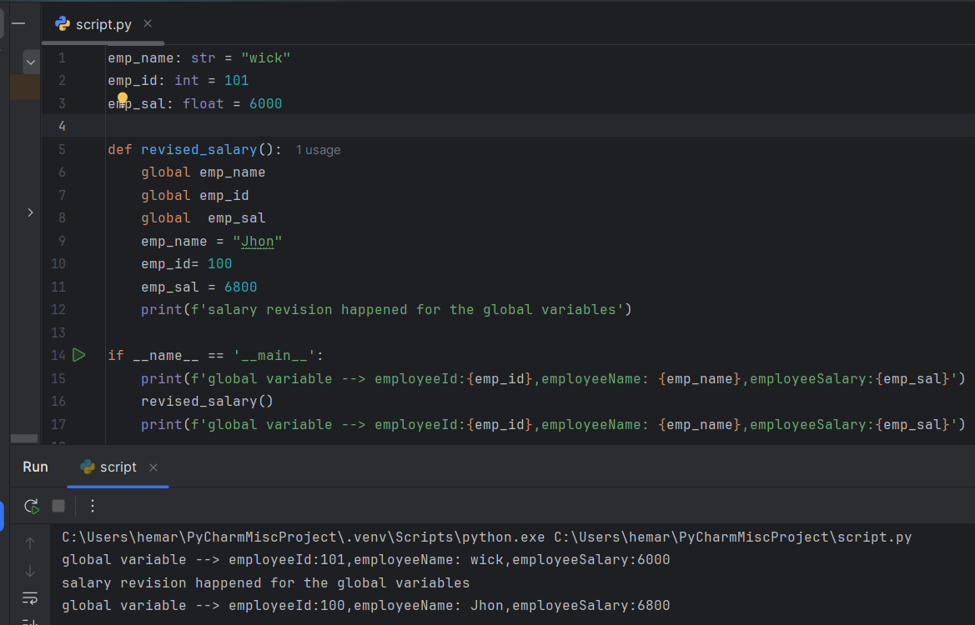

In the ***Python functions variable will be acting as local scope*** nested function inside the ***variable can replace this local scope by overriding the variable*** by mentioning

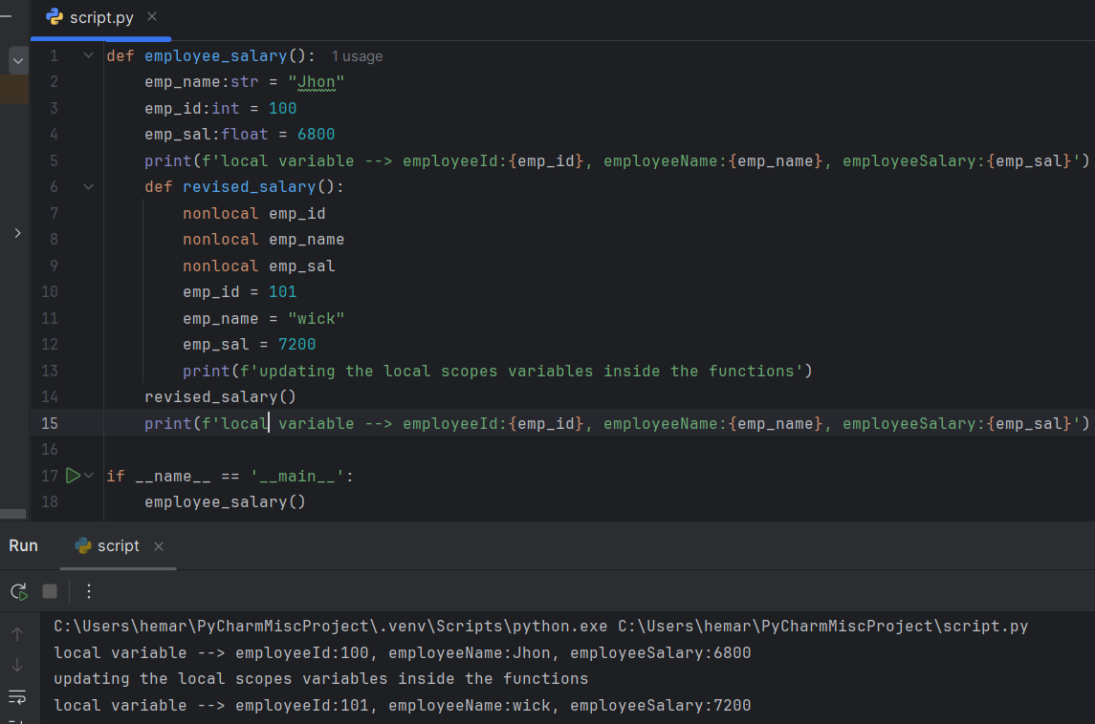.

***List Operation methods:***

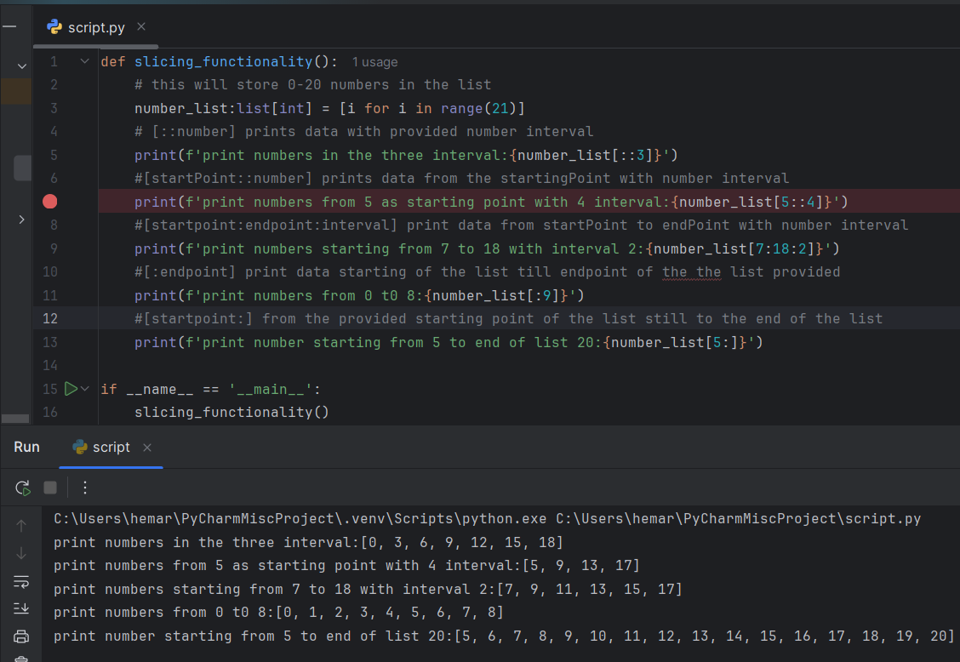

***# remember*** when ever you ***do a modify the list in a loop*** store the ***updated result in the another new list***.

***OOPS In Python Programming Language***

Variable declaration in python can be done in two ways.

1. One is declaring the ***class variables*** that is ***being shared across all the instances***.
2. Other is declaring the ***instance variable*** which ***will be unqiue for the each instance*** (this will be declared inside the constructor (__init__ method))

* ***_variableName*** this is will be consider a***s protected field*** which can be used in the ***current class and also the child class***. ***Outside the current class*** you can access it by ***setters and getters*** method

* ***__variableName*** this will be consider as ***private field*** which can be used in the ***current class*** only .Outside the current class you can access it by setters and getters method

***__init__ method*** is the constructor and ***self*** will be denoting the current instance simliar to ***this in java.***

