**TWO API CALL IN PARALLEL SEQUENCE**

**IDE USED**: ECLIPSE

**DEPENDENICES USED**:

1) Spring boot starter web parent

1. Spring Boot starter web
2. Spring Boot Starter Data JPA
3. Spring Boot Starter DEV-Tool
4. Mysql Connector
5. Hibernate core , Hibernate Entity Manager
6. Io.reactive-x(rxjava, recative-streams)

**Description** :

Created two get api service and created another aggregator api service to make a parallel api call by using zip

**REST SERVICE**:

**CONTROLLER**

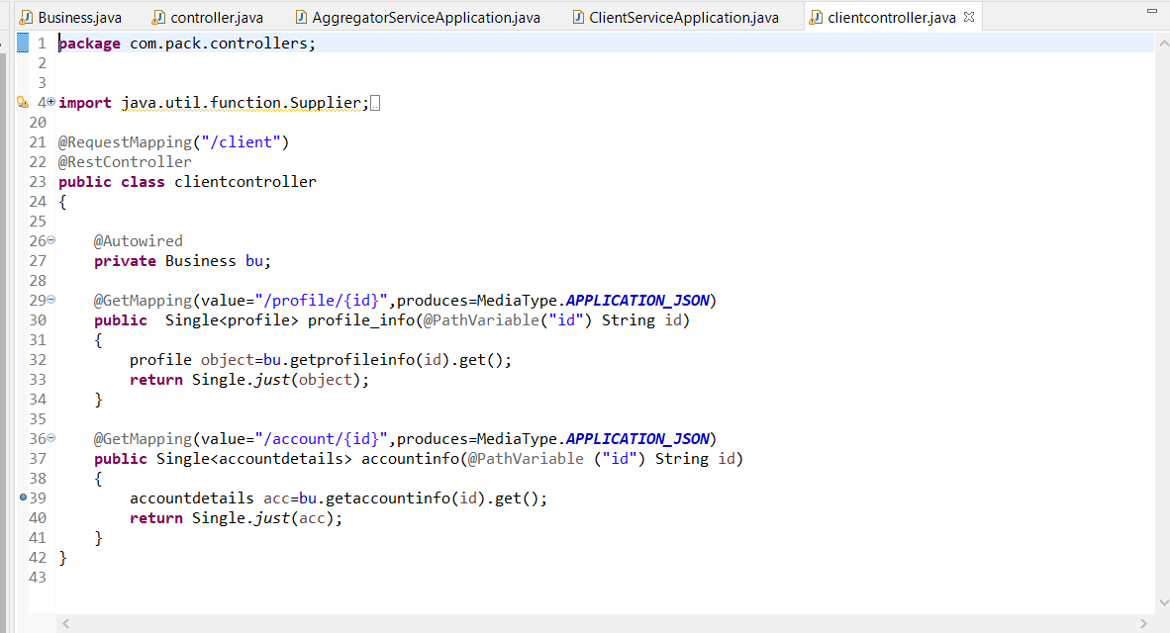

**BUSINESS LAYER**

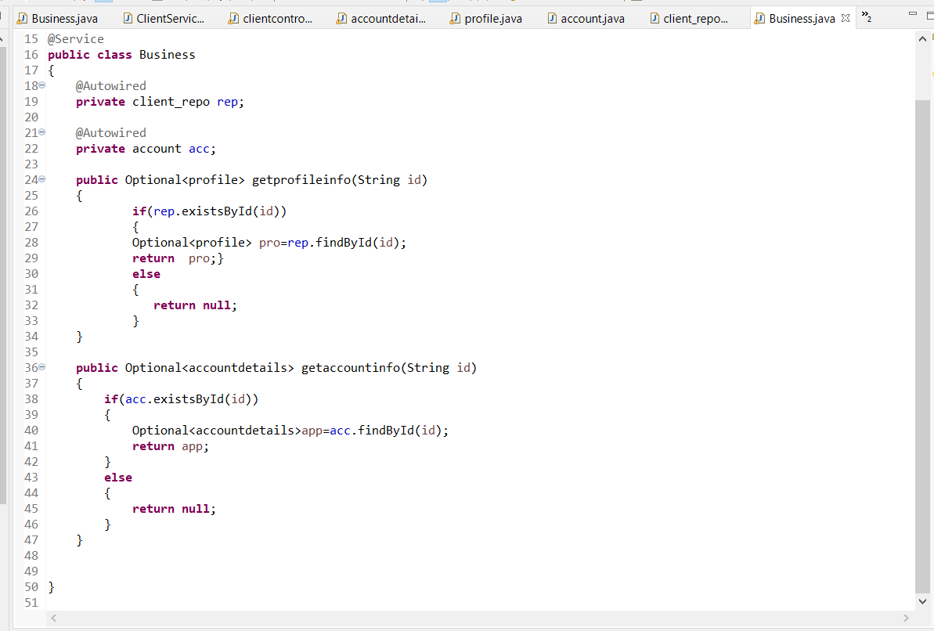

**MODEL LAYER**

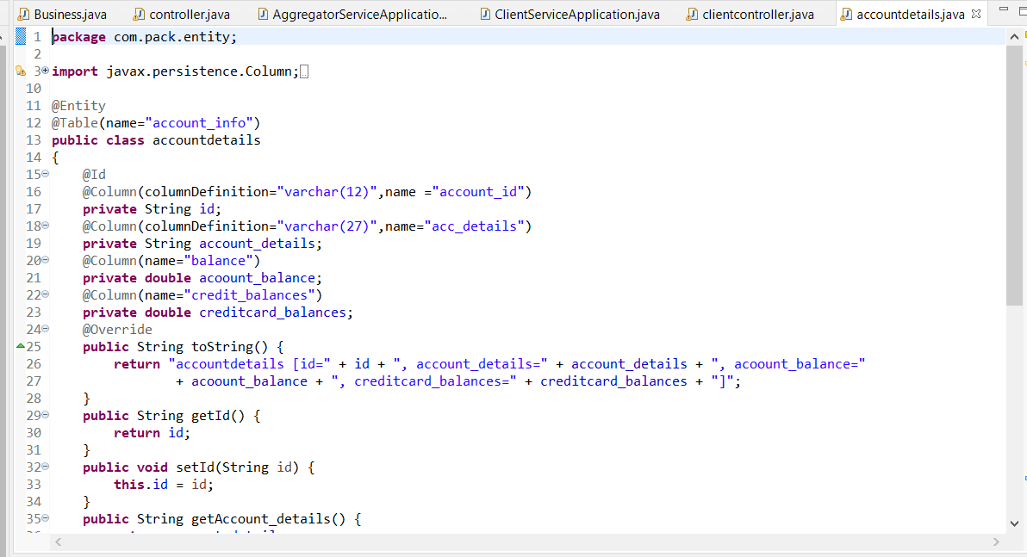

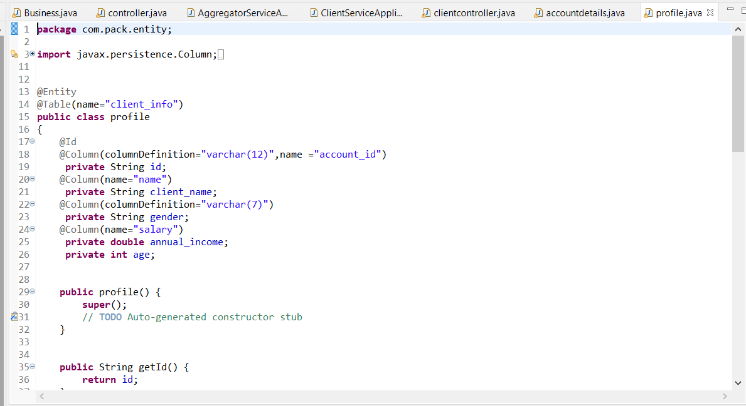

**REPOSITORY LAYER:**

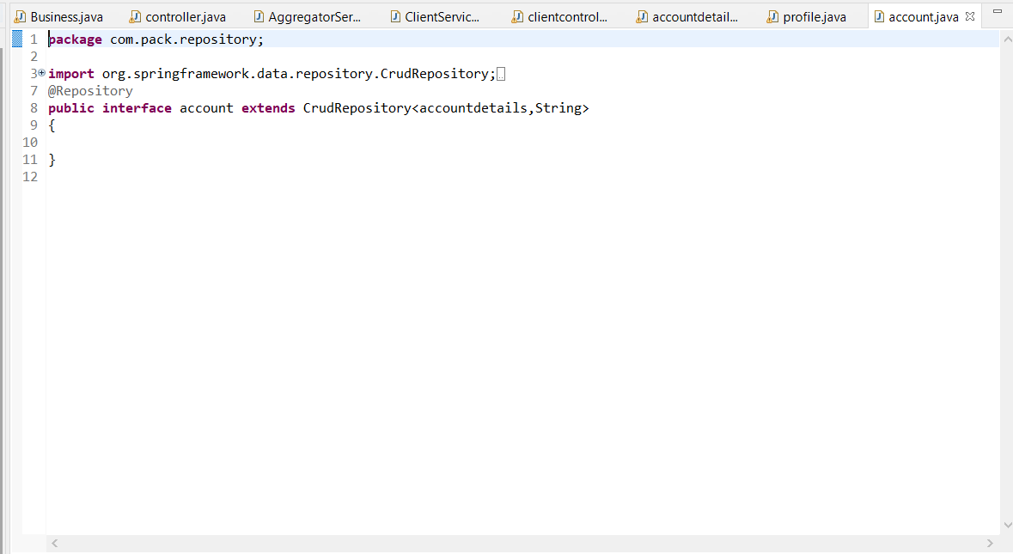

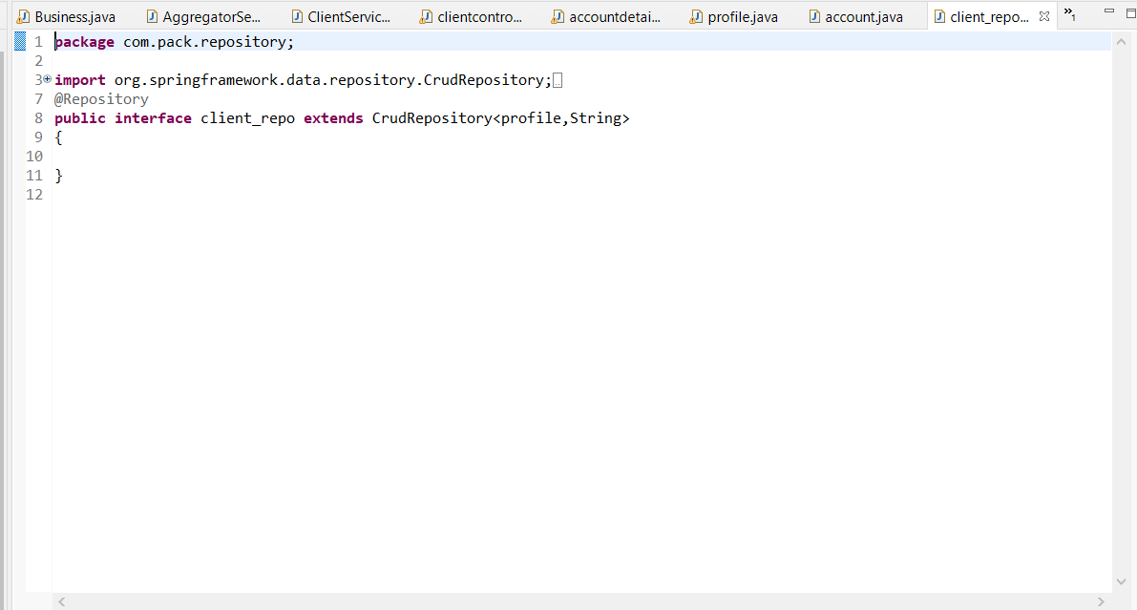

**AGGREGATOR SERVICE :**

**CONTROLLER**

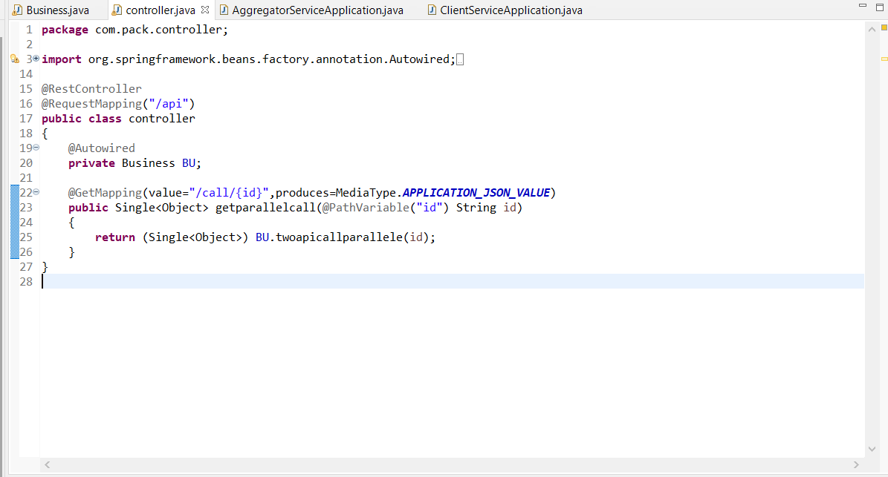

**SERVICE LAYER**

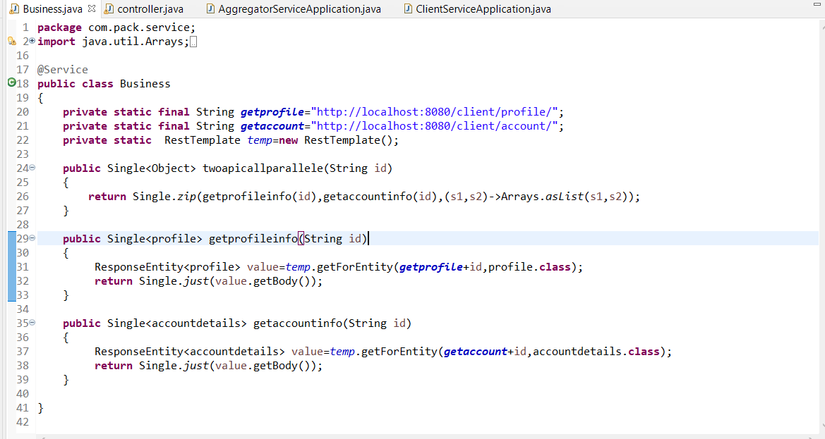

**POSTMAN OUTPUT**

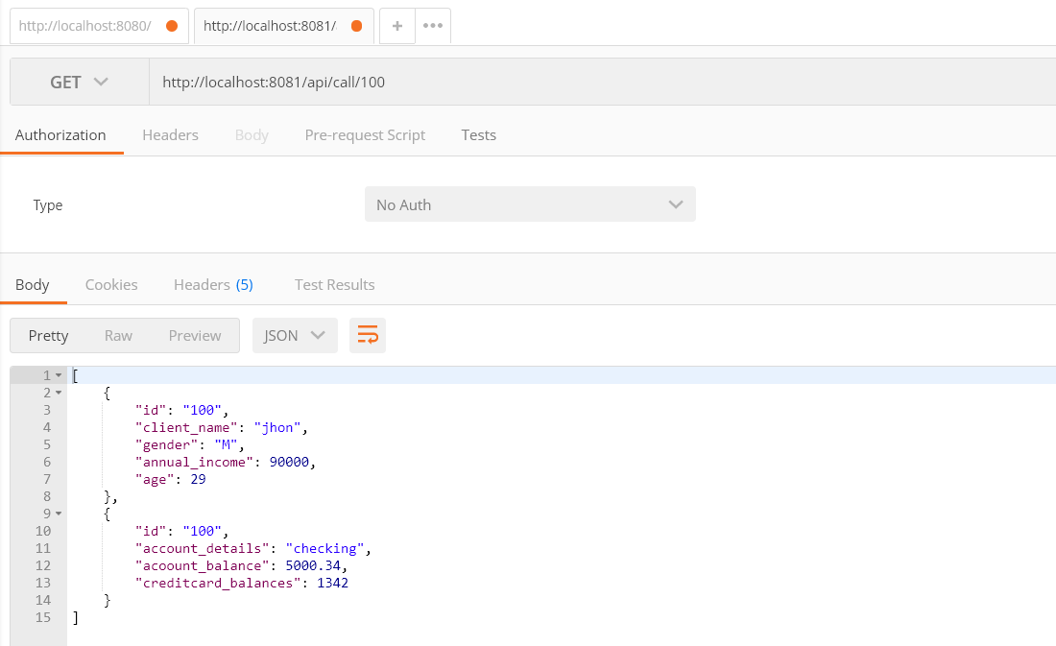

**DB**

