1.Familiar with Git commands like git init, git status, git add, git commit, git push, and git pull.

In this hands-on lab, you will learn how to

* Setup your machine with Git Configuration
* Integrate notepad++.exe to Git and make it a default editor
* Add a file to source code repository

Solution:-

**Step 1: Setup Git Configuration**

# Check Git installation

git --version

**Output:**

git version 2.43.0.windows.1

# Configure your name and email

git config --global user.name "Hemanth Kumar"

git config --global user.email "hkum8798@gmail.com"

# Check configuration

git config --global –list

**output:**

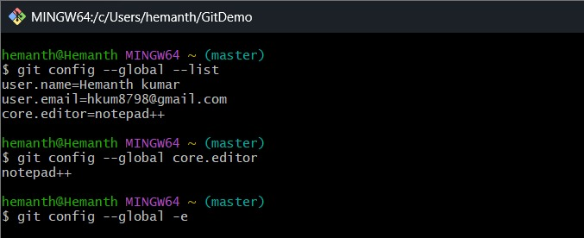

**Step 2: Integrate Notepad++ as Git Editor**

# Test Notepad++ from Git Bash

notepad++

#Set Notepad++ as Git default editor:

git config --global core.editor "notepad++"

Verify:

git config --global -e

**output:-**

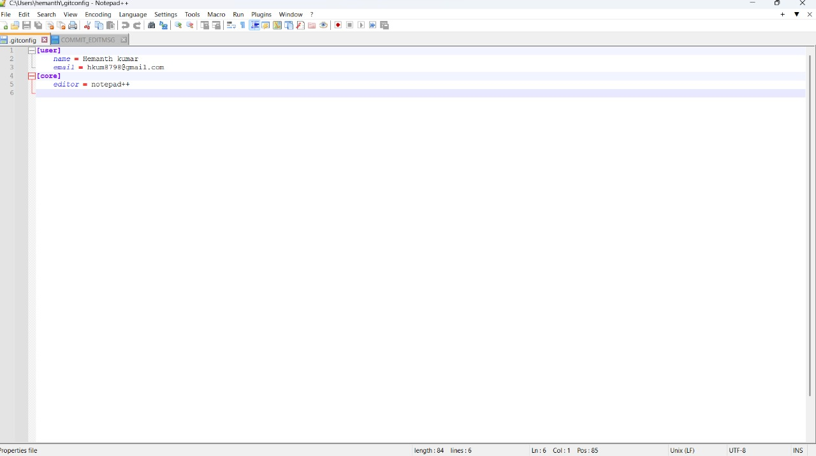

**Step 3: Create Local Git Project and Commit a File**

# Create a new folder

mkdir GitDemo

cd GitDemo

git init

**output:-**

Reinitialized existing Git repository in C:/Users/hemanth/GitDemo/.git/

ls -a

**Output:**

. .. .git

#Create a File and Commit It

echo "Welcome to Git!" > welcome.txt

ls

cat welcome.txt

**Output:**

Welcome to Git!

#Stage and Commit the File

git status

**Output:**

Untracked files: welcome.txt

git add welcome.txt

git status

**Output:**

Changes to be committed:

new file: welcome.txt

git commit

Notepad++ opens. Type:

Initial commit with welcome.txt

**Step 4: Connect to GitLab and Push**

#on GitLab:

git remote add origin https://gitlab.com/Hemanthkumarrc-group/GitDemo.git

git pull origin main --allow-unrelated-histories

git push -u origin main

**Output:-**



