**2**.**Create a “.log” file and a log folder in the working directory of Git. Update the .gitignore file in such a way that on committing, these files (.log extensions and log folders) are ignored.**

**Verify if the git status reflects the same about working directory, local repository and git repository**

Solution:

**Ignoring Files Using .gitignore**

# Create a new Git project directory

mkdir GitIgnoreDemo

cd GitIgnoreDemo

git init

**2. Create .log File and log Folder**

# Create a file with .log extension

echo "This is a log file" > error.log

# Create a log folder with a file inside it

mkdir log

echo "Log data here" > log/app.log

**3. Create .gitignore File**

# Create .gitignore

touch .gitignore

Open .gitignore using Notepad++:

notepad++ .gitignore

Add the following lines:

*.log

log/

**4. Verify .gitignore Works**

Check the status:

git status

**Output:**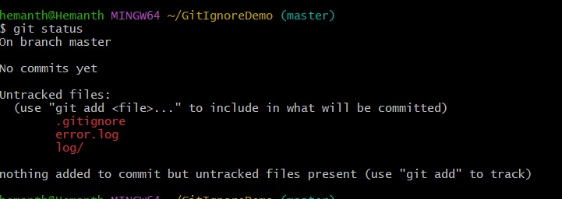

**5. Commit the .gitignore**

git add .gitignore

git commit -m "Added .gitignore to ignore .log files and log folder"

**6. Final Verification**

git status

**Output:**

nothing to commit, working tree clean