**Git Hands-On Lab: Clean Up and Push to Remote Git (Git-T03-HOL_002)**

1. Please follow the instructions to complete the hands-on. Each instruction expects a command for the Git Bash.

1. Verify if master is in clean state.
2. List out all the available branches.
3. Pull the remote git repository to the master
4. Push the changes, which are pending from **“Git-T03-HOL_002”** to the remote repository.
5. Observe if the changes are reflected in the remote repository.

**Solution:**

**Prerequisites:**

• Hands-on ID: Git-T03-HOL_002

• Git installed

• GitHub account

**Steps Performed:**

1. **Verify if master is in a clean state:** This command shows the current state of your working directory and staging area and a "clean" state means there are no changes to commit.

**Purpose:** Ensure no uncommitted changes exist on the master branch before you proceed.

**Command:**

* 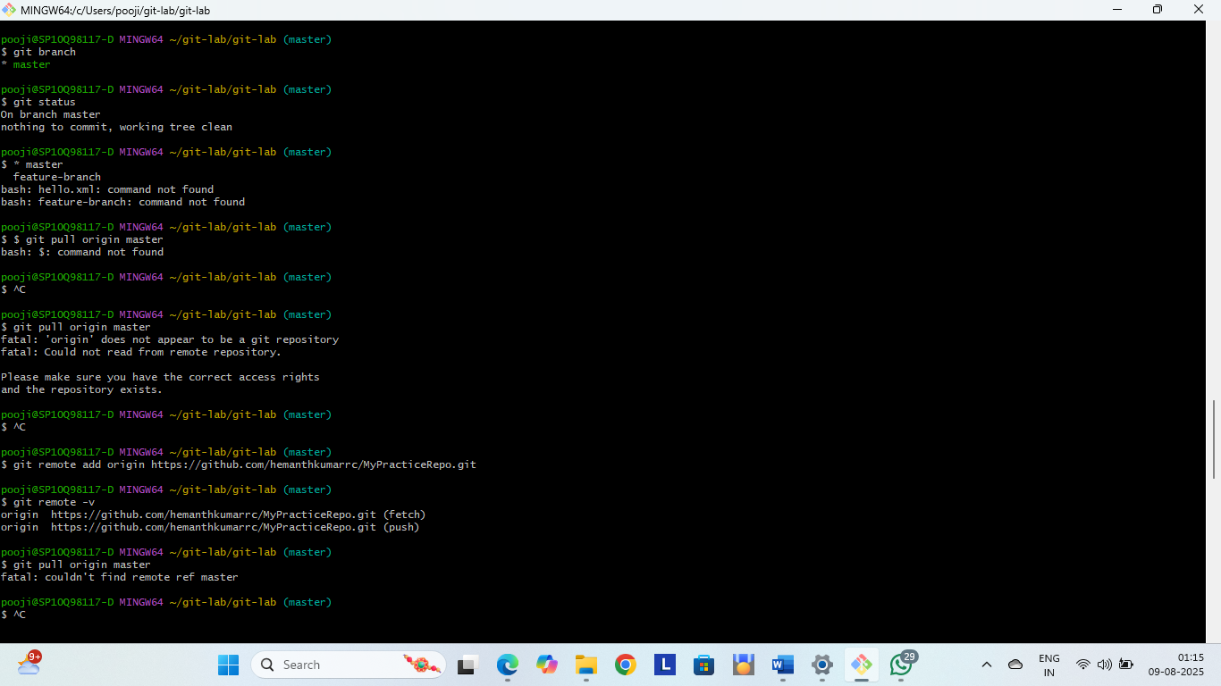git status

1. **List out all the available branches:** Displays all local branches and the current branch has an asterisk (*) next to its name.

**Purpose:** To identify all local branches and check which branch you are currently on.

**Command:**

* git branch



**3. Pull the remote git repository to the master:** Fetches and merges changes from the remote master branch to your local master and ensures your branch is up-to-date.

**Purpose:** Update your local master branch with the latest changes from the remote repository.

**Command:**

* 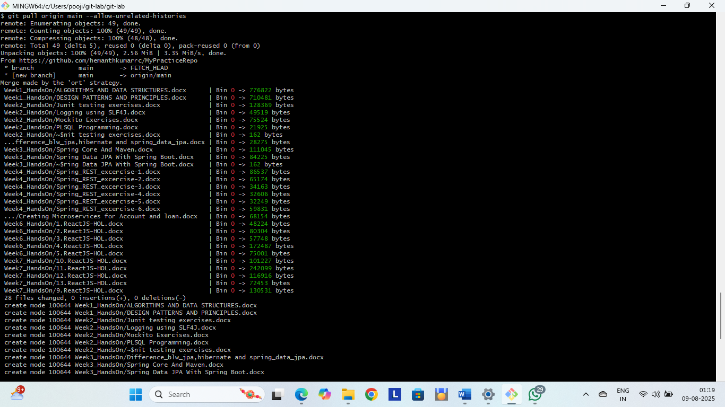git pull origin master

**4.** **Push the changes, which are pending from “Git-T03-HOL_002” to the remote repository:** First, switch to the branch containing your changes.

* Then, push your commits to the remote branch.

**Purpose:** Upload the commits you made in your local branch Git-T03-HOL_002 to the remote repository.

**Command:**

* git checkout Git-T03-HOL_002
* git push origin Git-T03-HOL_002



**5. Observe if the changes are reflected in the remote repository** **Observe if the changes are reflected in the remote repository:** Fetch updates remote tracking branches without merging and displays last 5 commits on the remote branch to confirm your changes were pushed.

**Purpose:** Confirm that your pushed changes are now available on the remote Git server.

**Command:**

* git fetch origin
* git log origin/Git-T03-HOL_002 --oneline -5

