HUMBER POLYTECHNIC

Lab 1: DevSecOps Fundamentals & SDLC Security Integration

Cybersecurity Architecture, Design, and Secure Software Development

Description | Values
Student Name | Hemanth Kumar Venkataram
Student ID | N10050367
Course | MCSC-6002-RNA
Professor Name | Debashish Roy
Date | November 8, 2026

Lab Overview

In this lab, you will explore the fundamentals of DevSecOps, understand the SDLC (Software Development Life Cycle) from a security perspective, and apply basic security principles to a sample application. You will practice integrating security into development processes, ensuring Confidentiality, Integrity, and Availability (CIA), and implementing data integrity verification.

Learning Objectives

By the end of this lab, you will be able to:

- Explain the DevSecOps Software Development Life Cycle (SDLC).
- Identify stages in development where security measures should be implemented.
- Design and implement mechanisms to ensure data confidentiality and integrity.
- Analyze potential threats in a software system and propose appropriate mitigation strategies.

Pre-Lab Preparation
- Ensure Python 3.x is installed.
- Familiarize yourself with Python libraries for encryption, hashing, and JSON manipulation.
- Have access to an IDE or text editor (e.g., VS Code, PyCharm, or Jupyter Notebook).
- Download the sample datasets:
  - users.json – original user dataset
  - users_tampered.json – dataset with a tampered record for integrity verification

Lab Tasks

- Task 1: DevSecOps Pipeline Mapping

  - Research the DevSecOps SDLC and its stages: Requirements, Development, Testing, Deployment, and Monitoring.
  - Identify security integration points in each stage, including automated testing, vulnerability scans, and feedback loops.
  - Draw a pipeline diagram (digital or hand-drawn) showing:
    - Security checkpoints at each stage
    - Where CIA principles can be enforced

Deliverable: Pipeline diagram highlighting security integration points.
The pipeline below integrates security checkpoints into Requirements, Development, Testing, Deployment, and Monitoring. CIA controls are applied throughout the lifecycle rather than being postponed until release.
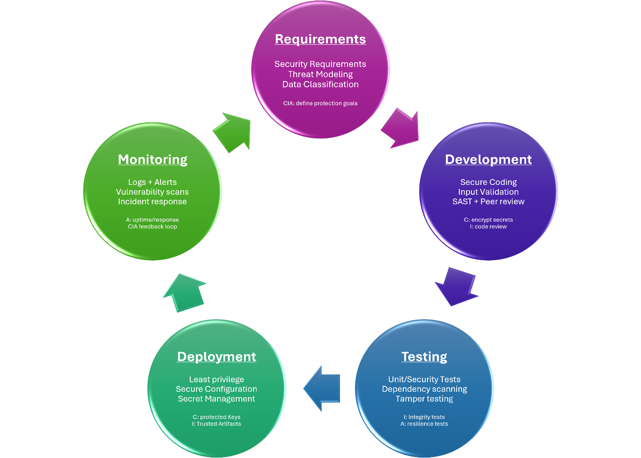
Figure 1: DevSecOps SDLC pipeline with security checkpoints and CIA enforcement.

Security integration summary: Requirements establishes security objectives and threat models; Development applies secure coding, input validation, source review, and static analysis; Testing automates functional and security checks; Deployment enforces least privilege, secure configuration, and protected secret handling; Monitoring uses logging, alerts, vulnerability scanning, and incident response to create a continuous feedback loop. Confidentiality is primarily enforced through access control and encryption, integrity through reviews, hashes, testing, and trusted artifacts, and availability through resilient testing, monitoring, recovery, and operational response.

- Task 2: Secure Data Storage

- Develop a Python script that takes user input and securely stores it in a file using users.json.
- Implement encryption mechanisms for sensitive data (e.g., passwords or tokens).
- Compute and store a data integrity value (hash) for each record in users.json.
- Implement functionality to verify data integrity when reading from users.json.

Deliverable: Python script implementing secure storage and integrity verification using users.json.
Add enough screenshots to demonstrate each subtask of Task 2

Screenshot for 2.a
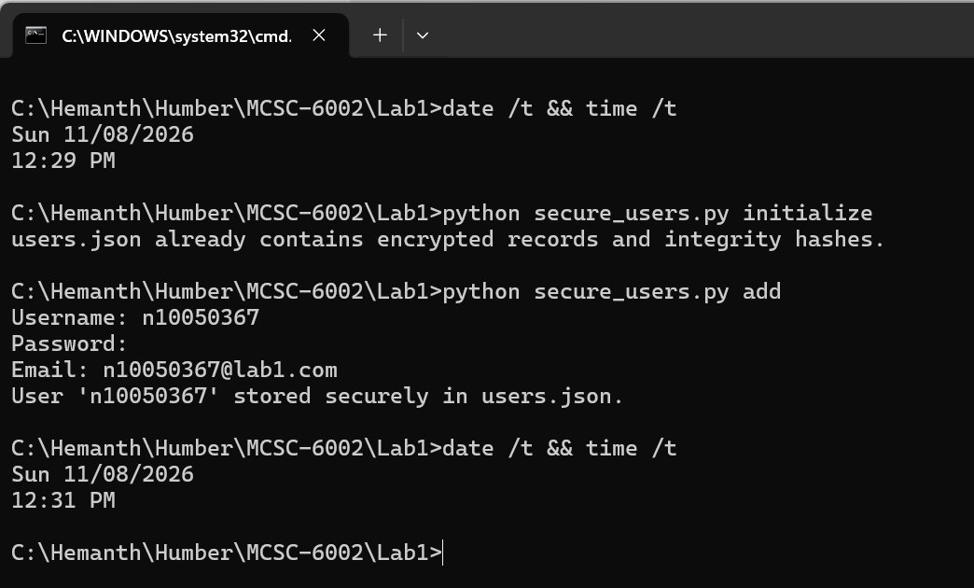
Figure 2. Task 2.a - user input is validated and stored through the secure script.

Screenshot for 2.b
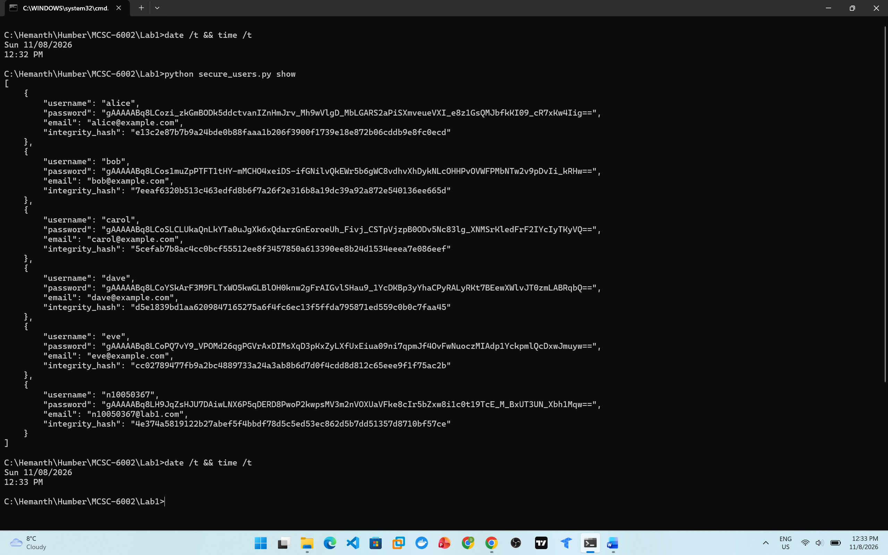
Figure 3. Task 2.b - password value is stored as Fernet ciphertext.

Screenshot for 2.c
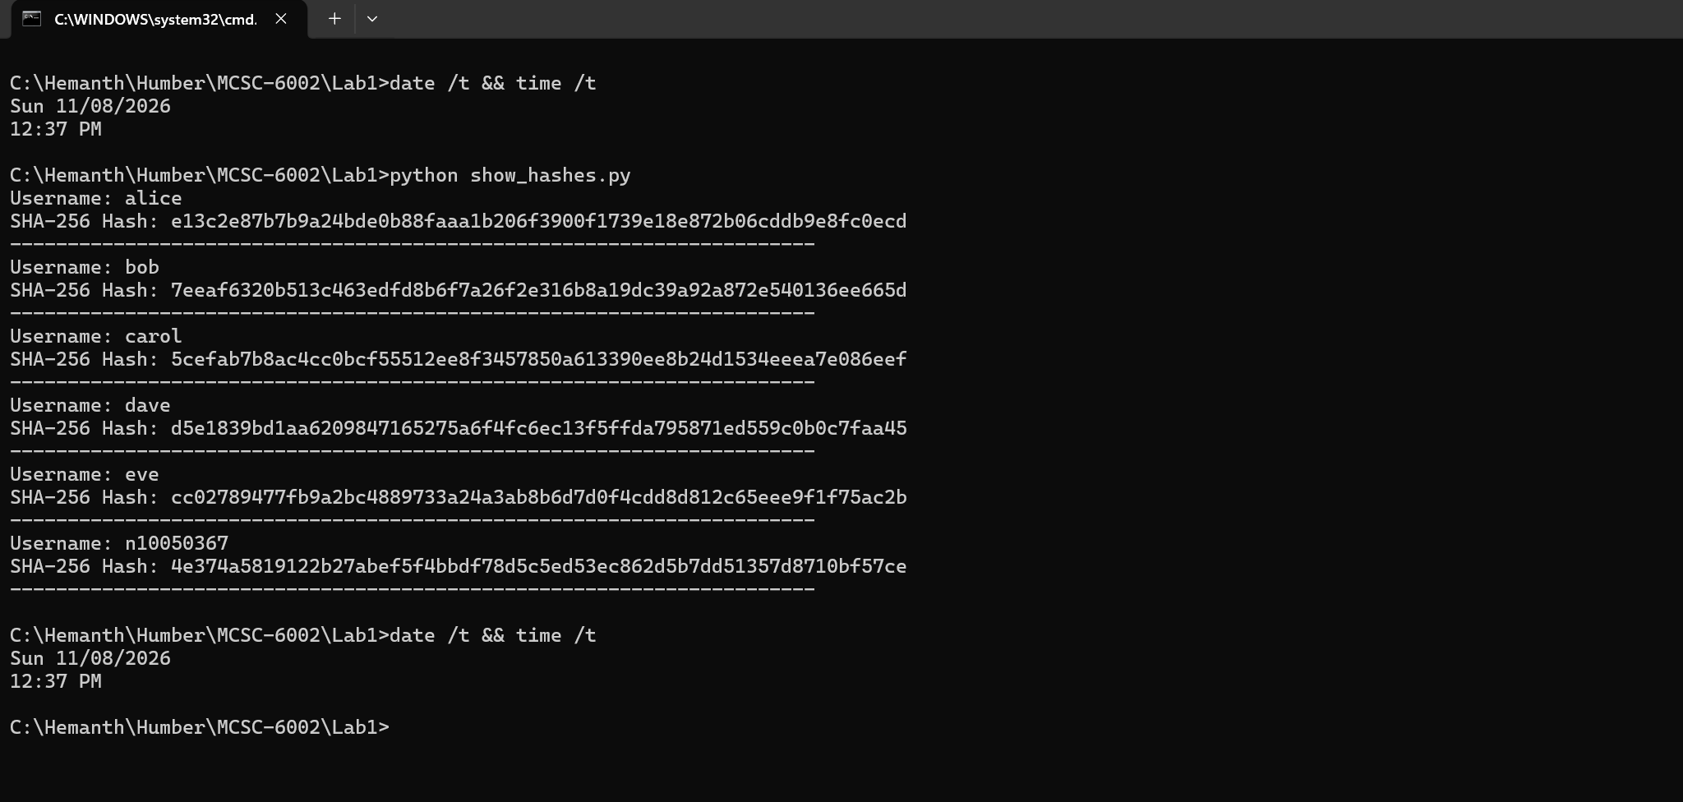
Figure 4. Task 2.c - each record contains a SHA-256 integrity hash.

Screenshot for 2.d
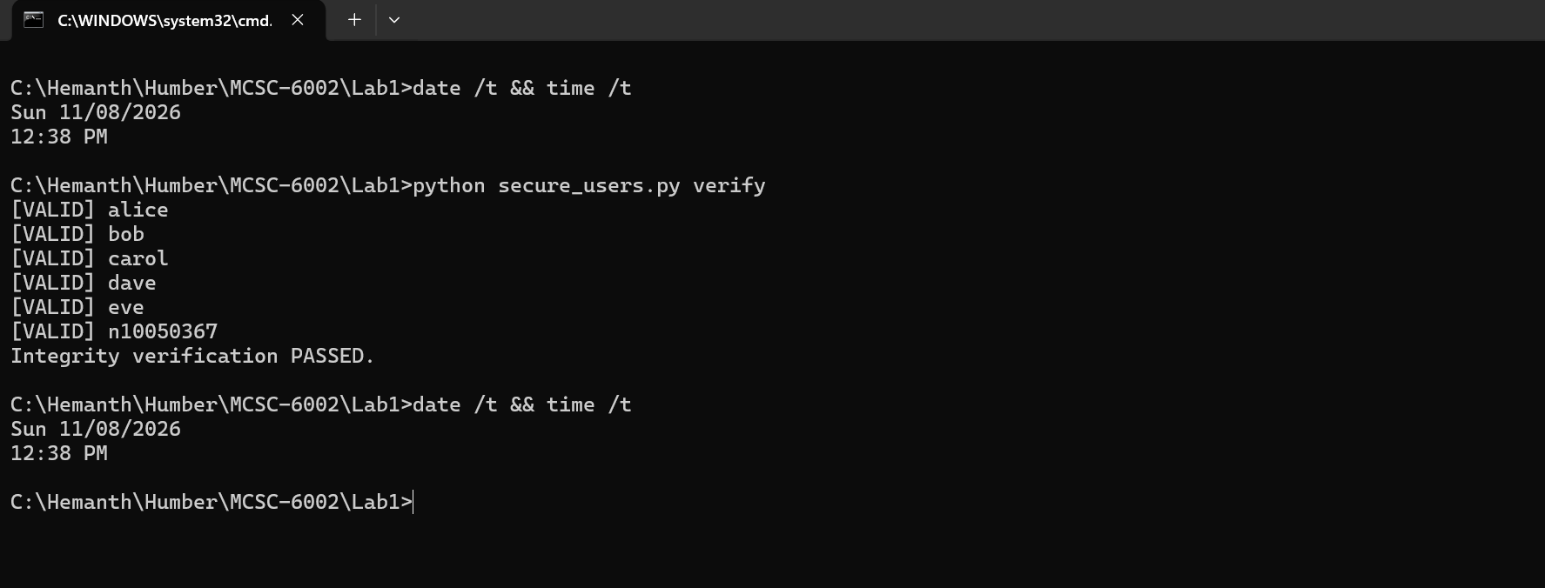
Figure 5. Task 2.d - clean secure records pass integrity verification.

- Task 3: Threat Analysis

Examine your pipeline diagram and Python script. Identify at least three potential security risks, such as weak encryption, insufficient input validation, or file tampering.
Write a brief report (1–2 pages) describing:
  - Each identified risk
  - Suggested mitigation strategies

Deliverable: Threat analysis report outlining security risks and mitigations.

Threat Analysis Report

1. Encryption Key Exposure
Risk: The Python program uses Fernet symmetric encryption, so confidentiality depends on protecting lab1.key. If an attacker obtains both users.json and the key file, the encrypted passwords can be decrypted. Storing the key in the same directory is acceptable for a controlled lab demonstration but is not sufficient for production systems.
Mitigation: keep encryption keys separate from application data, restrict file permissions, avoid committing keys to source control, rotate keys when exposure is suspected, and use an operating-system secret store, environment-backed secret manager, or enterprise key-management service in a real deployment.

2. Insufficient or Malicious Input
Risk: User-supplied usernames, passwords, and email addresses are untrusted input. Without validation, malformed values can break assumptions, create duplicate identities, or become dangerous when reused in other contexts.
Mitigation: the script applies an allow-list pattern to usernames, a minimum password length, basic email validation, and duplicate-username checking. A production system should add context-specific validation, stronger password policy controls, length limits, normalization rules, and automated tests for boundary and malicious inputs.

3. File Tampering and Hash Recalculation
Risk: Unauthorized edits to users.json can alter credentials or other user attributes. The lab stores a SHA-256 fingerprint for each record, which detects accidental or unsophisticated modification when compared with the trusted baseline. However, SHA-256 alone is not keyed; an attacker who can modify both the data and stored hash could recompute the hash.
Mitigation: protect the data file with least-privilege file permissions and auditing. For stronger adversarial integrity, use HMAC-SHA-256 with a secret key stored separately, or digitally sign records so an attacker cannot generate a valid integrity value without the signing secret.

4. Availability and File Corruption
Risk: Missing files, invalid JSON, a lost encryption key, or interrupted writes can make the application unavailable.
Mitigation: the script validates JSON structure, reports errors instead of silently failing, writes updates through a temporary file followed by an atomic replace, and preserves a lab backup during initialization. Production systems should also maintain tested backups, monitoring, recovery procedures, and controlled key backup/escrow appropriate to the environment.

Conclusion
The solution applies defense in depth across confidentiality, integrity, and availability. Fernet encryption protects sensitive password values at rest; SHA-256 record fingerprints support integrity verification; input validation reduces malformed-data risks; and controlled error handling plus backup/atomic-write behavior improves availability. The tampered dataset demonstrates that the integrity mechanism identifies the modified Bob record. The most important production improvement would be authenticated integrity (HMAC or digital signatures) combined with managed key storage and strict access controls.

- Task 4: Data Integrity Verification

- Extend your Python script to detect modifications in stored data.
- Use the users_tampered.json file to simulate a tampered dataset.
- Demonstrate that your integrity verification function detects the tampered record(s).

Deliverable: Demonstration of data integrity verification, detecting tampering in users_tampered.json (add enough screenshots).

Screenshot for 4.a
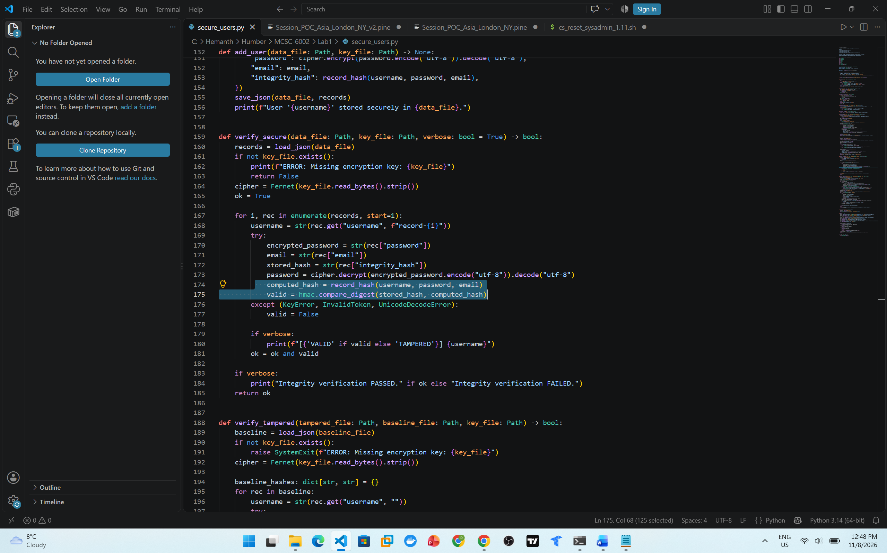
Figure 6. Task 4.a - verification recomputes and compares record integrity values.

Screenshot for 4.b
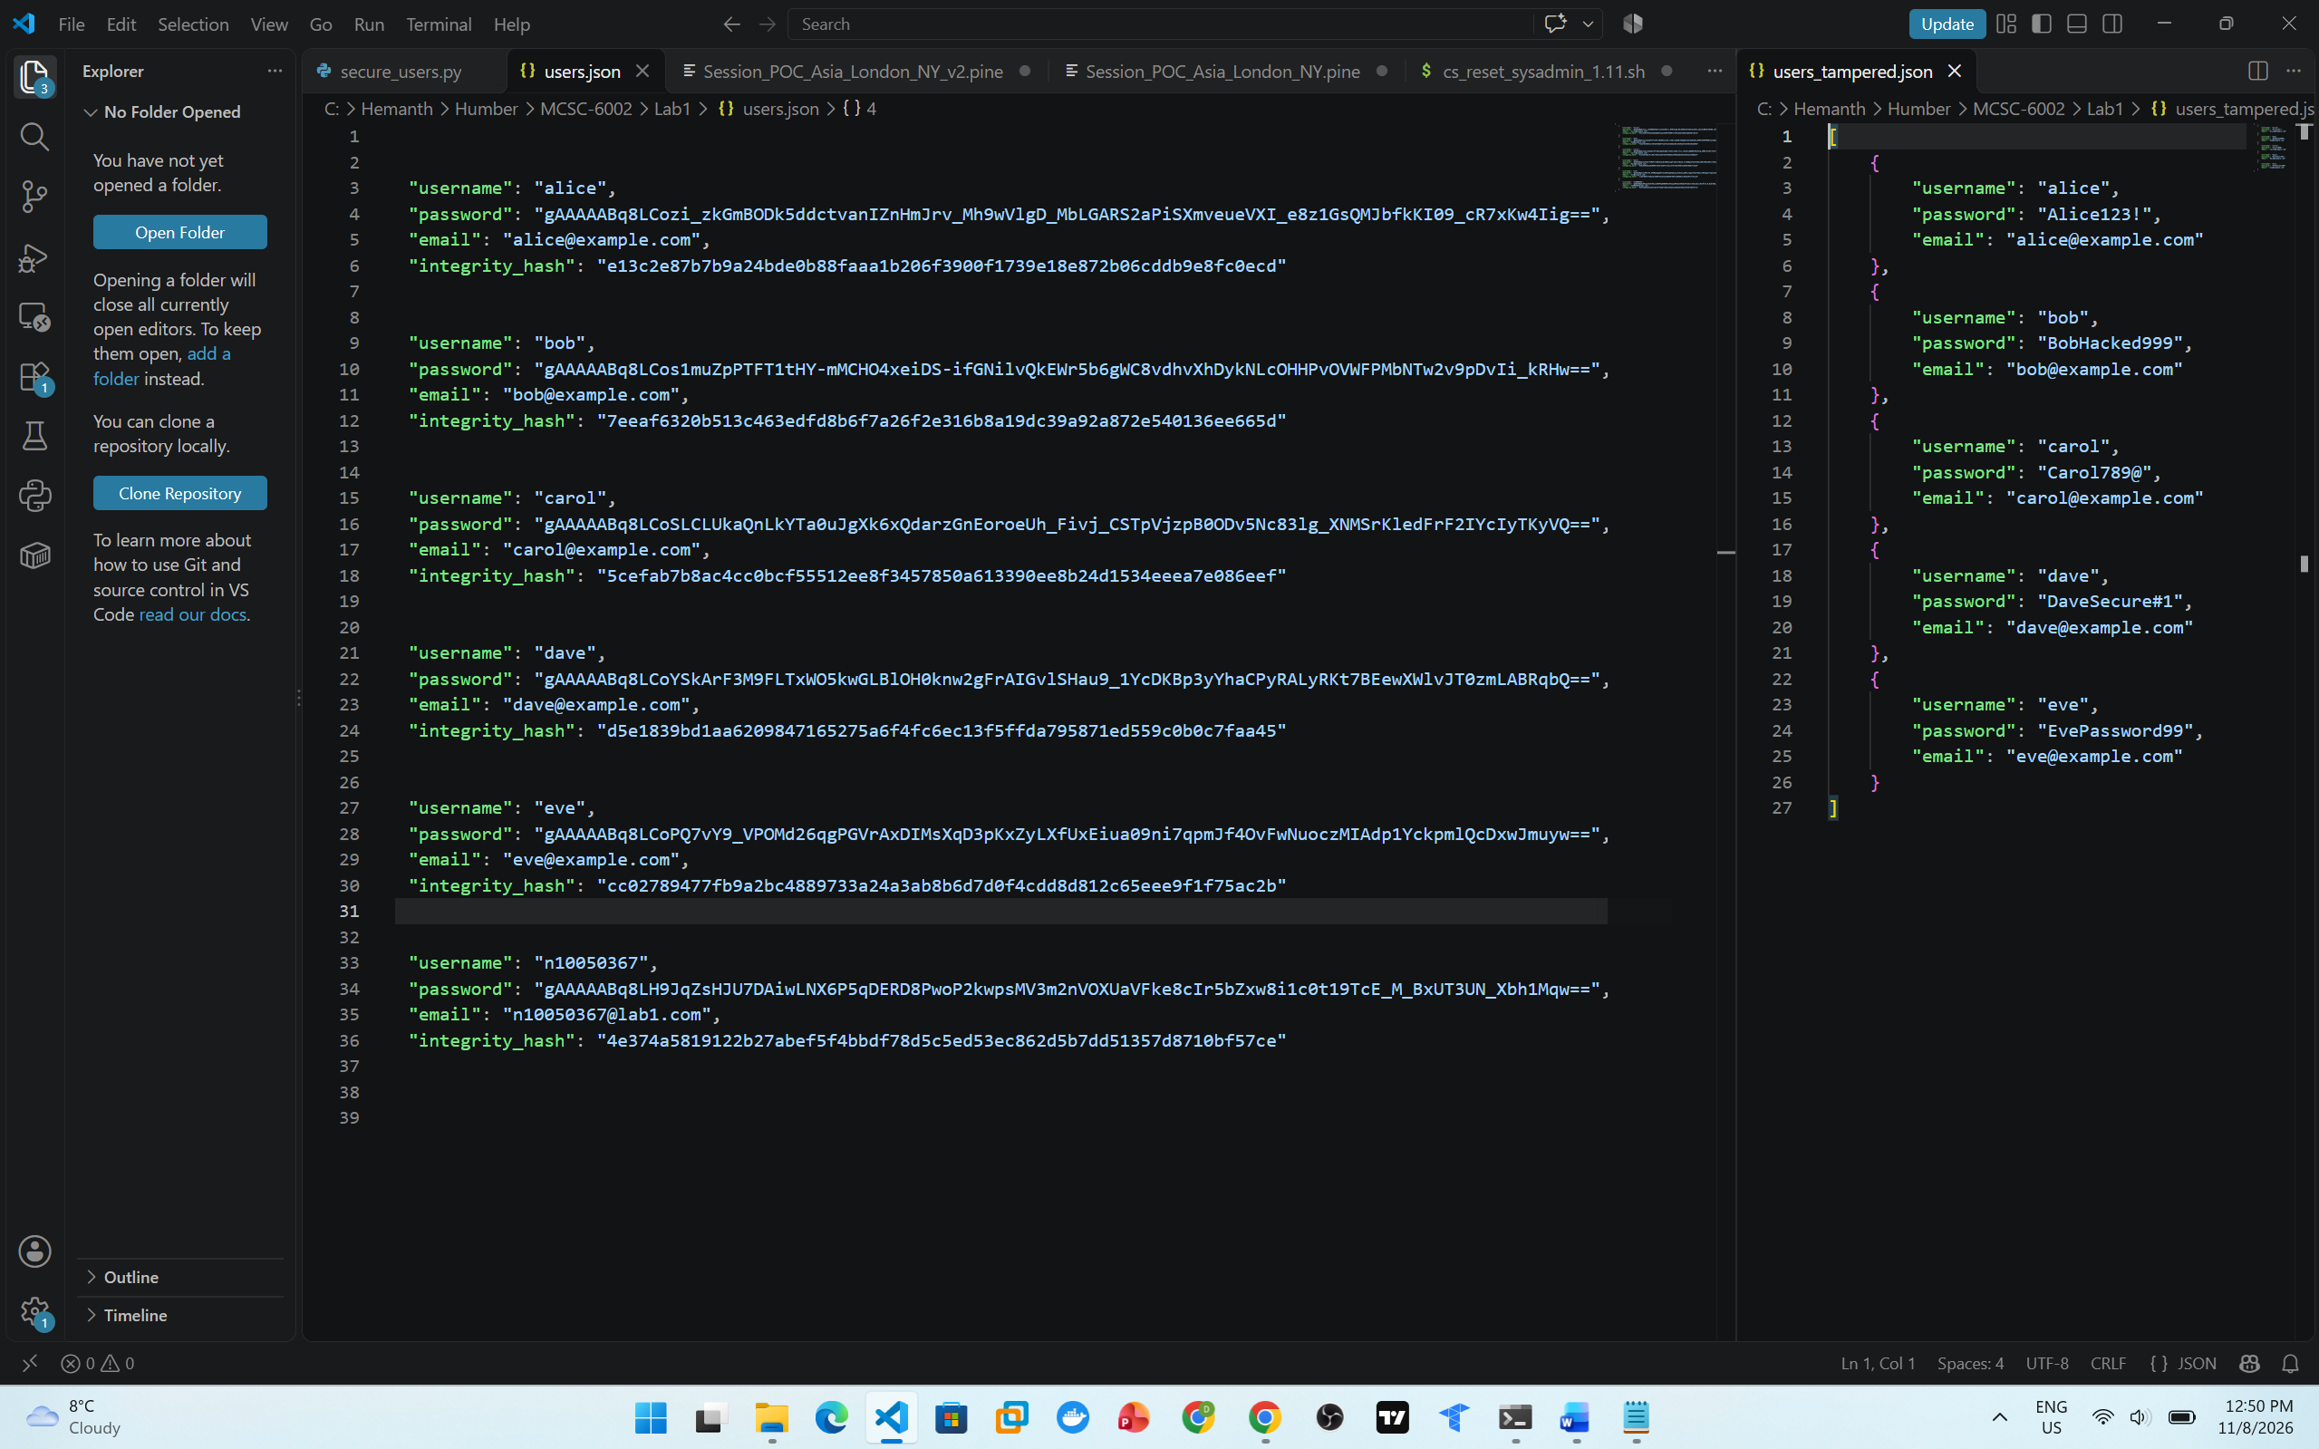
Figure 7. Task 4.b - the supplied tampered dataset changes Bob's password.

Screenshot for 4.c
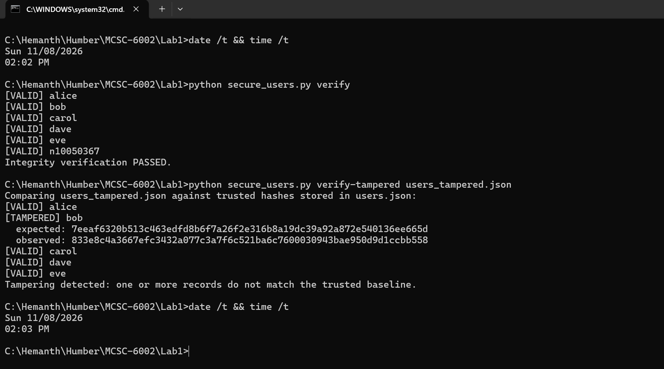
Figure 8. Task 4.c - the program detects Bob as tampered while the other records remain valid.
Deliverables
- The completed version of this file
- Python scripts implementing secure data storage and integrity verification for users.json.

Appendix A - Step-by-Step Reproduction Guide
- Create a folder named Lab1 and place
users.json
users_tampered.json
secure_users.py
show_hashes.py
2. Open a terminal in that folder and confirm Python is installed with:
python --version
3. Install the encryption library with:
python -m pip install cryptography
python -m pip show cryptography
4. Initialize the dataset with:
python secure_users.py initialize
This creates
lab1.key & users_original_backup.json
encrypts every password in users.json, and adds integrity_hash to each record.
5. Open users.json in VS Code and confirm password values start with Fernet ciphertext rather than the original plaintext. Confirm every record also has integrity_hash.
6. Add a user with:
python secure_users.py add
Enter a valid username, password of at least 8 characters, and email address. The password prompt is hidden by getpass.
7. Display the secured dataset with:
python secure_users.py show
python show_hashes.py
8. Verify the clean file with:
python secure_users.py verify
Every record should show [VALID] followed by “Integrity verification PASSED.”
9. Keep users_tampered.json unchanged.
Run: python secure_users.py verify-tampered users_tampered.json
The program should show [TAMPERED] bob and display different expected and observed hashes.

Expected Verification Results
Clean users.json: alice, bob, carol, dave, and eve (plus any user you add) should report VALID. Supplied users_tampered.json: bob should report TAMPERED because the supplied password differs from the trusted baseline; alice, carol, dave, and eve should remain VALID.

