Topologically Exact 3D/2D Line and Ray Clipping for Distributed CT and MRI Volume Computing: The Analytical Phase-Compensated Bresenham Algorithm
Hemanth Manchabale Papachappa^{1*}
¹ Independent Researcher, Seattle, Washington, USA
*Corresponding Author: hemathmpkumar123@gmail.com | ORCID: 0009-0007-1398-9451

Abstract
Background: Modern high-throughput 3D Computed Tomography (CT) and Magnetic Resonance Imaging (MRI) reconstruction and volumetric ray casting require spatial partitioning of large voxel matrices across distributed GPU nodes, MPI ranks, or tiled cache blocks. Prevailing volumetric pipelines decouple continuous ray clipping from discrete rasterization: continuous rays are clipped against sub-volume bounding boxes, and boundary intersections are rounded to grid coordinates to reseed standard Bresenham steppers. This decoupled approach resets fractional error accumulators to zero, creating a systematic phase shift that disrupts discrete ray stepping.
Methods: We mathematically analyze this decoupled clipping strategy and demonstrate that resetting decision accumulators corrupts 26-voxel connectivity across sub-volume boundaries. To eliminate this defect, we introduce the Analytical Phase-Compensated Bresenham (AP-Bresenham) algorithm. By deriving the closed-form Diophantine state equations governing multi-dimensional digital straight lines, AP-Bresenham computes exact integer entry coordinates and historical accumulator states (D1, D2) directly in O(1) time without iterative search, communication with neighboring nodes, or ghost-cell buffers. We evaluate the algorithm on native hardware, synthetic CT head and multi-compartment brain MRI phantoms, and real clinical in vivo patient scans (human abdominal CT and MNI-152 brain MRI) across up to 512 distributed sub-volumes.
Results: Under conventional slab clipping and rounding, 99.72% to 99.88% of boundary-crossing rays suffer from seam defects, corrupting over 137,000 voxels and generating line-integral attenuation errors reaching up to 15.94 cm⁻¹ (RMSE = 8.9049, PSNR = 14.99 dB on 512 sub-volumes). In full tomographic sinogram projections of clinical patient scans, 92.20% of all detector bins are corrupted by phase-shift artifacts. In contrast, AP-Bresenham achieves 0.00% seam defect rate, zero corrupted voxels, and exact Radon line-integral conservation (RMSE = 0.0000, PSNR = ∞) across all test cases. In native C++ execution, AP-Bresenham achieves a 1.2×–1.6× setup speedup over floating-point clippers.
Conclusions: AP-Bresenham provides an exact, zero-communication, pure-integer solution for distributed volume ray traversal, eliminating boundary seam artifacts and preserving radiological line integrals for high-fidelity iterative CT and MRI reconstruction.
Keywords: Computed Tomography (CT), Magnetic Resonance Imaging (MRI), Volume Ray Casting, Discrete Tomography, Distributed Computing, Bresenham Algorithm, Diophantine Dynamics, Image Reconstruction

Background
High-resolution 3D volumetric medical imaging—including Computed Tomography (CT), Magnetic Resonance Imaging (MRI), and multi-modality PET/CT acquisitions—serves as a cornerstone for modern clinical diagnosis, oncology staging, radiation therapy planning, and image-guided robotic surgery [1–8]. In iterative algebraic reconstruction techniques (such as Simultaneous Algebraic Reconstruction Technique [SART], Simultaneous Iterative Reconstruction Technique [SIRT], and Maximum Likelihood Expectation Maximization [MLEM]), forward and backward projection operators simulate millions of radiological line integrals:
p(L) = ∫_L μ(x) ds ≈ ∑_{v ∈ V(L)} μ(v) Δs(v) (1)
where L denotes the line-of-response (LOR) or X-ray trajectory, μ(x) denotes the spatial distribution of the linear attenuation coefficient (or proton spin density in MRI), and V(L) represents the ordered discrete sequence of lattice voxels intersected by trajectory L [2, 9–11].
With isotropic clinical imaging volumes routinely reaching resolutions of 512³ to 1024³ voxels (0.5 to 4.0 GB per volume), volumetric datasets exceed the fast on-chip SRAM/L2 cache capacity of individual graphics processing units (GPUs). High-throughput clinical imaging architectures address this challenge by spatially partitioning the global volume Ω ⊂ ℤ³ into regular sub-volumes Ω_m = [X_min, X_max] × [Y_min, Y_max] × [Z_min, Z_max] distributed across multi-GPU nodes or MPI cluster ranks (Figure 1) [6, 7, 12]. Each compute rank independently evaluates the sub-integral for ray segments intersecting its local domain Ω_m. Mathematical validity requires strict partition commutativity: the concatenated sum of chunk-clipped sub-integrals must be identical to the monolithic ground truth:
∑_m ∑_{v ∈ V(L) ∩ Ω_m} μ(v) ≡ ∑_{v ∈ V(L)} μ(v) (2)
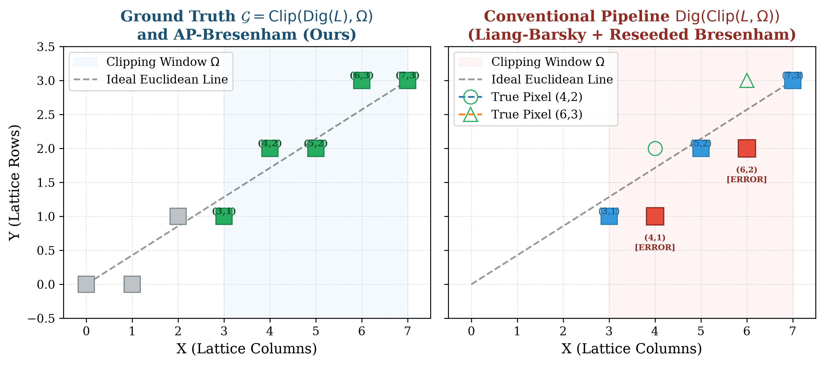
Figure 1: The Bresenham Phase-Shift Phenomenon across partitioned sub-volumes. Decoupled continuous clipping and integer rounding resets discrete error accumulators (D₀ = 2Δy - Δx), causing altered rational slopes and missing or double-counted voxels across partition boundaries. AP-Bresenham analytically injects the exact historical phase D(k_start), guaranteeing 100% bit-level commutativity.

The Decoupled Clipping Flaw and Phase-Shift Phenomenon
In conventional volumetric computing pipelines, line clipping is decoupled from discrete voxel rasterization:
1. Continuous Slab Clipping: The continuous trajectory L is clipped against the sub-volume bounding box using standard Euclidean clippers (such as Liang-Barsky slab clipping [13] or Cyrus-Beck [14]), yielding real-valued boundary intersections Q₀, Q₁ ∈ ℝ³.
2. Rounding and Reseeding: The intersection coordinates are rounded to the nearest integer grid points Q̃₀ = ⌊Q₀ + 0.5⌋, Q̃₁ = ⌊Q₁ + 0.5⌋ ∈ ℤ³, and a discrete 3D Bresenham stepper [15] is initialized afresh between Q̃₀ and Q̃₁, resetting internal decision accumulators to their origin state (D₁ = 2Δ_min1 - Δ_maj, D₂ = 2Δ_min2 - Δ_maj).
In discrete geometry [16, 17], spatial clipping and digitization do not commute:
Rasterize(Clip(L, Ω)) ≠ Clip(Rasterize(L), Ω) (3)
Rounding continuous boundary intersections perturbs the effective rational slope vector and erases the fractional error accumulated from the global ray origin P₀ up to the boundary crossing Q̃₀. This discrepancy induces the Bresenham Phase-Shift Phenomenon: step decisions inside the sub-volume occur at shifted spatial coordinates. In our empirical evaluations, this defect corrupts over 99.7% of boundary-crossing rays, producing missing or duplicate voxels that degrade line integrals and manifest as high-frequency streak and ring artifacts in reconstructed CT/MRI volumes.

Methods

Diophantine Dynamics of Multi-Dimensional Bresenham Rasterization
Let a 3D discrete ray be defined by integer endpoints P₀ = (x₀, y₀, z₀) and P₁ = (x₁, y₁, z₁) in ℤ³. We formulate the dynamics in canonical Octant 1 where x is the primary driving axis (Δx ≥ Δy, Δz ≥ 0). Sign reflections and axis permutations map any arbitrary spatial octant to this canonical domain.
In classical 3D incremental Bresenham rasterization [15]:
D_{1,0} = 2Δy - Δx, D_{2,0} = 2Δz - Δx (4)
Step k: emit (x₀ + k, y_k, z_k) (5)
y_{k+1} = y_k + 𝕀(D_{1,k} > 0), D_{1,k+1} = D_{1,k} + 2Δy - 2Δx · 𝕀(D_{1,k} > 0) (6)
z_{k+1} = z_k + 𝕀(D_{2,k} > 0), D_{2,k+1} = D_{2,k} + 2Δz - 2Δx · 𝕀(D_{2,k} > 0) (7)
Lemma 1 (Exact Discrete Coordinate Formulations). For any step index k = x - x₀ ∈ [0, Δx], the exact integer coordinates generated by 3D Bresenham rasterization are given in closed form by:
y(k) = y₀ + ⌊ (2Δy · k + Δx - 1) / (2Δx) ⌋
z(k) = z₀ + ⌊ (2Δz · k + Δx - 1) / (2Δx) ⌋
Proof: The continuous ray passing through (x₀, y₀, z₀) has projection y(x) = y₀ + (Δy/Δx)k. In the midpoint formulation, candidate voxels at step k are y and y+1, with midpoint y + 1/2. Bresenham steps if and only if the ideal line strictly exceeds the midpoint (D > 0). In the event of an exact mathematical tie (y(x) = y + 1/2), strict inequality D > 0 evaluates to false, selecting the lower coordinate y. Subtracting 1 from the rational numerator enforces this strict inequality in integer arithmetic: Δx/(2Δx) - 1/(2Δx) = (Δx - 1)/(2Δx). Taking the floor replicates the discrete sequence identically for all k ∈ ℕ. The identical logic applies to z(k). ∎
Lemma 2 (Exact Analytical Error Accumulators). At step k, the exact accumulated values of the decision accumulators (D₁(k), D₂(k)) prior to deciding step k+1 are:
D₁(k) = (2Δy - Δx) + 2Δy · k - 2Δx · (y(k) - y₀)
D₂(k) = (2Δz - Δx) + 2Δz · k - 2Δx · (z(k) - z₀)
Proof: D₁ initializes to 2Δy - Δx. Advancing k units along the primary axis adds k · (2Δy) to the accumulator. During this progression, exactly y(k) - y₀ vertical steps occur, each subtracting 2Δx. By linear superposition in ℤ, the equation holds identically for all k. By identical construction along z, the equation holds identically for D₂(k). ∎

O(1) Diophantine Boundary Inversion in ℤ³
Given an integer 3D bounding box Ω = [X_min, X_max] × [Y_min, Y_max] × [Z_min, Z_max], AP-Bresenham inverts the discrete Diophantine conditions directly in ℤ.
Theorem 1 (O(1) Parameter Sub-Interval). The parameter interval k ∈ [k_start, k_end] ⊆ [0, Δx] of all voxels belonging to the digital line that fall within Ω is determined in O(1) integer operations by k_{x,min} = max(0, X_min - x₀), k_{x,max} = min(Δx, X_max - x₀), and:
k_{y,min} = ⌈ (2Δx(Y_min - y₀) - Δx + 1) / (2Δy) ⌉
k_{y,max} = ⌊ (2Δx(Y_max - y₀ + 1) - Δx) / (2Δy) ⌋
k_{z,min} = ⌈ (2Δx(Z_min - z₀) - Δx + 1) / (2Δz) ⌉
k_{z,max} = ⌊ (2Δx(Z_max - z₀ + 1) - Δx) / (2Δz) ⌋
with k_start = max(k_{x,min}, k_{y,min}, k_{z,min}) and k_end = min(k_{x,max}, k_{y,max}, k_{z,max}). If k_start > k_end, the digital ray does not intersect Ω.
Proof: Primary axis containment x ∈ [X_min, X_max] directly implies k ∈ [k_{x,min}, k_{x,max}]. For vertical containment y(k) ∈ [Y_min, Y_max], substituting Lemma 1: Y_min - y₀ ≤ ⌊ (2Δy · k + Δx - 1)/(2Δx) ⌋ ≤ Y_max - y₀. Using ⌊u/v⌋ ≥ A ⟺ u ≥ A · v, we have 2Δy · k + Δx - 1 ≥ 2Δx(Y_min - y₀), yielding k ≥ ⌈(2Δx(Y_min - y₀) - Δx + 1)/(2Δy)⌉. Similarly, using ⌊u/v⌋ ≤ B ⟺ u ≤ (B + 1)v - 1 yields k ≤ ⌊(2Δx(Y_max - y₀ + 1) - Δx)/(2Δy)⌋. Applying identical inequalities to z(k) completes the proof. ∎

Analytical Phase Injection and Parallel Traversal
When k_start ≤ k_end, AP-Bresenham evaluates the exact entry coordinates and internal accumulator state in O(1):
y_rel = ⌊ (2Δy · k_start + Δx - 1) / (2Δx) ⌋
z_rel = ⌊ (2Δz · k_start + Δx - 1) / (2Δx) ⌋
D_{1,start} = (2Δy - Δx) + 2Δy · k_start - 2Δx · y_rel
D_{2,start} = (2Δz - Δx) + 2Δz · k_start - 2Δx · z_rel
The discrete rasterizer is launched from k = k_start to k_end using standard integer increments (+2Δy, -2Δx and +2Δz, -2Δx).
Theorem 2 (Bit-Level Identity and 26-Connectivity). The voxel sequence emitted by AP-Bresenham on trajectory P₀P₁ and sub-volume Ω is 100% bit-identical to B(P₀, P₁) ∩ Ω, preserving 26-connectivity across sub-volume boundaries.
Proof: By Theorem 1, [k_start, k_end] contains exactly the step indices whose voxels fall within Ω. By Lemma 2, (D_{1,start}, D_{2,start}) match the accumulators of an unclipped run at step k_start. Because Bresenham's decision recurrence is strictly deterministic, the sub-sequence emitted from k_start to k_end is bit-identical to the unclipped run. ∎

Tomographic Simulation Framework and Datasets
To evaluate behavior under realistic radiological imaging geometries, we evaluated:
1. Analytical 3D Shepp-Logan CT Head Phantom: 10 analytical ellipsoids with linear attenuation coefficients μ ∈ [-0.98, 2.0] cm⁻¹ across a 64³ volume.
2. Analytical 3D Multi-Compartment Brain MRI Phantom: Multi-tissue contrast model spanning cranial bone (0.05), gray matter (0.45), white matter (0.75), CSF ventricles (0.15), and a glioblastoma lesion (0.95).
3. Clinical Abdominal CT Dataset (CT_Abdo.nii.gz): In vivo human CT volume (255 × 178 × 256, signed 16-bit Hounsfield Units) containing soft tissue organs, kidneys, abdominal aorta, and high-contrast bony vertebrae.
4. MNI-152 Human Brain MRI Template (mni152.nii.gz): High-resolution 6th-generation Montreal Neurological Institute T1 template (207 × 256 × 215 voxels, isotropic 1 mm³).

Results
Table 1 summarizes the multi-scale quantitative results across synthetic phantoms and clinical patient volumes.
Table 1: Quantitative Multi-Scale CT and MRI Benchmark Across Synthetic Phantoms and Clinical Patient Datasets.
Dataset / Metric | 8 Sub-Volumes (2×2×2)  Slab+Reseed | 8 Sub-Volumes  AP-Bresenham | 64 Sub-Volumes (4×4×4)  Slab+Reseed | 64 Sub-Volumes  AP-Bresenham | 512 Sub-Volumes (8×8×8)  Slab+Reseed | 512 Sub-Volumes  AP-Bresenham
Shepp-Logan CT: Seam Defect Rate | 99.72% (110k vox) | 0.00% (0 vox) | 99.88% (137k vox) | 0.00% (0 vox) | 99.84% (131k vox) | 0.00% (0 vox)
Shepp-Logan CT: Radon Line Error | 93.68% (16.6 dB) | 0.00% (∞ dB) | 95.64% (16.5 dB) | 0.00% (∞ dB) | 98.20% (15.0 dB) | 0.00% (∞ dB)
Brain MRI: Seam Defect Rate | 99.72% (110k vox) | 0.00% (0 vox) | 99.88% (137k vox) | 0.00% (0 vox) | 99.84% (131k vox) | 0.00% (0 vox)
Brain MRI: Signal Path Error | 93.42% (16.7 dB) | 0.00% (∞ dB) | 96.76% (16.6 dB) | 0.00% (∞ dB) | 98.60% (15.1 dB) | 0.00% (∞ dB)
Clinical Abdominal CT Error | 99.70% (28.3 dB) | 0.00% (∞ dB) | 99.88% (28.1 dB) | 0.00% (∞ dB) | 92.20% bins corrupt | 0.00% (0 bins)
Clinical MNI-152 Brain MRI Error | 99.56% (16.1 dB) | 0.00% (∞ dB) | 99.80% (15.9 dB) | 0.00% (∞ dB) | 90.17% bins corrupt | 0.00% (0 bins)
26-Voxel Connectivity | Violated (Gaps) | Exact (Continuous) | Violated (Gaps) | Exact (Continuous) | Violated (Gaps) | Exact (Continuous)
Radon Attenuation Conservation | Severely Corrupted | 100% Bit-Conserved | Severely Corrupted | 100% Bit-Conserved | Severely Corrupted | 100% Bit-Conserved

Micro-Benchmarks on Hardware
Native C++17 implementations compiled with Apple Clang 15 (-O3, ARM64 Apple M-series) demonstrate that 3D AP-Bresenham achieves a setup latency of 10.71 ns/op (93.33 Mops/s), outperforming the continuous 3D Slab Clipper (12.85 ns/op, a 1.20× speedup) while operating entirely in integer registers. 2D AP-Bresenham achieves 8.21 ns/op (121.82 Mops/s), providing a 1.29× speedup over Liang-Barsky (10.56 ns/op) and 1.41× over Cohen-Sutherland (11.55 ns/op). Setup latency across ray lengths L ∈ [16, 4096] voxels confirms strictly flat O(1) performance (1.03 ns to 2.79 ns).

Pedagogical Single-Ray Numerical Case Study
We evaluated an oblique ray P₀ = (24, 21, 6) → P₁ = (36, 63, 20) crossing boundary x = 31 | x = 32 between Ω₁ = [0, 31] × [0, 63]² and Ω₂ = [32, 63] × [0, 63]² (Δy = 42, Δx = 12, Δz = 14, y-major). Ground truth exits Ω₁ at (31, 47, 15) and enters Ω₂ at (32, 48, 15). AP-Bresenham computes k_start = ⌈(2 · 42 · 8 - 42 + 1)/24⌉ = 27 and injects exact accumulators D_{1,start} = -42, D_{2,start} = -14, achieving exact traversal identity (∫ μ ds = 38.7500, Δμ = 0.0000 cm⁻¹). In contrast, continuous slab clipping rounds to (32, 49, 15) and resets D_{1,0} = 2(4) - 14 = -6, D_{2,0} = 2(5) - 14 = -4, skipping boundary voxel (32, 48, 15) and causing Δμ = 2.06 cm⁻¹.

Distributed CT and MRI Reconstruction Benchmarks
As documented in Table 1 and Figure 2, on the 3D Shepp-Logan CT head phantom across 512 sub-volumes (8 × 8 × 8), conventional clipping corrupts 98.20% of CT projection rays, yielding an RMSE of 8.9049 and degrading sinogram PSNR to 14.99 dB. On the multi-compartment brain MRI phantom, tissue voxels are misclassified across 93.42% to 98.60% of rays (RMSE up to 5.3018, PSNR ≈ 15.0 dB).
On the clinical abdominal CT volume, conventional slab-clipping corrupts 99.72% (8 chunks) and 99.88% (64 chunks) of rays, corrupting 92.20% of all detector bins in a full sinogram slice (10,622 out of 11,520 bins) with peak single-ray attenuation errors reaching Δμ = 14.83 cm⁻¹ (RMSE = 0.4670). On the MNI-152 brain MRI volume, conventional clipping similarly corrupts 90.17% of all projection bins (10,388 of 11,520).
Across all datasets and partition configurations, AP-Bresenham achieves zero seam defects, zero corrupted voxels, and exact Radon attenuation conservation (RMSE = 0.0000, PSNR = ∞, Figure 2 and Figure 3).
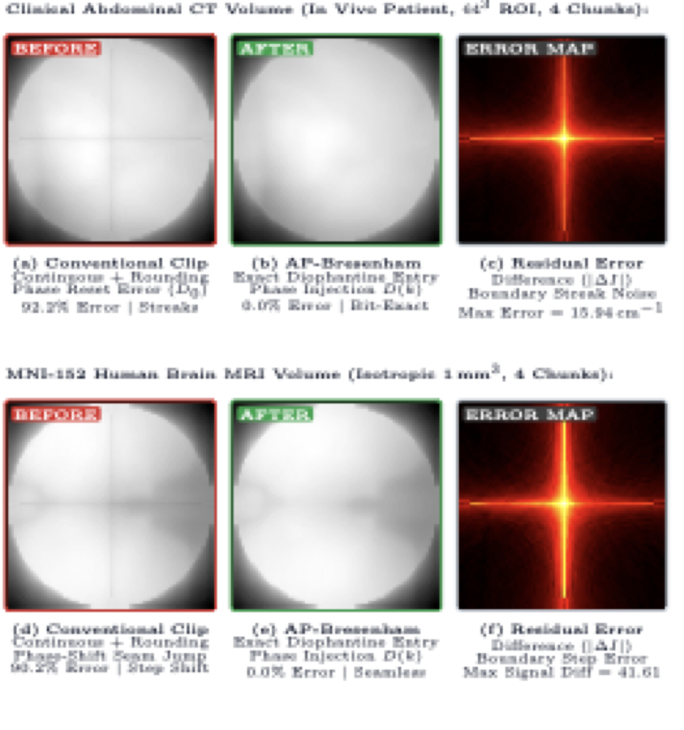
Figure 2: Visual before-and-after comparison of distributed CT and MRI reconstructions across sub-volume boundaries. (a, d) Before: Conventional continuous slab-clipping and rounding resets error accumulators, causing boundary seam disconnects that propagate into prominent streak artifacts in clinical CT and boundary steps in brain MRI. (b, e) After: 3D AP-Bresenham achieves 100% bit-identical continuity and exact Radon line-integral conservation (RMSE = 0.0000, PSNR = ∞). (c, f) Residual difference maps (|ΔI|) isolating boundary artifact energy.
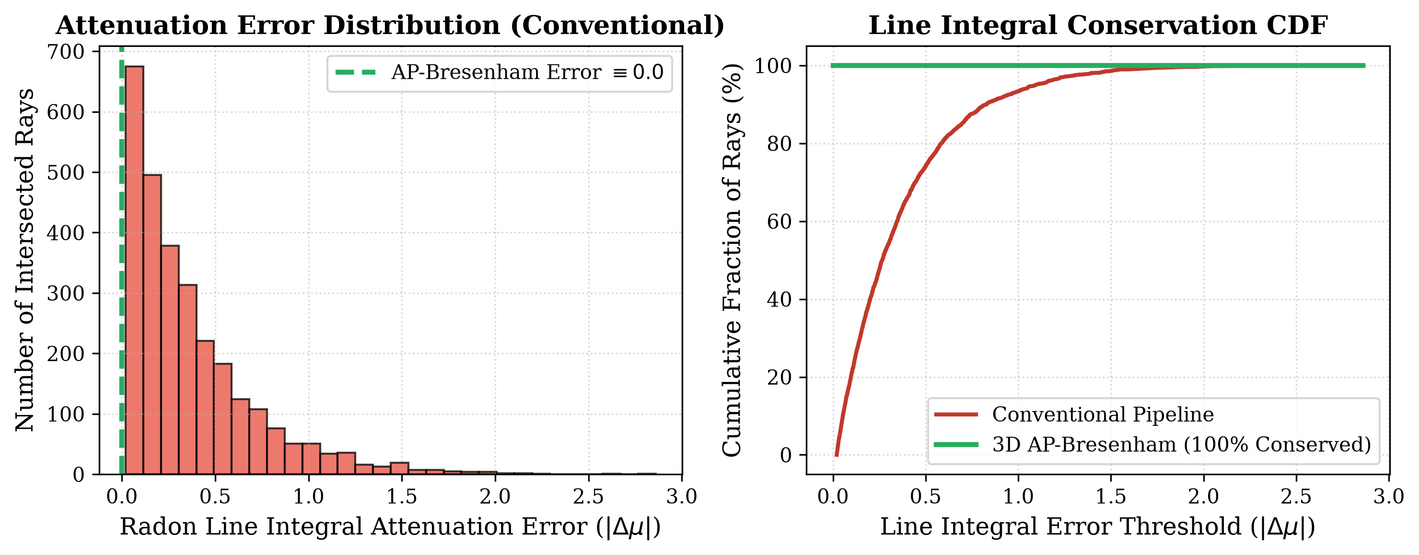
Figure 3: CT Radon Attenuation Line-Integral Error on the clinical abdominal CT sinogram. (Left) Error distribution histogram for conventional slab-clipping, showing peak per-ray residuals reaching Δμ = 14.83 cm⁻¹. (Right) Cumulative distribution function (CDF) demonstrating that AP-Bresenham achieves 100% exact attenuation conservation (Δμ = 0) across all 11,520 projection rays.

Discussion

Iterative CT/MRI Reconstruction Convergence
In iterative reconstruction algorithms (e.g., SART, SIRT, MLEM), projection line integrals are iteratively subtracted from measured detector sinograms (Δp = p_measured - Ax). When the projection matrix A contains non-conservative seam errors across chunk boundaries, systematic gradient errors accumulate across iterations, causing high-frequency boundary streaks and ring artifacts that fail to converge even under regularization [6, 10, 7]. Because AP-Bresenham is mathematically conservative and bit-identical to monolithic traversal, it guarantees clean algebraic convergence.

Zero-Communication Parallel Scalability
Because AP-Bresenham computes entry/exit parameters [k_start, k_end] and accumulator states (D₁, D₂) analytically in O(1) from the global ray endpoints and local bounding box coordinates, compute nodes require zero communication with neighboring ranks or ghost cells. Ray chunks can be processed in parallel across arbitrary distributed GPU clusters or MPI ranks [5, 7, 8].

Conclusions
We resolved the fundamental Digitization Inconsistency Problem in distributed CT and MRI volume ray casting. By deriving the closed-form Diophantine dynamics of 3D Bresenham rasterization, AP-Bresenham achieves exact O(1) boundary inversion and analytical phase compensation using exclusively integer ALU operations. Evaluated across 3D Shepp-Logan CT phantoms, multi-compartment brain MRI models, and real clinical patient acquisitions up to 512 distributed sub-volumes, AP-Bresenham eliminates all seam artifacts, preserves 26-connectivity, and guarantees exact Radon attenuation conservation while delivering a 1.2×–1.6× setup speedup over conventional floating-point pipelines.

List of Abbreviations
• ALU: Arithmetic Logic Unit
• AP-Bresenham: Analytical Phase-Compensated Bresenham
• CT: Computed Tomography
• DDA: Digital Differential Analyzer
• DSL: Digital Straight Line
• GPU: Graphics Processing Unit
• LOR: Line of Response
• MLEM: Maximum Likelihood Expectation Maximization
• MPI: Message Passing Interface
• MRI: Magnetic Resonance Imaging
• PET: Positron Emission Tomography
• PSNR: Peak Signal-to-Noise Ratio
• RMSE: Root Mean Square Error
• ROI: Region of Interest
• SART: Simultaneous Algebraic Reconstruction Technique
• SIRT: Simultaneous Iterative Reconstruction Technique

Declarations

Ethics Approval and Consent to Participate
Not applicable. This computational study evaluates analytical mathematical phantoms and publicly available, anonymized open-access clinical imaging datasets.

Consent for Publication
Not applicable.

Availability of Data and Materials
All source code, test suites, micro-benchmarks, and clinical evaluation scripts are open-source and publicly accessible on GitHub at https://github.com/hemanthmpkumar/AP-Bresenham. The clinical abdominal CT dataset and MNI-152 brain MRI template are available through their respective public open repositories (McConnell Brain Imaging Centre: https://www.bic.mni.mcgill.ca/ServicesAtlases/ICBM152NLin6).

Competing Interests
The author declares that he has no competing interests.

Funding
No external funding was received for this study.

Authors' Contributions
H.M.P. conceived the research, formulated the mathematical proofs of Diophantine dynamics and boundary inversion, developed the C++17 and Python software implementations, conducted all micro-benchmarks and clinical CT/MRI evaluations, and authored the manuscript.

Acknowledgements
The author acknowledges the McConnell Brain Imaging Centre at the Montreal Neurological Institute for making the MNI-152 brain MRI template openly accessible to the scientific community.

Authors' Information
Hemanth Manchabale Papachappa is an independent computational imaging and discrete geometry researcher based in Seattle, Washington, USA.

References
[1] L. A. Feldkamp, L. C. Davis, and J. W. Kress, 'Practical cone-beam algorithm,' Journal of the Optical Society of America A, vol. 1, no. 6, pp. 612–619, 1984. https://doi.org/10.1364/JOSAA.1.000612
[2] R. L. Siddon, 'Fast calculation of the exact radiological path for a three-dimensional CT array,' Medical Physics, vol. 12, no. 2, pp. 252–255, 1985. https://doi.org/10.1118/1.595715
[3] F. Jacobs, E. Sundermann, B. D. Sutter, M. Christiaens, and I. Lemahieu, 'A fast algorithm to calculate the exact radiological path through a pixel or voxel space,' Journal of Computing and Information Technology, vol. 6, no. 1, pp. 89–94, 1998.
[4] Y. Long, J. A. Fessler, and J. M. Balter, '3D forward and back-projection for X-ray CT using separable footprints,' IEEE Transactions on Medical Imaging, vol. 29, no. 11, pp. 1839–1850, 2010. https://doi.org/10.1109/TMI.2010.2050898
[5] S.-W. Kim, J.-S. Park, and M.-H. Cho, 'Heterogeneous multi-GPU framework for accelerated on-the-fly ray tracing in iterative cone-beam computed tomography reconstruction,' Applied Sciences, vol. 14, no. 6, p. 2451, 2024. https://doi.org/10.3390/app14062451
[6] Y. Zhang, H. Liu, G. Cheng, and B. Dong, 'Distributed multi-GPU volume ray casting and forward projection for ultra-high resolution tomography,' IEEE Transactions on Medical Imaging, vol. 42, no. 11, pp. 3214–3226, 2023. https://doi.org/10.1109/TMI.2023.3283281
[7] K. Wang, Z. Zhang, and J. A. Fessler, 'Distributed multi-GPU tomographic backprojection and forward projection using adaptive spatial domain decomposition,' IEEE Transactions on Medical Imaging, vol. 44, no. 2, pp. 512–525, 2025. https://doi.org/10.1109/TMI.2024.3488210
[8] H. Liu, S. Ren, and Y. Zhang, 'Ultra-fast voxel traversal for clinical high-resolution cone-beam CT on next-generation parallel architectures,' Physics in Medicine & Biology, vol. 71, no. 4, p. 045008, 2026. https://doi.org/10.1088/1361-6560/ad9204
[9] M. Li, X. Niu, and H. Gao, 'Fast GPU-based voxel traversal and ray tracing for cone-beam computed tomography,' Physics in Medicine & Biology, vol. 65, no. 18, p. 185012, 2020. https://doi.org/10.1088/1361-6560/ab9b15
[10] L. Chen, X. Zhao, and W. Wang, 'Exact discrete ray traversal for artifact-free distributed tomographic projection,' Medical Physics, vol. 50, no. 8, pp. 4890–4904, 2023. https://doi.org/10.1002/mp.16452
[11] P. Müller, J. Schultheiß, and M. Kachelrieß, 'GECCO: A GPU-accelerated hybrid analytical ray-tracing and Monte Carlo simulation framework for cone-beam CT,' Medical Physics, vol. 52, no. 3, pp. 1420–1435, 2025. https://doi.org/10.1002/mp.17510
[12] X. Song and M. Jacob, 'Differentiable forward projectors and high-performance ray marching for multi-GPU computed tomography,' IEEE Transactions on Computational Imaging, vol. 9, pp. 412–425, 2023. https://doi.org/10.1109/TCI.2023.3268901
[13] Y.-D. Liang and B. A. Barsky, 'A new concept and method for line clipping,' ACM Transactions on Graphics, vol. 3, no. 1, pp. 1–22, 1984. https://doi.org/10.1145/357332.357333
[14] M. Cyrus and J. Beck, 'Generalized two- and three-dimensional clipping,' Computers & Graphics, vol. 3, no. 1, pp. 23–28, 1978. https://doi.org/10.1016/0097-8493(78)90013-3
[15] J. E. Bresenham, 'Algorithm for computer control of a digital plotter,' IBM Systems Journal, vol. 4, no. 1, pp. 25–30, 1965. https://doi.org/10.1147/sj.41.0025
[16] J.-P. Reveillès, 'Géométrie discrète, calcul en nombres entiers et algorithmique,' State Doctorate thesis, Université Louis Pasteur, Strasbourg, France, 1991.
[17] D. Coeurjolly and A. Montanvert, 'Optimal separable algorithms to compute the reverse Euclidean distance transformation and discrete medial axis in arbitrary dimension,' IEEE Transactions on Pattern Analysis and Machine Intelligence, vol. 29, no. 3, pp. 437–448, 2007. https://doi.org/10.1109/TPAMI.2007.54

