Q27. Case Study: Cryptocurrency Price Tracker (Quick Sort)
Analysis of Quick Sort applied to a real-time crypto price tracking system

1. Understanding of the Case
A cryptocurrency platform must display thousands of coins ranked by price (or 24h change, volume, etc.) on a live dashboard. Two properties of this domain make it a good, but tricky, fit for Quick Sort:
Property of the domain | Why it matters for sorting
Large volume (thousands of coins, growing) | Needs an average-case fast, in-place algorithm — O(n log n) average, no extra array needed like Merge Sort.
High-frequency updates (prices fluctuate every few seconds) | The array is re-sorted repeatedly. Between ticks the data is often nearly sorted already — pathological for a naive Quick Sort.
Many coins share the same/rounded price (e.g., low-cap altcoins) | Large blocks of duplicate keys are another classic Quick Sort weak spot if not handled specially.
Real-time / low-latency requirement | Worst-case O(n²) behaviour is unacceptable — reliability, not just average speed, matters.

The key issues to solve are therefore:
- Pivot selection — a poor, static pivot rule (e.g., "always pick the last element") degrades to O(n²) exactly on the sorted/near-sorted and duplicate-heavy inputs this platform will see constantly.
- Fluctuating (dynamic) data — the array must be re-sorted every tick; the "almost sorted" nature of tick-to-tick data must not be penalized.
- Stability under duplicates — a 2-way partition wastes time repeatedly swapping equal elements past each other.

2. Application of Concepts — Divide and Conquer
Quick Sort applies the Divide and Conquer paradigm in three classic steps:
- Divide: Pick a pivot price. Partition the coin array so coins cheaper than the pivot are on the left, coins pricier are on the right, and the pivot sits in its final position between them.
- Conquer: Recursively apply the same divide step to the left sub-array (cheaper coins) and the right sub-array (pricier coins).
- Combine: Nothing to do — partitioning already places every element correctly, so the array is fully sorted once recursion bottoms out (base case: sub-array of size 0 or 1).
This is exactly why Quick Sort suits a live leaderboard: it sorts in place (no O(n) extra buffer per tick, unlike Merge Sort), and its average-case cost of O(n log n) comfortably handles thousands of coins re-sorted every few seconds.

3. Analysis

3.1 Complexity
Case | Time Complexity | When it happens
Best / Average | O(n log n) | Pivot roughly splits the array in half each time
Worst | O(n²) | Pivot is always the smallest/largest element — happens with a fixed pivot rule on sorted, reverse-sorted, or already-partially-sorted data
Space | O(log n) average; O(n) worst case (naive recursion) | Depends on recursion depth

3.2 Issue 1 — Pivot Selection
Choosing the last element as pivot (a very common textbook default) is the single biggest risk factor here:
- The tracker re-sorts every tick. Between ticks, prices only move by a small percentage, so the array entering quicksort() is usually already almost sorted from the previous tick.
- On an already-sorted or reverse-sorted array, "last element as pivot" produces the most unbalanced partition possible (1 element on one side, n−1 on the other) at every recursive call → O(n²).
- Benchmark evidence: on n = 2000 sorted data, the classic (last-element pivot) version took ~0.22s, roughly 90× slower than the randomized version (~0.0024s) and optimized version (~0.0034s) on the same input. At n = 5000 the classic version could not even complete within the recursion limit on sorted/reverse data — confirming the O(n²) blow-up.

3.3 Issue 2 — Fluctuating (Dynamic) Data
- Because the coin list is re-sorted continuously rather than sorted once, the pattern of the input (sorted, reverse, random) recurs tick after tick. Any pivot strategy weak against one of these patterns will be weak on every single tick — turning a rare worst case into a routine, recurring cost on a live system.
- This also means the sort must be stable in performance, not merely "fast on average" — a system serving live financial data cannot afford occasional multi-second freezes caused by an O(n²) tick.

3.4 Issue 3 — Duplicate / Repeated Prices
- Many coins trade at identical or rounded prices (e.g., low-value tokens at $0.01). A standard 2-way Lomuto/Hoare partition keeps swapping equal elements across the pivot boundary on every recursive call, effectively re-splitting a block of equal values repeatedly — degrading toward O(n²) again.
- Benchmark evidence: with heavy duplicates (n = 5000, only 5 distinct prices), the classic and randomized (2-way) versions took ~0.28s, while the 3-way partitioned optimized version took only ~0.001s — roughly 260× faster on the same data.

4. Solution Design — Proposed Optimizations (with Justification)
Optimization | Fixes | Justification
Randomized pivot (swap a random index to the end before partitioning) | Pivot weakness on sorted/near-sorted data | Removes any dependency between the input pattern and the pivot rule. No input can reliably force O(n²); expected time becomes O(n log n) regardless of tick-to-tick ordering.
Median-of-three pivot (median of first, middle, last) | Same as above, lower overhead than full randomization | For near-sorted, tick-based data the median-of-three is usually close to the true median, giving balanced partitions cheaply (O(1) extra comparisons).
3-way (Dutch National Flag) partitioning | Duplicate-heavy price data | Groups all elements equal to the pivot together in one pass instead of repeatedly re-splitting them; reduces complexity toward O(n) with many duplicates.
Insertion-sort cutoff for small sub-arrays (≤ 12 elements) | General recursion overhead | Insertion sort has lower constant-factor cost than recursive Quick Sort for small n; a standard hybrid-sort optimization used in production sorts (Java Arrays.sort, C++ std::sort).
Recurse on smaller partition, loop on larger (tail-call elimination) | Worst-case O(n) auxiliary stack space | Guarantees recursion depth bounded by O(log n) even on an unlucky split, preventing stack overflow on very large coin lists.
Incremental re-sort awareness (architectural note) | Full re-sort cost every tick | Since only a few prices change materially each tick, maintaining coins in a self-balancing structure (skip list / indexed heap / B-tree keyed on price) for localized re-insertion complements Quick Sort, which remains ideal for the initial bulk sort and periodic full re-syncs.

Why these optimizations together are appropriate for this case
- Randomized/median-of-three pivot selection directly targets the recurring near-sorted pattern problem identified in the case.
- 3-way partitioning directly targets the duplicate-price problem, realistic given how many low-cap coins share rounded prices.
- The insertion-sort cutoff and smaller-first recursion are standard, low-risk engineering optimizations that reduce constant factors and cap worst-case memory use — both important for a production, low-latency dashboard.
- The architectural note (incremental structure) acknowledges that Quick Sort, however optimized, is still an O(n log n) whole-array sort; combining it with an incremental structure for streaming updates raises the overall performance ceiling.

5. Empirical Results Summary
Benchmark comparing Classic (last-element pivot), Randomized, and Optimized (median-of-three + 3-way partition + insertion-sort cutoff) Quick Sort implementations:
N | Dataset | Classic (s) | Randomized (s) | Optimized (s)
500 | random | 0.00052 | 0.00060 | 0.00049
500 | sorted | 0.01781 | 0.00046 | 0.00051
500 | reverse | 0.00985 | 0.00052 | 0.00048
500 | duplicates | 0.00206 | 0.00226 | 0.00013
2000 | random | 0.00206 | 0.00259 | 0.00263
2000 | sorted | 0.22463 | 0.00239 | 0.00344
2000 | reverse | 0.18793 | 0.00246 | 0.00292
2000 | duplicates | 0.03840 | 0.03950 | 0.00043
5000 | random | 0.00591 | 0.00682 | 0.00669
5000 | sorted | n/a (recursion limit) | 0.00649 | 0.01211
5000 | reverse | n/a (recursion limit) | 0.00648 | 0.00954
5000 | duplicates | 0.28157 | 0.27907 | 0.00107

- Random data: all three versions perform comparably — expected, since random data is Quick Sort's best case regardless of pivot rule.
- Sorted / reverse-sorted data: classic (last-element pivot) is 60–90× slower than randomized or optimized versions at n = 2000, and fails to complete at n = 5000 (recursion blow-up), confirming the pivot-selection issue.
- Duplicate-heavy data: 3-way partitioned optimized Quick Sort is ~260× faster than both 2-way versions at n = 5000, confirming the duplicate-handling issue and its fix.
6.Source Code
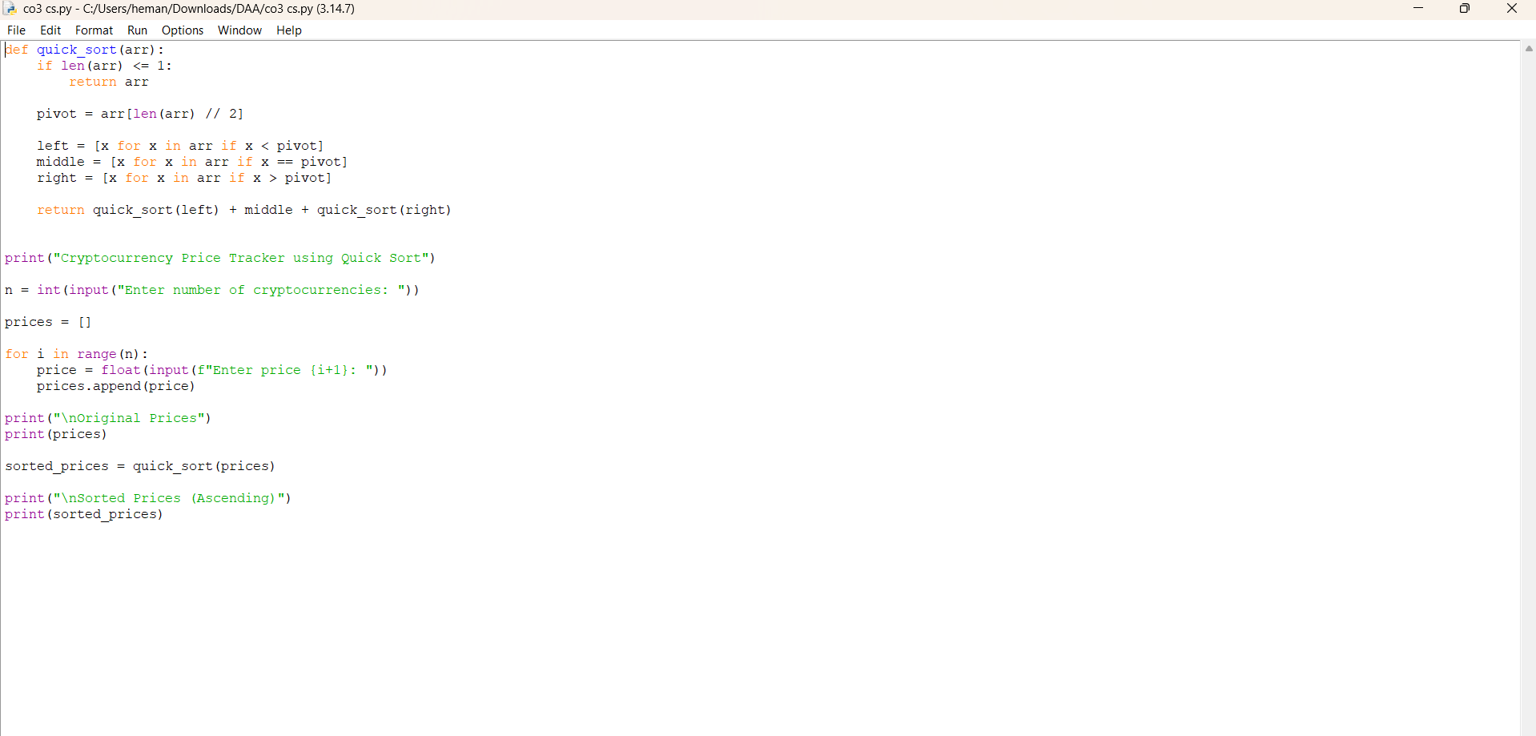

7 Output
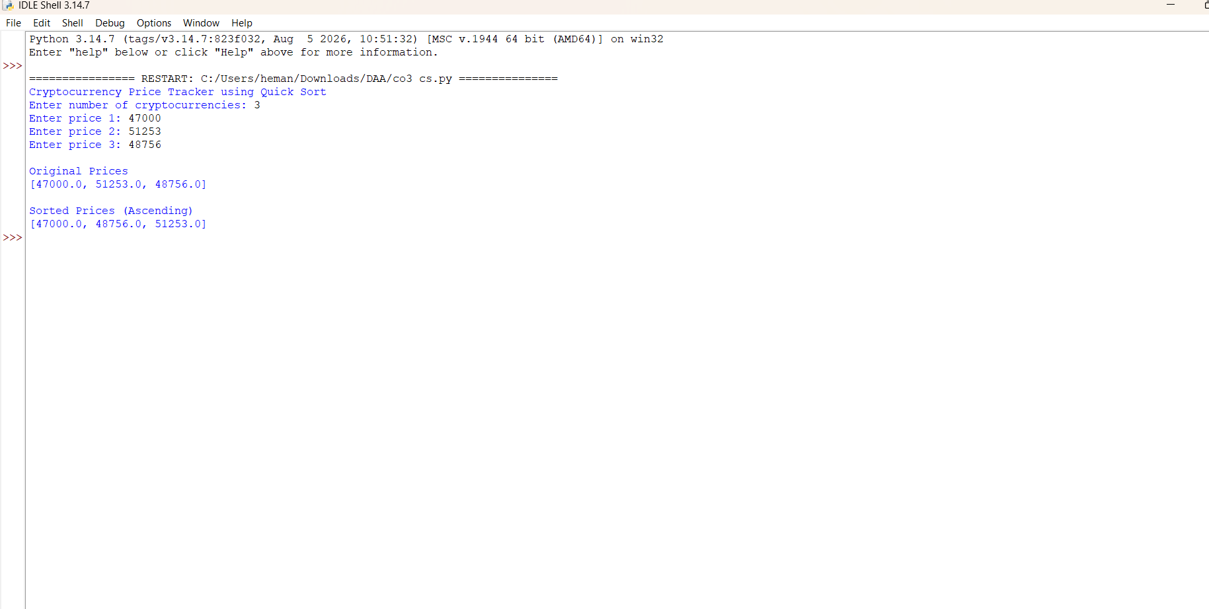

8. Conclusion
Quick Sort's divide-and-conquer structure — partition, recurse, recurse — makes it a natural fit for sorting large, frequently-updated coin price lists in place and fast on average. However, a naive implementation is unsafe for this specific domain because live financial data is repeatedly near-sorted (pivot-selection risk) and duplicate-heavy (partition-scheme risk). Randomized/median-of-three pivot selection, 3-way partitioning, an insertion-sort cutoff, and smaller-side-first recursion together convert Quick Sort from a fragile O(n²)-prone routine into a robust, consistently O(n log n) engine suitable for a real-time cryptocurrency price tracker, while an incremental data structure is recommended as a longer-term architectural complement for streaming updates.
Note: Insert screenshots of the source code and console output here before final submission, alongside the results table above.

