APPLICATION: SMART GRID ENERGY DISTRIBUTION SYSTEM
1. Aim
To determine the time complexity of the Smart Grid Energy Distribution System using the Master Theorem.
2. Problem Statement
An energy distribution system uses the recurrence relation
$$T(n)=4T(n/2)+nlog⁡n$$
Apply the Master Theorem to determine the time complexity. Identify the parameters and justify the selected case. Analyze its performance for large energy networks and interpret the efficiency using asymptotic notation.
3. Theory
The Master Theorem is used to solve divide-and-conquer recurrence relations of the form
$$T(n)=aT(n/b)+f(n)$$
where
- a = Number of recursive calls
- b = Division factor
- f(n) = Cost of combining subproblems
4. Master Theorem Analysis
Given,
$$T(n)=4T(n/2)+nlog⁡n$$
Parameters
- a = 4
- b = 2
- f(n) = n log n
Calculate
$$n^{{log⁡}_{2}4}=n^{2}$$
Since
$$nlog⁡n=O(n^{2-ε})$$
Master Theorem Case 1 is applicable.
Therefore,
$$\boxed{T(n)=Θ(n^{2})}$$5. Time Complexity
$$\boxed{Θ(n^{2})}$$
The execution time increases quadratically with the number of nodes in the energy network. Doubling the network size approximately quadruples the amount of computation.

6. Space Complexity
The recursion depth is
$${log⁡}_{2}n$$
Therefore,
$$\boxed{\text{Space Complexity}=Θ(log⁡n)}$$7. Performance Analysis
- The Smart Grid divides the energy network into four equal parts recursively.
- The additional work at each level is $nlog⁡n$.
- As the network grows, the execution time increases quadratically.
- The algorithm performs well for small and medium-sized networks but requires more processing time for very large networks.
8. Algorithm
- Identify a, b, and f(n).
- Compute $n^{{log⁡}_{b}a}$.
- Compare $f(n)$with $n^{{log⁡}_{b}a}$.
- Select the appropriate Master Theorem case.
- Determine the time and space complexity.
9. Source Code
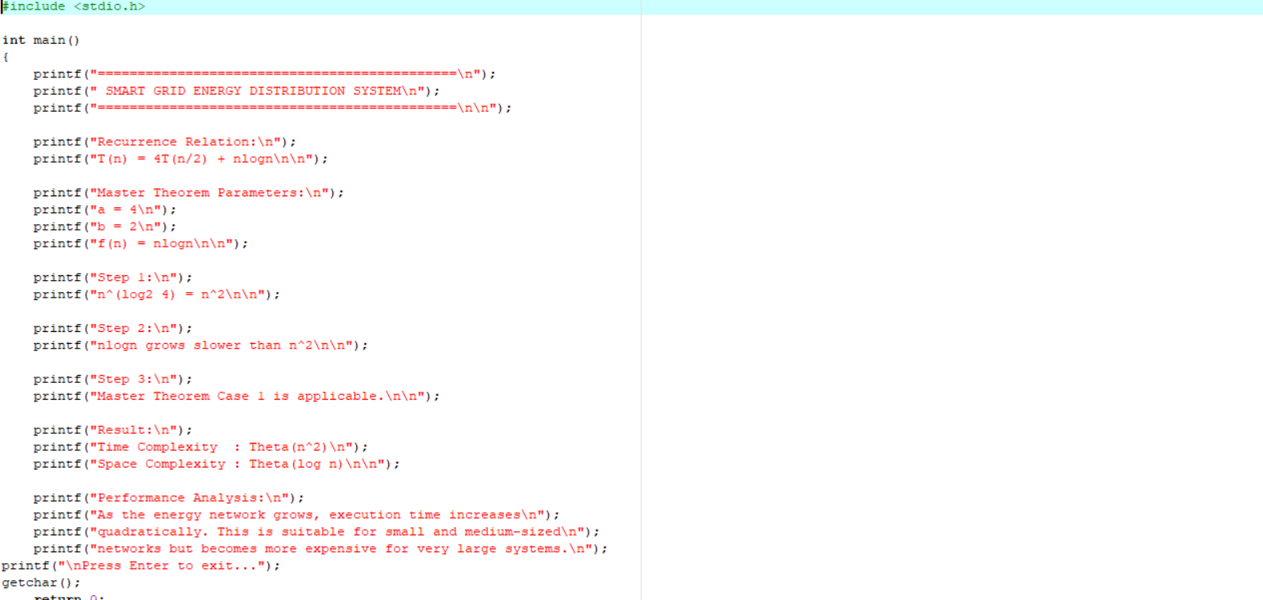
10. Output
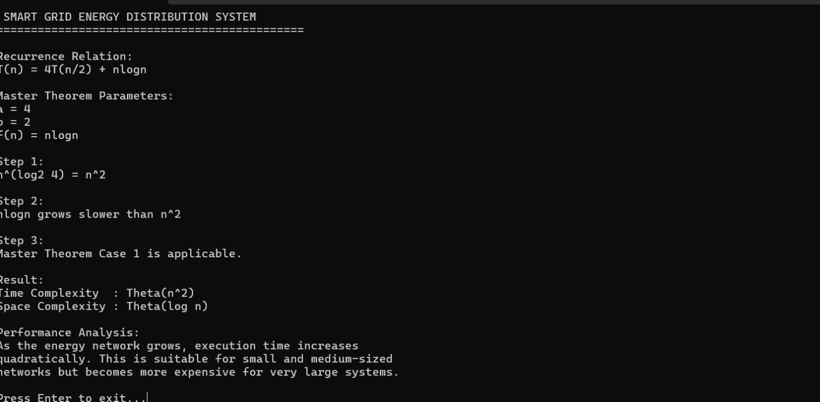

11. Result
Master Theorem Case 1 is applicable.

Time Complexity:-
$$\boxed{Θ(n^{2})}$$
Space Complexity:-
$$\boxed{Θ(log⁡n)}$$
12. Conclusion
The Smart Grid Energy Distribution System follows the recurrence relation $T(n)=4T(n/2)+nlog⁡n$. Applying the Master Theorem shows that the algorithm has Time Complexity $Θ(n^{2})$and Space Complexity $Θ(log⁡n)$. It efficiently distributes energy for moderate-sized networks, but the computation time increases significantly as the network size becomes very large.

