Experiment Number: 1 Simulation and Comparative Analysis of FDMA, TDMA and
CDMA: Resource Allocation, User Capacity and Mobile-Generation Context
PROGRAM:
clear; clc; close all;
%% 1. Illustrative system parameters totalBandwidthHz = 1e6; % Total bandwidth: 1 MHz fdmaChannelHz = 200e3; % FDMA channel width: 200 kHz tdmaSlots = 8; % TDMA slots per frame processingGain = 64; % CDMA processing gain targetSIRdB = 7; % Minimum acceptable CDMA SIR in dB
%% 2. Estimate supported users fdmaUsers = floor(totalBandwidthHz / fdmaChannelHz); tdmaUsers = tdmaSlots; targetSIR = 10^(targetSIRdB / 10); % Simplified CDMA capacity estimate cdmaUsers = floor(1 + processingGain / targetSIR); fprintf('Illustrative maximum supported users\n'); fprintf('FDMA: %d users\n', fdmaUsers); fprintf('TDMA: %d users\n', tdmaUsers); fprintf('CDMA: %d users at a target SIR of %.1f dB\n\n', ...
cdmaUsers, targetSIRdB); %% 3. Display comparison table method = ["FDMA"; "TDMA"; "CDMA"]; supportedUsers = [fdmaUsers; tdmaUsers; cdmaUsers]; results = table(method, supportedUsers); disp(results);
%% 4. Plot estimated user capacity figure; bar(categorical(method), supportedUsers); ylabel('Illustrative maximum supported simultaneous users'); xlabel('Multiple access technique'); title('FDMA, TDMA and CDMA: Capacity Estimate'); grid on;
%% 5. Estimate CDMA SIR as users increase K = 2:30; sirLinear = processingGain ./ (K - 1); sirDb = 10 * log10(sirLinear); figure; plot(K, sirDb, 'o-', 'LineWidth', 1.5); hold on;

yline(targetSIRdB, '--r', 'Target SIR'); xlabel('Number of simultaneous CDMA users (K)'); ylabel('Estimated SIR (dB)'); title('Estimated CDMA SIR versus Number of Users'); grid on; hold off;

OUTPUT:

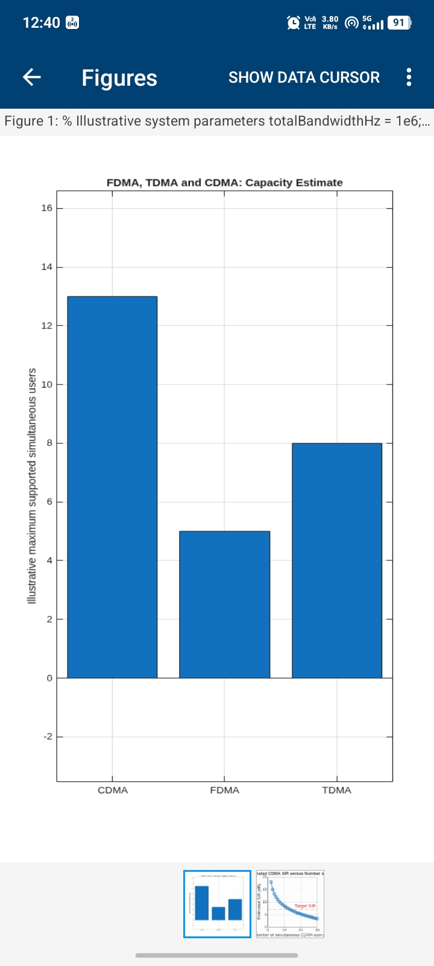
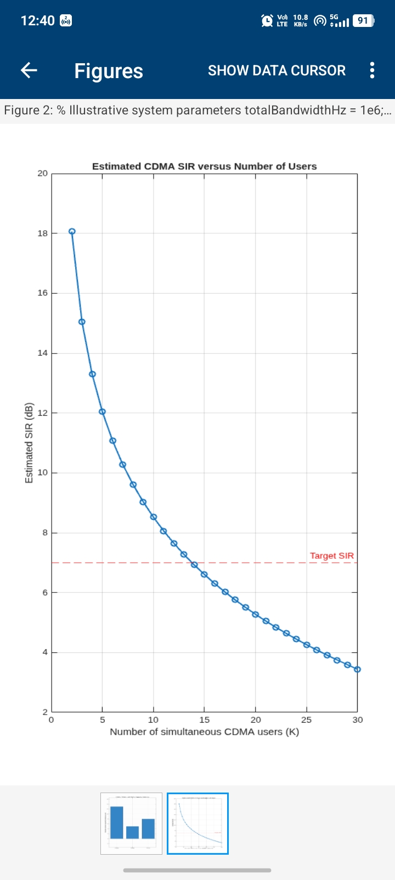

PROGRAM:
clear; clc; close all;
% Mobile communication generations generation = ["1G"; "2G"; "2G"; "3G"; "4G"; "5G"];
% Representative systems system = ["AMPS"; "GSM"; "IS-95"; "UMTS"; "LTE"; "5G NR"];
% Multiple access methods accessMethod = ["FDMA"; "TDMA"; "CDMA"; "WCDMA"; ...
"OFDMA"; "OFDMA-based"]; % Key idea of each system keyIdea = ["Analog voice communication"; ...
"Digital voice using time slots"; ...
"Digital voice using spread-spectrum codes"; ...
"Wideband code-division access"; ...
"Orthogonal frequency-division access"; ...
"Flexible OFDM-based radio access"];
% Create comparison table evolutionTable = table( ...
generation, system, accessMethod, keyIdea, ...
'VariableNames', ...
{'Generation', 'System', 'AccessMethod', 'KeyIdea'});
% Display table disp('Evolution of Mobile Communication Systems'); disp(evolutionTable);
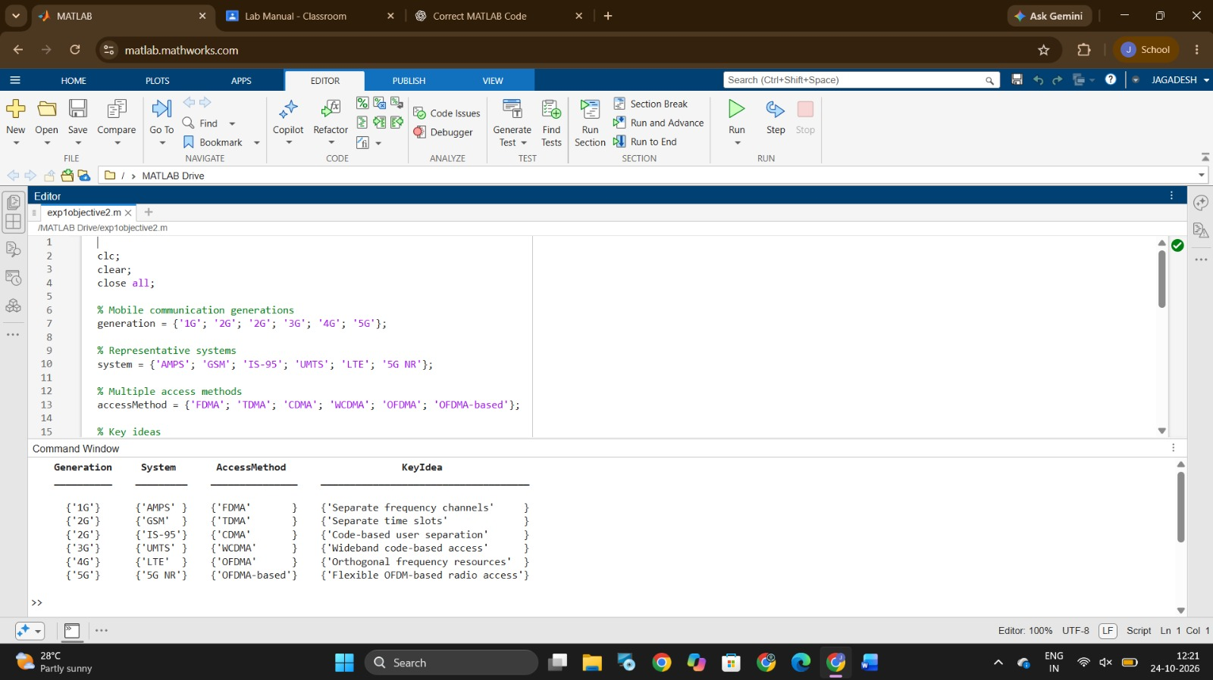

PROGRAM:
clear; clc; close all;
%% Create one figure with three diagrams figure('Color', 'w', 'Name', 'Multiple Access Techniques');

tiledlayout(1, 3, 'TileSpacing', 'compact', ...
'Padding', 'compact'); colors = lines(4);
%% 1. FDMA: Different frequency channels nexttile; hold on; for u = 1:4 rectangle('Position', [0, u-1, 1, 0.8], ...
'FaceColor', colors(u,:), ...
'EdgeColor', 'k'); text(0.5, u-0.6, sprintf('User %d', u), ... 'HorizontalAlignment', 'center'); end xlim([0 1]); ylim([0 4]); xlabel('Time'); ylabel('Frequency channel'); title('FDMA'); set(gca, 'YTick', []);
box on; hold off;
%% 2. TDMA: Different time slots nexttile; hold on;

for u = 1:4 rectangle('Position', [u-1, 0, 0.8, 1], ...
'FaceColor', colors(u,:), ... 'EdgeColor', 'k'); text(u-0.6, 0.5, sprintf('User %d', u), ... 'HorizontalAlignment', 'center'); end xlim([0 4]); ylim([0 1]); xlabel('Time slot'); ylabel('Frequency channel'); title('TDMA'); set(gca, 'YTick', []); box on; hold off;
%% 3. CDMA: Shared time-frequency resources
nexttile; hold on;
% Illustrative overlapping user transmissions for u = 1:4 rectangle('Position', [0, 0, 1, 1], ...
'FaceColor', colors(u,:), ...
'FaceAlpha', 0.15, ...
'EdgeColor', colors(u,:), ...
'LineWidth', 1.5); end text(0.5, 0.62, 'Users 1-4 share', ... 'HorizontalAlignment', 'center');

text(0.5, 0.40, 'band; different codes', ... 'HorizontalAlignment', 'center'); xlim([0 1]); ylim([0 1]); xlabel('Time'); ylabel('Frequency band'); title('CDMA'); set(gca, 'YTick', []);
box on; hold off; %% Overall title
sgtitle('Conceptual Time-Frequency Resource Allocation');
OUTPUT:

