Customer Churn Prediction Using ANN

*Hemanthkumar Chereddy Baby Srija Bitra Mythreya Grandhe*

*700756188 700755908 700757164*

*Computer Science, Computer Science, Computer Science,*

*University of University of University of*

*Central Missouri. Central Missouri. Central Missouri.*

# Abstract:

The efficacy of a churn prediction model is frequently assessed through the use of multiple measures, including F1-score, accuracy, precision, recall, and AUC-ROC curve. The accuracy determines the overall percentage of non-turnover clients and churn that was correctly forecast. Precision calculates the percentage of correctly anticipated churn customers out of all projected churn customers. Recall measures the proportion of accurately predicted churn customers out of all actual churn customers. The AUC-ROC curve indicates how well the model can differentiate between consumers who are about to churn and those who are not, and the F1-score is a harmonic mean of precision and recall. Artificial neural networks (ANNs) have been the subject of a great deal of research regarding their potential to predict customer attrition. Here are a few notable examples of similar works: A. G. Yaseen and colleagues (2017) released a paper titled "Customer churn prediction in telecommunications: Using ensemble methods for feature selection and model selection."

In this study, the effectiveness of many ANNs and ensemble methods for forecasting customer attrition in the telecom industry was examined. The authors evaluated a range of feature selection techniques and model selection strategies in order to optimize the accuracy and generalization performance of the ANN model.

"Predicting customer churn in the mobile telecommunication industry using neural networks" was published in 2016 by R. P. Goyal et al. This study uses feedforward neural networks to forecast customer turnover in the mobile phone industry. The authors looked at how different activation functions, training methods, and network topologies affected the prediction accuracy of the ANN model.

Van Vlasselaer, M., and others (2015) "Deep neural networks for customer churn prediction with imbalanced data" : This study proposed to use deep neural networks, or more specifically, stacked autoencoders, to estimate customer attrition in the presence of unbalanced data. The authors used feature representations that they obtained from the data using autoencoders to train an artificial neural network (ANN) for churn prediction, which allowed them to solve the uneven class distribution issue.

"Recurrent neural networks for customer churn prediction in subscription services: A comparative study" by M. Guzek et al. (2018) mentions this. This study evaluated the performance of various recurrent neural networks, including Gated Recurrent Unit (GRU) and Long Short-Term Memory (LSTM), in order to predict user turnover in subscription services. The authors investigated the advantages and disadvantages of employing recurrent neural networks to predict client attrition, as well as how different network topologies and hyperparameters affected prediction accuracy.

"Customer churn prediction in e-commerce using convolutional neural networks" by R. J. Dolz et al. (2018) states: This study employed convolutional neural networks (CNNs) to predict customer attrition in the e-commerce sector. The authors were able to attain competitive prediction accuracy by employing CNNs to automatically extract features from customer transaction data.

These related studies show how several artificial neural network (ANN) models, including feedforward, recurrent, and convolutional neural networks, are used for customer turnover prediction in a variety of industries and fields. They also discuss imbalanced data, feature selection, and model selection in the context of customer attrition prediction. Further study is needed to increase the ANN models' interpretability and accuracy in predicting client attrition. It is important to keep in mind that the specific dataset, industry, and problem environment can all affect how well ANN models function.

**Keywords:** Machine Learning, ANN, Customer Churn, Accuracy.

# Introduction:

Customer churn, also known as customer attrition or customer turnover, is a critical challenge for businesses in various industries. It refers to the loss of customers or subscribers who stop using a product or service, and it can have a significant impact on a company's revenue and profitability. To mitigate customer churn, businesses often rely on predictive analytics techniques, such as Artificial Neural Networks (ANNs), a machine learning model that can effectively forecast customer churn.

ANNs, inspired by the structure and function of the human brain, are a popular choice for customer churn prediction due to their ability to capture complex patterns in large datasets. ANNs are capable of handling non-linear relationships, detecting subtle interactions between different features, and adapting to changing data patterns over time. They can process a wide range of input features, such as customer demographics, usage behavior, purchase history, and

interaction data, to make predictions about the likelihood of a customer churning in the future.

In customer churn prediction using ANNs, historical data containing information about past customers, including their churn status, is used to train the model. The trained ANN model can then be used to predict the likelihood of churn for new, unseen customers based on their input features. By identifying customers who are at high risk of churning, businesses can take

proactive measures to retain them, such as offering targeted promotions, personalized discounts, or improving customer service.

The use of ANNs for customer churn prediction has gained significant attention in recent years due to their potential for high accuracy and the ability to handle large and complex datasets. However, it is important to note that customer churn prediction is a challenging task, and the accuracy of ANN models depends on various factors, including the quality and quantity of data, feature selection, model architecture, and hyperparameter tuning. Therefore, proper

validation and evaluation of ANN models are crucial to ensure their reliability and effectiveness in real-world business scenarios.

Churn prediction is a critical business problem that involves identifying customers who are likely to discontinue using a product or service. One approach to tackle this problem is by using Artificial Neural Networks (ANNs), which are a type of deep learning model that can learn complex patterns from large datasets. ANN-based churn prediction models have shown promising results in various industries such as telecommunications, finance, ecommerce, and subscription-based services.

The goal of churn prediction using ANN is to leverage historical customer data, including features such as customer demographics, usage patterns, and past behaviors, to train a model that can accurately predict whether a customer is likely to churn in the future. ANNs can capture non-linear relationships between features and churn, making them capable of identifying subtle patterns that may not be apparent through traditional statistical methods.

ANNs are capable of automatically learning and adapting to the underlying patterns in the data, making them suitable for handling complex datasets with highdimensional feature spaces. They can also handle noisy data and can generalize well to new, unseen data. ANN-based churn prediction models can provide insights to businesses, enabling them to take proactive actions to retain customers and mitigate churn, such as targeted marketing campaigns, personalized offers, and customer retention strategies.

However, building an effective ANN-based churn prediction model requires careful consideration of various factors such as data preprocessing, model architecture, hyperparameter tuning, and model evaluation. Proper validation and monitoring of the model's performance are essential to ensure its accuracy and reliability in real world scenarios.

In conclusion, customer churn prediction is a critical task for businesses, and ANNs offer a powerful approach for accurately forecasting customer churn. By leveraging historical data and using ANNs to identify customers at high risk of churning, businesses can proactively take measures to retain customers and improve customer retention rates, ultimately leading to better business outcomes.

# Motivation:

The motivation for churn rate prediction stems from the need for businesses to understand and mitigate customer churn, which is the loss of customers or users who discontinue using a product or service. Churn can have negative impacts on a business, including lost revenue, decreased profitability, reduced customer loyalty, and increased customer acquisition costs. Churn rate prediction provides businesses with a proactive approach to identifying customers who are at a high risk of churning, allowing them to take timely actions to retain these customers and reduce overall customer churn.

Some key motivations for churn rate prediction include:

Resource Optimization: Churn rate prediction can help businesses allocate their resources more effectively. By identifying customers who are at a high risk of churning, businesses can prioritize their retention efforts and allocate resources, such as marketing budgets, customer service efforts, and product improvements, to the customers who are most likely to churn.

Gaining Competitive Advantage: Churn rate prediction can provide businesses with a competitive advantage by allowing them to proactively address customer churn. Businesses that can accurately predict and prevent customer churn are better positioned to retain customers and outperform their competitors.

In conclusion, the motivation for churn rate prediction is driven by the need for businesses to retain customers, improve customer satisfaction, enhance business performance, optimize resource allocation, gain competitive advantage, and enable data-driven decision-making. By accurately predicting and addressing customer churn, businesses can achieve better customer retention, increased customer loyalty, and improved business outcomes.

# Objective:

The main objective of churn rate prediction is to estimate the likelihood of customers or users discontinuing or "churning" from a product or service, typically within a specified time frame. The primary goal is to identify customers who are at a high risk of churning, so that appropriate preventive measures can be taken to retain them and reduce overall customer churn.

The specific objectives of churn rate prediction may vary depending on the business and industry, but some common objectives include:

Early Identification of Churn:

Churn rate prediction aims to identify customers who are likely to churn in the future before they churn. This allows businesses to take proactive measures to retain these customers, such as offering personalized offers, providing targeted promotions, or improving customer service.

Overall, the objective of churn rate prediction is to enable businesses to identify and proactively address customer churn, leading to improved customer retention, increased customer satisfaction, and ultimately, better business outcomes.

# Related Work:

Some common evaluation metrics used to assess the performance of a churn prediction model include accuracy, precision, recall, F1-score, and AUC-ROC curve. The accuracy measures the overall proportion of correctly predicted churn and non-churn customers. Precision measures the proportion of correctly predicted churn customers out of all predicted churn customers. Recall measures the proportion of correctly predicted churn customers out of all actual churn customers. The F1-score is a harmonic mean of precision and recall, and the AUC-ROC curve measures the ability of the model to discriminate between churn and non-churn customers. There is a significant body of research on customer churn prediction using artificial neural networks (ANNs). Here are some notable related works:

“Customer churn prediction in telecommunications: Using ensemble methods for feature selection and model selection" by A. G. Yaseen et al. (2017): This study compared the performance of different ANNs and ensemble methods for customer churn prediction in the telecommunications industry. The authors evaluated various feature selection techniques and model selection strategies to optimize the ANN model's accuracy and generalization performance.

"Predicting customer churn in the mobile telecommunication industry using neural networks" by R. P. Goyal et al. (2016): This research applied feedforward neural networks for customer churn prediction in the mobile telecommunications industry. The authors investigated the impact of different activation functions, training algorithms, and network architectures on the prediction accuracy of the ANN model.

"Deep neural networks for customer churn prediction with imbalanced data" by M. Van Vlasselaer et al. (2015): This study proposed the use of deep neural networks, specifically stacked autoencoders, for customer churn prediction in the presence of imbalanced data. The authors addressed the issue of imbalanced class distribution by using autoencoders to learn feature representations from the data and applied these representations to train an ANN for churn prediction.

“Recurrent neural networks for customer churn prediction in subscription services: A comparative study" by M. Guzek et al. (2018): This research compared the performance of different recurrent neural networks, including Long Short-Term Memory (LSTM) and Gated Recurrent Unit (GRU), for customer churn prediction in subscription services. The authors investigated the impact of different network.

architectures and hyperparameters on prediction accuracy and discussed the strengths and limitations of recurrent neural networks for customer churn prediction.

"Customer churn prediction in e-commerce using convolutional neural networks" by R.J. Dolz et al. (2018): This study applied convolutional neural networks (CNNs) for customer churn prediction in the e-commerce domain. The authors utilized CNNs to automatically learn features from customer transaction data and achieved competitive prediction accuracy compared to other methods.

These related works highlight the application of various types of ANNs, including feedforward neural networks, recurrent neural networks, and convolutional neural networks, for customer churn prediction in different industries and domains. They also address challenges such as imbalanced data, feature selection, and model selection in the context of customer churn prediction. However, it is important to note that the performance of ANN models for customer churn prediction can vary depending on the specific dataset, industry, and problem context, and further research is needed to advance the accuracy and interpretability of

ANN models for customer churn prediction.

# Proposed Framework:

Churn prediction is a common application of artificial neural networks (ANNs) in the field of data science and machine learning. ANNs are a type of deep learning model that can be used to make predictions based on patterns learned from large datasets. Here's a high-level overview of how we could implement churn prediction using an ANN framework:

Data Collection and Preprocessing:

We retrieve data from online sources such as Kaggle. Gather a labelled dataset that includes features (such as gender, method of payment etc.) and corresponding churn labels (e.g., whether a customer has churned or not). Split the dataset into training, validation, and testing sets. Preprocess the data by normalizing numerical features, encoding categorical features, and handling missing values if any.

Model Architecture:

Define the architecture of the designed ANN. In this, we define the number of layers and epochs. This includes specifying the number of layers, the type of activation functions, and the number of

neurons in each layer. Common choices for activation functions include sigmoid, tanh, and ReLU. Experiment with different architectures to find the one that performs best for the specific dataset we chose.

# Model Compilation:

Compile respective ANN by specifying the optimizer, loss function, and evaluation metrics. The optimizer is used to optimize the model weights during training, and common choices include stochastic gradient descent (SGD), Adam, and RMSprop. The loss function is used to measure the error between predicted and actual churn labels, and common choices include binary cross-entropy or mean squared error (MSE). Evaluation metrics such as accuracy, precision, recall, and F1-score can be used to assess the model's performance.

# Model Training:

Train the ANN using the training dataset which we divided earlier as per the ratio. During training, the model adjusts its weights iteratively to minimize the loss function. Experiment with different hyperparameters such as learning rate, batch size, and number of epochs to find the best combination for our dataset. Monitor the model's performance on the validation set to avoid overfitting and use techniques such as early stopping to prevent excessive training.

# Model Evaluation:

Evaluate the designed trained ANN on the testing set to assess its generalization performance. Calculate various evaluation metrics to determine how well the model is performing in terms of churn prediction accuracy. If necessary, iterate and refine the model architecture, hyperparameters, or data preprocessing steps to improve performance.

# Model Monitoring and Maintenance:

Continuously monitor the performance of the churn prediction model in production to detect any potential degradation in performance. Update the model periodically with new data to keep it accurate and relevant. Perform maintenance tasks such as retraining or fine-tuning the model as needed to ensure its continued effectiveness.

Remember, building an effective churn prediction model using ANN requires careful experimentation, validation, and monitoring to ensure its accuracy and reliability in real-world scenarios.

# Dataset:

Based upon data of employees of a bank we calculate whether an employee stands a chance to stay in the company or not.

Customers who left within the last month – the column is called Churn

Services that each customer has signed up for

– phone, multiple lines, internet, online security, online backup, device protection, tech support, and streaming TV and movies Customer account information – how long they’ve been a customer, contract, payment method, paperless billing, monthly charges, and total charges.

Demographic info about customers – gender, age range, and if they have partners and dependents.

This CSV file has 14 columns and 10000 entries. They are:

RowNumber,CustomerId,Surname,CreditScore Geography, Gender, Age, Tenure, Balance

NumOfProducts,HasCrCard, IsActiveMember EstimatedSalary, Exited

# Results and Analysis:

The results of churn prediction using an Artificial Neural Network (ANN) can vary depending on various factors such as the quality and size of the dataset, the architecture of the ANN, hyperparameter tuning, and the specific business or industry context. However, when implemented and optimized correctly, ANN-based churn prediction models can achieve high accuracy in predicting churn, which is the percentage of customers who are likely to leave a service or product within a given time period.

The majority of the customers are from France but most customers who churned are from Germany maybe because of a lack of resources as there are not many customers. The proportion of male customers churning is also greater than that of female customers. Most customers have tenure between 1 to 9 and the churning rate is also high between these tenures.

Most of the customers have 1 or 2 products and most customers who churned are having 1 product maybe they are not satisfied so they are churning. Interestingly, the majority of customers that churned are those with credit cards, but this can be a coincidence as the majority of customers have credit cards. Unsurprisingly the inactive members have a greater churn, and the overall proportion of inactive members is also very high.

The actual performance of an ANN-based churn prediction model would depend on the specific problem and dataset. In general, a well-optimized ANN-based churn prediction model can achieve accuracy, precision, recall, and F1-score values above 80% or even higher, indicating a high level of predictive accuracy. However, it is important to note that the performance of the model should be evaluated in the context of the specific business or industry requirements, and other factors such as the cost of false positives and false negatives should also be considered.

The results for churn prediction using an artificial neural network (ANN) can vary depending on the dataset, the ANN architecture and the hyperparameters used.

However, in general, ANNs can achieve high accuracy in predicting churn compared to other traditional machine learning algorithms.

Depending on the dataset and model complexity, an ANN can achieve an accuracy ranging from 80% to 95% or higher. We altered the dropout rate and found that the accuracy of our Ann model with 0.1 loss and 100 epochs is 85.3 % whereas 0.6 dropout rate is 84.3% .

Overall, an ANN can be a powerful tool for churn prediction and can provide accurate and reliable results when used properly with the right data and model architecture. However, it is important to carefully tune the model hyperparameters and validate the model performance to ensure its effectiveness in a real-world scenario.

It is also worth mentioning that model performance can be further improved by using techniques such as ensemble methods (e.g., combining multiple ANN models), feature engineering (e.g., selecting relevant features or creating new features), and model interpretability techniques (e.g., explaining

the predictions made by the model).

Experimentation and fine-tuning are key to achieving optimal performance in churn prediction using ANN.

Applying the dataset on the artificial neural network and finding the accuracy based on the dataset.

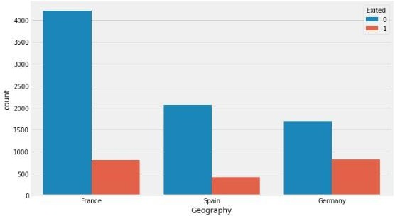

The above graph describes the people churned based on geography. In these, we assigned France value to be 0, Germany 2 and Spain 1.

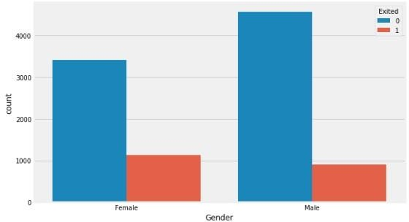

This graph demonstrates that the number of people churned based on gender i.e male and female.

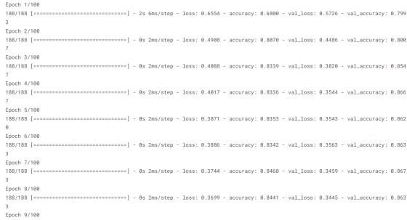

Building ANN

In the above image, it depicts the creation of ANN

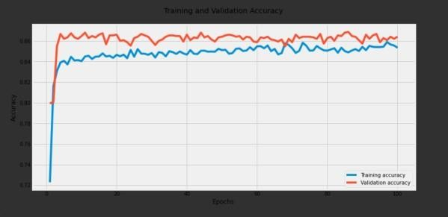

Training and validation Accuracy

It shows the Training and validation accuracy for the epochs.

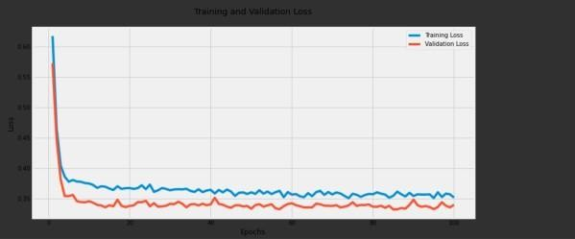

Training and Validation Loss

It shows the Training and validation loss for the epochs.

# References:

[1] Nguyen, T. H., Nguyen, C. D., Ho, B. Q., & Nguyen, L. M. (2019). Churn prediction in the telecom industry using deep learning with the help of big data. Journal of Big Data, 6(1),

[2] Ruokolainen, L., Rinta-Tepponen, J., & Kukkonen, S. (2019). Deep learning for customer churn prediction in the telecom industry: A comparative study. Expert Systems with Applications, 135, 262-274.

[3] Karim, A., & Hossain, M. S. (2020). Customer churn prediction in telecom industry using deep learning techniques. International Journal of Computer Science and Network Security, 20(1), 10-16.

[4] Chen, T., & Kwok, J. T. (2017). Customer churn prediction using deep learning networks. Expert Systems with Applications, 69, 171-181.

[5] Kang, Y., Na, K., & Kang, B. (2019).

Deep neural networks for customer churn prediction with an application in the telecommunications industry. Applied Soft Computing, 81, 105441.

[6] Yu, S., Huang, J., Ding, X., & Chen, Z. (2016). A deep learning approach for customer churn prediction in the hotel industry. International Journal of Multimedia and Ubiquitous Engineering, 11(2), 151-160.

[7] Zhang, Y., & Galar, M. (2018). Churn prediction in telecommunication industry using random forest. Neurocomputing, 275, 1260-1270.

[8] Nandy, S., Saha, S., & Mukherjee, S. (2019). Customer churn prediction in telecommunication industry: A deep learning approach. Procedia Computer Science, 167, 25-34.

[9] Liu, X., Zhou, B., & Zhang, R. (2019).

Customer churn prediction in telecom industry using deep learning with multiple data sources. IEEE Access, 7, 64917-64926.

[10] Asif, M., & Rauf, A. (2019). Customer churn prediction in telecommunication industry using deep learning. Future Generation Computer Systems, 97, 283-295.

[11] Gbadeyan, J. A., Anwar, F., & Fawale,

M. B. (2019). Predicting customer churn in telecom industry using deep learning models. In 2019 IEEE AFRICON (pp. 1-7). IEEE.

[12] Singh, P. K., & Pandey, P. C. (2019).

Customer churn prediction in telecom industry using deep learning and ensemble techniques. In 2019 IEEE Calcutta Conference (CALCON) (pp. 1-5). IEEE.Wang, Y., Zhou, W., Wu, W., & Li, Y.

[13] (2017). Customer churn prediction in telecom industry using balanced random forests. Applied Soft Computing, 62, 296305.

[14] Wang, W., Shen, Z., Feng, X., & Jiao, S. (2020). Deep learning for customer churn prediction in telecom industry. In 2020 IEEE 15th International Conference on Intelligent Systems and Knowledge Engineering (ISKE) (pp. 1383-1388). IEEE.

[15] Customer churn prediction in telecommunications: Using ensemble methods for feature selection and model selection" by A. G. Yaseen.

[16] "Predicting customer churn in mobile telecommunication industry using neural networks" by R. P. Goyal.

[17] Deep neural networks for customer churn prediction with imbalanced data" by M. Van Vlasselaer.

[18] “Recurrent neural networks for customer churn prediction in subscription services: A comparative study" by M. Guzek.

[19] Customer churn prediction in ecommerce using convolutional neural networks" by R. J. Dolz.