***Project_1***

***Introduction:-***

* The project is about taking an website(vulnerable website), and scanning using an “OWASP ZAP” tool.
* The tool performs an automated scanning and identifies set of vulnerabilities and after completion of the total scanning we can get to download an detailed report.

***Steps to perform in owasp zap Scanning:-***

🡪First find the url of the website you want to scan

🡪The “OWASP ZAP” interface looks like this.

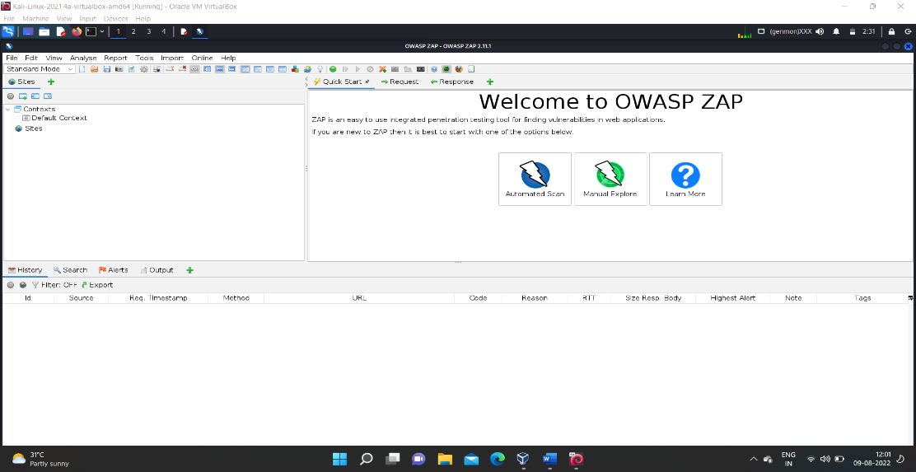

🡪Then click on “automated scan “ and paste the url of the website and click on start attack, first it performs an passive scan .

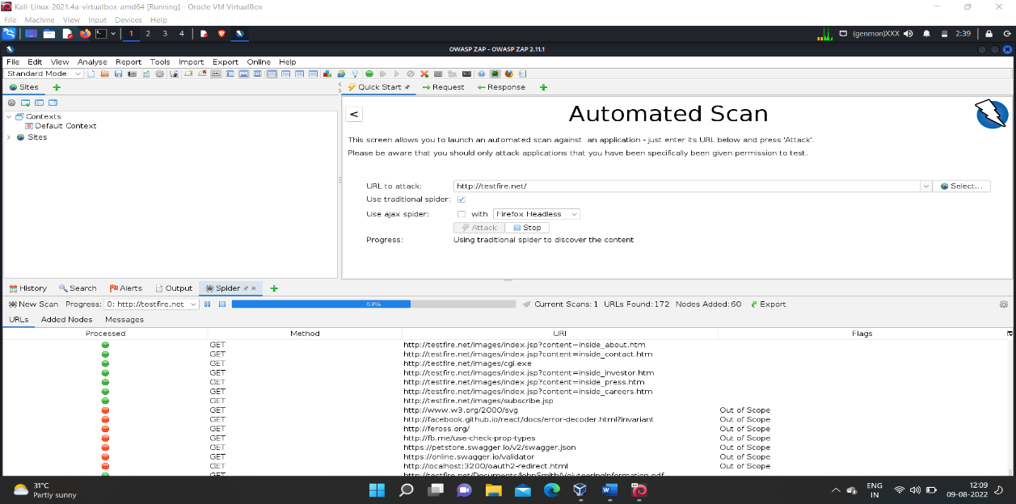

🡪And then it performs the active scanning , the active scanning is more time consuming since it includes to test against various scenarios.

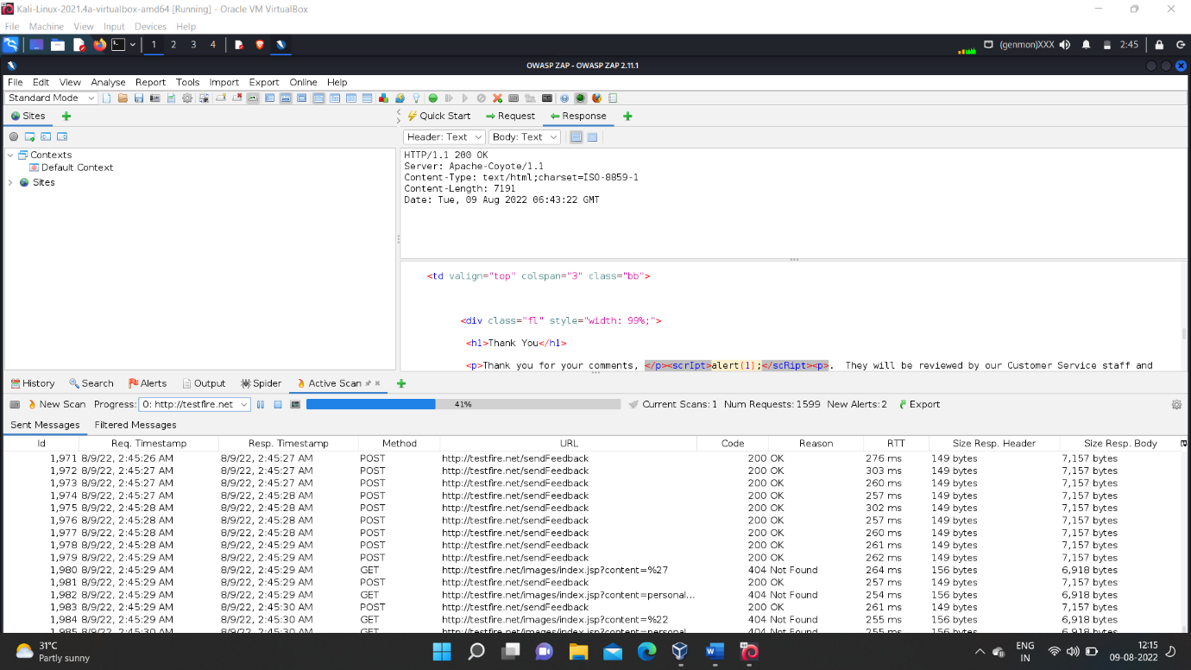

🡪During the active scanning we may find the alerts and the detailed description and reason for the problem and the remedy also.

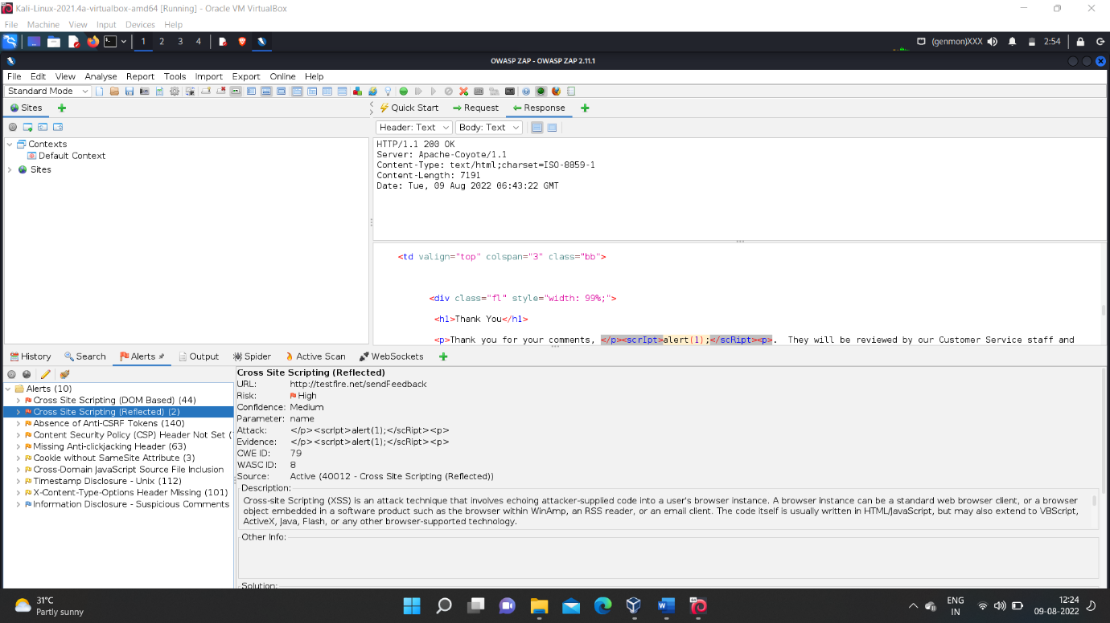

🡪Then after completion of the “active scanning “ we can enable to download the report , the ZAP report is an comprehensive which includes the problems and its solution and reference to prevent them.

🡪The step to download the ZAP report are shown in below screen shot.

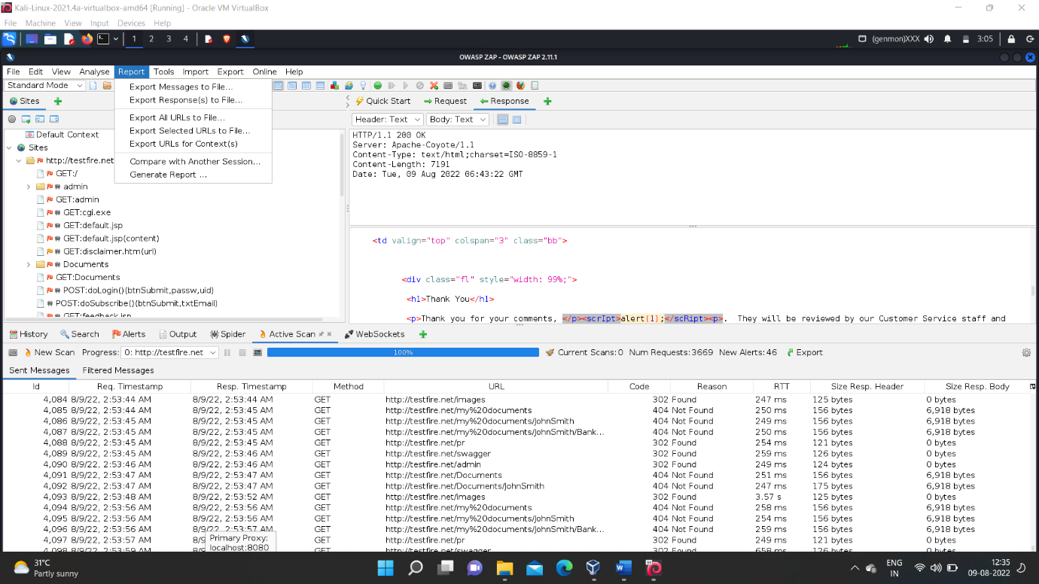

🡪Then choose the path where you want to store the report in your pc.

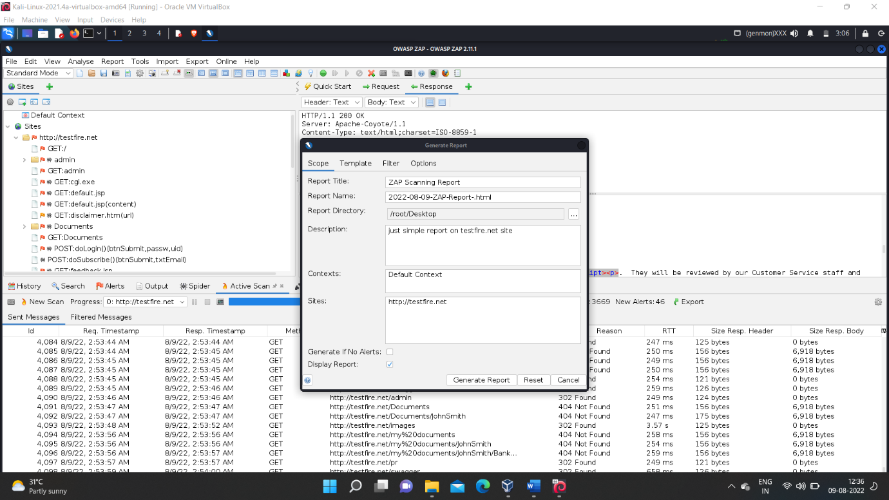

🡪Then the report will be downloaded into the specified location which you given and the over look of the downloaded ZAP report will be look like this and it would be shown in the below screen shot.

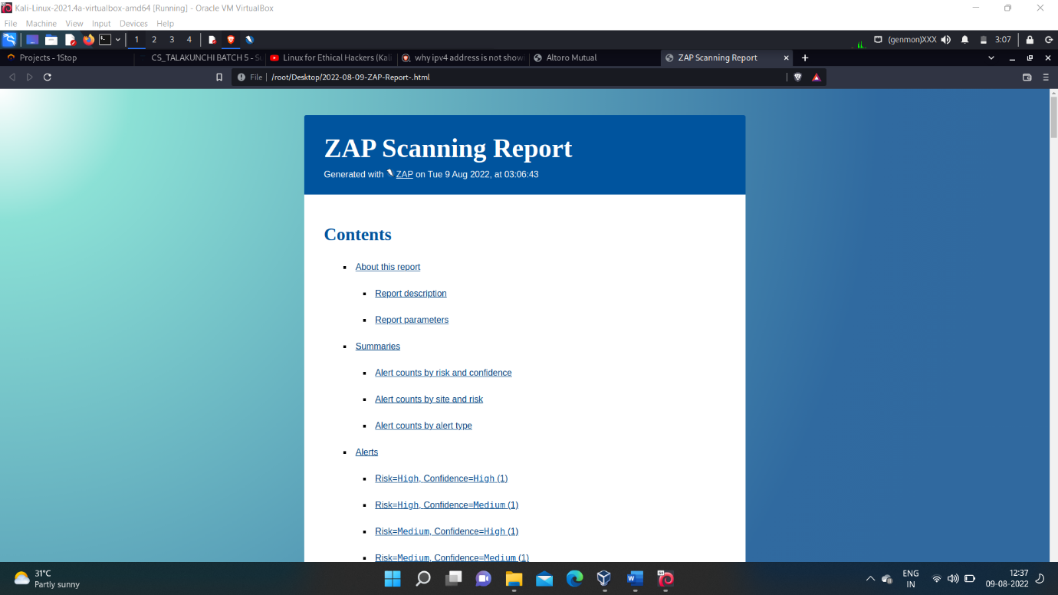

🡪The detailed report of the zap analysis is attached below .