Name: B. Hemanth Reddy

Roll No: 22KT1A0435

Strategic Data Preparation and Planning Report
Project Phase: Week 1 – Strategic Planning and Methodology Development
Target Goal: Advanced Analysis Readiness and Data Integrity
Project Effort: 35 Hours

1. Introduction and Strategic Objectives
The primary objective of this project is to develop a clear, step-by-step strategic plan for cleaning, consolidating, and preparing hypothetical data using Microsoft Excel. This strategy ensures that raw and fragmented data is transformed into a clean, structured, and reliable format suitable for advanced analysis. Establishing these protocols provides a strong foundation for accurate, data-driven decision-making and future project scalability.

2. Scope of Data Analysis Strategy
The analysis focuses on a comprehensive hypothetical dataset containing customer demographic information and transactional sales data. The dataset includes:
- Customer Identification: Customer IDs, names, email addresses, and phone numbers
- Sales Metrics: Purchase dates, product categories, sales amounts, and geographical regions
- Data Architecture: Data collected from multiple Excel sheets and independent sources

3. Identification of Data Preparation Challenges
The strategy identifies common challenges typically found in raw datasets:
- Missing values that interrupt calculations
- Duplicate records that cause inflated reporting
- Inconsistent date formats and spelling variations
- Extra spaces in text fields affecting lookup accuracy

4. Proposed Methodology for Data Cleaning
A structured data cleaning methodology will be applied to ensure accuracy and consistency:
Deduplication: The Remove Duplicates feature in Excel will be used to retain unique records.
Null Handling: Records missing critical data such as Customer IDs will be removed. Non-critical missing values will be replaced with 'Not Available' or average values.
Standardization Using Functions:
- TRIM to remove unnecessary spaces
- PROPER to standardize text capitalization
- TEXT to convert all date formats into a uniform structure

5. Advanced Data Consolidation Strategy
To consolidate data into a single master dataset, advanced Excel functions will be applied:
- VLOOKUP for retrieving related data from reference tables
- INDEX and MATCH for flexible and accurate lookups across complex datasets
- Array formulas for calculations involving multiple conditions

6. Summarization and Visualization Framework
After data preparation, analytical tools will be used to summarize and validate the dataset:
- Pivot Tables to generate summaries such as total sales by region or category
- Conditional Formatting to highlight high and low values and perform final data audits

7. Strategic Execution Timeline
Week 1: Strategic planning and methodology design
Week 2: Data cleaning execution
Week 3: Data consolidation and integration
Week 4: Analysis preparation and validation
Week 5: Final review and project delivery

8. Expected Outcomes
The final outcome of this strategy will be a clean, accurate, and consistent master dataset ready for advanced analysis. This structured planning approach minimizes downstream rework and aligns the project with industry-standard data governance practices.

9. Technical Appendix: Practical Implementation Guide
1)This picture displays the initial raw dataset containing missing values, duplicate records, and inconsistent data formats. It serves as a visual audit to understand data quality issues before applying any cleaning operations.

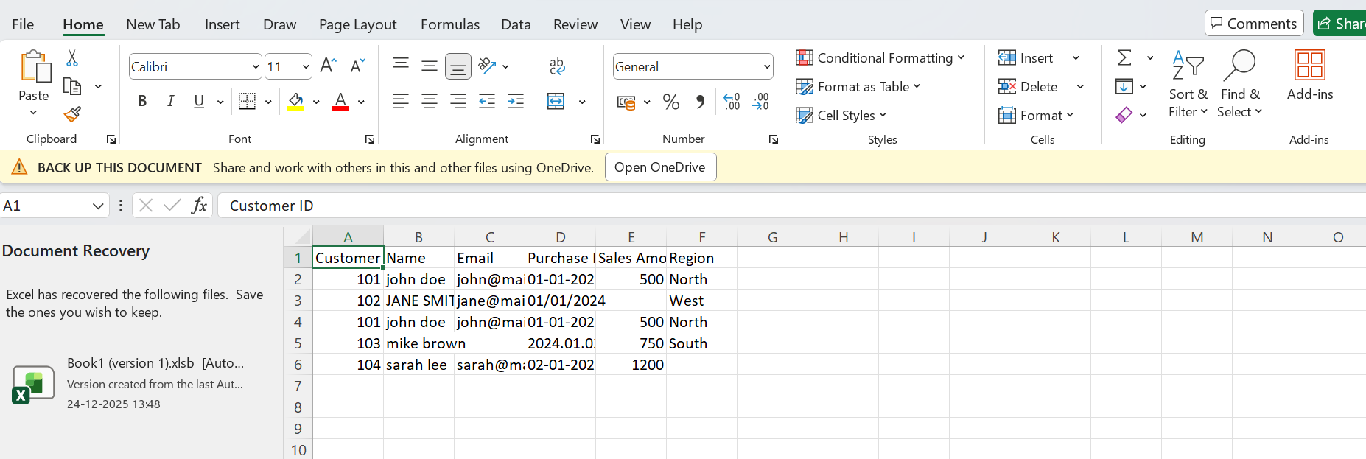
Picture1:- Raw Data Before Cleaning (Visual Audit)

2)This below picture demonstrates the use of Excel’s Remove Duplicates feature to eliminate redundant customer records. This step ensures data accuracy and prevents inflated results during analysis.
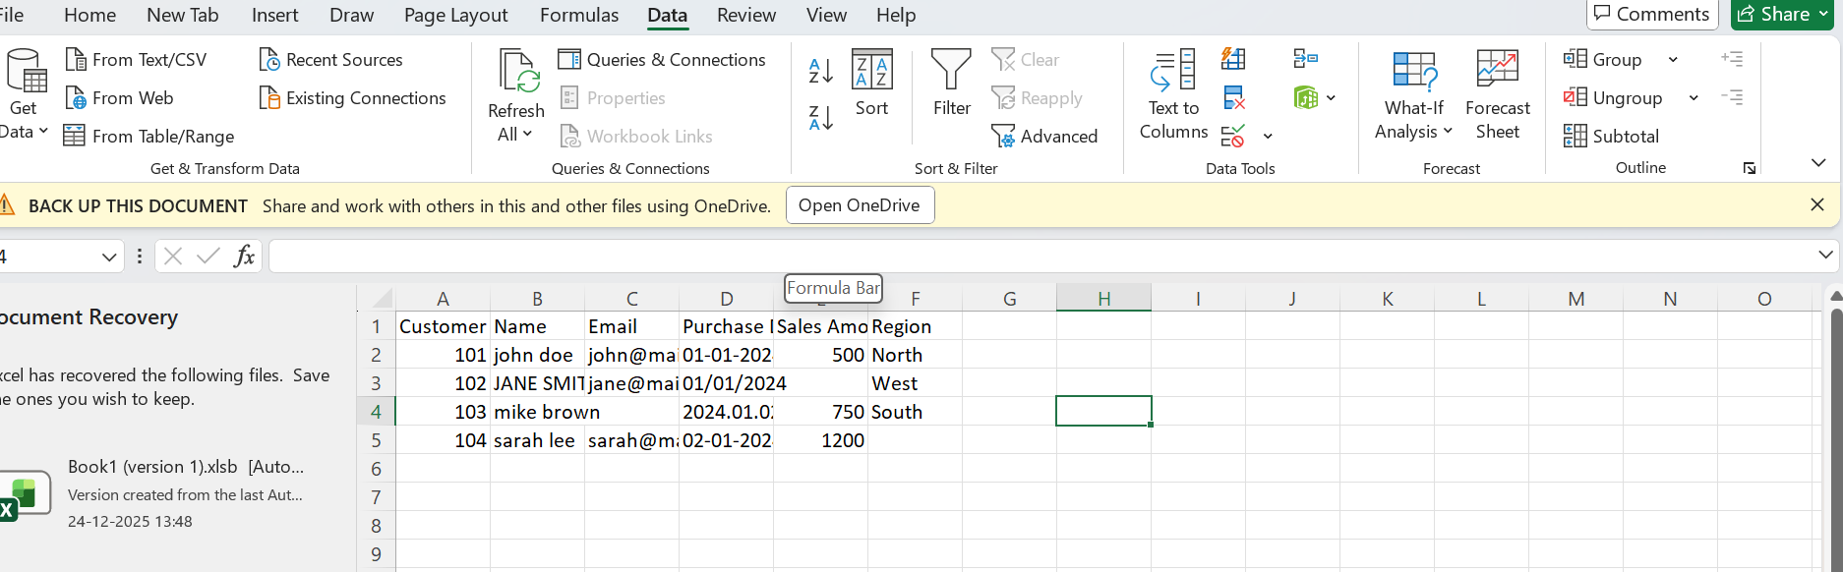
Picture 2:- Removal of Duplicate Records Using Excel

3)This picture highlights the application of Excel formulas such as PROPER(), TRIM(), and TEXT() to standardize text fields and date formats. These formulas improve data consistency and readability.
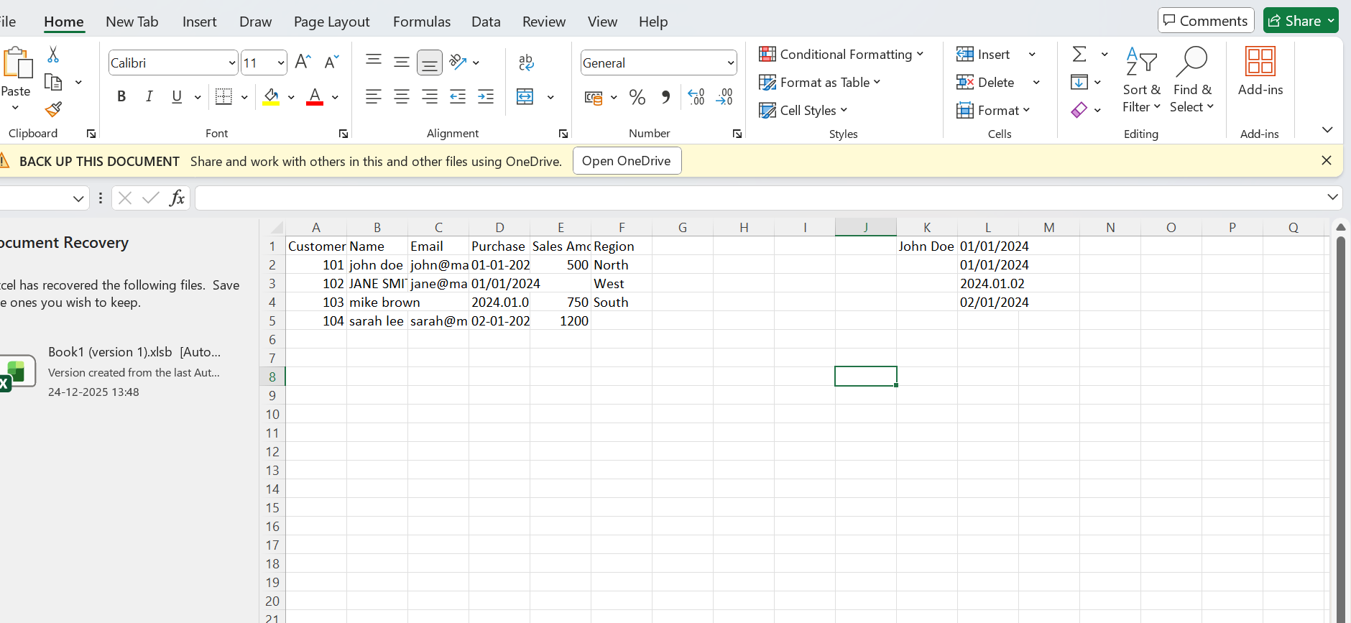
picture3:- Data Cleaning Using Excel Formulas

4)This below picture shows a Pivot Table created to summarize total sales by region. Pivot Tables enable quick aggregation and transformation of cleaned data into meaningful insights.
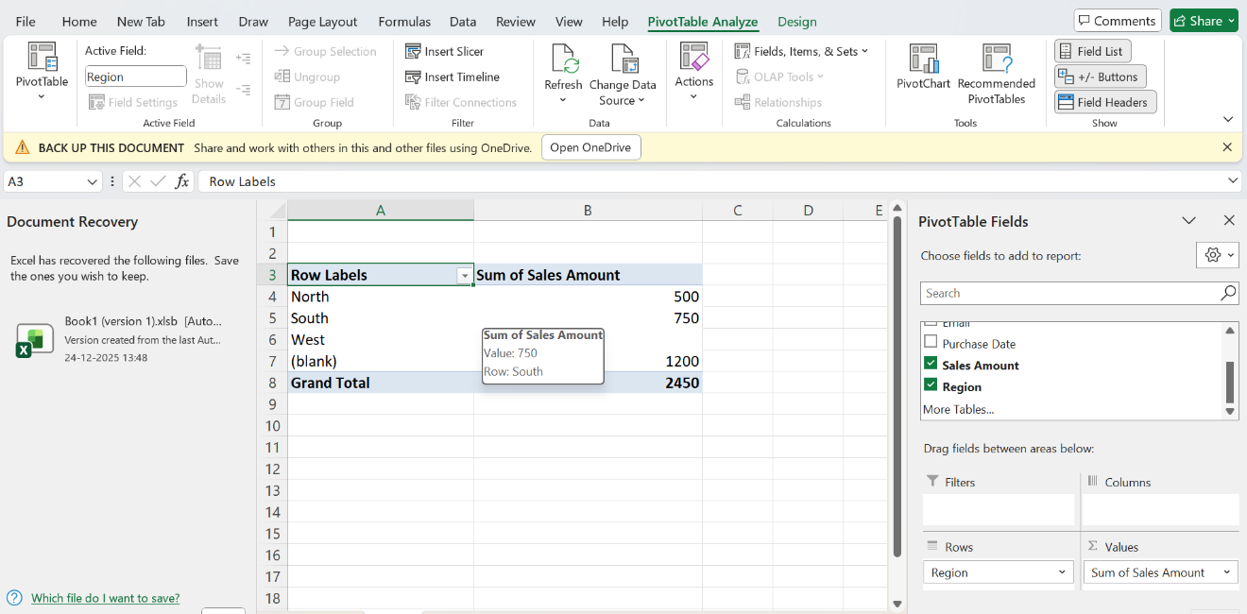picture 4:- Pivot Table summarizing sales data

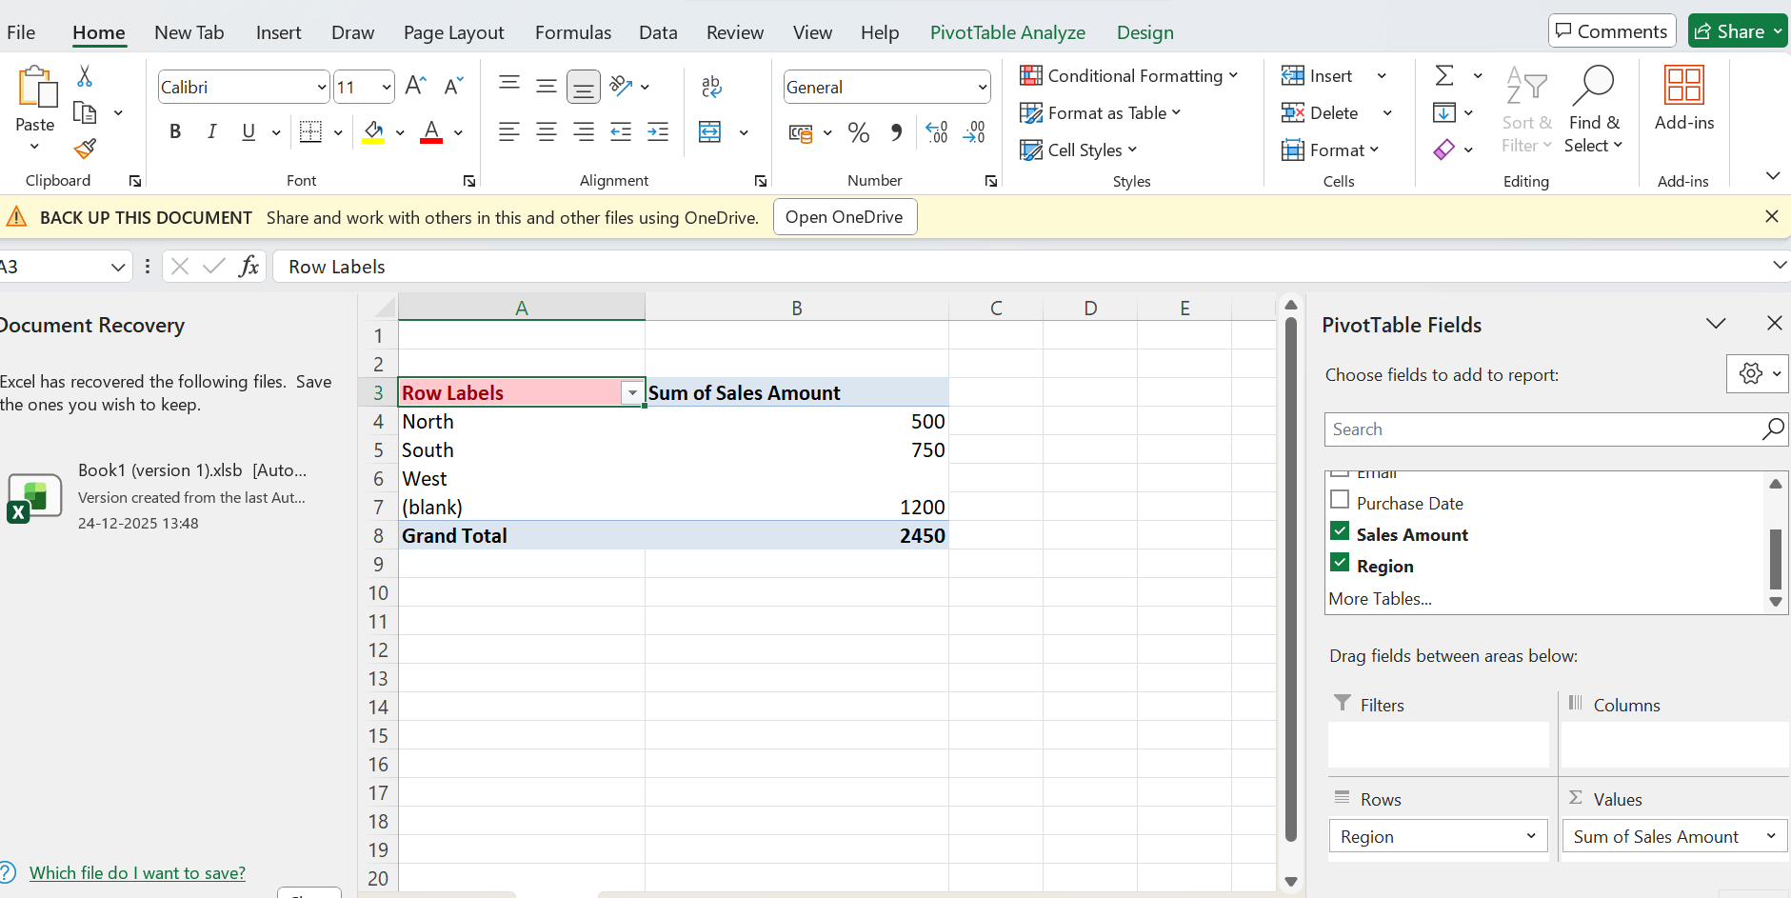
5)This below picture llustrates the use of Conditional Formatting to visually highlight significant sales values. It helps in validating the data and identifying patterns or anomalies efficiently.
picture5:- Conditional Formatting for final data validation

Sample Raw Data for pictures
Name | Email | Purchase Date | Sales Amount | Region
john doe | john@mail.com | 01-01-2024 | 500 | North
JANE SMITH | jane@mail.com | 01/01/2024 | Blank | West
john doe | john@mail.com | 01-01-2024 | 500 | North
mike brown | Blank | 2024.01.02 | 750 | South
Hemanth | hemanth@mail.com | 02-01-2024 | 1200 | Blank

