**Rational Unified process Model**

In project we have to use some model for their successful Completion . We are using Rational Unified process Model in our SCS project . Choosing Good model for the project help us to cost, time , performance . In SCS We are following Rational Unified Process Model which helps us during software life cycle . Each Project or model have same steps for their successful completion. In our Project Rational Unified Process model will cover following Aspects.

1. Business Modeling

2. Requirement Analysis

3. Analysis & Design

4. Implementation

5. Testing

6. Deployment

7. Configuration and chain Management#

8. Project Management

9. Environment

**Business Modeling** :In Business Modeling we use to analyze the business use cases , How the business should support business process. This is documented in a Business Object Model.#

**Requirement Analysis**: we used to get the requirement analysis to understand the project . what insulin pump should do, How the insulin pump works . For achieving this benchmark we organize and document required functionality and constraints track and document tradeoffs and decisions.

In our project , we are using functional requirements, safety requirements and graphic user interface requirements

**Functional Requirements:**

i) The System should measure blood glucose level in the body at equal time intervals and depending on the readings obtained and the rate of change of the sugar level it should inject Insulin and/ or Glucagon to bring the glucose level within 72-108 mg/dL.

ii) When blood glucose level goes above 108 mg/dL then system should be available to inject insulin.

iii) When blood glucose level goes below 72 mg/dL then system should system should be available to inject glucagon.

**Safety Requirement:-** We need to specify the minimum and maximum limit of the dose for both the hormones i.e. Insulin and Glucagon.

ii) We also need to give the safety alarm system if content of insulin or glucagon goes beyond certain limit or the battery of the system goes down.

iii) We need to reset the system every 10 minutes.

**Graphical user interface requirement:-**

.Power on/off button shall be displayed

.Two buttons to make a choice if the user wants to inject the insulin manually or automatic.

·We also need a screen which will display the total dosage that is injected.

·Battery status and other error messages to be signalled.

·Representation of the blood sugar level.

Software Requirement:-

1) Platform: Windows10 (64 Bit) Language: Eclipse Neon, Javafx

Repository: Git

Documentation: LaTex

Analysis & Design:- In the Analysis and Design Phase we will see , How the system realized on the implementation phase .

We have used Design model for GUI in Analysis & Design

1. **Design Model**:-

GUI Design Considerations: • We have considered a battery indicatory along with the progress bar to represent the user the available battery. • We have also taken a clock which displays the current time. • The Graph will represent the Blood Glucose Level in the body in mg/dL which will also represent the minimum and maximum safe limits and the variation the blood glucose level over a period. 6 • We have also taken into consideration the amount of Insulin that we need to inject when the BSL/BGL goes beyond a certain limit and a display which will show how much insulin is present in the bank and do we need to refill it. • Similarly, we have considered it for glycogen wherein we have displayed the amount of glycogen that is injected and the amount which is available currently in the bank. • We have also made sure that we display the current and previous Blood Sugar Level numerically to the patient. • We have taken a separate window were the error messages will be displayed to the user and a sound of alarm whenever there will be any error. E.g. Low battery, insufficient amount of insulin/glycogen in the bank, etc. The rough representation of our GUI is as shown below:

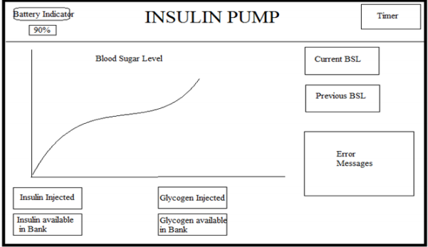

GUI DESIGN MODEL

**Implementation**:- The purpose of implementation is to implement classes and objects in terms of components also to develop the components as unit and to integrate the results produced by implementer

**Testing:-** Testing in rational unified process model is used to identify and ensure defects are addressed prior to the deployment of the software.

**Deployment**:- In this phase , we use to deliver the product to the End user . It covers wide range of activities like packaging , distributing , intalling and formal acceptance by the user.

**Project Management**:- It is a framework for managing software intensive project and for managing risk .

**Configuration & Change Management**:- In this phase , we can see how many people are working on a same project . It avoids costly confusion and resultant artifacts are not in conflict.**Environment:-** The purpose of the environment workflow is to provide the software development organization with the software development environment—both processes and tools—that are needed to support the development team.