Benchmarking Large Language Models on
Insurance Licensing–Style Multiple-Choice Exams:
Methods, Results, and Implications for Exam Prep Tools

Research Evaluation Report · CA-P&C-LLM-Benchmark · May 2026
Repository: hemanthsai126/CA-P-C-LLM-Benchmark

Abstract 1
1. Introduction 1
1.1 Motivation and Research Questions 1
1.2 Contributions 1
2. Materials and Methods 1
2.1 Benchmark Corpora 1
2.2 Models Evaluated 1
2.3 Task and Evaluation Protocol 1
2.4 Letter Accuracy 1
2.5 Explanation Judge (YouTube Corpus) 1
2.6 Curriculum Buckets 1
3. Results 1
3.1 Overall MCQ Accuracy Across Corpora 1
3.2 Mean MCQ Accuracy Across Corpora (Unweighted) 1
3.3 Per-Corpus MCQ Accuracy Tables 1
Table A — Quizlet / PDF-Derived Corpus (550 overlapping items) 1
Table B — YouTube-Oriented Corpus (150 items) 1
Table C — Synthetic Handbook-Style Corpus (400 items) 1
3.4 YouTube Corpus — Rationale Alignment (LLM-as-Judge) 1
3.5 Curriculum Bucket Ablations (MCQ Accuracy by Topic) 1
Quizlet / PDF-Derived Corpus 1
YouTube-Oriented Corpus 1
Synthetic Corpus 1
4. Discussion 1
4.1 On the Question of "Exam Readiness" 1
4.2 Domain Shift as the Dominant Story 1
4.3 Curriculum Buckets as a Diagnostic Tool 1
4.4 The Role of the LLM-as-Judge 1
5. Limitations 1
6. Conclusion 1
7. Data and Code Availability 1
References 1

Abstract

Many learners now turn to large language models (LLMs) as study aids when preparing for California property-and-casualty insurance licensing exams—using them to drill practice questions, generate explanations, and get rapid feedback on difficult concepts. The practical goal is almost always the same: pass the exam. But what does it actually mean for an LLM to be "exam-ready," and how do different models compare when put to the test on realistic material?
This report documents a reproducible, script-driven evaluation of twelve model configurations—OpenAI API models alongside open-weight models run locally via Ollama—on three complementary MCQ corpora: a Quizlet/PDF-derived pool, a YouTube-transcript-aligned validation set, and a synthetic handbook-style dataset. We measure letter accuracy against held-out answer keys, assess the alignment of model rationales to reference explanations using an LLM-as-judge protocol, and perform eight-way curriculum bucket ablations to diagnose topic-level weaknesses.
Frontier models reach approximately 75% accuracy on the hardest scraped-style pool and 99% on synthetic items. Mid-sized open-weight models (7–9B parameters) approach or exceed 80–95% on the friendlier splits. The central implication is provocative but important: if the only criterion were clearing a coarse MCQ threshold on practice-style material, then essentially any model above roughly three billion parameters already clears a low "passing" bar. The more meaningful research and product challenge therefore lies in validity, calibration, topic-level weakness profiling, and non-MCQ competencies—rather than in headline accuracy numbers alone.

1. Introduction

State licensing pathways for property and casualty insurance demand genuine breadth of knowledge: coverage lines, exclusions, state-specific regulatory rules, and the ability to parse dense legal prose under timed conditions. As generative AI models have become increasingly capable, they have found their way into study products of all kinds—question banks, chat-based tutors, explanation generators—and insurance licensing preparation is no exception.
The allure is understandable. A learner who can ask an LLM to explain why a particular answer is wrong, or to generate five more practice questions on inland marine coverage, has a qualitatively richer study experience than one working from static flashcards. But the question of whether any given model is actually good enough to serve as a reliable study partner—or, more ambitiously, to autonomously generate high-quality exam content—requires a careful answer grounded in data.

1.1 Motivation and Research Questions
A natural user goal is to pass the exam: to maximize expected score subject to the constraints of time and effort. From a research standpoint, however, "passing" is an underspecified target. It depends on the difficulty of the item bank, the cut score, and the degree to which practice-set performance correlates with performance on the operational exam. With that caveat in mind, this work pursues three questions:
1. How do frontier models (OpenAI API) compare with capable open-weight models on three deliberately different MCQ corpora?
2. Do model-generated rationales track reference explanations when a ground-truth explanation exists (YouTube corpus)?
3. Where do models fail within a fixed curriculum taxonomy comprising eight topic buckets?

1.2 Contributions
We release a compact, fully script-driven evaluation pipeline. Model predictions live in option/*.csv; accuracy tables are auto-generated; cross-corpus figures are produced by a single plotting script; an OpenAI-based judge evaluates rationales against explanations.txt; and per-bucket accuracy heatmaps are generated for each corpus and model. Together, these artifacts support interpretable, multi-dimensional comparisons that go well beyond a single leaderboard number.

2. Materials and Methods

2.1 Benchmark Corpora
Three corpora were constructed to provide complementary views of model capability. Each corpus was designed to stress different aspects of the task—real-world extraction noise, video-aligned reasoning, and controlled curriculum coverage—so that no single corpus could give a complete picture on its own.

Corpus | Folder | Role | Answer-key scope
Quizlet / PDF-derived | from_quizlet_pdfs/ | Large, heterogeneous pool; hardest for frontier models | 550 items (A–D keyed)
YouTube-oriented | from_youtube_video/ | Transcript- and video-aligned validation split | 150 items
Synthetic (handbook) | synthetic_data/ | Controlled 50×8 bucket layout | 400 items

The Quizlet/PDF-derived corpus represents the noisiest and most realistic evaluation surface: items were scraped or extracted from heterogeneous study materials, and answer keys were aligned through an automated matching procedure. The YouTube-oriented corpus is smaller but uniquely valuable because it includes reference explanations against which model rationales can be judged. The synthetic corpus offers a controlled, curriculum-balanced baseline useful for regression testing and for isolating topic-level performance.

2.2 Models Evaluated
Twelve model configurations were evaluated across two serving environments:
OpenAI API (cloud inference): GPT-4o, GPT-4o mini, GPT-4.1 mini, GPT-4.1 nano, GPT-3.5 Turbo. Parameter counts for the "mini" and "nano" variants are informal public estimates and are reported as such.
Local via Ollama (on-device inference): TinyLlama 1.1B, Gemma 2 2B / 9B, Phi-3 Mini 3.8B, Qwen2.5 7B, Mistral 7B, Llama 3.1 8B. These models were run using exact public weights without modification.

2.3 Task and Evaluation Protocol
All items are four-way multiple choice (options A–D). Models emit a letter answer and, where requested by the pipeline, a brief reasoning string. Accuracy is computed on the intersection of items with a valid gold key and a valid model prediction letter—a deliberate design choice that avoids penalizing models for abstaining but also excludes malformed outputs from the denominator.

2.4 Letter Accuracy
Let G be the set of question IDs with a gold letter in {A, B, C, D}, and P the set of IDs with a valid model prediction. Accuracy is computed on G ∩ P as the fraction of correct answers. This implementation matches scripts/update_option_results_tables.py in the repository.

2.5 Explanation Judge (YouTube Corpus)
For the YouTube corpus, reference explanations from explanations.txt are compared to each model's reasoning string by a fixed gpt-4.1-mini judge (scripts/judge_reasoning_openai.py). The judge assigns an alignment score in {0, 1, 2, 3} per item: 0 = wrong or no overlap, 3 = fully aligned with reference reasoning. In the run summarized here, 148 items received judge scores.

2.6 Curriculum Buckets
Items are mapped to one of eight curriculum buckets: Basic Concepts, Contract Law, CA Laws & Ethics, Tort & Property Fundamentals, Residential Property, Valuation & Government Programs, Personal Liability & Inland Marine, and Commercial Insurance. For the Quizlet and YouTube corpora, bucket assignments come from question_buckets_gpt-4.1.csv. For the synthetic corpus, buckets are defined structurally by the generator layout (50 consecutive items per bucket). Per-bucket accuracy is analyzed using the overlap of gold keys, model predictions, and bucket assignments via scripts/analyze_option_buckets.py.

3. Results

3.1 Overall MCQ Accuracy Across Corpora
Figure 1 presents accuracy across all twelve models and three corpora as a grouped bar chart. The pattern is immediately striking: performance varies substantially not just between models, but within the same model depending on which corpus is used. Models that appear highly capable on the synthetic data can look considerably weaker on the Quizlet PDF-derived material—sometimes by 20–30 percentage points. This is the signature of domain shift, and it is one of the most practically important findings in this study.
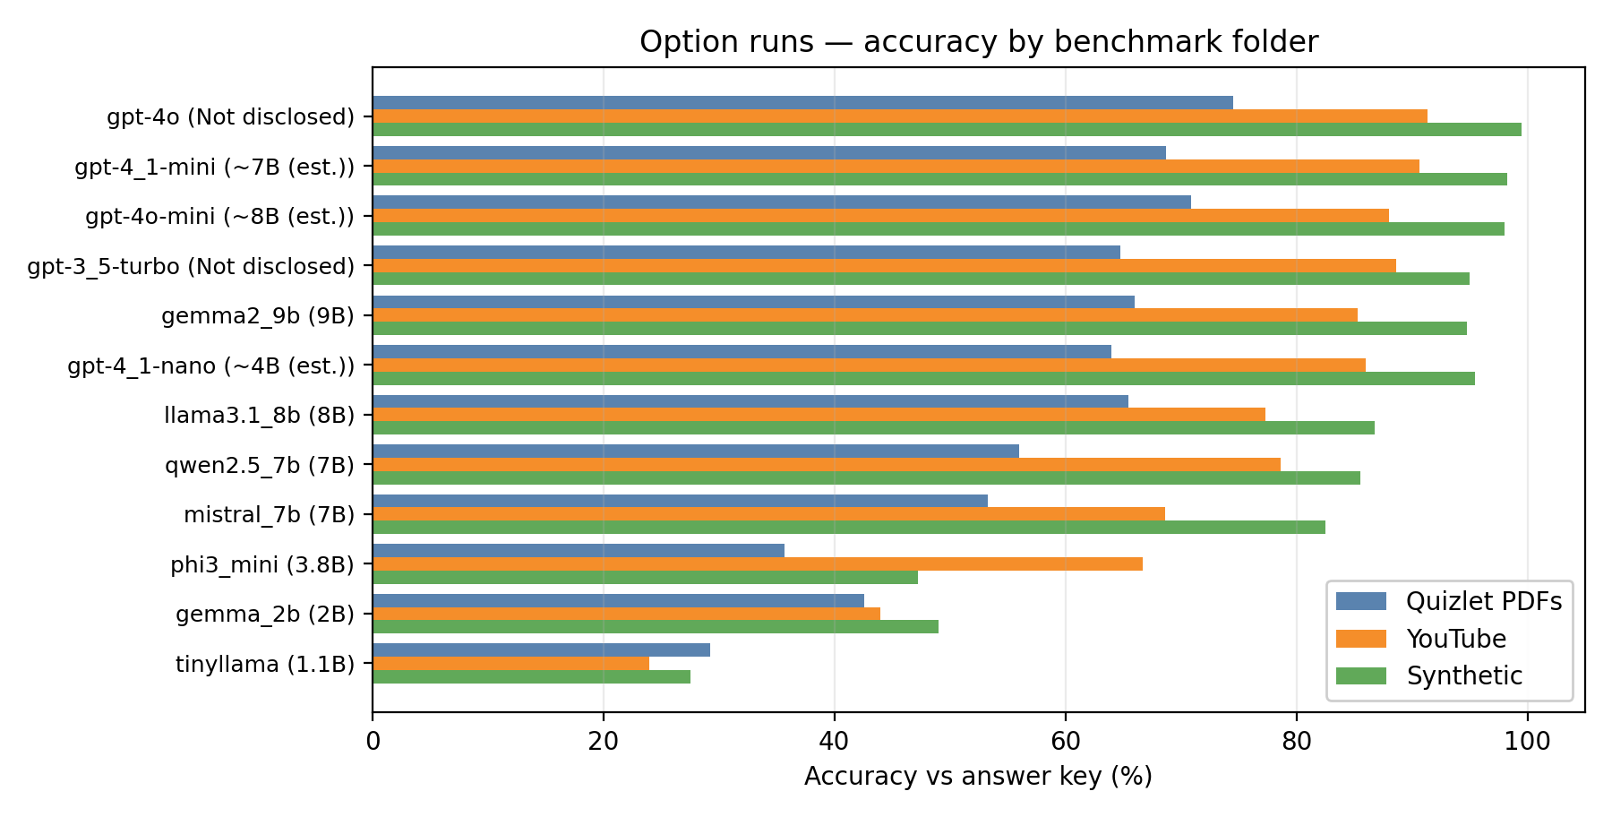
Figure 1. MCQ accuracy by benchmark folder across all twelve model configurations. Green bars = Synthetic, orange = YouTube, blue = Quizlet PDFs.
Takeaway: The same model family can appear exam-ready on synthetic items yet substantially weaker on Quizlet PDF-style material. Any single-corpus number is a partial view of true capability.
Takeaway: Open-weight parameter scale orders models roughly as expected on the Quizlet (hardest) axis, but performance separations compress on synthetic data, where the evaluation is less discriminative.

3.2 Mean MCQ Accuracy Across Corpora (Unweighted)
Figure 2 renders the same data as a heatmap (left), making within-model variance immediately readable as horizontal stripes of warmer (lower-accuracy) or cooler (higher-accuracy) cells. Table 1 then provides the numeric values for direct comparison.
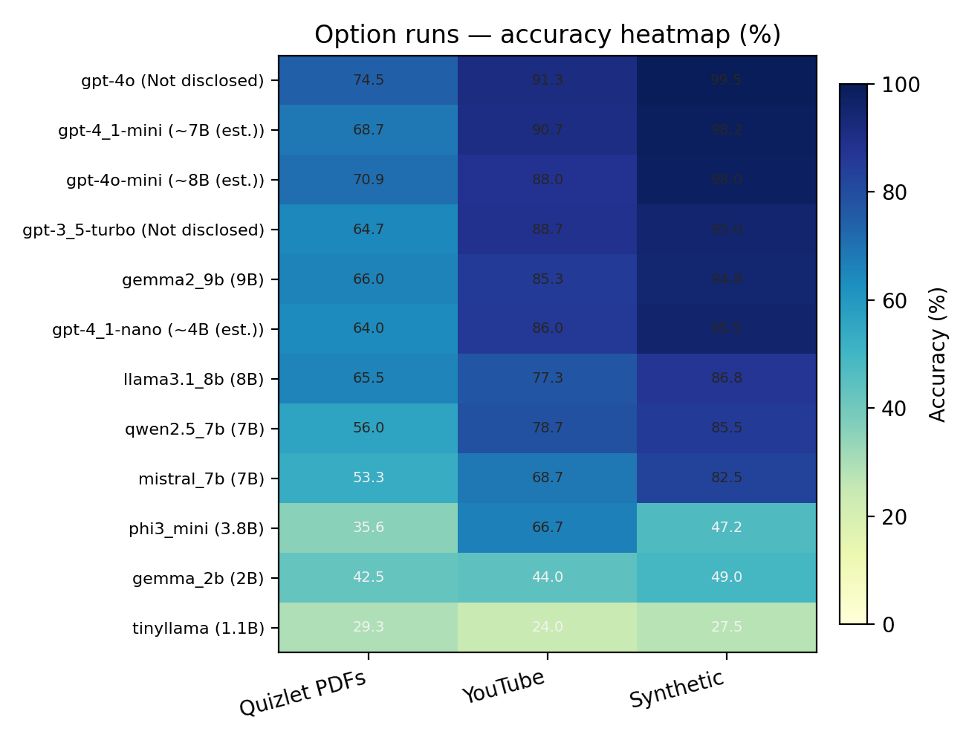
Figure 2. Accuracy heatmap (%) by model and benchmark folder. Each row is a model; each column is a corpus. Color intensity encodes accuracy.
Takeaway: The heatmap makes domain shift visible as horizontal stripes of warm vs. cool cells within the same row—the "cooling" effect from left to right (Quizlet → YouTube → Synthetic) is consistent across nearly all models.

Table 1. Mean MCQ accuracy across corpora (unweighted average of three corpus scores).
Model | Parameters | Quizlet PDFs | YouTube | Synthetic | Mean
GPT-4o | Not disclosed | 74.55% | 91.33% | 99.50% | 88.46%
GPT-4.1 mini | ~7B (est.) | 68.73% | 90.67% | 98.25% | 85.88%
GPT-4o mini | ~8B (est.) | 70.91% | 88.00% | 98.00% | 85.64%
GPT-3.5 Turbo | Not disclosed | 64.73% | 88.67% | 95.00% | 82.80%
Gemma 2 9B | 9B | 66.00% | 85.33% | 94.75% | 82.03%
GPT-4.1 nano | ~4B (est.) | 64.00% | 86.00% | 95.50% | 81.83%
Llama 3.1 8B | 8B | 65.45% | 77.33% | 86.75% | 76.51%
Qwen2.5 7B | 7B | 56.00% | 78.67% | 85.50% | 73.39%
Mistral 7B | 7B | 53.27% | 68.67% | 82.50% | 68.15%
Phi-3 Mini | 3.8B | 35.64% | 66.67% | 47.25% | 49.85%
Gemma 2 2B | 2B | 42.55% | 44.00% | 49.00% | 45.18%
TinyLlama | 1.1B | 29.27% | 24.00% | 27.50% | 26.92%

3.3 Per-Corpus MCQ Accuracy Tables
The following three tables break down letter accuracy for each corpus individually, showing the raw correct/wrong counts alongside the final accuracy percentage.

Table A — Quizlet / PDF-Derived Corpus (550 overlapping items)
Model | Parameters | Correct | Wrong | Accuracy
GPT-4o | Not disclosed | 410 | 140 | 74.55%
GPT-4o mini | ~8B (est.) | 390 | 160 | 70.91%
GPT-4.1 mini | ~7B (est.) | 378 | 172 | 68.73%
Gemma 2 9B | 9B | 363 | 187 | 66.00%
Llama 3.1 8B | 8B | 360 | 190 | 65.45%
GPT-3.5 Turbo | Not disclosed | 356 | 194 | 64.73%
GPT-4.1 nano | ~4B (est.) | 352 | 198 | 64.00%
Qwen2.5 7B | 7B | 308 | 242 | 56.00%
Mistral 7B | 7B | 293 | 257 | 53.27%
Gemma 2 2B | 2B | 234 | 316 | 42.55%
Phi-3 Mini | 3.8B | 196 | 354 | 35.64%
TinyLlama | 1.1B | 161 | 389 | 29.27%

Table B — YouTube-Oriented Corpus (150 items)
Model | Parameters | Correct | Wrong | Accuracy
GPT-4o | Not disclosed | 137 | 13 | 91.33%
GPT-4.1 mini | ~7B (est.) | 136 | 14 | 90.67%
GPT-3.5 Turbo | Not disclosed | 133 | 17 | 88.67%
GPT-4o mini | ~8B (est.) | 132 | 18 | 88.00%
GPT-4.1 nano | ~4B (est.) | 129 | 21 | 86.00%
Gemma 2 9B | 9B | 128 | 22 | 85.33%
Qwen2.5 7B | 7B | 118 | 32 | 78.67%
Llama 3.1 8B | 8B | 116 | 34 | 77.33%
Mistral 7B | 7B | 103 | 47 | 68.67%
Phi-3 Mini | 3.8B | 100 | 50 | 66.67%
Gemma 2 2B | 2B | 66 | 84 | 44.00%
TinyLlama | 1.1B | 36 | 114 | 24.00%

Table C — Synthetic Handbook-Style Corpus (400 items)
Model | Parameters | Correct | Wrong | Accuracy
GPT-4o | Not disclosed | 398 | 2 | 99.50%
GPT-4.1 mini | ~7B (est.) | 393 | 7 | 98.25%
GPT-4o mini | ~8B (est.) | 392 | 8 | 98.00%
GPT-4.1 nano | ~4B (est.) | 382 | 18 | 95.50%
GPT-3.5 Turbo | Not disclosed | 380 | 20 | 95.00%
Gemma 2 9B | 9B | 379 | 21 | 94.75%
Llama 3.1 8B | 8B | 347 | 53 | 86.75%
Qwen2.5 7B | 7B | 342 | 58 | 85.50%
Mistral 7B | 7B | 330 | 70 | 82.50%
Gemma 2 2B | 2B | 196 | 204 | 49.00%
Phi-3 Mini | 3.8B | 189 | 211 | 47.25%
TinyLlama | 1.1B | 110 | 290 | 27.50%

3.4 YouTube Corpus — Rationale Alignment (LLM-as-Judge)
Letter accuracy tells us whether a model picks the right answer; it says nothing about whether the model's reasoning is sound. To address this, we deployed a gpt-4.1-mini judge to score model rationales on the YouTube corpus against reference explanations on a four-point scale (0 = entirely wrong, 3 = fully aligned). Table 2 summarizes the judge output across all 148 scored items.
Table 2. Judge summary — alignment of model rationales to reference explanations (YouTube corpus, gpt-4.1-mini judge, n = 148).
Model | n | MCQ Acc. | Avg Align | Score 0 (%) | Score 1 (%)
GPT-4o | 148 | 91.22% | 2.87 | 1.35% | 3.38%
GPT-4.1 mini | 148 | 90.54% | 2.86 | 0.68% | 4.05%
GPT-4o mini | 148 | 87.84% | 2.78 | 0.68% | 8.11%
GPT-4.1 nano | 148 | 85.81% | 2.73 | 0.68% | 10.81%
GPT-3.5 Turbo | 148 | 88.51% | 2.70 | 2.70% | 9.46%
Gemma 2 9B | 148 | 85.14% | 2.70 | 1.35% | 10.81%
Qwen2.5 7B | 148 | 78.38% | 2.55 | 2.03% | 14.86%
Llama 3.1 8B | 148 | 77.03% | 2.50 | 2.03% | 20.27%
Mistral 7B | 148 | 68.24% | 2.46 | 2.03% | 18.24%
Phi-3 Mini | 148 | 66.89% | 2.26 | 2.70% | 24.32%
Gemma 2 2B | 148 | 43.92% | 1.64 | 14.86% | 36.49%
TinyLlama | 148 | 24.32% | 0.78 | 37.84% | 50.00%

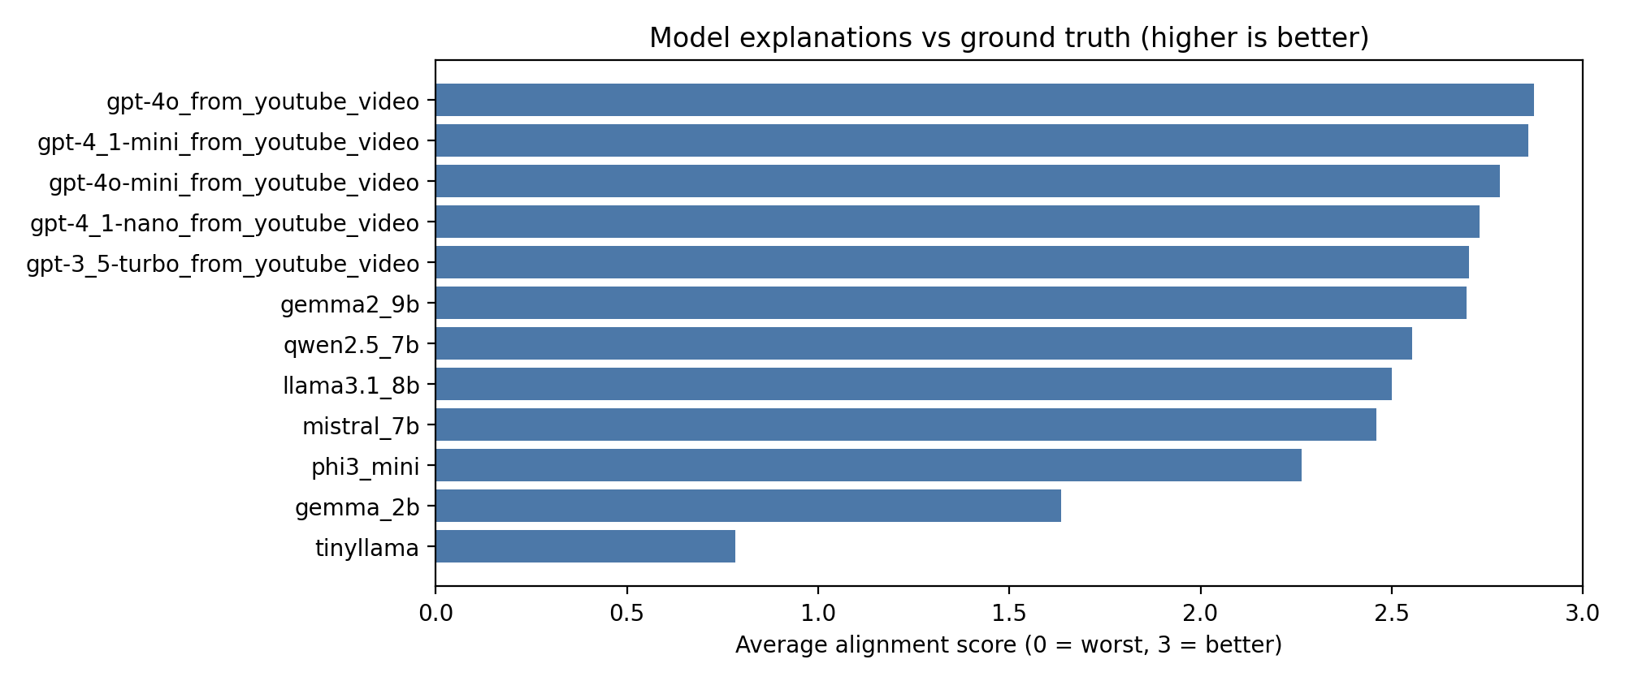
Figure 3. Average alignment score (0–3) by model on the YouTube corpus. Higher is better.
Takeaway: Mean alignment ranks models similarly to MCQ accuracy, but is not identical: it rewards reference-shaped reasoning, not merely the correct letter. This distinction matters for products that will show explanations to learners.

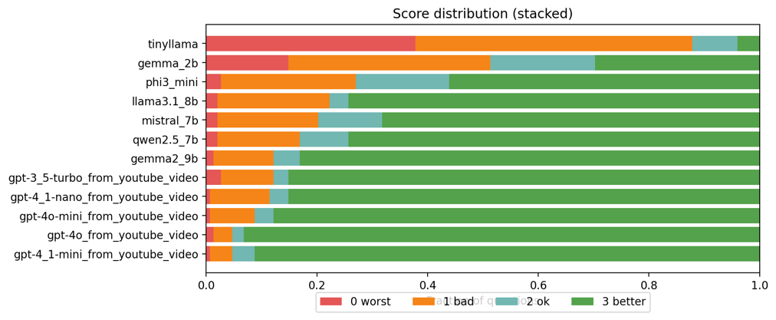
Figure 4. Score distribution (stacked) by model. Green = score 3 (best); red = score 0 (worst).
Takeaway: Top models show heavy mass at score 3; weak baselines accumulate at scores 0 and 1. Mid-tier models often show a thick 'score 2' band—mostly the right idea, but with imperfect wording—precisely where human review adds the most value.

The scatter plot in Figure 5 reveals a positive correlation between MCQ accuracy and average alignment score. This is reassuring: models that get more questions right also tend to produce better-aligned explanations. However, the relationship is not perfectly linear, and deviations from the diagonal are worth investigating—some models may be "lucky" on the letter choice without understanding why an answer is correct, while others may produce well-reasoned explanations that nonetheless end in the wrong letter.
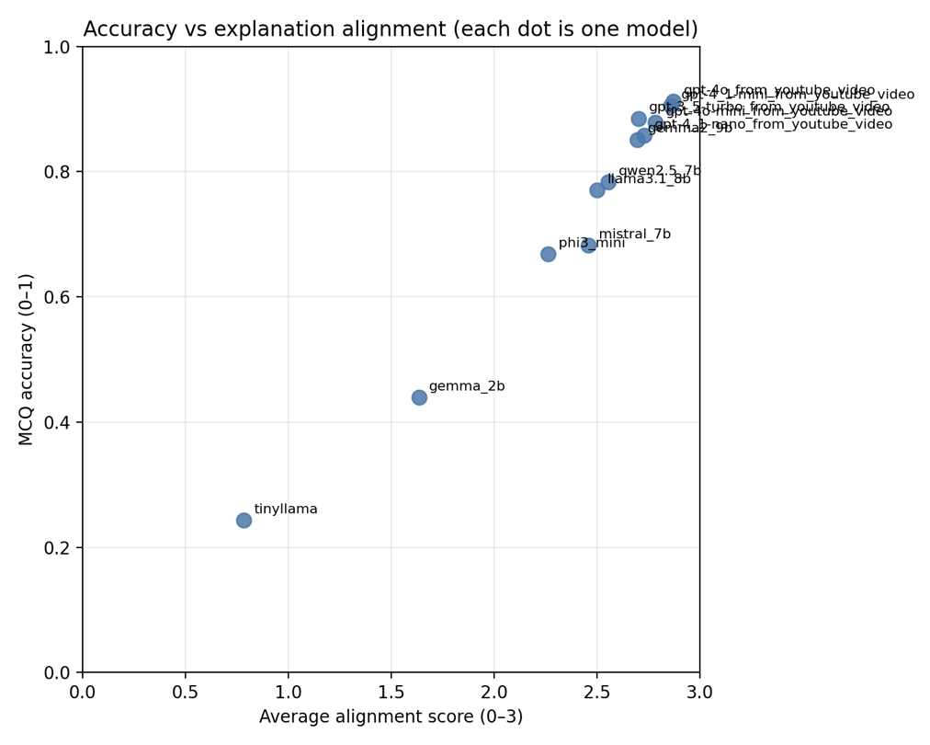
Figure 5. Accuracy vs. explanation alignment. Each point represents one model. The positive correlation supports using MCQ probes as a first screen, with judge or human checks when explanations will be shown to users.
Takeaway: Positive correlation supports using inexpensive MCQ probes as a first screening mechanism. Explanation quality checks should be added when model rationales are exposed to learners.

3.5 Curriculum Bucket Ablations (MCQ Accuracy by Topic)
One of the most practically useful analyses is to disaggregate accuracy by curriculum topic. A model that achieves 75% overall accuracy might be nearly perfect on basic concepts but systematically weak on commercial insurance—a fact that is completely obscured by the aggregate number. The bucket analysis exposes exactly this kind of uneven coverage.

Quizlet / PDF-Derived Corpus
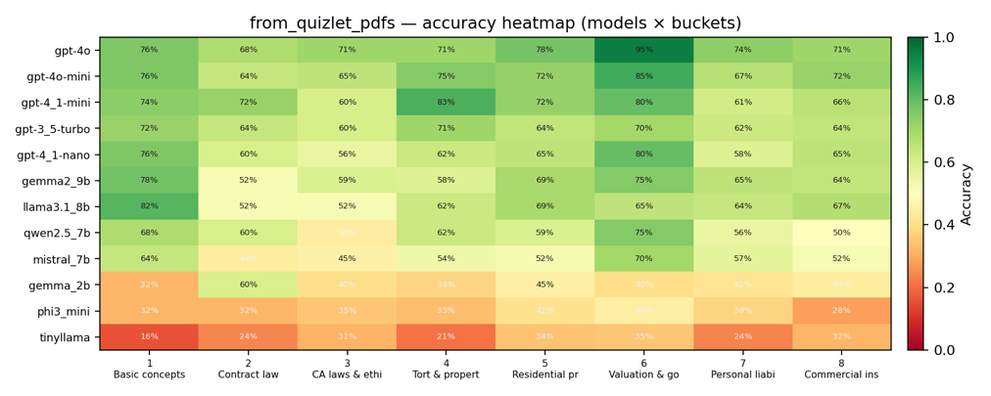
Figure 6. Per-bucket accuracy heatmap for the Quizlet / PDF-derived corpus. Rows = models (sorted by mean accuracy); columns = curriculum buckets.
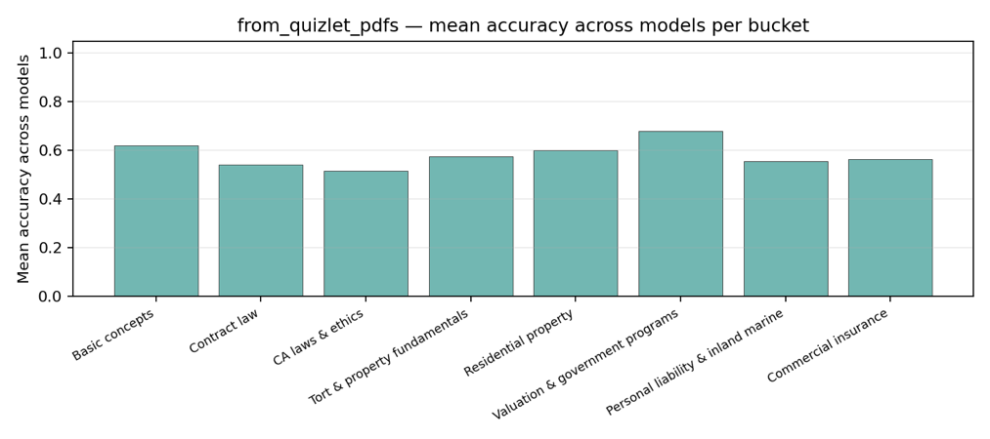
Figure 7. Mean accuracy across models per curriculum bucket (Quizlet / PDF-derived corpus).
Takeaway: Vertical 'cold' columns identify topic buckets that systematically depress accuracy across many models—these are high-priority targets for harder drill sets or instructor review.
Takeaway: Buckets with consistently low mean accuracy are hard for the field as a whole, not just for individual model families.

YouTube-Oriented Corpus
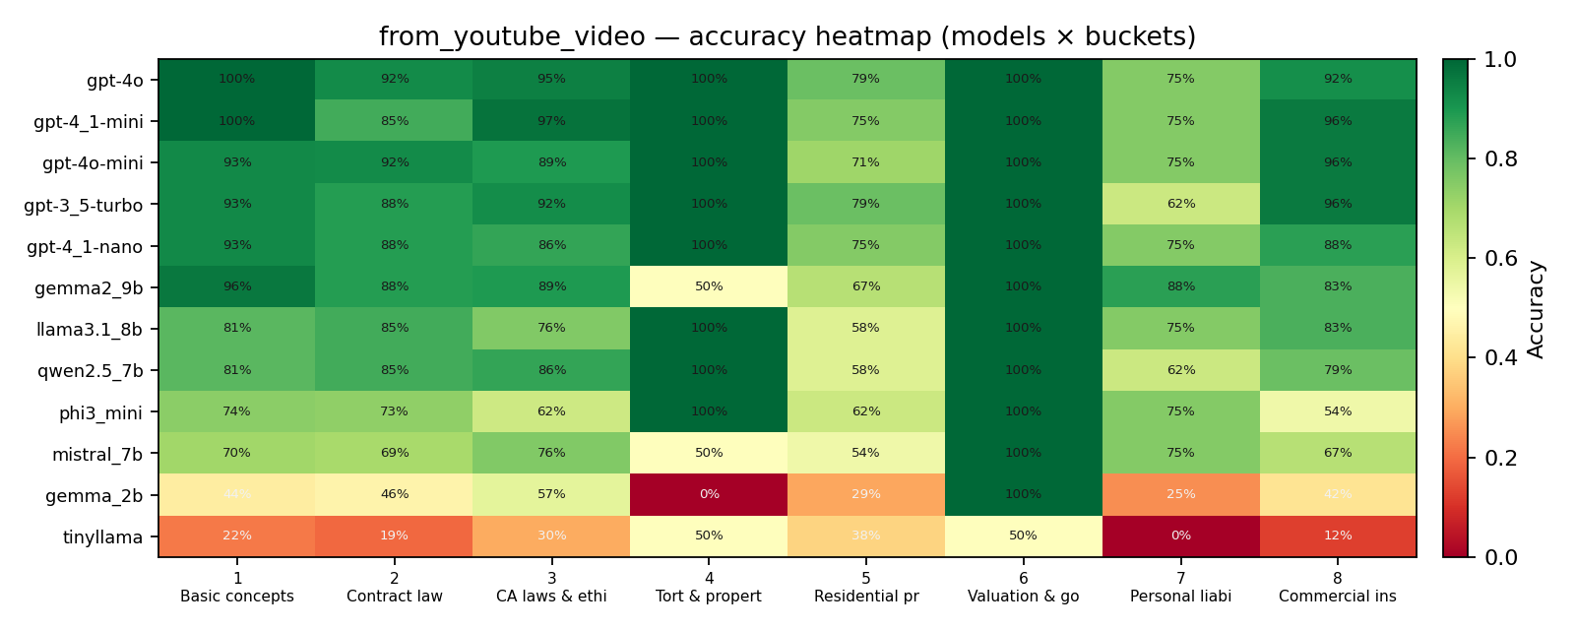
Figure 8. Per-bucket accuracy heatmap for the YouTube-oriented corpus.
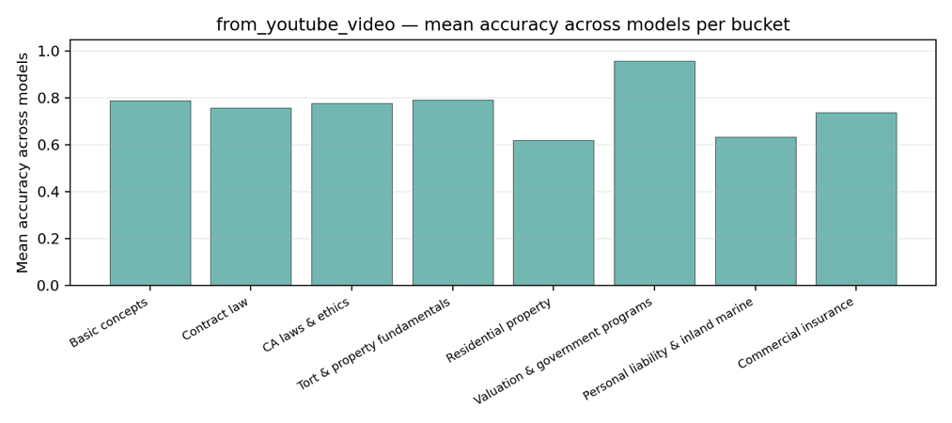
Figure 9. Mean accuracy per bucket (YouTube corpus). Note sparse bucket cells with N = 150 total items; interpret alongside raw counts.
Takeaway: With only 150 items, some bucket cells are sparse. Low-accuracy cells should be interpreted alongside the companion bucket_accuracy_long.csv counts before drawing conclusions.
Takeaway: Mean bucket accuracy on the YouTube corpus complements the judge analysis: a model can score well on letters within a bucket while still producing poorly-aligned explanations.

Synthetic Corpus
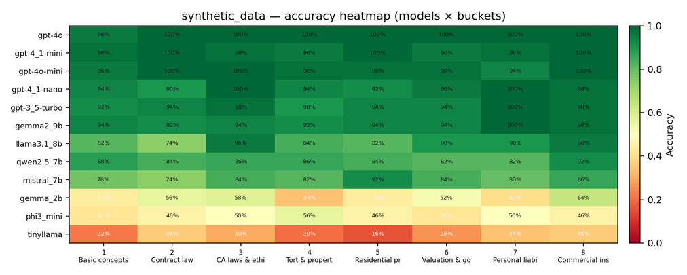
Figure 10. Per-bucket accuracy heatmap for the synthetic corpus. Overall 'greener' appearance reflects the high ceiling accuracy of controlled generation.
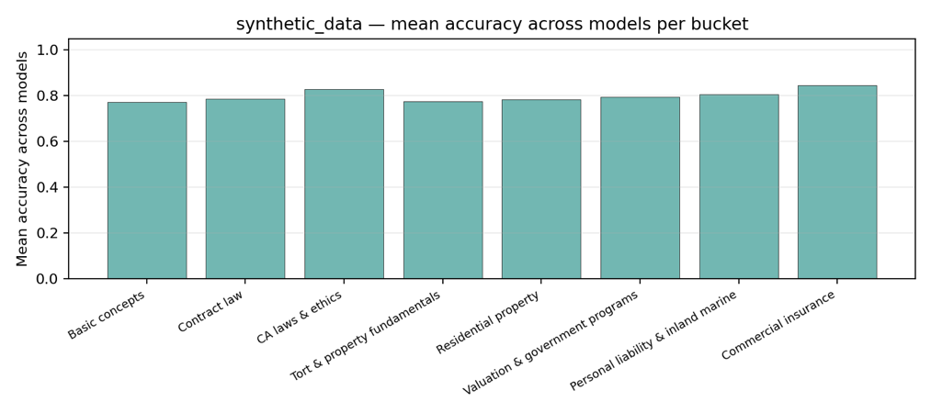
Figure 11. Mean accuracy per curriculum bucket (synthetic corpus). Performance is consistently high except for sub-3B models.
Takeaway: Synthetic heatmaps are visually greener overall, consistent with high ceiling accuracy. Residual 'red pockets' reveal which curriculum slices remain hard for sub-8B models.
Takeaway: When mean bucket accuracy is high, the evaluation shifts from identifying 'who passes' to ranking performance among strong systems. Synthetic results are best used for regression testing after prompt or pipeline changes, not as primary evidence of exam readiness.

4. Discussion

4.1 On the Question of "Exam Readiness"
If the benchmark is framed strictly as passing a multiple choice exam, then models above ~3B parameters are generally sufficient to pass on the practice style corpora. Performance saturates quickly beyond this scale, with even id sized models achieving accuracy levels consistent with a notional passing threshold.
Importantly, this condition holds even under adversarial adjustments to the synthetic dataset. We intentionally twisted options to be closer to the correct answers, increasing ambiguity and reducing the gap between choices. Despite this the models at or above the ~3B scale continued to perform strongly. However, it is important to acknowledge that these questions are generated by a OpenAI model, and this may partially contribute to the observed performance.
This does not mean that LLMs are ready to replace expert preparation, nor that they are reliable enough to stake regulatory and financial outcomes on their answers. Operational licensing exams impose procedural demands, reading-comprehension challenges, and adversarially constructed distractors that MCQ benchmarks of the kind evaluated here do not fully capture. The more defensible research conclusion is that practice-style MCQ accuracy saturates quickly with scale; the remaining and more important work lies in validity (does item-bank performance actually predict exam outcomes?), fairness across demographic groups, calibration (how well do models know what they do not know?), and safe deployment of explanations.

4.2 Domain Shift as the Dominant Story
Rankings are broadly stable across corpora—GPT-4o consistently leads, TinyLlama consistently trails—but absolute performance moves by tens of percentage points between the Quizlet and synthetic corpora. This domain-shift effect is large enough to matter practically. A product team that benchmarks only on clean synthetic items and then deploys on noisy, real-world study PDFs will substantially overestimate in-deployment performance. The recommendation is unambiguous: never quote a single-number pass probability derived from a single item bank.

4.3 Curriculum Buckets as a Diagnostic Tool
Aggregate accuracy is a coarse signal. The bucket analysis reveals that models can be simultaneously strong on one topic and weak on another, and that certain curriculum areas (notably commercial insurance and, in some corpora, CA-specific laws and ethics) are consistently harder across the entire field of models tested. For product teams working on "balanced mastery" learning goals, these bucket-level means directly indicate where practice content needs to be deepened or made more challenging—not just whether a model is globally "good."

4.4 The Role of the LLM-as-Judge
The gpt-4.1-mini judge provides a useful signal for relative comparison and for quality sampling, but it should not be treated as ground truth on pedagogical quality—particularly when judging near-identical API model families from the same vendor. The judge's alignment score tracks MCQ accuracy roughly but not perfectly, which is precisely its value: it adds a dimension that letter-based accuracy cannot capture. Mid-tier models often occupy a "score 2" regime where the core reasoning is correct but the explanation is imprecise—exactly the range where lightweight human review would add the most value before explanations are surfaced to learners.

5. Conclusion

This paper has presented a multi-corpus, multi-metric evaluation of large language models on California property-and-casualty insurance licensing–style multiple-choice questions. The evaluation spans three corpora with deliberately different characteristics—real-world extraction noise, video-transcript alignment, and controlled synthetic generation—and three measurement dimensions: letter accuracy, reference-aligned explanation quality, and topic-bucket error structure.
The evidence supports a practical conclusion for learners and product teams alike. Larger models and frontier APIs are strong practice assistants on clean or synthetic material, but messy study PDFs remain challenging. Exam prep products built on top of these models should surface uncertainty, provide citations to primary law and regulatory manuals, and maintain human oversight—especially when models are smaller than about 7B parameters or when items are adversarially constructed.
For the research community, the closing recommendation is to treat "passing" on practice MCQs as a low bar once models exceed a few billion parameters. The genuinely hard and important problem is to characterize when model advice is reliable enough to stake regulatory and financial outcomes on it—a question that demands validity studies, calibration analyses, and careful human evaluation, not just larger benchmark leaderboards.

