JENKINS TASK-02
- Configure 2 slave machines in the Jenkins master.
Created 3 instances 1 master and 2 agents
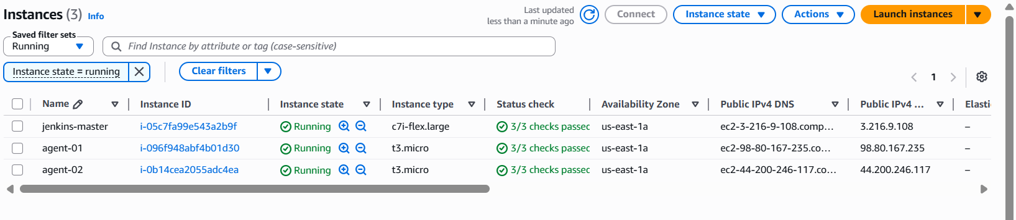
Connected to the master instance in master java already installed
Master-ip-172-31-0-217
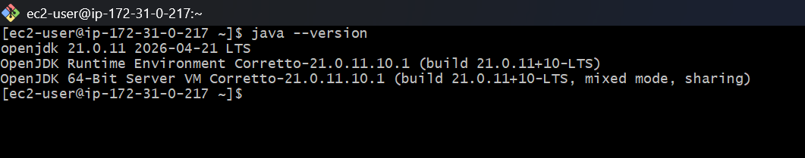
Connected to the agent-01 instance in java-21installed
Agent-01-ip-172-31-0-243
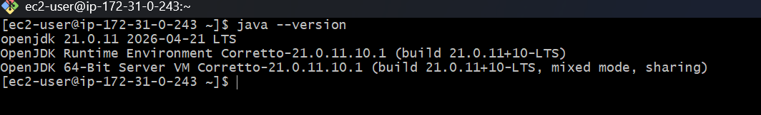
Connected to the agent-02 instance and java-21 installed
Agent-01-ip-172-31-0-67
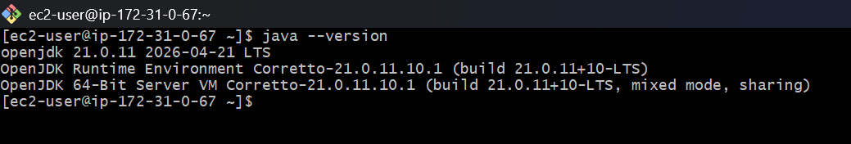
In master mechine created ssh keygen
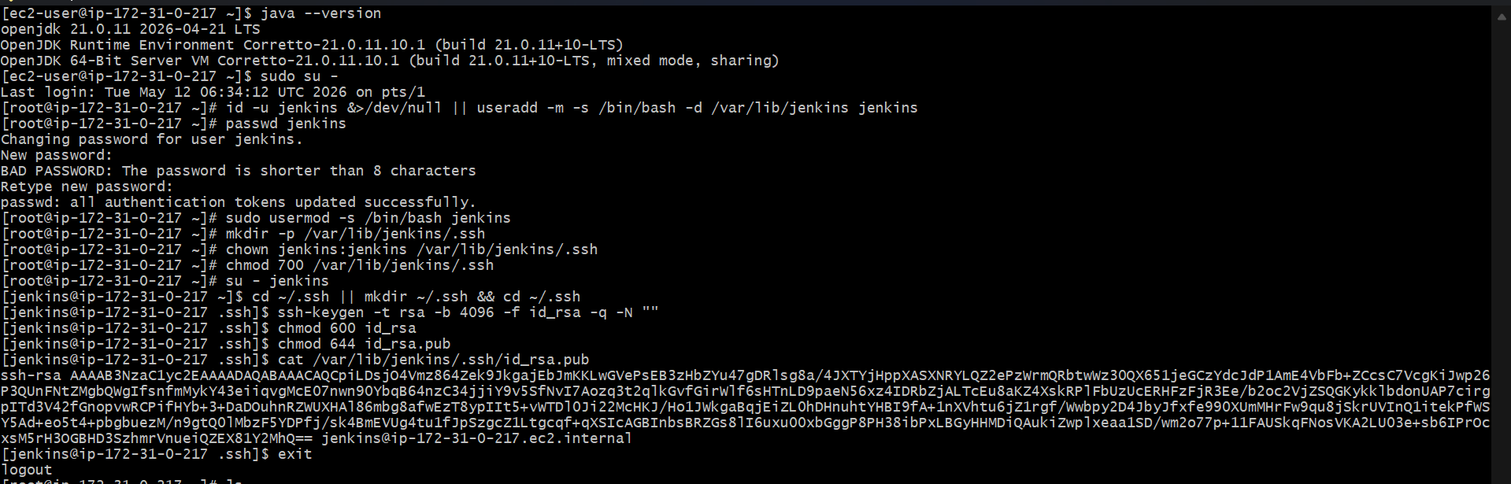
In agent-01 added the Jenkin master ssh key given permissions to the key

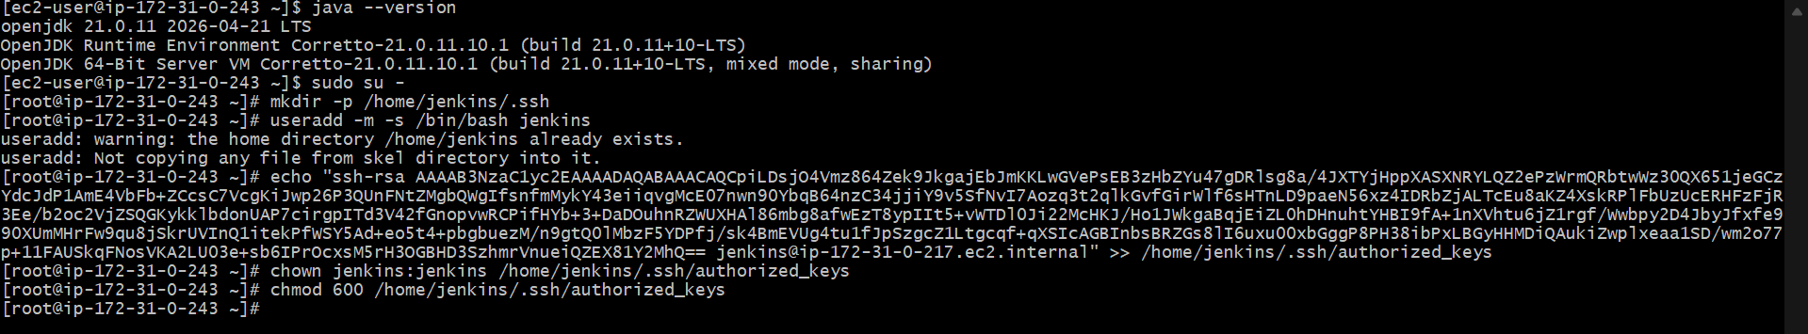
Same in agent-02 added the Jenkin master ssh key given permissions to the key
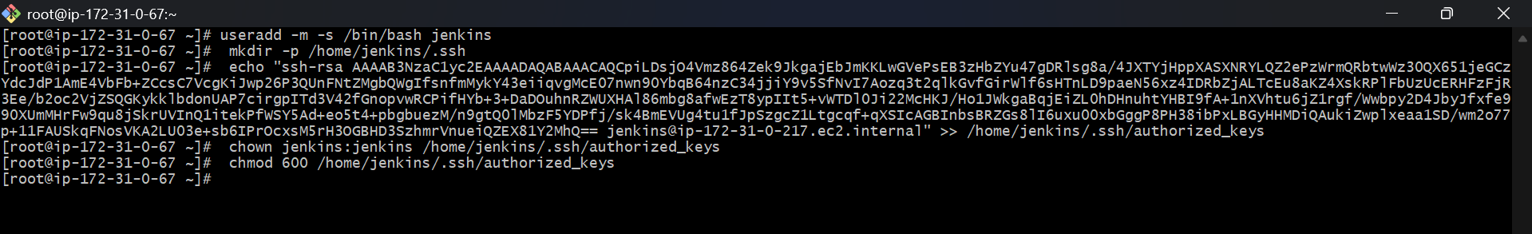
In master connect with ssh-keyscan of agent-01 public id known hosts
Now open Jenkins master and create new node for agent-01
Given label and host is agent-01 public and create credentials with ec2 pem
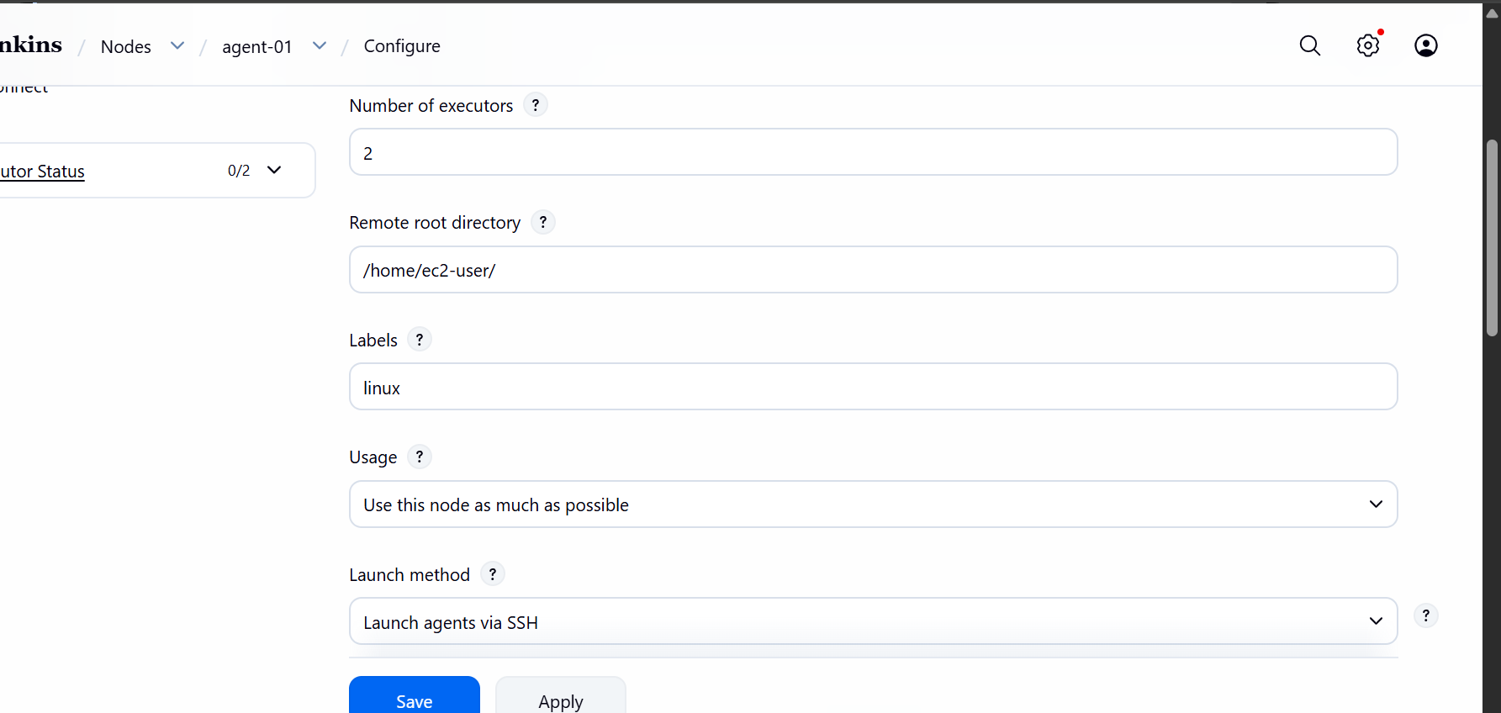
and host is agent-01 public ip adress and create credentials with ec2 pem

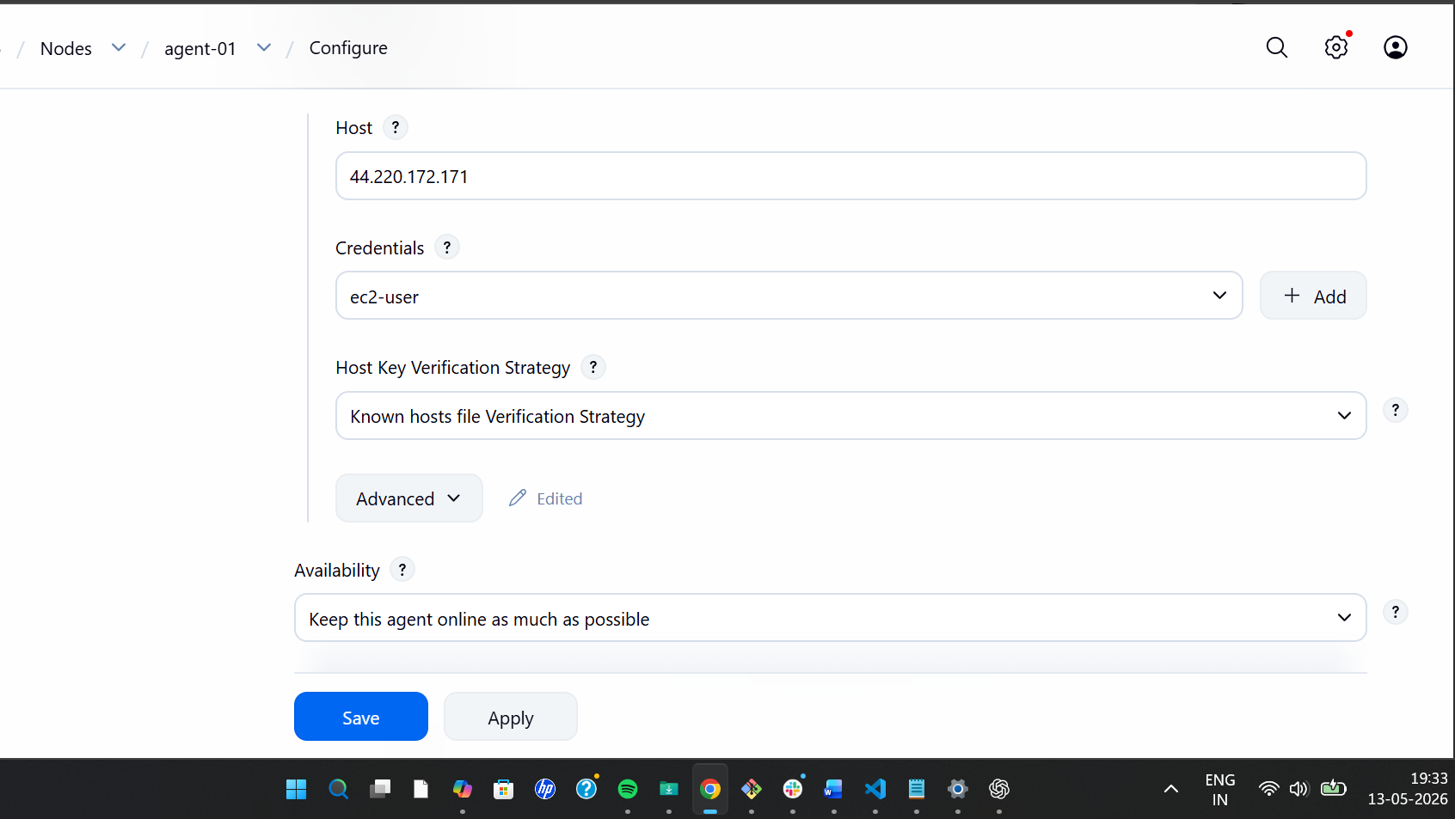
Created new item to agent-01 with linux lable which we used in agent-01 node to excute
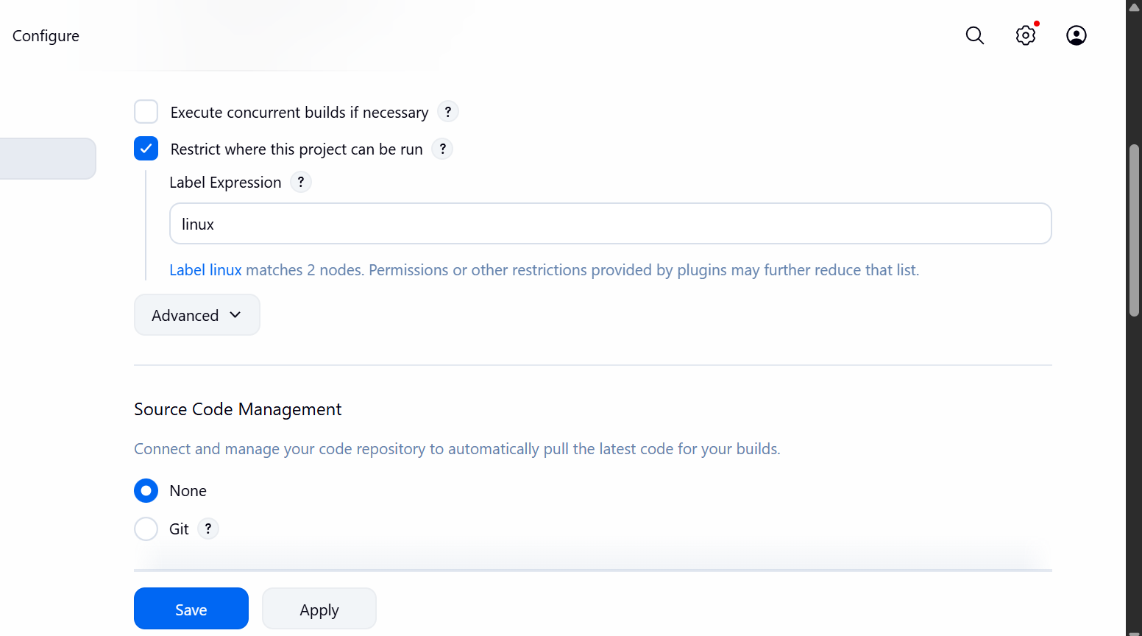
Check logs and agent successfully connected
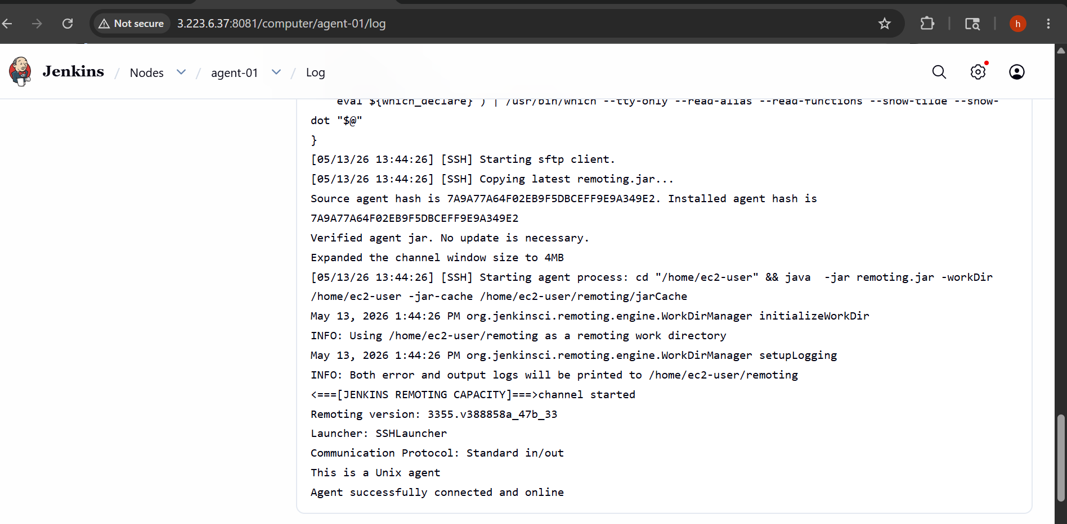
Agent-01 Console out put is success
Check logs and agent-02 successfully connected
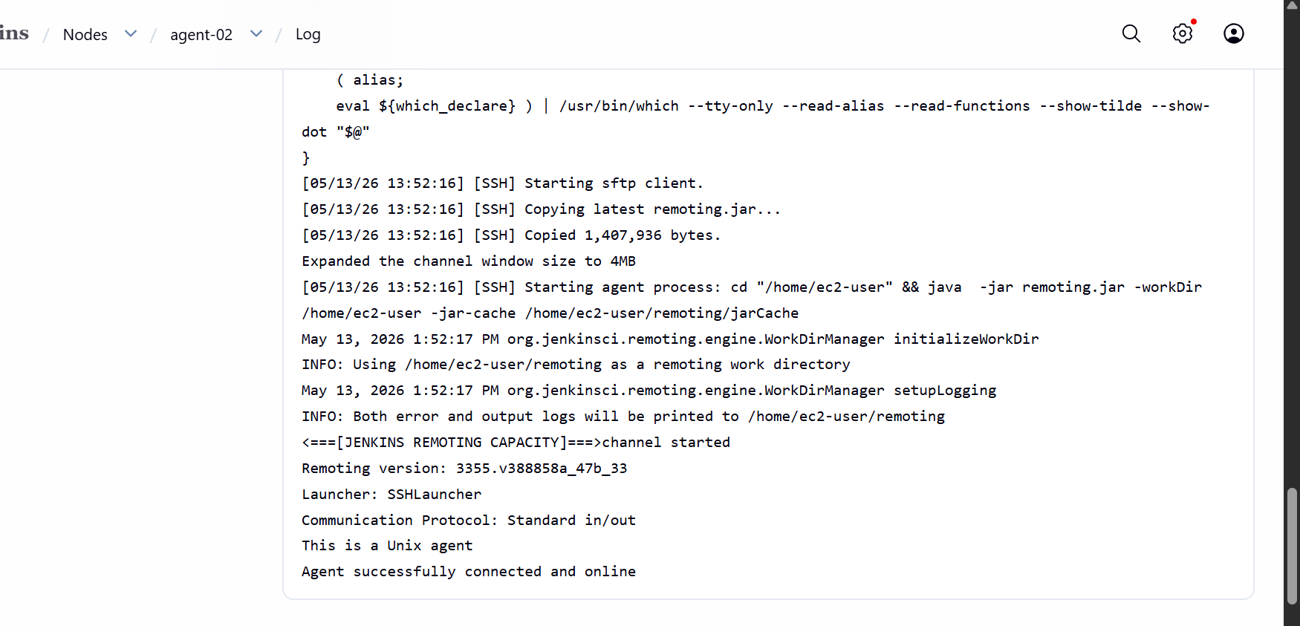
Agent-02 console output is success
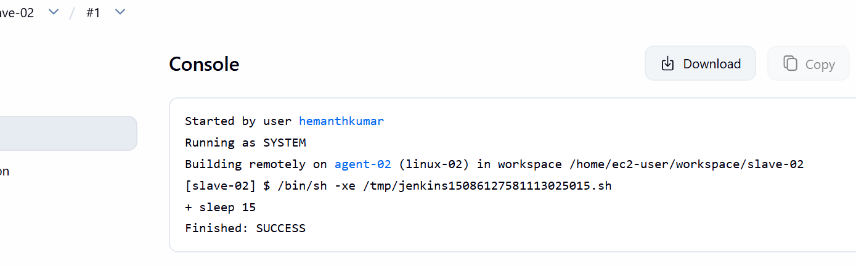

- Configure webhooks to the Jenkins job.
Create a webhooks in github repo→settings→webhhoks→create webhooks→url with path
prefix github-webhooks→created
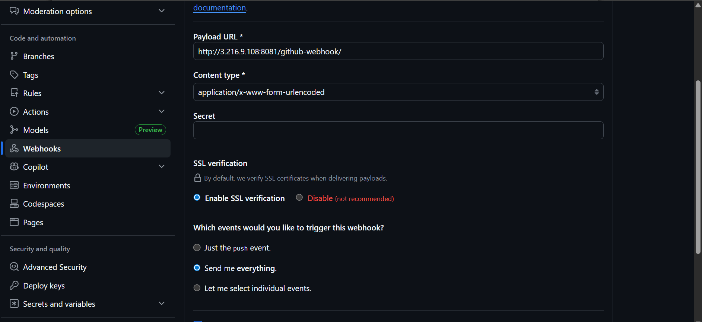
Webhook created
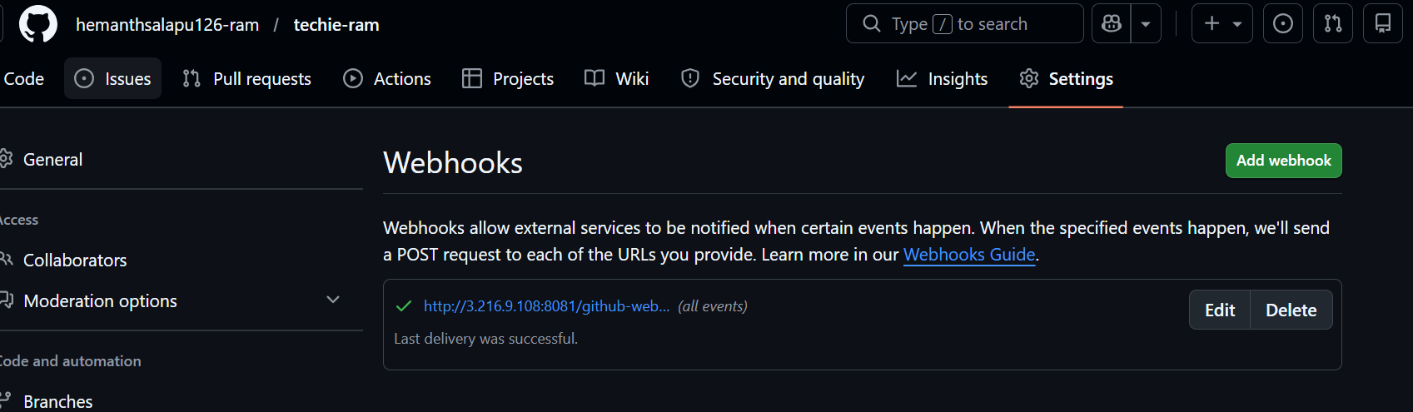
Configure git repo URL
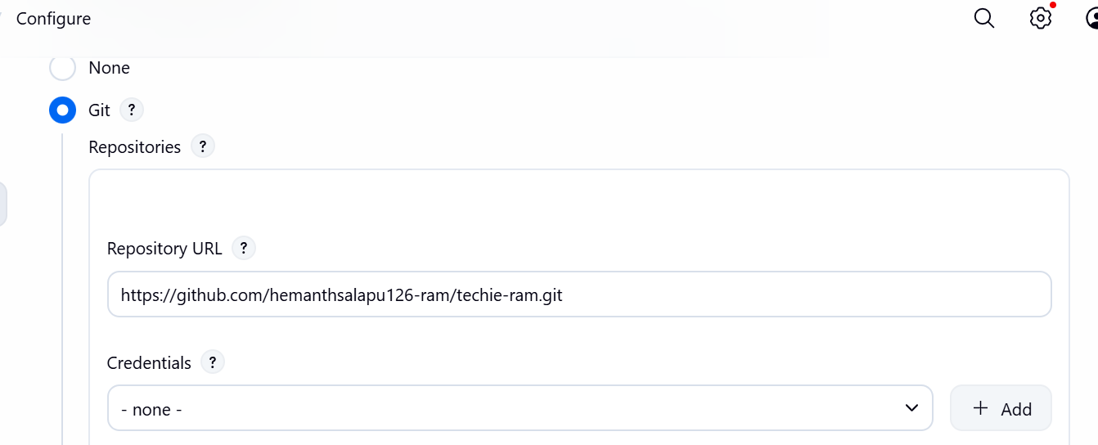
Select GitHub hook trigger
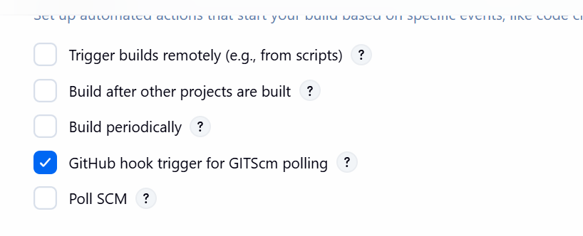
Now we can see automatically build
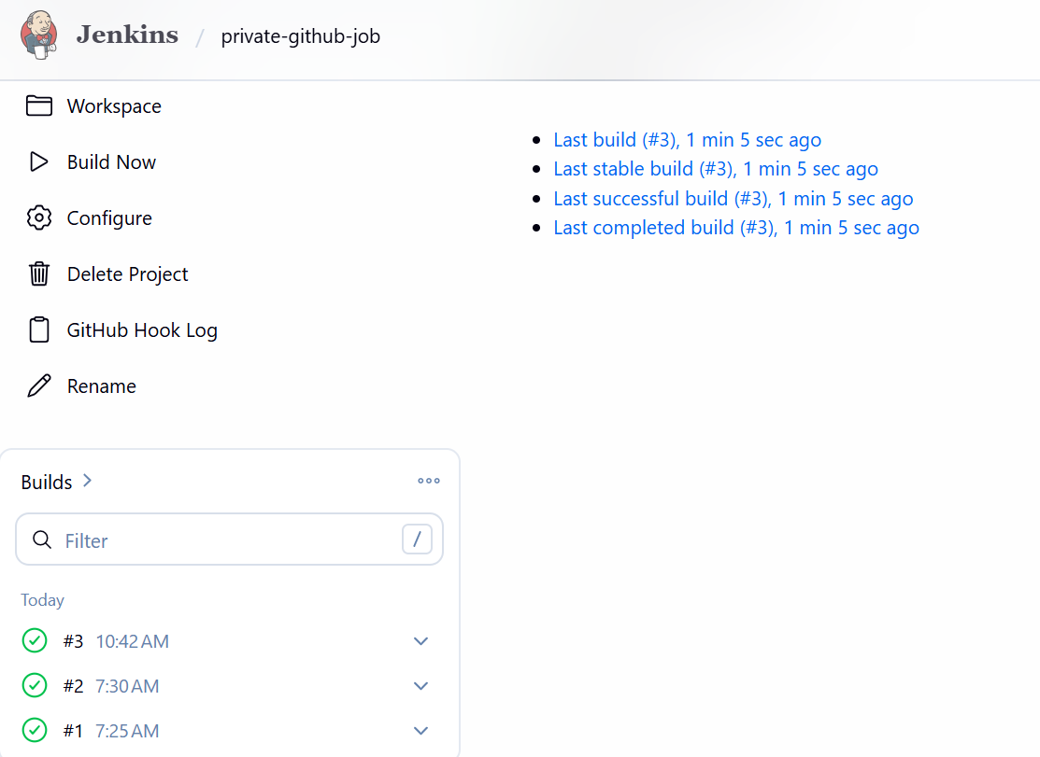
- ConfigurePoll SCMandBuild Periodicallyoptions in the Jenkins job.
Create a new item as poll -job for SCM
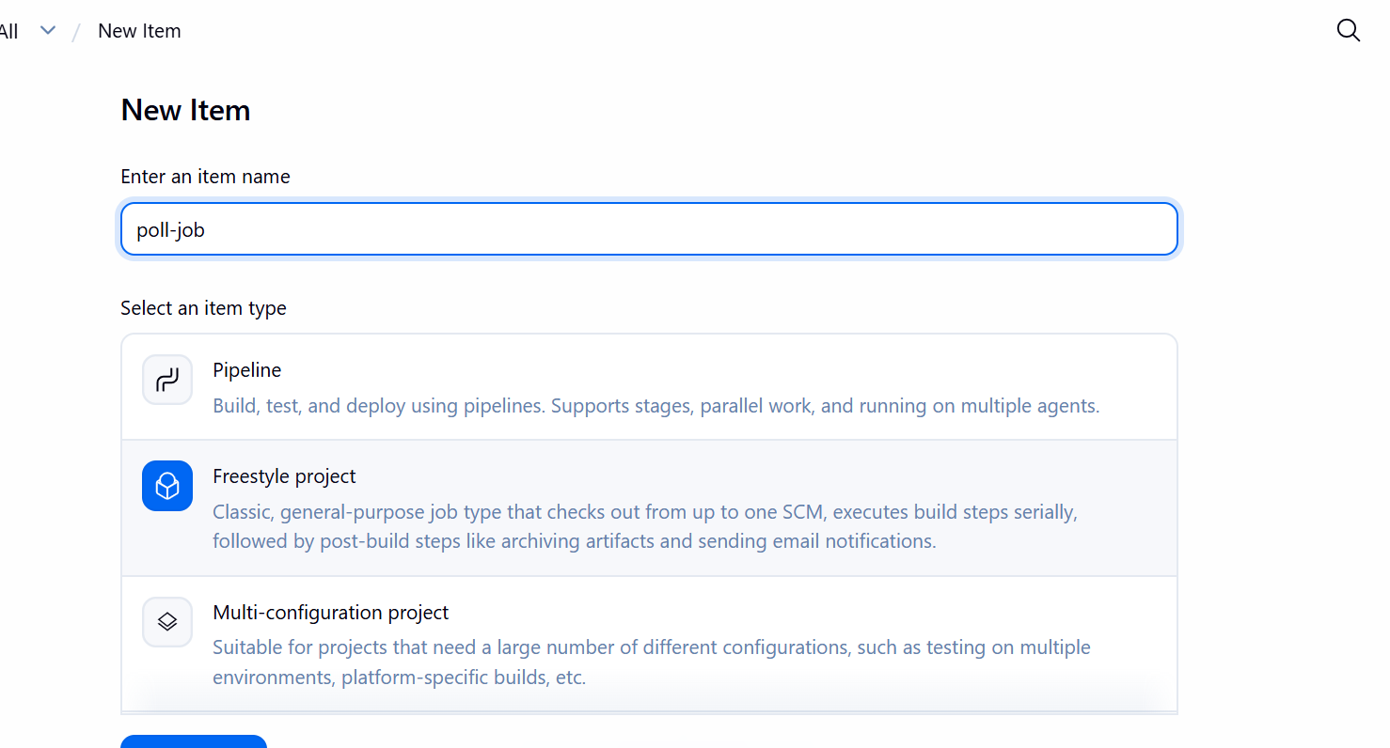
Insert git repo URL
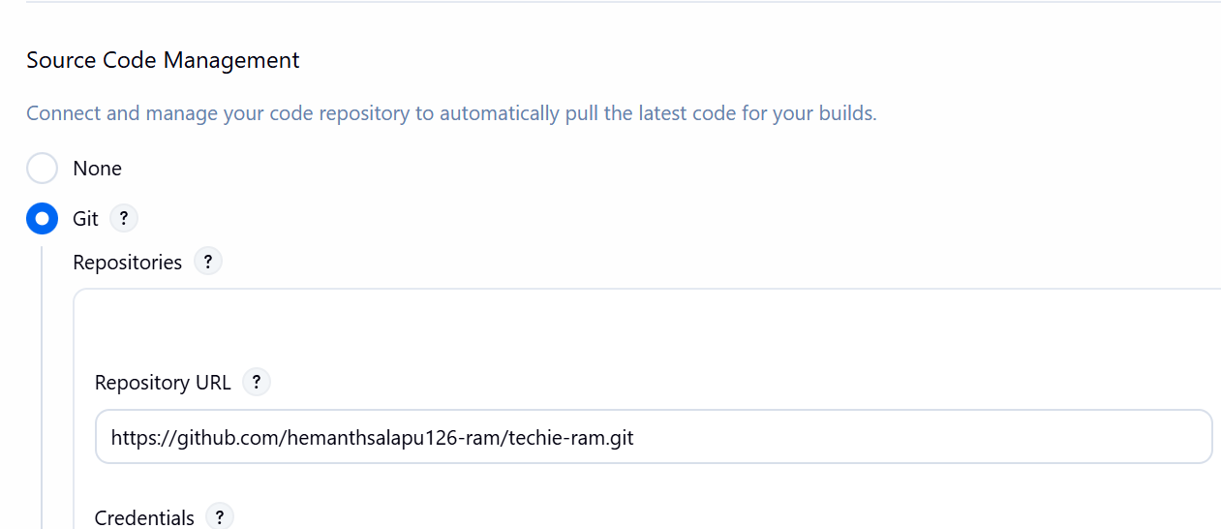
Add poll scm schedule
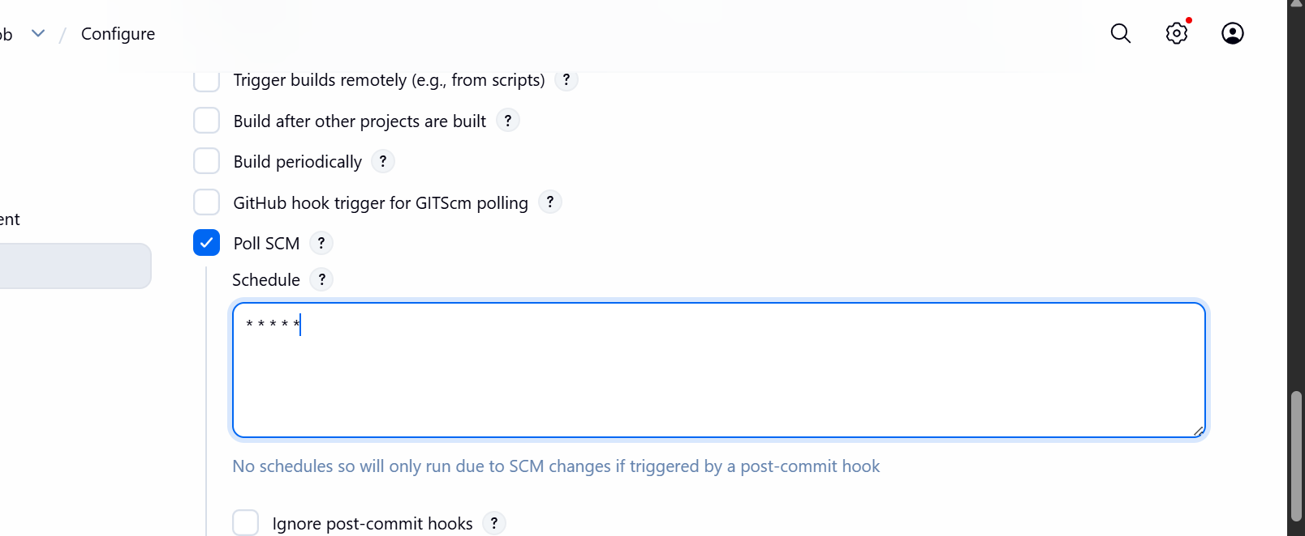
Made some changes in GitHub repo
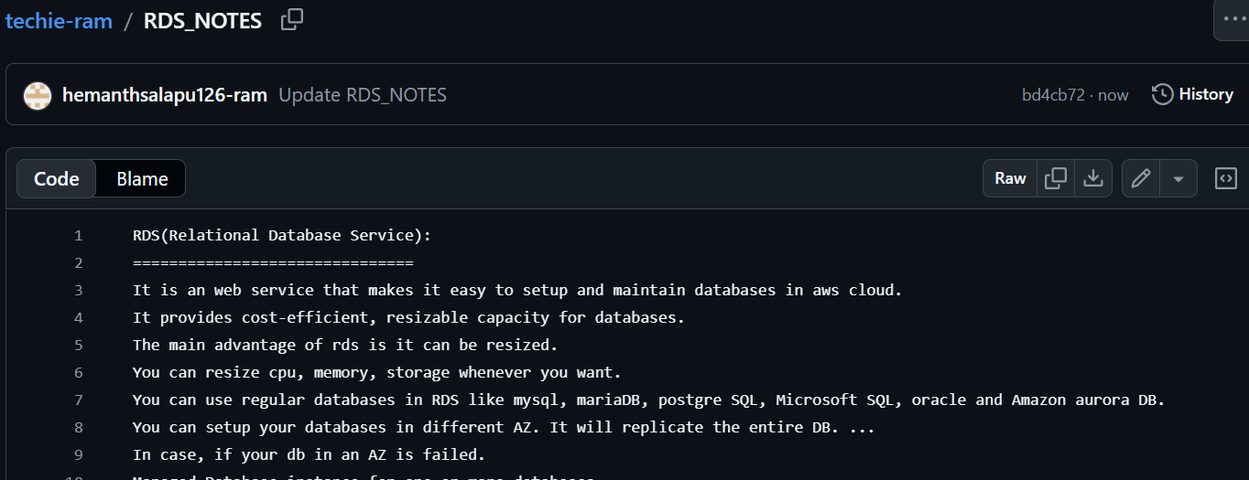
Open Jenkins and check in build automatically start new build.
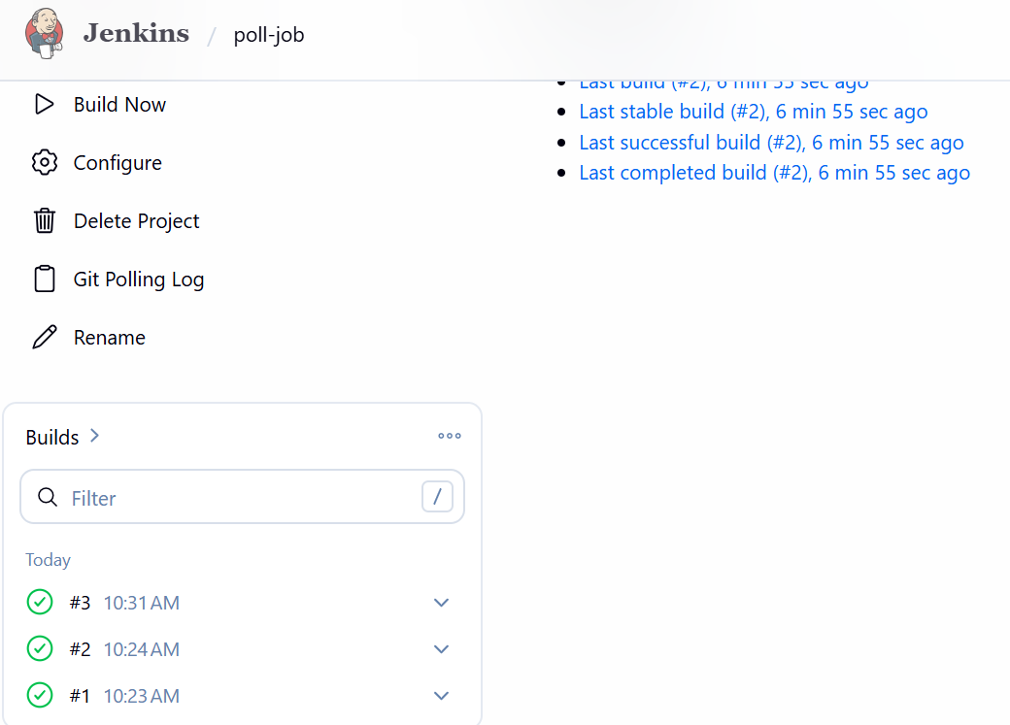
Consol output is success
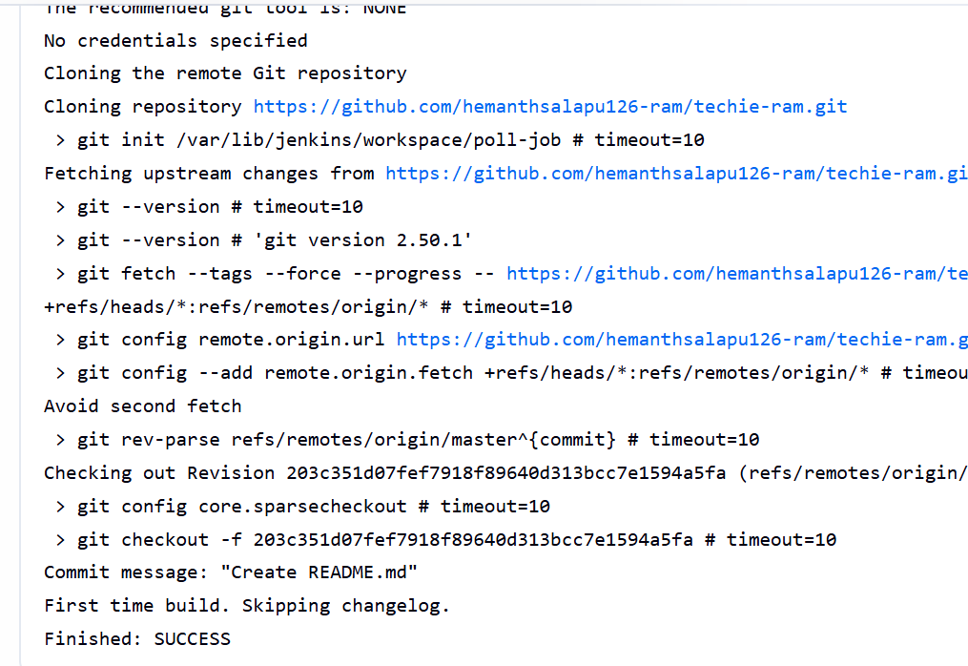
Build periodically
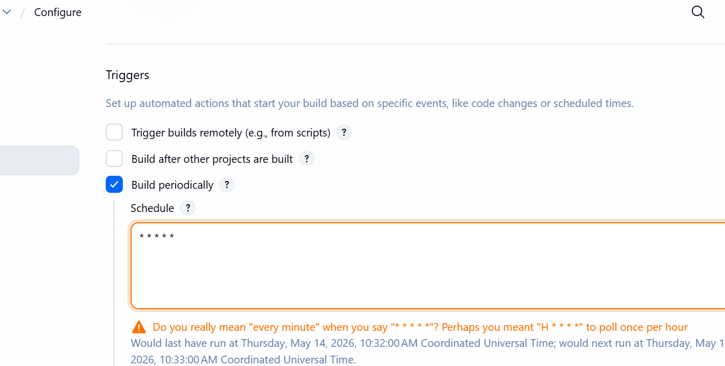
Open Jenkins and check in build automatically start new build.
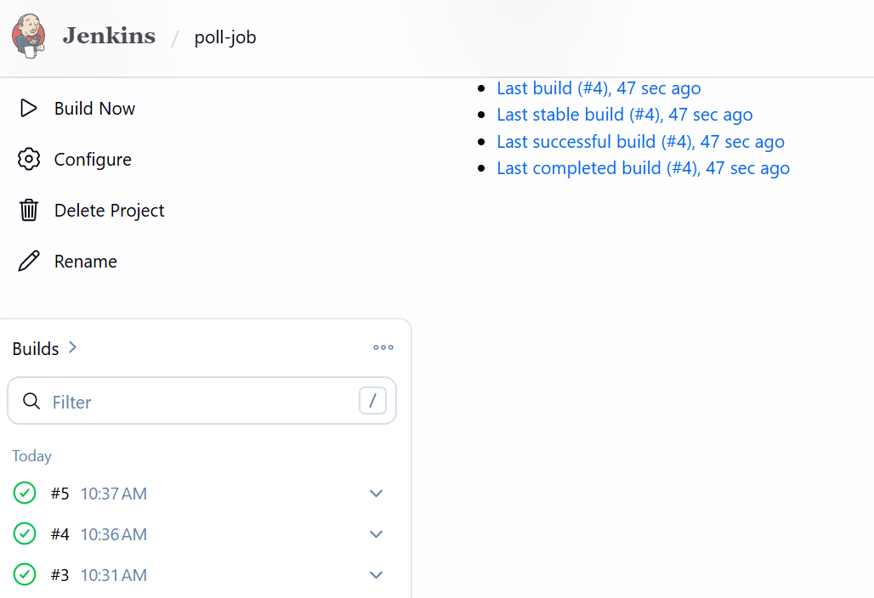
- Take a backup of the Jenkins server using abash-script.
Connected to the ec2 server where Jenkins installed
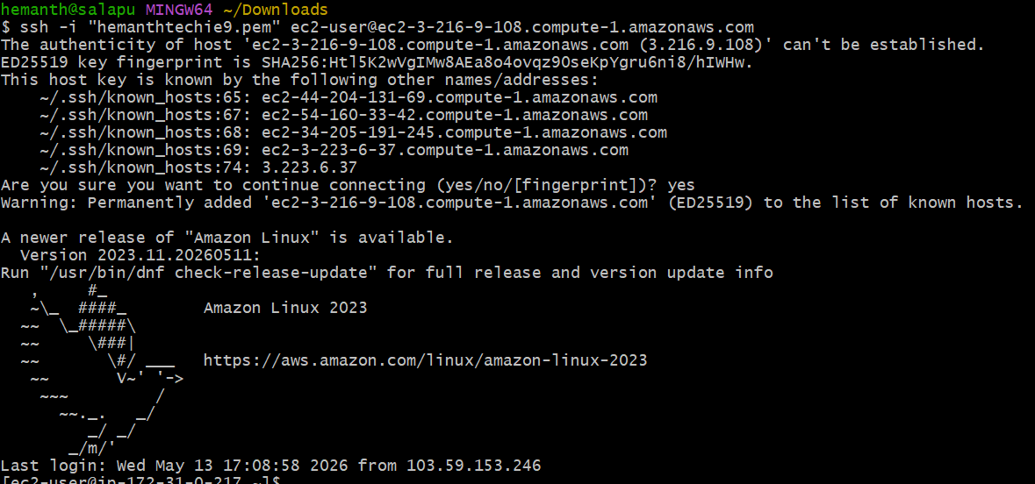
Create Backup Directory by using the command below
sudo mkdir -p /backup/Jenkins
Now create a bash script file by using vi or vim and write script
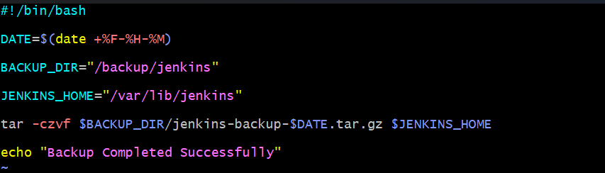
Now give permissions and run it and then backup Jenkins
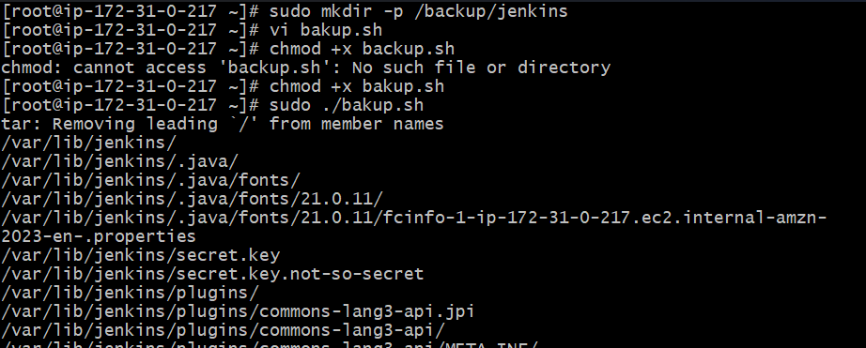
Backup done successfully now we can verify it by ls -lh
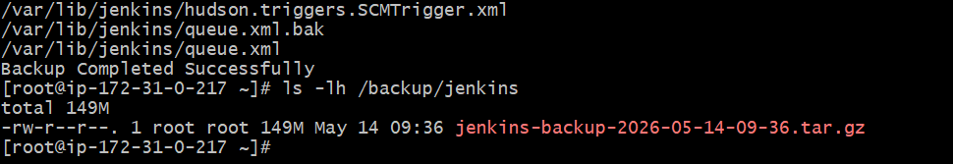
- Take a backup of Jenkins using theThinBackupplugin.
Open Manging jenkins and Install Thin Backup Plugin
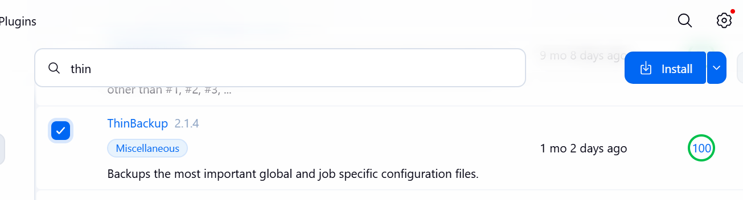
Download successfully
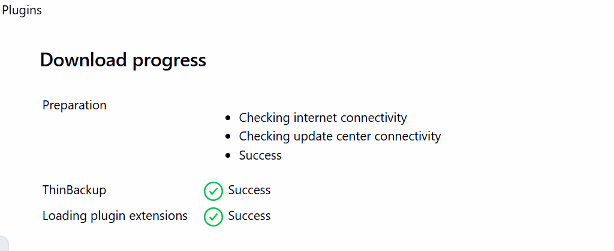
Configure Backup Directory
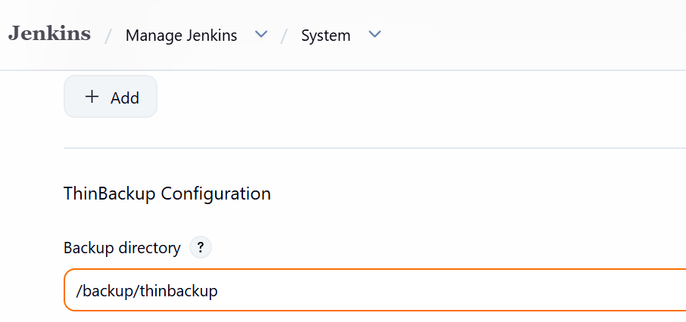
Enable this backup files and save it
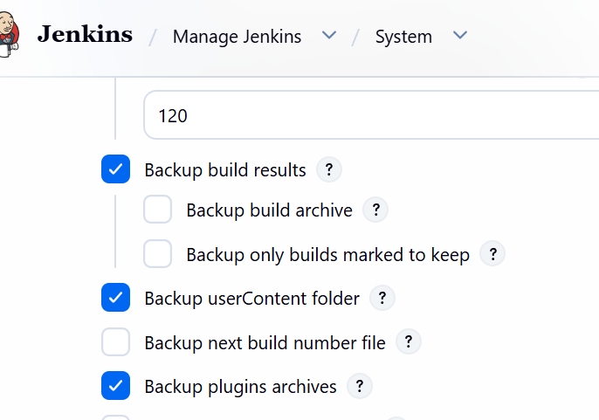
Now create directory in EC2 terminal and give permissions
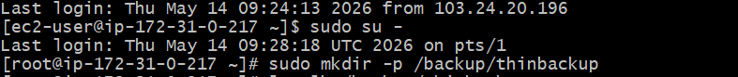
Now open thin backup from actions and do backup now
Successfully backup done
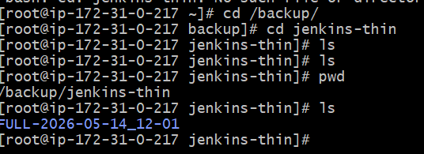
- Set up a new Jenkins server and restore the backup taken in task 4.
Created a new instance
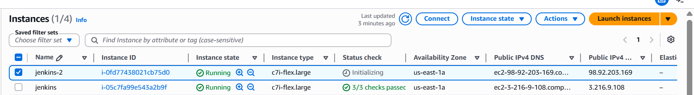
Connected to ec2
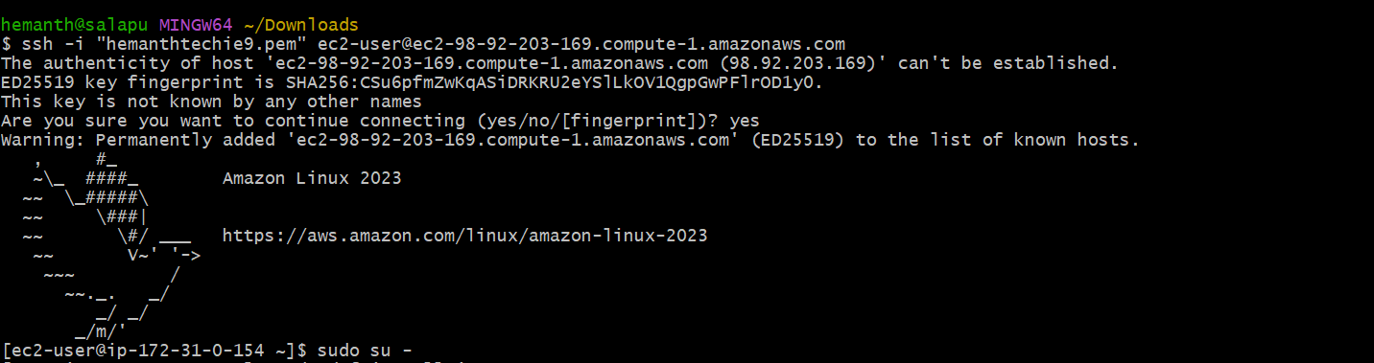
Installed java 21 version
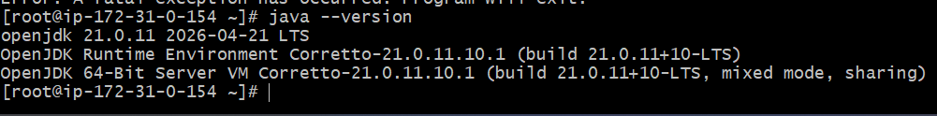
Installed Jenkins
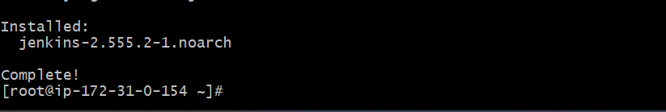
By using scp -i test.pem /backup/jenkins/jenkins-backup-2026-05-14-09-36.tar.gz ec2-user@98.92.203.169:/tmp
we can transfer the backup file to other instance
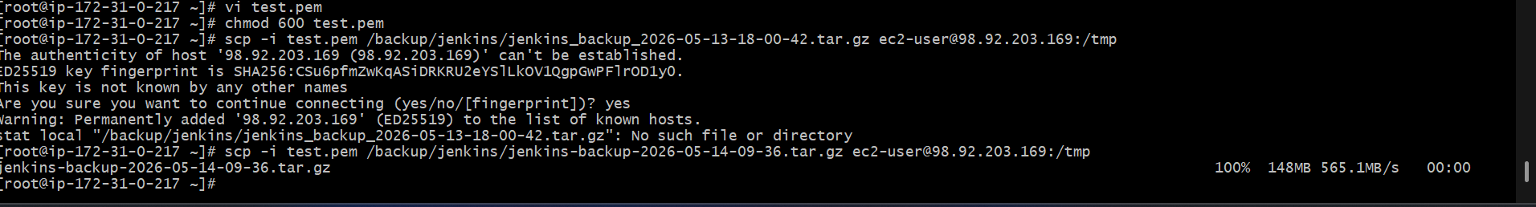
From the old server we got the backup to the new server
