AWS - IAM TASK
Create one IAM user and assign EC2 and S3 full access roles.
Go to IAM Click create user Give user name and give access according to the request in the question
Created a user and added the policy required

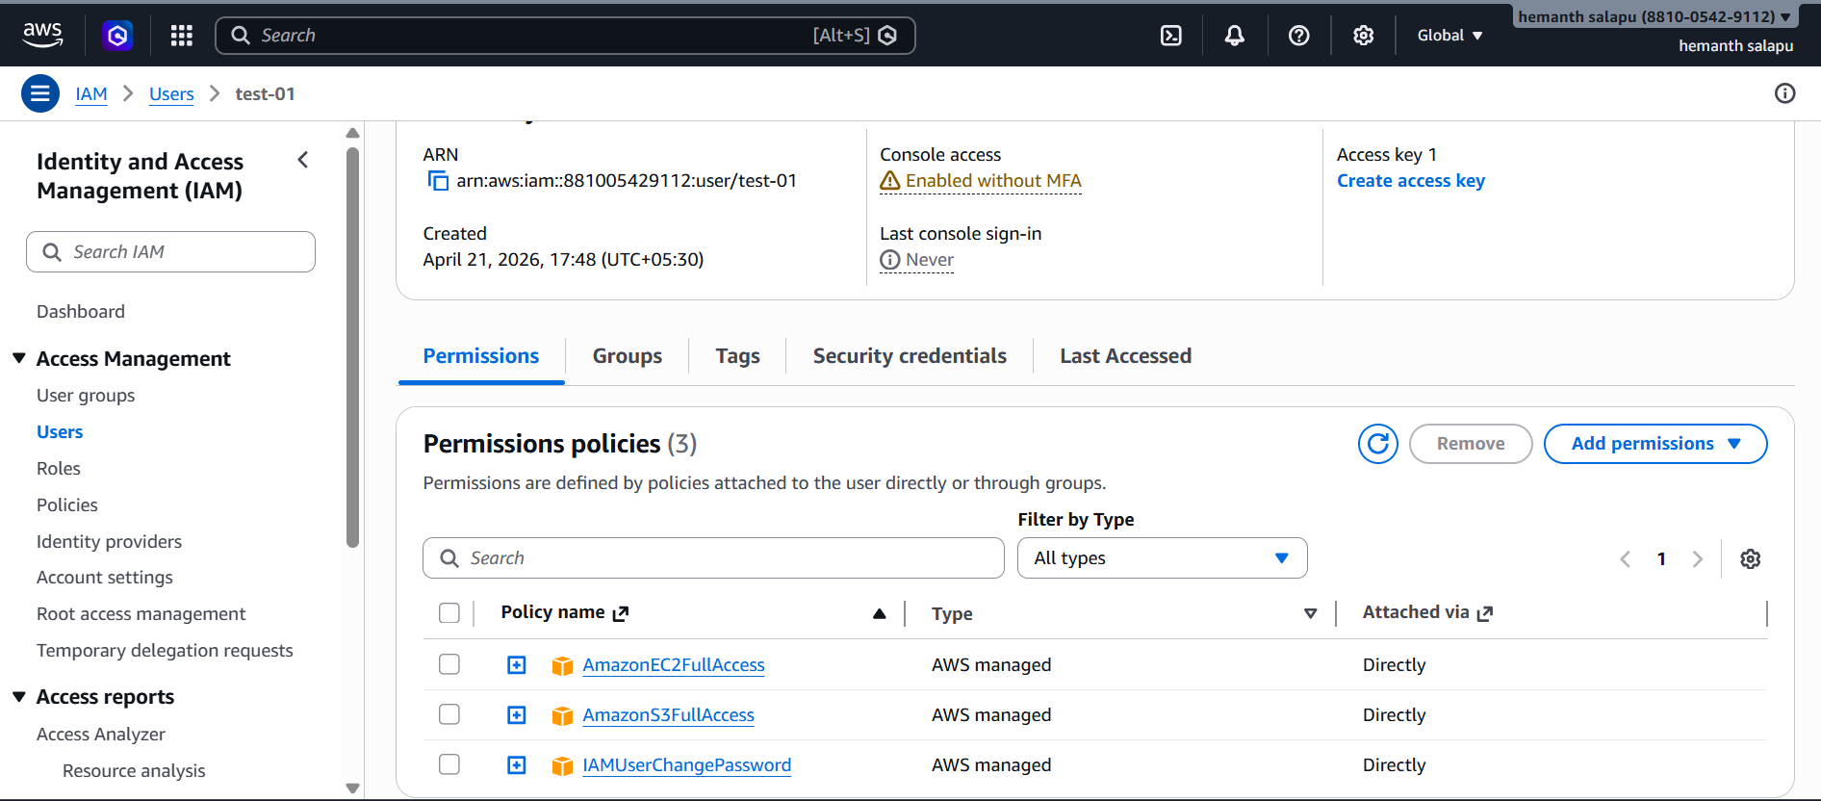

Create one group in IAM and assign read access for EC2.
Create a Group in IAM and gave specific permission
Ec2 read only permission and attach user to it
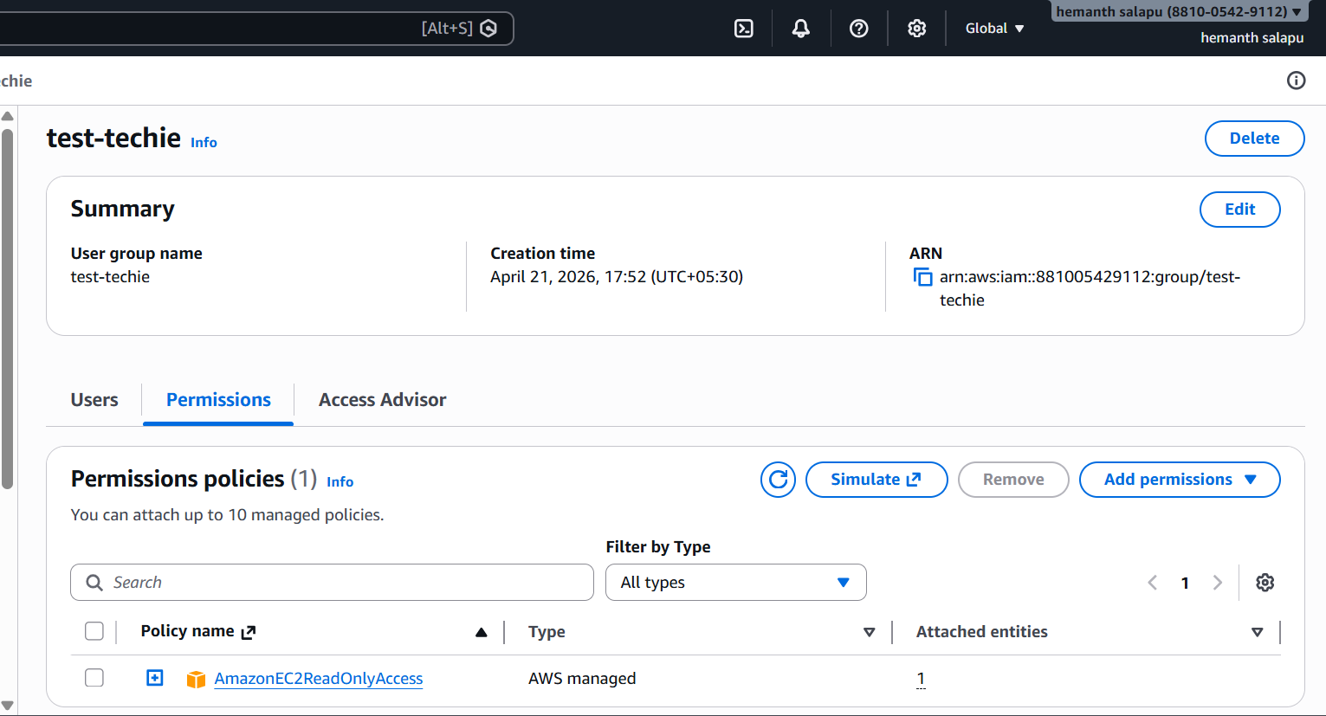
Create a new user named "Devops" and add to the group created in task 2.
Created new user and attached to that Group

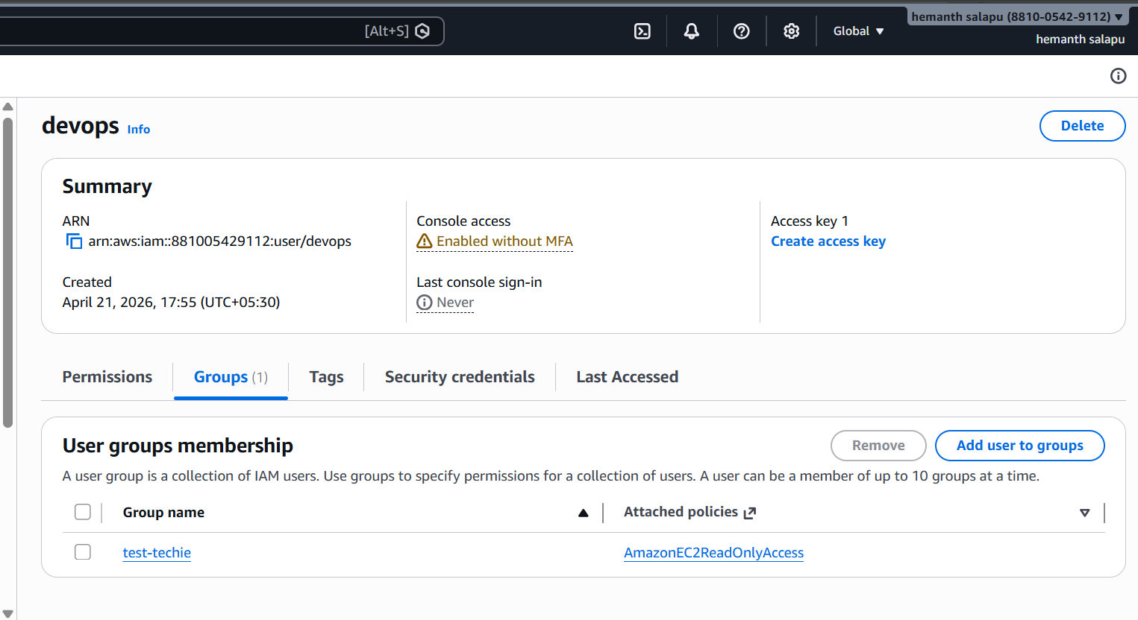

Write a bash script to create an IAM user with VPC full access.
Created a script to give access to the user name vpc
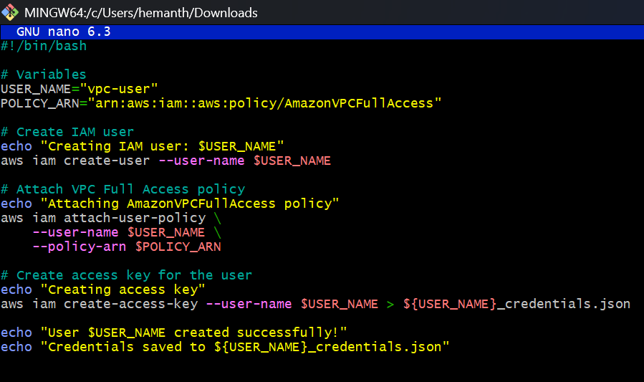
Now in GUI you will have the user with vpc access

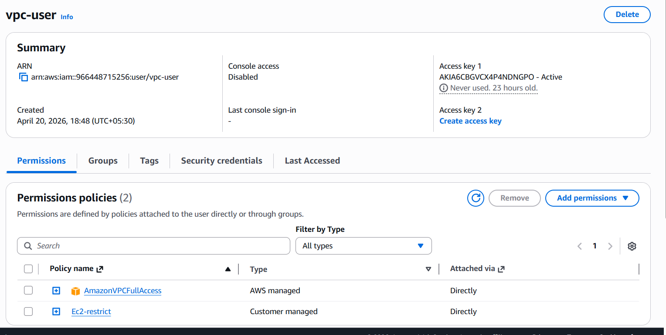

Create an IAM policy to allow EC2 access for a specific user in specific regions only.
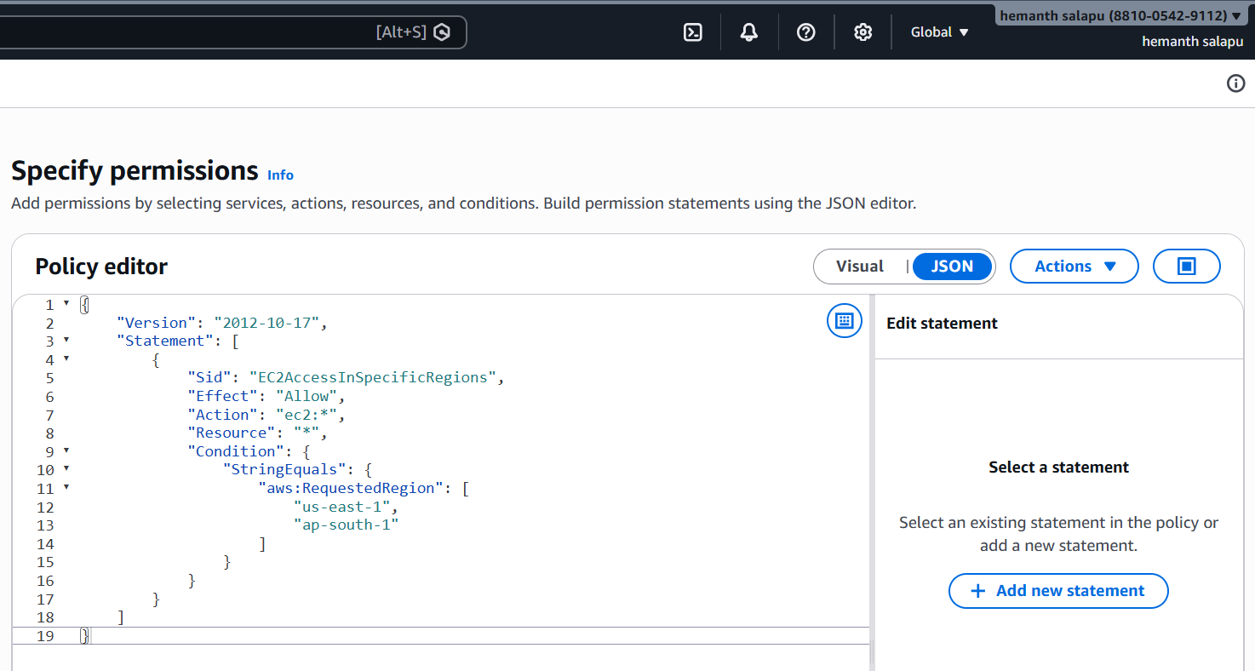
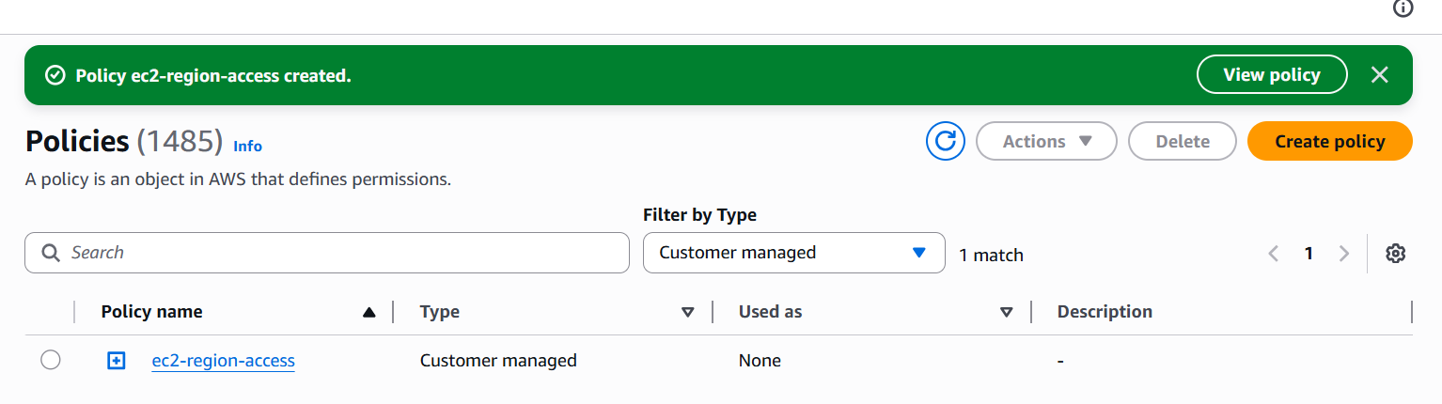
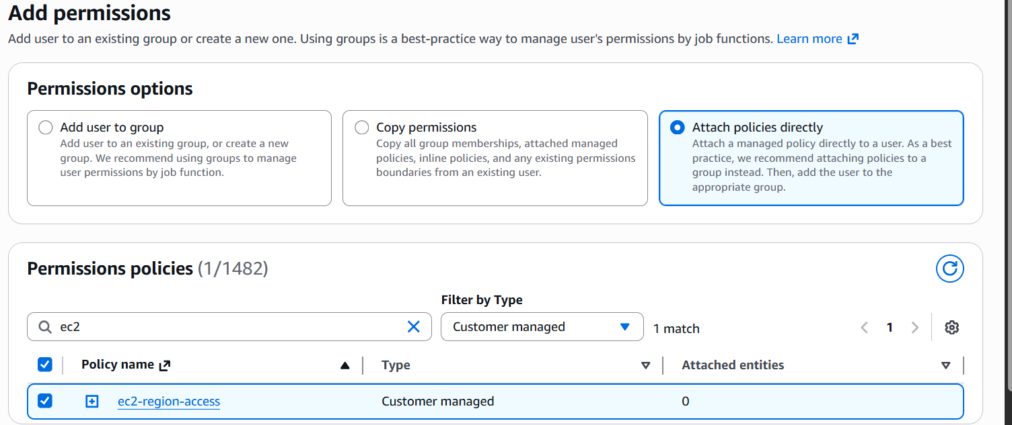

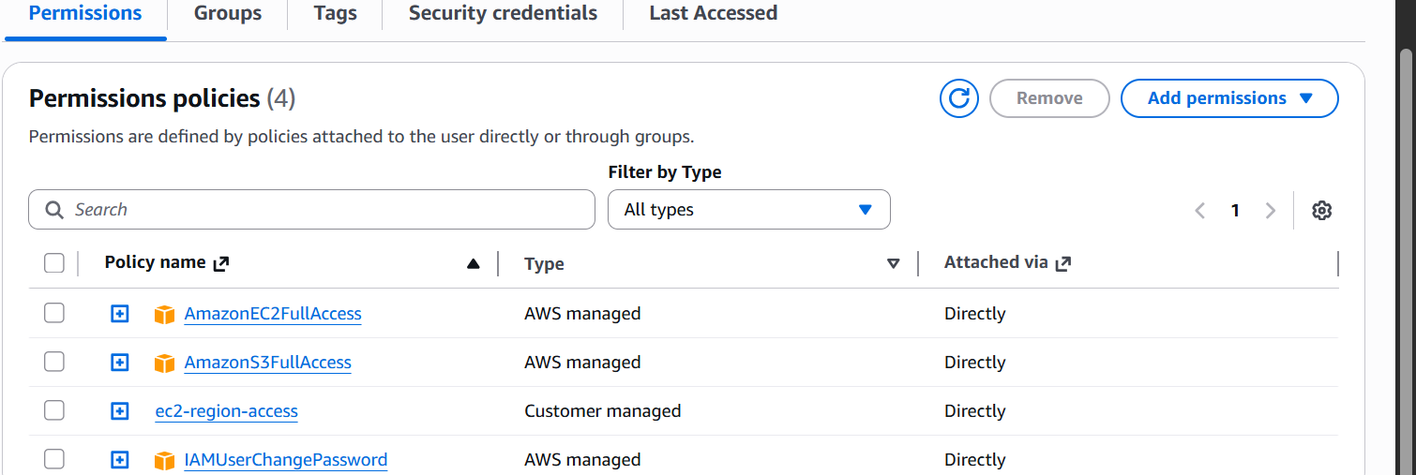

We have two accounts: Account A and Account B. Account A user should access an S3 bucket in Account B.
Used the policy for that
{
"Version": "2012-10-17",
"Statement": [
{
"Sid": "AllowSpecificUserS3Access",
"Effect": "Allow",
"Principal": {
"AWS": "arn:aws:iam::966448715256:user/Harshu-Shaik"
},
"Action": [
"s3:ListBucket",
"s3:GetObject",
"s3:PutObject"
],
"Resource": [
"arn:aws:s3:::iam-buckettechie",
"arn:aws:s3:::iam-buckettechie/*"
]
}
]
}
Now I am able to access my friend bucket
