AWS -01
Launch one EC2 instance using Amazon Linux 2
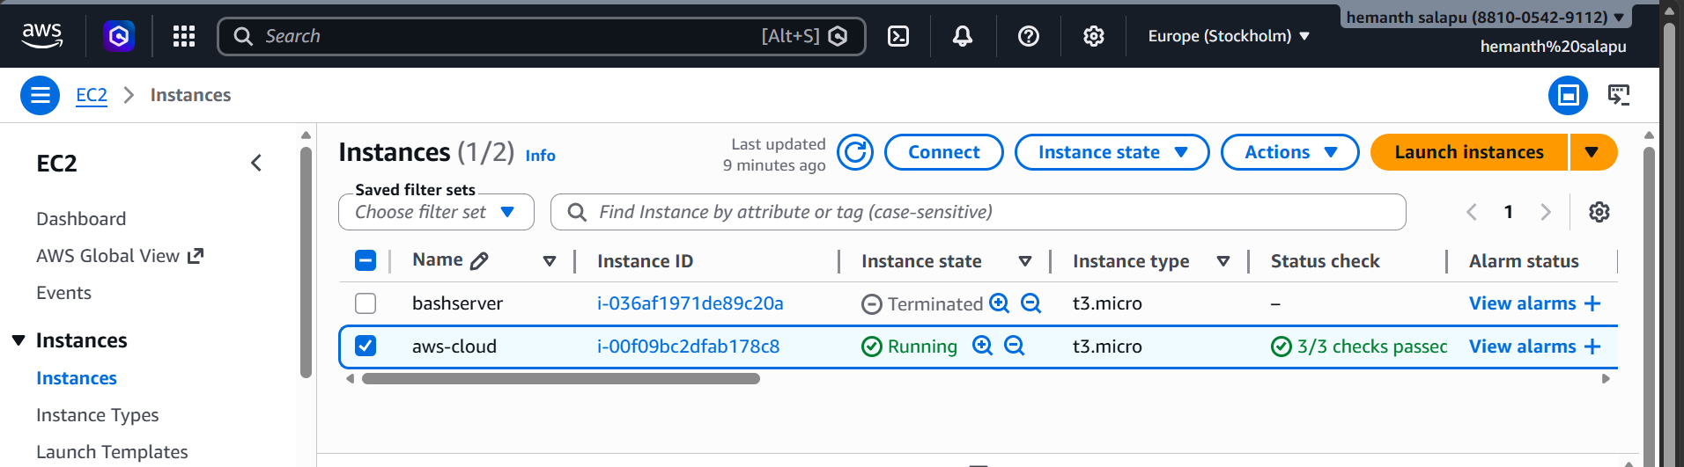
Install Docker
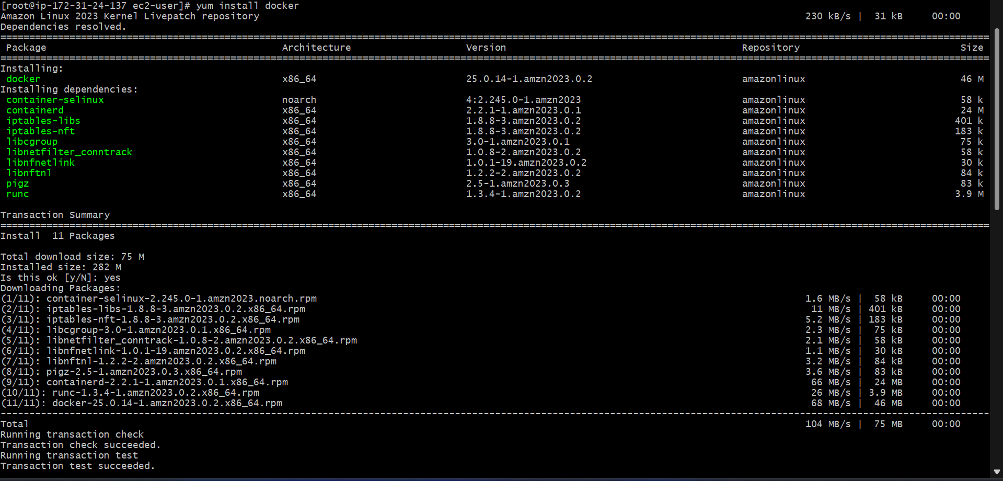
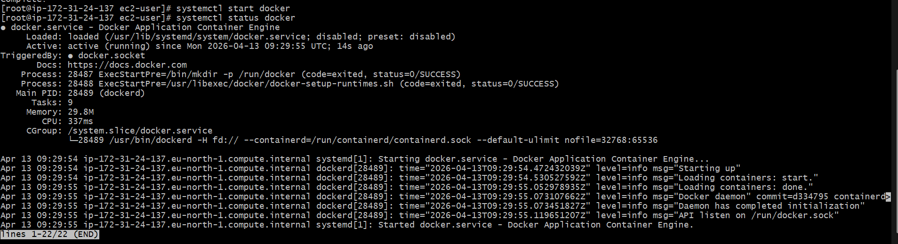
Install Jenkins:
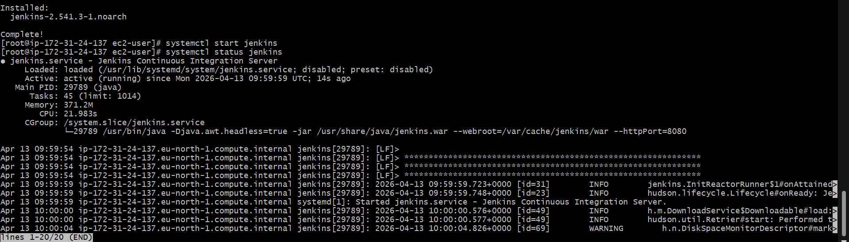
Install Apache. (httpd)
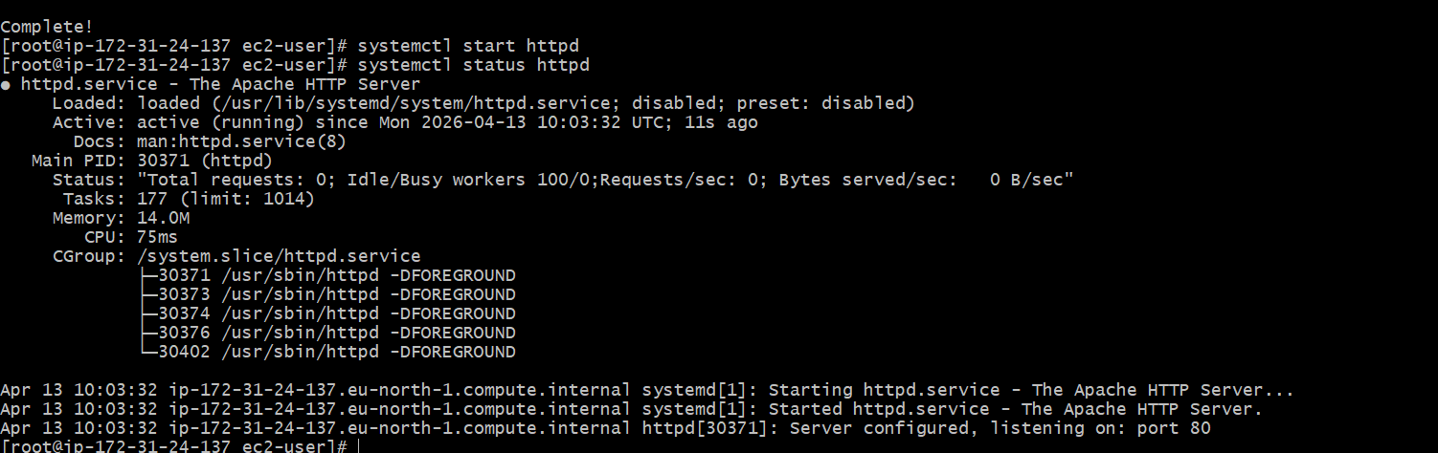

Install Nginx
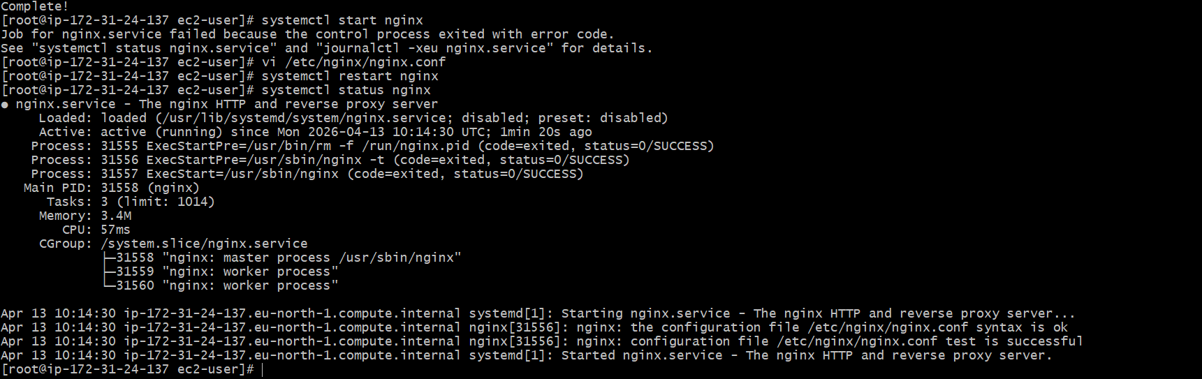
Port number change to 81
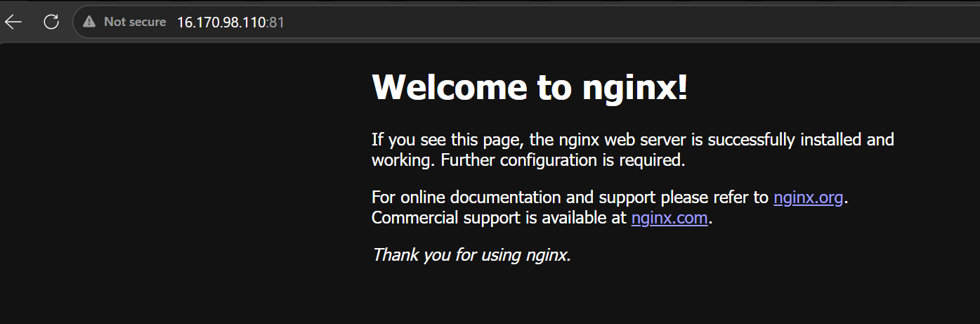
Install Apache Tomcat
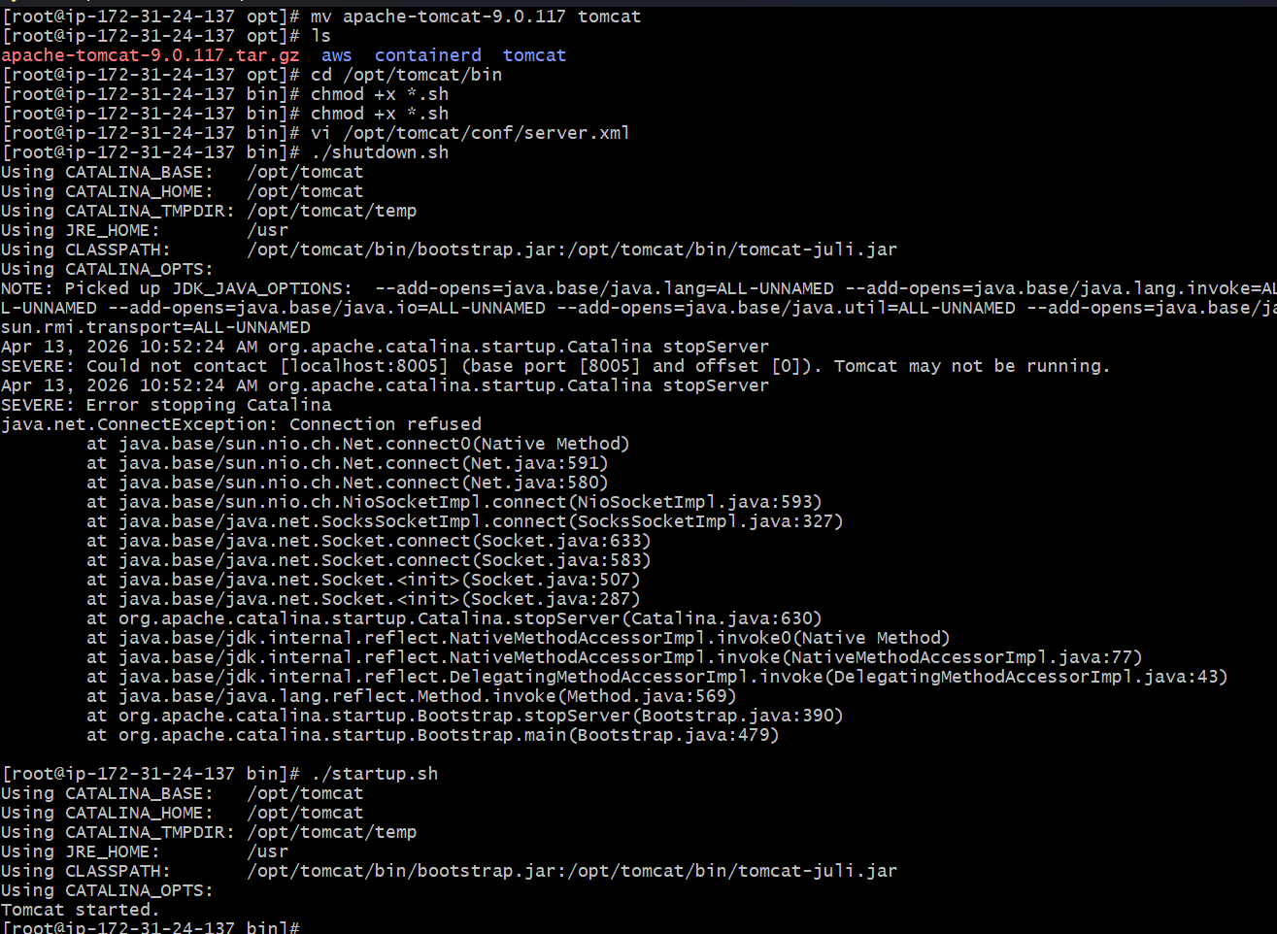
Port number changed to 8082

