LINUX COMMAND’S TASK AND EXECUTION
EXECUTION:
Shell = Shell is a program which takes input and gives output.
Terminal = Terminal is a tool to execute the shell commands, is also called as CLI (command line interface)..
--------------------------------------------------------------------------------------------
Echo $0 = Command is used to check which type shell you are using
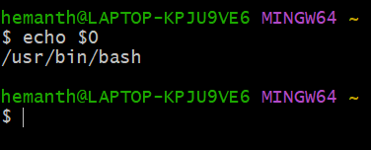
/ = Is the working root directory in which all the other directory
will comes in
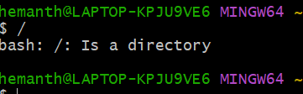
PWD = Will show the present working directory of the file or folder
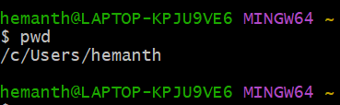

~ = Is basically a home directory for a user
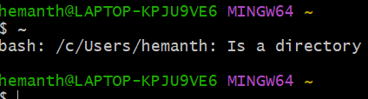

cd = is basically used to switch from one directory to another
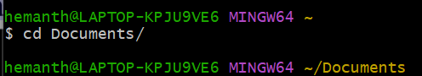

Cd ../.. = This is command is used to get back two steps
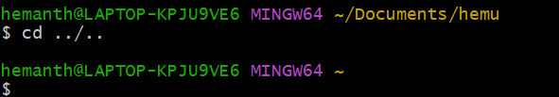

ls= Command used to list of file
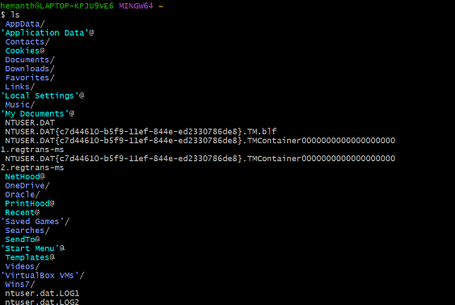
ll=Command used to display file and folder in long list which
include
file permission and creation date the file has been created
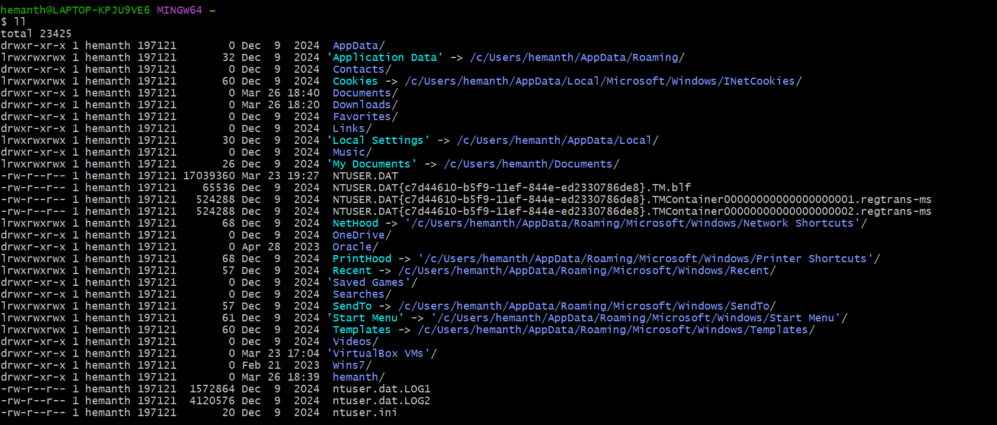

ls -ltr= This command is also used to long list the file permission
and creation date. -l Long listing format. - t Sort by time→ → . -r →
Revised order
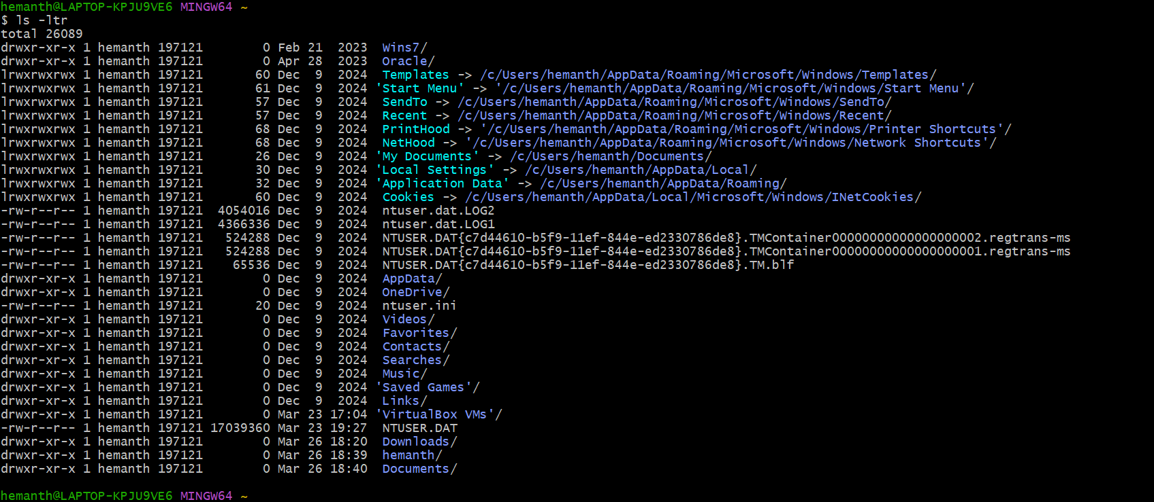
ls -a= This command is used to show the hidden files
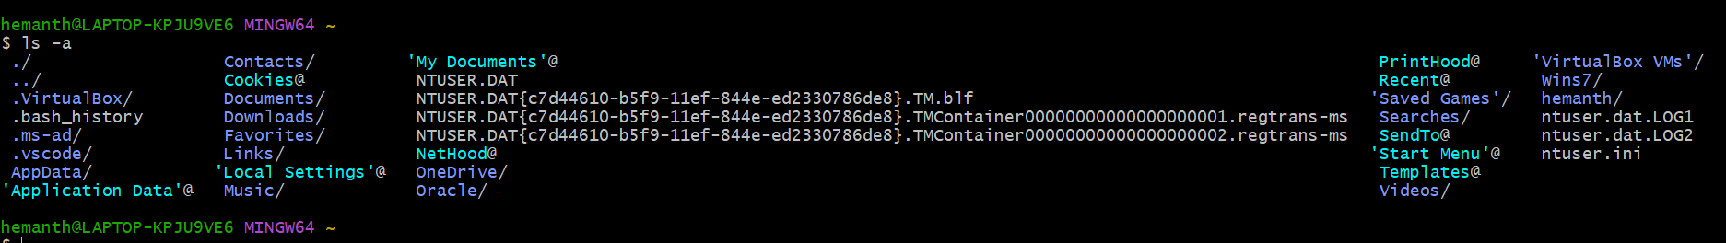
mkdir=This command is used to create the directory for user
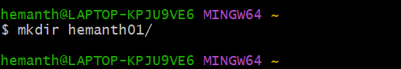
mv = This command is used for two type one is for rename the file.
And another one is you move your specific file to specific location
Here I have rename the file name
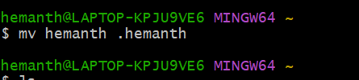
Rm -rf = This command is used to delete the folders and file
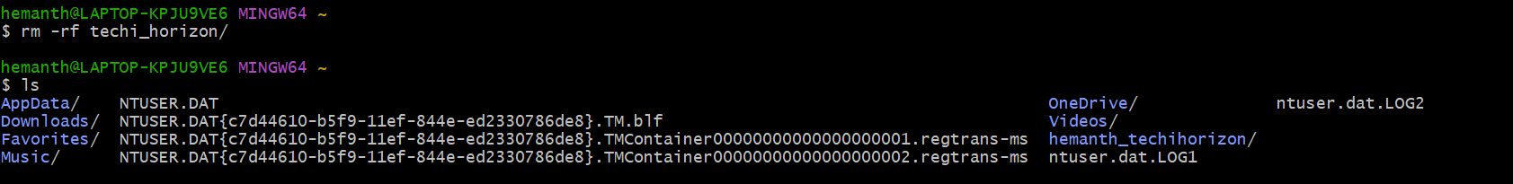
Touch=This command is used to create a zero byte file
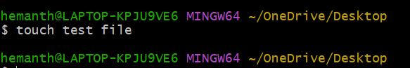

Vi=This command is used the edit the file and write content in that
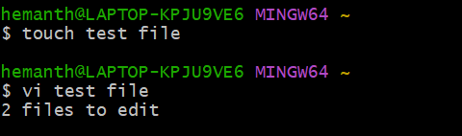
Cat = Command is used to cat the content in the file
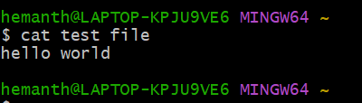
wc = Command is used to count the letters and string in the text file
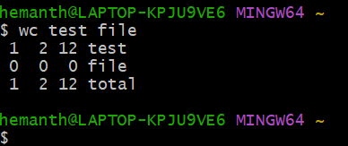
This commands which I have practiced with hands on in Git-
Bash
--------------------------------------------------------------------------------------------

