LINUX TASK
Task – 01 : create user with name techie and provide sudo access to user..
Created user with name techie and added passwd for techie
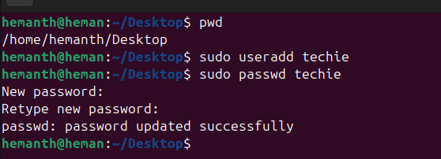
Provide sudo access to user (techie). Visudo
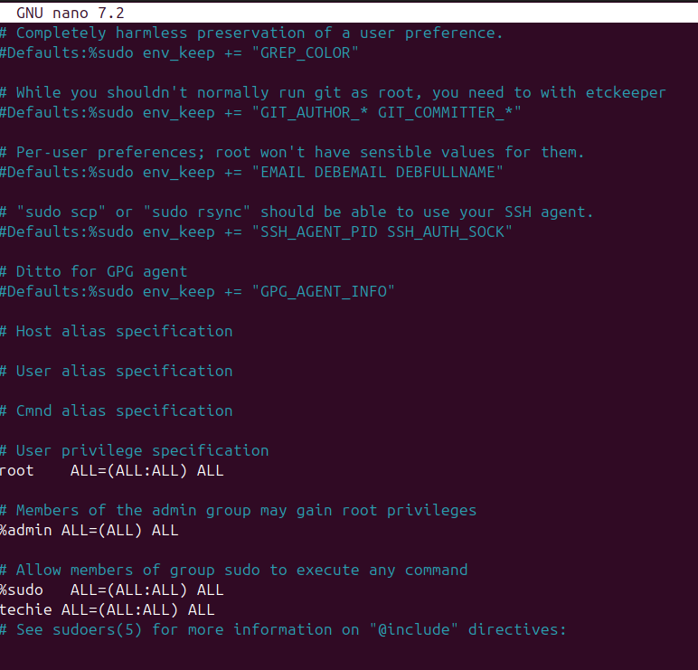
Task - 02 : Navigate to the home directory.
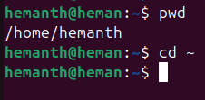
Task – 03 : create a new directory..
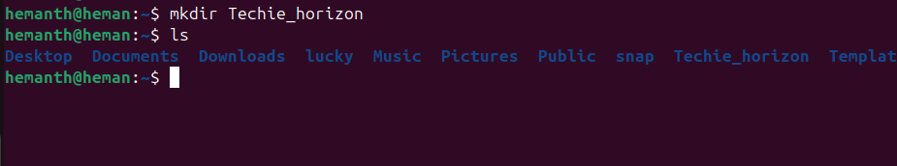

Task – 04 : List the contents of a directory..

Task – 05 : Change the current directory..
Cd= command used to change the current directory..
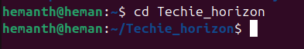
Task – 06 : Create a new empty file..
touch = touch is used to create a new empty file
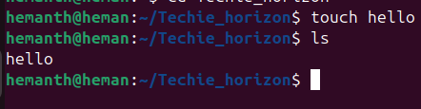
Task – 07 : view the contents of a file…
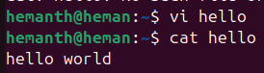
Task – 08 : Copy a file to another location..
Cp= Command used to copy a file to another location..
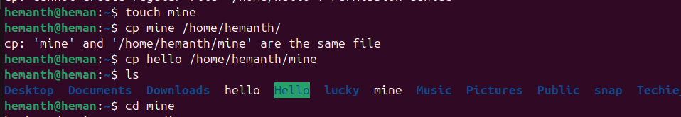
Task – 09 : Move a file to another location.
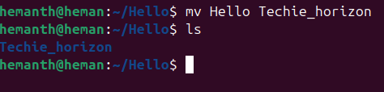
Task – 10 : Rename a file.

Task – 11 : Delete a file.
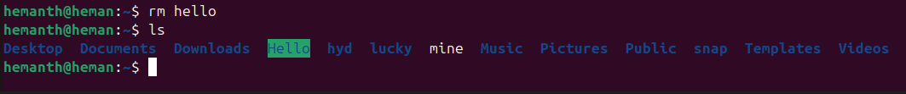

Task – 12 : Grant or revoke permissions on a file or directory.
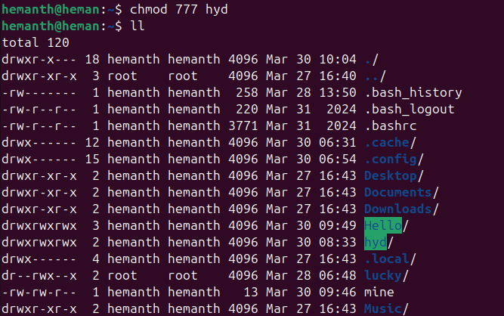
Task – 13 : View the current date and time.
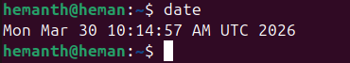
Task – 14 : Check the system uptime.
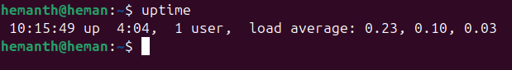
Task – 15 : View the running process
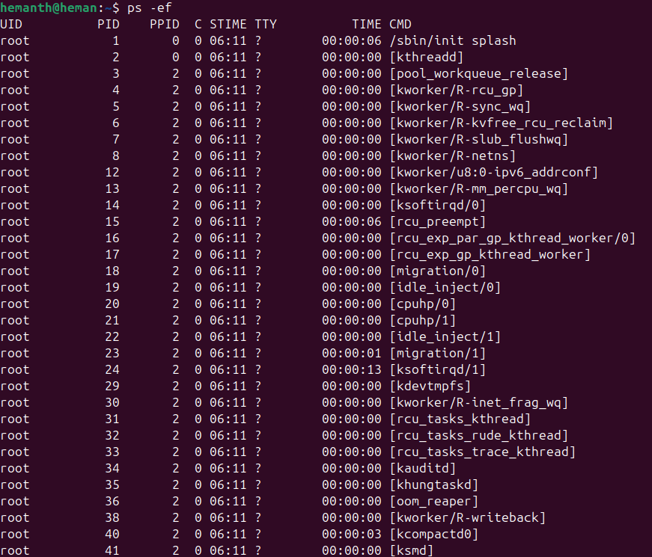

Task – 16 : Kill a running process.
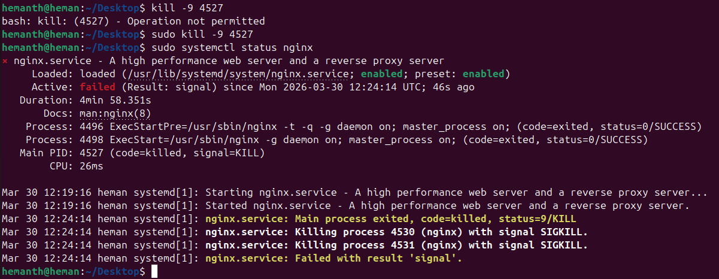
Task – 17 : Install a package using the package manager (e.g., apt or yum).
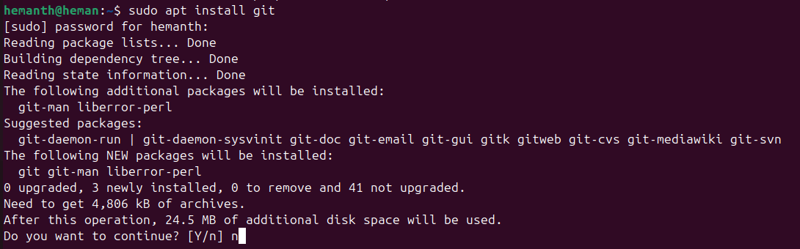
Task – 18 : Update the system packages.
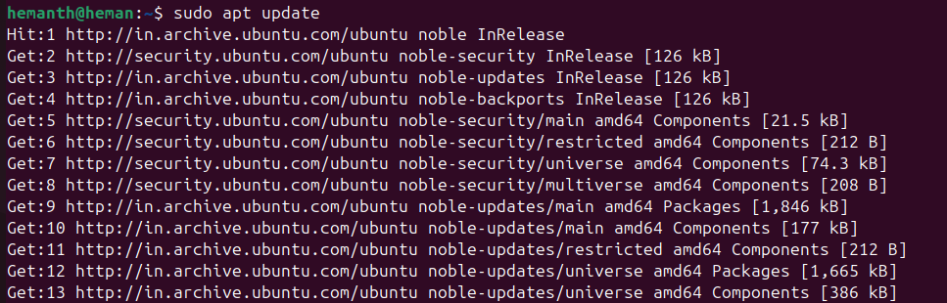
Task – 19 : Create a symbolic link.
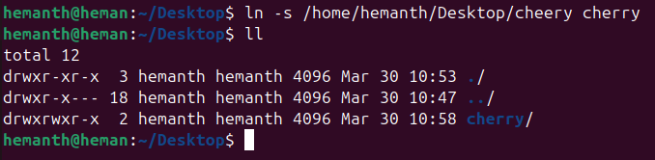
Task – 20 : Search for files using the find command.
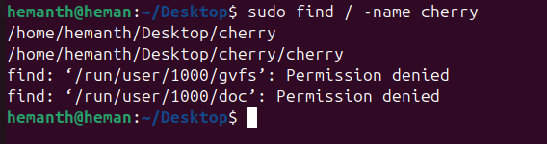

Task – 21 : Compress and decompress files using tar.
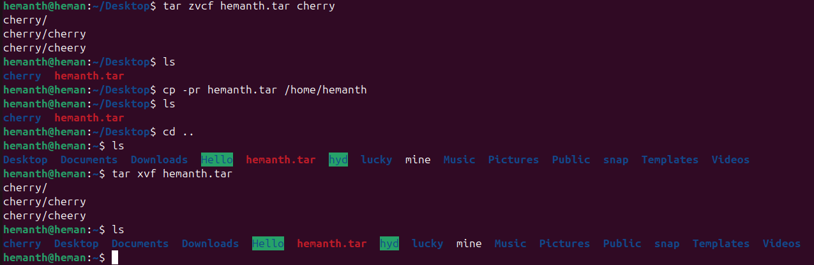
Task – 22 : Monitor system resources with top or htop.
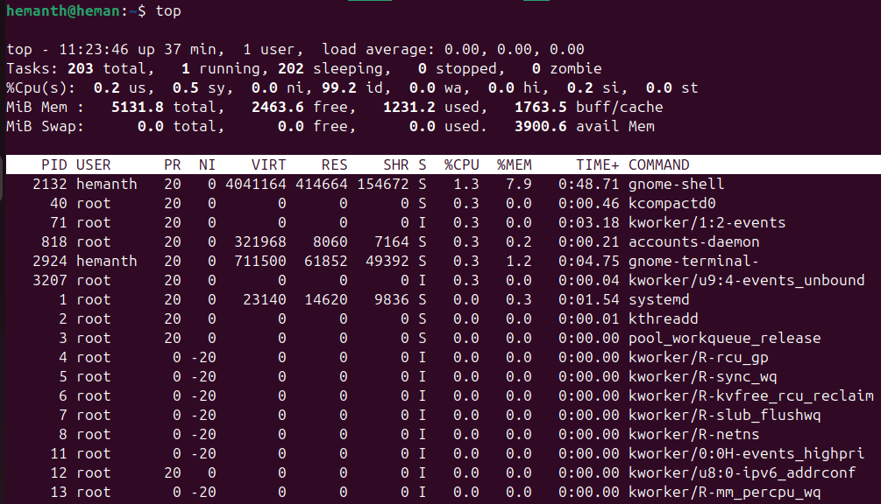
Task – 23 : Create and manage user groups.
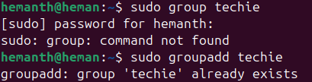
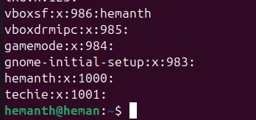
Task – 24 : Set up SSH password less authentication.
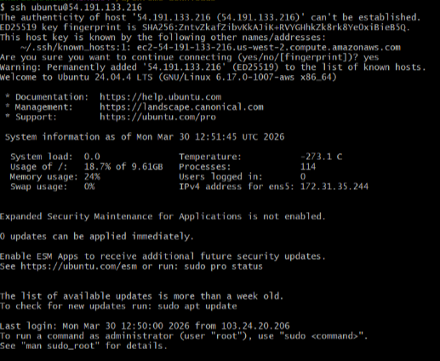
Task – 25 : Monitor log files using tail or grep.
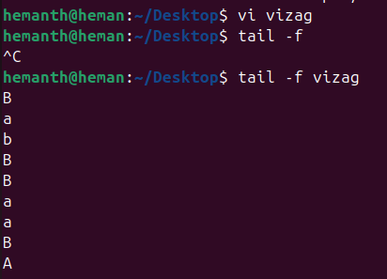
Task – 26 : Set up a web server (e.g., Apache or Nginx).
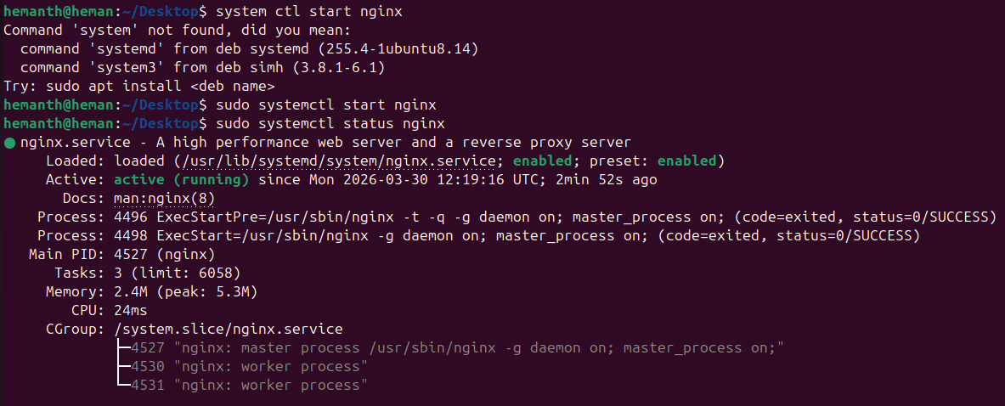

Task – 27 : Configure and secure a MySQL Database.
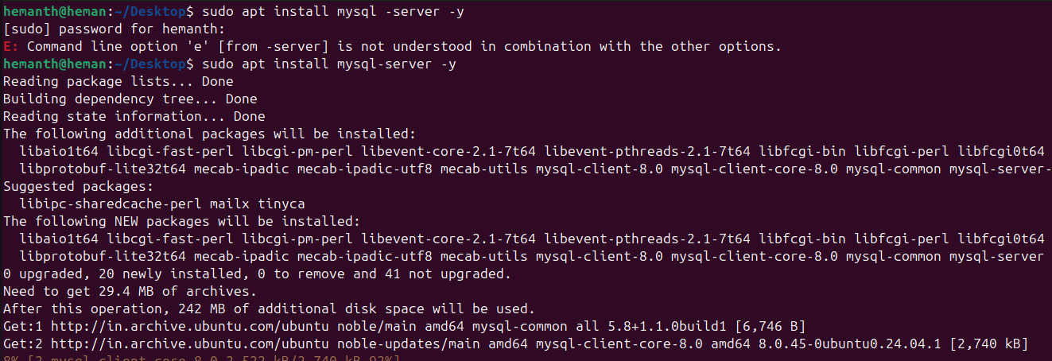
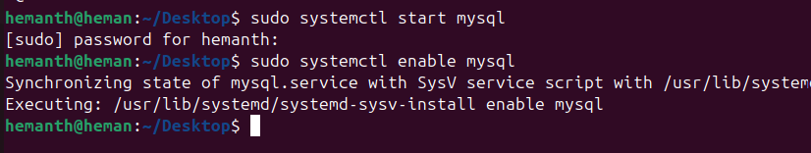
Task – 28 : Set up a Application Server (e.g.,Apache Tomcat)
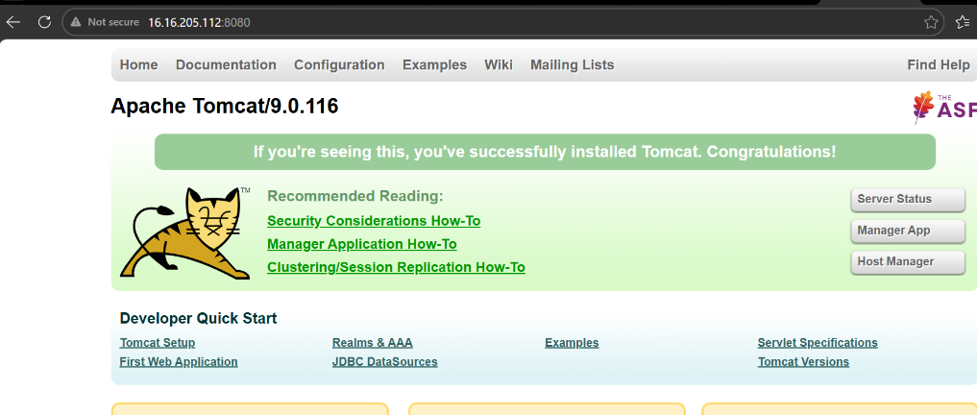

Task – 29 : create a service file for Apache Tomcat.(Should execute by using systemtctl command)
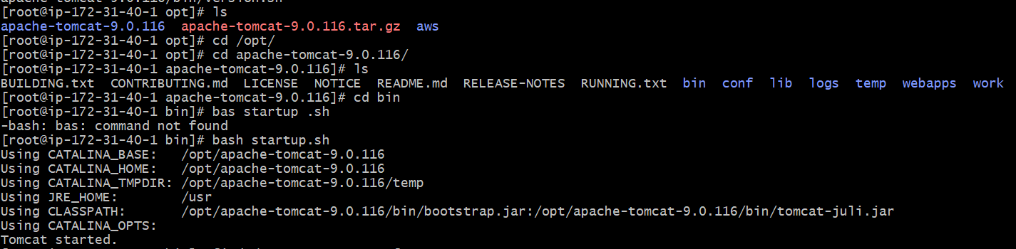
Task – 30 : Print specific columns from a delimited file.
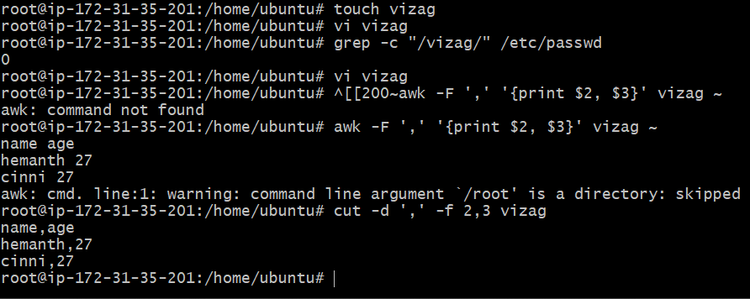
Task – 31 : Filter and print lines based on a specific pattern or condition.
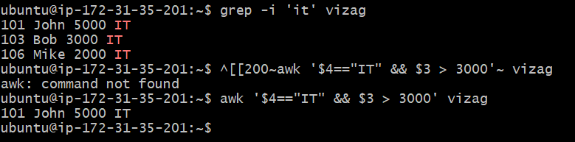
Task – 32 : Calculate and print the average, sum, or other statistics of a column.

Task – 33 : Perform string manipulation, such as extracting substrings or changing case.
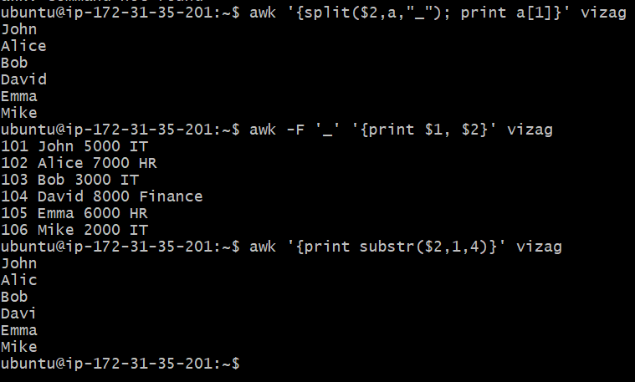
Task – 34 : Count the occurrences of a specific pattern in a file.
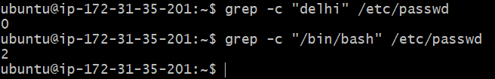
Task – 35 : Sort lines based on a specific field or column.
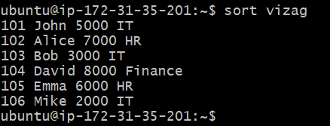
Task – 36 : Merge multiple files based on a common field or column.
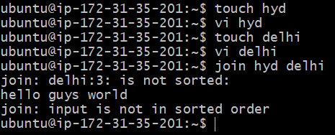
Task – 37 : Substitute text in a file using search and replace.
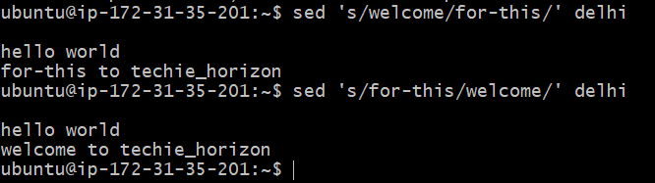
Task – 38 : Delete specific lines based on a pattern or line number.
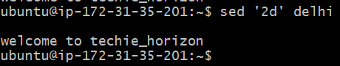
Task – 39: Append or insert text before or after a specific pattern or line.
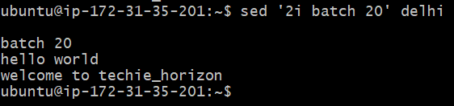
Task – 40 : Print only specific lines from a file.
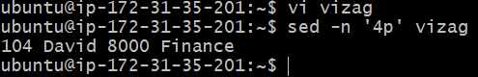
Task – 41 : Copy file from linux to windows machine
